**Lucky – Jason Mraz and Colbie Caillat**

C Am

Now do ya hear me talking to you

Dm G

Across the water, across the deep blue

Em Am Dm

Ocean, under the open sky, oh my

G

Baby I'm trying

C Am

Boy I hear you in my dreams

Dm G

I feel your whisper across the sea

Em Am

I keep you with me in my heart

Dm G

You make it easier when life gets hard

**[Chorus]**

Am Dm

Lucky I'm in love with my best

G

friend

C Am

Lucky to have been where I have been

Dm G G

Lucky to be coming home again

Am Dm G

Lucky we're in love in every way

C

Lucky to have stayed where we have

Am

stayed

Dm G

Lucky to be coming home some day

C Am Em G

Ooooh ooh-oooooh ooh-ooooooh...

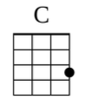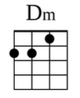 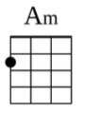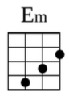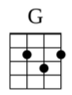

[Bridge]

Dm Am

They don't know how long it takes

G Dm

Waiting for a love like this

Dm Am

Every time we say goodbye

G Dm

I wish we had one more kiss

Dm Am

I'll wait for you, I promise you

G G

I will...

***(Repeat Chorus)***

C Am

And so I'm sailing, through the sea

Dm G

To an island, where we'll meet

Em Am

You'll hear the music, fill the air

Dm G

I put a flower in your hair

C

And though the breezes

Am

Through the trees

Dm G

Move so pretty, you're all I see

Em Am

Let the world keep spinning round

Dm G

You hold me right here, right now

***(Repeat Chorus)***

C Am Em G C

Ooooh ooh-oooooh ooh-ooooooh...