**Paris – The Chainsmokers**

G

We were staying in Paris

Bm

To get away from your parents and I thought, wow

A

If I could take this in a shot right now

Gbm

I don't think that we could work this out

G

Out on the terrace

Bm

I don't know if it's fair but I thought, how

A

Could I let you fall by yourself

Gbm

While I'm wasted with someone else

*[Chorus]*

G Bm

If we go down then we go down together

A

They'll say you could do anything

Gbm

They'll say that I was clever

G Bm

If we go down then we go down together

A

We'll get away with everything

Gbm

Let's show them we are better

G

We were staying in Paris

Bm

To get away from your parents, you look so proud

A

Standing there with a frown and a cigarette

Gbm

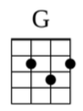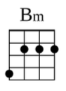

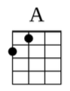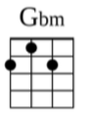

Posting pictures of yourself on the internet

G

Out on the terrace

Bm

We breathe in the air of this small town

A

On our own, cuttin’ class for the thrill of it

Gbm

Getting drunk on the past we were livin’ in

*[Repeat Chorus (2x)]*