**Slow Hands – Niall Horan**

C C Am G

We should take this back to my place

C C Am G

That's what she said right to my face

F F G G

'Cause I want you bad, yeah I want you baby

C Am G

I've been thinking 'bout it all day

C Am G

And I hope you feel the same way -yeah-

F G

'Cause I want you bad, yeah I want you baby

*[Chorus]*

F F

Slow, slow hands

G Am

Like sweat dripping down our dirty laundry

F F

No, no chance

G Em

That I'm leaving you without you on me

F F

I, I know

G Am

Yeah I already know that there ain't no stopping

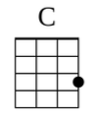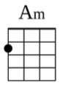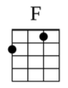

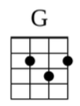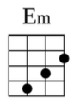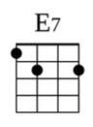

F F G G

Your plans and those slow hands -woo-

C C Am G

Slow hands

C C Am G

C Am G

I just wanna take my time

C Am G

We could do this baby, all night -yeah-

F G

'Cause I want you bad, yeah I want you baby

*[Repeat Chorus]*

Strum Patterns To Try:

1) **D D**

1 + 2 + 3 + 4 +

**D D D**

5 + 6 + 7 + 8 +

2) **D X U X**

1 + 2 + 3 + 4 +

**D X U D**

5 + 6 + 7 + 8 +

3) **D U D D U U D U**

1 e + a 2 e + a 3 e + a 4 e + a

4) **D U D U D D**

1 e + a 2 e + a 3 e + a 4 e + a

F F

Fingertips putting on a show

G G

Got me now and I can't say no

Em Em

Wanna be with you all alone

Am Am

Take me home, take me home

F F

Fingertips putting on a show

E7

Can't you tell that I want you baby

*[Repeat Chorus]*