**The Middle - Zedd**

C C G D

Take a seat, right over there, sat on the stairs

C C G D

Stay or leave, the cabinets are bare and I'm unaware

C C G D

Of just how we got into this mess, got so aggressive

C C G D

I know we meant all good intentions

*[Pre-Chorus]*

C C G

So pull me closer, why don't you pull me close?

D C C G D

Why don't you come on over, I can't just let you go

*[Chorus]*

C G D C

Baby, why don't you just meet me in the middle?

Em D C

I'm losing my mind just a little

Em D C

So why don't you just meet me in the middle?

G D

In the middle

C C G D

Take a step, back for a minute, into the kitchen

C C G D

Floors are wet, taps are still running, dishes are broken

C C G D

How did we get into this mess? Got so aggressive

C C G D

I know we meant all good intentions

Strum Patterns To Try:

Verse:

**D U D**

1 + 2 + 3 + 4 +

Chorus:

**D U X X X**

1 + 2 + 3 + 4 +

**D U U D**

1 + 2 + 3 + 4 +

*[Repeat Pre-Chorus + Chorus]*

Am C

Looking at you, I can't lie

G

Just pouring out admission

D

Regardless of my objection, oh

Am C

And it's not about my pride

G

I need you on my skin

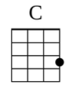 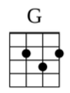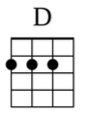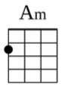

D

Just come over, pull me in, just

*[Repeat Chorus] x2*