**Too Good At Goodbyes – Sam Smith**

Strum Patterns To Try:

1) **D U D**

1 + 2 + 3 + 4 +

2) **D X U U X**

1 + 2 + 3 + 4 +

3) **D U D U D D**

1 e + a 2 e + a 3 e + a 4 e + a

Dm F

You must think that I'm stupid

C Gm

You must think that I'm a fool

Dm F

You must think that I'm new to this

C Gm

But I have seen this all before

*[Pre-Chorus]*

Dm

I'm never gonna let you close to me

F

Even though you mean the most to me

C Gm

'Cause every time I open up, it hurts

Dm

So I'm never gonna get too close to you

F

Even when I mean the most to you

C Gm

In case you go and leave me in the dirt

*[Chorus]*

Dm F

Every time you hurt me, the less that I cry

C Gm

And every time you leave me, the quicker these tears dry

Dm F

And every time you walk out, the less I love you

C Gm

Baby, we don't stand a chance, it's sad but it's true

Dm F

I'm way too good at goodbyes

C Gm

I'm way too good at goodbyes

Dm F

I know you're thinking I'm heartless

C Gm

I know you're thinking I'm cold

Dm F

I'm just protecting my innocence

C Gm

I'm just protecting my soul

*[Repeat Pre-Chorus + Chorus]*

Dm F

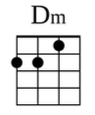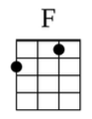 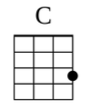 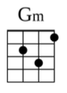

No, no, no, no, no No, no, no, no, no

C Gm

No, no, no, no, no

*[Repeat Chorus]*