**Under The Sea - The Little Mermaid**

Dashed chords indicate the chords should be played for 1/2 as long.

**C G7 - C**

Da seaweed is always greener

**C G7 - C**

In somebody else's lake

**C G7 - C**

You dream about going up dere

**C G7 - C**

But dat is a big mistake

**F C**

Just look at da world around you

**G7 C**

Right here on de ocean floor

**F C**

Such wonderful things surround you

**G7 C**

What more is you lookin' for

*[Chorus]*

**F C G7 C**

Under da sea, under da sea

**F**

Darling it's better

**G7**

Down where it's wetter

**C C7**

Take it from me

**F G**

Up on da shore dey work all day

**Am D7**

Out in da sun dey slave away

**F**

While we devotin'

**G**

Full time to floatin'

**C G7 - C**

Under da sea

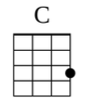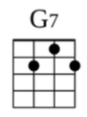 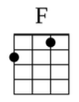 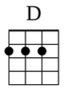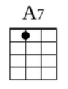

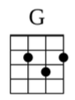 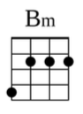 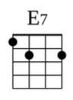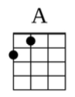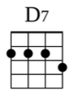

**C G7 - C**

Down here all de fish is happy

**C G7 - C**

As off through da waves dey roll

**C G7 - C**

Da fish on da land ain't happy

**C G7 - C**

Dey sad 'cause dey in da bowl

**F C**

But fish in da bowl is lucky

**G7 C**

Dey in for a worser fate

**F C**

One day when da boss get hungry

**G7 C**

Guess who gon' be on da plate

*[Chorus]*

**C F C G C**

Under da sea, under da sea

**F G**

Nobody beat us, fry us and eat us

**C C7**

In fricassee

**F G**

We what da land folks love to cook

**Am D7**

Under da sea we off da hook

**F**

We got no troubles

**G**

Life is de bubbles

**F C G C**

Under da sea, Under da sea

**C F**

Since life is sweet here

**G C C7**

We got da beat here, naturally

**F G7**

Even da sturgeon and de ray

**Am D7**

Dey get de urge and start to play

**F**

We got de spirit,

**G C**

You got to hear it, under da sea

*[Bridge]*

**G7**

Da newt play da flute

**C**

De carp play de harp

**G7**

De plaice play de bass

**C**

And dey soundin' sharp

**F**

Da bass play da brass

**C**

Da chub play da tub

**G7 C**

Da fluke is the duke of soul

**G7**

Da ray he can play

**C**

De ling's on de strings

**G7**

Da trout rockin' out

**C**

Da blackfish she sings

**F**

Da smelt and da sprat

**C**

Dey know where it's at

**G7 C**

An' oh, dat blowfish blow

**C G7 – C C G7 - C**

**D A7 – D D**

*[Chorus]*

**G D A7 D**

Under da sea, under da sea

**G A**

When da sardine begin da beguine,

**D D7**

It's music to me

**G A7**

What do dey got, a lot of sand

**Bm E7**

We got a hot crustacean band

**G**

Each little clam here

**A7**

Know how to jam here

**D D**

Under da sea

**G**

Each little slug here

**A7**

Cutting a rug here

**D D**

Under da sea

**G**

Each little snail here

**A7**

Know how to wail here

**Bm**

Dat's why it's hotter

**E7**

Under da water

**G**

Ya, we in luck here

**A7**

Down in de muck here

**D A7 - D**

Under da sea

**D A7 - D**

    