**White Christmas - Irving Berlin**

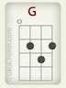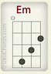

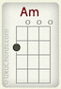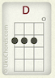

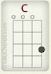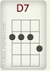

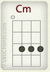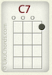

Macintosh HD:Users:amelialin:Dropbox:Screenshots:Screenshot 2017-11-30 21.34.58.png

G Em Am D

I’m dreaming of a white Christmas

C D7 G C–D7

Just like the ones I used to know

G G7

Where the treetops glisten

C Cm

And children listen

G Am D7 C7

To hear sleigh bells in the snow

G Em Am D

I’m dreaming of a white Christmas

C D7 G C-D7

With every Christmas card I write

G G7 C Cm

May your days be merry and bright

G D7 G

And may all your Christmases be white

xA|--------5-----4-----3-----|

xE|--------5-----4-----3-----|

xC|--------------------------|

xG|--------------------------|

1 + 2 + 3 + 4 +

*(repeat)*

------------------------

(swing time)

D D U U D U

1 + 2 + 3 + 4 +