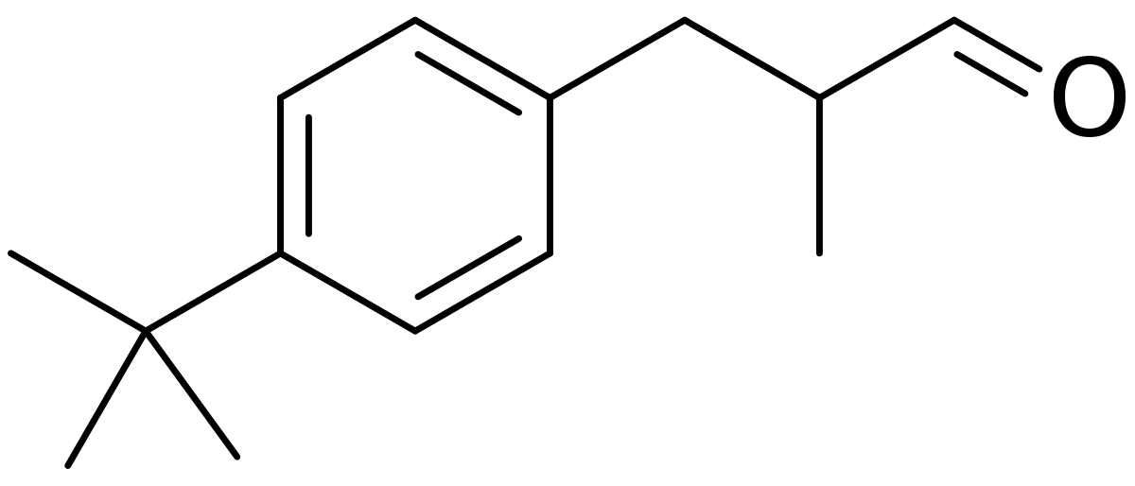

**Lilial Charge Adjustment**

An alkane >C< (#84) has a charge of 0, but this needs to be adjusted because the C is attached to an aromatic ring instead of an alkane chain.

An alkane -CH2- (#81) has a charge of -0.12, while an ethyl benzene -CH2- (adjacent to an aromatic ring) (#94) has a charge of -0.005, a difference of +0.115 from the chain to the ring.

Therefore we need to assign a charge of +0.115 to this C.