In previous research on Optical Audio Reconstruction (OAR), different methods have been tested however they all follow a similar procedure that involves the grooves on the record being scanned, then the groove undulations (tiny wave pattern along the groove path) are isolated and extracted before these undulations are converted into audio. Iwai et al. and Nakamura et al researched a method involving shining a laser beam onto the grooves and the undulations are processed using the measured angle of the reflected light. Errors were recorded using this method that stemmed from the laser beam missing a groove entirely, also laser beams have a finite width, and as undulations are incredibly small, it has been reported that a laser beam is too thick to properly measure an undulation resulting in simultaneous high and low frequency noise in the reconstructed audio signals. Fadeyev and Haber produced a method that involved the use of confocal laser scanning microscopy scanning surface height along the record and producing a 3D image, and using 2D edge detection the boundaries of the grooves can be traced meaning the groove undulations can be recorded. Stotzer et al. created a method involving a 2D analogue camera rapidly photographing the record with these images stored on film. This film is then digitised into 2 digital images. During scanning, the film sits on a rotating tray with a stationary overhead camera. The camera is only able to see a small window at a time and imaging of the grooves pass through this window. By doing this the curved grooves from the record are straightened out in the images making it easier to analyse. Edge detection is then used again for extracting the groove undulations.
In imaging, three distinct sections can be seen; tops, valleys and bottoms. And before the groove undulations can be extracted, these 3 regions need to be identified. This is done through height thresholding where each pixel of the image has a recorded height so therefore a cutoff can be set so each pixel can be labelled either a top or a bottom. Also, based on the geometry of how tops, bottoms and valleys work, a bottom will always be sandwiched by two valleys and a top and valley will never sandwich each other. So in figure 1, it can be seen that the narrow blue sections are the bottoms, the red sections are valleys and the orange sections are tops.
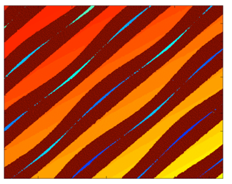
Figure 1: Topview of a groove image
To then extract audio, an edge detection algorithm is used to find the inner and outer top edges aswell as the groove bottom for each field of vision. These are then matched up for where neighbouring FOVs overlap, and spiral grooves are unwrapped into a straight line. This gives us three measurable signals, the two edge wiggles and the depth wiggles. The two edge signals are averaged to create one signal, T which follows the centre of the groove. Records are cut a constant velocity, so sound is carried by how fast the groove moves, not by position. So the software takes the numerical derivative (change from point to point) of the centre position signal and depth signal.
- Left = ΔT − ΔD
- Right = ΔT + ΔD
Then a RIAA filter is applied to restore original bass and treble balance as when the record is cut, bass turns down and treble turns up.

OPTICAL AUDIO RECONSTRUCTION FOR STEREO PHONOGRAPH... - Google Scholar

