

TABLE OF CONTENTS:
CHAPTER 1: INTRODUCTION
Sl.NO CONTENTS PAGE NO
1.1 Project Background and Motivation 04
1.2 Problem Statement 04
1.3 Project Objectives 04-05
1.4 Tools and Technologies Used 05
CHAPTER 2: REQUIREMENTS AND ANALYSIS
Sl.NO CONTENTS PAGE NO
2.1 Functional Requirements 05-06
2.2 Non-Functional Requirements 06 -07
2.3 Flowchart of Program Execution 07-08
CHAPTER 3: OBJECT-ORIENTED DESIGN AND METHODOLOGY
Sl.NO CONTENTS PAGE NO
3.1 Methodology 09
3.2 UML Class Diagram 10
3.3 Class Order List 10
3.4 Class Description 11
CHAPTER 4: IMPLEMENTATION AND CORE OOP PRINCIPLES
SI.NO CONTENTS PAGE NO
CHAPTER 5: TESTING AND RESULTS
Sl.NO CONTENTS PAGE NO
5.1 Test Plan 13
CHAPTER 6: CONCLUSION AND FUTURE WORK
Sl.NO CONTENTS PAGE NO
6.1 Conclusion 13
6.2 Limitations 13
6.3 Future Enhancements 13-14
ADDITIONAL
SI.NO CONTENTS PAGE NO
References 14
FIGURES

Sl.NO FIGURE PAGE NO
1.1 Code Snippet ( ATM MAIN CLASS) 14
1.2 Code Snippet (Account Manager ) 15
1.3 Code Snippet ( Database Manager) 16
1.4 Code Snippet ( PIN Manager) 17
1.5 Code (Screen Manager) 18
  - Code (sessional manager) 19
1.7 Transaction Manager 21
1.8 User. Java 23
1.9 Terminal Output 24
2.0 GUI Output Screen 26

Introduction:
1.1 Project Background and Motivation:
In today’s digital world, banking systems are highly automated for faster and easier services. An Automated Teller Machine (ATM) allows users to perform basic banking tasks like cash withdrawal and balance inquiry without visiting a bank.
This project, “ATM Simulation”, is designed to model the basic functions of a real ATM using programming concepts. It demonstrates how banking operations can be handled in a simple and structured way. The system also applies object-oriented programming principles to ensure clarity, modularity, and efficiency.

1.2 Problem Statement:
An ATM is widely used for quick and convenient banking services but understanding its internal working through traditional systems can be complex. There is a need for a simple and efficient system that can simulate essential ATM operations in a secure and user-friendly way.
This project aims to address this issue by developing an ATM Simulation System that allows users to perform basic functions such as cash withdrawal, balance inquiry, and secure authentication. The system is designed to reduce manual dependency and represent real-world ATM operations in a simplified software model.
1.3 Project Objectives:
a) To apply Java OOP concepts in developing a real-world expense management application.
b) To ensure data integrity and maintain modular, reusable code for better system organization.
c) To enable users to record and manage their incomes and expenses efficiently.
d) To provide features for adding, editing, deleting and viewing transactions in categorized formats.
e) To implement file handling for reliable and persistent data storage.
f) To incorporate exception handling to enhance system stability.

1.4 Tools and Technologies Used
The development utilizes a combination of programming concepts, tools and technologies to ensure a functional, reliable and well-structured application. The key tools and technologies used include:
1.Java Programming Language
2. Object-Oriented Programming (OOP) Principles
3. Java I/O (File Handling)
4. Java Scanner Class
5. UML Diagramming Tools (Draw.io)
6. Text File Storage (txt)
7.Java Exception Handling
Chapter:2
Requirement Analysis for ATM Simulation System
The Requirement Analysis phase identifies the needs and expectations of users for the ATM Simulation System. This system is designed to simulate the real-life operations of an Automated Teller Machine (ATM) in a secure and user-friendly way. The analysis helps define system functionalities, limitations, and user interactions before development begins.
Functional Requirements
The ATM Simulation System should perform the following functions:
- User Registration and Login
Users can create an account with necessary information.
Existing users can log in using account number and PIN.
- PIN Verification
The system verifies the entered PIN before granting access.
Invalid PIN attempts are restricted for security purposes.
- Balance Inquiry
Users can check their current account balance.
- Cash Withdrawal
Users can withdraw money if sufficient balance is available.
The system updates the remaining balance automatically.
- Deposit Money
Users can deposit money into their account.
The balance is updated after successful deposit.
- Fund Transfer
Users can transfer money from one account to another.
- PIN Change
Users can securely change their ATM PIN.
- Transaction History
The system stores and displays previous transaction records.
- Logout Feature
Users can safely end their ATM session after completing transactions.

Non-Functional Requirements
- Security
User information and PIN must remain protected.
Unauthorized access should be prevented.
- Reliability
The system should perform transactions accurately without data loss.
- Usability
The interface should be simple and easy to use.
- Performance
Transactions should be processed quickly and efficiently.
- Maintainability
The system code should be organized for future updates and modifications.

System Analysis
The ATM Simulation System is developed to imitate the operations of a real ATM machine. The system allows users to perform banking activities digitally without visiting a bank branch. It improves transaction speed, accuracy, and convenience.
The system follows a menu-driven approach where users select different banking operations after successful login. Each transaction updates the database automatically and provides feedback to the user. Proper validation techniques are used to ensure secure and error-free operations.
The project is developed using programming concepts such as classes, objects, methods, condition checking, loops, and file/database handling. The system demonstrates practical implementation of Object-Oriented Programming (OOP) concepts in banking applications.
Flowchart of Program Execution:

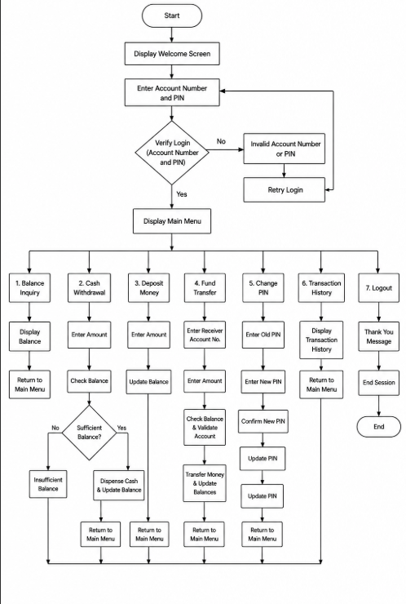

CHAPTER 3: OBJECT-ORIENTED DESIGN AND METHODOLOGY
3.1 Methodology
The ATM Simulation system is developed using an object-oriented approach. The system follows a structured software development methodology to ensure proper planning, design, implementation, and testing.
The development process includes:
- Requirement analysis to understand ATM functionalities such as deposit, withdrawal, balance inquiry, and PIN verification.
- System design using UML diagrams to model the structure and behavior of the system.
- Implementation using Java programming language with object-oriented principles.
- Testing to ensure all ATM operations work correctly without errors.
The system simulates real-world ATM operations in a simplified and user-friendly manner.

3.2 UML Class Diagram
The UML Class Diagram represents the structure of the ATM system by showing classes, attributes, methods, and relationships between them.
Main classes include:
1.ATM
2.Account
3.Bank Database
4.Transaction
5.Withdrawal
6.Deposit
7.Balance Inquiry
8.Screen
9.Keypad
Key Relationships:
- ATM interacts with Account through Bank Database.
- Transaction is a parent class of Withdrawal, Deposit, and Balance Inquiry.
- Screen and Keypad are used for user interaction.

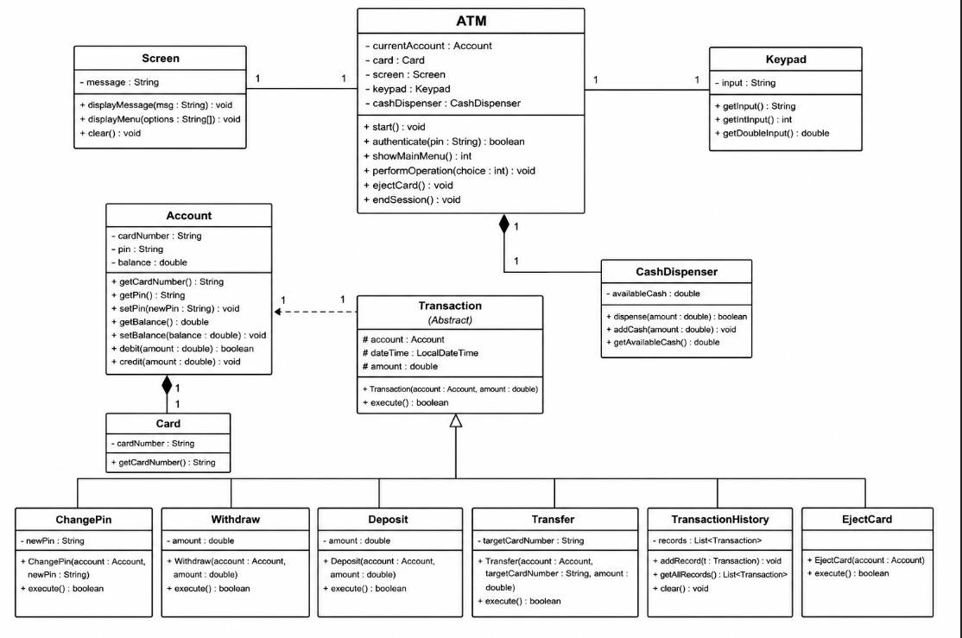

3.3 Class Order List
The execution order of classes in the ATM simulation system is as follows:
- ATM
- Screen
- Keypad
- Bank Database
- Account
- Transaction (Abstract Class)
- Withdrawal (Child Class)
- Deposit (Child Class)
- Balance Inquiry (Child Class)

3.4 Class Description
ATM Class
Controls the overall system operations and coordinates between user input and transaction processing.
Account Class
Stores account details such as account number, PIN, and balance.
Bank Database Class
Manages account verification and updates account balances.
Transaction Class (Abstract)
Base class for all types of transactions.
Withdrawal Class
Handles cash withdrawal operations and balance deduction.
Deposit Class
Handles deposit operations and balance addition.
Balance Inquiry Class
Displays current account balance to the user.
Screen Class
Displays messages and instructions to the user.
Keypad Class
Takes numeric input (PIN, amount) from the user.

CHAPTER 4: IMPLEMENTATION AND CORE OOP PRINCIPLES
4.1 Key OOP Principles
In this ATM Simulation project, Object-Oriented Programming (OOP) principles are used to make the system structured, reusable, and easy to maintain.

Encapsulation: Encapsulation is used to hide sensitive data such as PIN, account balance, and transaction details inside classes. These data members are made private and accessed only through public methods like deposit (), withdraw (), and check Balance ().
Abstraction:
The complex implementation details of ATM operations are hidden from the user. The user only interacts with simple functions like withdrawing money or changing PIN, without knowing the internal processing.
Inheritance:
Inheritance allows reuse of common properties and methods. For example, a base class like Account or User can be extended by ATM operations to avoid code duplication.
Polymorphism:
Polymorphism is applied where methods with the same name behave differently based on context, such as different transaction types (deposit, withdraw, transfer) using a common interface.
Modularity:
The program is divided into separate functions/classes for each feature (login, withdraw, deposit, transfer, etc.), making the system easier to manage and debug.

4.2 Code
This section includes important parts of the ATM system code to demonstrate functionality.
Login / PIN Verification:
Used to verify user identity before allowing access to the ATM system. It checks if the entered PIN matches the stored PIN.
Withdraw Function:
Handles cash withdrawal by checking available balance and deducting the amount if sufficient funds are available.
Deposit Function:
Adds the entered amount to the current account balance and updates it.
Transfer Function:
Transfers money from one account to another after verifying balance and account validity.
PIN Change Function:
Allows the user to update their PIN securely after proper authentication.

CHAPTER 5: TESTING AND RESULTS
5.1 Test Plan
The testing phase ensures that all ATM functions work correctly and handle both valid and invalid inputs.
Login Test:
Checks whether correct PIN allows access and wrong PIN denies entry.
Withdrawal Test:
Verifies that money is deducted correctly and prevents withdrawal if balance is insufficient.
Deposit Test:
Ensures deposited money is correctly added to the account balance.
Transfer Test:
Confirms that funds are transferred only when sufficient balance exists and account details are valid.
PIN Change Test:
Validates that the PIN is updated only after correct authentication.
Error Handling Test:
Checks how the system responds to invalid inputs such as negative values or incorrect options.

CHAPTER 6: CONCLUSION AND FUTURE WORK
6.1 Conclusion
The ATM Simulation project successfully demonstrates the working of a real-world ATM system using Object-Oriented Programming concepts. It provides essential banking functionalities such as deposit, withdrawal, transfer, and PIN management in a simplified environment. The project improves understanding of OOP concepts and system design.

6.2 Limitations
The system works only in a simulated environment without real banking integration.
Limited security features compared to real ATM systems.
Does not support multi-user database storage (if not implemented).
6.3 Future Enhancements
Integration with a database for real account management.
Development of a graphical user interface (GUI).
Implementation of advanced security features like OTP verification.
Support for multiple users and account types.
Real-time transaction history storage.

REFERENCES
- Java Official Documentation
https://docs.oracle.com/en/java/javase/

- Object-Oriented Programming Concepts (OOP Basics)
https://www.geeksforgeeks.org/object-oriented-programming-oops-concept-in-java/

- ATM Simulation Project Examples (Java)
https://github.com/topics/atm-simulation

- ATM Project Collection (Java / Beginner Projects)
https://github.com/topics/atm-project

- Sample ATM Machine Simulation in Java (Mini Project Guide)
https://www.campcodes.com/mini-projects/java-mini-projects/atm-machine-simulation-java/

- Example ATM System with OOP Implementation (GitHub Project)
https://github.com/Ragav63/ATM-Machine-Mini-Project

- Java Swing ATM Simulator (GUI Project Example)
https://github.com/sparsh-99/Java-Swing-ATM-Simulator

Code Snippets

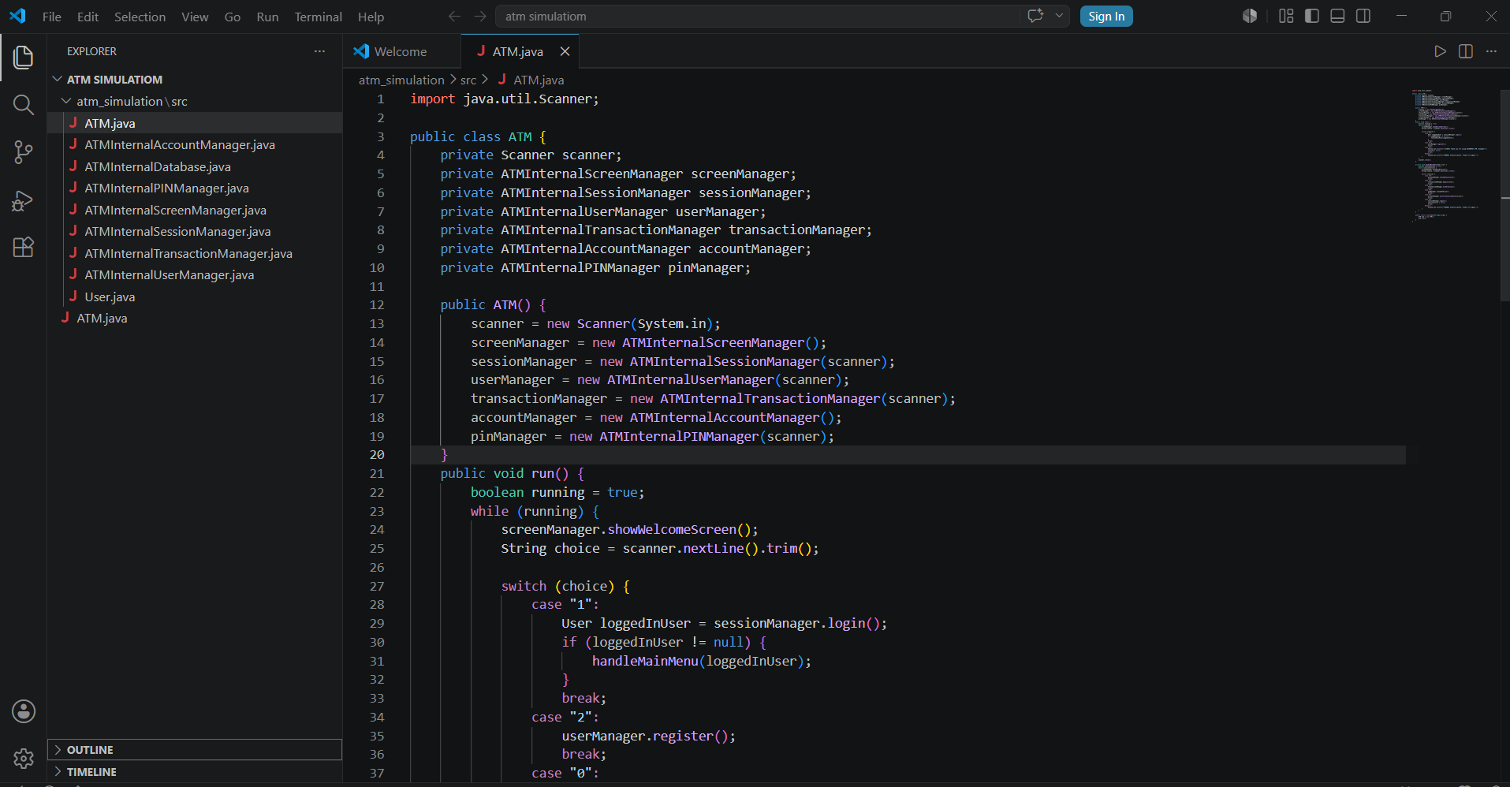

Fig:1.1- ATM.java (ATM SIMULATION)

Explanation:
1. The ATM class is the main controller that manages all ATM operations and components.
- It uses Scanner to take user input from the console.
- Multiple manager classes (session, user, account, PIN, transaction, screen) are declared for modular design.
4. The constructor initializes all managers and connects them with the shared scanner.
5. The run () method contains the main loop that keeps the ATM system active.
6.It shows the welcome screen and takes user choice as input in each iteration.
7. A switch statement handles actions like login (case 1) and user registration (case 2).

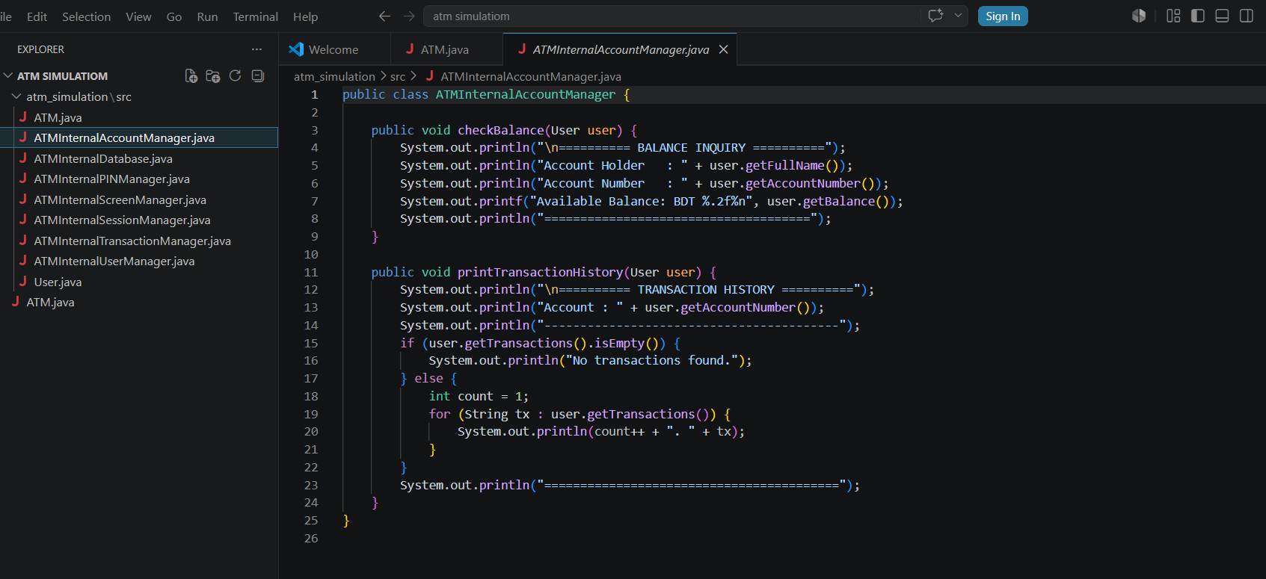
Fig:1.2- ATMINTERNALACCOUNTMANAGER.JAVA

Explanation:
. The class ATM Internal Account Manager handles account-related operations like balance check and transaction history.
. check Balance (User user) displays the account holder’s name, account number, and current balance in formatted output.
. print Transaction History (User user) shows all past transactions or prints “No transactions found” if empty.
. It uses loops and condition checks to iterate through transaction lists and present data in a user-friendly format.

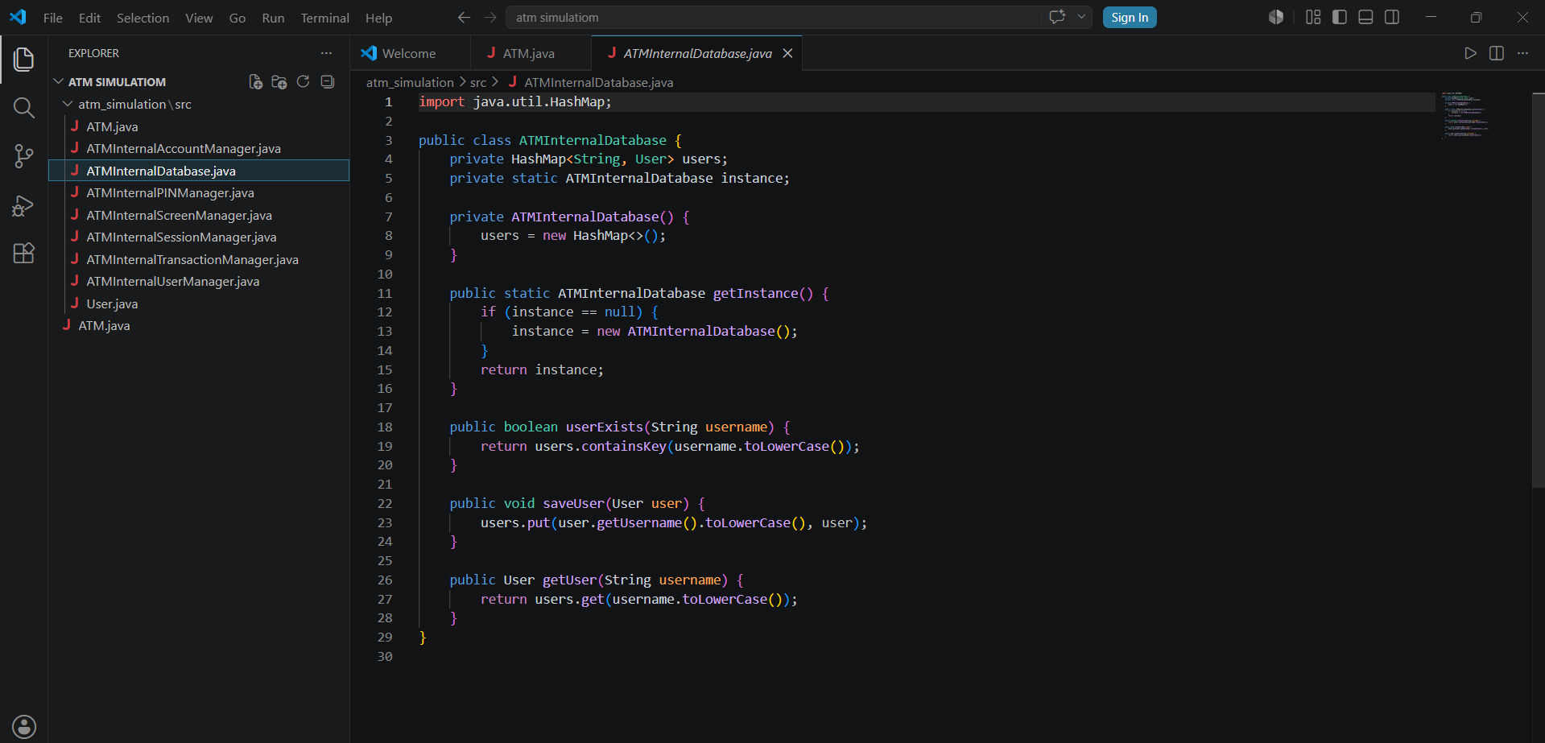

Fig :1. 3- ATMINTERNALDATABASE

Explanation:

- Get Instance () method is used to create only one object of the ATM Internal Database class using the Singleton design pattern.

- It first checks if instance is null, meaning no database object has been created yet.

- If no object exists, a new ATM Internal Database () object is created and stored in instance.

- Finally, the same instance object is returned every time, so the whole ATM system uses one shared database.

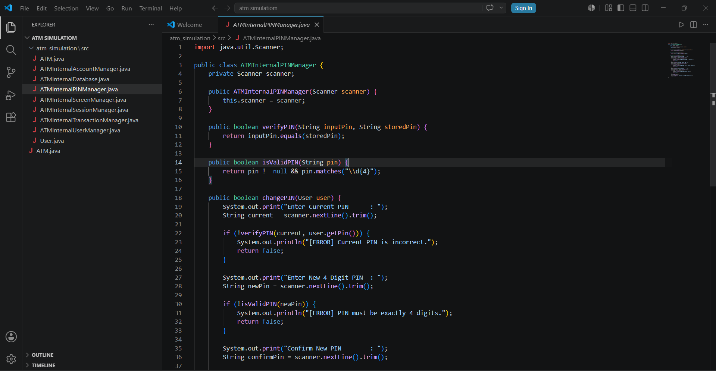
Fig:1.4- ATMINTERLANPINMANAGER.JAVA

Explanation:

- The ATM Internal PIN Manager class manages all PIN-related operations such as PIN verification, validation, and changing the PIN.
- Verify PIN () checks whether the entered PIN matches the user’s stored PIN using the equals () method.
- Is Valid PIN () ensures the PIN is exactly 4 digits by using a regular expression
- In change PIN (), the system first verifies the current PIN, then checks the new PIN format and confirmation before updating the user’s PIN successfully.

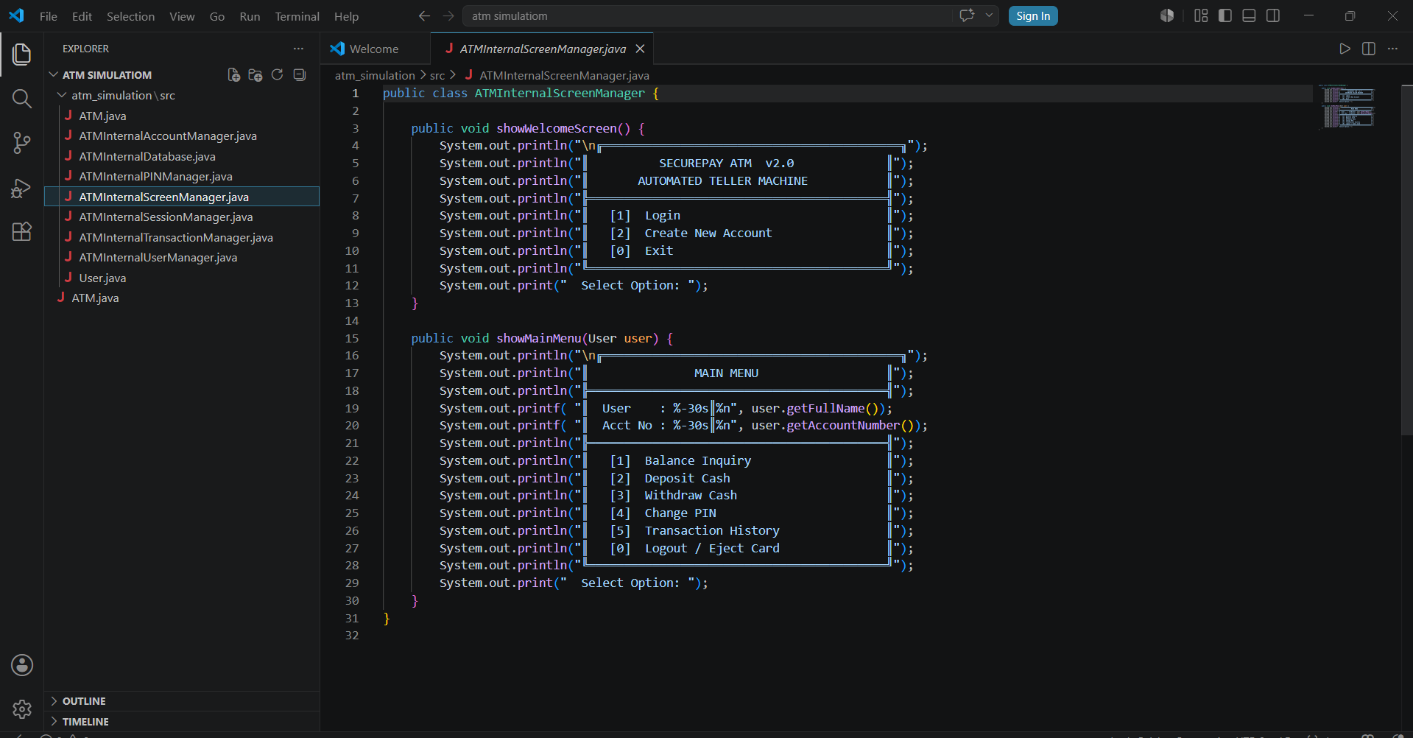
Fig :1.5- ATMINTERNALSCREENMANAGER.JAVA

Explanation:

- The ATM Internal Screen Manager class is responsible for displaying all ATM interface screens and menus to the user.
- Show Welcome Screen () prints the welcome interface with options like Login, Create Account, and Exit using formatted console output.
- Show Main Menu (User user) displays the main ATM menu after login , including the user’s name and account number dynamically.
- The class improves user interaction by organizing ATM features such as balance inquiry, deposit, withdrawal, PIN change, and transaction history in a clear menu format.

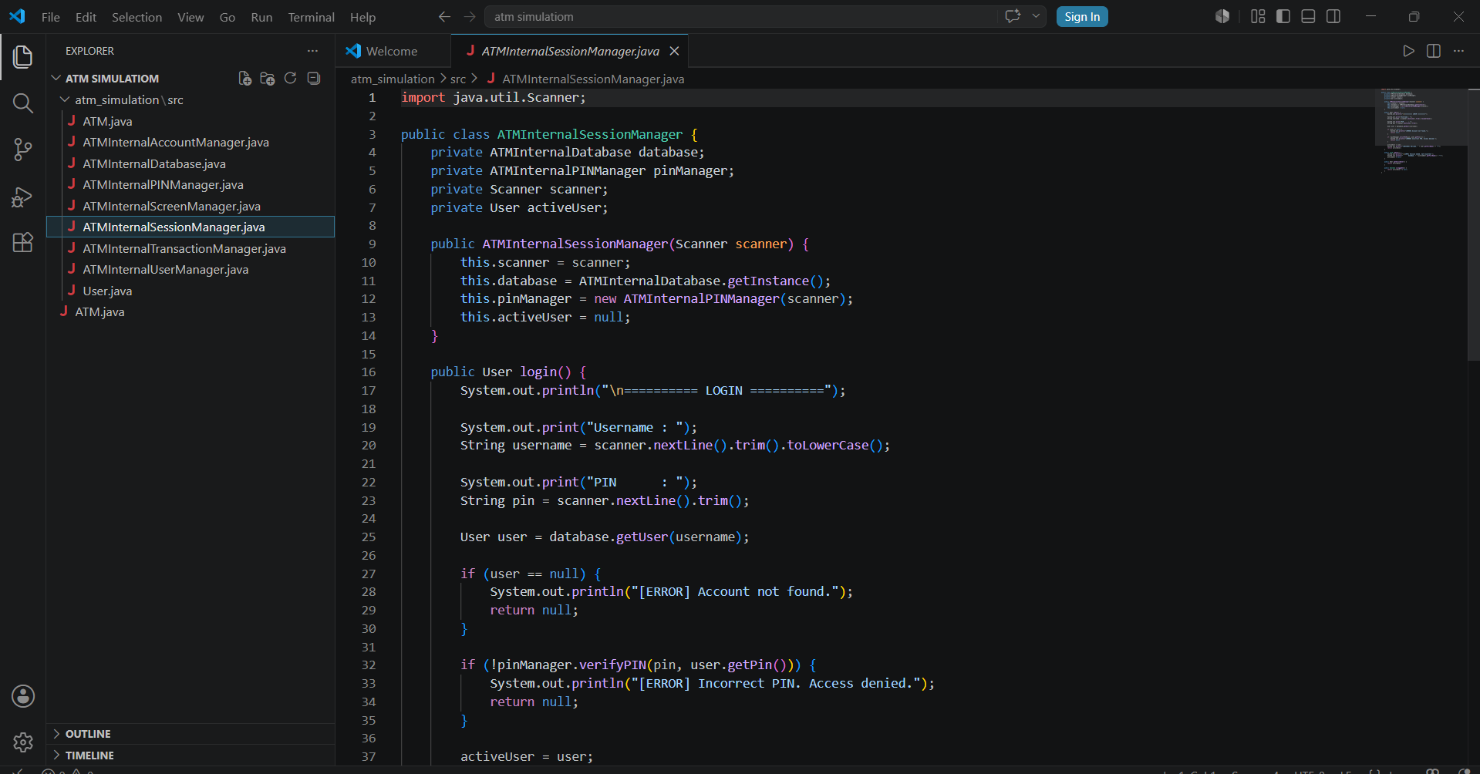
Fig: 1.6-ATMINTERNALSESSIONALMANAGER.JAVA

Explanation:

- The ATM Internal Session Manager class handles user login sessions, authentication, and logout operations in the ATM system.
- During login, the program takes the username and PIN from the user, then checks the account information from the database.
- The verify PIN () method is used to confirm whether the entered PIN matches the stored PIN before granting access.
- If login is successful, the user becomes the active User; otherwise, error messages are shown, and logout () safely ends the session by ejecting the card.

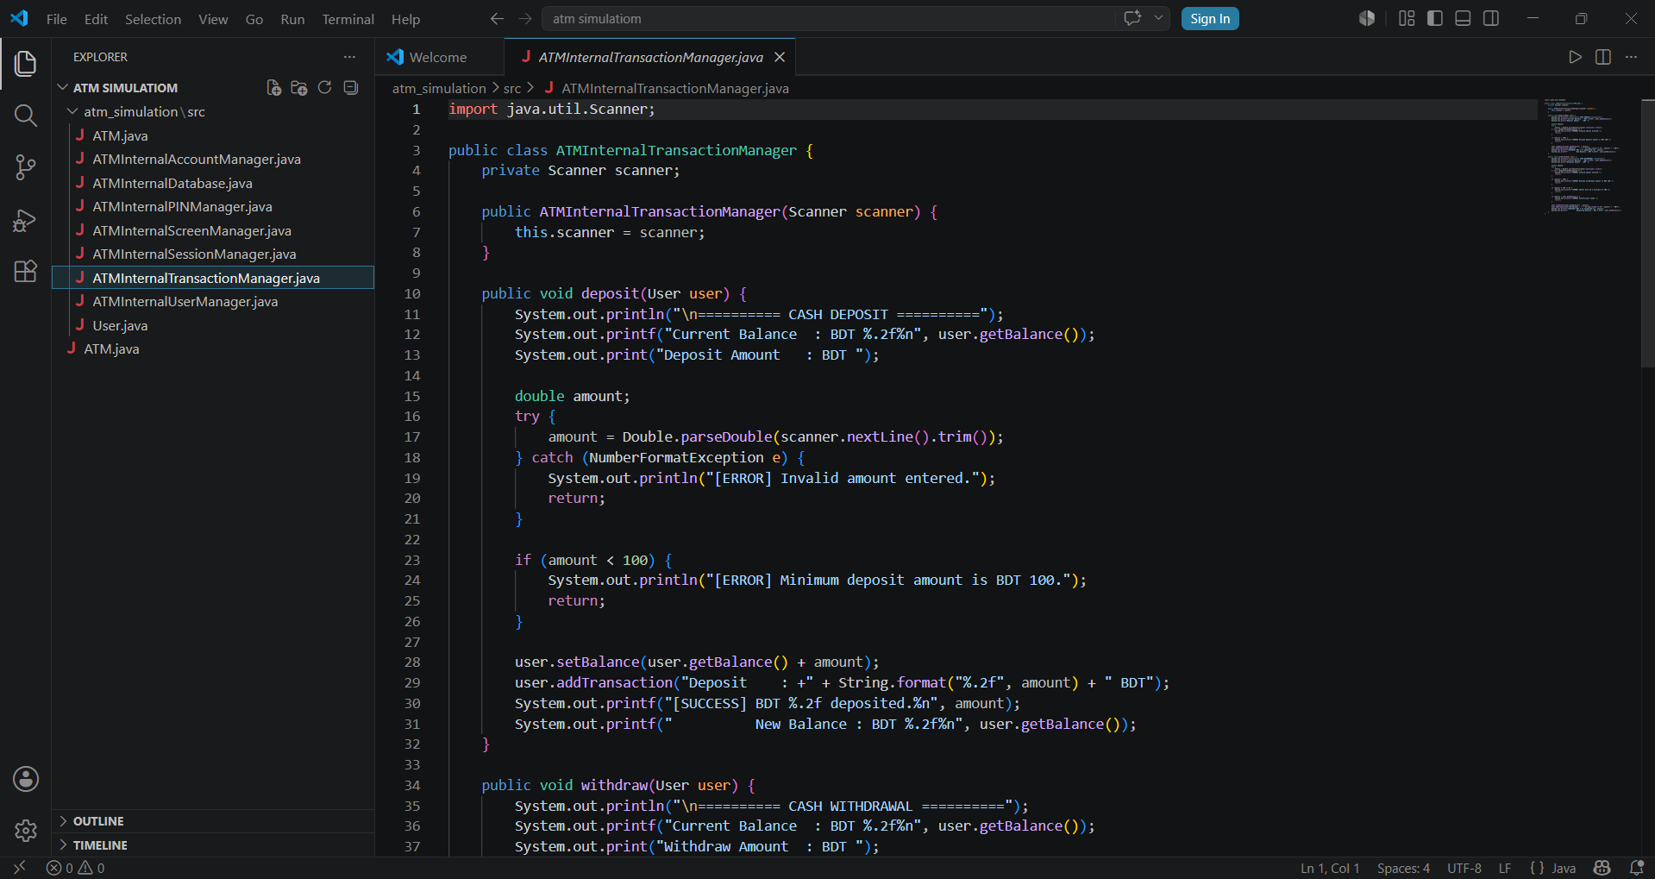
Fig: 1.7-ATMINTERNALTRANSICTIONMANAGER.JAVA

Explanation:
- The ATM Internal Transaction Manager class handles all financial operations like deposit and withdrawal for a user in the ATM system.
- In the deposit () method, the system takes input, validates it, ensures a minimum deposit of BDT 100, and then adds the amount to the user’s balance.
- After depositing, the transaction is recorded in the user’s history using add Transaction () and the updated balance is displayed.
- In the withdraw () method, the system checks input validity, minimum withdrawal limit, multiple-of-100 rule, and sufficient balance before deducting money securely.

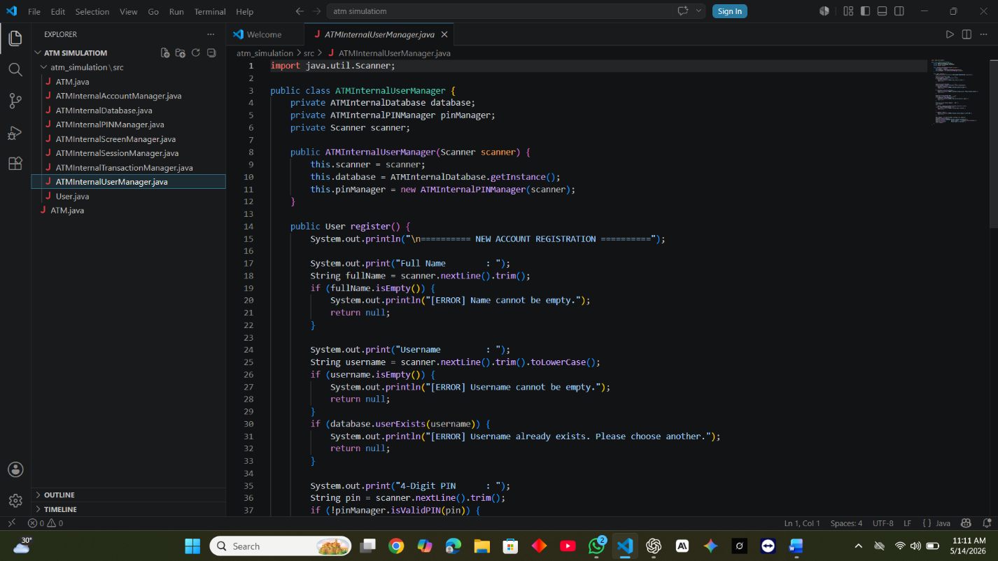
Fig: 1.8- ATMINTERNALUSERMANAGER.JAVA

Explanation:

- The ATM Internal User Manager class is responsible for creating new user accounts in the ATM system through the register () method.
- It collects user details such as full name, username, PIN, and initial deposit from the console input.
- The system validates each input, ensuring the username is unique, the PIN is exactly 4 digits, and the initial deposit is at least BDT 500.
- If all validations pass, a new User object is created, saved in the database, and the system displays a success message with the generated account number.

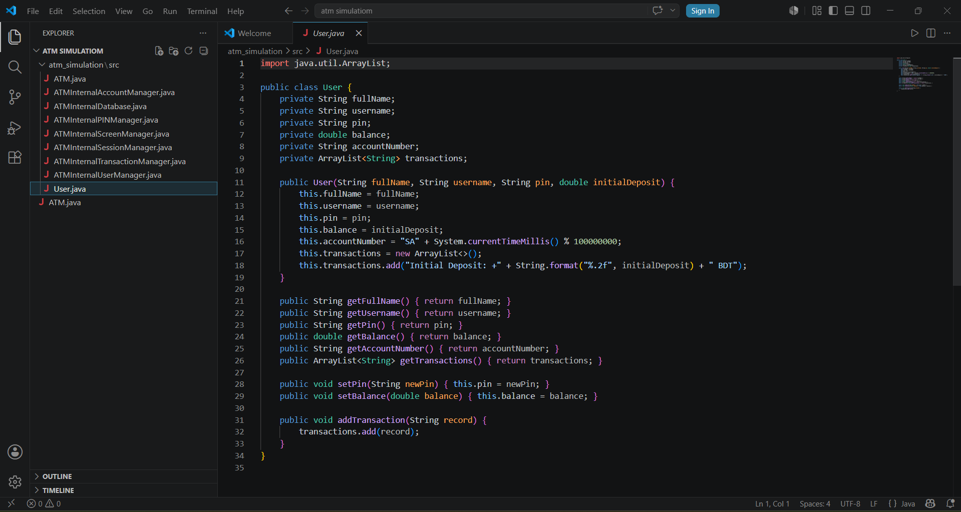
Fig 1.9 – USER.JAVA

Explanation:

- The User class represents an ATM customer and stores all personal and banking-related information such as name, username, PIN, balance, and account number.
- When a new user is created, the constructor initializes these values and automatically generates a unique account number using the current system time.
- It also creates a transaction list (Array List) to store all banking activities, starting with an initial deposit record.
- The class provides getter methods to access user data and setter methods to update sensitive information like PIN and balance, along with a method to record transactions.

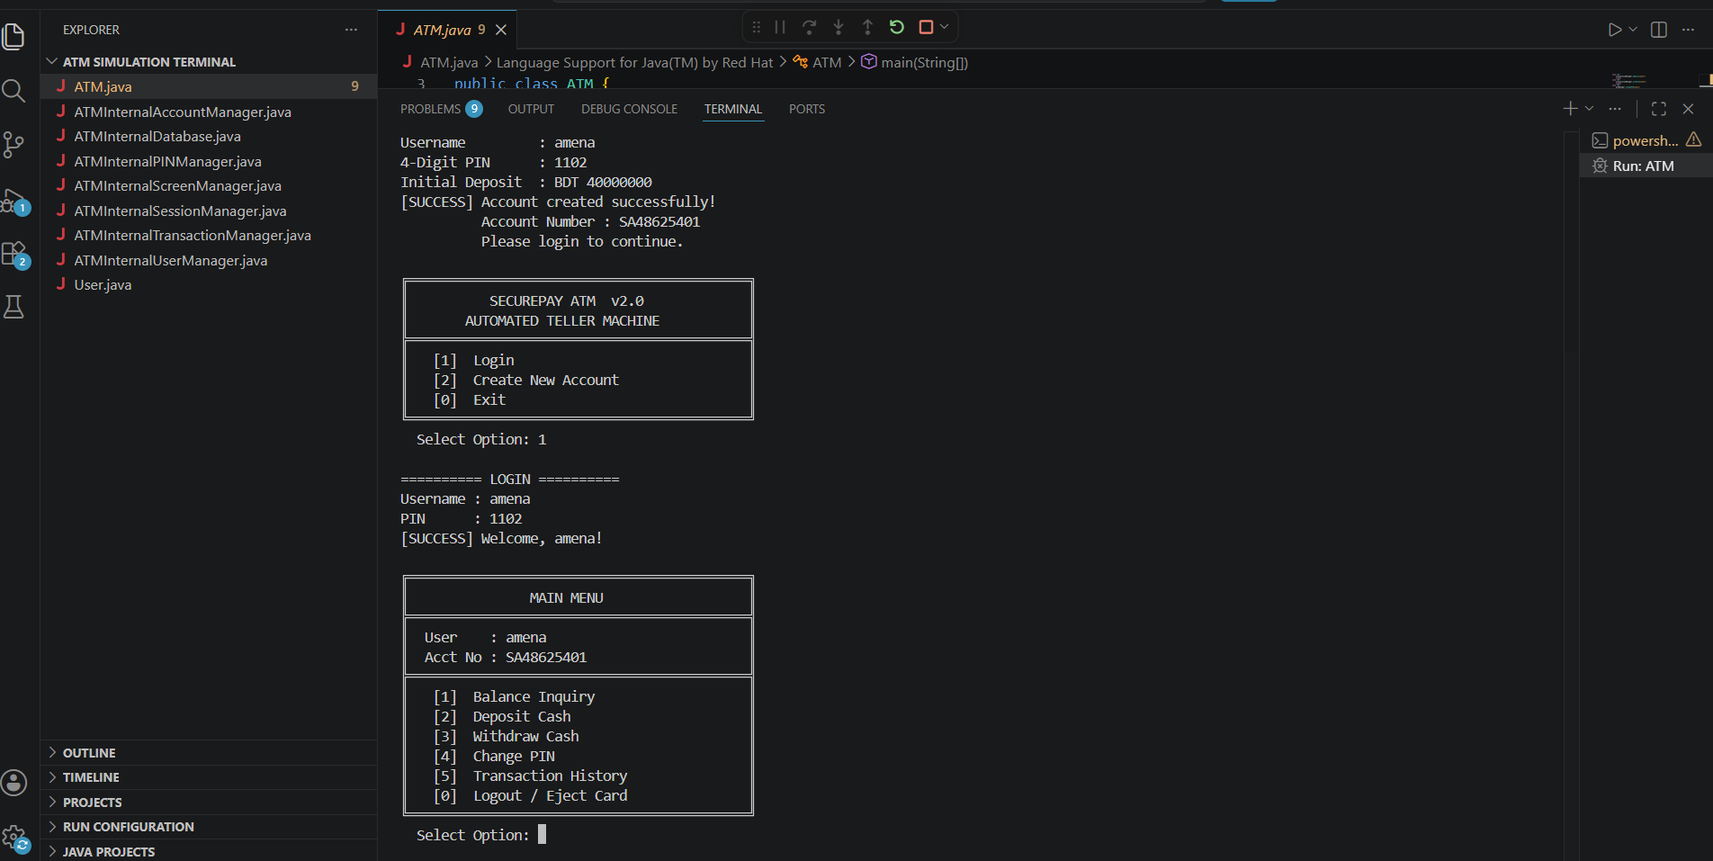
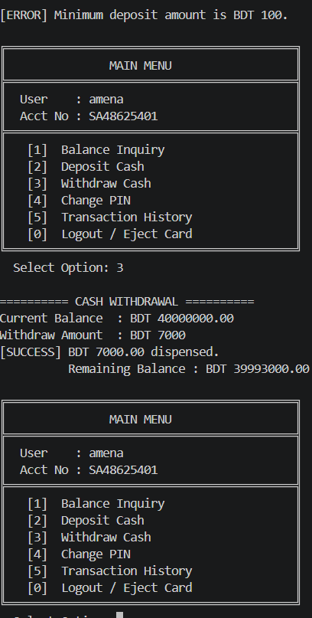
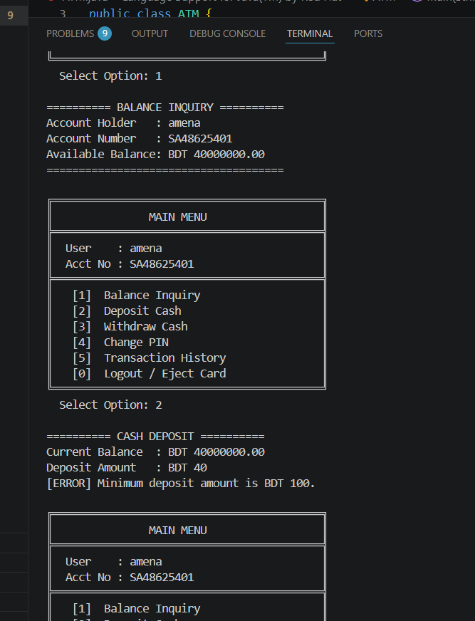
Fig 2.0: Terminal output

Explanation:
- The ATM simulation output provides realistic banking experience through an interactive user interface and system responses.
- The long screen displays account information, menus, and transaction options for user interaction.
- The feature screen presents different ATM functionalities such as withdrawal, deposit, and balance checking.
- The terminal output shows backend processing, user inputs, and transaction execution results.
- Together, these outputs demonstrate both the frontend interface and internal working process of the ATM simulation system.

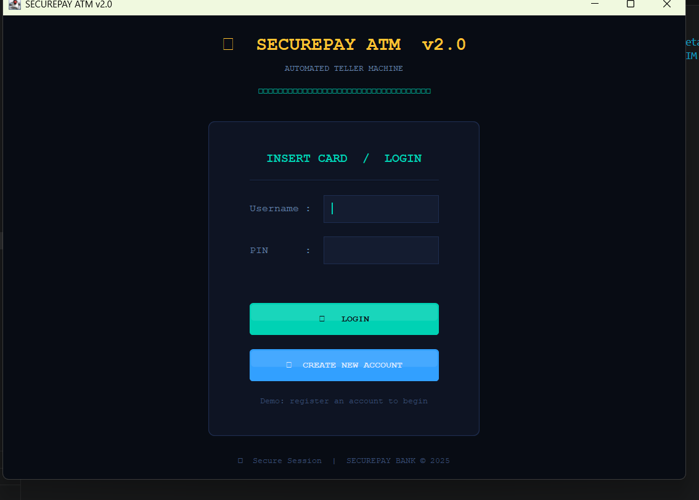

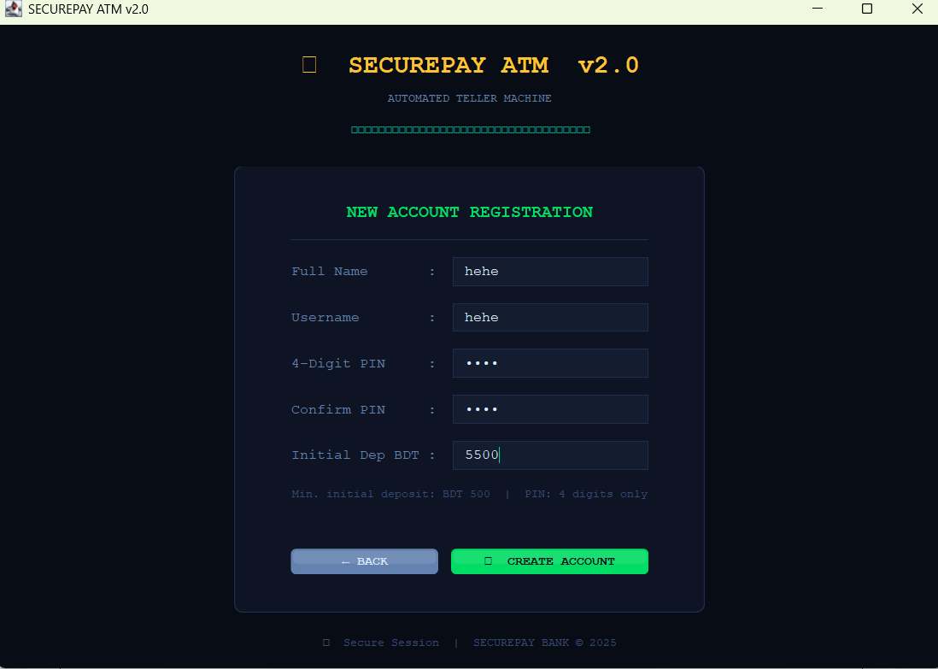
Fig2.1 GUI OUTPUT
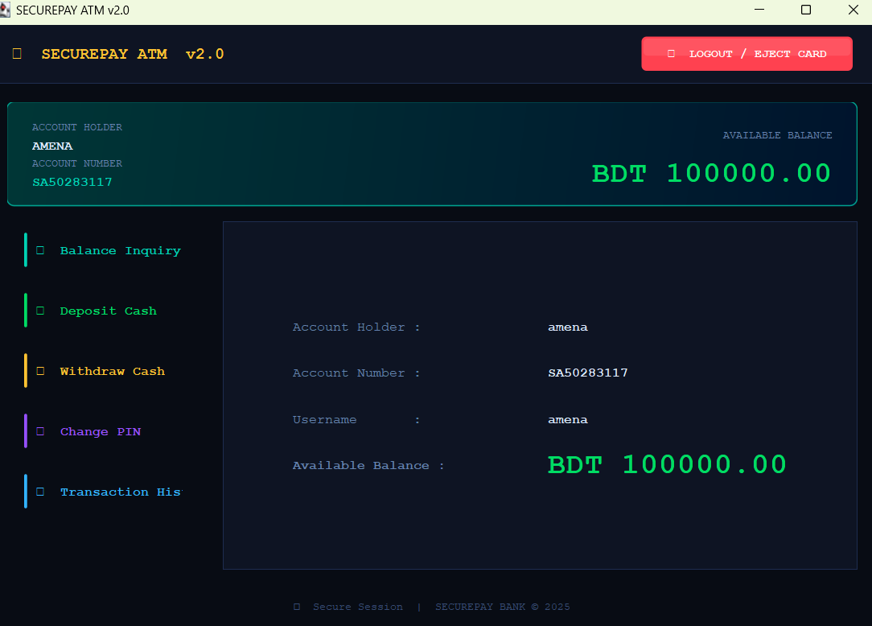

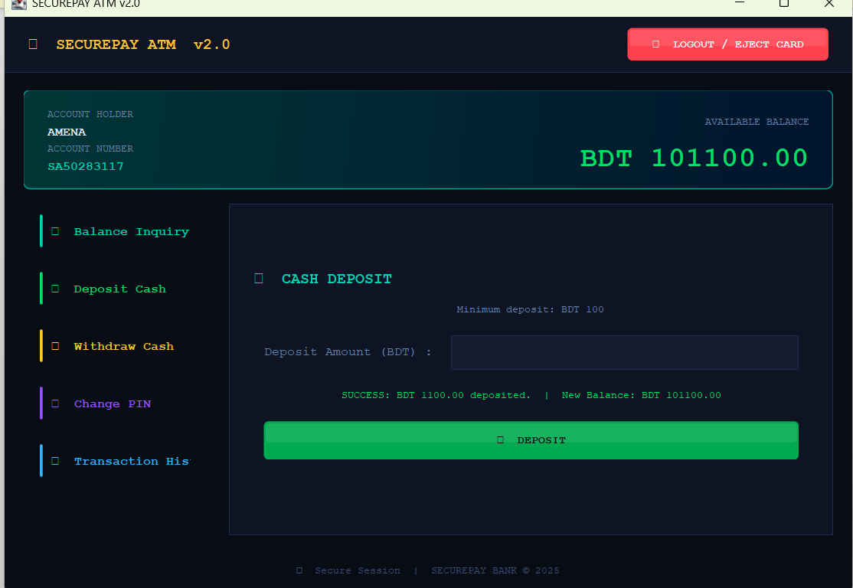

Fig 2.1 : GUI OUTPUT

Explanation:
- This GUI screen represents the New Account Registration interface of the ATM simulation system where users can create a new banking account.
- The interface contains input fields for personal information, username, PIN creation, PIN confirmation, and initial deposit amount.
- Interactive buttons such as Create Account and Back are integrated to improve navigation and user interaction within the system.
- GUI interface integrates essential ATM functionalities including account creation, cash deposit, cash withdrawal, balance inquiry, transaction history, and account management features.
- Users can perform banking operations through interactive buttons, input fields, and navigation panels designed for efficient transaction processing.
- The system processes deposits, withdrawals, and fund management operations while updating account information dynamically within the interface.
- Transaction-related features allow users to view account activities, monitor balances, and manage banking operations through a structured graphical environment.
- Overall, the GUI demonstrates the implementation of real-world ATM functionalities by combining graphical components with backend transaction processing and account management systems.

