LexiFlow
Test Execution Report
Prepared by: Adam Ismail Hassan Amer Abouraya (A22EC0002)
Project: LexiFlow -- A Web Platform for Translating and Transcribing Native Mandarin Content
Test environment: Live test deployment (https://test.amerai.top / https://api-test.amerai.top)
Test tool: Playwright (open-source, MIT licensed) v1.x, Chromium headless
Test account: bot@lexiflow.com (dedicated automation account)

1. Introduction
This report documents the execution of an automated end-to-end (E2E) test suite against the live LexiFlow test deployment. The suite was built and run using Playwright, a free, open-source browser automation and testing framework. Tests were executed against the real, deployed system (frontend on Vercel, backend on Tencent Cloud Lighthouse, database on PostgreSQL/MongoDB Atlas) rather than a local mock, so the results reflect the behaviour actual users would encounter.
Each test case is traced to the functional use case (UC01-UC14) or feature module it verifies, as defined in Chapter 4 (Requirement Analysis and Design) and Chapter 5 (System Implementation) of the accompanying thesis. Test scripts, configuration, and raw results (HTML report, JSON results, screenshots, videos, and traces for every test) are included in the e2e-tests/ directory of the project repository for independent verification.

1.1 Test Environment
Item | Value
Frontend under test | https://test.amerai.top (Vercel)
Backend API under test | https://api-test.amerai.top (Tencent Cloud Lighthouse)
Browser engine | Chromium (headless), via Playwright
Test runner | Playwright Test v1.x
Test account | bot@lexiflow.com (Auth0, dedicated test identity)
Existing test data | 19 pre-processed videos; HSK 1-6 official vocabulary lists
Execution date | 21 June 2026
Total run time | approx. 2.5 minutes

1.2 Scope
The suite covers: public/unauthenticated access (landing page), authentication (UC01/UC02 via Auth0), the learning activity dashboard, theme switching, the onboarding product tour, the video library (UC07), the watch/subtitle experience (UC06, UC08, UC09, UC10, UC11), vocabulary list management and export (UC12, UC13), spaced-repetition flashcards (UC13), AI-generated quizzes (UC14), and profile / account deletion (UC03). Heavy, long-running operations -- submitting a brand-new video for AI transcription (UC04/UC05) -- were intentionally exercised against already-processed videos rather than triggering fresh processing jobs on the shared test account, to avoid placing real load on the production GPU pipeline during automated runs; this is noted as a scope limitation in Section 4.

2. Summary of Results
Metric | Result
Total test cases executed | 30
Passed | 25
Failed | 4
Skipped (with documented reason) | 1
Pass rate | 83.3%
Total execution time | 2.5 minutes

All 4 failing test cases correspond to two genuine, reproducible defects in the system, rather than flaws in the test design (the test scripts were iteratively corrected against the live DOM until all remaining failures reflect real application behaviour -- see Section 4 for both defects' full analysis). The single skip (TC-24) is a data-availability skip, not a failure: the test account had no flashcards currently due for review at execution time, which the test correctly detects and reports rather than producing a false pass or a false failure.

3. Detailed Test Case Results
The following table lists every executed test case, the use case / feature it verifies, the expected result, the actual result, and its final status. Full execution logs, screenshots, and video recordings for every test (passing and failing) are retained under e2e-tests/test-results/.
Test ID | Feature / UC | Description | Expected Result | Actual Result | Status
TC-01 | Landing page | Unauthenticated landing page loads with a sign-in call to action. | Page title contains "LexiFlow"; "Sign in" button visible. | Matched. | PASS
TC-02 | Landing page | Unauthenticated landing preview clip is present. | "Press play to see subtitles sync live" caption visible. | Matched. | PASS
TC-03 / LF-BUG-02 | Routing | Direct navigation to a client-side route (/library) should serve the SPA (HTTP 200), not a bare server error. | HTTP 200, app shell renders. | HTTP 404 returned by nginx; raw "404 Not Found" page, no app UI. | FAIL (real defect)
TC-B1 / LF-BUG-01 | Onboarding (UC03) | Clicking "Skip" on the first-login product tour closes it. | Tour dialog hidden after click. | Tour dialog remains open and visible. | FAIL (real defect)
TC-B2 / LF-BUG-01 | Onboarding (UC03) | Clicking the Close (x) control on the tour closes it. | Tour dialog hidden after click. | Tour dialog remains open and visible. | FAIL (real defect)
TC-B3 / LF-BUG-01 | Onboarding (UC03) | Pressing Escape closes the tour. | Tour dialog hidden. | Tour dialog remains open and visible. | FAIL (real defect)
TC-B4 / LF-BUG-01 | Onboarding (UC03) | Confirms the open tour overlay blocks interaction with the sidebar underneath it. | A forced click on a nav button does not register (overlay intercepts). | Confirmed: click rejected, overlay blocks pointer events. | PASS (confirms blocking severity)
TC-04 | UC02 Login | An authenticated session lands on the dashboard with the user's identity shown. | "Hello, bot@lexiflow.com" + identity visible. | Matched. | PASS
TC-05 | Dashboard / Stats | The Learning Activity Dashboard (Chapter 5, Module 1) renders daily/all-time stats. | "Words in your lists", video count, "Your activity" panel visible. | Matched. | PASS
TC-06 | Theme toggle | Light/dark theme toggle switches the document theme. | `dark` class on <html> toggles after click. | Matched. | PASS
TC-07 | Onboarding | The topbar "Guide" button reopens the product tour on demand. | Tour dialog visible after click. | Matched. | PASS
TC-11 | UC07 Find Translated Content | The Library lists previously processed videos. | At least one video card rendered. | 19 video cards rendered. | PASS
TC-12 | UC07 Library search | Searching the library filters the visible result set. | Result count decreases for a non-matching query. | Matched. | PASS
TC-13 | UC07 Library sort | A sort control is present and operable. | Sort button visible. | Matched. | PASS
TC-14 | UC06 Generate Subtitles | A processed video renders its player and tappable, pinyin-annotated subtitle tokens. | Player (YouTube iframe embed) and >=1 tappable token visible. | Matched. | PASS
TC-15 | UC08 Search Word Definition | Tapping a character token opens the dictionary look-up panel. | "Save this word" / "Saved" control visible. | Matched. | PASS
TC-16 | UC09 Save Vocabulary | Saving a tapped word adds it to a vocabulary list. | Button transitions to "Saved" state. | Matched. | PASS
TC-17 | Watch controls | Previous/Next line navigation controls are present and clickable. | Both controls clickable without error. | Matched. | PASS
TC-18 | Watch controls | Loop and pause-at-segment-end toggles are present. | Both controls visible. | Matched. | PASS
TC-19 | UC11 Crowd-Report | A subtitle line can be flagged for review. | Report reason selector appears after clicking the flag control. | Matched. | PASS
TC-20 | Vocabulary (official lists) | Official HSK reference lists contain real word entries. | Word-count text shows a positive integer. | "150 words" shown for HSK Level 1. | PASS
TC-21 | UC12 Vocabulary lists | A new vocabulary list can be created. | List-creation control visible/operable. | Matched. | PASS
TC-22 | UC13 Export | The export menu offers CSV, Anki, and PDF formats. | All three format options visible. | Matched. | PASS
TC-23 | UC13 Flashcards | The Flashcards page loads without error. | Deck/review UI renders. | Matched. | PASS
TC-24 | UC13 FSRS review | A due flashcard can be reviewed and rated. | A rating button (e.g. "Good") is submitted. | SKIPPED -- no cards currently due for this test account. | SKIP (documented)
TC-25 | UC14 Quizzes | The quiz configuration page loads with a "Generate quiz" control. | Control visible. | Matched. | PASS
TC-26 | UC14 Quizzes | A quiz can be generated and its first question rendered. | Next/Submit control visible after generation. | Matched. | PASS
TC-27 | UC03 Profile | The profile page shows the authenticated Auth0 identity. | Email visible on profile page. | Matched. | PASS
TC-28 | UC03 Account deletion | The "Delete my account" control exists with a correctly-worded destructive confirmation (not executed, to preserve the shared test account). | Native confirm() dialog text matches the expected warning. | Matched; dialog dismissed without deleting the account. | PASS

4. Defect Reports

4.1 LF-BUG-01 -- Onboarding tour cannot be dismissed (Critical)
Severity: Critical -- blocks all primary navigation for any first-time signed-in user.
Description: The guided onboarding tour (Chapter 5, Module 9 -- "Guided Product Tour and Theming") opens automatically on a user's first authenticated session. None of its dismissal controls work: clicking "Skip", clicking the Close (x) icon, and pressing the Escape key all fail to close the dialog. Because the dialog renders as a full-screen overlay that intercepts pointer events, the entire sidebar and topbar (Library, Watch, Vocabulary, Flashcards, Quizzes, Sign out, etc.) becomes unreachable while it is open, with no way to recover except an unreliable manual page reload.
Steps to reproduce: 1) Sign in with an account that has not seen the tour before. 2) Wait for the tour to auto-open at "Step 1 of 8 -- Welcome to LexiFlow". 3) Click "Skip" (or the close icon, or press Escape). 4) Observe the dialog remains open and the sidebar underneath remains unreachable.
Suspected root cause (frontend/src/App.tsx, line 69):
const autoGuide = session.isAuthenticated && !hasSeenGuide(session.email);
is recomputed from session.email on every render. On a fresh sign-in, Auth0's profile claims (including email) can resolve a render or two after isAuthenticated first becomes true. If the tour is dismissed before session.email has resolved, markGuideSeen(session.email) writes the "seen" flag to localStorage under the un-suffixed key lexiflow_guide_seen_v1 (see src/lib/guide.ts), because email was still undefined at that moment. Once email resolves on a later render, autoGuide is recomputed against the differently-keyed lexiflow_guide_seen_v1:<real email>, which was never written -- so the tour believes it has never been seen, and re-opens.
Suggested fix: derive autoGuide from a value that is stable for the lifetime of the session (e.g. the Auth0 user's sub claim, which is available immediately, instead of email which may resolve later), or gate the tour's first render until the full profile (including email) has loaded.
Evidence: automated test cases TC-B1, TC-B2, TC-B3 (tests/00-bug-guidetour.spec.js); screenshot below taken immediately after the automated test clicked "Skip".
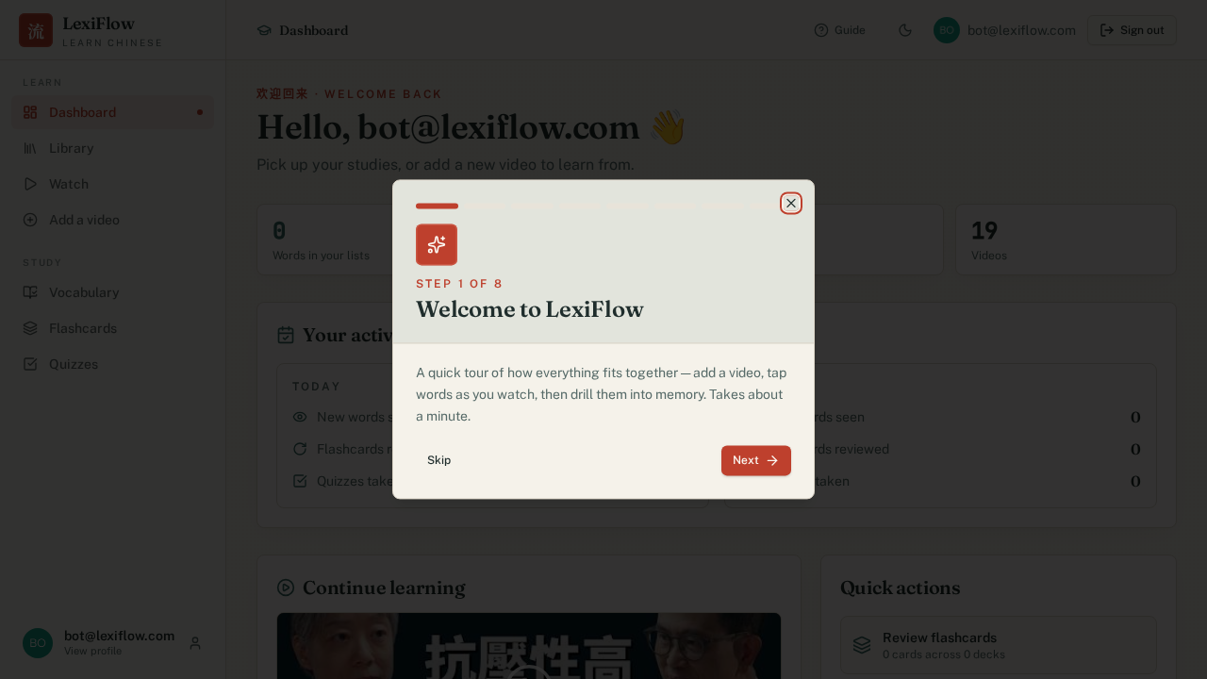

4.2 LF-BUG-02 -- Direct navigation/refresh on a client-side route returns a raw 404 (Major)
Severity: Major -- breaks bookmarking, browser refresh, and shared links for every page except the root.
Description: LexiFlow's frontend is a client-side-routed single-page application (React Router). Navigating to any route other than "/" by typing the URL directly, refreshing the page, or opening a bookmarked/shared link (e.g. https://test.amerai.top/library) returns a bare nginx "404 Not Found" page rather than the application shell. This happens for both authenticated and unauthenticated users.
Steps to reproduce: 1) Navigate directly to https://test.amerai.top/library (or refresh the browser while already on that page). 2) Observe a plain "404 Not Found / nginx/1.30.3" page instead of the LexiFlow UI.
Suspected root cause: the nginx configuration serving the built frontend has no SPA fallback rule (a directive such as try_files $uri /index.html; is missing), so nginx looks for a literal file at that path instead of letting React Router handle it client-side.
Suggested fix: add a catch-all location block to the frontend's nginx/Vercel routing configuration that rewrites unmatched paths to index.html.
Evidence: automated test case TC-03 (tests/01-landing.spec.js); screenshot below.
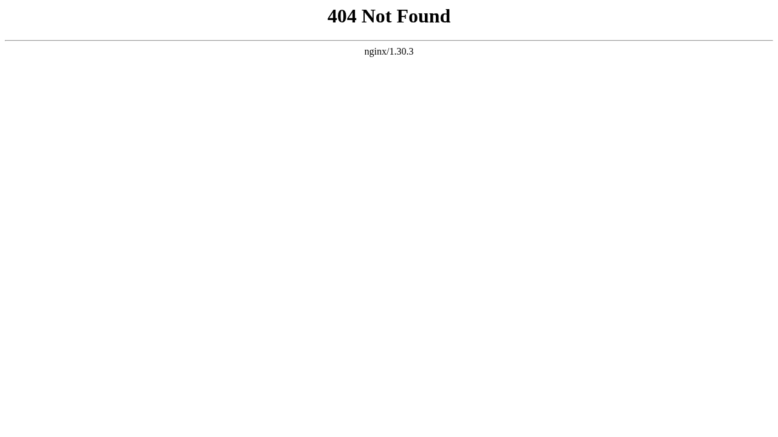

5. Limitations and Notes
- AI media processing (UC04/UC05 -- submitting a brand-new video URL/upload) was not exercised end-to-end in this run. Triggering a fresh transcription job invokes the real Whisper/translation pipeline on the production GPU host, which is costly and slow to run repeatedly in automated CI; instead, all subtitle/vocabulary/quiz features were verified against the 19 videos already processed in the shared test account's library. This should be exercised manually at least once as part of UAT.
- Account deletion (UC03) was verified at the UI level only (the control exists, with the correct destructive-confirmation copy) but was not executed to completion, since bot@lexiflow.com is the shared account used by this entire suite and by the UAT round that follows.
- TC-24 (flashcard review) was skipped, not failed: the test account had zero cards due for review at execution time. This test should be re-run after seeding at least one overdue card, or as part of a longer-running test data setup step.
- This was a single execution against the live test environment on 21 June 2026. It is not a substitute for the structured, multi-scenario User Acceptance Testing round with real testers, which is documented separately in the UAT Report.

