Appendix 1:
List of Prompts Used

1.
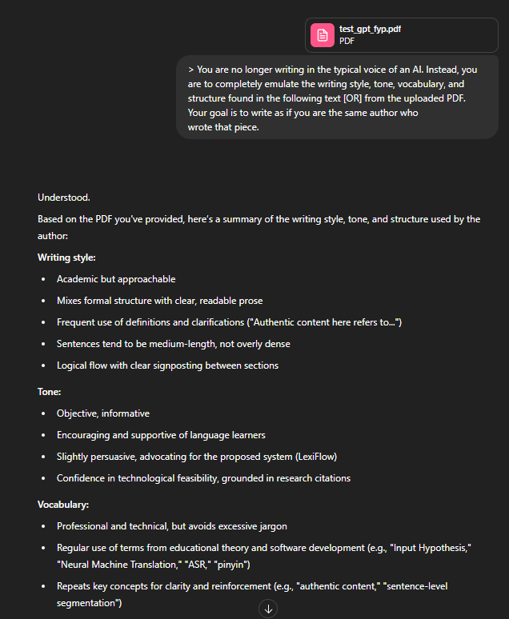
2.

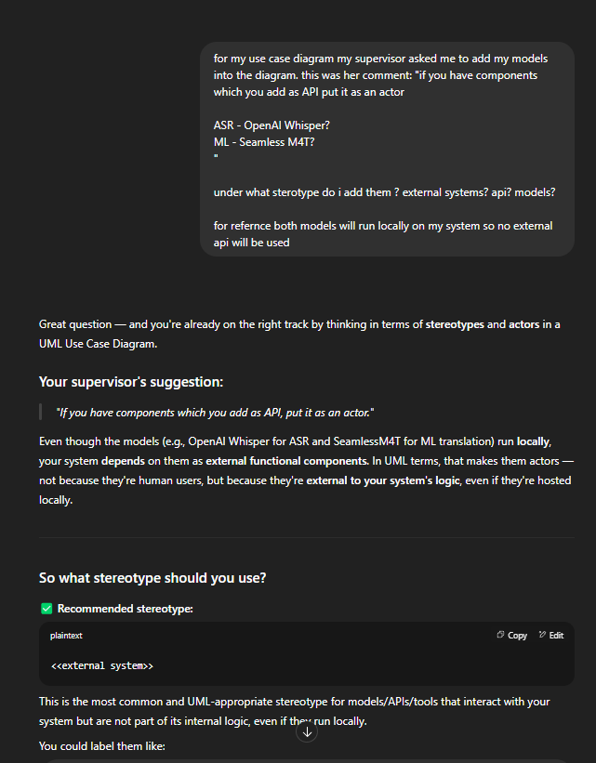

Additional Prompts Used (AI-Assisted Development)

Reviewing FYP2 grading rubric alignment
Asked the assistant to compare the implemented system and thesis report against the official FYP2 grading rubric, surfacing missing deliverables such as the UAT Report and Test Execution Report.
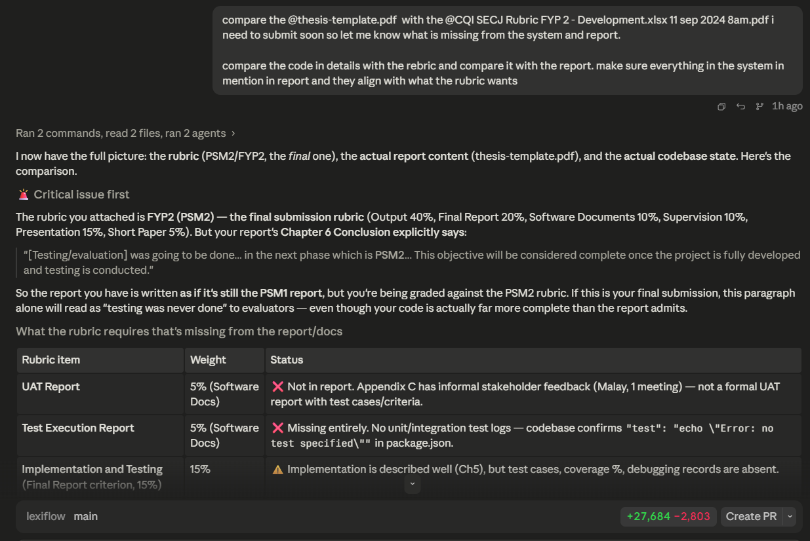

Requesting a full frontend redesign for reviewer clarity
Instructed the assistant (via the web-artifacts-builder skill) to rebuild the entire frontend because it was lacking, confusing, and not user-friendly, with an explicit requirement to add info pop-ups explaining unfamiliar concepts for a lecturer reviewing the project, and to apply one consistent theme across the system.
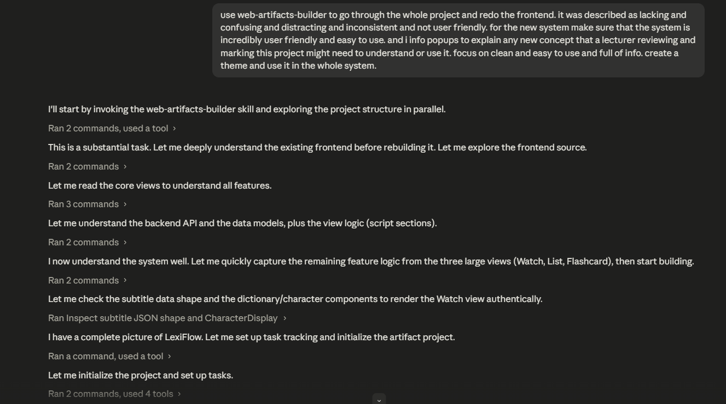

Requesting a feature-parity migration plan
Instructed the assistant to read every view in the legacy Vue frontend, catalogue all existing features, and produce a self-contained TODO plan file that a separate chat session could later execute against the new React frontend.
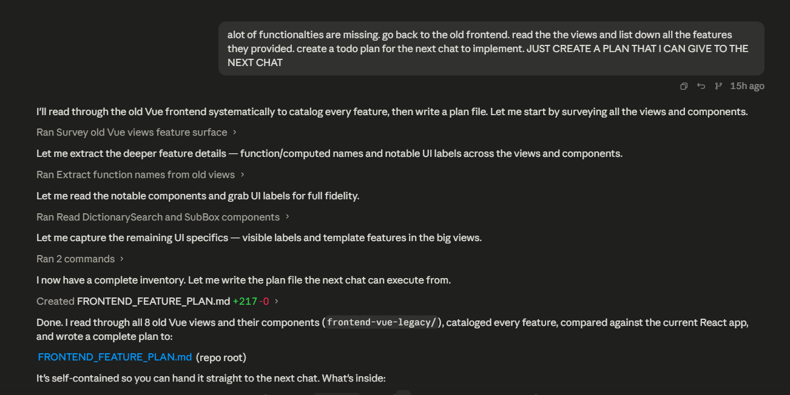

Reviewing the generated migration plan
The assistant's response surveying all legacy Vue views/components and compiling the cross-referenced feature plan (FRONTEND_FEATURE_PLAN.md) used to guide the React rewrite.
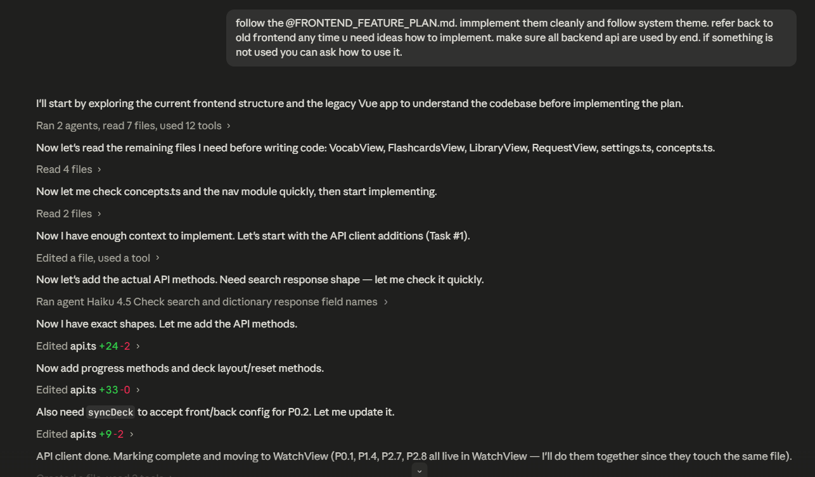

Rubric gap analysis - Software Documents criteria
Continuation of the rubric comparison, focusing specifically on the Software Documents (UAT Report / Test Execution Report) marking criteria and their current status.
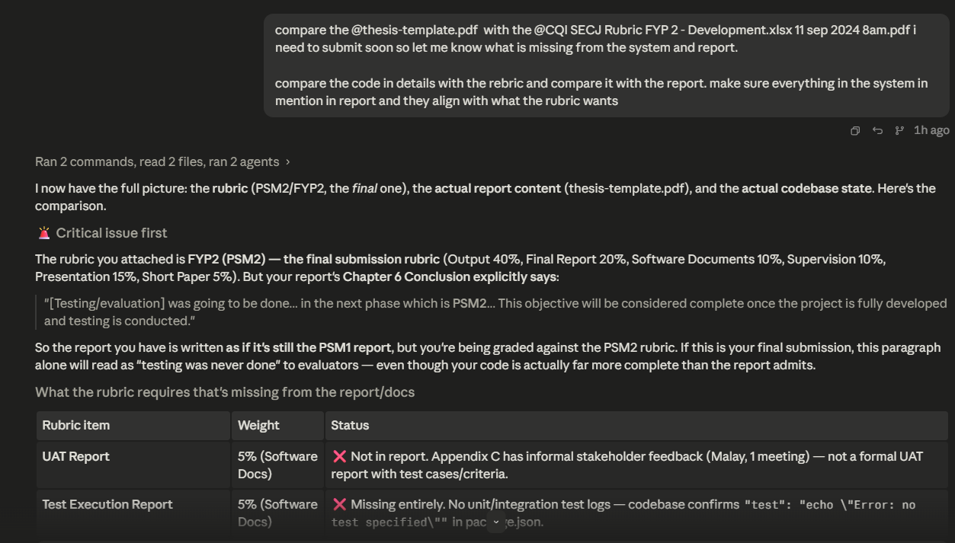

Requesting Watch View redesign with theater mode
Asked the assistant to redesign the video Watch View: subtitle navigation arrows, segment looping, pause-at-segment-end, a settings panel to toggle translation/pinyin/characters, and a theater mode with a draggable, auto-hiding subtitle overlay.
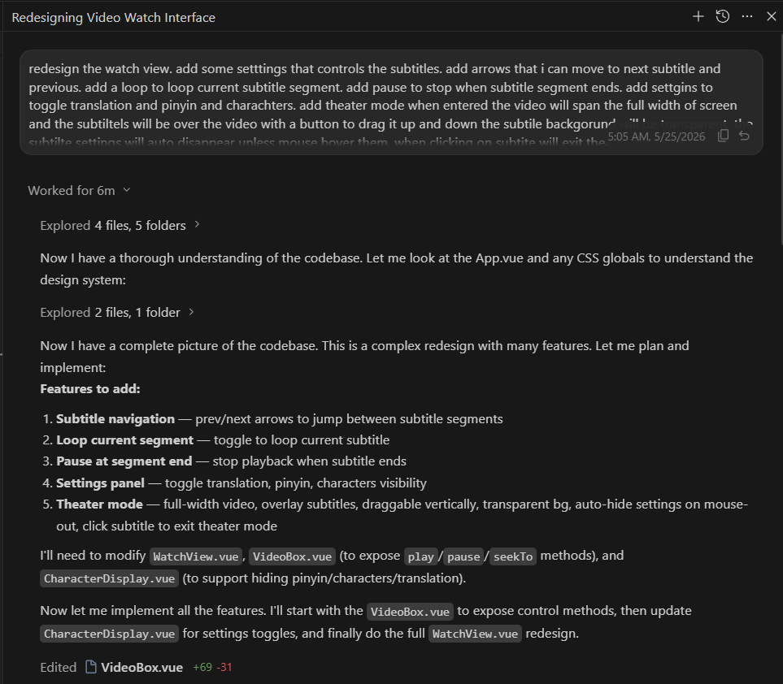

Refactoring backend to Domain-Driven Modular architecture
Instructed the assistant to migrate the Node.js Express backend from a flat layered architecture (controllers/, services/, utils/) into a Domain-Driven Modular architecture, encapsulating each feature inside its own modules/ directory.
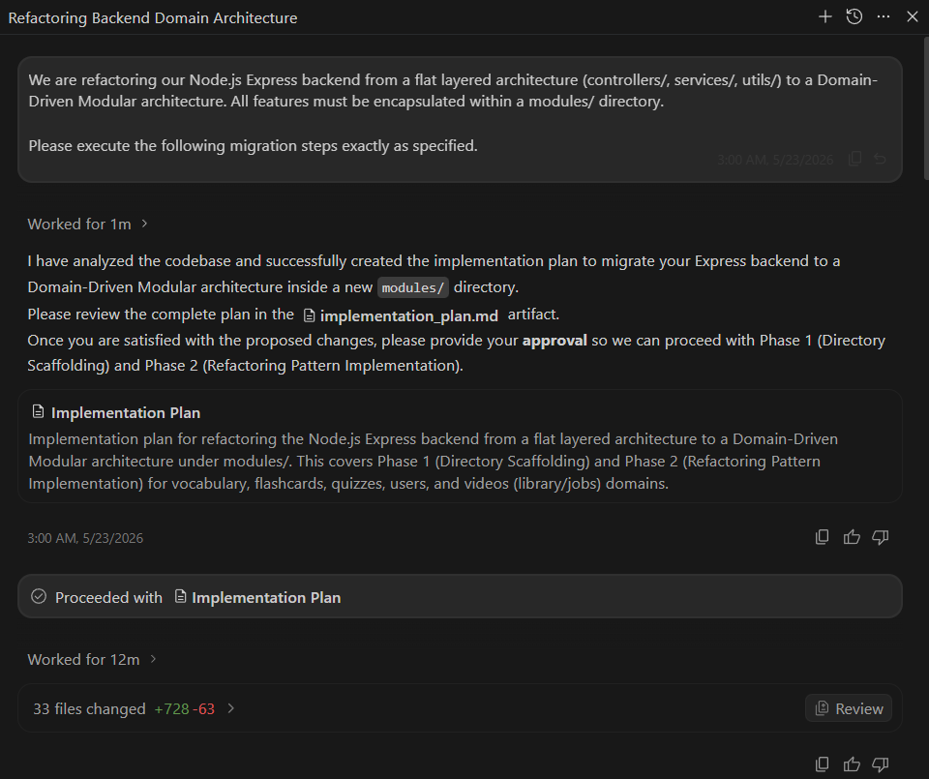

Adding PostgreSQL to the Docker deployment pipeline
Asked the assistant how to add a PostgreSQL service to the existing Docker Compose / GitHub Actions deployment pipeline on the Tencent Cloud Lighthouse server.
