Haut du formulaire

Bas du formulaire

**DATA SOURCES**

From EUROSTAT:

**Air passenger transport by main airports in each reporting country**

<https://ec.europa.eu/eurostat/databrowser/bookmark/15424aa3-01d4-4b6f-98f2-c3c213a85a3b?lang=en>

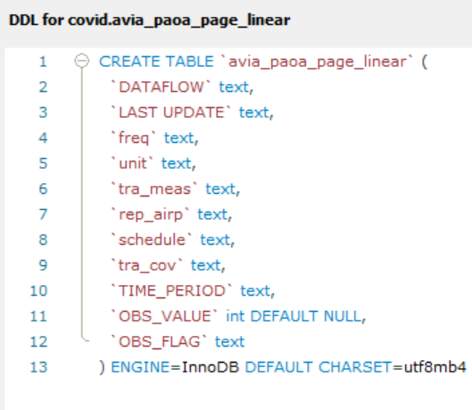

From ECDC (European Centre for Disease Prevention and Control)

New Covid cases and deaths (“cases”)

Hospital Covid admission data (“occup”)

Covid 19 Vaccination (broken down in “vaccin_yy”, yy for each year 20 to 23)

**COVID RAW DATA**

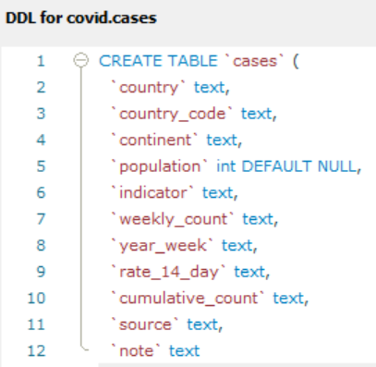 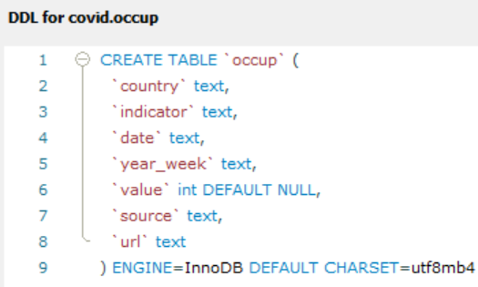

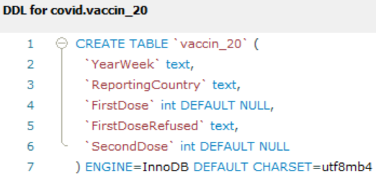

**WORKING TABLES**

**GENERIC DATA TABLES**

**Population Country codes**

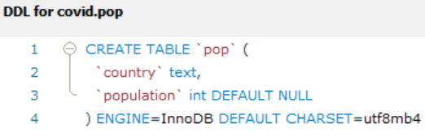 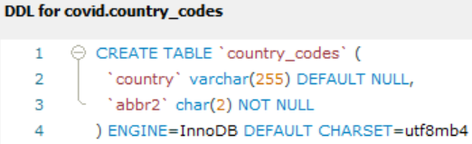

**NORMALIZED COVID DATASETS**

**Confirmed cases Hospital standard occupation**

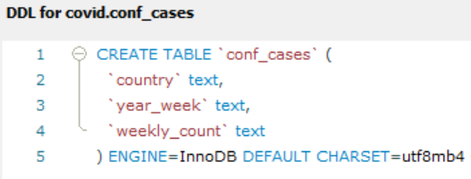 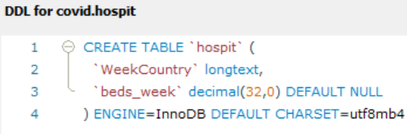

**ICU (intensive care) Deaths**

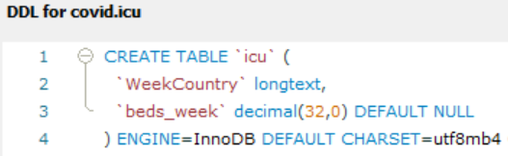 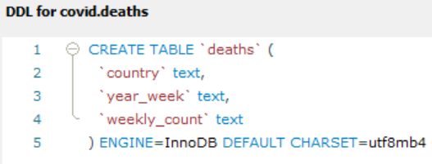

**VACCINATION TEMPORARY DATASETS**

**Vaccination 2020 Vaccination 2021**

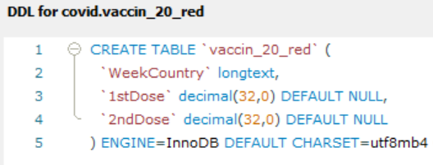 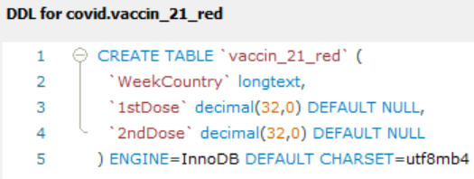

**Vaccination 2022 Vaccination 2023**

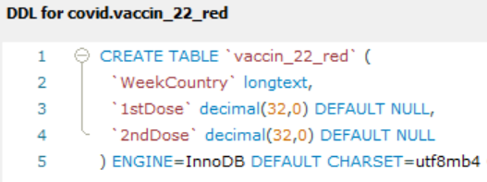 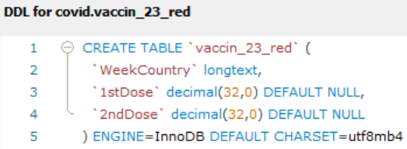

**“BEHAVIORAL” NORMALIZED DATASETS**

**4 year vaccination Flying passengers**

