# APPENDICES

**Appendix I: Application form *(fill up where applicable)***

|  |  |
| --- | --- |
| **A. Contact details** | |
| **Applicant 1: Fintech company** | |
| Name of company |  |
| SSM registration number |  |
| Website URL |  |
| Name of key personnel1  (e.g. CEO, CFO) |  |
| Email address |  |
| Phone number |  |
| Mailing address |  |
| Shareholders |  |
| Describe the nature and  scale of your operations in Malaysia | *(Please keep the response below 200 words)* |
| Provide details of high- skilled jobs that your company is creating in  Malaysia |  |
| **Applicant 2: Financial institution** | |
| Name of financial  institution |  |
| Name of designated officer (e.g. CEO or Head of  Innovation) |  |
| Email address |  |
| Phone number |  |
| Mailing address |  |

1





|  |  |
| --- | --- |
| **B. About the product, service or solution** | |
| Describe the product, service or solution | *(Please keep the response below 200 words. Additional information may be provided as supporting documents)* |
| Eligibility criteria (As per paragraph 5.1) | |
| Explain how the product, service or solution is genuinely innovative with clear potential to   1. improve accessibility, efficiency, security or quality in the provision of financial services; 2. enhance the efficiency and effectiveness of Malaysian financial   risk management; or   1. address gaps in or open up new opportunities for financing and investments in the   Malaysian economy. | *(Please keep the response below 200 words. Additional information may be provided as supporting documents)* |
| Describe how the usefulness and functionality of the product, service or solution has been assessed and/or  tested | *(Please keep the response below 200 words. Additional information may be provided as supporting documents)* |
| Provide evidence of resources available to support testing in the sandbox | *(Please keep the response below 200 words. Additional information may be provided as supporting documents)* |
| Explain the business plan for the product, service or solution to be offered on wider commercial scale | *(Please keep the response below 200 words. Additional information may be provided as supporting documents)* |
| Identify the legal or regulatory requirements that are incompatible with  the proposed product, | *(Please keep the response below 200 words. Additional information may be provided as supporting documents)* |

|  |  |
| --- | --- |
| service or solution and the regulatory flexibilities needed to undertake the  test |  |
| Potential risks and safeguards (As per paragraphs 6.1- 6.3) | |
| Describe the risks associated with the testing and identify appropriate risk mitigation measures/safeguards | *(Please keep the response below 400 words. Additional information may be provided as supporting documents)* |
| Application requirement (As per paragraph 7.2) | |
| Explain the intended key outcomes of the testing | *(Please keep the response below 200 words. Additional information may be provided as supporting documents)* |
| Other relevant information | |
| State the expected  duration of the test |  |
| State the location of the IT  infrastructure |  |
| State the source of funding  for the testing |  |
| Any other information that may support the  application |  |
| **C. Details of the collaboration between financial institution and fintech company**  Eligibility criteria (As per paragraph 5.2) | |
| Describe the collaboration between financial institution and fintech company (e.g. outsourcing of service, equity stake participation, joint venture  etc.) | *(Please keep the response below 200 words. Additional information may be provided as supporting documents)* |

# Appendix II: Application process

* 1. 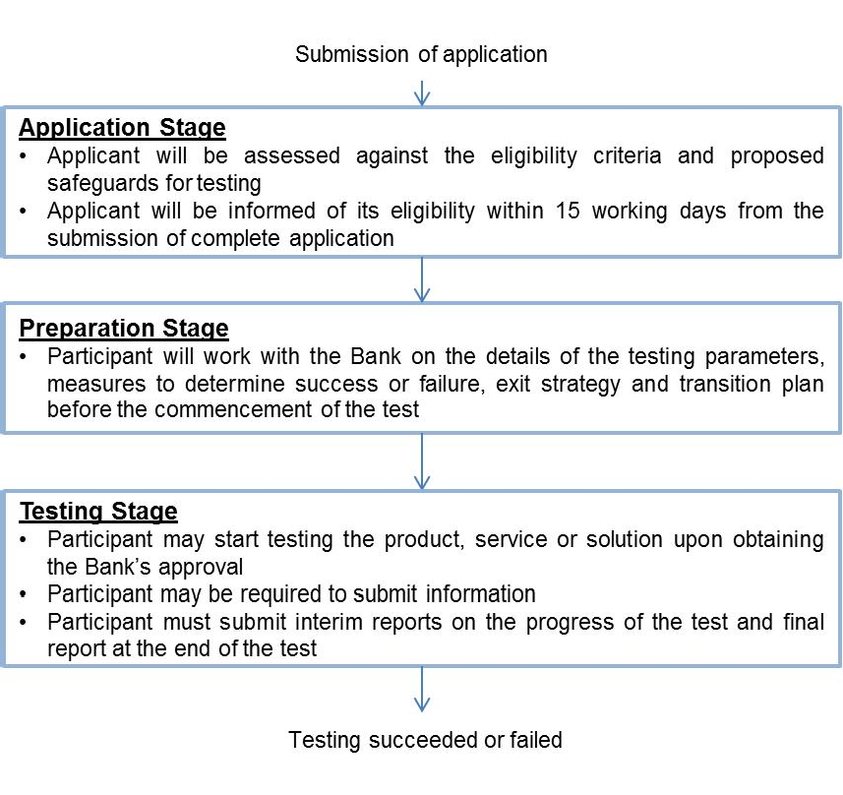The flowchart below illustrates the application process upon submitting the application for sandbox.
  2. For a rejected application, a cooling off period of six (6) months shall be observed before the applicant is allowed to resubmit the application.