- Patient/Doctor/Pharmaceutical
Assumptions:
- Every patient in this context will have a doctor, because in the context of receiving prescribed medicine, they need one that’s why the relationship between doctors and patients is total participation on both sides.
- Pharmaceutical companies in this context also wouldn’t be in the database without making a medicine for the pharmacy chain to sell – so total participation on both sides.
- Total participation for the patients, doctors and, medicines – the pharmacy chain doesn’t care about patients/doctors that aren’t taking medicines.
- While the trade name could be unique, I didn’t want to assume it would be, so I included the Pharmaceutical company’s name as an attribute in the medicine table.
- Each supervisor works on at least one contract.

Schema Statement:
Patient (SSN, name, address, age)
Doctor (SSN, name, specialty, years)
PharmaCo (name, phone)
Medicine (tname, pharmaco_name, formula)
Pharmacy (name, phone, address)
Supervisor (superID, name, date)

Treats (patient_SSN, doctor_SSN)
Prescribes (patient_SSN, doctor_SSN, tname, pharmaco_name, date, quantity)
Sold By (pharmacy_name, tname, pharmaco_name, price)
Contracts (contractID, pharmacy_name, pharmaco_name, start date, end date, text, superID)
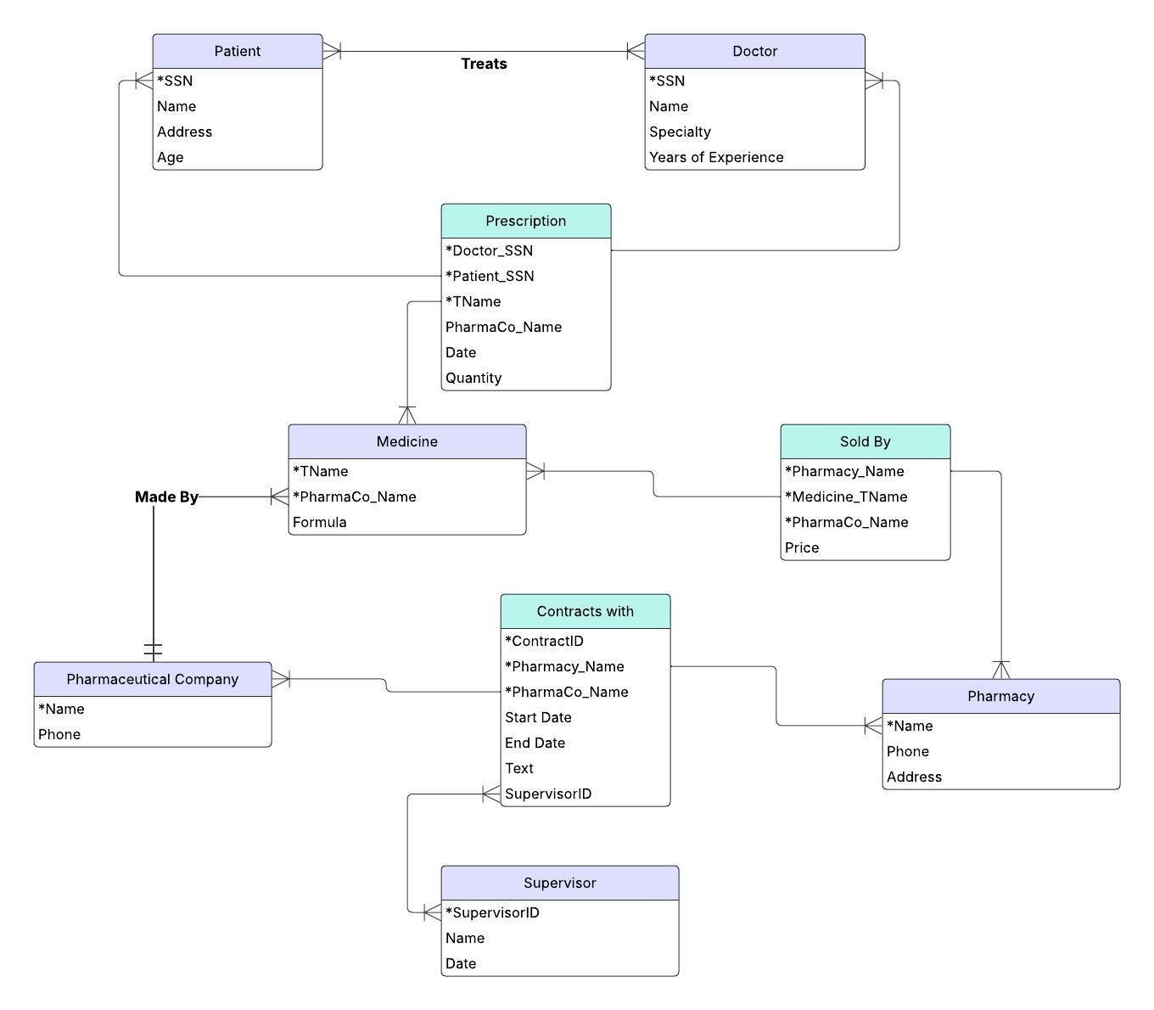

- Mineral and Energy Lease for Land Parcels
Assumptions:
- Different resource types for the same parcel will stored as separate leases.

Schema Statement:
Owner (ownerID, name, phone, address)
Parcel (parcelID, address, size)
Lease (leaseID, companyID, parcelID, beginning date, duration, resourcetype)
Company (companyID, Name)

Ownership (ownerID, parcelID)
ParcelLease (parcelID, leaseID)

