🚗 Auto-Buyer CRM Platform – Software Requirements Specification (SRS)

1. Introduction
Purpose: Define functional and non-functional requirements for the Auto-Buyer CRM integrated with the vehicle sourcing dashboard.
Scope: Manage leads, contacts, deals, vehicles, tasks, and analytics in one platform.
Users: Buyers/Sales Reps, Admins/Leadership, Analysts.

2. System Overview
Unified CRM integrating lead management, deal tracking, vehicle scoring, and analytics. Provides real-time communication, automated follow-ups, and data synchronization with external systems.

3. Functional Requirements

Lead Management
- Capture and store lead data (name, contact, vehicle interest).
- Filter leads by source, score, date, or assigned user.
- Auto-update lead status: New → Contacted → Qualified → Converted → Lost.
- Bulk import/export of leads (CSV/API).
- Integration with external lead sources (marketplaces, website).
- ✅ Expanded Lead Details
- Each lead profile will include:
- Name (first + last)
- City, State, ZIP
- Contact Information (phone, email)
- Date/Time Added (timestamp of creation/import)
- Lead Source (marketplace, website, referral, etc.)
- Assigned Buyer / Sales Rep
- Status (New, Contacted, Qualified, Converted, Lost)
- Tags (Hot Lead, Repeat Seller, Fleet Owner, etc.)
- ✅ “Vehicle Interest” Clarification
- In our business model, we defined vehicle interest as the term that refers to the vehicle(s) the private owner is selling – i.e., the vehicle we want to acquire from them.
- The field should store:
- Vehicle Make / Model / Year / Trim
- VIN (if available)
- Asking Price
- Mileage / Condition
- Listing Source URL
- Images (urls for the preview)
- ✅ Lead Example:
Field | Example
Lead Name | John Smith
City / State | Austin, TX
Contact | (555) 123-4567
Vehicle | 2022 Toyota Camry LE
Asking Price | $28,500
Images | https://scontent-bog2-2.xx.fbcdn.net/v/t39.30808-6/573913684_1671688080457820_1331935848526037111_n.jpg?stp=dst-jpg_s960x960_tt6&amp;_nc_cat=109&amp;ccb=1-7&amp;_nc_sid=454cf4&amp;_nc_eui2=AeGhFzE6HN0cFBeGRE8BgK5bAeYgySWa_N0B5iDJJZr83UxGO-xlUF-jbG6YvcVFp7OO4HtOTpMgGvdNFCE81laV&amp;_nc_ohc=BY7CxhB08NYQ7kNvwFP3Kv3&amp;_nc_oc=Adkc2WRZyusS4FyfaGhj2kpZbrXpFxBPQUDR6G8xOZZ2niAg_SbrkjRmz8eA5sxBCDI&amp;_nc_zt=23&amp;_nc_ht=scontent-bog2-2.xx&amp;_nc_gid=kURvwfTIGlo2WwHZChfudQ&amp;oh=00_AfemRQfp5JLMPb6iuc63tH3IeTE-ASwtBqssQ41lsrT6Zg&amp;oe=69089A09
Added On(or Updated At) | 2025-10-29 14:22 CST
Assigned To | Blake
Source | Facebook Marketplace Or Url

Contact Management
- Maintain customer/company profiles.
- Log all communications (calls, emails, SMS, meetings).
- Display recent activity timeline per contact.
- Tag contacts (prospect, customer, partner).

Deal Pipeline
- Stage-based visualization of deals: Prospecting → Qualification → Proposal → Negotiation → Closed.
- View total deal value per stage.
- Track expected close date and revenue forecasts.
- Real-time deal updates synced with CRM dashboard.

Task Management
- Create, assign, and track tasks with priorities and due dates.
- Display task completion analytics.
- Integrate with Slack and email for reminders.
- Auto-generate tasks from CRM triggers (e.g., 'Lead uncontacted for 2 days').

Vehicle Integration
- Pull vehicle data from sourcing API with score, price, mileage, location.
- Filter by make, model, year, score, and price range.
- Match vehicles to relevant leads automatically.
- Show vehicle analytics (score distribution, price trends).
- ✅ Clarify “Match vehicles to relevant leads”
- This means linking each vehicle record to the lead (the seller) who owns that vehicle.
- When a new lead is created (e.g., scraped or imported from a marketplace), the system:
- Extracts vehicle details.
- Create or links a vehicle record.
- Associates that vehicle record with the lead profile
- ✅ Optional Expansion:
- If the same seller lists multiple vehicles, all can be tied to one lead profile with a “Vehicles Owned” tab.
- If a vehicle already exists (same VIN), it’s deduped and linked to the correct lead automatically.

Analytics & Reporting
- Track KPIs (conversion rate, revenue, average deal size, response time).
- Monthly revenue trend charts and sales leaderboards.
- Export analytics data to CSV or external BI tools.

Communication System
- Send/receive emails, SMS, and calls directly from the CRM.
- Log and transcribe calls automatically.
- Use message templates with auto-filled variables.
- Slack integration for instant notifications.
- ✅ Email Functionality
- The CRM should have the same capabilities for email as for messaging (SMS):
- Native email sending through company domain (via SendGrid API).
- Email templates with merge fields like {lead_name}, {vehicle_model}, {asking_price}, {buyer_name}.
- Auto-logging of all sent/received emails under the lead profile.
- Option to trigger automated follow-up emails (e.g., “No reply in 48h → send template B”).
- Optional read receipts / open tracking.
- ✅ Interface Integration
- Email editor integrated alongside the message panel.
- Unified communication timeline for calls, messages, and emails — all visible under each lead profile.

Mobile & Responsive Design
- Optimized for mobile and tablet screens.
- Quick-access dashboards and lead cards.
- Bottom navigation menu for major modules.

4. Non-Functional Requirements
- Performance: Must support 1,000+ concurrent users with <1s response time.
- Security: Role-based access control, encryption in transit (TLS 1.2+) and at rest (AES-256), secure audit logging.
- Scalability: Modular microservice architecture for load handling.
- Availability: 99.5% uptime SLA.
- Compliance: GDPR-compliant lead data management.
- Usability: Intuitive dashboard; accessible design (WCAG 2.1).

5. System Architecture (Conceptual)
- Frontend: Next.js + React Query + TailwindCSS
- Backend: Node.js (NestJS) + PostgreSQL + Redis
- AI/ML: Vehicle scoring & lead ranking via Python microservice
- Comms Layer: Twilio (Voice/SMS), SendGrid (Email), Slack Webhooks
- Analytics: TBD

6. Future Enhancements
- Predictive AI for deal closure probability.
- Customer satisfaction tracking (CSAT integration).
- Dynamic pricing suggestions from vehicle market data.
- Chatbot for automated lead qualification.

Appendix A – Visual Prototypes
The following ASCII wireframes represent the CRM interfaces and dashboards currently implemented in the prototype:

📊 CRM Dashboard Overview
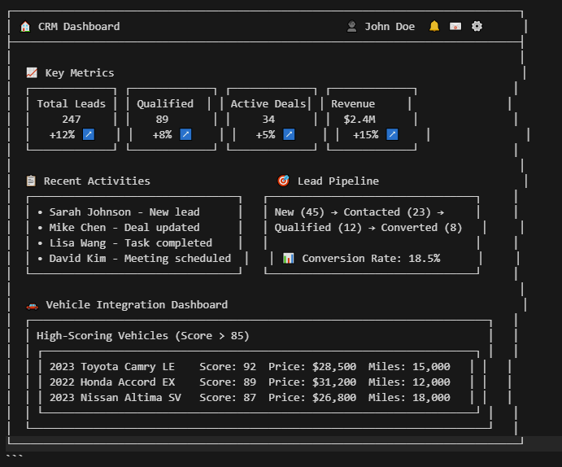

👥 Lead Management Interface
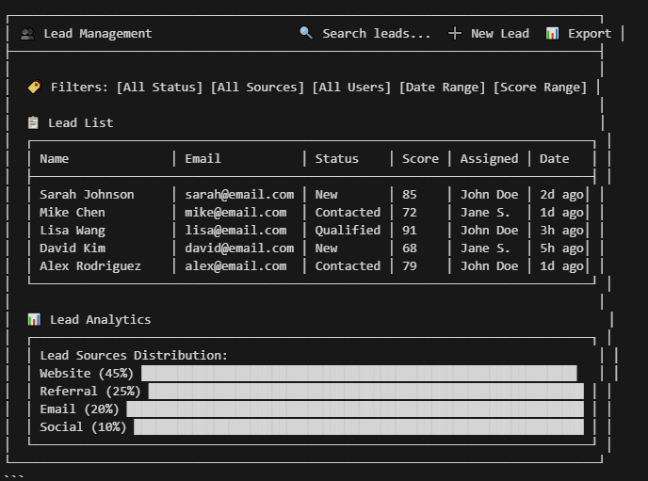

📞 Contact Management Interface
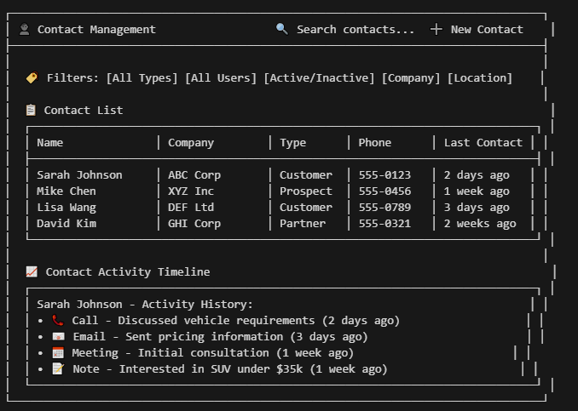

💼 Deal Pipeline Interface
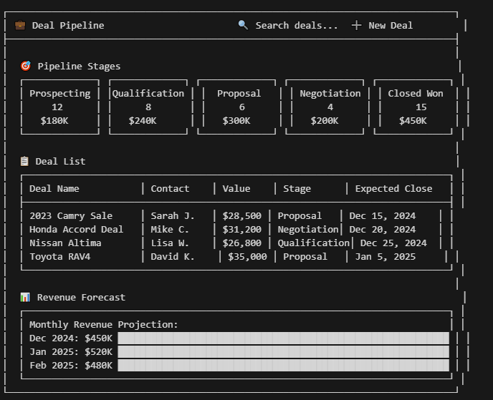

✅ Task Management Interface
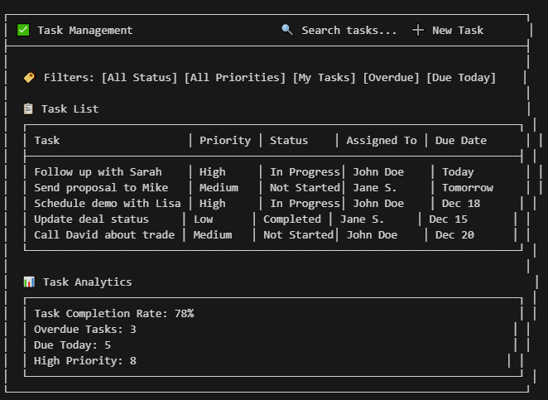

🚗 Vehicle Integration Dashboard
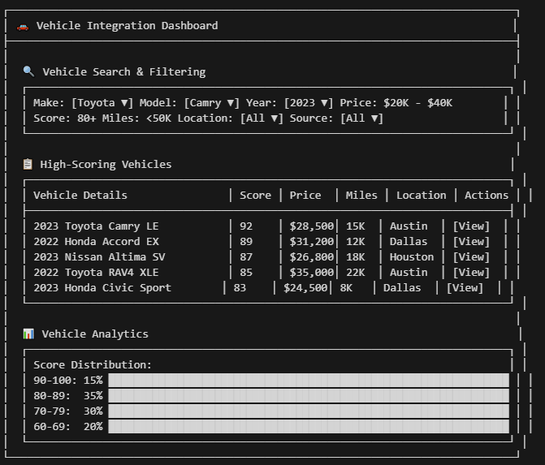

📊 Analytics & Reporting Interface
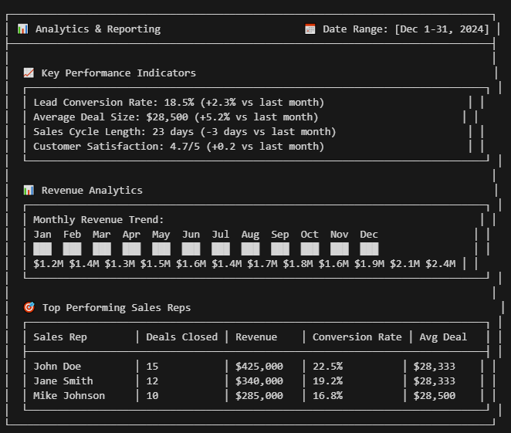

📱 Mobile Responsive Design
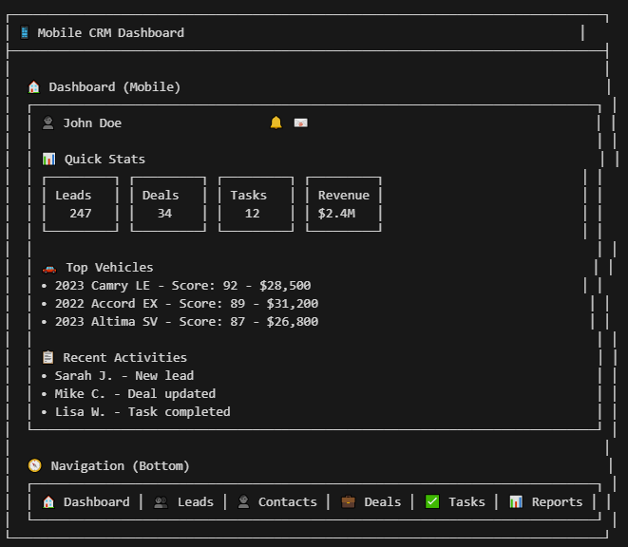

🎨 Design System & Color Palette

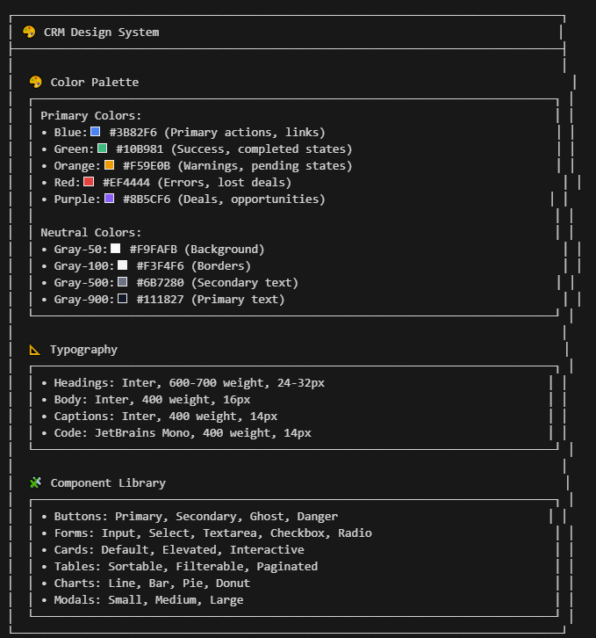

🔗 Integration Points
