Simulation of V2I-Based Advance Detection Using Gipps’ Car-Following Model

William Alexander

Michael Dunn

CE 391F: Advanced Theory of Traffic Flow

Dr. Christian Claudel

Semester Project

December 13, 2017

# Introduction

Vehicle-to-Infrastructure, or V2I, communication is one of the advanced technologies that is changing the way traffic systems operate. One of the major anticipated applications of this technology is related to advance detection, a technique involving the placement of traffic sensors upstream of an intersection in order to provide information on traffic approaching the intersection. It is thought that using V2I technology for advance detection would result in a more accurate, flexible system than the traditional techniques. In order to explore this hypothesis further, we set out to develop a traffic microsimulation and test various detection schemes in order to assess the effectiveness of V2I communication in decreasing travel time through an intersection.

This report provides background on the various concepts and technologies used, details the methodology involved with building the simulation, and gives an overview of the results generated therein.

# Background on Car-Following Models and Gipps’ Model

Car-following models are a subset of microscopic traffic flow models, in that they aim to represent the dynamics of individual vehicles. Specifically, the basic principle behind car-following models is that drivers follow each other by adopting a velocity that is based on the vehicle(s) in front of them. The earliest basis for a car-following model was first proposed in the mid 1950s, and since then many refinements and additions have been made to match the models more closely with realistic driver behavior. Car-following models of different sorts are the foundation of traffic microsimulation software platforms, such as VISSIM, CORSIM, AIMSUN (which uses Gipps’ model), and others.

Gipps’ model is a car-following model developed by Peter Gipps in the late 1970s, and first published in 1981. Gipps brought two unique developments to the concept of the car-following model. First, he identified vehicles based on their velocity, as opposed to their acceleration. Additionally, his model uses a timestep equal to the driver’s reaction time. This eases the computation required for numerical analysis, an important advancement since Gipps intended his model to be used in early computer simulation of traffic. Though this development is no longer of extreme importance given advancements in computing technology, we chose to use Gipps’ model in developing our simulation because it is straight-forward and provides a good balance between simplicity and capturing the major aspects of driver behavior and vehicle constraints necessary to simulate realistic traffic.

The basis of Gipps’ model is the institution of two regimes, the minimum of which determines the speed that a driver will adopt. The top line of the equation below represents the “free” regime, which corresponds to the condition where there is no vehicle in front of the vehicle in question. In other words, the driver can adopt their desired speed, constrained only by their maximum desired rate of acceleration. The bottom line of the equation represents the “following regime,” where the driver in question is behind another vehicle, and therefore bases their speed on the characteristics of the vehicle in front (vehicle “”). The follower adjusts their speed such that they always maintain a safe headway to the vehicle in front of them. This headway is just enough to allow the follower to respond to any action by the leader and avoid a collision.

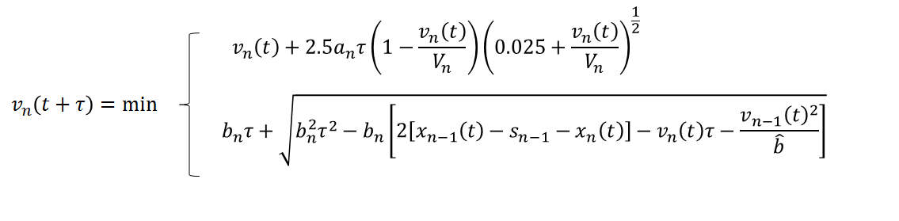

The inputs for Gipps’ model are shown below in Table 1. In building our simulation, we elected to use the same input values that Gipps outlined in his original publication. For the parameters , , and , we selected random values from the normal distribution shown in Table 1. This provided for some variability in driver behavior, and increased the realistic nature of the simulation. Additionally, it is important to note the parameter , which is vehicle n’s estimate of . In other words, it accounts for the fact that any one driver will not know the maximum desired deceleration rate of other drivers, and will therefore estimate this parameter using their own preferences.

*Table 1: Inputs for Gipps’ Model*

|  |  |  |
| --- | --- | --- |
| **Parameter** | **Definition** | **Value** |
|  | Max acceleration of vehicle |  |
|  | Max desired deceleration of vehicle |  |
|  | Effective size of vehicle (length + margin) |  |
|  | Desired speed of vehicle |  |
|  | Reaction time |  |
|  | Vehicle ’s estimate of |  |
|  | Position of vehicle | -- |
|  | Speed of vehicle | -- |

There are some important drawbacks to Gipps’ model. It is based on the assumption that a following driver will always be able to react to the leader’s motion in order to avoid colliding. This means that, in the model, the follower adopts a gap that corresponds to their reaction time, which isn’t precisely realistic behavior. In the calculation of , it is possible for the follower’s estimation of the leader’s deceleration rate to be smaller than their own maximum deceleration rate, which is unlikely to occur in reality. Additionally, Gipps’ model was developed for use in basic highway simulations. For that reason, the equation is not perfectly suited to handle vehicles coming to a complete stop.

# Methodology

#### Building the simulation

To model the impacts of different control strategies, we created a simulated intersection consisting of two one-way links on which cars would travel, each with a length of 400 kilometers, as depicted in Figure 1. We then established a simple traffic signal controller to manage traffic at the intersection of the two links, allowing us to investigate different control strategies in a simple, controlled simulation. In programming the traffic signal controller, we set the guaranteed minimum amount of time that must be served (minimum green time) to 30 seconds, and the maximum which can be served when advance detection is in use (maximum green time) to 50 seconds. We set the total intersection demand to be 800 vehicles per hour.



*Figure 1: Representation of Simulated Intersection with V2I Advance Detection Threshold*

#### Extending Gipps’ Model

Because Gipps’ model was designed for use in simulating traffic flow in a highway setting, it is not perfectly suited for cases in which vehicles would come to a complete stop, such as at a stoplight. In order to address this shortcoming, we augmented the model by adding a third regime, the “red light” regime, which is similar in nature to the follower regime. We place a “vehicle” of zero length, zero speed, and zero acceleration at the stop bar location when a light turns red and remove it when it turns green. This requires any vehicles approaching the red light to decelerate and come to a stop. However, since Gipps’ model was not designed to allow for cars to complete halt their motion, the vehicles approaching the red light maintained velocities that were miniscule, albeit slightly non-zero. This appeared in practice as vehicles “inching towards” the stop bar and eventually crossing into the intersection during long wait times. In order to combat this, we modified the stoplight regime to cause velocity to decay exponentially as the vehicle approached a red signal.

#### Simulating vehicle-to-infrastructure communication

The foundational assumption of this experiment was that a traffic signal controller can gain reliable information regarding the position of approaching vehicles using V2I communication. To date, this technology remains hobbled by imperfect communication signals. In order to account for this, we set each vehicle to only communicate when it is within range of a distance . This distribution was chosen to provide vehicles with ranges from 235 to 365 with 95% probability. This provides for a rough approximation of desired V2I capabilities. Additionally, we assumed a near-perfect line of sight between the vehicles and the receiver, and did not provide for any interference from vehicles or other obstacles in between, as would be expected in practice.

#### Simulating advance detection

We designed our experiment to have a base scenario of a traffic signal controller running fixed phase times with no advance detection capabilities, and then compared two different scenarios for improving this intersection using advance detection.

* **Traditional advance detection**

The first scenario replicates traditional advance detection techniques. It includes an extension timer and a detector placed five seconds upstream from the intersection (calculated based on free-flow speed). In practice, this is usually realized using a loop magnetometer or other sensor placed in or adjacent to the roadway. The extension timer is engaged whenever a vehicle passes over the detector, until the maximum green time has been served for the phase.

* **V2I-based advance detection**

The second scenario, that of V2I-based advance detection, provides what we termed an “extension threshold” as opposed to a fixed detector. This threshold translated to an area stretching from the stop bar back down the link to a certain distance within which a car must be present for the extension timer to be enacted. The threshold corresponds to the distance that could be covered by a vehicle traveling at the speed limit which would still cross the stop bar by the time that the maximum amount of time has been served.

#### Setting up the experiment

To gather our data, we ran each of the three different model scenarios five times, varying the volume split between main line and side street each time (main line 50%, 60%, 70%, 80% and 90%). For each of the scenarios we ran 30 experimental trials of 30 minutes each for a total of 450 model runs across the different volume splits.

# Results

Figure 2 shows the mean travel times on the main line for each scenario. Note that as a higher percentage of traffic is placed on the main line, the travel time increases for every detection scenario. However, there is a slight improvement over the fixed time scenario with the addition of traditional advance detection, and a much more noticeable improvement when implementing our V2I-based advanced detection scheme.

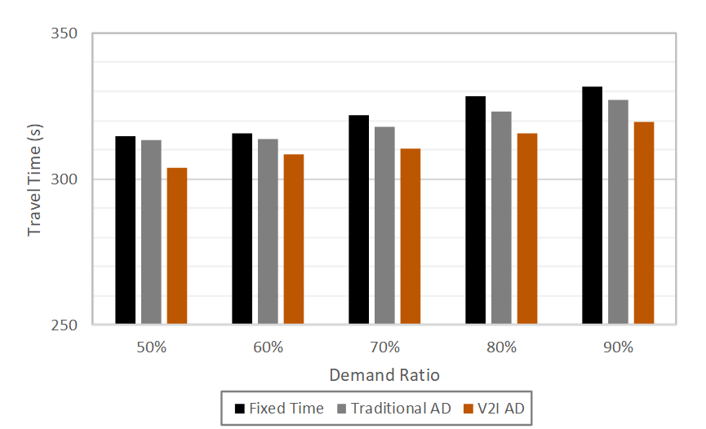

*Figure 2: Mean Main-Line Travel Time*

As an indicator of the dispersion of our data, Figure 3 shows the change in standard deviation of the main line travel times. Note that, while the standard deviation decreases slightly upon implementation of traditional advance detection (about a 2% decrease), the decrease from implementing V2I advance detection is much larger (about a 7% decrease, on average).

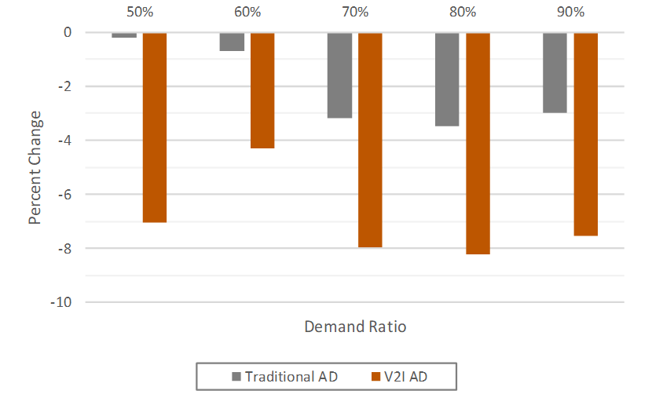

*Figure 3: Percent Change in Standard Deviation of Main Line Travel Time*

Since advance detection makes it possible to give additional time to the main line, it is important to assess the effect it has on the side street traffic. This is to ensure that any benefit gained on the main line is not outweighed by negative impacts to vehicles waiting on the side street. Figures 4 and 5 help do this by showing the percentage change in mean travel time for the main line and the side street, respectively.

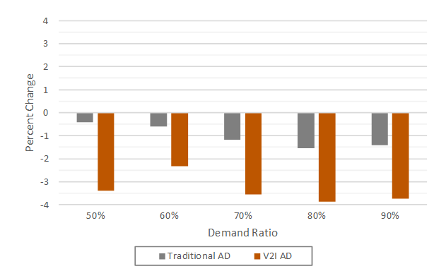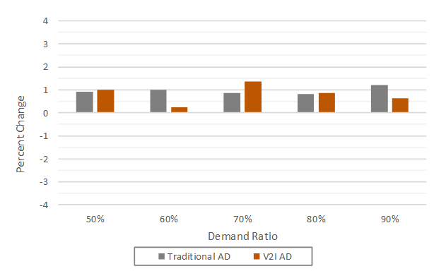

*Figure 4: Percent Change in Main-Line Travel Time Figure 5: Percent Change in Side-Street Travel Time*

Figure 4 shows consistent decreases in mean travel time for the main line, for both of the advance detection scenarios. Figure 5, shows consistent increases in travel time for the side street. Some negative effect is expected to be felt by the side street traffic when advance detection gives priority to the main line, so this is not out of the ordinary. Note, however, that for traditional advance detection, the magnitude of the improvements was about the same as that of the negative side street effects (means of -1.03% and 0.96% respectively). For the V2I scenario, on the other hand, the improvements were, on average, 2.3% greater than traditional advance detection and the negative side street effects were around the same magnitude for the two scenarios.

# Conclusion

Based on our results, V2I advance detection was effective at decreasing main line travel time through an intersection. Our results clearly depicted a net travel time improvement for our system.

It is important to recognize that our simulated network is very basic. In order to confirm our results, it would be desirable to expand the simulation to include a more diverse palette of intersections and routes. This would likely be made much easier by integrating with a professional-grade microsimulation platform. Additionally, it would be interesting to explore car-following models other than Gipps’ model and compare how they work in generating driver behavior in a simulation setting. Eventually, it is our home that a simulation framework such as this could be used to assess the impact of V2I advance detection in a transitionary landscape which would include both connected and non-connected vehicles, as this will be an important proving ground for V2I technology.

# References

Alexander, W., X. Hong, A. Hainen. “V2I Communication-Enables Real-Time Intersection Traffic Signal

Scheduling.” The University of Alabama, 2017.

Day, C. M., D. M. Bullock, H. Li, S. M. Remias, A. M. Hainen, R. S. Freije, A. L. Stevens, J. R. Sturdevant, and

T.M. Brennan. “Performance Measures for Traffic Signal Systems: An Outcome-Oriented Approach.”

Purdue University, West Lafayette, Indiana, 2014.

Gipps, P.G. “A Behavioural Car-Following Model for Computer Simulation.” Transportation Research Board

Part B, 15. 1981

Olstam, Johann J, and Andreas Tapani. “Comparison of Car-Following Models.” Swedish National Road and

Transportation Institute, vol. 960A, 2004.