Game Design Document

COMP3064 – Game Development

Team DNS

Nooran El-Sherif | 100695733 | nooran.el-sherif@gmail.com

Sean Price | 101015020 | sean.price@georgebrown.ca

Dylan Roberts | 100727526 | dylan.roberts@georgebrown.ca

# Name and Description

**Game Name:**

Contract Negotiator 2: Back To Work

**Game Description:**

The teachers are being forced back to work by legislation. Now they need to get there on time to start their first day back. The player must run forward and jump while avoiding all obstacles in their way to make it back in time. Busses, cars, and miserable weather will all try and prevent the player from getting to their class in time.

# Backstory

Game designer Dylan Roberts was applauded for his late 2017 opus ‘Contract Negotiator’ because of it’s topical theme and addictive gameplay. The runaway success achieved success all around the globe. When the Faculty Strike conflict changed and the teachers were being forced back to work, Dylan decided to team up with Team DNS to create a sequel ‘Contract Negotiator 2: Back to Work’. With more levels, better graphics, and new gameplay mechanics ‘Contract Negotiator 2’ will be another success.

# Screen Layout

|  |  |
| --- | --- |
| Image Thumbnail | Description |
|  | Menu Screen (Entry Point) |
|  | First Sequence |
|  | Second Sequence |
|  | Game Over |

# UI Flow Diagram

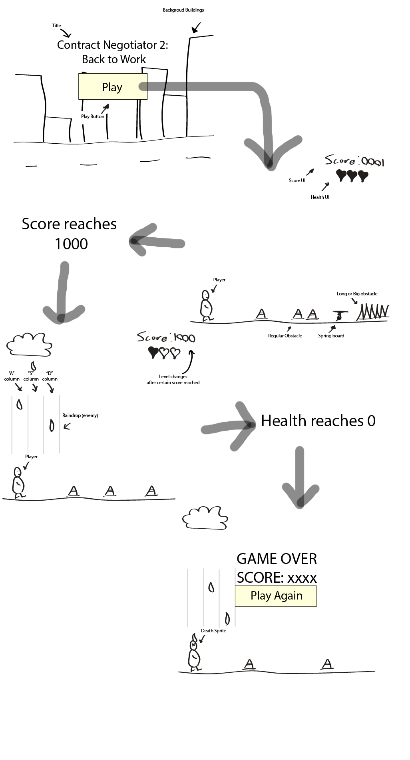

# Assets

|  |  |
| --- | --- |
| Image Thumbnail | Description |
|  | The background for level 1.  A sunny city backdrop. |
|  | The background for level 2.  A dark, rainy city backdrop. |
|  | The atlas for the Teacher representing the Player. |
|  | An enemy/ obstacle for the Player to avoid.  A blue car. |
|  | An enemy/ obstacle for the Player to avoid.  A city bus. |
|  | An obstacle for the Player to avoid. Falls from the sky in level 2.  Water droplet animation. |

# Game Mechanics

* Up Arrow press: the Player jumps.
* Space Button press: the Player jumps
* Left Arrow (A Key) Press on Level 2: the Player dodges raindrop by moving to the first segment of screen
* Down Arrow (S Key) Press on Level 2: the Player dodges raindrop by moving to the second segment of screen
* Right Arrow (D Key) Press on Level 2: the Player dodges raindrop by moving to the third segment of screen