Dylan Roberts – 100727526

dylan.roberts@georgebrown.ca

Contract Negotiator

Contents

Game Description 1

Controls Description 2

Interface Sketch 2

Screen Descriptions 5

Enemies 8

Scoring 8

Sound Index 8

Art/Multimedia Index 8

# Game Description

In the game “Contract Negotiator” you are a teacher who is going on strike to negotiate a better contract. You must collect cash to counter offer the authorities with a better deal for you and your colleagues. Avoid the bad contracts, collect the cash on your way to save the school!

The player moves along a running background constantly moving to the right. The player cannot move outside of the boundaries of the screen. ‘Contracts’ and ‘Cash’ float in and out of the screen and in the players way. The player must collect the ‘Cash’ where they will score one hundred points for each one they collect and must avoid the ‘Contracts’ where they will lose one life if they hit a ‘Contract’. If the player loses all five lives, the game ends.

# Controls Description

The controls for this game are W,A,S,D or the arrow keys.

W (Up Arrow Key) – Moves the player upwards

S (Down Arrow Key) – Moves the player downwards

A (Left Arrow Key) – Moves the player to the left

D (Right Arrow Key) – Moves the player to the right

# Interface Sketch

**Start Menu Sketch:**

# C:\Users\Dylan\AppData\Local\Microsoft\Windows\INetCache\Content.Word\InterfaceSketchMenu.png

**In Play Sketch:**

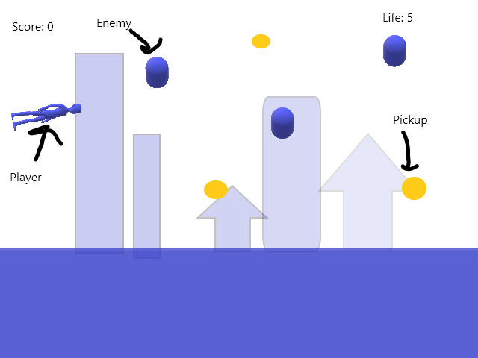

**Game Over Sketch:**

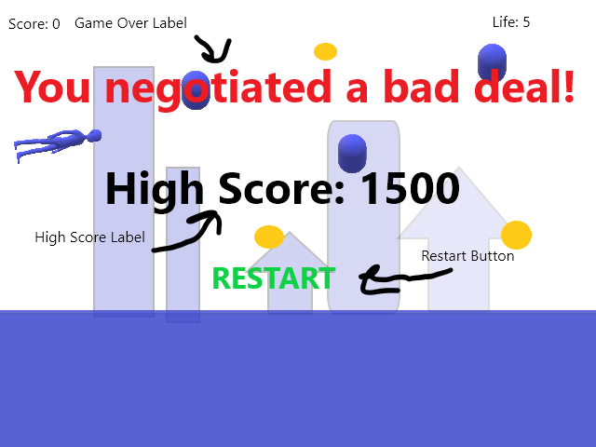

# 

# Screen Descriptions

**Start Menu:**

This is the main menu of the game. It displays the name of the game in a cool arcade style font. The start button starts the game.

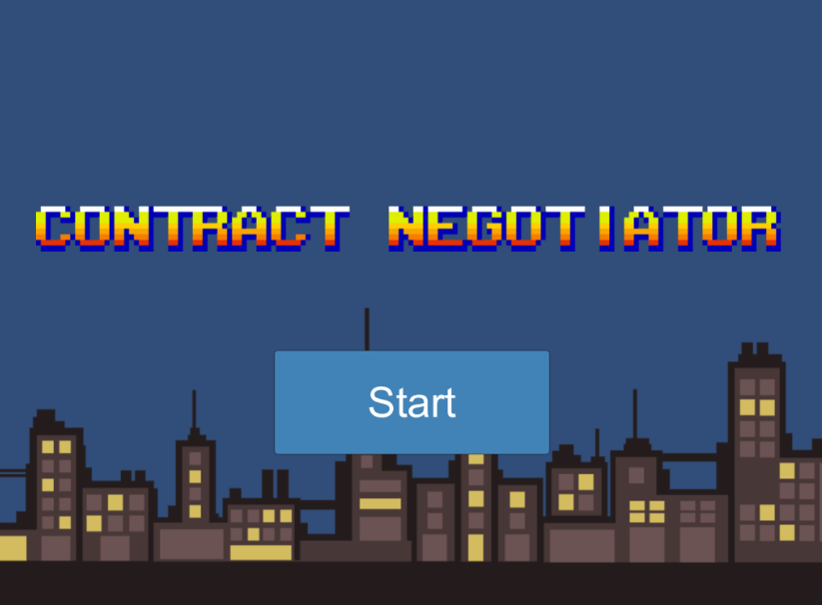

**In Play:**

While the game is in play you can see your score on the top left and your lives on the top right. You can see the player floating on the left and a ‘Cash’ pickup above him. To the right of him is the ‘Contract’ which is an enemy you avoid. The background is a simple city in the night time.

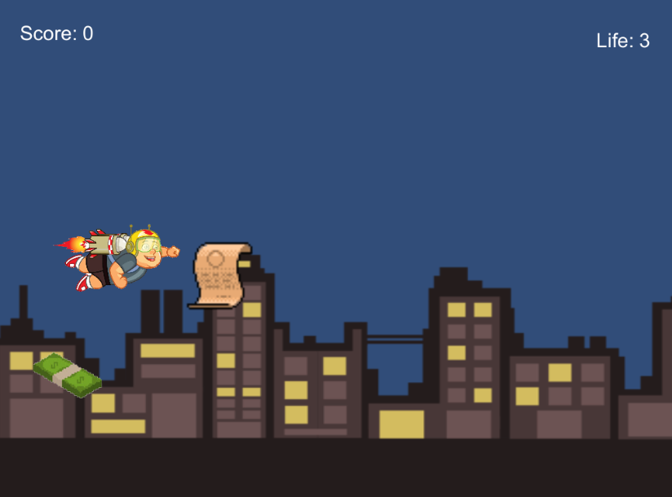

**Game Over:**

The game over screen displays the game over message (“You negotiated a bad deal!”) as well as the high score so far. On the bottom is the restart button to start playing again.

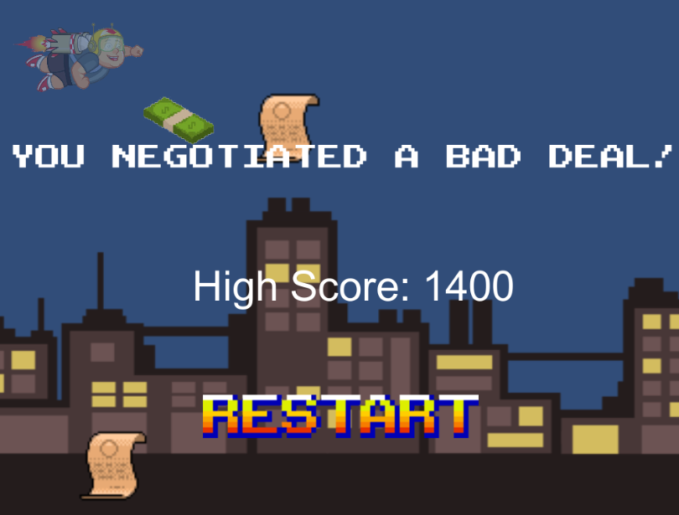

# 

# Enemies

The enemies in this game are called ‘Contracts’. Players must avoid them to collect more Cash. If the player loses all five of their lives they lose the game. The enemies spawn just a bit off screen and float at random speeds through the game scene. Clones of the enemies also spawn at random intervals to make the game increasingly harder as the player moves on.

# Scoring

The player can gather points by collecting ‘Cash’. Each time they collect Cash they gain 100 points. Each time the game notices a collision with a Cash object it adds an integer of one hundred to the Score variables in the Player instance. When the score is being added to the variable in the Player instance, it also checks if the current score is higher than the “highscore” integer stored in the PlayerPrefs object. If the current score is higher than the current high score, it replaces it. When the player loses all their lives their current score as well as the highest score yet is displayed.

# Sound Index

coin_10.wav – A ‘ding’ sound clip that plays when a coin is picked up.

music_cartoony_background.mp3 – A backing track that plays if the game is running.

paper_rustle.wav – A paper rustling sound that plays when the player hits an enemy, the contract.

# Art/Multimedia Index

1. Cash (CoinSprite.png)

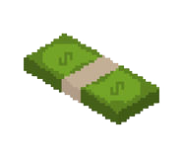

1. Contract (ContractSprite.png)



1. Explosion (ExplosionSprite.jpg)­­



1. Restart Button (RestartSprite.png)



1. Teacher (RocketTeacher.png)

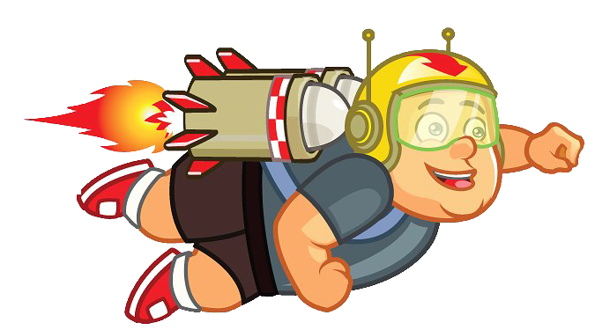

1. City Background (CityBackground.png)



1. Title Screen Logo (ContractNegotiator.png)

