COCS 4368

Group Project

University of Houston

April 2023

Group 19 (Deneb) Members:

Dante Zorrilla,

Jarod Melo

Code:

Choosing experiment:

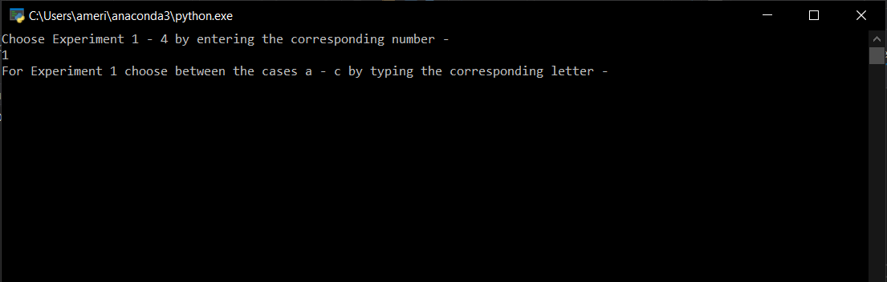

1-a:

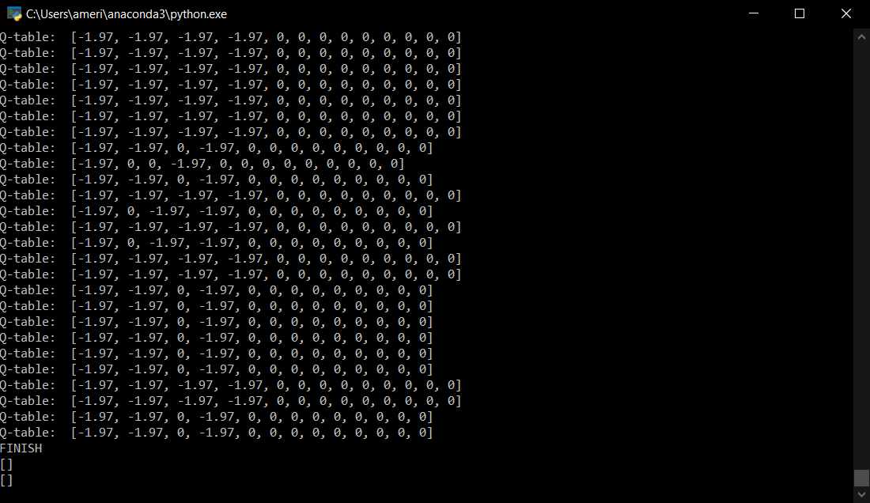

1-b:

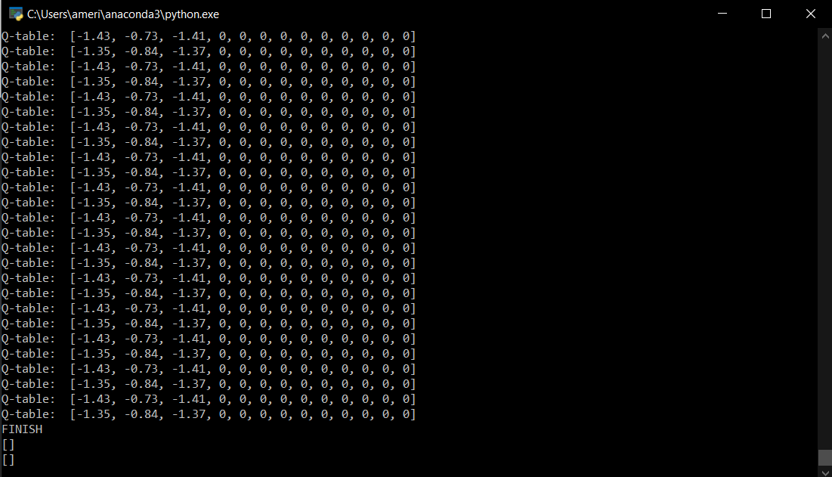

1-c:

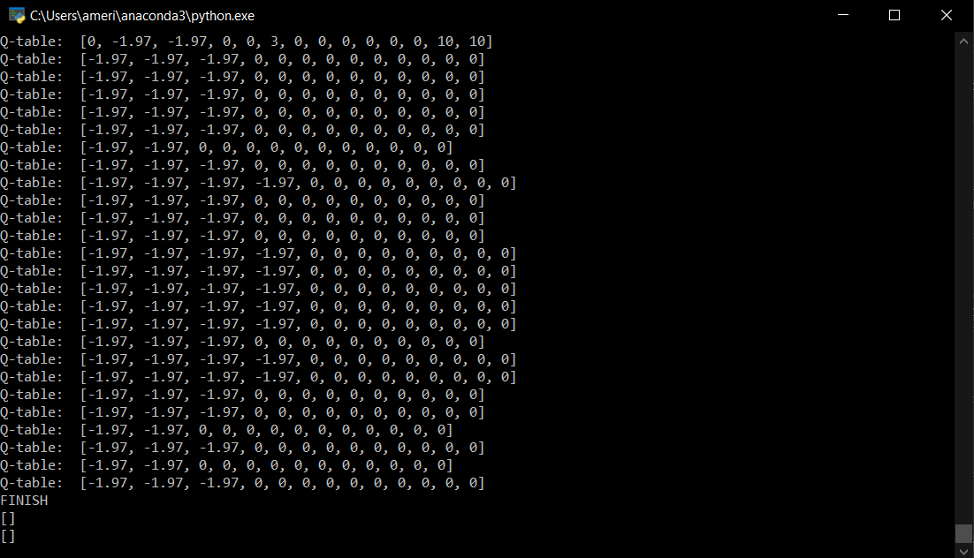

2:

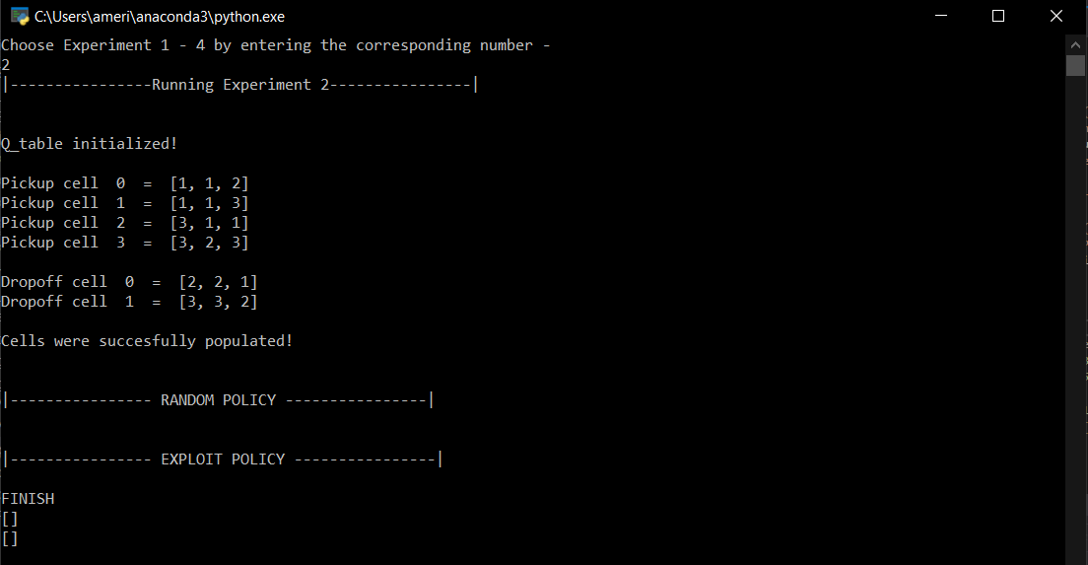

3:

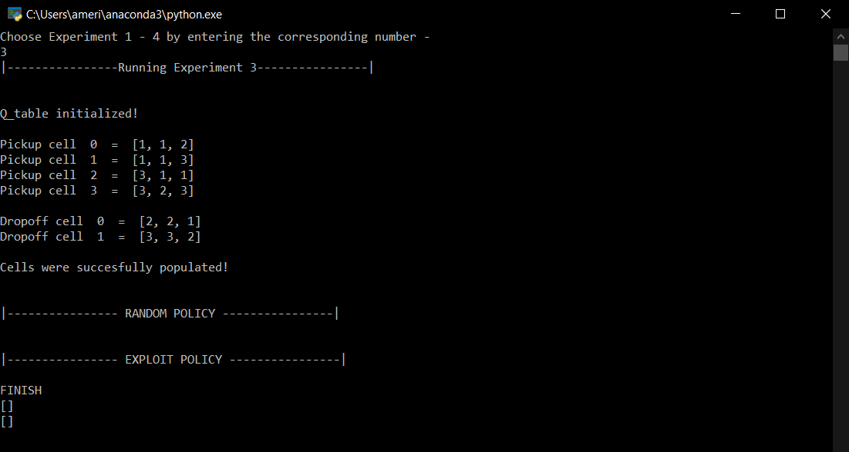

4:

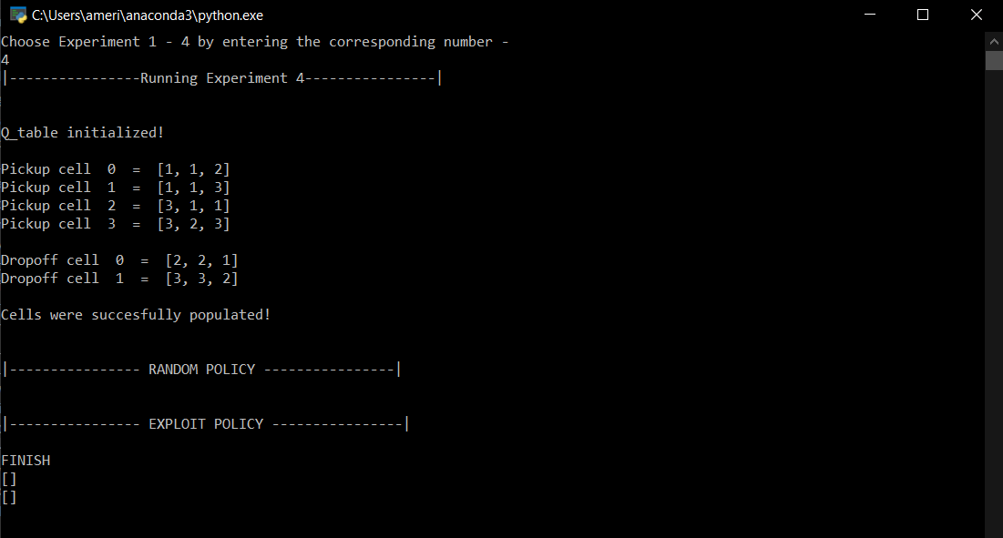

We are showing above the script results for each one of the experiments, obviously the code is not completed yet and needs more work. So far, we had been able to populate the create the agent, move the agent, record the position and populate the q-tables. As of now, the script cannot determine is agent is in dropoff location and therefore it does not reach a terminal state. We have a function for Q-learning, and a pseudocode for the SARSA, which is currently not giving any result. The initial idea was to use TKinter PhotoImage to implement the visualization, but unfortunately, we ran out of time.