

**ÇANAKKALE ONSEKİZ MART ÜNİVERSİTESİ**

**BİLGİSAYAR MÜHENDİSLİĞİ**

**Nesneye Dayalı Analiz ve Tasarım Dersi**

**Proje Adı:**

Lokanta Sipariş sistemi ( Restaurant Ordering System : ROSys )

**Rapor 4:**

System Sequence Diagrams; State Machine Diagrams; Operation Contracts

**Grup No:** 06

**Grup Adı:** Firestone

**Grup Üyeleri:**

**Amer Sawan (130401073)**

**Abdoul Karim Touré (130401078)**

**DANIŞMAN: Yrd. Doç. Dr. Ali Murat Tiryaki**

Çanakkale 2017

# **Use Case 1 : Placing order**

1. System Sequence Diagram

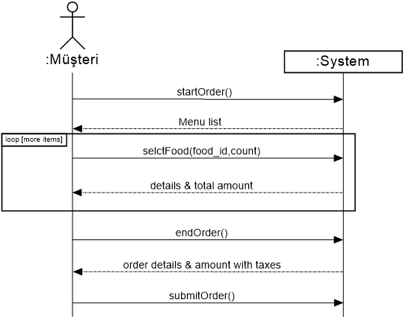

1. State Machine Diagram

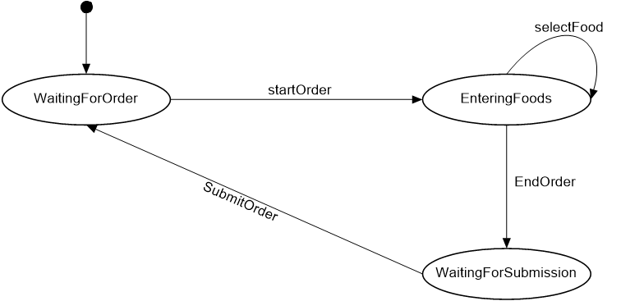

1. Operation Contracts

|  |  |
| --- | --- |
| Contract CO1: startOrder | |
| **Operation** | startOrder() |
| **Cross References** | Use Case : Placing order |
| **Preconditions** | none |
| **Postconditions** | * An Order instance was created with name (o). * (o) was associated with the currently logged in customer instance. |

|  |  |
| --- | --- |
| Contract CO2: selectFood | |
| **Operation** | selctFood(food_id, count) |
| **Cross References** | Use Case : Placing order |
| **Preconditions** | There is an order underway. |
| **Postconditions** | * A FoodLineItem instance was created with name (fli). * (fli) was associated with the current order. * (fli) was associated with Food, based on food_id match. * (fli.count) became count (which came from parameters) |

|  |  |
| --- | --- |
| Contract CO3: endOrder | |
| **Operation** | endOrder() |
| **Cross References** | Use Case : Placing order |
| **Preconditions** | There is an order underway. |
| **Postconditions** | * The current underway order item’s isCompleted attribute became true. |

|  |  |
| --- | --- |
| Contract CO4: submitOrder | |
| **Operation** | submitOrder () |
| **Cross References** | Use Case : Placing order |
| **Preconditions** | There is an order underway. |
| **Postconditions** | * The current underway order item’s isSubmitted attribute became true. |

**Use Case 2: Process Payment**

1. System Sequence Diagram

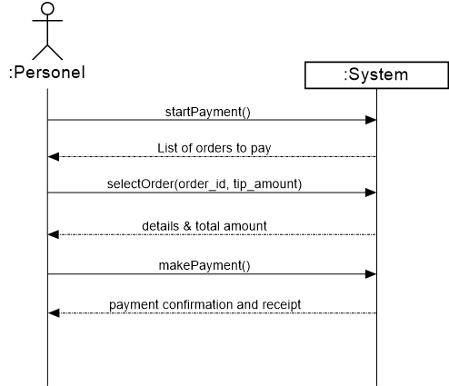

1. State Machine Diagram

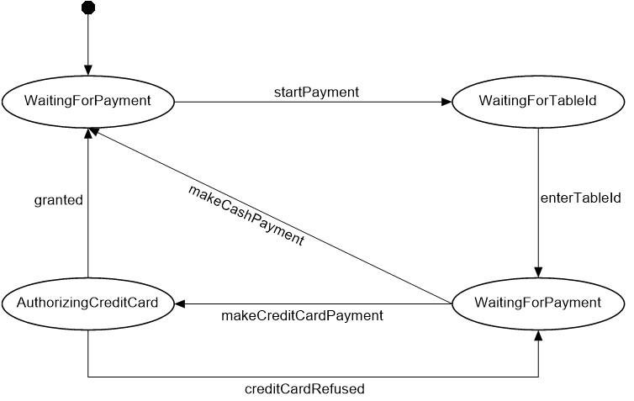

1. Operation Contracts

|  |  |
| --- | --- |
| Contract CO1: startPayment | |
| **Operation** | startPayment() |
| **Cross References** | Use Case : Process Payment |
| **Preconditions** | none |
| **Postconditions** | * A Payment instance was created with name (p). |

|  |  |
| --- | --- |
| Contract CO2: selectOrder | |
| **Operation** | selectOrder(order_id, tip_amount) |
| **Cross References** | Use Case : Process Payment |
| **Preconditions** | There is payment underway with name (p) |
| **Postconditions** | * The current payment was associated with order instance, based on order_id * p.tip_amount attribute became equals to tip_amount (parameter) |

|  |  |
| --- | --- |
| Contract CO3: makePayment | |
| **Operation** | makePayment() |
| **Cross References** | Use Case : Process Payment |
| **Preconditions** | There is payment underway with name (p) |
| **Postconditions** | * p.isCompleted became true * the current order attached to the payment p became associated with the Ledger instance. |

**Use Case 3** **Update Order Status to Ready**

1. System Sequence Diagram

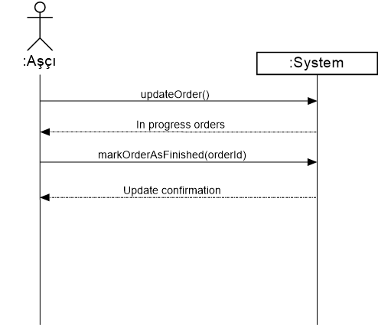

1. State Machine Diagram

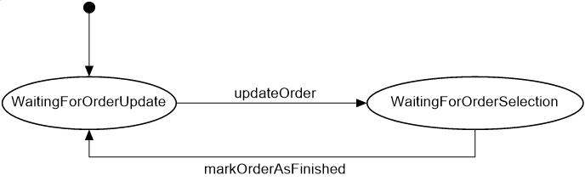

1. Operation Contracts

|  |  |
| --- | --- |
| Contract CO1: updateOrder | |
| **Operation** | makePayment() |
| **Cross References** | Use Case : Process Payment |
| **Preconditions** | None |
| **Postconditions** | None |

|  |  |
| --- | --- |
| Contract CO2: markOrderAsFinished | |
| **Operation** | markOrderAsFinished(orderId) |
| **Cross References** | Use Case : Process Payment |
| **Preconditions** | None |
| **Postconditions** | * The order instance (o) that has o.id equals to oderId is updated so o.Status became “Finished” |