

ÇANAKKALE ONSEKİZ MART ÜNİVERSİTESİ
BİLGİSAYAR MÜHENDİSLİĞİ
Nesneye Dayalı Analiz ve Tasarım Dersi

Proje Adı:
Lokanta Sipariş sistemi ( Restaurant Ordering System : ROSys )

Rapor 4:

System Sequence Diagrams; State Machine Diagrams; Operation Contracts

Grup No: 06
Grup Adı: Firestone

Grup Üyeleri:
Amer Sawan (130401073)

Abdoul Karim Touré (130401078)

DANIŞMAN: Yrd. Doç. Dr. Ali Murat Tiryaki

Çanakkale 2017

Use Case 1 : Placing order
- System Sequence Diagram
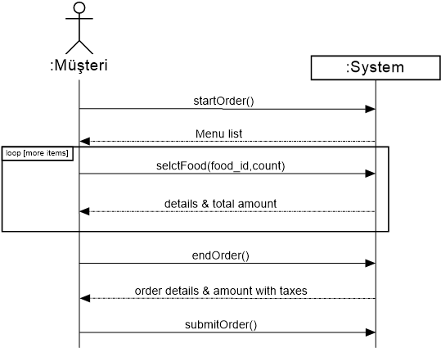

- State Machine Diagram

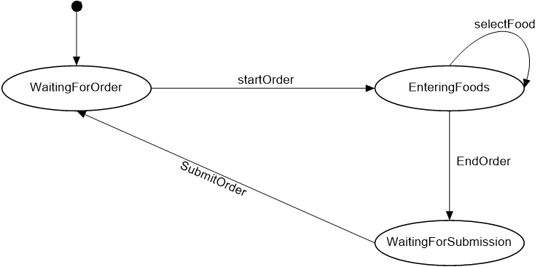

- Operation Contracts

Contract CO1: startOrder
Operation | startOrder()
Cross References | Use Case : Placing order
Preconditions | none
Postconditions | - An Order instance was created with name (o).  - (o) was associated with the currently logged in customer instance.

Contract CO2: selectFood
Operation | selctFood(food_id, count)
Cross References | Use Case : Placing order
Preconditions | There is an order underway.
Postconditions | - A FoodLineItem instance was created with name (fli).  - (fli) was associated with the current order.  - (fli) was associated with FoodDescription, based on food_id match.  - (fli.count) became count (which came from parameters)

Contract CO3: endOrder
Operation | endOrder()
Cross References | Use Case : Placing order
Preconditions | There is an order underway.
Postconditions | - The current underway order item’s isCompleted attribute became true.

Contract CO4: submitOrder
Operation | submitOrder ()
Cross References | Use Case : Placing order
Preconditions | There is an order underway.
Postconditions | - The current underway order item’s isSubmitted attribute became true.

Use Case 2: Process Payment
- System Sequence Diagram

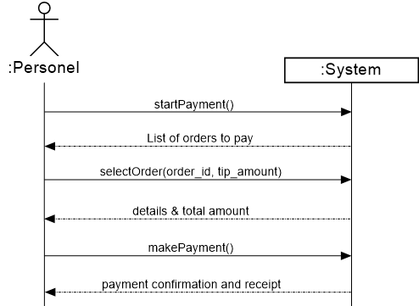

- State Machine Diagram

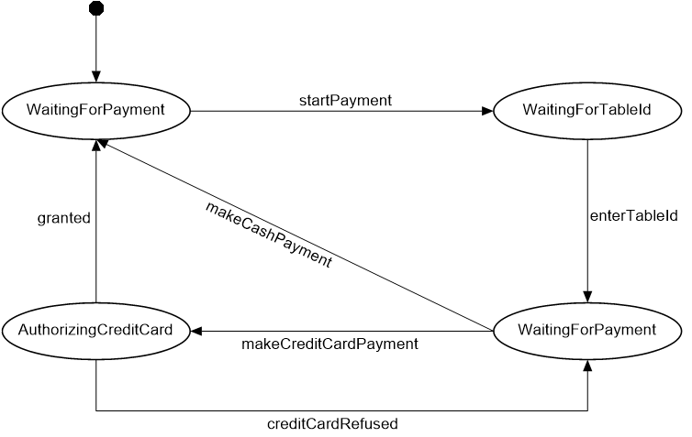

- Operation Contracts

Contract CO1: startPayment
Operation | startPayment()
Cross References | Use Case : Process Payment
Preconditions | none
Postconditions | - A Payment instance was created with name (p).

Contract CO2: selectOrder
Operation | selectOrder(order_id, tip_amount)
Cross References | Use Case : Process Payment
Preconditions | There is payment underway with name (p)
Postconditions | - The current payment was associated with order instance, based on order_id  - p.tip_amount attribute became equals to tip_amount (parameter)

Contract CO3: makePayment
Operation | makePayment()
Cross References | Use Case : Process Payment
Preconditions | There is payment underway with name (p)
Postconditions | - p.isCompleted became true  - the current order attached to the payment p became associated with the Ledger instance.

Use Case 3 Update Order Status to Ready
- System Sequence Diagram
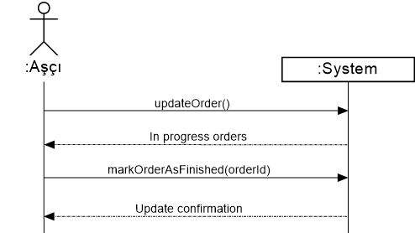

- State Machine Diagram

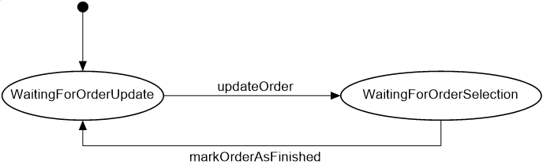
- Operation Contracts
Contract CO1: updateOrder
Operation | makePayment()
Cross References | Use Case : Process Payment
Preconditions | None
Postconditions | None

Contract CO2: markOrderAsFinished
Operation | markOrderAsFinished(orderId)
Cross References | Use Case : Process Payment
Preconditions | None
Postconditions | - The order instance (o) that has o.id equals to oderId is updated so o.Status became “Finished”

