Amer Sulieman

CSCI 4/5588

Programming Assignment #2

**Features Engineering:**

Since the features were given as 256 columns per sample, I extracted two main features. First feature is the Ratio of width/height. Second feature is number of shaded pixels from 3 different locations where the number was drawn.

Explain feature 1:

I look for first column that has shaded pixel and the first column from the other side that has shaded pixel. This gives me width start and width end. Subtracting width end minus width start will give me what is the width. Height, I do same steps as width but instead of columns, it is rows therefore I get the height.

Then I divide width/height to get the ratio.

NOTE: I also have the indexes where the number start and end. That is from width start and width end. As well as height start and end. These indices tell me where in the grid the number is drawn which will be needed for the next feature.

Explain feature 2:

Since I know where on the grid the letter is drawn. I pick three different rows from the area that the number is drawn. I pick height/2, height/4 and height/6. These give me the row for each of those divisions. I calculate the number of shaded pixels for each one of those rows and add them all up. This can give me an idea of what the number looks like in the middle.

**Layers and nodes:**

There were 4 different ANN.

1. Has 1 hidden layer with 20 nodes
2. Has 3 hidden layers each with 30 nodes
3. Has 5 hidden layers each with 50 nodes
4. Has 7 hidden layers each with 70 nodes

**Results:**

**MSE:**

Here The lowest MSE error for each number of layers ran per 2000 epoch

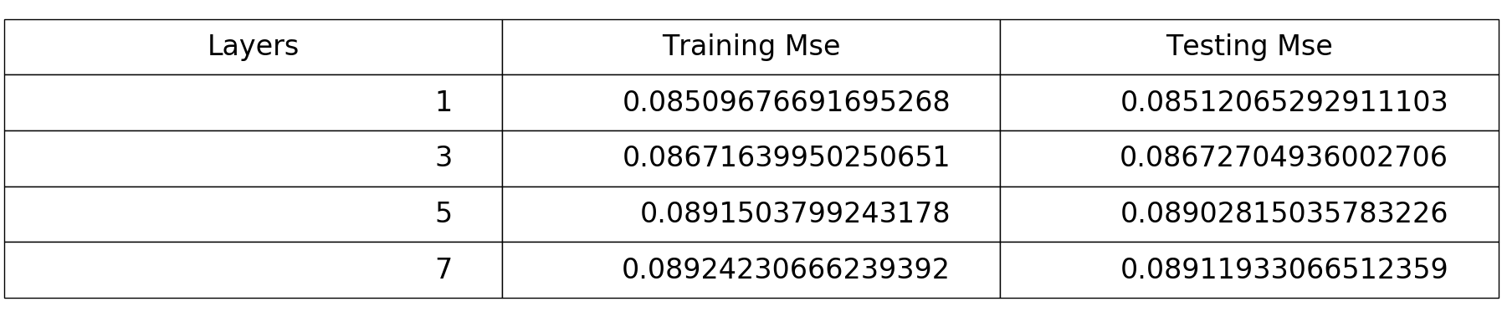

**Accuracy:**

**For number of layers 1:**

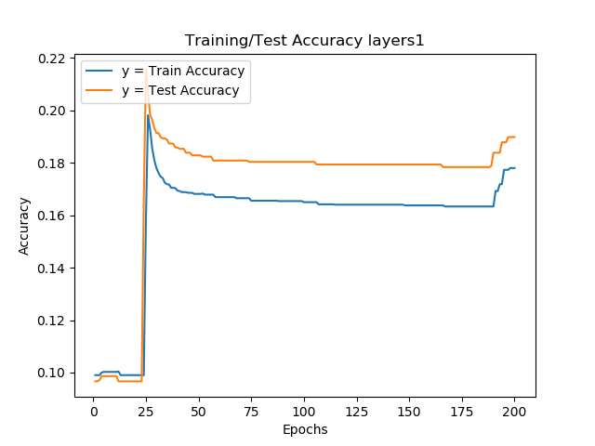

**For number of layers 3:**

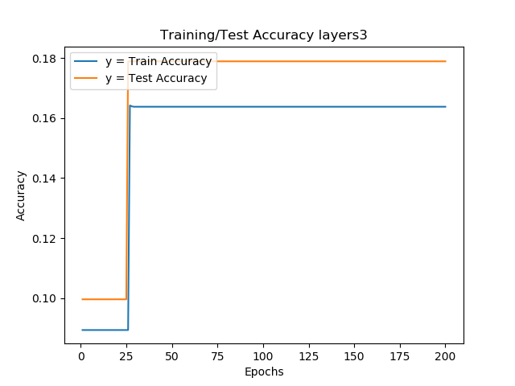

**For number of layers 5:**

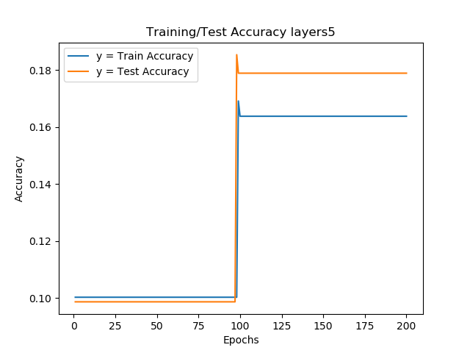

**For number of layers 7:**

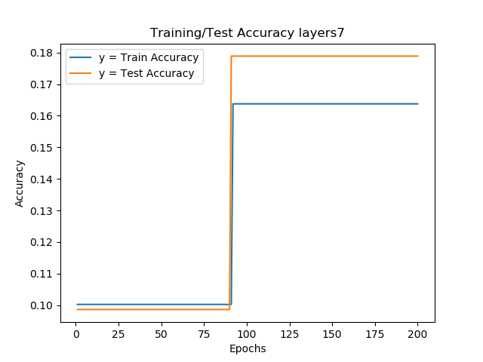

**MSE GRAPHS:**

**For number of layers 1:**

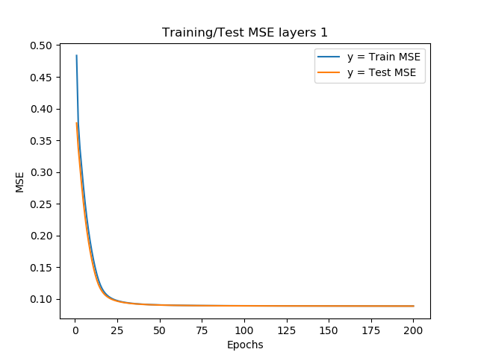

**For number of layers 3:**

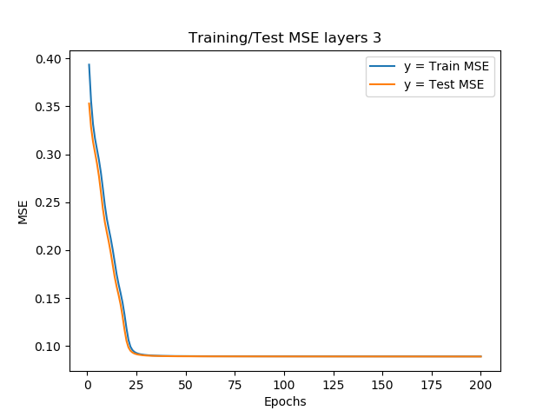

**For number of layers 5:**

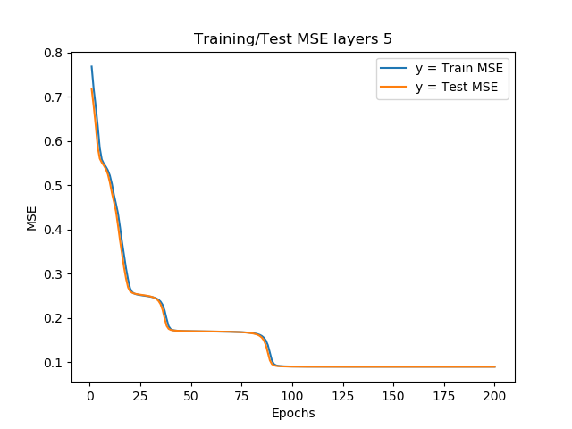

**For number of layers 7:**

