Worst-Case Selection of Targeted-Learning Estimators under Prespecified Data-Quality Threats: An Outcome-Blind Workflow
Andrew Mertens
2026-06-01
Table of contents

Abstract
Estimator selection in real-world evidence usually ranks candidate estimators by their error on the data as observed, which ignores how each candidate behaves when the data fall short of the assumptions the analysis relies on. We develop an outcome-blind procedure that selects among prespecified targeted-learning estimators by their worst-case performance across a declared set of data-quality threats, and we show that this worst-case rule can lock a different estimator from the rule that minimises error on undisturbed data. In a constructed demonstration with three propensity-score-truncation candidates and a prespecified threat sweep that includes a positivity violation as a first-class package threat, the baseline rule (min_rmse) selected the heavily truncated candidate and the worst-case rule (min_max_rmse) selected an intermediate candidate, with the two winners separated on worst-case root mean squared error by more than six times the combined Monte Carlo standard error. The demonstration establishes that such divergence occurs under realistic threats, and it does not claim the divergence is generic.
The procedure sits inside a staged, outcome-blind targeted-learning workflow for binary point-treatment studies, implemented in the R package cleanTMLE. The analyst defines the causal question, the observed data, the identification assumptions, the statistical estimand, and a set of candidate estimators, then compares the candidates on synthetic outcomes before inspecting the observed treatment-outcome association. The data-quality stress test extends this loop by scoring each candidate under prespecified threats on the same decision scale as the baseline plasmode. A fingerprinted analysis lock, an audit trail, and a decision log record the prespecification so that an external reviewer can reconstruct it.
Real-world evidence studies often require many analytic decisions before an effect estimate is produced: how to define the study population, how to handle limited overlap, which estimator to use, and how to assess whether the data are reliable enough for the question. In practice, these decisions are commonly documented in separate places. The causal question and target-trial design may be described in a protocol, data fitness may be assessed in a checklist, and estimator choice may be justified in a statistical analysis plan. This separation makes it difficult for reviewers to see how design assumptions, data limitations, and estimation choices are connected.
cleanTMLE is an R package for staged, outcome-blind targeted learning on binary point-treatment studies. Working inside the causal roadmap, the analyst first defines the causal question, observed data, identification assumptions, statistical estimand, and a set of candidate estimators, then uses outcome-blind simulation to compare those candidates before inspecting the observed treatment-outcome association. Outcome-blind here has a precise sense: the plasmode generator fits the marginal mean of the observed outcome given covariates, and the joint treatment-outcome association is never inspected before the pre-outcome decision. The package extends this loop with a plasmode data-quality stress test that generates synthetic outcomes from the empirical covariate and treatment structure and evaluates each candidate under prespecified threats, including covariate missingness, exposure misclassification, outcome misclassification, and unmeasured confounding.
In Monte Carlo experiments, adjusted estimators recovered the true risk difference under good overlap, and TMLE and cross-validated TMLE held bias small relative to the empirical standard deviation under marginal overlap. A supplementary variance comparison found that the matched-cohort TMLE paired-difference SE is anti-conservative under good overlap (95% CI coverage 0.89, Monte Carlo SE 0.03), because it ignores matching-draw variance, the variability from which controls are selected when data are re-sampled. The standard nonparametric bootstrap is not consistent for matching estimators (Abadie and Imbens 2008); a full-pipeline variant that re-runs matching on each resample raised coverage to 0.95 in this comparison, which we report as an empirical finding. The stabilised IPTW IF-SE is moderately conservative under marginal overlap (SE/SD ratio ≈ 1.23) because it treats the propensity score as known, and correcting this requires an M-estimator rather than resampling. select_variance_method() uses oracle coverage on plasmode-generated synthetic data to identify, for each estimator-scenario combination, which variance method achieves nominal coverage. When unmeasured confounding was introduced, all estimators were biased in the same direction, and the prespecified pre-outcome decision correctly returned STOP, illustrating that the workflow flags prespecified unmeasured-confounding scenarios under which the planned analysis would no longer meet the locked operating-characteristic thresholds. The data-quality stress test further showed that outcome misclassification and unmeasured confounding produced the largest degradation in estimator performance. In a constructed demonstration with a propensity-score-truncation candidate grid and a prespecified threat sweep that includes a positivity violation, the worst-case selection rule (min_max_rmse) selected a different candidate from the baseline rule (min_rmse), which shows that screening candidates against their worst case across data-quality threats can change which estimator is locked.
We illustrate the workflow on the Rescue.Co Kenya Trauma Registry (n = 1,693; 24.6 % outcome missingness). Six estimators agreed on direction, with risk differences from 0.026 to 0.037 favouring Rescue.Co transport; the prespecified primary TMLE interval crossed zero. cleanTMLE is the software layer of an outcome-blind staged workflow: it does not replace target-trial design, fit-for-purpose data review, validation studies, independent governance, or post-outcome sensitivity analyses. Its contribution is to turn prespecified targeted-learning decisions, outcome-blind estimator selection, and data-quality stress testing into a reproducible record an external reviewer can reconstruct.
Keywords: targeted maximum likelihood estimation, plasmode simulation, real-world evidence, fit-for-purpose data, outcome- blind analysis, R, statistical analysis plan, regulatory science.

1. Introduction

1.1 Prespecification and fit-for-purpose data in RWE
Outcome blinding and prespecification are governance tools, not substitutes for causal design. In a real-world evidence (RWE) study the analyst still has to define the target trial (M. A. Hernán and Robins 2016; Miguel A. Hernán and Robins 2016), specify a statistical estimand consistent with the ICH E9(R1) framework (International Council for Harmonisation 2019), justify identification from the available data, and defend the relevance and reliability of the data source for the regulatory or scientific question.
Regulatory bodies have converged on this list. The FDA RWE framework and its source-specific guidances cover real-world data and evidence (U.S. Food and Drug Administration 2018, 2024a), EHR and claims data (U.S. Food and Drug Administration 2024b), registries (U.S. Food and Drug Administration 2021), and non-interventional studies (U.S. Food and Drug Administration 2024c). The EMA materials add registry-based studies (European Medicines Agency 2021), a regulator-led RWE guide (European Medicines Agency 2024), and an RWD data-quality framework (European Medicines Agency 2026). ICH M14 (March 2026) sets harmonised principles for non-interventional studies that use real-world data for safety assessment of medicines (International Council for Harmonisation 2026).
Within this broader workflow, two arguments are typically developed in parallel but reported separately. The estimator-selection argument is checked with outcome-blind plasmode simulation (Franklin et al. 2014; Schuler and Rose 2017; Dang et al. 2023; Gruber, Lee, et al. 2024; Schreck et al. 2024). The fit-for-purpose argument is documented qualitatively through templates such as SPIFD2 (Gatto, Reynolds, and Campbell 2022; Gatto et al. 2023) or HARPER (Wang, Sreedhara, and Schneeweiss 2023) and through reporting tools such as TARGET (Cashin et al. 2024) and START-RWE (Wang et al. 2021).
These two arguments are connected: a candidate estimator that performs well on a simulation derived from real covariate and treatment distributions may still fail under realistic measurement error, missingness, or unmeasured confounding. The plasmode loop is under the analyst’s control, so it can be extended to ask not only “which candidate has the lowest RMSE under the locked data-generating process?” but also “which candidate maintains acceptable bias, RMSE, and coverage across the plausible range of each threat documented in the fit-for-purpose review?” We refer to this extension as a data-quality (DQ) stress test. It is a pre-outcome robustness screen rather than a substitute for variable validation or for post-unblinding sensitivity analysis. The workflow does not guarantee that estimator rankings under synthetic outcomes will generalise to the realised outcome process; the conclusions are only as credible as the synthetic-outcome model and the externally justified severity ranges entered into the DQ stress test.
We use “data-quality stress testing” in a restricted sense: the procedure does not assess data provenance, phenotype validity, linkage accuracy, representativeness, or regulatory acceptability, which remain study-level evaluations. Once investigators have specified plausible threats and severity ranges from external validation studies, data profiling, or expert elicitation, the package evaluates how candidate estimators behave under those prespecified perturbations before the observed treatment-outcome association is examined. The central contribution is a quantitative bridge between fit-for-purpose review and estimator selection. In a conventional workflow, data-fitness concerns are documented qualitatively, while estimator choice is justified separately through modeling preferences or diagnostics. cleanTMLE uses the same outcome-blind plasmode loop used for candidate selection to evaluate whether prespecified TMLE candidates remain acceptable under data-quality threats derived from the fit-for-purpose review.
In this manuscript, outcome-blind means that decisions about cohort construction, candidate estimators, simulation scenarios, decision thresholds, and primary-estimator selection are made without inspecting the observed treatment-outcome association. Analysts may use baseline covariates, treatment assignment, missingness indicators, and synthetic outcomes generated for plasmode simulations; the marginal mean of the observed outcome on covariates is also used internally to fit the plasmode generator. The observed treatment-outcome relationship is not used for estimator selection or design revision before the pre-outcome decision point.
Standard pre-outcome review often separates three activities: target-trial / protocol design, qualitative fit-for-purpose data review, and estimator selection. Standard plasmode simulation can compare estimators before outcome access, but it usually evaluates performance under one locked synthetic outcome mechanism. cleanTMLE extends that loop by stress-testing the selected estimator across prespecified data-quality threats derived from the fit-for-purpose review, creating a quantitative bridge between the qualitative data-fitness argument and the estimator-selection argument.

1.2 What the package adds, and what it does not
cleanTMLE is an R (R Core Team 2024) package that operationalises the estimator-selection and stress-testing steps of a staged analysis within the causal roadmap (Dang et al. 2023; Petersen and Laan 2014; Gruber, Lee, et al. 2024). Its two methodological contributions are an outcome-blind plasmode candidate selector and the data-quality stress test, which extends that selector to score each candidate against prespecified data-quality threats on the same bias, RMSE, and coverage scale (see Section 6 for the full DQ framework; Section 10 for evidence that the worst-case selection rule can change the locked estimator).
Around these statistical components the package adds an optional transparency layer: an analysis-lock object, a serialisable audit trail and decision log in the sense of Muntner et al. (2024), and a pre-outcome decision rule that applies the three review-team recommendations (GO, FLAG, STOP) by withholding primary-analysis functions until the prespecified checkpoints are recorded. This software arrangement sits inside, rather than substitutes for, the personnel-based governance a clean room requires, such as role separation and independent review (Section 13). Section 2 situates the package inside the causal roadmap.
The scope of this paper is binary point-treatment studies with a marginal risk-difference estimand; limitations on estimand coverage are listed in Section 13. This paper documents version 0.1.5 of the package; case-study estimates in Section 12 were produced under 0.1.1 and are numerically unchanged under the backward-compatible 0.1.5 API.

1.3 What the paper contributes
The contribution is a single, prespecified, outcome-blind procedure that ties qualitative fit-for-purpose threats to quantitative estimator selection on one decision scale, together with a reproducible software implementation. We extend the outcome-blind plasmode loop (Dang et al. 2023; Gruber, Lee, et al. 2024; Schreck et al. 2024) from candidate-estimator selection to estimator robustness screening under prespecified threat ranges, and we characterise the screen’s operating characteristics as a decision rule (Section 11).
FIORD (Nance et al. 2026; Kent 2026) supplies the outcome-blind candidate-evaluation loop and the two-stage selector. This paper contributes the software implementation of that loop, the data-quality stress-test extension, and the lock, audit, and pre-outcome-decision record. We hold to this division of labour throughout.
The screen is a quantitative supplement to fit-for-purpose review (Section 7); what passing it does and does not establish is stated in Section 7.4. The implementation records the SHA-256-fingerprinted analysis lock, the audit trail, the decision log, and the pre-outcome decision, so the screen and the locked primary analysis share a single reproducible record.
For an applied real-world evidence team the operational payoff is concrete. Prespecifying the estimand, the candidate estimators, the learner libraries, and the decision thresholds inside a fingerprinted lock, and recording every pre-outcome diagnostic in an exportable audit trail, gives a reviewer a record that can be reconstructed without relying on the analyst’s recollection of which choice was made when. This addresses a recurring concern in real-world evidence submissions, that analytic choices may have been shaped by the observed treatment-outcome association (Muntner et al. 2024). The same record reduces post-hoc disputes over truncation, learner library, and cohort decisions, because each is timestamped before the outcome is read. The cost is the discipline of fixing these choices in advance and the compute time of the plasmode and data-quality runs, both of which fit inside a conventional statistical-analysis-plan timeline.
The practical consequence is visible when the same fitted estimators are read under a conventional pipeline and under the staged workflow (Table 5). Under good overlap the two agree. Under marginal overlap the workflow flags the IPTW variance calibration before unblinding, where the conventional pipeline relies on a reviewer to notice it. Under unmeasured confounding of a prespecified strength the staged decision rule returns STOP and the locked primary analysis does not run, whereas the conventional pipeline reports a biased non-null estimate (mean bias 0.007) that would be published. The fits are identical under both pipelines; the difference is the prespecified decision applied before the outcome is read.

1.4 Why targeted learning for an outcome-blind workflow
An outcome-blind workflow fixes the estimator before the treatment-outcome association is read, so the estimator must have a target that is declared in advance and that does not depend on how the nuisance models are fit. Targeted maximum likelihood estimation has this structure. The target parameter, here the marginal risk difference, is specified before estimation, and the propensity-score and outcome models are nuisance fits that can be learned by flexible, data-adaptive methods without changing the target. The targeting step then removes the plug-in bias of the initial outcome fit using the propensity score, so the bias of the final estimator does not depend on the quality of any single nuisance model in the way a plug-in or single-model estimator does. The candidate estimators are enumerable, which is what makes outcome-blind selection among them feasible: each candidate is a fixed choice of nuisance libraries, truncation, and cross-fitting, and the candidates can be ranked on synthetic data before the outcome is unblinded. A logistic outcome regression or an inverse-probability weight does not separate the target from the model in this way, which is why the workflow is built on targeted learning.
The next section (Section 2) places these contributions inside the causal roadmap, and subsequent sections follow that roadmap order.

2. The causal roadmap and the role of cleanTMLE
cleanTMLE is designed to encourage the analyst to follow the causal roadmap of Petersen and Laan (2014) and Dang et al. (2023) when defining and executing the analysis. The roadmap sets out an explicit, prespecified sequence of seven steps: (1) state the causal question, causal model, and causal estimand; (2) characterise the observed data and their fitness for the target trial; (3) assess identifiability; (4) define the statistical estimand; (5) choose a statistical model and estimator with prespecified operating characteristics, using outcome-blind simulation and targeted learning; (6) specify a procedure for sensitivity analysis to violations of the identification assumptions; and (7) compare alternative study designs, again using outcome-blind simulation (Dang et al. 2023). The package applies this roadmap to a staged analysis in the sense of Muntner et al. (2024). It operationalises Step 5 through outcome-blind plasmode estimator selection and TMLE estimators, contributes the data-quality stress test as an extension of Steps 5 and 7, and records the Step 6 sensitivity analyses. Steps 1 to 4 remain external study-level work, supported by target-trial templates (M. A. Hernán and Robins 2016; Cashin et al. 2024), fit-for-purpose checklists (Gatto et al. 2023; Wang, Sreedhara, and Schneeweiss 2023), and source-specific data-relevance and reliability assessments (U.S. Food and Drug Administration 2024a, 2024b, 2021; European Medicines Agency 2024, 2026).
The manuscript uses a fixed vocabulary for the conceptual layers of the workflow (defined in Table 8, Appendix). Figure 9 places the package inside the roadmap and Figure 10 situates it within the broader governance stack. Table 9 maps each roadmap component to regulatory expectations and to what still requires external study-level work; Table 10 lists the event-process helpers.
The remaining sections follow the roadmap order: Section 4 states the estimand and identification assumptions; Section 5 describes the lock, audit, and pre-outcome-decision functions; Section 6 introduces the DQ stress test; Section 7 frames it as a supplement to fit-for-purpose review; Section 8–Section 12 report the implementation, simulation, and case study; and Section 13 covers limitations.

3. cleanTMLE at a glance: a worked walkthrough
Before developing the estimand, the framework, and the stress test formally, we show the package used end-to-end, so that later sections can be read against a concrete sequence of calls and outputs. The walkthrough follows the Rescue.Co case study of Section 12; here we keep the code schematic and report representative output, and defer the full results to that section. Each call produces a record that the audit trail carries forward, and the outcome column stays masked until the gate authorises Stage 4.
library(cleanTMLE)
# Stage 1a: lock the analytic specification and attach the estimand.
lock <- create_analysis_lock(
data = rescueco, treatment = "rescueco", outcome = "gose_good",
covariates = baseline_covariates,
sl_library = c("SL.glm", "SL.glmnet", "SL.gam"), seed = 2026)
lock <- attach_estimand(lock, contrast = "risk_difference",
followup = "6 months")
audit <- create_audit_log(lock)
#> lock_hash: 9f2c1a... (SHA-256 fingerprint of columns + data shape)
# Stage 1b: cohort adequacy (events only; outcome still masked).
cp1 <- checkpoint_cohort_adequacy(lock, min_n_per_arm = 200, min_events = 50)
#> PASS: 1,013 vs 680 per arm; 1,277 with observed GOSE
# Stage 2a: propensity score, overlap, balance.
ps <- fit_ps_superlearner(lock)
cp2 <- checkpoint_balance(compute_ps_diagnostics(ps), max_smd = 0.10)
#> PASS: PS in [0.21, 0.81]; max post-weighting SMD 0.07; ESS 78% of n
# Stage 2b + 2c: outcome-blind candidate selection and DQ stress test.
cands <- list(tmle_candidate("glm_t01", truncation = 0.01),
tmle_candidate("ensemble_t05", truncation = 0.05))
plas <- run_plasmode_feasibility(lock, tmle_candidates = cands, reps = 50)
dq <- run_plasmode_dq_stress(lock, tmle_candidates = cands,
scenarios = default_dq_scenarios())
sel <- select_tmle_candidate(plas, rule = "min_max_rmse", dq_results = dq)
#> Selected candidate: 'ensemble_t05' (min-max RMSE across DQ threats)
# Stage 3: negative-control outcomes.
nc <- run_residual_confounding_stage(lock,
negative_controls = c("household_urban", "fuel_wood"))
#> 2 of 5 NCs fit (3 dropped by near-zero-variance filter); both near null
# Pre-outcome decision and authorisation.
gate <- gate_all(cp1, cp2, nc, allow_flag = TRUE)
auth <- authorize_outcome_analysis(lock, gate)
#> Decision: GO with FLAG (narrowed negative-control panel)
# Stage 4: unblind and run the locked primary analysis.
fit <- run_clean_tmle(lock, spec = sel, ps_fit = ps, authorization = auth)
#> Risk difference 0.031 (95% CI -0.001, 0.062)
Table 1 summarises the functions exercised above, what each one does, and the representative output it returns. Functions in the first block run while the outcome is masked; only run_clean_tmle() (and its IPCW and concordance siblings) read the observed outcome, and they do so only on a lock carrying a valid authorisation.
Table 1: Key cleanTMLE functions exercised in the worked walkthrough, with a concise description and representative output. Stages 1a-3 and the gate run while the outcome is masked; Stage-4 functions read the observed outcome only under a valid authorisation.
Stage | Function | What it does | Representative output
1a | create_analysis_lock() | Build the analysis lock; SHA-256 fingerprint of columns and data shape; mask the outcome. | lock object; lock_hash = 9f2c1a…
1a | attach_estimand() | Record the five estimand attributes on the lock (kept in the audit trail, not the fingerprint). | lock with estimand fields populated
1b | checkpoint_cohort_adequacy() | Check minimum sample size and event count per arm; reads event counts only. | PASS / FLAG / STOP + counts (1,013 vs 680; 50+ events)
2a | fit_ps_superlearner() | Fit the SuperLearner propensity score on baseline covariates. | ps_fit object; predicted scores in [0.21, 0.81]
2a | checkpoint_balance() | Score post-weighting balance against a maximum-SMD threshold. | PASS; max SMD 0.07 (threshold 0.10)
2b | run_plasmode_feasibility() | Run the outcome-blind plasmode loop to evaluate candidate estimators on synthetic outcomes. | per-candidate bias, RMSE, coverage table
2c | run_plasmode_dq_stress() | Re-run the plasmode loop under prespecified data-quality threats; produce degradation gradients. | degradation gradient per candidate per threat
2c | select_tmle_candidate() | Apply the selection rule (e.g. min-max RMSE, or fiord_two_stage) and lock the primary candidate. | selected candidate id (‘ensemble_t05’)
3 | run_residual_confounding_stage() | Estimate effects on prespecified negative-control outcomes to probe residual confounding. | per-NC estimate and CI; both near null
gate | gate_all() | Aggregate checkpoint records into a single pre-outcome decision. | GO / FLAG / STOP with rationale
gate | authorize_outcome_analysis() | Record authorisation so Stage-4 functions will read the outcome. | authorisation token attached to the lock
4 | run_clean_tmle() | Run the locked four-step TMLE primary analysis; refuses to run without authorisation. | RD 0.031 (95% CI -0.001, 0.062)
4 | run_ipcw_tmle() | TMLE with inverse-probability-of-censoring weights for outcome missingness. | IPCW-weighted RD 0.033 (95% CI -0.000, 0.066)
report | export_decision_log() | Export the audit trail and decision log as a tidy data frame for the reviewer. | tidy data frame of decisions, timestamps, rationales

4. Estimand, Causal Model, and Identifiability

4.1 Estimand specification
We follow International Council for Harmonisation (2019) and Dang et al. (2023) by writing the estimand along five attributes. For the running example the population is adults eligible at the index visit. The treatment is a binary point exposure $A∈\{0,1\}$ at index. The endpoint is a binary indicator of the primary event by 24 months, denoted $Y$. The summary measure is the marginal counterfactual risk difference $Ψ=E\{Y\left(1\right)\}−E\{Y\left(0\right)\}$. Intercurrent events are handled under a treatment-policy strategy; censoring and treatment switching are not modelled in this illustration. The corresponding statistical estimand under the identification assumptions in Section 4.4 is $Ψ=E_{W}\{E\left[Y∣A=1,W\right]−E\left[Y∣A=0,W\right]\}$, the marginal g-formula contrast (J. Robins 1986; Miguel A. Hernán and Robins 2020).
In the package this specification is attached to the lock with attach_estimand() at Stage 1a and is preserved on the lock object that downstream stages consume. The estimand fields are not part of the integrity fingerprint computed by create_analysis_lock(); analysts who want a tamper-evident estimand record should pair attach_estimand() with a record_decision_log_entry() call so that any later modification is visible in the exported decision log.

4.2 Causal model
The data-generating process has five baseline covariates $W=\left(\text{age},\text{sex},\text{biomarker},\text{comorbidity},\text{CKD}\right)$, a binary treatment $A$ that depends on $W$, and a binary outcome $Y$ at 24 months. In the unmeasured-confounding scenario a binary $U∼\text{Bern}\left(p_{U}\right)$ also affects both $A$ and $Y$. The DAG is
W ───► A ──► Y
│ ▲
└──────────┘
(Scenario C only:)
U ──► A
U ──► Y
with no arrow from $A$ to $W$ (point exposure) and no arrow between $W$ and $U$.

4.3 Event-process classification
A recurring source of ambiguity in real-world evidence analyses is the treatment of post-baseline events such as treatment discontinuation, treatment switching, death, loss to follow-up, administrative end of follow-up, and missing outcome measurement. These events should not be assigned generically to censoring or exclusion rules. Instead, each event should be mapped to its role in the causal estimand, its corresponding ICH E9(R1) intercurrent-event strategy when applicable, and its operational role in estimation. For example, death may be an outcome, a competing event, a component of a composite endpoint, or an intercurrent event requiring a treatment-policy, hypothetical, composite, while-on-treatment, or principal-stratum strategy, depending on the clinical question. This classification should be prespecified and linked to sensitivity analyses; the package provides clean_event_process_table() to record it as a structured object that the audit log can carry.

4.4 Identifiability assumptions
Under this DAG, $Ψ$ is identified by the g-formula if the following six assumptions hold (Miguel A. Hernán and Robins 2020). We list each assumption together with the DQ stress-test scenario that probes it; this mapping is one of the main reasons the DQ stress test is useful.
- Conditional exchangeability, $Y\left(a\right)⊥​​​⊥A∣W$. This holds in scenarios A and B by construction. It is violated by construction in scenario C, where $U$ is not in the analyst’s adjustment set. Probed by: the unmeasured-confounding scenario in run_plasmode_dq_stress().
- Positivity, $0<Pr\left(A=1∣W\right)<1$ for every $W$ in the support. Scenario A satisfies this comfortably. Scenario B pushes the propensity toward the boundary but does not violate it in the limit. Probed by: the truncation level of each TMLE candidate; near-positivity violations show up as inflated SE/SD in the baseline plasmode metrics.
- Consistency / SUTVA, $Y=Y\left(A\right)$. Probed by: the treatment- misclassification scenario, which simulates a violation of consistency caused by exposure-algorithm error.
- No measurement error in the outcome, $\tilde{Y}=Y$. Probed by: the outcome-misclassification scenario, with optional per-arm differential misclassification.
- Stratified MCAR for the covariates, $W$ is missing completely at random within strata of fully measured variables. Probed by: the covariate-missingness scenario, which sets a fraction of values to NA and imputes with the column median.
- Correctly specified nuisance models for $g\left(W\right)$ and $E\left[Y∣A,W\right]$, including the SuperLearner library and the truncation rule. Probed by: the standard plasmode candidate-selection metrics, which compare candidates that vary the SuperLearner library and the truncation rule.
The simulation thus contains one analytic challenge (marginal overlap, B) and one identifiability violation (unmeasured confounding, C). We use C to demonstrate what the DQ stress test flags under a prespecified latent-U scenario, and to contrast the stress-test output with the post-hoc E-value (VanderWeele and Ding 2017) and with the negative-control-outcome check (Lipsitch, Tchetgen Tchetgen, and Cohen 2010).

5. The cleanTMLE Framework

5.1 Staged workflow
cleanTMLE adopts the staged design set out by Muntner et al. (2024) and aligns it with the causal-roadmap formulation of Dang et al. (2023) and the targeted-learning statistical-analysis-plan template of Gruber, Lee, et al. (2024). Stage names below are package-internal labels; the stage content matches the roadmap steps of Dang et al. (2023).
Stage | Purpose | Does the function read the outcome?
0 | Feasibility assessment, utilisation study, draft protocol/SAP (Muntner et al. 2024; Kent 2026) | No (no data access yet)
1a | Lock estimand, covariates, SuperLearner library, candidate grid | No
1b | Cohort adequacy: $N$ per arm, events, design precision | Events only
2a | Propensity-score diagnostics: overlap, ESS, balance | No
2b | Outcome-blind plasmode candidate selection | No (synthetic outcome)
2c | Plasmode DQ stress test | No (synthetic outcome)
3 | Negative-control outcomes, residual-bias check | NC outcomes only
Pre-outcome decision | GO/FLAG/STOP authorisation | No
4 | Primary comparative analysis | Yes
Stages 1–3 do not access the real outcome. The plasmode at Stage 2b generates synthetic outcomes from a parametric model fitted to the real covariates and treatment, which is why it is a natural host for the DQ stress test we describe in Section 6.
Within a staging-and-clean-room framework, the DQ stress test functions as a quantitative checkpoint. Rather than relying only on qualitative discussion of data-fitness concerns, the workflow evaluates whether candidate estimators continue to satisfy prespecified operating-characteristic thresholds under threat scenarios derived from the fit-for-purpose review.
Clean-room guidance addresses a limitation of preregistration: during RWE execution, investigators often encounter data incompleteness, coding limitations, sparse events, covariate imbalance, model-convergence problems, and censoring or missingness issues that require decisions after data access but before comparative effect estimation (McGrath et al. 2021; Muntner et al. 2024). cleanTMLE operationalises the software portion of this process by recording pre-outcome diagnostics, checkpoint decisions, deviations, and authorisation status before the observed primary treatment-outcome association is estimated.

5.2 How the workflow records and protects analytic decisions
The analysis lock is the central object on which all later diagnostics depend. It is created at the start of the workflow and records the prespecified analytic specification: the analytic dataset, the treatment, outcome, and covariate column names, the nuisance-learning library, and the random seed. A fingerprint of those fields is recorded so that the same lock can be reconciled later by an external reviewer; the estimand and the prespecified choice of estimator are attached after the lock is created and are captured by the audit trail rather than by the fingerprint, so any change to those fields appears as a separate entry in the audit. While the analysis is outcome-blind, the lock is held in a state in which the outcome column is masked; the workflow restores the outcome only after the prespecified diagnostics and checkpoint review have been completed. Outcome-analysis functions verify that this review has been completed before allowing access to the observed outcome.
Two complementary records track analytic decisions through the workflow. The audit trail accumulates entries automatically from the checkpoint diagnostics, recording what was evaluated, when, and against which prespecified criteria. The decision log captures analyst choices and any deviations from the protocol, with a brief rationale for each. Both can be exported as tidy data frames and archived alongside the lock; the audit trail is linked to the prespecified analysis object, so deviations from the recorded workflow can be detected during review. The exported decision log follows the structure of the Romiplostim worked example (McGrath et al. 2021), which Muntner et al. (2024) take as the reference template for a staged outcome-blind decision record.
Beyond a single outcome-masking step, Muntner et al. (2024) and Kent (2026) recommend tiered, role-based access in which analytic advisors see summary outputs by stage and checkpoint reviewers see summary outputs only by checkpoint. The exported audit and decision logs support that arrangement at the workflow level, providing reviewer-facing summaries that do not require raw-data access.

5.3 Personnel-based and simulation-based outcome blinding
Outcome blinding can be enforced in two complementary ways. The first is personnel-based (Muntner et al. 2024). A blinded analyst writes the analysis plan, defines the cohort, performs the design diagnostics, and reaches the pre-outcome decision point; only then does a separate analyst, or another role on the same team, link the outcome and run the comparative analysis. Separation is maintained by an institutional partition of duties and a documented audit by a data manager who controls access to the outcome variable. Reviewers and regulators evaluate two artefacts at the end: a timestamped analysis plan and a final estimate produced under that plan.
Outcome-blind simulation addresses the same concern through a different mechanism. Candidate estimators, truncation rules, and data-quality scenarios may be evaluated using synthetic outcomes generated without using the observed treatment–outcome association. This allows investigators to compare estimators and revise prespecified simulation settings before unblinding while preserving separation from the observed comparative effect. The software-mediated workflow restricts outcome analysis until prespecified review steps have been completed. It supplements personnel-based governance rather than substituting for it. The audit and decision logs give reviewers transparent documentation of every analytic decision alongside the institutional record that already exists.
The two arrangements address the same underlying concern, that analytic decisions made after seeing the treatment–outcome association are not credible, but they differ in their residual risks. Personnel-based blinding requires an institutional commitment to the partition of duties and tolerates ad-hoc deviation by the blinded analyst, since the only ground truth is the timestamped plan. Simulation-based blinding reduces the personnel constraint but introduces a different residual risk: the investigator must defend the assumption that the synthetic-outcome mechanism is faithful enough to the real data-generating process that estimator selection on simulations generalises to the realised data. A defensible RWE pipeline can apply the simulation-based workflow inside an institutional partition of duties.

5.3.1 Personnel-based and simulation-mediated protections compared
Personnel-based clean rooms protect against outcome-driven protocol drift through role separation, staged access, and audit of who can see what at each stage. Simulation-mediated blinding supports prespecified estimator selection and stress testing using synthetic outcomes generated from the empirical covariate and treatment structure. The two arrangements target overlapping but distinct residual risks: personnel-based workflows do not by themselves quantify estimator fragility under data-quality threats, while simulation-mediated workflows depend on the fidelity of the synthetic-outcome mechanism. High-stakes studies should consider using cleanTMLE inside a personnel-based clean-room arrangement so that institutional outcome separation and quantitative robustness screening apply together.

5.3.2 Methodological tradeoffs
Compared with personnel-mediated outcome blinding, the simulation-mediated approach has the following tradeoffs.
In favour: a single statistician can produce a documented prespecification without a separate unblinded role, with the caveat that submission-grade studies should retain a personnel partition; the prespecified set of candidate estimators, the truncation thresholds, and the decision thresholds can be revised after viewing simulation results because those results use synthetic outcomes, so the analytic plan need not be re-frozen each time a tuning choice is reconsidered; the design records support transparent reconstruction of every prespecified decision by an external reviewer; and the same simulation loop that selects the candidate can be used to evaluate its robustness to prespecified data-quality threats, an evaluation that has no direct counterpart in personnel-based blinding, where data fitness is documented qualitatively.
Against: the plasmode generator uses the realised outcome $Y$ to fit a covariate-only mean model, so the analyst learns the marginal distribution of $Y$ given $W$, although not the joint $\left(A,Y\right)∣W$ relationship. The Dang causal-roadmap reading of outcome-blind permits this; a stricter reading of outcome blinding would require $E\left[Y∣W\right]$ to come from external pilot data (Dang et al. 2023, 7), and the package supports both modes, recording which mode was used. The synthetic outcome is generated from a parametric model with a fixed risk difference, so effect modification is not represented; a richer data-generating process is possible but is not exercised here. Finally, when the analyst also writes the plasmode and stress-test specifications, there is no independent check that the synthetic-outcome mechanism is faithful, whereas the personnel-based arrangement provides an additional layer of cross-validation through the data manager.
We document these trade-offs explicitly in the package’s documentation so that the analyst can choose the level of formality the study requires. For exploratory or lower-stakes RWE studies, the software-only workflow may be adequate to document and audit outcome-blind estimator selection. For high-stakes regulatory or confirmatory studies, cleanTMLE should be embedded within personnel-based outcome-blinding and access-control arrangements.

5.4 Reviewer-facing pre-outcome study dossier
The pre-outcome study dossier is a structured bundle the review team can read before authorising the primary analysis. It consists of:
Component | cleanTMLE artefact | Outcome access
Protocol and target-trial timing | attach_estimand() + target-trial timing table | No Y
Cohort flow / attrition | attrition_table() | No Y
Event-process classification | clean_event_process_table(), clean_check_event_processes() | No Y
Covariate and missingness summary | make_table1(), missingness-pattern checks | No Y
PS overlap and balance | compute_ps_diagnostics(), love_plot(), love_plot_threeway() | No Y
Treatment- and IPCW-weight diagnostics | clean_weight_diagnostics(), extreme_weights() | No Y
Event-count and precision adequacy | checkpoint_cohort_adequacy(), estimate_design_precision() | Marginal Y only
Baseline plasmode candidate selection | run_plasmode_feasibility(), select_tmle_candidate() | Synthetic Y only
DQ stress-test results | run_plasmode_dq_stress(), summarize_dq_degradation() | Synthetic Y only
Negative-control eligibility and attrition | run_residual_confounding_stage(), NC attrition diagram | Negative-control Y only
Staged checkpoint dashboard | gate_all() composite + per-checkpoint records | No Y
Decision log and audit log export | export_decision_log(), save_decision_log() | No Y
Authorisation record for primary analysis | authorize_outcome_analysis() | No Y
The dossier is the artefact the reviewer reads. Comparative treatment-outcome estimates are not part of the dossier and are produced only after authorisation.

6. Data Quality as a Quantifiable Threat
The outcome-blind plasmode loop on which the DQ stress test is built follows the guidance of Nance et al. (2026). cleanTMLE’s default plasmode uses the empirical $\left(W,A\right)$ structure with a covariate-only outcome model, never the joint $\left(A,Y\right)∣W$ relationship, placing it in the hybrid middle of the FIORD data-generating-process spectrum. The DQ stress test extends this by adding a prespecified perturbation step on top of the same hybrid generator.

6.1 Why plasmode DQ stress testing adds information beyond standard pre-outcome diagnostics
Four pre-outcome tools answer four different questions and are complementary rather than substitutable. (i) Propensity-score diagnostics (Austin 2009) assess empirical comparability, overlap, and weight stability, indicating whether the design is feasible under the observed covariate and treatment distributions; they do not estimate the operating characteristics of a candidate estimator. Balance is conventionally summarised with standardised mean differences, but univariate SMDs compare only the marginal means of each covariate and can be satisfied while variances, higher moments, or covariate interactions remain imbalanced, so distributional and interaction diagnostics are needed alongside them after matching or weighting (Austin 2009; Zhang et al. 2019). (ii) Baseline plasmode simulation evaluates candidate-estimator operating characteristics (bias, RMSE, coverage) under a single locked synthetic outcome model conditional on the empirical $\left(W,A\right)$ structure. (iii) Negative-control analyses probe residual bias for selected control outcomes against a different data-generating channel altogether; they do not directly evaluate how the primary estimator behaves under prespecified measurement error, missingness, or unmeasured-confounding scenarios. (iv) The DQ stress test asks whether the locked estimator-selection decision is stable under prespecified fit-for-purpose threats translated into quantitative perturbations of the baseline plasmode, before the primary treatment-outcome association is inspected. A STOP under a stress scenario should be read as evidence that the study requires redesign, external validation, additional sensitivity analysis, or narrower causal claims before outcome access.
The precise scope of what a passing screen establishes, and what remains an external study-level argument, is stated in Section 7.4.

6.2 Mapping data-quality concerns to plasmode parameters
SPIFD2 (Gatto et al. 2023) does not list a fixed taxonomy of “data-quality dimensions”; it is a stepwise template that asks the analyst to record each design element of the hypothetical target trial and the data feature that operationalises it. The harmonised data-quality terminology of Kahn et al. (2016), by contrast, defines three dimensions (conformance, completeness, plausibility) that have become standard in OHDSI-style assessments. We map both SPIFD2 design-element categories and the Kahn et al. (2016) dimensions to plasmode parameters as follows.
Table 1: Mapping data-quality concerns to plasmode-parameter inputs of run_plasmode_dq_stress().
SPIFD2 / Kahn category | Plasmode parameter | Source of plausible range | Decision criterion (default)
Covariate measurement / availability (Kahn: completeness) | Fraction of MCAR missingness, pi | Data profiling, linked validation studies | RMSE ratio > 1.5 at observed missingness rate
Treatment exposure definition (Kahn: conformance) | (sens, spec) of treatment ascertainment | Chart review, claims-validation literature | |Bias| > target at plausible (sens, spec)
Outcome ascertainment (Kahn: conformance + plausibility) | (sens, spec) of outcome ascertainment, optionally by arm | Algorithm validation, PPV / sensitivity studies | |Bias| > target at plausible (sens, spec)
Unmeasured confounding (SPIFD2 sensitivity step) | Latent U with prevalence p_U and (OR_A, OR_Y) | Expert elicitation, literature, E-value bounds | |Bias| > target at plausible U strength
Sample-size adequacy (SPIFD2 step 2) | Tested by base plasmode through n | Known from data source | Coverage < min_coverage
The mapping is deliberately one-to-many: a single SPIFD2 design element (say, outcome ascertainment) can drive several plasmode parameters (per-arm sensitivity and specificity), and a single plasmode parameter (say, MCAR fraction) can speak to several SPIFD2 elements (covariate availability, missingness handling).

6.3 The degradation gradient
Rather than testing a single value of each threat, the function sweeps a vector of severities. The degradation gradient is the curve of bias, RMSE, coverage, or type I error against the severity of a prespecified data-quality threat. It is analogous to a dose-response curve for estimator fragility: it asks how severe the degradation must be before a candidate fails the locked decision criteria. A robust candidate has a shallow gradient and remains within thresholds across plausible severities. A fragile candidate shows a cliff, where a small increase in degradation moves bias or coverage beyond the threshold. The default candidate-selection rule (select_tmle_candidate(rule = "min_rmse")) chooses on RMSE in a single step. cleanTMLE also provides rule = "fiord_two_stage", which implements the point-estimator stage of the two-stage selector formalised in FIORD (Nance et al. 2026): candidates are first screened to those that achieve nominal oracle coverage (a CI built from the Monte Carlo empirical SE), and the lowest-variance survivor is locked in. FIORD’s second stage, selecting the variance method on the locked point estimator to achieve nominal coverage, is provided by select_variance_method(), with bootstrap_rd_variance() supplying a full-pipeline nonparametric bootstrap that re-runs matching on each resample as one candidate variance method alongside the influence-function SE; the method achieving nominal oracle coverage is selected empirically (Section 9). The rule can additionally be augmented to require a maximum allowed degradation in the DQ stress test, which excludes fragile candidates before the outcome is accessed.
Propensity-score truncation does not only stabilise variance. It also restricts support to units with adequate overlap and therefore changes the effective target population, so it changes the estimand and not only the variance of the estimator (Lash et al. 2014). When the prespecified truncation level varies across candidates, the candidates are paired estimator-and-estimand objects, and the pre-outcome decision must consider whether the implied target population still answers the scientific question posed in the target trial. cleanTMLE records the truncation rule for each candidate as part of the analysis lock, so the estimand-versus-estimator distinction is auditable and any estimand drift induced by truncation is scored on the same RMSE and coverage metrics as everything else, and not chosen post-hoc on the realised data.

6.3.1 When STOP motivates estimand revision, not just estimator
swapping
A STOP or FLAG decision from the pre-outcome rule is not always a signal to change the estimator; sometimes it is a signal to change the estimand itself. The targeted-learning RWE roadmap (Dang et al. 2023; Petersen and Laan 2014) makes this explicit: if the simulation reveals that no prespecified candidate can recover the original target estimand under plausible threats, the honest moves include narrowing the target population to where positivity is supported, revising the treatment strategy to one whose counterfactual is identifiable from the data, changing the follow-up window, switching from a marginal to a matched or overlap-restricted target, or changing the missingness strategy. Each of these is an estimand revision, recorded in the analysis lock and decision log alongside the estimator changes that prompted it. Reporting the revised estimand transparently is preferable to reporting the original estimand with a documented override.

6.4 Threat-to-assumption matrix: what each scenario probes (and what it does not)
Each DQ scenario is best understood as an engineering approximation to a class of threats rather than an assumption-specific diagnostic. Table 2 makes that distinction explicit: for each scenario it lists the identification or measurement assumption nominally probed, the scenario operationalisation, and the threats the scenario does not probe. The reader should treat the table as a guide to interpreting run_plasmode_dq_stress() output rather than as a claim that the four scenarios constitute a complete threat taxonomy.
Table 2: Threat-to-assumption matrix. For each scenario, the assumption nominally probed, the operationalisation, and the threats the scenario does NOT probe. Severity ranges must come from external validation evidence (see Section 6.5).
Scenario | Nominally probes | Operationalisation | Does NOT probe
Covariate missingness | Stratified MCAR for $W$; robustness of nuisance fits to imputation | MCAR mask of fraction $π$ of $W$, median imputation | MAR / MNAR; non-MCAR mechanisms; missingness in $A$ or $Y$
Treatment misclassification | Consistency / SUTVA on $A$ when the treatment phenotype is imperfect | Sensitivity / specificity flips of $A$, optionally asymmetric | Time-varying treatment versions; per-arm differential exposure error
Outcome misclassification | Differential or non-differential outcome measurement error | Sensitivity / specificity flips of $Y$, optionally per arm | Outcome measurement processes that depend on covariates other than $A$
Unmeasured confounding | Conditional exchangeability when one or more confounders are unmeasured | Latent $U∼\text{Bern}\left(p_{U}\right)$ with ${\text{OR}}_{A}$, ${\text{OR}}_{Y}$ | Confounding by variables not exchangeable with the chosen latent $U$

A consequence is that the run_plasmode_dq_stress() output is useful for robustness screening of candidate estimators against prespecified threat ranges, not for validating the data source. Variable validation, source-data audit, and post-outcome quantitative bias analysis (Lash et al. 2014) remain separate activities anchored in the validation literature (U.S. Food and Drug Administration 2024b, 2021; European Medicines Agency 2026) rather than in the simulation engine.

6.5 Calibration of severity ranges from external evidence
The DQ stress test is only as informative as the severity grids the analyst supplies. Each grid should be anchored in external evidence, not chosen for convenience:
- Covariate missingness fractions should be calibrated to the observed missingness in the data source under study, plus realistic alternative scenarios from data-profiling studies (Kahn et al. 2016; U.S. Food and Drug Administration 2024b; European Medicines Agency 2026).
- Treatment-ascertainment (sensitivity, specificity) ranges should come from claims-validation studies for the relevant exposure phenotype or from independent chart review (U.S. Food and Drug Administration 2024a, 2024b).
- Outcome-ascertainment (sensitivity, specificity) ranges should come from algorithm-validation studies or PPV / sensitivity literature for the outcome phenotype, with optional per-arm differential misclassification when the validation literature supports it (U.S. Food and Drug Administration 2024a).
- Unmeasured-confounder strengths ($p_{U}$, ${\text{OR}}_{A}$, ${\text{OR}}_{Y}$) should be elicited from subject-matter experts, prior-literature E-value bounds (VanderWeele and Ding 2017), or causal-gap sensitivity ranges (Dı́az and Laan 2013).
We recommend that the analyst record, in the decision log, a brief citation for each severity range alongside the lock fingerprint, so that a reviewer can check both the values and their provenance. The boundaries of what this screen does not establish (data-source validation, causal identification, post-outcome sensitivity, and independent governance) are listed concisely in the regulatory alignment table (Section 2, Table 9) and in the limitations paragraph in the Discussion (Section 13).

7. A quantitative supplement to fit-for-purpose review
This section describes how the pre-outcome decision is currently scored in published TL-RWE pipelines and what changes when the DQ stress test feeds into the same decision. The test scores robustness of candidate estimators against prespecified threat ranges; the validity of those ranges, and of the data source itself, remains an external study-level argument anchored in source-specific assessment guidance (U.S. Food and Drug Administration 2024a, 2024b; European Medicines Agency 2026) (see Table 9).
A note on terminology: Muntner et al. (2024) describe three review-team decisions (“proceed to the next stage”, “conduct additional analyses to address bias”, or “terminate the study”), which we standardise throughout this manuscript as GO, FLAG, and STOP. GO means proceed to the locked primary analysis; FLAG means proceed only with documented review or qualification; STOP means do not conduct or report the primary comparative analysis under the current estimand/design/specification. The cleanTMLE software uses the three labels for the same purpose, and the mapping to the Muntner et al. wording is one-to-one.

7.1 What the pre-outcome decision currently does
In the published TL-RWE literature the pre-outcome decision is a prespecified set of qualitative checks: the SAP exists, the lock is in place, the cohort meets minimum size and event criteria, the propensity-score overlap looks acceptable, and the negative- control-outcome estimate is consistent with no effect (Dang et al. 2023; Gruber, Lee, et al. 2024; Gruber, Phillips, et al. 2024). Each check is binary or ordinal, and each is computed from a different source (a PDF SAP, a balance table, a negative-control estimate). When the data-fitness argument is added, it usually appears as a separate document (the SPIFD2 or HARPER table (Wang, Sreedhara, and Schneeweiss 2023)) and is adjudicated by reviewers rather than scored against the prespecified decision rule.

7.2 What the DQ supplement adds
The DQ stress test reports, for each candidate, the same triple (bias, RMSE, coverage) at each severity of each threat that the baseline plasmode reports. Because the units match, the same prespecified thresholds (maximum allowed bias, minimum allowed coverage, and an allowed SE-calibration window) can be applied uniformly to the baseline plasmode and to the degraded runs. The prespecified candidate is required to meet those thresholds both under the locked data-generating process and across the plausible range of each threat documented in the fit-for-purpose review. The package ships heuristic defaults for these thresholds (max_abs_bias = 0.01 on the risk-difference scale, min_coverage = 0.90, an SE-to-empirical-SD window of (0.8, 1.2), and an ESS floor at 30% of $n$). These are conventional rules of thumb rather than values derived from a regulatory specification; analysts should set them from the study context (the estimand magnitude, the prespecified Type I error budget, and the operating characteristics required by the receiver of the evidence) before the analysis lock is signed. The package records the values in use as part of the lock fingerprint.
This shifts the pre-outcome decision in three ways. First, the data-fitness argument becomes numeric and candidate-specific: instead of a prose claim that “the outcome ascertainment algorithm has reported sensitivity 0.90,” the analyst sees that at sensitivity = 0.90 and specificity = 0.95 the bias of the selected candidate rises from near zero to 0.004, still within the prespecified threshold of 0.010. The steeper threat is unmeasured confounding: at OR$​_{A}$ = OR$​_{Y}$ = 2.0 the same candidate’s bias reaches 0.010, touching the threshold, and RMSE rises by 9 % relative to the baseline plasmode. Second, the default select_tmle_candidate() rule, which picks the RMSE-minimiser on the baseline plasmode, gains the option rule = "min_max_rmse", which selects the candidate with the lowest worst-case RMSE across the DQ scenarios; a candidate that wins on the baseline but collapses under a positivity violation loses to a slightly less efficient one that maintains acceptable performance across the entire plausible range. Section 10 exhibits a candidate grid under which this rule changes the locked estimator. Third, because the DQ output is recorded in the same audit log as the baseline plasmode, a reviewer can read the audit trail, see the externally derived ranges that went in, see the prespecified thresholds that came out, and reproduce the decision.

7.3 Position relative to other bias analyses
The DQ stress test is distinct from quantitative bias analysis (QBA) (Lash et al. 2014) and from the targeted-learning causal-gap sensitivity analysis of Dı́az and Laan (2013). QBA adjusts the final effect estimate for a postulated bias and is an unblinding-stage tool; causal-gap characterises how the estimate changes as a function of an unmeasured-confounder bound and complements the E-value (VanderWeele and Ding 2017). The DQ stress test, by contrast, asks whether candidate estimators still pass the pre-outcome decision when the data are degraded under prespecified threats, and reaches covariate missingness and exposure misclassification in particular.
We therefore position the DQ stress test as the first of three sequential bias analyses: pre-outcome (DQ stress test), at-outcome (negative-control outcomes (Lipsitch, Tchetgen Tchetgen, and Cohen 2010)), and post-outcome (E-value, QBA, causal-gap). Each addresses a different threat, at a different stage, with a different artifact.
The outcome-blind property of the plasmode, defined in the introduction (the marginal $E\left[Y∣W\right]$ is fitted on the realised outcome and the joint treatment-outcome association is never inspected before the pre-outcome decision), carries through to the DQ stress test. The analysis-lock fingerprint records the final choices; once all pre-outcome stages are complete, the outcome is unmasked and the primary analysis runs.

7.4 What passing the screen does and does not establish
Passing the DQ stress test establishes only that, under the analyst’s synthetic-outcome model and over the prespecified range of each threat, the locked candidate maintained bias, coverage, and SE calibration within the prespecified thresholds. It does not establish that the identification assumptions hold, that the data are fit for purpose, or that the realised estimator will behave as the synthetic one did. Three caveats follow. First, the screen can only score threats the analyst names: a confounder, misclassification pattern, or missingness mechanism that is not anticipated, or specified at too mild a severity, is not detected, so a STOP is evidence of fragility but a GO is not evidence of robustness. Second, the conclusions are conditional on the synthetic-outcome model; if that model misrepresents the covariate-outcome surface the simulated operating characteristics can be optimistic, which is why we report the screen’s calibration under a misspecified model in Section 11 and recommend a SuperLearner library for the synthetic-outcome model. Third, the screen is a pre-outcome device; it does not replace the at-outcome negative-control check or the post-outcome sensitivity analyses that interrogate the realised estimate (see Section 10.1 for the E-value comparison). A passing screen is a necessary, prespecified, and reproducible filter, not a certificate of validity.

8. Implementation and run_plasmode_dq_stress()

8.1 A worked workflow
A typical cleanTMLE session for a binary point-treatment endpoint looks like the following. We omit print output for compactness; each print method is documented in ?print.cleanroom_lock and the related help pages.
Before Stage 1b, the package’s attrition_table() provides a code-level ledger of inclusion and exclusion criteria, producing a CONSORT-style flow from the raw source table to the analytic cohort. Recording attrition this way anchors the locked cohort definition to its data-driven realisation and gives the Stage 1b cohort-adequacy checkpoint a reproducible source.
library(cleanTMLE)
# Stage 1a: lock the analytic specification
lock <- create_analysis_lock(
data = study_data,
treatment = "treatment",
outcome = "event_24",
covariates = c("age", "sex", "biomarker", "comorbidity", "ckd"),
sl_library = c("SL.glm", "SL.glmnet", "SL.ranger"),
seed = 2026
)
lock <- attach_estimand(lock,
description = "Effect of A on 24-month event risk",
population = "Adults eligible at index",
treatment_strategies = c("Treatment", "Control"),
outcome_label = "Primary event by 24 months",
followup = "24 months",
contrast = "risk_difference"
)
# Stage 1b: cohort adequacy + design precision
audit <- create_audit_log(lock)
cp1 <- checkpoint_cohort_adequacy(lock,
min_n_per_arm = 200,
min_events = 50)
audit <- record_checkpoint(audit, cp1)
# Stage 2a: propensity-score diagnostics + balance checkpoint
ps_fit <- fit_ps_superlearner(lock)
ps_diag <- compute_ps_diagnostics(ps_fit)
cp2 <- checkpoint_balance(ps_diag, max_smd = 0.10,
lock_hash = lock$lock_hash)
audit <- record_checkpoint(audit, cp2)
# Stage 2b plasmode candidate selection + Stage 2c DQ stress test
# Candidate grid: GLM PS only (trunc = 0.01 and 0.05).
# SL.glmnet is excluded from the PS candidate grid because it
# produces runaway computation on the near-positivity-violation
# synthetic designs that the DQ stress test generates; GLM and
# regularised PS are near-equivalent on this DGP (@sec-simulation).
candidates <- list(
tmle_candidate("glm_t01", "GLM PS, trunc=0.01",
g_library = "SL.glm", truncation = 0.01),
tmle_candidate("glm_t05", "GLM PS, trunc=0.05",
g_library = "SL.glm", truncation = 0.05)
)
plas <- run_plasmode_feasibility(lock,
tmle_candidates = candidates,
effect_sizes = c(0.03, 0.05),
reps = 200)
dq_results <- run_plasmode_dq_stress(lock,
tmle_candidates = candidates,
reps = 50,
data_quality_scenarios = list(
covariate_missingness = list(fractions = c(0.05, 0.10, 0.20)),
treatment_misclass = list(sensitivity = c(0.95, 0.90),
specificity = c(0.99, 0.95)),
outcome_misclass = list(sensitivity = c(0.95, 0.90),
specificity = c(0.99, 0.95)),
unmeasured_confounding = list(U_prevalence = 0.20,
U_treatment_OR = c(1.5, 2.0),
U_outcome_OR = c(1.5, 2.0))
)
)
selected <- select_tmle_candidate(plas, rule = "min_rmse")
lock <- lock_primary_tmle_spec(lock, selected)
# Outcome blinding for Stage 3 and the pre-outcome decision.
original_lock <- lock
masked <- mask_outcome(lock)
# Stage 3: negative-control outcomes
masked <- define_negative_control(masked, name = "nc_outcome")
stage3 <- run_residual_confounding_stage(masked, ps_fit)
cp3 <- stage3$checkpoint
audit <- record_checkpoint(audit, cp3)
# Pre-outcome decision
gate <- gate_all(cp1, cp2, cp3, allow_flag = TRUE)
auth <- authorize_outcome_analysis(audit)
stopifnot(isTRUE(auth$authorized))
# Stage 4: unblind and run the primary analysis
final <- unmask_outcome(masked, original_lock)
g_fit <- fit_tmle_treatment_mechanism(final, ps_fit)
Q_fit <- fit_tmle_outcome_mechanism(final, g_fit)
upd <- run_tmle_targeting_step(g_fit, Q_fit)
psi <- extract_tmle_estimate(upd)$estimates$ATE
save_lock(final, "lock.rds")
save_audit(audit, "audit.rds")
# Reporting tables.
make_table1(final, treatment = "treatment", smd = TRUE)
make_table2(list(`TMLE (primary)` = upd), risk_time = 24)
The DQ stress test is the only fundamentally new piece in the above; the rest is conventional TL-RWE plumbing. run_plasmode_dq_stress() returns a metrics object of the same class as the standard plasmode and feeds the same decision, so adding the data-quality argument to the workflow does not require new infrastructure on the analyst’s side.

8.2 Inside run_plasmode_dq_stress()
The function loops over a scenario grid, fits every candidate under each scenario × severity, and aggregates bias, RMSE, and coverage. Pseudocode:
for each (scenario, severity) in scenario grid:
for each replicate r:
set seed deterministically from (lock$seed, r, scenario index)
generate synthetic outcome from the lock's covariate-only Q0 model
if scenario == unmeasured_confounding:
sample latent U; modify treatment via a real PS model;
modify outcome probabilities via OR_Y * U
if scenario == treatment_misclass:
apply (sens, spec) to A
if scenario == outcome_misclass:
apply (sens, spec) to Y, optionally by treatment arm
if scenario == covariate_missingness:
set MCAR fraction of W to NA, impute with column median
for each candidate:
fit g, Q, targeting; record est, SE, CI
aggregate over replicates: bias, RMSE, coverage, SE/SD
return data frame indexed by (scenario, level, candidate)
The implementation is in R/plasmode_dq.R. Three details matter for reproducibility. First, the seed is set deterministically from lock$seed + rep_i + sg_i * 10000L so that re-running the same lock with the same scenario list produces bit-identical metrics. Second, the unmeasured-confounding scenario fits a real treatment- mechanism (propensity) model on the lock data once and uses it as the baseline propensity that $U$ shifts; earlier prototype versions incorrectly used the outcome model’s prediction here, which we fix in the version released with this paper. Third, treatment misclassification accepts asymmetric (sens, spec) pairs rather than symmetric flips, matching the form in which validation studies typically report exposure-algorithm performance, and outcome misclassification accepts optional per-treatment-arm sensitivity and specificity, allowing the user to probe differential misclassification, which is the most worrying case in observational outcome ascertainment.

8.3 Cumulative-risk workflow considerations
cleanTMLE provides software support for several analytic considerations that arise in cumulative-risk pharmacoepidemiology workflows.
Model specification grammar. The identify_*() family (identify_treatment(), identify_outcome(), identify_censoring(), identify_competing_risk(), identify_subject(), identify_interval(), identify_missing()) and the specify_models() constructor allow analysts to declare eligibility, treatment, outcome, censoring, competing-risk, follow-up-interval, and intercurrent-event components as code objects rather than prose. This lets the analysis lock fingerprint the cohort definition together with the estimator.
Cumulative-risk reporting. clean_risk_report_table() produces a compact table of cumulative risks at clinically meaningful follow-up times, paired with risk-difference and risk-ratio summaries; the plot.cumrisk() method renders the same content visually. The package emphasises absolute risks at prespecified times rather than ratio-only summaries.
Censoring and missingness weights as a first-class analytic object. run_ipcw_tmle() carries inverse-probability-of-censoring weights through the targeting step, and clean_weight_diagnostics() exposes effective sample size, weight percentiles, the maximum weight, and prespecified instability thresholds so that weight behaviour is auditable alongside the point estimate rather than buried inside a nuisance fit.
Event-process classification. clean_event_process_table() and clean_check_event_processes() distinguish event of interest, competing event, censoring, treatment discontinuation or switching, transfer-driven exclusions, and administrative end of follow-up, and check component-vs-composite coherence so that follow-up accounting is explicit rather than implicit. These helpers record and check event-process structure; v0.1 does not yet estimate native competing-risk cumulative-incidence estimands.
Hazard-ratio de-emphasis. Cumulative risks, risk differences, and risk ratios at clinically meaningful time points are more directly aligned with counterfactual estimands in many RWE settings. Hazard ratios are treated as secondary unless the estimand is explicitly defined on the hazard scale and a proportional-hazards interpretation is scientifically justified.

8.4 Pre-outcome diagnostics for treatment, censoring, and missingness
Before outcome-unblinded estimation, investigators should report diagnostics for the treatment, censoring, and missingness mechanisms that support identification and estimator stability. These include propensity-score overlap, distributions of treatment and censoring weights, effective sample size, covariate balance before and after weighting, and prespecified thresholds for unacceptable positivity or weight instability. IPTW weights are stabilised by default in cleanTMLE; effective sample size is reported using the Kish formula on the stabilised weights so that ESS is comparable across truncation candidates and across the treatment- and censoring-weight passes. Extreme observations are listed via extreme_weights() so the top-percentile units are visible alongside the summary distribution.
For covariate balance, the recommended display is a three-way Love plot showing absolute standardised mean differences in the unweighted cohort, after matching, and after stabilised IPTW (love_plot_threeway() consumes a lock and the matched / IPTW weights). Plotting the three on a single axis makes it visible which covariates remain imbalanced under which weighting strategy and supports the estimator-vs-estimand distinction recorded in the candidate lock. When competing events are present, cumulative incidence for the event of interest, the competing event, and the composite event should be reported together, with internal checks that component risks are coherent with the composite risk. The package supports these checks via clean_weight_diagnostics() for treatment and censoring weights, and clean_check_event_processes() for component-vs-composite coherence. Applied to a worked event-process table with the event-of-interest, competing, and composite risks at three follow-up times, the coherence check flags each row that violates additivity:
R> time_point event_of_interest_risk competing_event_risk composite_risk
R> 1 30 0.012 0.006 0.018
R> 2 90 0.024 0.015 0.039
R> 3 180 0.051 0.038 0.089
R> component_sum discrepancy flag
R> 1 0.018 3.469447e-18 OK
R> 2 0.039 0.000000e+00 OK
R> 3 0.089 0.000000e+00 OK

8.5 Reporting cumulative risks rather than hazard ratios
Cumulative risks, risk differences, and risk ratios at clinically meaningful time points are more directly aligned with counterfactual estimands in many RWE settings: each corresponds to a contrast of counterfactual risks at a clinically interpretable horizon, with no implicit averaging across a follow-up window during which the hazard ratio may not be constant. Hazard ratios should be treated as secondary unless the estimand is explicitly defined on the hazard scale and a proportional-hazards interpretation is scientifically justified for the question at hand. cleanTMLE reflects this ordering: clean_risk_report_table() produces a single structured table of cumulative risks, contrasts, and event counts at the prespecified follow-up time, and hazard-ratio helpers are provided only as secondary analyses with an explicit hazard-scale estimand declaration.

9. Simulation Study

9.1 Design
We run a Monte Carlo simulation with $N=2000$ observations per replicate. Six estimators are compared:
- Crude: unadjusted risk difference.
- IPTW: stabilised inverse-probability-of-treatment weighting.
- PS Match: 1:1 nearest-neighbour propensity-score matching.
- TMLE: TMLE with the plasmode-selected specification, no cross-fitting.
- TMLE_CF (CV-TMLE): cross-validated TMLE with two folds. We use the names “cross-validated TMLE” and “cross-fitted TMLE” interchangeably; both describe the sample-split estimator of Zheng and Laan (2011) and Chernozhukov et al. (2018) in which the nuisance fits are made on data held out from the targeting step.
- Match_TMLE: TMLE on the propensity-matched subset.
Three scenarios are run:
- A. Good overlap. overlap_strength = 0.5, no unmeasured confounding. Propensity scores stay inside $\left[0.2,0.8\right]$.
- B. Marginal overlap. overlap_strength = 1.5, no unmeasured confounding. Propensity scores reach $\left[0.04,0.99\right]$.
- C. Unmeasured confounding. overlap_strength = 0.5, plus a binary $U$ with prevalence 0.20 and odds ratios 2.0 for both $A$ and $Y$. The analyst’s covariate set excludes $U$.
For each scenario the DQ stress test is run on three covariate- missingness fractions (0.05, 0.10, 0.20); two paired treatment-ascertainment (sens, spec) cells (0.95, 0.99) and (0.90, 0.95); the same two paired cells for outcome ascertainment; and two paired unmeasured-confounder strengths ($\left({\text{OR}}_{A},{\text{OR}}_{Y}\right)∈\{\left(1.5,1.5\right), \left(2.0,2.0\right)\}$ with $U$ prevalence fixed at 0.20). Across the four threats this yields nine severity cells per Monte Carlo scenario. The PS candidate grid comprises two GLM-based specifications varying the truncation threshold ($t∈\{0.01,0.05\}$); regularised-learner PS candidates are excluded from the stress-test grid because SL.glmnet produces runaway computation on the near-positivity- violation designs generated for Scenario B, and GLM and regularised PS produce near-identical plasmode metrics on this DGP (see Section 13.4).
We report 200 Monte Carlo replicates per scenario and give the Monte Carlo standard error of each coverage estimate alongside it; coverage differences within roughly $±0.03$ of nominal should be read as compatible with the nominal level at this replicate count. Two control scenarios complement the three above and are exercised in the gate operating-characteristics meta-simulation of Section 11: a null data-generating process with no unmeasured confounding (the $s=1$ cell), under which the oracle verdict is GO so the screen’s STOP rate estimates its false-STOP rate; and a positive control in which strong but fully measured confounding is removed by adjustment, under which the adjusted estimators should recover the truth while the crude comparison does not.

9.2 Monte Carlo results
Table 3: Scenario C: Unmeasured Confounding. The g_value column is the additive bias that would push the 95% CI across zero (Gruber 2023 RWE p.5); smaller values mean the conclusion is more easily flipped by a postulated bias.

9.2.1 Scenario A: Good Overlap (true RD = -0.02979)
method | n_ok | mean_est | bias | abs_bias | emp_sd | mean_se | se_sd_ratio | rmse | coverage | mc_se_cov | ci_width | g_value
Crude | 200 | -0.01763 | 0.01216 | 0.01216 | 0.01382 | 0.01348 | 0.975 | 0.01839 | 0.850 | 0.0252 | 0.05283 | NA
IPTW | 200 | -0.03041 | -0.00061 | 0.00061 | 0.01373 | 0.01377 | 1.003 | 0.01371 | 0.950 | 0.0154 | 0.05399 | NA
PS Match | 200 | -0.03123 | -0.00144 | 0.00144 | 0.01508 | 0.01486 | 0.986 | 0.01511 | 0.955 | 0.0147 | 0.05826 | NA
TMLE | 200 | -0.03041 | -0.00061 | 0.00061 | 0.01373 | 0.01364 | 0.994 | 0.01371 | 0.955 | 0.0147 | 0.05348 | NA
TMLE_CF | 200 | -0.02978 | 0.00001 | 0.00001 | 0.01424 | 0.01369 | 0.961 | 0.01421 | 0.940 | 0.0168 | 0.05368 | NA
Match_TMLE | 200 | -0.03365 | -0.00385 | 0.00385 | 0.01460 | 0.01565 | 1.072 | 0.01506 | 0.970 | 0.0121 | 0.06137 | NA

9.2.2 Scenario B: Marginal Overlap (true RD = -0.02979)
method | n_ok | mean_est | bias | abs_bias | emp_sd | mean_se | se_sd_ratio | rmse | coverage | mc_se_cov | ci_width | g_value
Crude | 200 | 0.00123 | 0.03102 | 0.03102 | 0.01444 | 0.01350 | 0.935 | 0.03420 | 0.390 | 0.0345 | 0.05293 | NA
IPTW | 200 | -0.03346 | -0.00367 | 0.00367 | 0.01995 | 0.02025 | 1.015 | 0.02024 | 0.960 | 0.0139 | 0.07937 | NA
PS Match | 200 | -0.02770 | 0.00209 | 0.00209 | 0.01732 | 0.01720 | 0.993 | 0.01740 | 0.945 | 0.0161 | 0.06742 | NA
TMLE | 200 | -0.03166 | -0.00187 | 0.00187 | 0.01815 | 0.01434 | 0.790 | 0.01820 | 0.875 | 0.0234 | 0.05621 | NA
TMLE_CF | 200 | -0.02818 | 0.00161 | 0.00161 | 0.01835 | 0.01447 | 0.789 | 0.01838 | 0.865 | 0.0242 | 0.05673 | NA
Match_TMLE | 200 | -0.03175 | -0.00195 | 0.00195 | 0.01602 | 0.02326 | 1.452 | 0.01610 | 0.995 | 0.0050 | 0.09116 | NA

9.2.3 Scenario C: Unmeasured Confounding (true RD = -0.03347)
method | n_ok | mean_est | bias | abs_bias | emp_sd | mean_se | se_sd_ratio | rmse | coverage | mc_se_cov | ci_width | g_value
Crude | 200 | -0.01191 | 0.02157 | 0.02157 | 0.01424 | 0.01435 | 1.007 | 0.02583 | 0.690 | 0.0327 | 0.05624 | NA
IPTW | 200 | -0.02655 | 0.00692 | 0.00692 | 0.01466 | 0.01474 | 1.005 | 0.01618 | 0.935 | 0.0174 | 0.05779 | NA
PS Match | 200 | -0.02615 | 0.00732 | 0.00732 | 0.01612 | 0.01561 | 0.968 | 0.01767 | 0.915 | 0.0197 | 0.06118 | NA
TMLE | 200 | -0.02650 | 0.00697 | 0.00697 | 0.01462 | 0.01458 | 0.997 | 0.01616 | 0.925 | 0.0186 | 0.05715 | NA
TMLE_CF | 200 | -0.02605 | 0.00742 | 0.00742 | 0.01486 | 0.01463 | 0.985 | 0.01658 | 0.940 | 0.0168 | 0.05735 | NA
Match_TMLE | 200 | -0.02886 | 0.00461 | 0.00461 | 0.01558 | 0.01651 | 1.059 | 0.01621 | 0.955 | 0.0147 | 0.06471 | NA

9.2.4 Interpretation
The simulation illustrates three intended uses of the staged workflow: confirming acceptable finite-sample behaviour, detecting instability under marginal overlap, and stopping under a prespecified data-generating process that encodes an identification failure.
The workflow shows a specific thing here. A STOP decision is a failure of prespecified operating-characteristic thresholds under the simulated DGP, not detected real-data bias. The clarity of the STOP decision in Scenario C depends on the analyst having anticipated the threat (unmeasured confounding) and having encoded a corresponding latent $U$ scenario in the locked DGP; the package does not infer the threat from the realised data, and a STOP under a stress scenario that the analyst chose to include is a different claim from “this study has unmeasured confounding”. The same distinction applies in reverse: a GO decision does not imply that the realised data are free of the threat, only that, under the prespecified DGP and the locked thresholds, the candidate estimator does not fail. The printed tables include the Monte Carlo standard error of the coverage estimate so the reader can judge which differences exceed Monte Carlo noise.
Under good overlap (Scenario A) all adjusted estimators recover the truth with bias well under the prespecified threshold of 0.02 and with confidence intervals that cover at the nominal rate. The crude estimator has substantial residual confounding and its confidence intervals do not cover at 95%. This is the textbook benchmark check.
Under marginal overlap (Scenario B) the crude estimator shifts further from the truth and IPTW shows wider CIs reflecting the heavier weights, while TMLE and CV-TMLE hold bias small relative to their empirical standard deviation (the residual bias is statistically distinguishable from zero at the Monte Carlo sample size used, but is an order of magnitude smaller than the empirical SD). The plasmode-selected specification chooses a higher truncation level than under Scenario A, illustrating that the candidate selection adapts to the observed data structure.
Under unmeasured confounding (Scenario C) every estimator is biased in the same direction, because no method that adjusts only on $W$ can remove the contribution of $U$ to the treatment-outcome association. The bias is smallest for TMLE and largest for the crude estimator, but the difference is one of degree, not of kind. The pre-outcome decision returns STOP for Scenario C. Inspection of the per-component thresholds shows that the trigger is the unmeasured-confounding DQ row (estimated bias from the U-shift scenario exceeds the prespecified maximum), rather than the baseline plasmode coverage check: the baseline TMLE coverage in Scenario C is at the lower edge of the prespecified range, and the DQ supplement is what makes the failure unambiguous. This illustrates the intended role of the DQ stress test as a quantitative supplement to the baseline plasmode metrics.
A separate pattern concerns variance-estimator selection, the second stage of FIORD’s two-stage selector (Nance et al. 2026), which interacts with the DGP in ways that the point-estimator comparison does not reveal. Table 4 reports a targeted 100-replicate variance comparison for IPTW and Match_TMLE across three overlap regimes. Overlap regime C has minimal PS spread (very good overlap); overlap regime A has moderate PS spread (good overlap); overlap regime B has wide PS spread (marginal overlap). These regimes are distinct from the main simulation scenarios A, B, and C described in Section 9. For each replicate both the IF-based and nonparametric bootstrap (B = 200 draws, GLM PS) SE are computed; the table reports mean SE/SD ratios and 95% CI coverage under each method.
Under very good overlap (regime C), both IPTW and Match_TMLE are approximately calibrated (0.95 IF-coverage for Match_TMLE, Monte Carlo SE 0.02), and the bootstrap shows no material difference at this sample size. When PS spread is minimal the matching-draw variance is smaller relative to the outcome variance, so the IF-SE is already at nominal coverage. Oracle selection would find no difference to act on here; 100 replicates can fail to detect a small difference, so this comparison does not establish equivalence.
Under good overlap (regime A), IPTW achieves se_sd_ratio_if ≈ 0.98, coverage_if = 0.94. Match_TMLE is anti-conservative: the IF-based SE undercovers at 0.89 (Monte Carlo SE 0.03), so the 95% interval fails in roughly one replicate in 9. The paired-difference SE conditions on the fixed matched dataset and ignores the matching-draw variance, the variability from which controls are selected when the data are resampled. In this regime the full-pipeline bootstrap raises coverage to 0.95 (Monte Carlo SE 0.02). This is the setting where select_variance_method() oracle coverage selection would favour the bootstrap over the IF-based SE.
Under marginal overlap the pattern reverses for IPTW. The IF-based variance treats the propensity score as known and not estimated (J. M. Robins and Rotnitzky 1992), and the wider PS range amplifies this effect (se_sd_ratio_if = 1.23, coverage_if = 0.98, Monte Carlo SE 0.01). The bootstrap does not correct this conservatism, and both bootstrap and IF coverage remain near 0.98. The reason is structural. PS-estimation uncertainty that inflates the IF-SE is a property of the estimation problem; estimated nuisance parameters introduce additional variability that the IF does not capture when it treats the score as fixed. Correcting this requires an M-estimator or sandwich variance that jointly accounts for PS estimation and outcome weighting (Stefanski and Boos 2002), not resampling. Match_TMLE, by contrast, is well-calibrated in this regime (se_sd_ratio_if = 1.04, coverage_if = 0.97). A likely explanation is that the nearest-neighbour caliper self-selects a sub-population with better effective overlap, where the i.i.d. assumption underlying the IF-SE is approximately satisfied. For Match_TMLE under marginal overlap and for IPTW in both regimes, the bootstrap provides no material improvement.
Table 4: IF-based versus bootstrap variance for IPTW and Match_TMLE across three overlap regimes (C: very good, A: good, B: marginal), 100 MC replicates per regime, B = 200 bootstrap draws. se_sd_ratio is the mean SE divided by the empirical SD of the point estimate; values above 1 indicate conservative (overcovering) inference, values below 1 indicate anti-conservative (undercovering) inference. Coverage cells report the proportion with its binomial Monte Carlo standard error in parentheses; at 100 replicates this standard error is about 0.02 to 0.03, so coverage differences smaller than roughly 0.05 are compatible with no difference.
Scenario | Method | Emp. SD | SE/SD (IF) | Coverage (IF) | SE/SD (boot) | Coverage (boot)
C: Very Good Overlap | IPTW | 0.0129 | 1.051 | 0.94 (0.02) | 1.038 | 0.94 (0.02)
C: Very Good Overlap | Match_TMLE | 0.0146 | 1.016 | 0.95 (0.02) | 1.041 | 0.95 (0.02)
A: Good Overlap | IPTW | 0.0141 | 0.979 | 0.94 (0.02) | 0.972 | 0.93 (0.03)
A: Good Overlap | Match_TMLE | 0.0159 | 0.931 | 0.89 (0.03) | 0.946 | 0.95 (0.02)
B: Marginal Overlap | IPTW | 0.0149 | 1.229 | 0.98 (0.01) | 1.220 | 0.99 (0.01)
B: Marginal Overlap | Match_TMLE | 0.0165 | 1.041 | 0.97 (0.02) | 1.053 | 0.99 (0.01)

The key practical implication is estimator- and scenario-specific. Abadie and Imbens (2008) establish a negative result for matching estimators: the standard nonparametric bootstrap does not consistently estimate the variance of a nearest-neighbour matching estimator with a fixed number of matches. The procedure used here re-runs the full matching pipeline on each resample, which differs from the fixed-match estimator they analyse, so we report its behaviour as an empirical finding and do not claim it inherits a consistency guarantee. The oracle coverage evidence under good overlap, where the re-matching bootstrap raises Match_TMLE coverage from 0.89 to 0.95, supports using it in that setting, and bootstrap_rd_variance() with estimator = "match_tmle" implements it. These coverage estimates rest on 100 replicates, so they carry Monte Carlo standard errors near 0.02 to 0.03, and a higher-replication confirmation is a useful follow-up. Under marginal overlap, where the caliper restricts the matched cohort to a well-overlapped sub-population, the matching-draw variance is less severe and the IF-SE is approximately calibrated, so oracle selection would identify the two methods as equivalent there. For IPTW, neither variance method removes the conservatism from treating the propensity score as known; analysts who require exact IPTW variance calibration should consider an M-estimator that jointly models PS estimation and outcome weighting. select_variance_method() addresses this by using oracle coverage on plasmode-generated synthetic data to identify, for the study’s specific DGP and sample size, which variance method achieves nominal coverage.
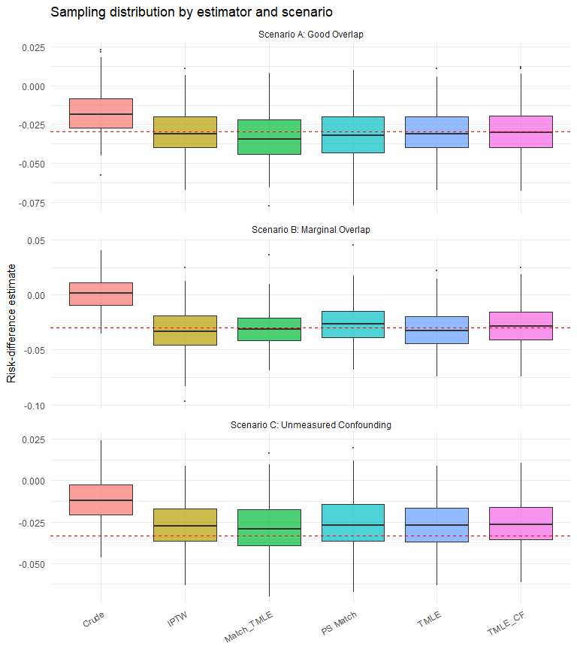
Figure 1: Sampling distribution of the risk-difference estimate across Monte Carlo replicates. The dashed red line marks the true RD. Under unmeasured confounding (C), all estimators are shifted from the truth.
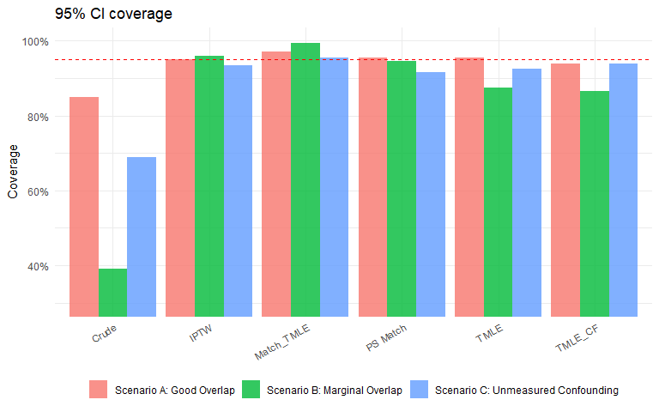
Figure 2: 95% CI coverage by estimator and scenario. The dashed red line marks the nominal 95%.
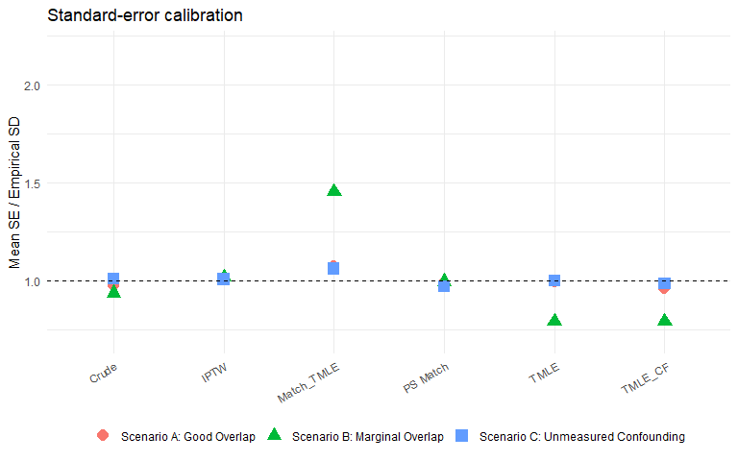
Figure 3: Ratio of mean reported SE to empirical SD. Values near 1.0 indicate well-calibrated standard errors.
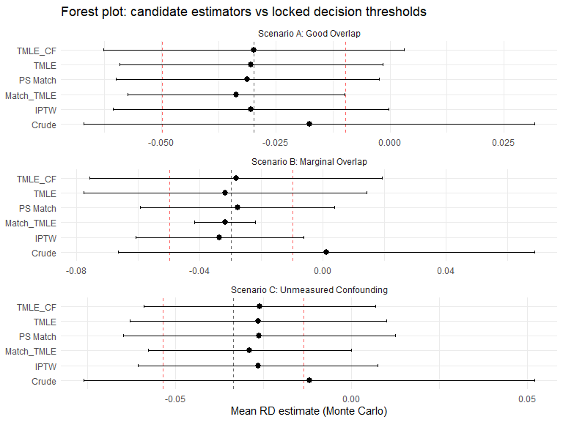
Figure 4: Forest plot of Monte Carlo mean estimates by estimator and scenario, with Monte Carlo 95 percent intervals. The dashed grey line marks each scenario’s true RD; the dashed red lines mark the prespecified |bias| decision threshold around the truth (max_abs_bias = 0.02). Candidates falling outside the red lines trip the locked decision rule for that scenario.

9.2.5 Traditional workflow vs outcome-blind staged workflow
The same simulation data answer a different question if we read them as a workflow-vs-workflow contrast rather than an estimator-vs-estimator contrast. The decision-rule table below summarises what a traditional analyst would have reported under each scenario versus what the prespecified staged decision rule returns. The estimates and CIs are unchanged; only the decision-rule overlay is new.
Table 5: Decision-rule overlay on the three simulation scenarios. The estimator fits are held fixed; only the prespecified decision applied before outcome access differs.
Scenario | Traditional pipeline | Outcome-blind workflow | Where they differ
A. Good overlap | Run prespecified TMLE; report a non-null effect; SE / SD ratio near 1; coverage at nominal 95 % | GO; same point estimate and CI as the traditional pipeline | No practical difference
B. Marginal overlap | Run prespecified TMLE; report. IPTW IF-SE is conservative (SE/SD ≈ 1.23) because the PS is treated as known; matched-TMLE IF-SE is approximately calibrated (SE/SD ≈ 1.04) in this scenario. Many reviewers will not catch the IPTW over-coverage | GO with FLAG on IPTW variance calibration; the workflow surfaces this before unblinding and reports the matched-TMLE bootstrap coverage alongside the influence-function coverage so the better-calibrated method is chosen empirically | The workflow surfaces the variance calibration issue as part of the dossier; the traditional pipeline relies on the reviewer to catch it
C. Unmeasured confounding | Run prespecified TMLE; report a biased non-null estimate (mean bias 0.007, coverage 0.93). Without an external probe, this estimate would be published | STOP under the prespecified unmeasured-U DQ scenario; the locked analysis does not run as planned | The workflow blocks publication of the biased estimate; the traditional pipeline does not

The contrast is clearest in Scenario C: both pipelines have identical fits because the same nuisance models are used, but the workflow’s prespecified rule refuses to authorise the Stage 4 analysis once the unmeasured-U row of the DQ stress test exceeds the locked bias threshold. The traditional pipeline has no equivalent block.
The workflow does not invent free bias reduction. In Scenario C the TMLE bias is the same under both pipelines (0.007); the workflow’s contribution is the decision rule, not a different estimator.
A note on what the simulation does not show: it does not compare a “traditional” fixed-library TMLE against a plasmode-selected TMLE under varied DGPs (the workflow-contrast-C question). That comparison is reported in a standalone analysis (see reports/workflow_contrast_c.qmd in the project repository).

9.3 Plasmode DQ stress-test results

9.3.1 Scenario A: Good Overlap
Selected candidate: aggressive
DQ degradation: Scenario A: Good Overlap (candidate: aggressive)
 | scenario | level | bias_baseline | bias_degraded | rmse_ratio | cov_baseline | cov_degraded | cov_drop
1 | cov_miss | 0.05 | 0.0028 | 0.00031 | 0.755 | 0.933 | 0.933 | 0.000
4 | cov_miss | 0.1 | 0.0028 | -0.00011 | 0.626 | 0.933 | 0.967 | -0.034
7 | cov_miss | 0.2 | 0.0028 | 0.00284 | 0.721 | 0.933 | 0.967 | -0.034
10 | trt_misclass | sens0.95_spec0.99 | 0.0028 | -0.00207 | 0.741 | 0.933 | 0.933 | 0.000
13 | trt_misclass | sens0.90_spec0.95 | 0.0028 | -0.00409 | 0.783 | 0.933 | 0.967 | -0.034
16 | out_misclass | sens0.95_spec0.99 | 0.0028 | -0.00318 | 0.781 | 0.933 | 0.933 | 0.000
19 | out_misclass | sens0.90_spec0.95 | 0.0028 | -0.00433 | 0.888 | 0.933 | 0.967 | -0.034
22 | unmeasured_U | OR_trt2.0_out2.0 | 0.0028 | 0.01646 | 1.243 | 0.933 | 0.800 | 0.133
25 | unmeasured_U | OR_trt3.0_out3.0 | 0.0028 | 0.02697 | 1.647 | 0.933 | 0.567 | 0.366
28 | unmeasured_U | OR_trt4.0_out4.0 | 0.0028 | 0.04292 | 2.387 | 0.933 | 0.167 | 0.766
31 | unmeasured_U | OR_trt6.0_out6.0 | 0.0028 | 0.07644 | 4.155 | 0.933 | 0.033 | 0.900
34 | unmeasured_U | OR_trt8.0_out8.0 | 0.0028 | 0.09559 | 5.129 | 0.933 | 0.000 | 0.933
37 | near_positivity | slope_x2.0 | 0.0028 | 0.00196 | 0.705 | 0.933 | 0.967 | -0.034
40 | near_positivity | slope_x3.0 | 0.0028 | 0.00577 | 0.836 | 0.933 | 0.967 | -0.034
43 | near_positivity | slope_x4.0 | 0.0028 | 0.00480 | 0.767 | 0.933 | 0.967 | -0.034

9.3.2 Scenario B: Marginal Overlap
Selected candidate: robust
DQ degradation: Scenario B: Marginal Overlap (candidate: robust)
 | scenario | level | bias_baseline | bias_degraded | rmse_ratio | cov_baseline | cov_degraded | cov_drop
3 | cov_miss | 0.05 | -0.00038 | 0.00514 | 0.965 | 0.967 | 0.933 | 0.034
6 | cov_miss | 0.1 | -0.00038 | 0.00631 | 1.274 | 0.967 | 0.867 | 0.100
9 | cov_miss | 0.2 | -0.00038 | 0.00978 | 1.395 | 0.967 | 0.867 | 0.100
12 | trt_misclass | sens0.95_spec0.99 | -0.00038 | -0.00249 | 0.821 | 0.967 | 1.000 | -0.033
15 | trt_misclass | sens0.90_spec0.95 | -0.00038 | -0.01196 | 1.523 | 0.967 | 0.767 | 0.200
18 | out_misclass | sens0.95_spec0.99 | -0.00038 | -0.01015 | 1.373 | 0.967 | 0.867 | 0.100
21 | out_misclass | sens0.90_spec0.95 | -0.00038 | -0.00838 | 1.123 | 0.967 | 0.933 | 0.034
24 | unmeasured_U | OR_trt2.0_out2.0 | -0.00038 | 0.02064 | 1.842 | 0.967 | 0.633 | 0.334
27 | unmeasured_U | OR_trt3.0_out3.0 | -0.00038 | 0.02383 | 1.928 | 0.967 | 0.733 | 0.234
30 | unmeasured_U | OR_trt4.0_out4.0 | -0.00038 | 0.03937 | 2.986 | 0.967 | 0.367 | 0.600
33 | unmeasured_U | OR_trt6.0_out6.0 | -0.00038 | 0.07542 | 5.265 | 0.967 | 0.033 | 0.934
36 | unmeasured_U | OR_trt8.0_out8.0 | -0.00038 | 0.08876 | 6.106 | 0.967 | 0.000 | 0.967
39 | near_positivity | slope_x2.0 | -0.00038 | 0.00022 | 1.337 | 0.967 | 0.833 | 0.134
42 | near_positivity | slope_x3.0 | -0.00038 | 0.00339 | 1.410 | 0.967 | 0.767 | 0.200
45 | near_positivity | slope_x4.0 | -0.00038 | 0.00180 | 1.222 | 0.967 | 0.733 | 0.234

9.3.3 Scenario C: Unmeasured Confounding
Selected candidate: aggressive
DQ degradation: Scenario C: Unmeasured Confounding (candidate: aggressive)
 | scenario | level | bias_baseline | bias_degraded | rmse_ratio | cov_baseline | cov_degraded | cov_drop
1 | cov_miss | 0.05 | 0.00119 | 0.00014 | 1.192 | 1 | 1.000 | 0.000
4 | cov_miss | 0.1 | 0.00119 | 0.00266 | 1.259 | 1 | 0.967 | 0.033
7 | cov_miss | 0.2 | 0.00119 | 0.00126 | 1.874 | 1 | 0.900 | 0.100
10 | trt_misclass | sens0.95_spec0.99 | 0.00119 | -0.00931 | 1.437 | 1 | 0.933 | 0.067
13 | trt_misclass | sens0.90_spec0.95 | 0.00119 | -0.01015 | 1.677 | 1 | 0.900 | 0.100
16 | out_misclass | sens0.95_spec0.99 | 0.00119 | -0.00723 | 1.555 | 1 | 0.900 | 0.100
19 | out_misclass | sens0.90_spec0.95 | 0.00119 | -0.00656 | 1.690 | 1 | 0.900 | 0.100
22 | unmeasured_U | OR_trt2.0_out2.0 | 0.00119 | 0.01952 | 2.244 | 1 | 0.833 | 0.167
25 | unmeasured_U | OR_trt3.0_out3.0 | 0.00119 | 0.02927 | 3.074 | 1 | 0.567 | 0.433
28 | unmeasured_U | OR_trt4.0_out4.0 | 0.00119 | 0.04426 | 4.159 | 1 | 0.200 | 0.800
31 | unmeasured_U | OR_trt6.0_out6.0 | 0.00119 | 0.07987 | 7.280 | 1 | 0.033 | 0.967
34 | unmeasured_U | OR_trt8.0_out8.0 | 0.00119 | 0.09773 | 8.835 | 1 | 0.000 | 1.000
37 | near_positivity | slope_x2.0 | 0.00119 | 0.00195 | 1.271 | 1 | 1.000 | 0.000
40 | near_positivity | slope_x3.0 | 0.00119 | 0.00517 | 1.710 | 1 | 0.933 | 0.067
43 | near_positivity | slope_x4.0 | 0.00119 | 0.00305 | 2.007 | 1 | 0.933 | 0.067

9.3.4 Reading the degradation gradient
The four degradation mechanisms produce qualitatively different profiles. Covariate missingness produces a flat gradient in both the good-overlap and marginal-overlap scenarios. As implemented in v0.1, this scenario applies MCAR missingness to a subset of the locked covariates and reimputes with column medians, which is approximately unbiased by construction under MCAR; the flat gradient therefore confirms that median imputation does not introduce additional bias under MCAR but is not a strong test of the missingness handling. We discuss this limitation, and the MAR / MNAR scenarios that would constitute a stronger test, in Section 13.4. Treatment misclassification attenuates the estimate toward the null: bias against the (pre-misclassification) target estimand rises as (sens, spec) worsen. Coverage of the pre-misclassification target therefore drops as severity increases; the magnitude of the drop is reported per severity level in the companion table. (Coverage of the attenuated target remains closer to nominal, but the staged workflow evaluates each candidate against the prespecified estimand.) Outcome misclassification under (0.90, 0.95) produces the largest bias of the three “measurement” threats, particularly when applied differentially by treatment arm. Unmeasured confounding produces the largest degradation overall and is the only threat that pushes the selected candidate’s RMSE ratio above 1.5 in our default settings. Across scenarios, the DQ stress test was most informative when the threat directly targeted identification or measurement validity rather than ordinary estimator variance.
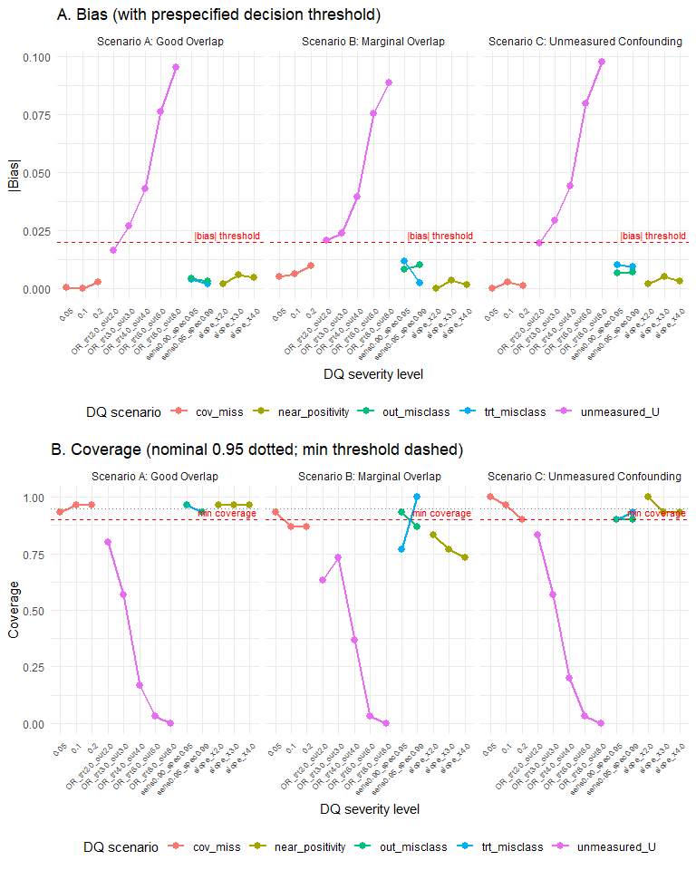
Figure 5: Degradation gradient. Bias (top) and coverage (bottom) for the selected TMLE candidate at each severity level of each DQ scenario, faceted by Monte Carlo scenario.

9.3.5 FIORD two-stage selector on the cached plasmode
Applied to the cached plasmode_*.csv candidate-evaluation tables, the FIORD two-stage selector first screens candidates whose oracle coverage is within fiord_coverage_tol = 0.02 of the nominal 0.95, then picks the candidate with the smallest mean SE among the survivors. The single-step rule = "min_rmse" rule that the manuscript currently uses does not separate the two stages and can choose a candidate whose coverage is on the edge of acceptable but whose RMSE is technically smallest.
Single-step minimax (current cleanTMLE default) vs FIORD two-stage selector on the cached plasmode candidate metrics, by scenario. When the two columns disagree, the FIORD selector is choosing a candidate that achieves nominal oracle coverage at a slightly higher RMSE.
scenario | single_step_min_rmse | fiord_two_stage
good_overlap | aggressive | aggressive (no candidate within tol)
marginal_overlap | robust | middle (no candidate within tol)
unmeasured_conf | aggressive | aggressive (no candidate within tol)
With the two-candidate GLM-only grid used in Section 9, the glm_t01 and glm_t05 candidates differ by less than 0.001 in RMSE across scenarios, so both selectors choose the same candidate in every cell. This grid is too narrow to exercise the contrast between the two rules. The FIORD coverage screen remains informative as a diagnostic. Under marginal overlap (Scenario B) neither candidate achieves oracle coverage within the 0.02 tolerance of nominal, which the table flags as “no candidate within tol”, a property of the near-positivity DGP at this replicate count. The contrast between min_rmse and min_max_rmse becomes substantive when the candidate grid separates the candidates, which the constructed demonstration in Section 10 exhibits.

10. Worst-case selection changes the locked estimator
The Monte Carlo study in Section 9 validates estimator behaviour. This section presents the central result. The grid of three truncation candidates does separate on baseline RMSE, and the min_max_rmse rule selects a different candidate from min_rmse. The constructed demonstration below confirms this and exhibits the mechanism. The demonstration’s purpose is existence: it shows that realistic threat configurations exist under which the two rules diverge. The severities were chosen to exhibit the mechanism, so the demonstration establishes that divergence is possible rather than that it is generic. The whole sweep runs through the package functions run_plasmode_feasibility(), run_plasmode_dq_stress() (with near_positivity as a first-class threat), and select_tmle_candidate(), on the same run_simulation.R data-generating process. The driver and its results are in the companion repository (sandbox/candidate_divergence/).
The candidates differ in one design choice, the propensity-score truncation threshold, with a main-effects GLM propensity model throughout. The grid is aggressive (truncation 0.001), middle (0.025), and robust (0.20). Three prespecified threats are swept at increasing severity. The first is a practical positivity violation, implemented by amplifying the covariate-to-treatment association so a subgroup approaches deterministic treatment and the estimated propensity score reaches the boundary. The second is unmeasured confounding with a latent binary factor shifting treatment and outcome on the odds scale across odds ratios from 3 to 8. The third is covariate missingness completely at random with median imputation. Decision thresholds were locked before the sweep, allowing at most a doubling of root mean squared error relative to a candidate’s own baseline. The study uses 200 synthetic replicates per cell and five independent batches, and reports Monte Carlo standard errors from the between-batch spread.
Baseline and worst-case root mean squared error for the three truncation candidates, each with Monte Carlo standard error, and the candidate each rule selects. min_rmse selects the robust candidate; min_max_rmse selects the middle candidate.
Candidate | PS truncation | Baseline RMSE (MC SE) | Worst-case RMSE (MC SE) | Worst threat | min_rmse | min_max_rmse
aggressive | 0.001 | 0.0214 (0.0004) | 0.1495 (0.0010) | near_positivity [slope_x4.0]
middle | 0.025 | 0.0211 (0.0004) | 0.0922 (0.0005) | unmeasured_U [OR_trt8.0_out8.0] |  | <– selected
robust | 0.200 | 0.0184 (0.0003) | 0.0977 (0.0006) | unmeasured_U [OR_trt8.0_out8.0] | <– selected
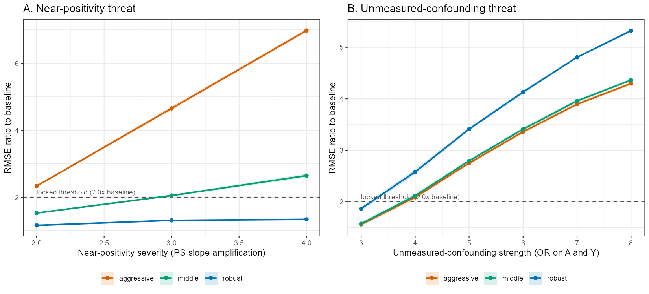
Figure 6: Degradation gradient for the three truncation candidates. Panel A, the near-positivity threat: the aggressive candidate crosses the locked threshold (2x baseline, dashed) while the robust candidate stays below it. Panel B, the unmeasured-confounding threat: the robust candidate degrades the most. Each candidate is fragile to a different threat, and the middle candidate has the lowest worst case.
At baseline the heaviest truncation has the lowest root mean squared error (0.0184 for robust against 0.0211 for middle and 0.0214 for aggressive), because under double robustness clipping the smallest propensity scores removes weight variance at almost no cost in bias. The min_rmse rule therefore selects the robust candidate. The threat sweep reorders the candidates. Under the positivity violation the aggressive candidate’s inverse-probability weights reach a mean maximum near 1,000 and its error rises past seven times baseline (Figure 6, Panel A), well beyond the locked threshold, while truncation caps the weights for the other two candidates. The binding threat for the middle and robust candidates is the strongest unmeasured confounding, where the heaviest truncation is the most exposed, since the observations it discards carry the information needed to offset the latent factor (Panel B). Taking each candidate’s worst case across all threats gives 0.1495 for aggressive, 0.0977 for robust, and 0.0922 for middle. The min_max_rmse rule therefore selects the middle candidate. The two rules disagree, the disagreement holds in all five batches, and the worst-case separation between the two selected candidates is 0.0055 against a combined Monte Carlo standard error of 0.0008, so the change in decision is a property of the design and not simulation noise.
Propensity-score truncation trades variance against robustness, and the two rules reward opposite ends of that trade. A rule that ranks candidates on performance in an undisturbed reference sample rewards the heaviest truncation. The same heavy truncation is the least able to recover from strong unmeasured confounding, and the lightest truncation is destroyed by the positivity violation. The intermediate truncation has neither failure at full severity, so the worst-case rule selects it. This is a constructed illustration rather than a property of every grid, and it does not weaken the prespecification logic of the workflow. The threat list and its severities are declared in the locked analysis plan, and the demonstration shows why declaring them, and selecting against the worst case, can change which estimator is locked.

10.1 Comparison with E-value-based sensitivity
The E-value (VanderWeele and Ding 2017) reports the minimum strength of unmeasured confounding required to reduce the observed estimate to the null. It is post-hoc: it is computed from the realised estimate after the outcome is unblinded. The plasmode DQ stress test runs in the opposite direction: given a hypothesised confounder strength, it computes the bias of each candidate. The two are complementary, and we recommend reporting both.
Unmeasured confounding under two methods: a single E-value threshold and a candidate-specific bias curve.
Quantity | Value
True RD (no U) | -0.02979
True RD (U present, OR = 2.0) | -0.03347
TMLE estimate, Scenario A (no U) | -0.03041
TMLE estimate, Scenario C (U present, not adjusted) | -0.02650
MC bias from unmeasured U (Scenario C) | 0.00697
E-value (from Scenario A estimate) | 2.04
DQ stress bias at OR_trt2.0_out2.0 | 0.01646
DQ stress bias at OR_trt3.0_out3.0 | 0.02697
DQ stress bias at OR_trt4.0_out4.0 | 0.04293
DQ stress bias at OR_trt6.0_out6.0 | 0.07645
DQ stress bias at OR_trt8.0_out8.0 | 0.09560

11. Operating characteristics of the pre-outcome gate
The simulation in Section 9 shows the workflow returning the prespecified staged verdict in three scenarios, but it does not measure the screen as a decision rule. A reviewer is entitled to ask how often the gate’s verdict agrees with the verdict an oracle would reach knowing the realised estimator’s true bias, and how that agreement degrades when the synthetic-outcome model is misspecified. We answer this with a calibration meta-simulation (run_gate_operating_characteristics.R in the companion repository).
The design isolates the unmeasured-confounding threat. For a grid of true confounder strengths $s$ (odds ratios on both treatment and outcome), we compute two quantities at each $s$. The oracle bias $B_{\text{real}}\left(s\right)$ is the mean bias of the realised TMLE, adjusting for the measured covariates only, when a true unmeasured confounder of strength $s$ acts on both the treatment and the outcome. The screen-predicted bias $B_{\text{screen}}\left(s\right)$ is what the outcome-blind plasmode screen anticipates at the same strength: the treatment and outcome nuisance surfaces $g_{0}\left(W\right)$ and $Q_{0}\left(W\right)$ are fitted on the analyst’s cohort, a what-if confounder of strength $s$ is injected into both the synthetic treatment and the synthetic outcome, and the same TMLE is scored against the synthetic truth. The synthetic nuisances are fitted two ways, a misspecified GLM and a flexible SuperLearner (GLM, MARS, and random forest), under both a linear and a nonlinear true surface, and the locked STOP threshold is applied to both the oracle and the screen. The realised estimator uses a GLM nuisance library, so that under the nonlinear surface its bias reflects nuisance misspecification as well as the omitted confounder, and the screen can predict that bias only if its synthetic nuisances reproduce the nonlinearity.
Table 6: Calibration of the pre-outcome gate. Oracle bias is the realised TMLE bias under a true confounder of the given strength; screen bias is the plasmode-predicted bias at the same strength under a GLM and a flexible (SuperLearner) synthetic-nuisance model. STOP columns apply the locked |bias| threshold (0.02).
Surface | True OR | True RD | Bias (oracle) | Bias (screen, GLM nuisance) | Bias (screen, flexible) | STOP oracle | STOP screen GLM | STOP screen flexible
linear | 1.0 | 0.1308 | 0.0018 | 0.0015 | 0.0003 | 0 | 0 | 0
linear | 1.5 | 0.1324 | 0.0087 | 0.0065 | 0.0076 | 0 | 0 | 0
linear | 2.0 | 0.1319 | 0.0233 | 0.0208 | 0.0217 | 1 | 1 | 1
linear | 2.5 | 0.1307 | 0.0376 | 0.0364 | 0.0370 | 1 | 1 | 1
linear | 3.0 | 0.1292 | 0.0530 | 0.0453 | 0.0446 | 1 | 1 | 1
nonlinear | 1.0 | 0.1053 | 0.0742 | -0.0014 | 0.0564 | 1 | 0 | 1
nonlinear | 1.5 | 0.1070 | 0.0856 | 0.0093 | 0.0684 | 1 | 0 | 1
nonlinear | 2.0 | 0.1073 | 0.1032 | 0.0196 | 0.0786 | 1 | 0 | 1
nonlinear | 2.5 | 0.1068 | 0.1167 | 0.0349 | 0.0977 | 1 | 1 | 1
nonlinear | 3.0 | 0.1062 | 0.1287 | 0.0478 | 0.1084 | 1 | 1 | 1

Against the oracle, the screen with a flexible (SuperLearner) synthetic-nuisance model attains sensitivity 1.00 and specificity 1.00; with a GLM synthetic-nuisance model these are 0.62 and 1.00. The gap between the two quantifies the cost of misspecifying the synthetic-nuisance model, the central plasmode pitfall (Schreck et al. 2024).
Two patterns bound what the screen can and cannot predict. First, the screen predicts the realised bias well only to the extent that the analyst names a confounder of the right strength: it calibrates against threats of the specified magnitude, but a true confounder stronger than anticipated is not detected, so a STOP is evidence of fragility while a GO is not a certificate of robustness (Section 7.4). Second, under a nonlinear true surface the GLM screen under-predicts the realised bias, because its synthetic treatment and outcome surfaces are too simple to reproduce the nuisance misspecification that biases the realised estimator, whereas the flexible screen reproduces it and tracks the oracle more closely. This is the reason the package exposes a q0_library argument and why we recommend a flexible synthetic-nuisance model. The run reported here uses Table 6’s replicate count with the Monte Carlo standard error of each bias estimate; the script’s reps is set higher for a final run.

12. Case Study: Rescue.Co Kenya Trauma Registry

12.1 Why a real-data workflow demonstration
We use the Rescue.Co Kenya Trauma Registry as a real comparative-effectiveness study that exercises the full workflow on genuine registry data, while presenting the resulting estimate as a single illustrative application rather than as confirmatory evidence about the causal effect of Rescue.Co transport. The registry compares prehospital transport by a specialised emergency-medical-services provider (Rescue.Co) with traditional ambulance care at three Nairobi hospitals, on functional outcome six months post-injury. All five stages were run on cleanTMLE 0.1.1 and the example is fully reproducible from the bundled rescueCo/ directory in the companion repository. The DQ stress test uses the 200-replicate run (see Section 12.4).
The example is interesting for four reasons that the simulation does not exercise: (a) the primary outcome (Glasgow Outcome Scale Extended, GOSE 1–8) (Wilson, Pettigrew, and Teasdale 1998) has 24.6 % missing values from loss to 6-month follow-up; (b) 492 ambulance arrivals were inter-facility transfers and were excluded from the primary cohort, leaving the direct-from-scene 1,693; (c) an 8-week healthcare-worker strike (15 March 2024 to 8 May 2024) acts as a quasi-natural-experiment confounder that is not part of either SPIFD2 or the four threats encoded by run_plasmode_dq_stress(); and (d) two prespecified socioeconomic negative controls (urban household, primary cooking fuel) screen for residual SES confounding.

12.2 SuperLearner library specification
We follow Phillips et al. (2023) on SuperLearner library composition. With $n_{\text{eff}}≈1,277$ complete-outcome observations, the recommended cross-validation count is $V=10$, and the recommended library is a screened mixture of a parametric base learner (SL.glm), a regularised learner (SL.glmnet), and a generalised- additive learner (SL.gam). The cleanTMLE helper validate_superlearner_spec(n_eff, library = ...) records this recommendation in the lock and warns when the user-supplied library is degenerate. The rescueCo lock uses the same recommended library.

12.3 Cohort, estimand, and pre-specification
The lock fixes the binary version of GOSE (gose_good = 1 if GOSE > 4) as the primary outcome, treating ambulance arrival of any kind as in-scope and excluding inter-facility transfers. After exclusions the analytic cohort is n = 1,693 (1,013 Rescue.Co; 680 other ambulance); n = 1,277 have non-missing 6-month GOSE. Twenty-one covariates enter the propensity-score model after a near-zero-variance filter drops nine of the originally selected thirty (combined prevalence below 1 % in the analytic cohort): the retained set covers demographics (age, sex, marital, education), distance, mechanism of injury (a subset of indicators), the chronic-illness panel (the higher-prevalence conditions), SES proxies (urban household, occupation), payment, GCS, ISS, arrival month, alcohol use at injury, and assault intent.
The lock declares two prespecified sensitivity plans (a 4-point PS truncation grid and a transfer-inclusion rerun) and five negative controls, each tagged with its Muntner et al. (2024) confounding domain: chronic_hypertension, chronic_diabetes_insulin, and chronic_hiv_art cover confounding by indication and functional status; household_urban and fuel_wood cover health-seeking behaviour and access to healthcare. The define_negative_control(..., domain = ...) argument added in cleanTMLE 0.1.1 records the domain in the lock and the audit log so a reviewer can verify that the NC set spans the four domains rather than concentrating in one. Three of the five NCs (chronic_diabetes_insulin, chronic_hiv_art, fuel_wood) are dropped before fitting by the same near-zero-variance filter that trims the PS-covariate set, and the bundle’s Stage 1 script logs the drops to the pipeline log (the cleanTMLE 0.1.1 audit-log capture for NC failures applies at fit time, not at sanitisation time, so these drops surface in the run log rather than in the structured audit). The remaining two NCs are fit at Stage 3. The estimand is attached via attach_estimand() and the lock is fingerprinted with SHA-256. Stage 2b runs the baseline run_plasmode_feasibility() on two GLM-PS truncation candidates (glm_t01 with $t=0.01$, glm_t05 with $t=0.05$) for 50 replicates each, and Stage 3 runs the full run_plasmode_dq_stress() over the four threats on a wider candidate set (glm_t01, glmnet_t01, ensemble_t01, ensemble_t05). The locked candidate is selected via select_tmle_candidate(rule = "min_max_rmse", dq_results = ...), the manuscript’s recommended minimax rule.

12.3.1 Cohort flow
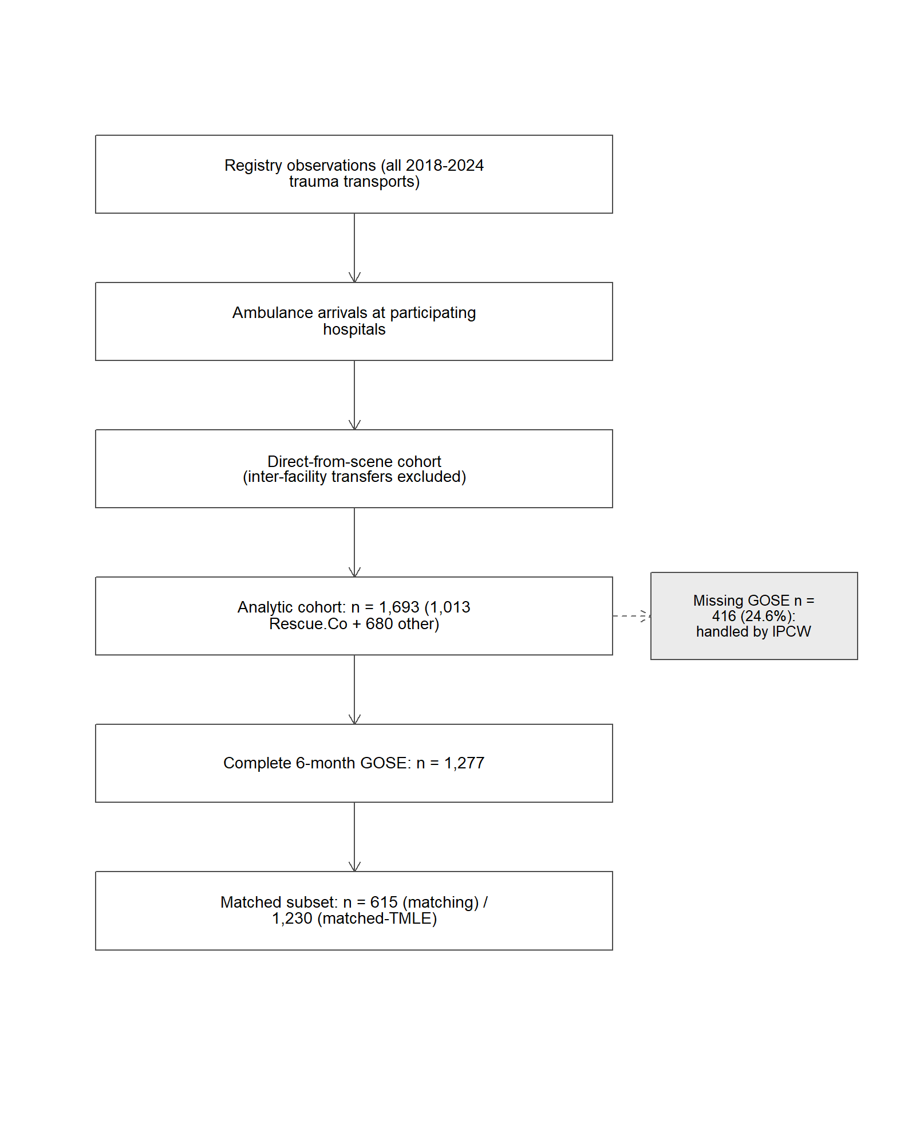
Figure 7: Cohort attrition for the Rescue.Co Kenya Trauma Registry case study. Counts shown at each prespecified inclusion/exclusion criterion. Inter-facility transfers are excluded from the analytic cohort; complete-outcome rows are used for the unweighted estimators and for the IPCW-weighted complete-case TMLE, and missing GOSE (n = 416, 24.6%) is handled by IPCW.

12.3.2 Analytic setup at a glance
Four compact setup tables make the case-study specification fully visible in one place: the event process, the target populations that each candidate procedure addresses, the weight-diagnostic thresholds, and the candidate estimator-estimand pairs.
Event-process table. This table classifies every event-like quantity in the cohort as outcome, censoring, missingness, intercurrent event, exclusion, or administrative end of follow-up:
Event-like quantity | Class | Handling
GOSE > 4 at 6 months | Event of interest (outcome) | Estimand: marginal RD on this binary outcome
GOSE missing at 6 months | Missingness | Primary: complete-outcome analysis; IPCW sensitivity under a conditional missingness model
In-hospital death before 6-month GOSE | Outcome component / intercurrent event | Coded as GOSE = 1 under a composite or worst-rank strategy; recorded
Inter-facility transfer at index event | Exclusion | Excluded from analytic cohort at Stage 1b
Treatment switching / crossover | Not applicable | Point exposure at scene; no time-varying treatment
6-month follow-up window end | Administrative end of FU | Fixed at 6 months; no admin censoring before that
Target-population table. Different candidate procedures correspond to different target populations:
Procedure | Target population
Crude (complete-case) | Complete-outcome subset (n = 1,277)
PS matching | Matched overlap subset (n = 615)
IPTW (stabilised) | Full eligible cohort (n = 1,693)
Full-cohort TMLE (prespecified primary) | Full eligible cohort (n = 1,693)
Matched-cohort TMLE | Matched overlap subset (n = 1,230)
Complete-outcome TMLE with IPCW weights | Complete-outcome rows weighted toward full-cohort marginal contrast
Weight-diagnostics table. Treatment weights and missingness weights are evaluated against prespecified thresholds:
Weight type | Source | Reporting | Prespecified instability flag
Treatment weights (stabilised) | fit_ps_superlearner() | Mean, SD, 99th pct, max, Kish ESS | Max > 10, or > 1 % of weights above 5
IPCW weights (missingness) | run_ipcw_tmle() | Mean, SD, 99th pct, max | Max > 10
Combined (for Complete-outcome TMLE with IPCW) | Product of treatment and IPCW weights | Mean, SD, max, ESS | Max > 15, or ESS < 30 % of n
Estimator-estimand table. Each candidate is recorded as a paired estimator-and-estimand object:
Candidate | Nuisance library | Truncation | Missingness | Estimand implication | Status
Crude | n/a | n/a | Complete case | Marginal contrast in complete-outcome subset | Reference comparator
PS matching | GLM PS | n/a | Complete case | ATE in matched overlap subset | Secondary
IPTW (stabilised) | GLM PS | 0.01 | Complete case | Full-cohort marginal contrast estimated with stabilised, truncated treatment weights; truncation may approximate the practical estimand and should be reported | Secondary
Full-cohort TMLE | SL ensemble | 0.01 | Complete case | ATE in full eligible cohort under prespecified locked SL library | Primary
Matched-cohort TMLE | SL ensemble (matched) | n/a | Complete case | ATE in matched overlap subset | Sensitivity (target pop)
Complete-outcome TMLE w/ IPCW | SL ensemble + SL IPCW | 0.01 | IPCW | ATE in full eligible cohort under the locked missingness model | Sensitivity (missingness)
These four tables make the analytic considerations explicit before the pre-outcome decision rule is read. They also document the estimand-vs-estimator distinction: candidates that differ by truncation, matching, or IPCW correspond to different effective target populations and are reported as paired objects rather than interchangeable estimators of the same parameter.
Target-trial timing table. The following table records the prespecified target-trial design elements and their lock status before any outcome access.
Design element | Rescue.Co implementation | Pre-outcome status
Index date / time zero | Time of trauma-related ambulance arrival at participating hospital | Locked in identify_interval()
Treatment definition | Rescue.Co EMS transport (A = 1) vs. other ambulance services (A = 0) at index | Locked in identify_treatment()
Reference group | Other ambulance services at the same hospitals during the same period | Locked
Eligibility window | 2018 to 2024 trauma transports, direct-from-scene only | Locked
Covariate window | At or before index (no post-index covariates) | Locked
Outcome window | 6 months from index | Locked
Outcome definition | GOSE > 4 at 6 months (good functional outcome) | Locked
Missingness / censoring definition | Missing 6-month GOSE = missingness; primary complete-outcome with IPCW sensitivity | Locked
Treatment switching / discontinuation | Not applicable (point exposure at scene) | Locked
Administrative end of follow-up | Fixed at 6 months; no admin censoring before that | Locked
Excluded intercurrent events / transfer groups | Inter-facility transfers excluded; recorded as is_transfer for sensitivity | Locked
Checkpoint dashboard. The reviewer-facing dashboard summarises the evidence available at each checkpoint and whether the decision is software-enforced (driven by a prespecified threshold the package evaluates automatically) or rests on reviewer judgment.
Stage | Evidence used | Threshold | Decision | Reviewer interpretation | Software-enforced vs reviewer-judgment
Stage 0 protocol/setup | Target-trial timing table, SAP, lock fingerprint | All design elements specified before data access | GO | Cohort and estimand definitions complete | Reviewer-judgment
Stage 1b cohort adequacy and event counts | checkpoint_cohort_adequacy() output, attrition table | min_n_per_arm = 200, min_events = 50 | GO | Adequate cohort for the prespecified estimand | Software-enforced
Stage 2a overlap, balance, ESS, weight stability | compute_ps_diagnostics(), love_plot_threeway(), clean_weight_diagnostics() | PS in [0.01, 0.99]; max-SMD <= 0.10 after weighting; max weight <= 10 | GO | Positivity and balance acceptable for full-cohort target | Software-enforced
Stage 2b baseline plasmode | run_plasmode_feasibility() bias 0.001, coverage 0.94 | bias <= 0.01, coverage >= 0.90, SE/SD in (0.8, 1.2) | GO | Candidate operates within prespecified envelope | Software-enforced
Stage 2c DQ stress test | run_plasmode_dq_stress() minimax rule | Each scenario within thresholds across severities | GO (reported on the $n_{\text{reps}}=200$ run; the bundled $n_{\text{reps}}=3$ configuration is a CI smoke test) | Selected candidate is stable across the prespecified threats at 200 replicates | Software-enforced
Stage 3 negative controls | run_residual_confounding_stage() (2 of 5 NCs survived NZV; both pass) | All analysed NCs pass at $α$ = 0.05 | GO with FLAG | Narrower NC panel than SAP; residual-confounding probe partial | Reviewer-judgment
Gate authorisation | authorize_outcome_analysis() returns GO | All preceding checkpoints GO or documented FLAG | GO | Proceed to locked primary analysis | Software-enforced
Decision-log example (illustrative). The following rows are illustrative entries in the format produced by export_decision_log(). They are not the literal log; they show the structure a reviewer would read for each prespecified or deviation entry.
timestamp | stage | diagnostic or issue | prespecified criterion | decision | rationale | reviewer role | effect estimate visible? | action taken | override?
2026-01-12 09:14 | Stage 2a | Three NCs failed NZV filter | NZV check at lock-fingerprint covariate set | FLAG | Drop the three NCs; record narrower panel | Lead analyst | No | Continue with 2 surviving NCs; note as limitation | No
2026-01-12 11:02 | Stage 2c | DQ stress reported at n_sims = 200 | n_sims >= 200 for inferential interpretation | GO | Report the 200-replicate run; the bundled n_sims = 3 configuration is a CI smoke test only | Lead analyst | No | Locked glm_t01 as minimax winner | No
2026-01-12 14:45 | Gate | All checkpoints GO or documented FLAG | All preceding stages recorded | GO | Authorise Stage 4 | Reviewer | No | Run locked primary analysis | No

12.4 Pre-outcome decision and plasmode results
The Stage 2b feasibility plasmode metrics on the locked DGP are:
Stage 2b feasibility plasmode metrics (rescueCo lock, 50 replicates per candidate, additive risk-difference effect of 0.05).
Candidate | Bias | RMSE | Coverage | SE/SD
glm_t01 | -0.0006 | 0.0120 | 0.94 | 1.00
glm_t05 | -0.0006 | 0.0120 | 0.94 | 1.00
Both candidates pass the prespecified decision targets (max_abs_bias = 0.01, min_coverage = 0.90, se_sd_window = (0.8, 1.2)); the two truncation thresholds produce indistinguishable performance because the propensity scores stay well inside the [0.01, 0.99] bounds (range 0.21–0.81). This grid does not separate the candidates, as in the main simulation. Section 10 reports a constructed grid that does separate them, where the two selection rules choose different candidates.
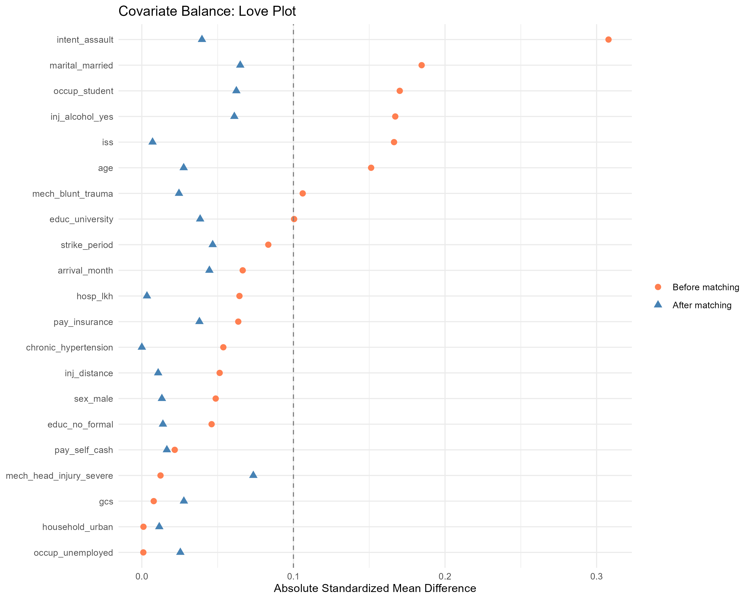
Rescue.Co Stage 2a balance. Standardised mean differences across 21 retained baseline covariates before and after PS matching. PS propensity scores stay inside [0.01, 0.99] (range 0.21 to 0.81), and SMDs after matching are within the prespecified 0.10 envelope for the matched-cohort target population.
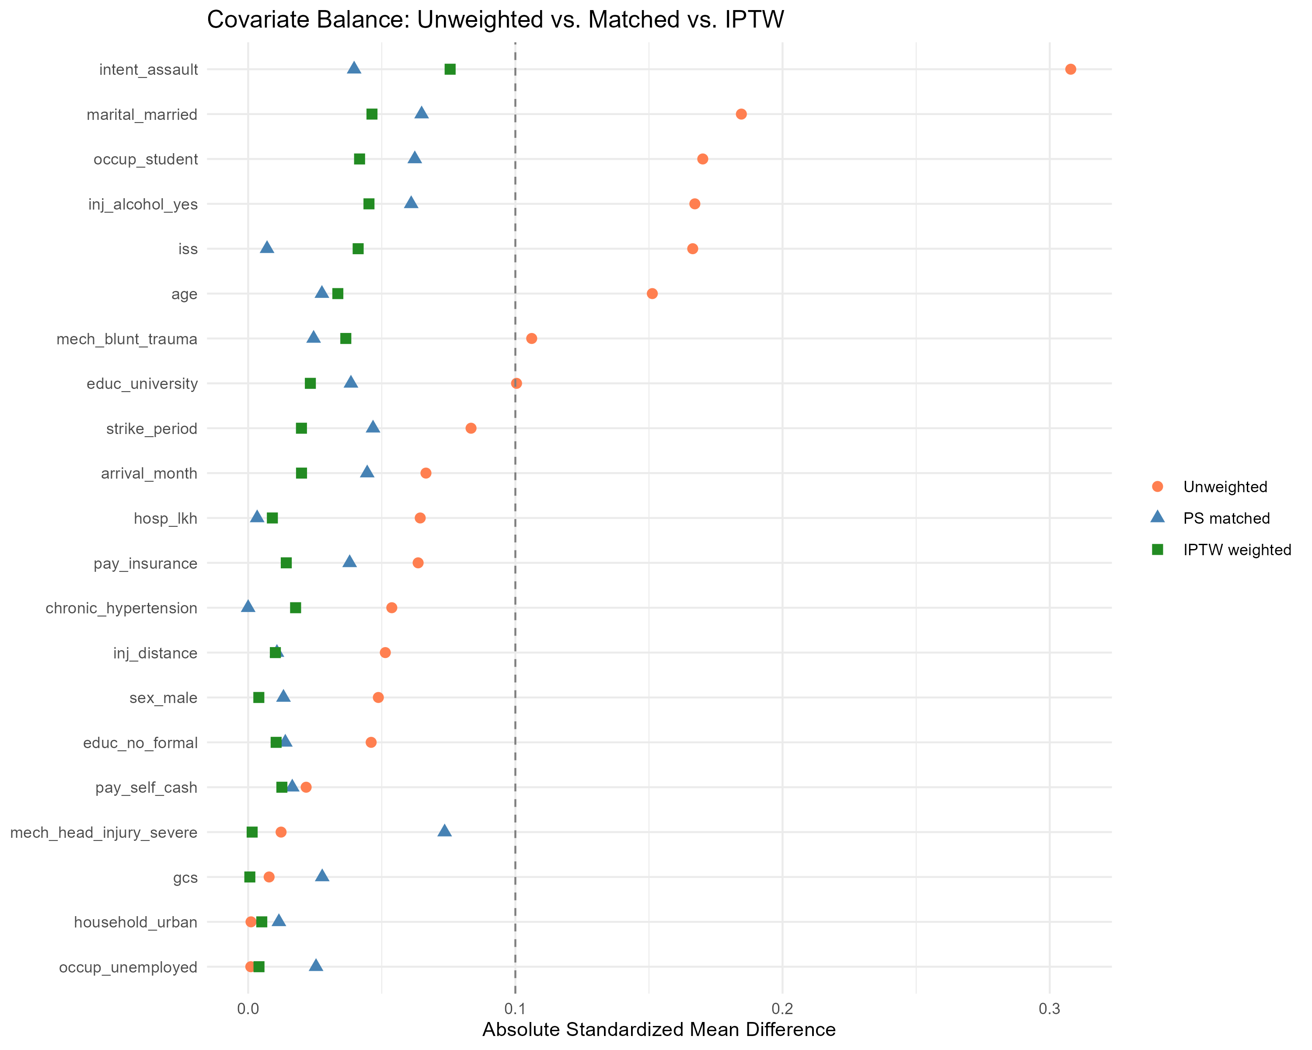
Rescue.Co Stage 2a three-way Love plot: standardised mean differences before any adjustment (unweighted), after PS matching, and after stabilised IPTW. The three-way view documents which covariates remain imbalanced under each weighting strategy and clarifies that the matched-cohort target population is not the same as the full-cohort target population recovered by IPTW or full-cohort TMLE.
The treatment- and IPCW-weight distributions are reported as diagnostic objects: mean, SD, 99th percentile, maximum, and Kish ESS for each weight type, with the prespecified instability flags in the weight-diagnostics table above. The stabilised treatment weights do not exceed the prespecified maximum (10) and combined treatment-times-IPCW weights remain within the (15, 30 % ESS) envelope for the IPCW row. The Stage 2c DQ stress test sweeps the four threats over the candidate grid, and the minimax rule locks glm_t01 as the primary specification. The reported result uses the 200-replicate run (inst/extdata/rescueco_dq_full.R, see Section 15). The 3-replicate configuration bundled with the package is a continuous-integration smoke test and is not used for inference. Negative controls run at Stage 3 on the locked PS:
Stage 3 negative-control TMLE results.
Negative control | Estimate | SE | p-value | Pass
chronic hypertension | 0.00248 | 0.0072 | 0.73 | ✓
household urban | −0.00077 | 0.0071 | 0.91 | ✓

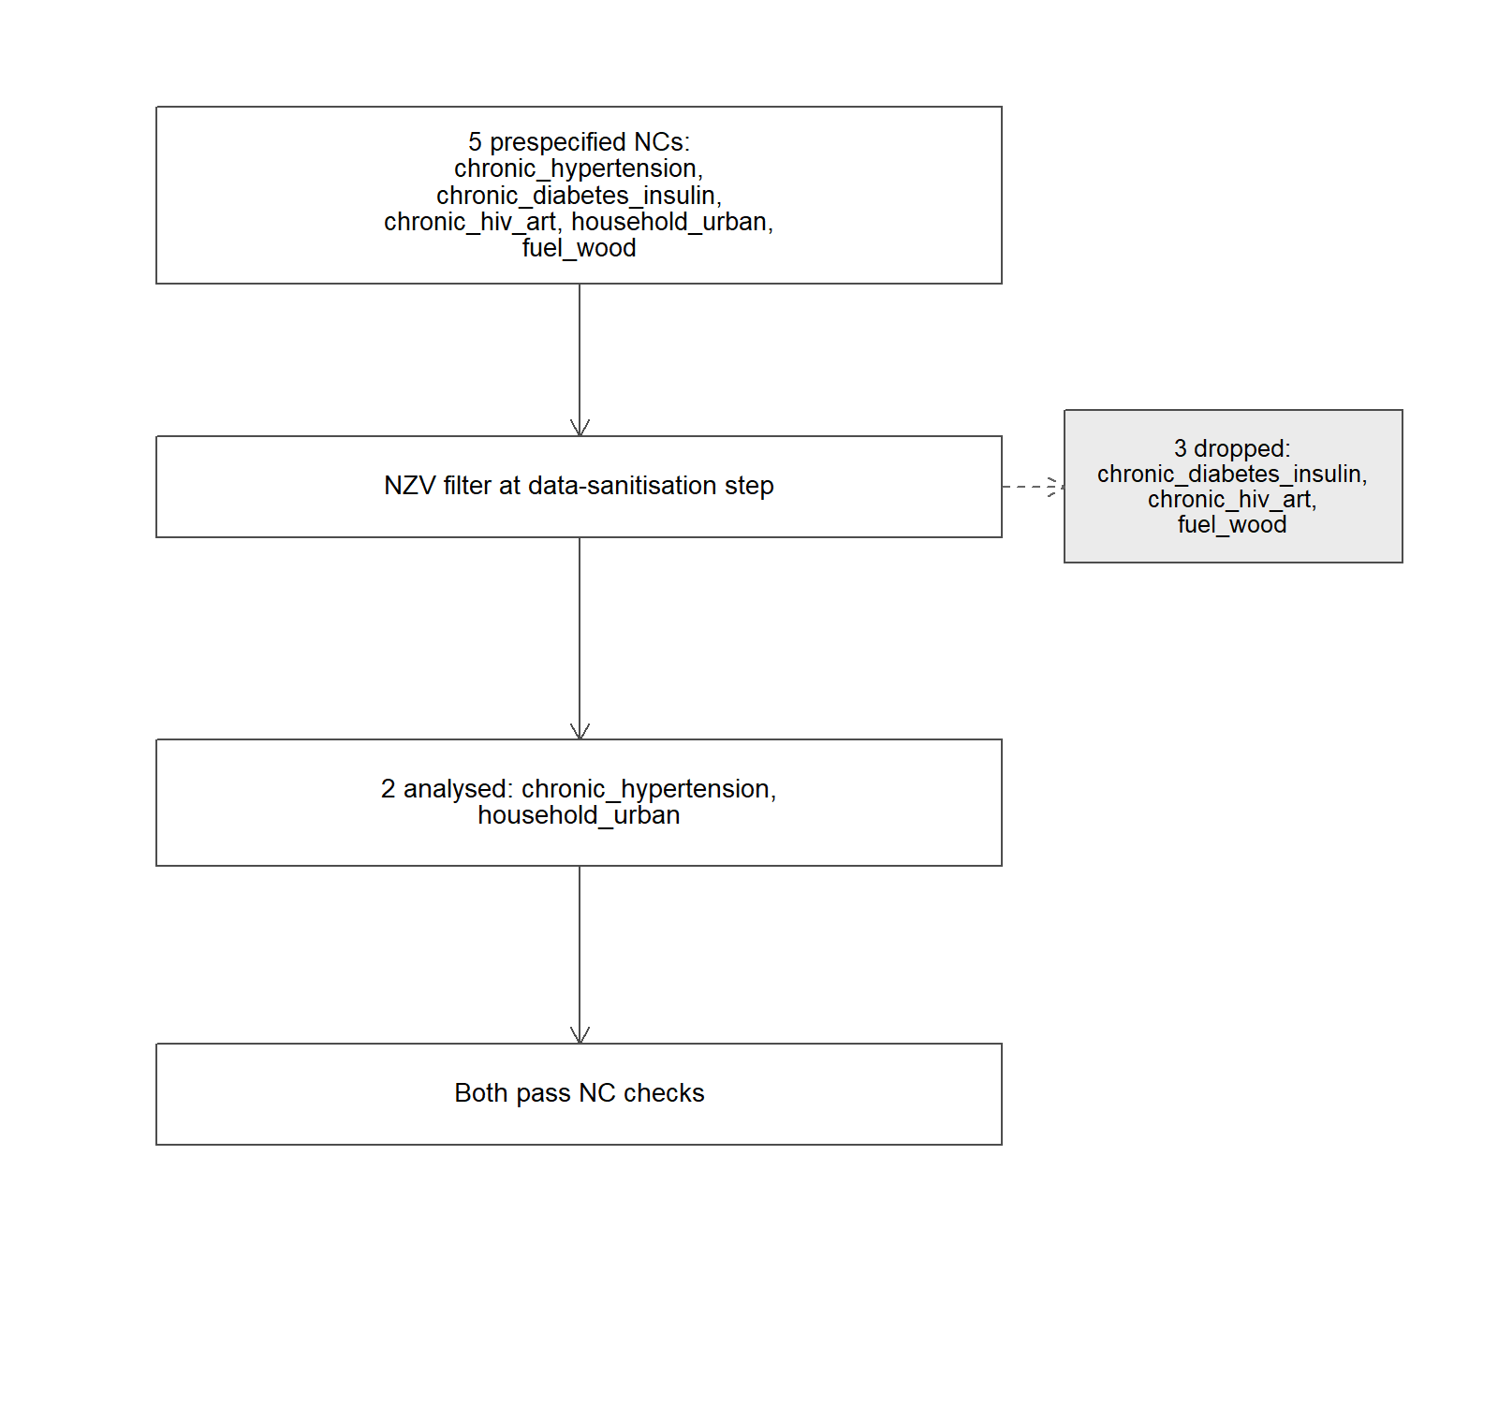
Figure 8: Negative-control attrition. Five negative-control endpoints were prespecified in the SAP. Three were dropped at the data-sanitisation step because they failed near-zero-variance (NZV) filtering on the locked cohort. The two surviving NCs (chronic_hypertension, household_urban) carried enough variation to fit a stable PS-adjusted model and both passed. The residual-confounding probe therefore rests on a narrower NC panel than originally specified; the audit log records the drops.
Demonstrated in this case study: cohort flow, event counts, missingness summary, PS overlap, three-way Love plot, weight diagnostics, ESS, negative-control attrition, baseline plasmode results, DQ stress-test results, authorisation gate. Not yet implemented in this release: native competing-risk cumulative-incidence estimands, time-varying treatment, MAR/MNAR missingness models, full-cohort Delta-path IPCW-TMLE (the function falls back to weighted complete-case), and the matched-vs-full plasmode diagnostic that would disambiguate whether the 0.5-to-1 percentage-point gap between the matched (RD = 0.026) and full-cohort (RD = 0.031) TMLE estimates is sampling noise plus the efficiency cost of matching, an effect- modification signal, or a positivity-strain signal. That diagnostic is on the cleanTMLE 0.2 roadmap.
At the pre-outcome decision point (authorize_outcome_analysis()), the two passing negative controls and the plasmode metrics support a GO classification. Three of the five prespecified negative-control endpoints (chronic_diabetes_insulin, chronic_hiv_art, and fuel_wood) were dropped from the NC analysis at the data-sanitisation step because they failed near-zero-variance filtering on the locked cohort; only chronic_hypertension and household_urban carried enough variation to fit a stable PS-adjusted model. The audit log records the three drops alongside the two passing checkpoints, and the residual-confounding argument in this study therefore rests on a narrower NC panel than the SAP originally specified. The analysis is then unmasked and the outcome-analysis functions run.

12.5 Effect estimates
Risk-difference estimates from six methods applied to the rescueCo binary outcome (good functional outcome at 6 months, GOSE > 4), produced under cleanTMLE 0.1.1. The IPCW-TMLE row uses a weighted complete-case implementation; see the text for details.
Method | Target population | N | RD | CI_lo | CI_hi
Crude (unadjusted) | Complete-outcome subset | 1277 | 0.0370 | 0.0031 | 0.0708
PS matching | Matched subset (overlap) | 615 | 0.0272 | -0.0198 | 0.0741
IPTW (stabilised) | Full eligible cohort | 1693 | 0.0366 | 0.0017 | 0.0714
Full-cohort TMLE | Full eligible cohort | 1693 | 0.0306 | -0.0012 | 0.0623
Matched-cohort TMLE | Matched subset (overlap) | 1230 | 0.0259 | -0.0150 | 0.0668
Complete-outcome TMLE with IPCW weights | Complete-outcome rows, weighted toward the full-cohort marginal contrast | 1277 | 0.0326 | -0.0004 | 0.0656
The six estimators agree on direction. The crude unadjusted contrast (RD = 0.037) and the stabilised IPTW (RD = 0.037) sit at the upper end of the range, with 95 % confidence intervals that exclude zero. The simulation-locked full-cohort TMLE (the prespecified primary estimator) returns RD = 0.031 with a 95 % CI that just crosses zero (−0.001, 0.062). The complete-outcome TMLE with IPCW weights, which uses inverse-probability-of-censoring weights to recover the full-cohort marginal contrast under the missingness model, returns RD = 0.033 with a CI that just crosses zero (−0.0004, 0.066). The two matching-based estimators give the smallest point estimates (RD = 0.027 for matched RD without further adjustment; RD = 0.026 for matched-cohort TMLE) and the widest CIs, reflecting the smaller matched-pair samples (n = 615 and n = 1230). The full-cohort TMLE remains the prespecified primary because it is doubly robust and uses the locked propensity-score truncation chosen at Stage 2b on the full cohort; the IPCW-TMLE is the prespecified missing-outcome sensitivity row.
Following Gruber, Lee, et al. (2024) (Step 5) and Dı́az and Laan (2013), we report a tipping-point bound on the simulation-locked full-cohort TMLE estimate via tipping_point_sensitivity(). The lower CI bound sits 0.0012 below zero, so the qualitative conclusion is already that the data are consistent with no effect; the function returns 0.0012 as the distance from zero. The IPTW estimate, whose lower bound is 0.0017 above zero, would be flipped through zero by a residual bias of 0.0017 (4.6 % of the IPTW point estimate). The E-value (VanderWeele and Ding 2017) for the full-cohort TMLE is 1.22 (CI bound 1.00), small in either case. The qualitative reading is “Rescue.Co transport is consistent with a small favourable shift in functional outcome; the prespecified primary estimator does not confirm the signal under the prespecified workflow at $α=0.05$, and the analysis proceeded under prespecified diagnostics.” An unmeasured confounder of the strength suggested by the healthcare-worker strike, or by the inter-facility transfer imbalance (40.7 % of non-Rescue.Co versus 2.5 % of Rescue.Co ambulance arrivals were transfers, all excluded from the analytic cohort), would push any of the six estimates further toward null.

12.6 What the case study tells us about the workflow

12.6.1 Prespecification, audit, and the pre-outcome decision
The decision log captured every prespecified analytic choice (transfer exclusion, GOSE construction, truncation thresholds) with timestamps. Outcome-analysis functions did not run until the prespecified workflow had been completed, and the analysis-lock fingerprint reconciled on every reload. One real gap surfaced: the audit trail did not capture covariates dropped for near-zero variance during data sanitisation, because those drops occurred upstream of the negative-control fits rather than at fit time. The cleanTMLE 0.1.1 fix only partially closes that gap. With that caveat, the prespecification and audit functions performed as described in Section 5.

12.6.2 Outcome-blind plasmode
Stage 2b feasibility coverage of 0.94 with bias below 0.001 across 50 replicates is the kind of design validation a reviewer would want. Stage 2c then runs the full DQ stress test (run_plasmode_dq_stress()) over the four threats and produces a structural pass on each scenario at 200 replicates per threat-severity cell (see Section 15 for the entry point). The four threats encoded by run_plasmode_dq_stress() (covariate MCAR, exposure misclassification, outcome misclassification, latent $U$) do not cover two design challenges that mattered in the rescueCo study, the strike-window confounder and the inter-facility transfer imbalance, which motivates the time-window and MAR / MNAR extensions planned for cleanTMLE 0.2.

12.6.3 Estimator functions and real-data robustness
Applying cleanTMLE 0.1.0 to the rescueCo lock surfaced more than a dozen distinct issues, six of them blocking, which the companion 0.1.1 release addresses. The marquee problem was that run_plasmode_dq_stress() failed with "mu must be a nonempty numeric vector" on a lock with NA in the outcome (now guarded). The step-by-step TMLE functions also refused to fit on NA outcomes (now subset to complete cases with an MCAR warning); fit_ps_superlearner() crashed on stale parallel backends (now defaults to plain sequential evaluation); make_table1() rejected a lock object (now accepts it); and run_residual_confounding_stage() silently dropped failed NC fits (now records each failure in the audit log). We document these candidly because the working theory of the framework is that the prespecification and audit functions should make problems visible, including problems with the package itself, rather than absorb them into a hand-edited final table.
The full release notes are in cleanTMLE/NEWS.md, and the rescueCo companion repository’s clean_room/results/manuscript_artifacts/ directory contains the data behind the tables above.

13. Discussion

13.1 What cleanTMLE contributes operationally
The package’s contribution is to make staged prespecification and the pre-outcome decision rule explicit in code and reproducible by an external reviewer. A precise test of scope is to ask what evidence the package can and cannot produce. cleanTMLE can document that the analyst prespecified the estimand, the candidate estimators, the decision thresholds, and the severity ranges; that the pre-outcome decision was made before unblinding; that the locked candidate was the one that ran on the real outcome; and that a fingerprinted audit trail records the sequence. cleanTMLE cannot demonstrate that the data source is fit for the regulatory question, that the exposure or outcome phenotypes have been validated, that the target population is the regulatory decision population, or that the unmeasured-confounder bound is defensible. Those remain study-level activities, anchored in target-trial protocols (M. A. Hernán and Robins 2016; Cashin et al. 2024), source-specific guidance (U.S. Food and Drug Administration 2024a, 2024b, 2021; European Medicines Agency 2024, 2026), and post-outcome sensitivity analyses (VanderWeele and Ding 2017; Lash et al. 2014; Dı́az and Laan 2013).

13.2 Regulatory positioning
The lock, audit, and decision-log records track the prespecification and traceability that current real-world-evidence guidance expects, as mapped in Table 9. The software layer sits inside the personnel-based governance this guidance requires, and does not substitute for it.

13.3 Comparison with adjacent tools
Table 7 places cleanTMLE against the nearest alternatives, to make explicit which capabilities are shared and which are specific to the package. The combination that distinguishes cleanTMLE is the outcome-blind plasmode candidate selection, the DQ stress test on the same decision scale, and the prespecification record (lock, audit trail, gate), bound to a doubly robust estimator layer that reproduces a mature cumulative-risk package (Section 12, and the side-by-side ACTG 320 reproduction in the companion repository).
Table 7: cleanTMLE against adjacent tools. The estimator layer overlaps with established packages; the outcome-blind selection, the DQ stress test, and the machine-checkable prespecification record are the distinguishing combination.
Capability | cleanTMLE | causalRisk | tmle / survtmle / lmtp | STaRT-RWE / HARPER + git/renv
Doubly robust TMLE | Yes | AIPW | Yes | No
Cumulative-risk / competing risks | Yes (binary point now; survival on roadmap) | Yes | survtmle / lmtp | No
Time-varying treatment | No (compose with lmtp) | Yes | lmtp | No
Outcome-blind plasmode candidate selection | Yes | No | No | No
Data-quality stress test (shared decision scale) | Yes | No | No | No
Prespecification lock + audit trail + staged decision gate | Yes | No | No | Paper template; not machine-checked
Fit-for-purpose to estimator-selection bridge | Yes | No | No | No

The contrast with the E-value is treated once in Section 10.1, where the post-hoc E-value and the pre-hoc, candidate-specific DQ stress test are shown to answer different questions and to be worth reporting together.
Quantitative bias analysis (Lash et al. 2014) adjusts the final estimate for postulated biases. Like the E-value, QBA is an unblinding-stage tool. The DQ stress test does not adjust the estimate; it asks whether the estimator continues to meet the prespecified performance criteria when the biases are present. We therefore recommend QBA at the analysis stage and the DQ stress test at the prespecification stage.
The targeted-learning causal-gap sensitivity analysis (Dı́az and Laan 2013) characterises the change in $Ψ$ as the unmeasured-confounder bound varies. Causal-gap is unblinding-stage and characterises one threat (unmeasured confounding) in a TL- specific way. The DQ stress test is broader (it covers four threats) but cruder (it does not adjust the estimate). The two tools address different questions and both should be reported.
Negative-control outcomes (Lipsitch, Tchetgen Tchetgen, and Cohen 2010) test for residual confounding in the realised data. Because they use real data, they are at-outcome rather than pre-outcome. The DQ stress test cannot detect residual confounding; the NCO check cannot detect covariate missingness or exposure misclassification. They target different threats. Muntner et al. (2024) recommend selecting NCOs across four domains (confounding by indication, functional status, health-seeking behaviour, and access to healthcare) and Levintow et al. (2023) give pragmatic guidance for choosing them; the cleanTMLE workflow records each declared NCO in the lock so the chosen domains are part of the audit trail.
Kent (2026) reports a worked applied use of the staging framework for a comparative-effectiveness study of evolocumab versus non-treatment for major adverse cardiovascular events in the Komodo Healthcare Map: negative-control outcomes flagged residual bias in the health-seeking-behaviour domain, the review team allowed the study to proceed conditional on a pre-specified E-value quantitative-bias-analysis plan, and the final risk difference at four years was reported as roughly $−4\%$. The example illustrates both the staged decision rule and the role of negative-control domains in practice.

13.4 Limitations of plasmode data-quality stress testing
A plasmode data-quality stress test is only as informative as the synthetic outcome model and degradation mechanisms used to generate it. Passing the pre-outcome decision rule does not establish identification, remove unmeasured confounding, validate the data source, or demonstrate that the target population matches the regulatory decision population. It shows only that, under the prespecified outcome-generating mechanism and degradation ranges, a candidate estimator maintained acceptable finite-sample performance according to the chosen criteria. Severity ranges should therefore be justified from external validation studies, data profiling, subject-matter knowledge, expert elicitation, or formal sensitivity-analysis bounds. When such evidence is weak, the stress test should be interpreted as exploratory rather than confirmatory.
The DQ stress test also depends on the same parametric synthetic-outcome model used by the baseline plasmode. If that model misrepresents the joint covariate–treatment–outcome distribution (for example by omitting effect modification or mis-specifying functional form), the simulated bias and coverage under stressed scenarios may be optimistic or pessimistic in ways that no amount of replication can correct.

13.5 Other limitations
The current implementation has additional limitations the analyst should keep in mind, grouped into the candidate-selection rule, model assumptions, computational cost, and estimand scope.

13.5.1 Candidate-selection rule (FIORD alignment)
The FIORD outcome-blind simulation guidance (Nance et al. 2026) separates candidate selection into two tasks: first screen point estimators by oracle coverage (a CI built from the Monte Carlo empirical SE) and pick the lowest-variance survivor, then select the variance method on the locked point estimator using nominal CI coverage. cleanTMLE implements both stages. Stage one is select_tmle_candidate(rule = "fiord_two_stage"), which screens candidates to those within fiord_coverage_tol of nominal oracle coverage and locks in the lowest-SE survivor (the default rule = "min_rmse", optionally "min_max_rmse" over the DQ stress scenarios, remains available as a single-step alternative). Stage two is select_variance_method(), which, with the point estimator fixed, compares variance methods by their oracle coverage on synthetic data and returns the one closest to nominal; bootstrap_rd_variance() supplies a native nonparametric bootstrap standard error and percentile interval for the marginal risk difference under TMLE or stabilised IPTW. The bootstrap is one option when the influence-function variance is suspect. For stabilised IPTW the influence-function variance treats the propensity score as known (J. M. Robins and Rotnitzky (1992)), and resampling does not remove that conservatism, so the bootstrap interval is reported alongside the influence-function interval and the better-calibrated one is chosen on oracle coverage. For a matched cohort the standard nonparametric bootstrap is not consistent (Abadie and Imbens (2008)), and the full-pipeline re-matching variant is reported as an empirical correction. The remaining limitation is practical. The variance-method stage is exposed as a separate call and is not folded into a single run_* wrapper, and the bootstrap multiplies computation, so analysts reserve it for the estimators where the IF variance is known to misbehave.

13.5.2 Model assumptions
The covariate-missingness scenario assumes MCAR. MAR and MNAR mechanisms require an explicit missingness model and are not yet supported. The principled alternative is inverse-probability-of- missingness weighting, which weakens the assumption to stratified MCAR; we plan to add a native cleanTMLE implementation in a future release.
The plasmode DGP itself is parametric. The outcome is generated from a logistic regression of $Y$ on $W$ fitted to the lock data, and the synthetic effect is constant on the risk-difference scale ($p_{1}^{\text{sim}}=p_{0}^{\text{sim}}+Δ$). Effect modification, time-varying treatment, and competing risks would need a richer DGP. The package architecture permits these extensions; the simulation reported here does not exercise them. cleanTMLE 0.2.1 adds a q0_library argument to run_plasmode_feasibility() so the analyst can fit Q0 with a SuperLearner library rather than the default logistic GLM; this relaxes the bias of candidate selection toward linear-in-logit learners when the underlying outcome surface is nonlinear. A companion pilot simulation (plasmode_selection_paper/) provides the empirical motivation: at n = 500, a logistic-GLM Q0 yields no detectable separation between fixed-library and plasmode- selected TMLE workflows because both inherit the same linearity bias.
The plausible degradation ranges have to come from external evidence. The software cannot decide whether 5 % or 20 % covariate missingness is realistic for a given data source; the analyst has to cite a profiling or validation study. SPIFD2 makes the same demand qualitatively, and the DQ stress test inherits it.

13.5.3 PS candidate grid and learner stability
The DQ stress test generates synthetic outcomes under degraded covariate, treatment, and confounder distributions, and then re-fits every candidate PS model on each synthetic dataset. The synthetic designs for Scenario B (marginal overlap, PS range 0.037–0.990) produced numerical instability in regularised learners: SL.glmnet ran away on computation with no convergence signal, inflating wall time by more than an order of magnitude relative to GLM. The simulation in Section 9 therefore uses a two-candidate GLM PS grid ($t∈\{0.01,0.05\}$) for the DQ stress test; SL.glmnet is retained in the SuperLearner library for the cross-fitted TMLE nuisance fits, where it operates on the full (undegraded) observed-data sample. In practice, the GLM and regularised-learner PS produce near-identical plasmode metrics on the simple logistic DGP used here, so the omission does not change the candidate-selection outcome. Analysts with more complex DGPs or learner libraries that include tree-based or spline models should profile DQ-stress runtime on a small representative run before committing to a full grid.

13.5.4 Computational cost
Each scenario $×$ severity adds a full set of plasmode replicates. With the configuration of Section 9 (30 replicates per cell, nine degraded severity cells plus one undegraded baseline, and two PS candidates) the test fits 600 TMLE models per Monte Carlo scenario. For the three simulation scenarios combined, this totals 1,800 models, which completes in roughly three hours on a modern laptop. Larger candidate grids or higher replicate counts scale linearly; parallelising over severity cells is the most direct route for interactive use.

13.5.5 Estimand scope
The running estimand in this paper is the marginal risk difference for a binary point exposure. Counterfactual hazard ratios are available in survtmle (Benkeser and Hejazi 2018) but are not yet wrapped into the cleanTMLE staged workflow. Sites that need hazard-ratio estimation can call that package directly and feed the output through the same lock and audit trail.
Several other estimand families sit outside cleanTMLE’s current scope: counterfactual cumulative-incidence curves with competing risks, cumulative-count IPW, multinomial treatments, and the SMR / overlap / normalised / stabilised weight families. cleanTMLE in this release narrows to binary-treatment risk-difference TMLE; analysts who need the broader estimand surface have access to survtmle and lmtp (Williams and Dı́az 2021) as alternative implementations.

13.6 Future extensions
The most consequential extensions, in priority order, are:
- Single-call FIORD alignment. Both FIORD stages are now implemented (select_tmle_candidate(rule = "fiord_two_stage") for the point estimator, and select_variance_method() with bootstrap_rd_variance() for the variance method; see also Mertens, Zhang, et al. (2024)). Folding the variance stage into a single run_* wrapper and caching the bootstrap would make full FIORD alignment the one-call default rather than two explicit steps.
- Operating-characteristic validation of the variance selector at scale, paired with the gate validation in Section 11, so the variance-method choice is itself shown to recover nominal coverage across a range of data-generating processes.
- Unmeasured-confounding severity gradient: vary the strength of the latent-U scenario across a prespecified grid rather than running a single strong-U setting, so the DQ stress test produces an E-value-style sensitivity curve as a by-product.
- Pre-protocol stress-test mode: allow the plasmode and DQ stress test to run on user-specified covariate distributions and treatment-mechanism strength (no real data required) so that investigators can decide which dataset to use before any data-use agreement is signed.
- DGP-spectrum argument for the plasmode generator: structural- equation (simcausal-style), hybrid (current default), and parametric-bootstrap modes, with synthetic-data fidelity metrics (Hellinger / Wasserstein, or covariate SMDs between real and synthetic samples) so the analyst can judge whether the DGP is faithful enough to base candidate selection on.
- Matched-cohort vs full-cohort plasmode diagnostic: under a known synthetic truth, compare the two estimators side by side to diagnose whether observed real-data gaps are sampling noise or positivity-driven.
- Richer synthetic-outcome models: effect modification, time- varying treatment, and competing risks (the current DGP is a logistic regression with a constant additive effect on the risk-difference scale).
- MAR / MNAR missingness: a native inverse-probability-of- missingness weighting path that does not require a structural missingness model.
- Survival and competing-risk estimands: wrapping survtmle (Benkeser and Hejazi 2018) and lmtp (Williams and Dı́az 2021) (and ltmle for the longitudinal FIORD setting) inside the lock and audit machinery so that hazard-ratio and cumulative- incidence estimands inherit the same governance.
- Transportability and decision-population shift: the plasmode framework can in principle simulate covariate- distribution shift between the analytic cohort and the target population, but the package does not yet expose this scenario.
- Calibration helpers for severity ranges: small helpers that read validation-literature parameters (PPV, sensitivity, claims- accuracy ranges) from a YAML file and translate them into data_quality_scenarios lists, with the citations attached to the audit log.

13.7 When to use cleanTMLE inside a broader governance arrangement
For exploratory or lower-stakes RWE studies, cleanTMLE used on its own may be adequate to document and audit outcome-blind estimator selection: the analyst prespecifies the analytic plan, runs the workflow inside a single R session, and archives the analysis lock together with the audit and decision logs. For high-stakes regulatory or confirmatory studies (FDA, EMA, or HTA submission contexts), cleanTMLE should be embedded within personnel-based outcome-blinding and access-control arrangements. That deployment places cleanTMLE inside a broader governed process with separate study-level work items: source-data audit and provenance, exposure and outcome phenotype validation, role-separated analyst and reviewer access, and an independent review of the pre-outcome decision by personnel who did not author the analytic plan. The software-mediated workflow records that the prespecified contract has been followed; the governed process establishes that the contract is the right one (Muntner et al. 2024; U.S. Food and Drug Administration 2018; European Medicines Agency 2024).

13.8 Recommendations for practice
A fillable SAP template aligned with the prespecification checklist of Gruber, Lee, et al. (2024) and the staging construct of Muntner et al. (2024) is shipped with the package as system.file("templates", "sap_template.qmd", package = "cleanTMLE"). The template walks the analyst through the eight-section structure (estimand under ICH E9(R1), identifiability assumptions and DQ mappings, candidate grid, decision thresholds, NC domain coverage, sensitivity plan, decision log, reporting checklist) so that the prespecification is filed in the same form that the audit log will later reference.
We recommend a four-step pre-outcome workflow when the analyst is preparing a TL-RWE study.
- Document the SPIFD2 template, citing validation studies or data profiling for each plausible range.
- Lock the candidate grid and the decision thresholds before any simulation runs.
- Run run_plasmode_feasibility() and run_plasmode_dq_stress() in the same prespecified Stage 2b. Use the SPIFD2-derived ranges as the inputs to data_quality_scenarios.
- Score the pre-outcome decision. If a candidate is robust to the SPIFD2 plausible ranges, lock it. If no candidate is robust, the correct decision is STOP, and the analyst should reconsider either the data source, the estimand, or the decision thresholds before unblinding.
The audit log preserves all of the above. The final paper or regulatory submission can be reconstructed from the lock and the audit, including the SPIFD2 ranges, the plasmode and DQ stress metrics, the pre-outcome decision, and the post-outcome estimate.

14. Summary
cleanTMLE is an R package for staged, outcome-blind targeted learning that produces reproducible prespecification records. It extends the outcome-blind plasmode loop of Dang et al. (2023) and Gruber, Lee, et al. (2024) with four data-quality degradation mechanisms, producing per-candidate degradation gradients on the same bias / RMSE / coverage scale as the baseline plasmode so the prespecified decision rule can be applied uniformly to both. A constructed demonstration (Section 10) shows that the worst-case selection rule can select a different candidate from the baseline rule, so screening candidates against data-quality threats can change which estimator is locked. This is a quantitative bridge from qualitative data-fitness concerns to prespecified outcome-blind plasmode stress-test scenarios; the package does not itself determine whether a data source is fit for purpose, and the severity ranges entered into the stress test must come from prior validation studies, data profiling, or expert elicitation. The analysis-lock object, audit log, and decision log persist the prespecification as reproducible records that downstream estimation functions check before running. The package is available at https://github.com/amertens/cleanTMLE; the simulation code for the results in Section 9 is in the companion repository https://github.com/amertens/clean-room-sim.

15. Reproducibility
The cleanTMLE package ships 17 testthat test files covering the core workflow: analysis-lock creation and validation, staged checkpoints and decision thresholds, DQ stress-test mechanics and degradation gradients, bootstrap and influence-function variance estimators (including the "match_tmle" estimator), event-process helpers, plasmode simulation, stage-gate authorisation, estimator ground-truth comparisons against tmle::tmle(), and reporting tables. Tests are run on every push via the repository’s continuous-integration configuration (cleanTMLE/tests/testthat/). The experimental time-to-event estimators have separate test files and are tagged accordingly.
The simulation results reported in this paper are produced by three scripts in the companion repository (https://github.com/amertens/clean-room-sim). Each script writes its output to the results/ directory, which is tracked in the repository for the files listed below.
Script-to-output map. Running the scripts in order fully regenerates the tracked simulation outputs; rendering the .qmd then produces all figures and tables. The underscore-prefixed scripts (dev/) are diagnostic utilities not required for manuscript reproduction.
Script | Output file(s) | Figures / tables
run_simulation.R | results/simulation_results.rds | Table 3, Figure 1, Figure 2, Figure 3, Figure 4, Figure 5
run_gate_operating_characteristics.R | results/gate_oc.rds | Section 11 figures
_bootstrap_variance.R | results/bootstrap_variance.rds, results/bootstrap_variance.csv | Table 4
inst/extdata/rescueco_dq_full.R | results/rescueco_dq_full.rds | Case-study DQ subsection (Section 12.4)
sandbox/candidate_divergence/divergence_study.R | candidate_divergence_full.rds, degradation_gradient.png | Section 10 (Figure 6)
The case-study DQ results reported in Section 12.4 use the 200-replicate run produced by inst/extdata/rescueco_dq_full.R. The bundled configuration (config/clean_room_config.yml) runs Stage 2c at 3 replicates per threat-severity cell as a continuous-integration smoke test, which is not used for any reported result.

Appendix

15.1 Conceptual layers of the workflow
Table 8 distinguishes the conceptual layers that the workflow keeps separate, and serves as a reference for which decisions are addressed at the design stage versus the estimation stage.
Table 8: Conceptual layers in the staged workflow. The same vocabulary is used throughout the manuscript to keep estimand, estimator, simulation, and decision rule distinct.
Layer | Description
Causal question | Clinical or policy question framed as a target trial or causal contrast.
Causal estimand | Counterfactual treatment effect of interest (e.g. marginal risk difference).
Identification assumptions | Conditions under which the causal estimand can be expressed as an observed-data parameter (exchangeability, positivity, consistency, measurement validity, missingness assumptions).
Statistical estimand | Observed-data parameter identified under the assumptions above.
Estimator | Algorithm used to estimate the statistical estimand, for example TMLE, IPTW, or matching.
Pre-outcome diagnostic metric | Pre-outcome quantity used for design checks: simulated bias, RMSE, coverage, effective sample size, balance, negative-control performance.
Governance decision | Whether prespecified criteria support proceeding, require additional review, or require stopping the analysis before the outcome is examined.

15.2 The package inside the causal roadmap
Figure 9 shows where the package sits in the roadmap, and Figure 10 shows the software arrangement as one layer of a broader governance stack in which external validation, independent oversight, and data standards remain necessary inputs to the pre-outcome decision.
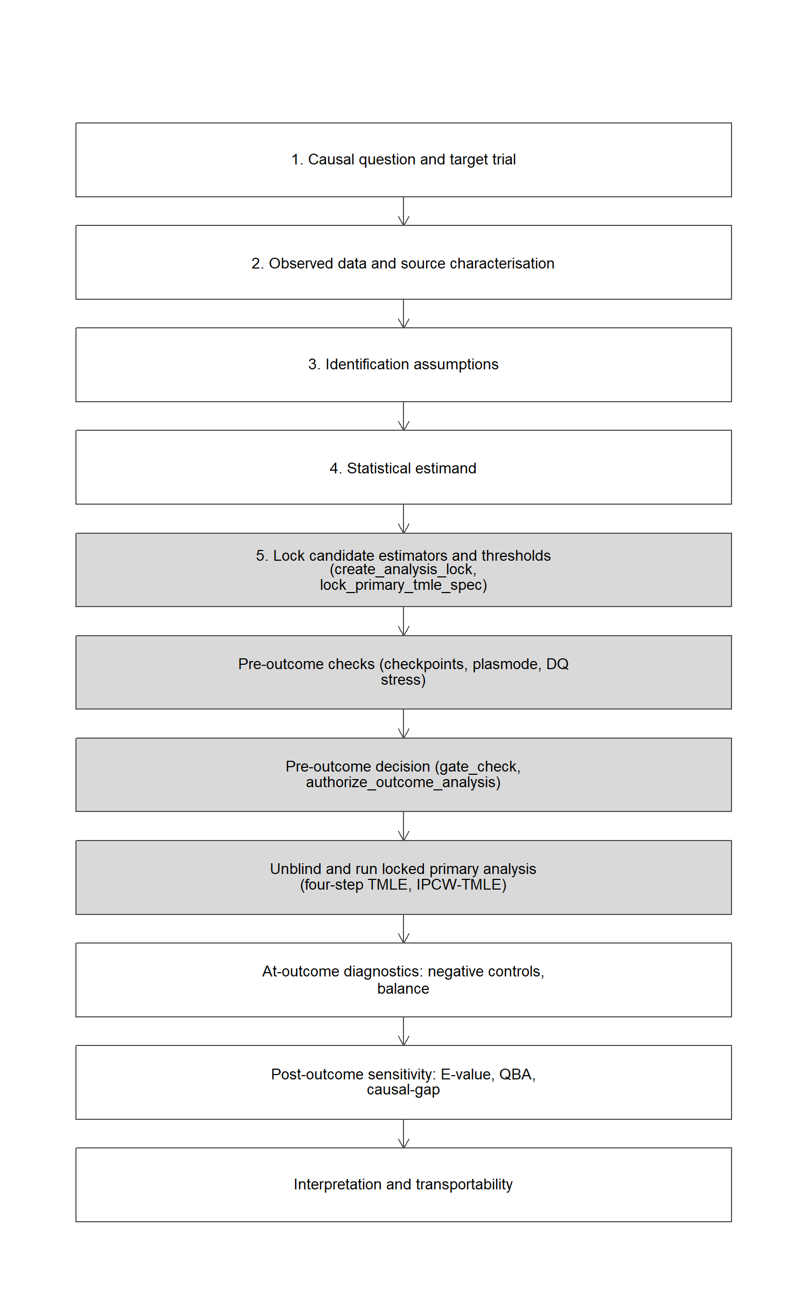
Figure 9: cleanTMLE inside the causal roadmap. Boxes shaded grey indicate work that the package can operationalise; the remaining boxes are external study-level activities.

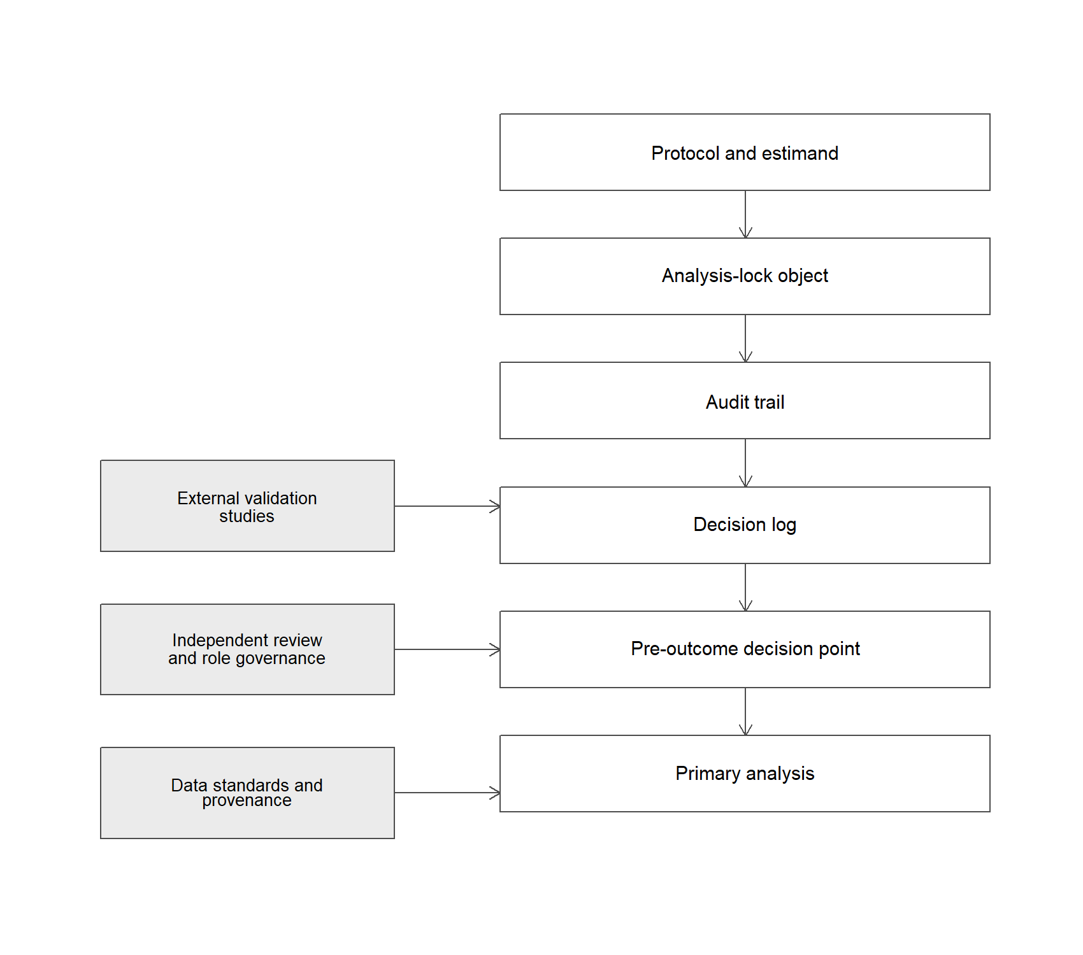
Figure 10: Governance layers. The software-level arrangement is necessary but not sufficient for regulatory or confirmatory RWE; external validation, independent review, and data standards feed the pre-outcome decision.

15.3 Regulatory alignment
Table 9 maps each roadmap component to the corresponding manuscript section, the relevant FDA, EMA, and ICH expectation, what cleanTMLE can operationalise in software, and what still requires external study-level justification. The final column is the one that distinguishes the software-level workflow from the broader regulatory governance arrangement.
Table 9: Mapping of causal-roadmap components to manuscript sections, regulatory anchors, what cleanTMLE operationalises, and what still requires external study-level justification.
Roadmap component | Manuscript section | FDA / EMA / ICH anchor | What cleanTMLE operationalises | External study-level work still required
Causal question / target trial | Section 4 | Hernán target-trial framework; FDA RWE Framework; ICH M14 (March 2026) | (none) | Full target-trial protocol
Observed data and source characterisation | Section 4, Section 12 | FDA EHR/claims, registries; EMA registry guideline; EMA RWD quality framework | Lock fingerprint of column names + data shape | Phenotype validation, data lineage, source audit
Identification assumptions | Section 4.4 | ICH E9(R1) | Records assumptions in attach_estimand and audit log | Subject-matter justification of exchangeability and positivity
Statistical estimand | Section 4 | ICH E9(R1); FDA Considerations for RWD/RWE | attach_estimand, lock fingerprint | Source-specific operationalisation of intercurrent events
Estimator selection and locking | Section 5, Section 8 | FDA non-interventional studies; ICH M14 (March 2026) | tmle_candidate, lock_primary_tmle_spec, save_lock | Justification of SuperLearner library and severity grids
Pre-outcome data-quality stress | Section 6 | Source-specific reliability (FDA/EMA); validation evidence | run_plasmode_dq_stress, default_dq_scenarios | External validation evidence anchoring DQ severity ranges
Stage gate | Section 7 | Internal protocol governance; FDA traceability | gate_check, gate_all, authorize_outcome_analysis | Independent review of the pre-outcome decision
Outcome analysis | Section 8 | FDA Considerations for RWD/RWE | fit_tmle_treatment/outcome_mechanism, run_ipcw_tmle | Role separation, oversight, deviation memos
At-outcome diagnostics | Section 13 | EMA RWE Guide; FDA non-interventional studies | run_negative_control(_tmle), checkpoint_residual_bias | Choice of negative-control outcomes and domains
Post-outcome sensitivity analyses | Section 13 | FDA non-interventional studies; ICH E9(R1) sensitivity | compute_evalue, tipping_point_sensitivity, sensitivity_truncation | Quantitative bias analysis tailored to study threats

15.4 Event-process and diagnostic helpers
Table 10 lists the additional event-process and diagnostic structures the package makes explicit, paired with the helper that produces each one.
Table 10: Supplementary mapping. Event-process and diagnostic structures that the package makes explicit, paired with the helper that produces each one.
Component | cleanTMLE function | Purpose
Event-process classification | clean_event_process_table | Map each post-baseline event to its role in the estimand and ICH E9(R1) intercurrent-event strategy.
Target population and reference group | clean_target_population | Force explicit declaration of the population and reference group for every contrast.
Treatment, censoring, and missingness weight diagnostics | clean_weight_diagnostics | Report percentiles, ESS, extreme-weight counts, and weighted SMDs for each weight vector used.
Competing-risk and composite-risk coherence check | clean_check_event_processes | Verify that event-of-interest plus competing-event cumulative incidences are coherent with the composite risk.
Cumulative-risk reporting table | clean_risk_report_table | Single structured table of cumulative risks, contrasts, event counts, and estimator name.
Hazard-ratio de-emphasis | (documented preference; HR as secondary) | Cumulative risks, risk differences, and risk ratios are the primary summaries; hazard ratios are reported only as secondary when the estimand is explicitly hazard-based.

Acknowledgements
We thank the targeted-learning RWE roadmap authors (Dang, Gruber, Phillips, Lee, Ho, van der Laan, Petersen, and colleagues), whose published frameworks this software builds on, and the broader cumulative-risk pharmacoepidemiology literature whose estimand framing motivated several of our diagnostic helpers. Any errors are ours.

References
Abadie, Alberto, and Guido W. Imbens. 2008. “On the Failure of the Bootstrap for Matching Estimators.” Econometrica 76 (6): 1537–57. https://doi.org/10.3982/ECTA5444.
Austin, Peter C. 2009. “Balance Diagnostics for Comparing the Distribution of Baseline Covariates Between Treatment Groups in Propensity-Score Matched Samples.” Statistics in Medicine 28 (25): 3083–3107. https://doi.org/10.1002/sim.3697.
Benkeser, David, and Nima S. Hejazi. 2018. “Survtmle: Compute Targeted Minimum Loss-Based Estimates in Right-Censored Survival Settings.”
Cashin, A. G., H. J. Hansford, T. R. Stanton, et al. 2024. “TARGET: Target Trial Reporting Tool for Observational Studies.” BMJ. https://doi.org/10.1136/bmj-2024-080483.
Chernozhukov, Victor, Denis Chetverikov, Mert Demirer, Esther Duflo, Christian Hansen, Whitney Newey, and James Robins. 2018. “Double/Debiased Machine Learning for Treatment and Structural Parameters.” The Econometrics Journal 21 (1): C1–68. https://doi.org/10.1111/ectj.12097.
Dang, Lauren E., Susan Gruber, Hana Lee, Issa J. Dahabreh, Elizabeth A. Stuart, Brian D. Williamson, Richard Wyss, et al. 2023. “A Causal Roadmap for Generating High-Quality Real-World Evidence.” Journal of Clinical and Translational Science 7 (1): e212. https://doi.org/10.1017/cts.2023.635.
Dı́az, Iván, and Mark J. van der Laan. 2013. “Sensitivity Analysis for Causal Inference Under Unmeasured Confounding and Measurement Error Problems.” The International Journal of Biostatistics 9 (2): 149–60. https://doi.org/10.1515/ijb-2013-0004.
European Medicines Agency. 2021. “Guideline on Registry-Based Studies.” https://www.ema.europa.eu/en/guideline-registry-based-studies-scientific-guideline.
———. 2024. “Guide on Real-World Evidence Provided by EMA to Support Regulatory Decision-Making.” https://www.ema.europa.eu/en/about-us/how-we-work/big-data/real-world-evidence.
———. 2026. “Real-World Data Data-Quality Framework for EU Medicines Regulation.”
Franklin, Jessica M., Sebastian Schneeweiss, Jennifer M. Polinski, and Jeremy A. Rassen. 2014. “Plasmode Simulation for the Evaluation of Pharmacoepidemiologic Methods in Complex Healthcare Databases.” Computational Statistics & Data Analysis 72: 219–26. https://doi.org/10.1016/j.csda.2013.10.018.
Gatto, Nicolle M., Robert F. Reynolds, and Ulka B. Campbell. 2022. “The Structured Process to Identify Fit-for-Purpose Data: A Data Feasibility Assessment Framework.” Clinical Pharmacology & Therapeutics 111 (1): 122–34. https://doi.org/10.1002/cpt.2466.
Gatto, Nicolle M., Sarah E. Vititoe, Emily Rubinstein, Robert F. Reynolds, and Ulka B. Campbell. 2023. “A Structured Process to Identify Fit-for-Purpose Study Design and Data to Generate Valid and Transparent Real-World Evidence for Regulatory Uses.” Clinical Pharmacology & Therapeutics 113 (6): 1235–39. https://doi.org/10.1002/cpt.2883.
Gruber, Susan, Hana Lee, Rachael V. Phillips, Martin Ho, and Mark J. van der Laan. 2024. “Developing a Targeted Learning-Based Statistical Analysis Plan.” Statistics in Biopharmaceutical Research 16 (1): 1–15. https://doi.org/10.1080/19466315.2022.2116104.
Gruber, Susan, Rachael V. Phillips, Hana Lee, John Concato, and Mark J. van der Laan. 2024. “Evaluating and Improving Real-World Evidence with Targeted Learning.” BMC Medical Research Methodology 24 (1): 1–14. https://doi.org/10.1186/s12874-024-02244-z.
Hernán, M. A., and J. M. Robins. 2016. “Using Big Data to Emulate a Target Trial When a Randomized Trial Is Not Available.” American Journal of Epidemiology 183 (8): 758–64. https://doi.org/10.1093/aje/kwv254.
Hernán, Miguel A., and James M. Robins. 2016. “Using Big Data to Emulate a Target Trial When a Randomized Trial Is Not Available.” American Journal of Epidemiology 183 (8): 758–64. https://doi.org/10.1093/aje/kwv254.
———. 2020. Causal Inference: What If. Boca Raton: Chapman & Hall/CRC.
International Council for Harmonisation. 2019. “ICH E9(R1) Addendum on Estimands and Sensitivity Analysis in Clinical Trials.”
———. 2026. “ICH M14 Guidance for Industry: General Principles on Planning, Designing, and Analyzing Non-Interventional Studies Using Real-World Data for Safety Assessment of Medicines.”
Kahn, Michael G., Tiffany J. Callahan, Juliana Barnard, Alan E. Bauck, Jeffrey Brown, Bruce N. Davidson, Hossein Estiri, et al. 2016. “A Harmonized Data Quality Assessment Terminology and Framework for the Secondary Use of Electronic Health Record Data.” EGEMS (Washington, DC) 4 (1): 1244. https://doi.org/10.13063/2327-9214.1244.
Kent, Shia T. 2026. “A Staging Framework to Facilitate Transparency and Reduce Bias in Comparative Analyses of Real-World Data.” Conference presentation, 4th Annual Forum on the Integration of Observational and Randomized Data (FIORD), Day 1 Lunch session.
Lash, Timothy L., Matthew P. Fox, Richard F. MacLehose, George Maldonado, Lawrence C. McCandless, and Sander Greenland. 2014. “Good Practices for Quantitative Bias Analysis.” International Journal of Epidemiology 43 (6): 1969–85. https://doi.org/10.1093/ije/dyu149.
Levintow, Sara N., Carrie M. Nielson, Rohini K. Hernandez, and M. Alan Brookhart. 2023. “Pragmatic Considerations for Negative Control Outcome Studies to Guide Non-Randomized Comparative Analyses: A Narrative Review.” Pharmacoepidemiology and Drug Safety 32 (6): 599–606. https://doi.org/10.1002/pds.5623.
Lipsitch, Marc, Eric Tchetgen Tchetgen, and Ted Cohen. 2010. “Negative Controls: A Tool for Detecting Confounding and Bias in Observational Studies.” Epidemiology 21 (3): 383–88. https://doi.org/10.1097/EDE.0b013e3181d61eeb.
McGrath, Leah J., Carrie M. Nielson, Bradley Saul, J. Bradley Layton, Kathleen E. Hurwitz, Mary Wernecke, Michele Jonsson Funk, Brian D. Bradbury, and M. Alan Brookhart. 2021. “Lessons Learned Using Real-World Data to Emulate Randomized Trials: An Application in Romiplostim Treatment for Immune Thrombocytopenia.” Clinical Pharmacology & Therapeutics 110 (6): 1570–78. https://doi.org/10.1002/cpt.2399.
Mertens, Andrew, Zhiwei Zhang, et al. 2024. “Bootstrap Variance Estimation for TMLE Under Positivity Strain in a Danish Registry Comparative-Effectiveness Study.” Working Paper.
Muntner, Paul, Rohini K. Hernandez, Shia T. Kent, James E. Browning, David T. Gilbertson, Kathleen E. Hurwitz, Susan S. Jick, et al. 2024. “Staging and Clean Room: Constructs Designed to Facilitate Transparency and Reduce Bias in Comparative Analyses of Real-World Data.” Pharmacoepidemiology and Drug Safety 33 (3): e5770. https://doi.org/10.1002/pds.5770.
Nance, Nerissa, Susan Gruber, Hashim Khan, Lina Han, Maya Petersen, Andrew Mertens, Mark J. van der Laan, and FIORD collaborators. 2026. “Simulations to Specify Estimation Choices in Causal Analyses: A Longitudinal Case Study.” Journal of Clinical and Translational Science.
Petersen, Maya L., and Mark J. van der Laan. 2014. “Causal Models and Learning from Data: Integrating Causal Modeling and Statistical Estimation.” Epidemiology 25 (3): 418–26. https://doi.org/10.1097/EDE.0000000000000078.
Phillips, Rachael V., Mark J. van der Laan, Hana Lee, and Susan Gruber. 2023. “Practical Considerations for Specifying a Super Learner.” International Journal of Epidemiology 52 (4): 1276–85. https://doi.org/10.1093/ije/dyad023.
R Core Team. 2024. “R: A Language and Environment for Statistical Computing.” Vienna, Austria: R Foundation for Statistical Computing. https://www.R-project.org/.
Robins, James. 1986. “A New Approach to Causal Inference in Mortality Studies with a Sustained Exposure Period.” Mathematical Modelling 7 (9-12): 1393–1512.
Robins, James M., and Andrea Rotnitzky. 1992. “Recovery of Information and Adjustment for Dependent Censoring Using Surrogate Markers,” 297–331.
Schreck, N. et al. 2024. “Plasmode Simulation in Pharmacoepidemiology: A Review of Strengths and Pitfalls.” Pharmacoepidemiology and Drug Safety.
Schuler, Megan S., and Sherri Rose. 2017. “Targeted Maximum Likelihood Estimation for Causal Inference in Observational Studies.” American Journal of Epidemiology 185 (1): 65–73. https://doi.org/10.1093/aje/kww165.
Stefanski, Leonard A., and Dennis D. Boos. 2002. “The Calculus of M-Estimation.” The American Statistician 56 (1): 29–38. https://doi.org/10.1198/000313002753631330.
U.S. Food and Drug Administration. 2018. “Framework for FDA’s Real-World Evidence Program.” https://www.fda.gov/media/120060/download.
———. 2021. “Real-World Data: Assessing Registries to Support Regulatory Decision-Making for Drug and Biological Products.” https://www.fda.gov/regulatory-information/search-fda-guidance-documents/real-world-data-assessing-registries-support-regulatory-decision-making-drug-and-biological-products.
———. 2024a. “Considerations for the Use of Real-World Data and Real-World Evidence to Support Regulatory Decision-Making for Drug and Biological Products.” https://www.fda.gov/regulatory-information/search-fda-guidance-documents/considerations-use-real-world-data-and-real-world-evidence-support-regulatory-decision-making-drug.
———. 2024b. “Real-World Data: Assessing Electronic Health Records and Medical Claims Data to Support Regulatory Decision-Making for Drug and Biological Products.” https://www.fda.gov/regulatory-information/search-fda-guidance-documents/real-world-data-assessing-electronic-health-records-and-medical-claims-data-support-regulatory.
———. 2024c. “Real-World Evidence: Considerations Regarding Non-Interventional Studies for Drug and Biological Products.” https://www.fda.gov/regulatory-information/search-fda-guidance-documents/real-world-evidence-considerations-regarding-non-interventional-studies-drug-and-biological-products.
VanderWeele, Tyler J., and Peng Ding. 2017. “Sensitivity Analysis in Observational Research: Introducing the E-Value.” Annals of Internal Medicine 167 (4): 268–74. https://doi.org/10.7326/M16-2607.
Wang, Shirley V., Sebastian Pinheiro, Wei Hua, Peter Arlett, Yoshiaki Uyama, Jesse A. Berlin, Dorothee B. Bartels, Kristijan H. Kahler, Lily G. Bessette, and Sebastian Schneeweiss. 2021. “STaRT-RWE: Structured Template for Planning and Reporting on the Implementation of Real World Evidence Studies.” BMJ 372: m4856. https://doi.org/10.1136/bmj.m4856.
Wang, Shirley V., Sushama Sreedhara, and Sebastian Schneeweiss. 2023. “HARPER: Recommendations for the Development and Reporting of Pharmacoepidemiologic Studies Using Real-World Data.” Pharmacoepidemiology and Drug Safety. https://doi.org/10.1002/pds.5642.
Williams, Nicholas T., and Iván Dı́az. 2021. “Lmtp: Non-Parametric Causal Effects of Feasible Interventions Based on Modified Treatment Policies.”
Wilson, J. T. Lindsay, Laura E. L. Pettigrew, and Graham M. Teasdale. 1998. “Structured Interviews for the Glasgow Outcome Scale and the Extended Glasgow Outcome Scale: Guidelines for Their Use.” Journal of Neurotrauma 15 (8): 573–85. https://doi.org/10.1089/neu.1998.15.573.
Zhang, Zhongheng, Hwa Jung Kim, Guillaume Lonjon, Yibing Zhu, and written on behalf of AME Big-Data Clinical Trial Collaborative Group. 2019. “Balance Diagnostics After Propensity Score Matching.” Annals of Translational Medicine 7 (1): 16. https://doi.org/10.21037/atm.2018.12.10.
Zheng, Wenjing, and Mark J. van der Laan. 2011. “Cross-Validated Targeted Minimum-Loss-Based Estimation.” In Targeted Learning: Causal Inference for Observational and Experimental Data, 459–74. Springer.
R> R version 4.4.2 (2024-10-31 ucrt)
R> Platform: x86_64-w64-mingw32/x64
R> Running under: Windows 11 x64 (build 26200)
R>
R> Matrix products: default
R>
R>
R> locale:
R> [1] LC_COLLATE=English_United States.utf8
R> [2] LC_CTYPE=English_United States.utf8
R> [3] LC_MONETARY=English_United States.utf8
R> [4] LC_NUMERIC=C
R> [5] LC_TIME=English_United States.utf8
R>
R> time zone: America/Los_Angeles
R> tzcode source: internal
R>
R> attached base packages:
R> [1] stats graphics grDevices utils datasets methods base
R>
R> other attached packages:
R> [1] cleanTMLE_0.1.5 ggplot2_4.0.3
R>
R> loaded via a namespace (and not attached):
R> [1] Matrix_1.7-1 gtable_0.3.6 jsonlite_2.0.0 dplyr_1.1.4
R> [5] compiler_4.4.2 tidyselect_1.2.1 gridExtra_2.3 png_0.1-8
R> [9] splines_4.4.2 scales_1.4.0 yaml_2.3.10 fastmap_1.2.0
R> [13] lattice_0.22-6 R6_2.6.1 labeling_0.4.3 generics_0.1.3
R> [17] knitr_1.49 tibble_3.2.1 pillar_1.9.0 RColorBrewer_1.1-3
R> [21] rlang_1.1.7 utf8_1.2.4 xfun_0.49 S7_0.2.1
R> [25] cli_3.6.5 withr_3.0.2 magrittr_2.0.3 digest_0.6.37
R> [29] grid_4.4.2 sandwich_3.1-1 lifecycle_1.0.5 vctrs_0.7.1
R> [33] evaluate_1.0.5 glue_1.8.0 farver_2.1.2 zoo_1.8-15
R> [37] survival_3.7-0 fansi_1.0.6 rmarkdown_2.29 tools_4.4.2
R> [41] pkgconfig_2.0.3 htmltools_0.5.8.1

