WASH Benefits Bangladesh Analysis of Stress Biomarkers and Growth Outcomes

Andrew Mertens

05/14/2024

## Motivation

* Children who experience growth failure may never reach their maximum possible cognitive development and growth failure is associated with increased risk of mortality or long-term morbidity.
* Globally, 151 million children under 5 years of age are stunted (low height for age).
* Prenatal development and the first 2 years of life represent a particularly critical window for linear and ponderal growth.

## Background

* Chronic biological stress can impair development during critical windows of growth.
  + Stressful stimuli are associated with the set point, reactivity, and regulation of the two primary neuroendocrine axes, the sympathetic adrenomedullary (SAM) and the hypothalamic-pituitary- adrenal (HPA) axes.
  + Activation of the SAM leads to increased blood pressure and heart rate as well as production of salivary amylase (sAA).
  + The HPA axis modulates the sympathetic nervous system through the production of glucocorticoids, catecholamines, and cytokines.
  + The production of cytokines activates the HPA axis, which responds by producing glucocorticoids that inhibit the HPA axis and immune activity.

## Background

* Cortisol is a glucocorticoid that is particularly important to the stress response and follows a diurnal, circadian rhythm.
  + In children, chronic stress is associated with disruption of diurnal rhythm of cortisol production.
* Cortisol binds to glucocorticoid receptors that are encoded by the NR3C1 gene.
* The NR3C1 gene is associated with early life stress, and methylation of this gene is associated with stress reactivity. Furthermore, excess levels of glucocorticoids can lead to neurological and genetic damage through an imbalance in the production and elimination of reactive oxygen species (ROS), a process known as oxidative stress.
* F2-isoprostanes are a group of prostaglandin-like compounds that have been validated as a measure of oxidative stress.

## Background

* The term allostatic load refers to the cumulative burden of biological stressors that are operationalized by the biomarkers described above in the HPA and SAM axes.
* Studies investigating the relationship between allostatic load in children have found chronic stress to contribute to impaired growth.
* Allostatic load is related with nutritional outcomes, as higher allostatic load is associated with increased consumption of fat and decreased micronutrient intake.
* Furthermore, prolonged HPA-axis activity can lead to the overproduction of insulin and the underproduction of growth and sex hormones, which can alter metabolism and growth.
* Chronically high glucocorticoid levels inhibit child growth through a decrease in bone formation, a loss in bone mineral density, and altered growth-plate function.

## Stress Measures

* Urinary F2-isoprostanes (Year 1)
* Salivary alpha-amylase (Year 2)
* Salivary cortisol (Year 2)
* Blood pressure (Year 2)
* Heart rate (Year 2)
* NR3C1 methylation status (Year 2)

## Outcomes

Exact outcomes depend on timing and type of stress measurement

* Primary Outcome: Concurrent or subsequent child LAZ or linear growth velocity
* Secondary Outcome: Concurrent or subsequent child WAZ, HCZ, weight change, or head circumference change
* Tertiary Outcomes: Concurrent or subsequent child WLZ

## Hypotheses

* H1. Urinary F2-isoprostane measures are negatively associated with child growth.
* H2. Salivary cortisol reactivity is positively associated with concurrent child growth, and sAA reactivity is negatively associated with concurrent child growth. Pre- and post- stressor cortisol concentrations are positively associated with concurrent child growth. Pre- and post-stressor sAA concentrations are negatively associated with concurrent child growth.
* H3. SAM biomarker measures are negatively associated with concurrent child growth
* H4. Glucocorticoid receptor methylation is negatively associated with concurrent child growth

## Primary findings: H1

Evidence for hypothesis 1 but not the other hypotheses.

| name | Outcome | Coefficient (95% CI) | P-value |
| --- | --- | --- | --- |
| IPF(2a)-III | LAZ Year 1 | -0.13 (-0.21, -0.06) | 0* |
|  | WAZ Year 1 | -0.14 (-0.22, -0.06) | 0* |
|  | WLZ Year 1 | -0.14 (-0.25, -0.04) | 0.01* |
| 2,3-dinor-iPF(2a)-III | LAZ Year 1 | -0.19 (-0.3, -0.07) | 0* |
| iPF(2a)-VI | LAZ Year 1 | -0.22 (-0.35, -0.1) | 0* |
|  | WAZ Year 1 | -0.12 (-0.21, -0.03) | 0.01* |
|  | WAZ Year 1 | -0.12 (-0.24, 0.01) | 0.06* |
| Combined urinary oxidative stress biomarkers | LAZ Year 1 | -0.31 (-0.51, -0.11) | 0* |
|  | WAZ Year 1 | -0.18 (-0.27, -0.08) | 0* |
|  | WLZ Year 1 | -0.12 (-0.21, -0.02) | 0.02* |

## Primary findings - HAZ

## Warning: Using `size` aesthetic for lines was deprecated in ggplot2 3.4.0.  
## ℹ Please use `linewidth` instead.  
## This warning is displayed once every 8 hours.  
## Call `lifecycle::last_lifecycle_warnings()` to see where this warning was  
## generated.

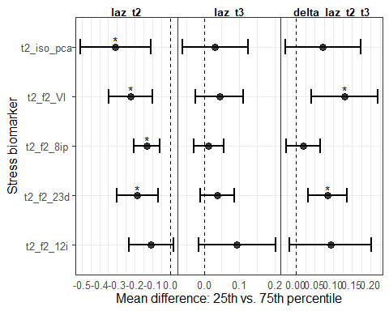

## Exposure-response: Concurrent f2 8ip and LAZ

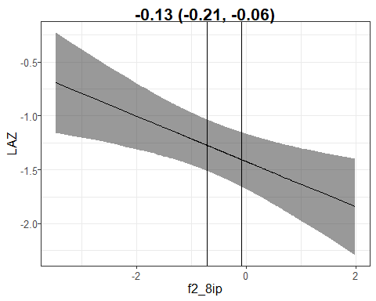

## Exposure-response: Concurrent f2 8ip and LAZ

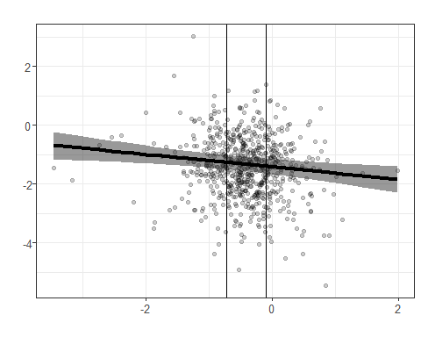

## Exposure-response: Concurrent f2 23d and LAZ

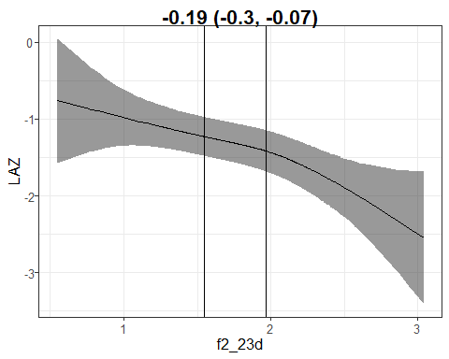

## Exposure-response: Concurrent f2 VI and LAZ

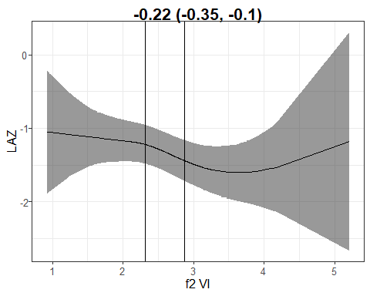

## Exposure-response: Concurrent f2 iso pca and LAZ

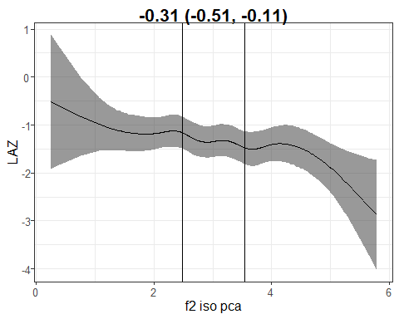

## Primary findings - HCZ

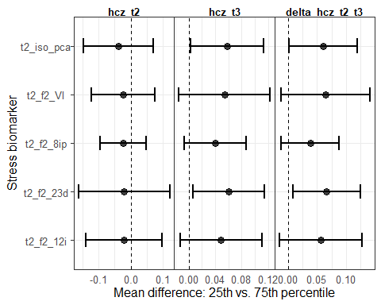

## Primary findings - WAZ

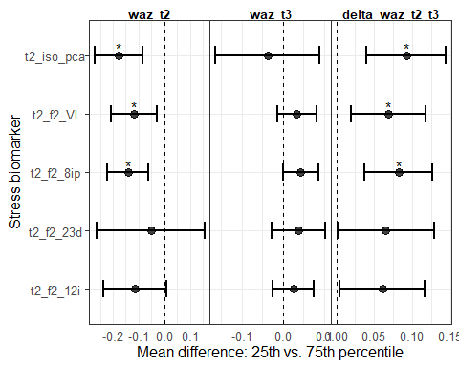

## Primary findings - WHZ

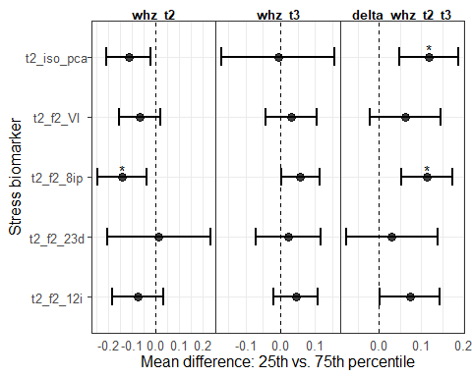

## Primary findings: synthesized in a heatmap

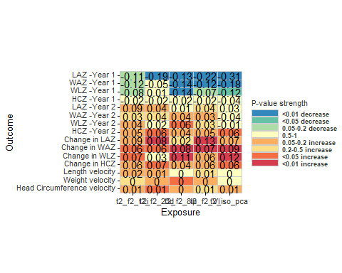

## Sensitivity analysis: unadjusted estimates

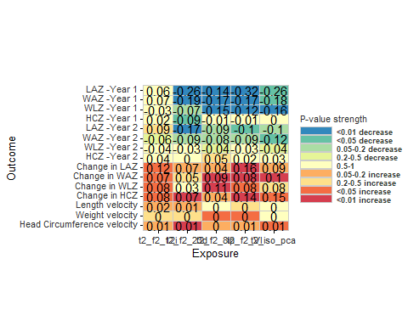

## Sensitivity analysis: linear regression results

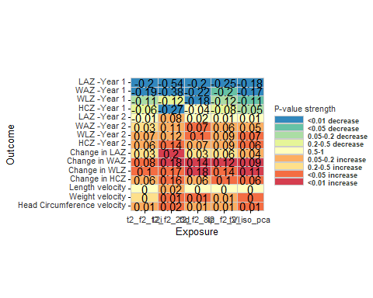

## Descriptive results: boxplots of isoprotanes by growth category

## Warning: Removed 13404 rows containing non-finite values (`stat_boxplot()`).

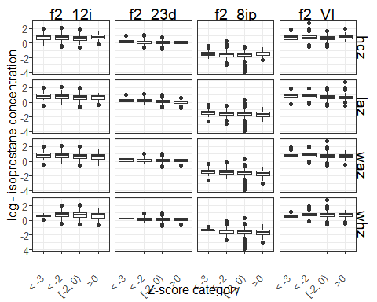

## Primary findings: H2

No associations significant after P-value correction with other growth outcomes

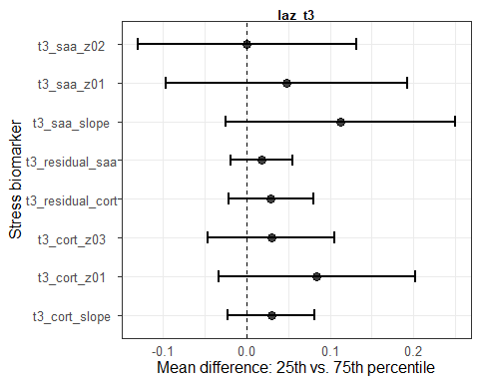

## Primary findings: H3

No associations significant after P-value correction with other growth outcomes

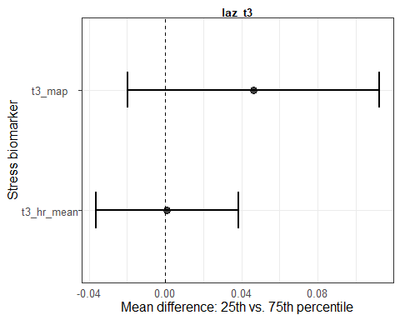

## Primary findings: H4

No associations significant after P-value correction with other growth outcomes

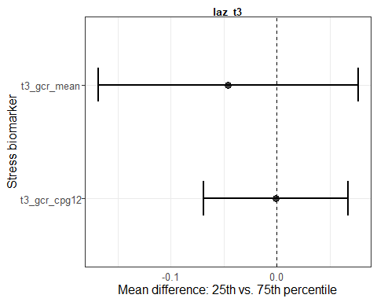

## Conclusions

* Consistent evidence of hypothesis that urinary F2-isoprostane measures are negatively associated with child growth.
* Findings are robust to analytic method and covariates adjusted for.
* Many estimates are not significant after correction for multiple comparisons, but consistency of effect points to true finding.
* No strong evidence for other three hypotheses.
* F2-isoprostanes are a group of prostaglandin-like compounds that have been validated as a measure of oxidative stress, indicating oxidative stress is associated with decreased child growth.
* Evidence that children with higher concentrations of urinary F2-isoprostane measures have faster growth velocity, evidence of catch-up growth or possible regression to the mean.

## Conclusions

* Possible alternative explanation? Children with low growth have higher F2-isoprostane measures (reverse causality), so we wouldn’t expect an association between 14 month F2-isoprostane concentrations and 28 month growth. Mild catch-up growth explains the positive association with growth trajectories.
* Evidence against this: LAZ at 3 months not associated with F2-isoprostane measures
* Alternatively, some acute insult like diarrheal disease or failure to appropriately breastfeed leads to both reduced growth and increased oxidative stress. Chronic undernutrition or small stature, which would lead to maintained small stature at 28 months, has less of an impact on oxidative stress so there isn’t an association 28 months growth.

## Exploratory visualizations - Change in LAZ by quartile of F2-23d

