Effect of pathogens in the environment on diarrhea, child growth, and enteric infections: Individual participant data meta-analysis

Andrew Mertens, Jack Colford, Oliver Cumming, Joe Brown, Jill Stewart, David Holcomb, Jackie Knee, Tom Clasen, Heather Reese, Amy Pickering, Clair Null, Steve Luby, Jessica Grembi, Ben Arnold, Audrie Lin, Jade Benjamin-Chung, Laura Kwong, Lauren Steinbaum, Ali Boehm, Kara Nelson, Erica Fuhrmeister, Ayse Ercumen

# Notes

* Due to sparsity, consider moving all MST results to the appendix
* Note serious sparsity in Fuhrmeister as almost all samples were taken after health samples
* Consider changing requirements to allow for anthropometry outcomes taken within 1-month after env. outcomes (3 months?) because there isn’t the reverse causation concern as for with diarrhea.
* As most of the primary results are null, do you think keeping the aims separate as 2 different manuscripts still makes sense? Combining into one manuscript would lead to a very long supplementary material, but could have just a few main figures with some more targeted presentations of results.
* Aim 3 analysis-
* Should we add a sensitivity analysis imposing a time between samples and anthro measures?… I’ve included baseline samples so there could be a long gap in some cases.

# Abstract

(to write)

# Background

# Methods

* Prescreening
* Clustering
* Handling multiple rounds
* Handling time- 3 months for diarrhea
* Covariate adjustment set:
  + Child sex
  + Child age
  + Treatment arm
  + Household food security
  + Maternal age
  + Maternal education
  + Asset-based household wealth
  + Number people in the household
  + Number of rooms
  + Household construction (walls, floor)
  + Electrification
  + Parent works in agriculture
  + Owns land

# Results

* Studies included

1. The WASH Benefits Bangladesh trial10
2. The WASH Benefits Kenya trial10
3. The MapSan trial in Mozambique11
4. The Gram Vikas matched cohort study in India12
5. Total Sanitation Campaign trial in India13

* Data from each study (Targets, methods of)
* Number of outcomes for each study, number of samples
* Prevalences for primary outcomes
* PR’s
* Abundance results
* Note no possible estimates of any-MST’s and diarrhea due to sparsity (too few positives in households with children with diarrhea, or too many positives)

# Discussion

* Limitations
  + Sparse in many categories

# Figures

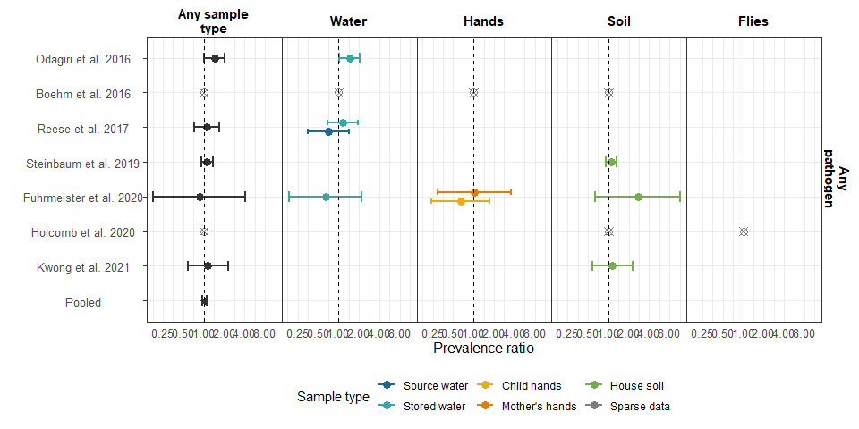

**Figure 1.** Forest plots of the effects of any enteropathogen or any MST presence on diarrhea risk in different samples of environmental samples. Pooled estimates are presented when there are four or more study-specific estimates for a specific sample and target combination.

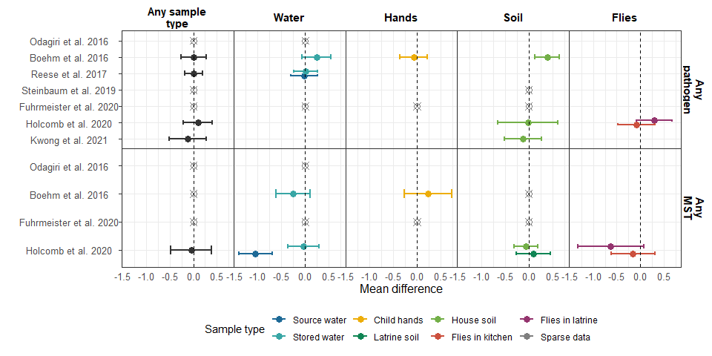

**Figure 2.** haz

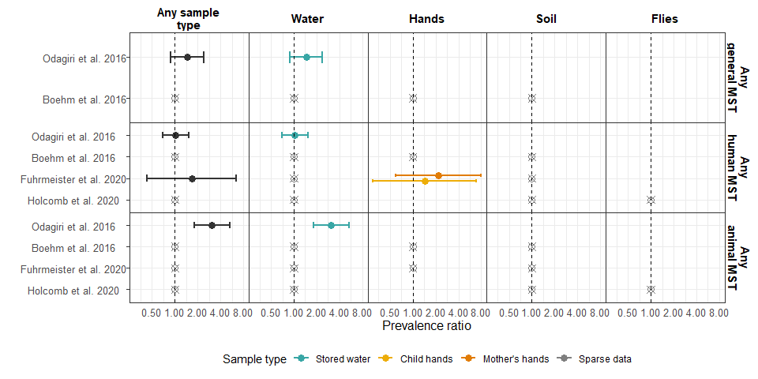

**Figure 3.** diar-MST

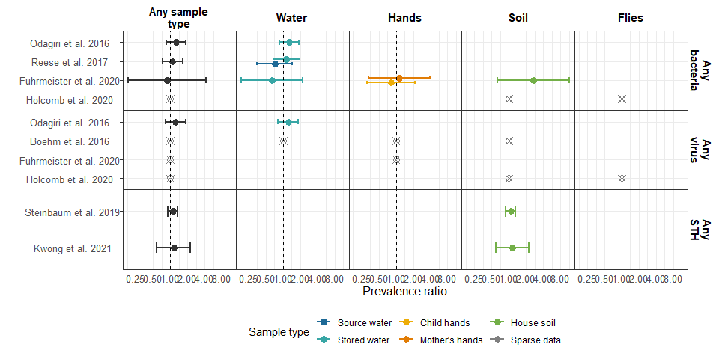

**Figure 4.** diar-pathogens

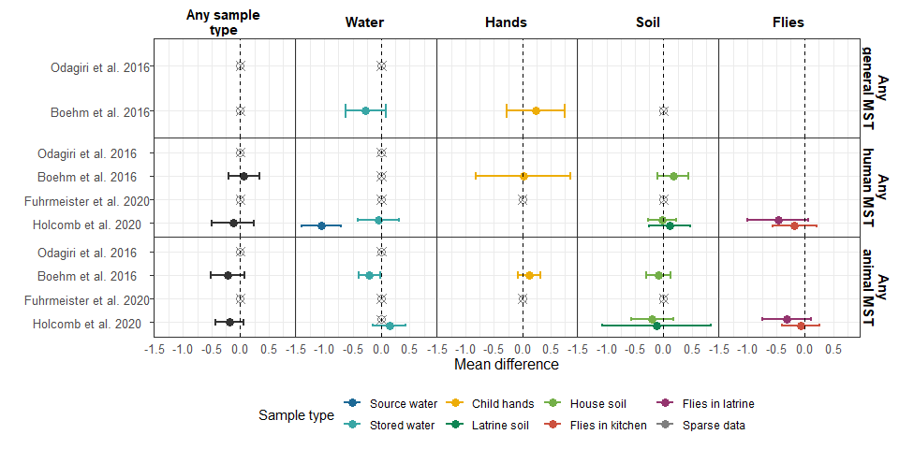

**Figure 5.** haz-MST

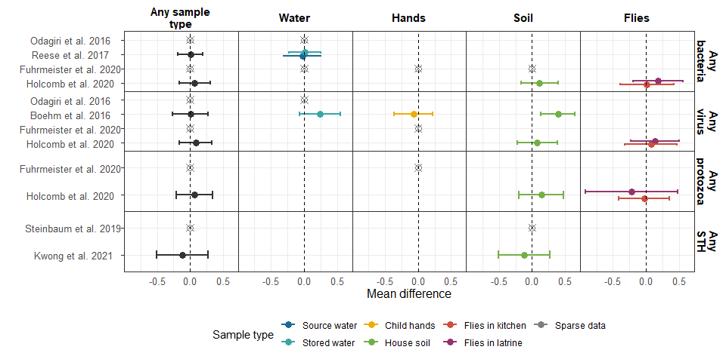

**Figure 6.** haz-pathogens

# Tables

# Supplimentary Figures

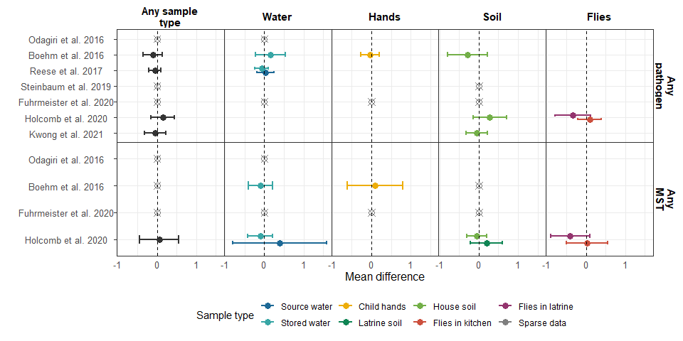

**Supplementary Figure 1.** Weight-for-height

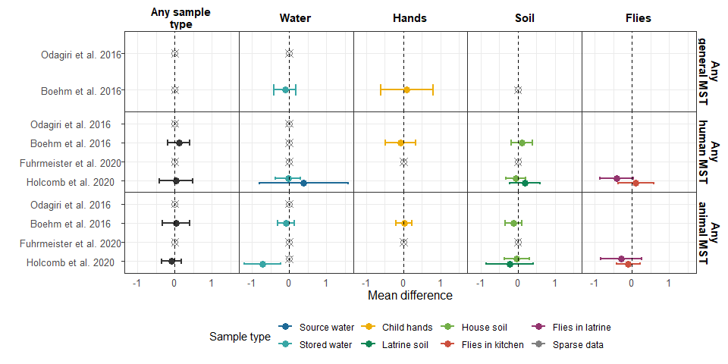

**Supplementary Figure 1.** Weight-for-height

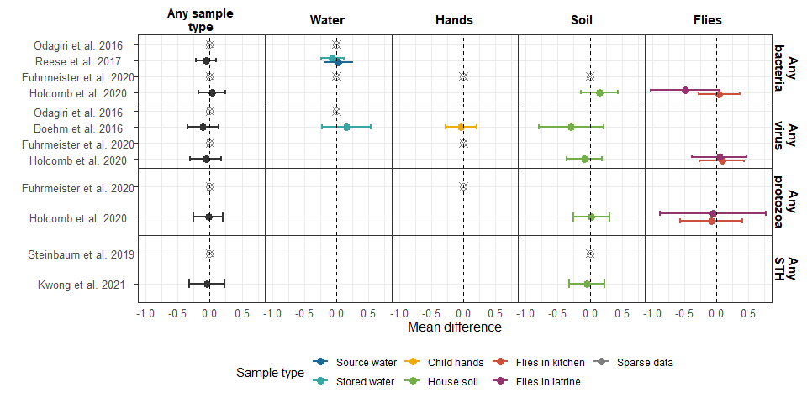

**Supplementary Figure 1.** Weight-for-height

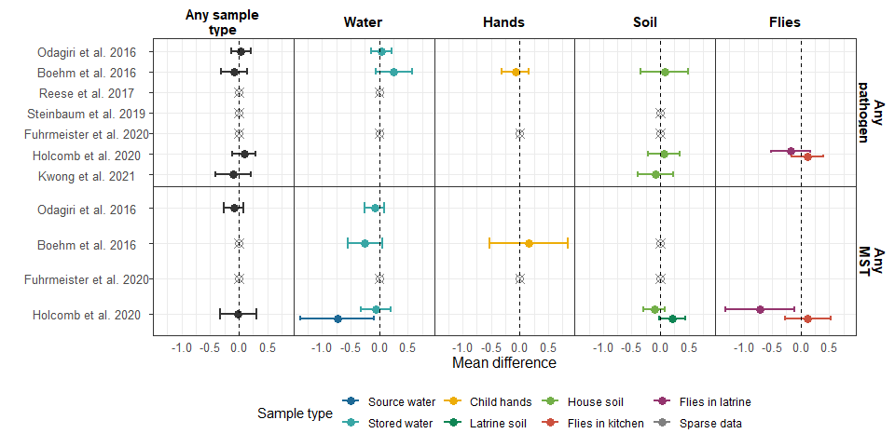

**Supplementary Figure 1.** Weight-for-age

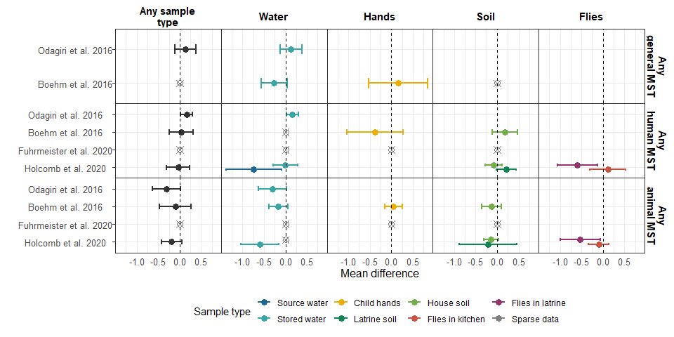

**Supplementary Figure 1.** Weight-for-age

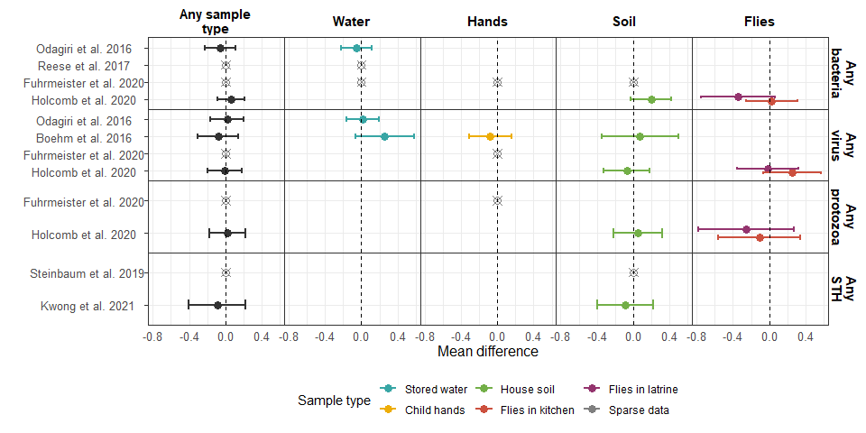

**Supplementary Figure 1.** Weight-for-age

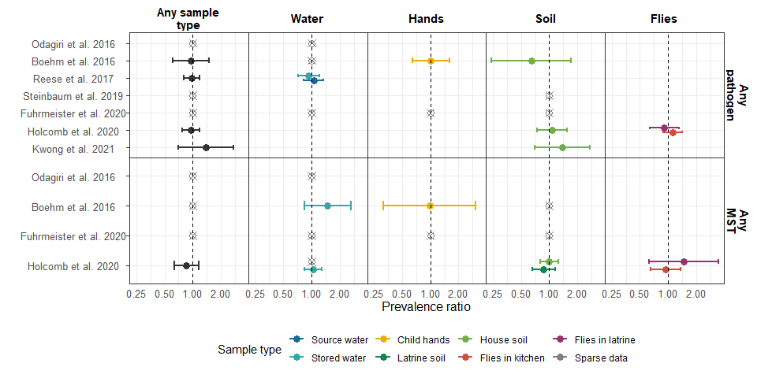

**Supplementary Figure 1.** Stunting

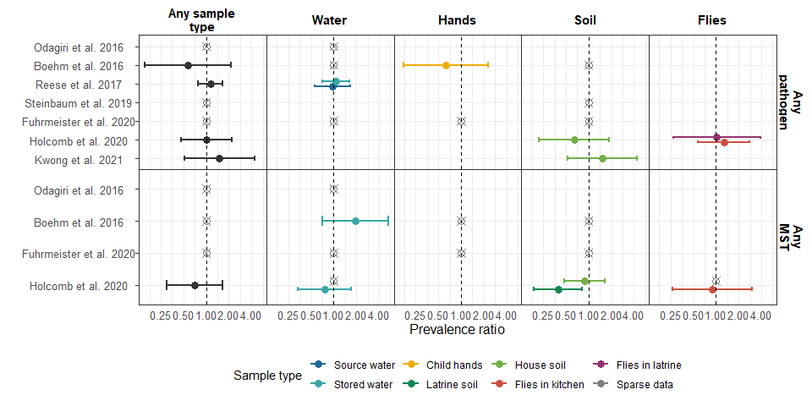

**Supplementary Figure 1.** Wasting

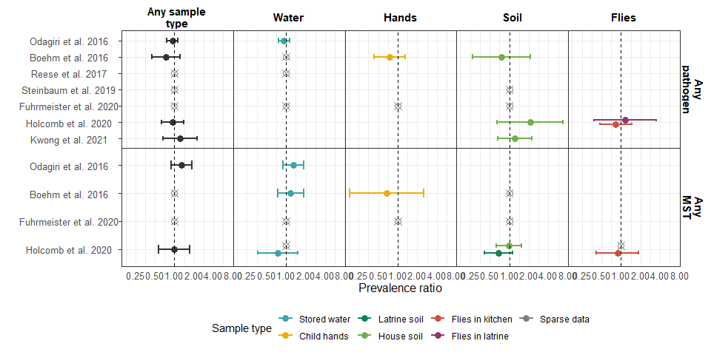

**Supplementary Figure 1.** Underweight

# References