Fact-Check Sheet — 1840s State Debt Credibility Project
Every figure here was recomputed from the source data on 2 September 2026. Where a number is rounded or a prose version elsewhere disagrees slightly, that's flagged. This is the sheet to hold the paper against — dry by design, but written to read.

The question we're testing
- Did the transatlantic bond market believe the U.S. federal government's early-1840s refusal to bail out defaulting states — treat it as a permanent commitment rather than a bluff?
- The test: if the market believed it, states that defaulted should have kept paying noticeably higher interest for years afterward, states that stayed safe shouldn't have, and states that got scared but paid up should land somewhere in between.
- We build the interest rates ourselves from historical bond prices — the records give prices, not yields — covering the 1830s through the 1850s.
- Why it matters now: the EU's current "blue bonds" debate is the same dilemma — does a credible no-bailout rule actually force fiscal discipline? (Hanno Lustig, March 2026.)

The data we're working from
- Bond prices — the EH.net Early U.S. Securities Prices database: the New York exchange file and the Philadelphia exchange file. Parsed into new_york_state_debt_prices.csv (3,492 weekly rows, 194 securities) and philadelphia_state_debt_prices.csv (3,147 rows, 37 securities).
- The codebook — Securities Index.xls maps each bond code to its name, coupon, and maturity year. It has no issue-date field for anything, which is why we can't date the Indiana canal bonds.
- Not used — the Bayley federal-loans document is in the repo but turned out to be a history of federal Treasury borrowing, not state-bond detail. Other cities' exchange files (Baltimore, Boston, etc.) were never downloaded.

The anchor date for the "no-bailout signal"
- We date it to February 1843 — the 11 February 1843 House floor debate on assuming state debts (27th Congress, 3rd session, under Tyler), reinforced by the U.S. consul at The Hague telling European bankers in April–July 1843 that the federal government would not be held responsible "for any default, actual or eventual."
- Caveat to carry into the paper: two secondary sources plus a genuine primary-source read of the right Congressional Globe volume (right people, right topic, right week) — but the exact day, Feb 11 vs. an adjacent day of the same multi-day debate, isn't pinned down.
- The earlier 1839–40 assumption episode is deliberately not the anchor — it predates the actual defaults.

How prices become interest rates
- For Pennsylvania, Ohio, and New York we use yield-to-maturity — there's a real maturity year to work from.
- For Alabama and Indiana we use current yield (coupon ÷ price) — their codebook entries have no usable maturity date. This is a genuine inconsistency between states; we keep it visible in the data rather than hide it.
- The active-default override — yield-to-maturity assumes a bond is repaid in full, on time. That's plainly wrong for a state currently in default, so for any date inside a state's known default window we switch that bond to current yield. This is what fixed Pennsylvania's numbers (below). Pennsylvania's window: Aug 1842 to Feb 1845. Indiana's: Jan 1841 onward. Alabama is deliberately not on the list — it raised taxes and liquidated its state bank to keep paying, and never defaulted.
- Bonds trading within a year of their own maturity, or past it, are flagged and dropped from the trend lines — the math gets unstable near maturity. The rows stay in the file, just flagged.

The three buckets
- Pennsylvania — defaulted (confirmed). Bonds S-2240 / S-2250 / S-2270 / S-2330 / S-2410. Suspended interest August 1842, handed creditors paper instead of cash, resumed 1845. The marquee case.
- Indiana — defaulted / restructured (confirmed). Bonds S-0510 / S-0540 (the original general loan). Defaulted January 1841; the 1846–47 Butler Bill handed the Wabash & Erie Canal to creditors for half the debt.
- Ohio — safe (confirmed). Bonds S-2100 / S-2110 / S-2080 / S-2010. Never defaulted; took a hard hit in the 1842 panic and fully recovered by 1844.
- New York — risky but survived (bucket confirmed; the premium is weak in the data). Bond S-1650. Real railroad and bank-failure stress, never defaulted.
- Alabama — risky but survived (still needs Hall / Sargent's sign-off). Bonds S-0030 / S-0040. Three independent secondary sources say it didn't default; the advisors haven't personally confirmed the reclassification.

What we found — the numbers

Main comparison, after the no-bailout signal (April 1843 on)
- Pennsylvania (defaulted): 8.76% average — over a short window that runs out in January 1845 (88 dates).
- Indiana (defaulted): 13.87% average, through December 1848 (203 dates).
- Alabama (risky / survived): 7.01%, through mid-1853 (142 dates).
- Ohio (safe): 5.78%, through the end of 1853 (444 dates).
- New York (risky / survived): 5.37%, through January 1848 (117 dates).
- Reading: the two clear defaulters carry a premium — Indiana a big one; Alabama sits a bit above safe Ohio; New York sits at or below it. The pattern holds for Pennsylvania and Indiana and is weak for New York.
Source: primary_yields.csv, via scripts/calculate_yields.py — usable rows, averaged by date.
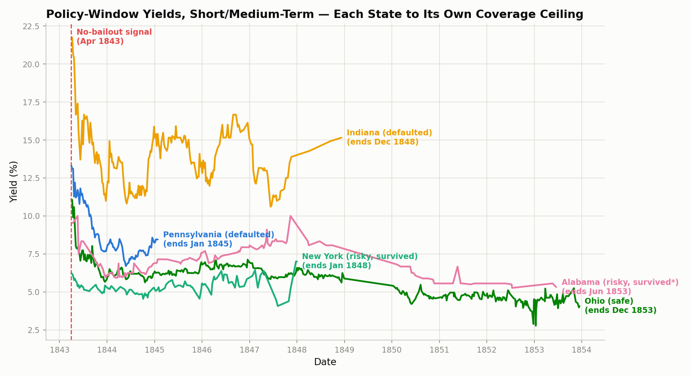
Policy window, each state truncated to its own real coverage. Pennsylvania sits high but its line is short; Ohio and New York run low; Alabama in between.
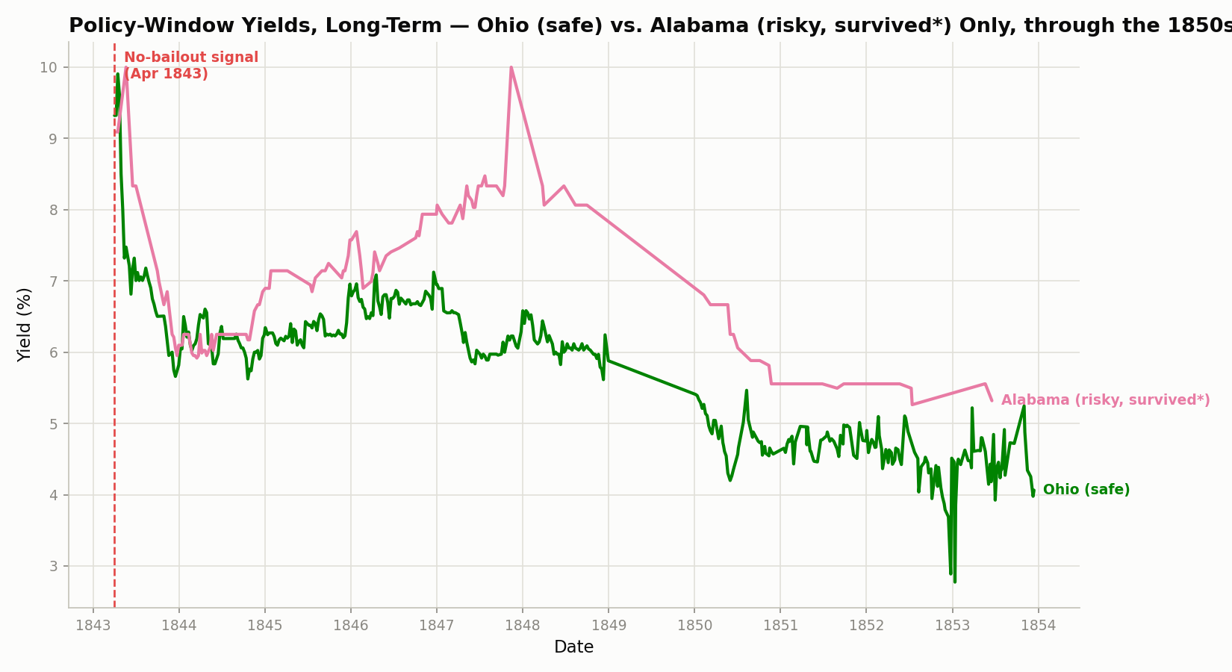
The long run — only Ohio and Alabama have dense decade-long data. Alabama holds a ~1–2 point gap over safe Ohio that narrows but never closes.

The Pennsylvania correction — important
- Before the active-default override, Pennsylvania's post-signal average came out at 19.81% — a 13-point gap over Ohio. That was an artifact: yield-to-maturity was assuming a defaulted bond would still be repaid at par.
- After the override it's 8.77% — a ~2-point gap over Ohio, not 13.
- Bottom line: the persistence finding survives, but it's a modest 2 points, not a dramatic 13. The old 13-point number must not appear anywhere in the paper.
Source: primary_yields.csv vs primary_yields_before_default_override.csv. 221 rows had their yield changed by the override.

Alabama vs. Ohio, year by year
- 1843: 8.23% vs 8.18% — basically identical (+0.04 points).
- 1845: 7.11% vs 6.31% (+0.81). 1847: 8.26% vs 6.22% (+2.04). 1848: 8.12% vs 6.11% (+2.01).
- 1850: 6.21% vs 4.83% (+1.38). 1852–53: ~5.5% vs ~4.4% (~+1.0).
- Reading: Alabama opens level with safe Ohio right after the signal, opens a ~2-point gap by 1847–48, then narrows but never fully closes. A clean "landed in between" pattern — arguably cleaner than New York's.
- Rounding note: PROJECT_CONTEXT prose says the 1843 gap is +0.05 and 1847 Alabama is 8.22%; recomputed they're +0.04 and 8.26%. Rounding only — story unchanged.
Source: primary_yields.csv, full-calendar-year averages.

New York vs. Ohio, and Indiana's own bonds
- New York runs 5.0–5.6% and sits below safe Ohio for essentially the whole window, ticking up to 7.0% only in a single January 1848 reading. On this bond, New York reads more like "safe" than "risky but survived."
- Indiana's general-obligation bonds run 12.6–16.6% year by year, 1843–1848 — a large, sustained premium (roughly 6–10 points over Ohio). The strongest defaulted-bucket signal we have.

The 1837 panic, for context
- Pennsylvania's bonds fell from the 90–110 range to 37–40 by August–September 1842, right at the default.
- Ohio's bonds bottomed in a tight four-week window, March–April 1842, with yields spiking to 11.5–16%. Then they recovered fully by 1844 — before the 1843 policy signal. So Ohio's yield spike is the panic, not the policy.
Source: raw price files; output/ohio_yield_check.csv.
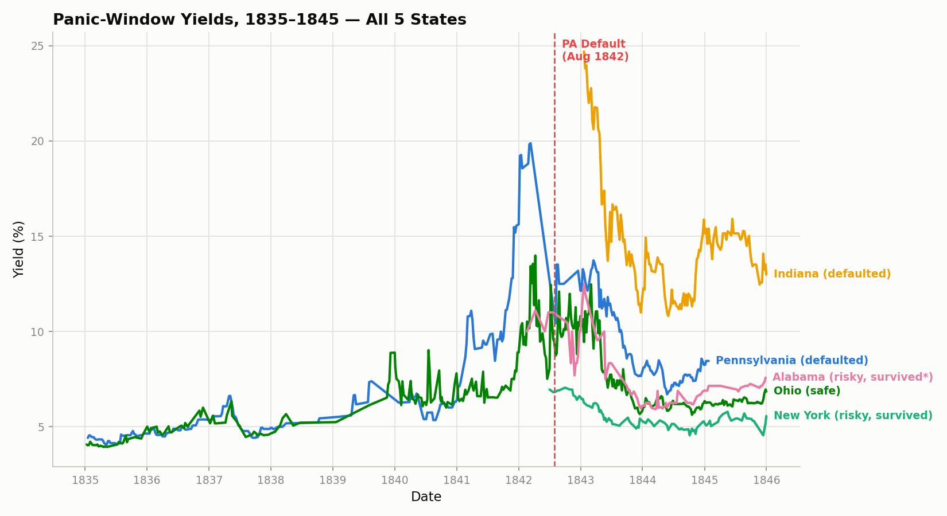
The panic window — every state collapses in 1841–42. Pennsylvania and the defaulters don't recover; Ohio and New York snap back by 1843–44.

Does a state's default spill onto its own city?
- Philadelphia vs. Pennsylvania: before the signal the city was already ~1.6 points cheaper than the state; after, in the overlap window where we have both, 2.68 points. The whole widening is Pennsylvania's own rate climbing — Philadelphia's barely moved.
- Pittsburgh vs. Pennsylvania: a 2.65-point gap post-signal — essentially the same as Philadelphia. A second Pennsylvania city, same result.
- Cincinnati vs. Ohio: basically no gap (−0.11 points). But Ohio never defaulted, so this isn't a third confirmation — it's the baseline: when the state's fine, the city tracks it.
- New York City vs. New York State: also near zero (≈ −0.19). Same story as Cincinnati — a safe state, no city gap.
- Reading: the city/state gap only opens when the state itself is in trouble. The market told the two credits apart.
Source: scripts/compare_city_vs_state*.py; city_vs_state*.csv; nyc_brooklyn_check.csv.
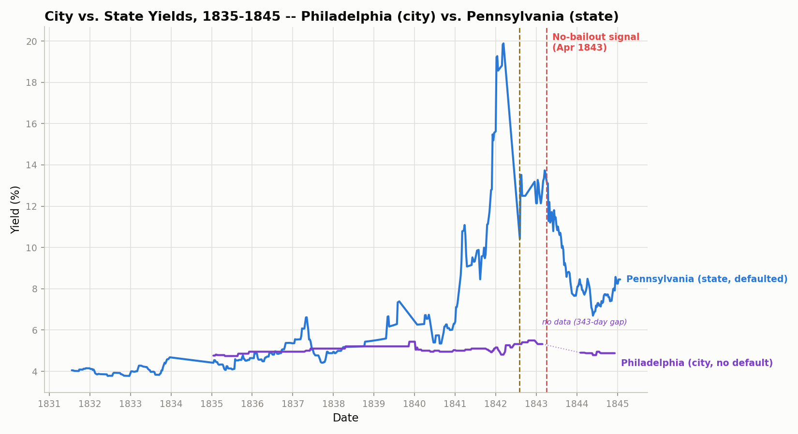
Philadelphia (city) vs. Pennsylvania (state). The state's line spikes toward 20%; the city's stays flat around 5%.
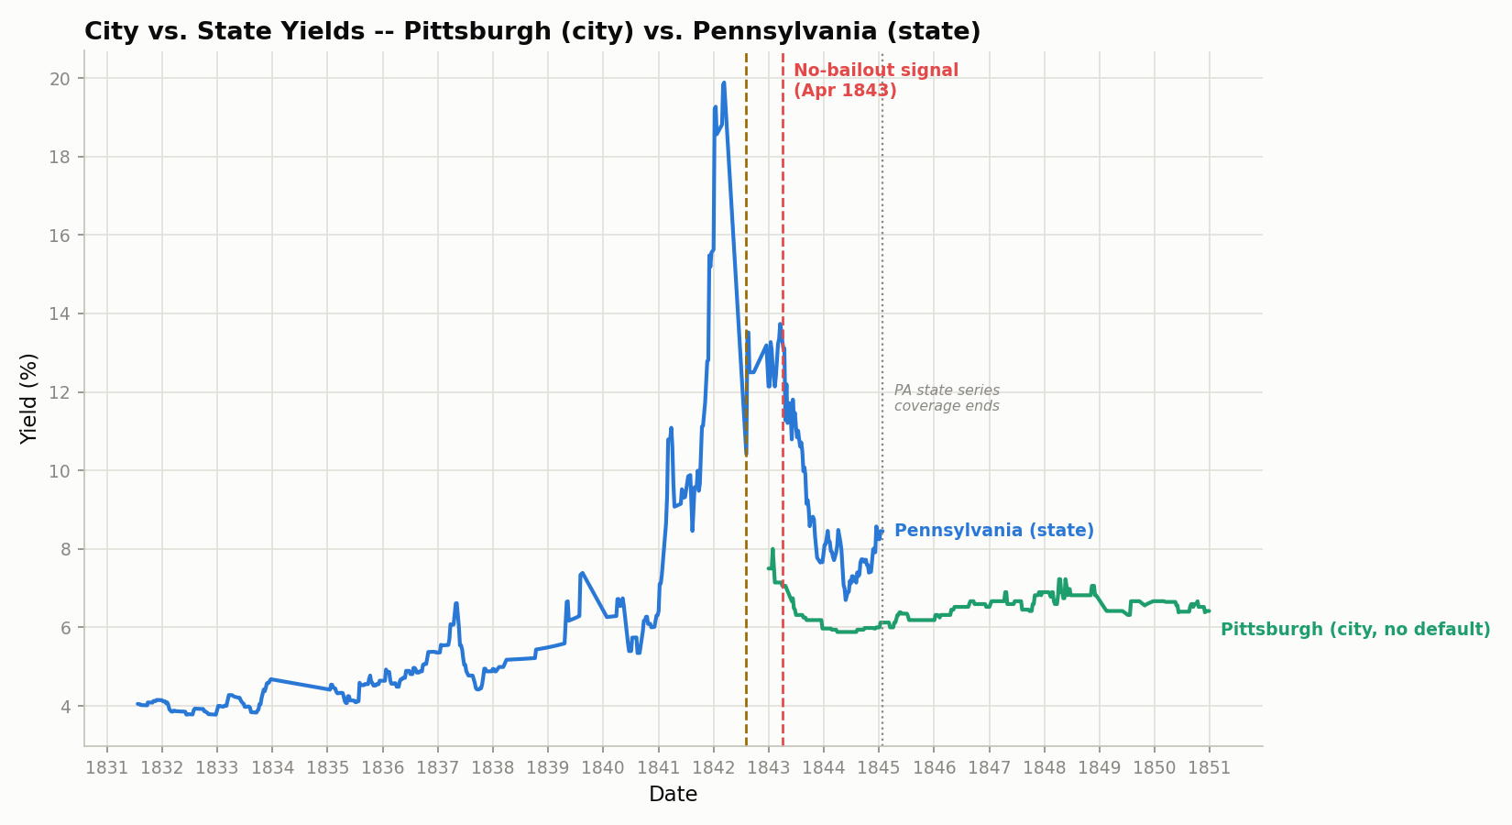
Pittsburgh (city) vs. Pennsylvania (state) — the same ~2.65-point gap as Philadelphia.
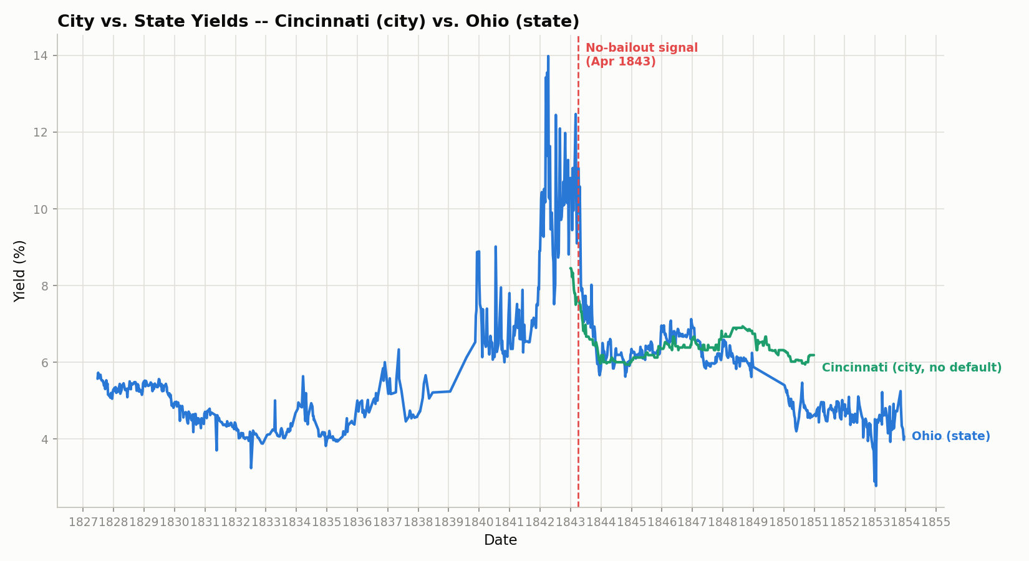
Cincinnati (city) vs. Ohio (state) — no gap, because Ohio was never in trouble. The baseline contrast.

The second Philadelphia bond — closes the biggest gap in that finding
- The main Philadelphia bond has a 343-day hole in its data covering exactly the immediate post-signal months. A second Philadelphia bond (C-1260) fills that hole.
- In that window: Philadelphia ~5.6% vs. Pennsylvania 11.5–11.9% — a 5.95 to 6.28-point gap, right when it mattered.
- So the no-spillover finding is if anything stronger than first reported. The earlier "5.4 points" figure was a miscount and should be replaced with these.
Source: output/philadelphia_second_bond_check.csv. Not yet folded into the protected comparison script.

The canal bonds and the Indiana tranches — the robustness check
- A separate test using bonds backed specifically by canal toll revenue.
- Indiana's 1847 restructuring split its canal debt into "preferred" (paid first) and "deferred" (paid after) slices. The market priced that split by ~40 percentage points — deferred averaged 58% current yield, preferred ~18%. The largest gap anywhere in the project.
- Stress-tested the same way we caught the Pennsylvania problem: it holds across 146 observations over ~3 years, it's not a handful of odd days, and no maturity-math artifact is possible here.
- All this data is 1850–1853 though — years after the policy signal — so it speaks to seniority pricing, not the 1843 question.
- Two data-quality catches, flagged not hidden: one New York canal bond has a 4.5-year gap (drawn as a broken line, not a smooth climb); one single New York price of 160.00 looks like a transcription error in the original records (kept in the file, left off the chart).
Source: scripts/compare_canal_robustness.py; canal_robustness_yields.csv; indiana_tranche_sanity_check.csv.
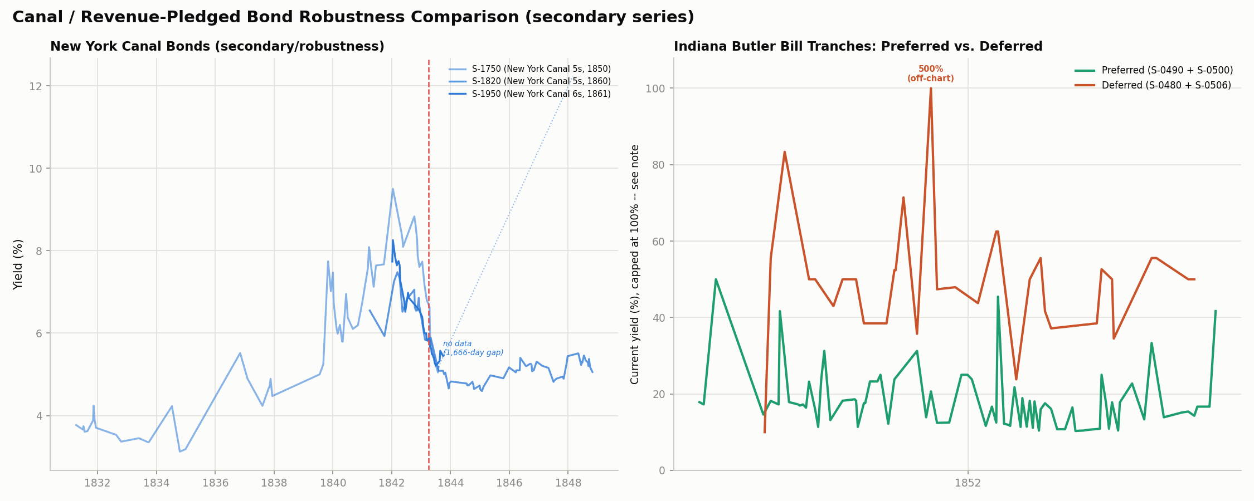
Left: New York's canal bonds. Right: Indiana's preferred (green) vs. deferred (orange) tranches of the 1847 restructured loan — a ~40-point gap.

Thinly-traded bonds
- Four bonds trade unusually thin: Alabama's S-0040, Ohio's S-2010, New York's canal bond S-1750, and Ohio's canal bond S-2190 (only 2 observations, both 1825 — unusable).
- New York's 1838 Free Banking Act (banks had to hold state bonds) is the best fit for S-1750's sparsity. The others we can't fully explain.
- None of these carry a headline number, so this doesn't change any result.
Source: output/trade_density.csv.

Every caveat on record
Severity: H = affects a headline number. M = affects how far a claim generalizes. L = affects wording only.
- [H] Pennsylvania / Ohio / New York use yield-to-maturity; Alabama and Indiana use current yield. The two diverge most when prices are far from par — exactly mid-panic. This bit the Alabama–Ohio 1843 row once; now fixed.
- [H] Pennsylvania's post-signal data runs out around January 1845. Its "persistence" claim is really a ~20-month test, not a decade.
- [H] New York's usable bond (S-1650) doesn't start until July 1842 — it missed the worst of New York's 1839–42 stress. Its "no premium over Ohio" result is substantially a data-coverage artifact, not clean evidence New York was safe.
- [H] The Alabama reclassification (defaulted → risky-but-survived) is still not personally confirmed by Hall or Sargent.
- [M] New York's bond data ends December 1848 — no long-run picture for New York.
- [M] Alabama and Indiana have no codebook maturity, so we can't even run the near-maturity check for them — a real blind spot.
- [M] The Philadelphia main-bond gap means the immediate post-signal reaction was only recoverable via the second bond, which isn't yet folded into the protected comparison script.
- [M] The city comparison is a handful of pairs — two Pennsylvania cities for the stress case, two safe-state cities as baseline. Not "cities in general."
- [M] The default-period dates that drive the override are secondary-source, not primary.
- [M] The "why the city stayed solvent" explanation is inference from legal / financial structure plus our own price data — no single contemporary source states it outright, and only Philadelphia was researched.
- [L] The 11 February 1843 anchor date isn't pinned to the exact day.
- [L] The Indiana canal-tranche data is all 1850–53 — it tests seniority pricing, not the 1843 signal.
- [L] Whether Indiana's "deferred" tranche stopped paying interest or just paid late is unresolved — affects the wording of the 40-point figure, not the figure.
- [L] Indiana canal-bond issuance timing can't be determined — no issue-date field, no legislative rollout schedule.
- [L] One New York canal price (160.00) and one Indiana first print (50.00) are likely transcription errors — kept in the files, off the charts.
- [L] primary_yields.csv has 3,711 rows. An old note said 3,441 — that was before two Pennsylvania bonds (S-2330, S-2410) were added; 3,441 + 270 = 3,711.

What's still open

Needs the advisors
- Alabama: defaulted, or risky-but-survived? Three sources say the latter; need a yes / no.
- Indiana's deferred tranche: interest suspended, or just subordinated-but-paid? Changes wording, not the finding.
- Indiana canal payment rule: strict waterfall, or proportional split? No source states it; the prices suggest both classes took a hit.

Needs more research (already tried)
- Indiana canal-bond issue dates — the codebook, the market data, and the standard histories all come up empty.
- A source that directly states why Philadelphia's credit held while Pennsylvania's collapsed — we have the structural facts, not a single quotable line.
- Folding the second Philadelphia bond into the protected comparison script (~15 minutes, not advisor work).
- Reading the exact day off the Congressional Globe (needs a human to clear a CAPTCHA).

Can't be resolved
- Whether New York's general-obligation bond dipped in 1839–42 — it simply wasn't quoted then.
- The two thinniest-traded bonds (Alabama S-0040, Ohio canal S-2190) — too few records survive.

Where every number comes from
- scripts/calculate_yields.py → primary_yields.csv (3,711 rows) + primary_yields_before_default_override.csv. The core pipeline — all state-level yields, the truncation flags, the active-default override.
- scripts/compare_city_vs_state.py → city_vs_state_yields.csv + chart_city_vs_state.png. Philadelphia vs. Pennsylvania.
- scripts/compare_city_vs_state_cincinnati_pittsburgh.py → city_vs_state_cincinnati.csv, city_vs_state_pittsburgh.csv + their charts.
- scripts/compare_canal_robustness.py → canal_robustness_yields.csv + chart_canal_robustness.png. New York canal bonds and the Indiana tranches.
- scripts/build_yield_charts.py → chart_panic_window / chart_policy_short_medium / chart_policy_long_term. The three-tier chart set.
- Diagnostic files (one-off, no saved script): trade_density.csv, ohio_yield_check.csv, nyc_brooklyn_check.csv, philadelphia_second_bond_check.csv, philadelphia_county_check.csv, indiana_tranche_sanity_check.csv.
- The full dry version, with the exact tables: output/FACTS_LAB_REPORT.md.

All five pipeline scripts were re-run on 2 September 2026 and reproduce their outputs byte-for-byte. Every figure above traces to one of the files listed here; the only claims that don't are the historical dates and institutional facts (the anchor date, the default periods, the bucket evidence, the Butler Bill chronology, the municipal-law points), which rest on secondary sources and are flagged where they appear.

