1840s State Debt Credibility — Short Update
Four things: the Indiana payment-order answer to Hall's question, why Philadelphia itself never defaulted, how the paper will flow, and how I'll run the meeting.

1. The Indiana Payment Order — Answering Hall's Question
Last meeting, Hall asked which of Indiana's canal bonds actually got paid first. Here's the clean version.
- The line-up: two bonds got paid first — S-0490 and S-0500, the ones labeled "preferred." Two got paid only after those — S-0480 and S-0506, the "deferred" ones. A fifth bond, S-0470, labeled just "Indiana Canal," doesn't fit either group: it traded far higher than all four and looks like a separate, better-secured instrument, probably the part of the debt the state itself still stood behind.
- There's even a pecking order inside "preferred": the plain preferred bond (S-0490) traded higher than the one labeled "special preferred" (S-0500) — roughly $42 vs. $20 median price. So the market wasn't just splitting these into two tiers, it was pricing finer distinctions than that.
- What we can't tell: whether a shortfall got split strictly (the preferred group paid in full before the deferred group sees a cent) or proportionally (both groups take a haircut at the same time). No source we found states the rule directly.
- What the prices themselves imply: the deferred bonds traded at a real, positive price — not near zero — so the market expected those holders to get something eventually. And even the preferred bonds only traded around 20 to 50 cents on the dollar, well below full value. So both groups were priced as taking a loss — not a clean "the senior bond gets everything, the junior bond gets wiped out" split.
- Issuance timing: we couldn't pin it down. The codebook has no issue-date field, and the legislative histories don't give a rollout schedule. The five bonds first show up on the exchange at staggered dates in 1850–51 — but that's three years after the 1847 restructuring act, and reflects when they started trading, not when they were issued. This is a genuine gap in the historical record, not something more digging is likely to fix.
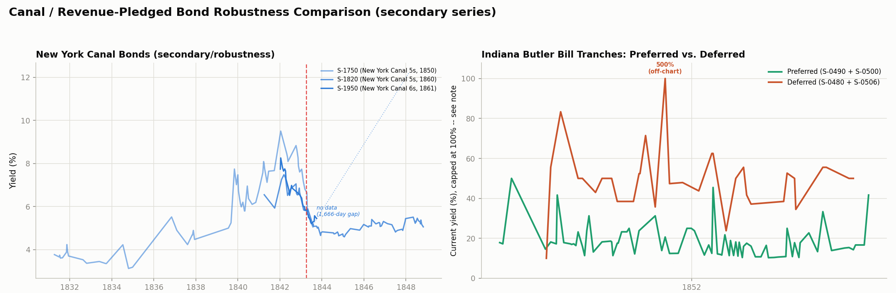
Right panel: Indiana's preferred tranches (green) vs. deferred tranches (orange) of the same 1847 restructured canal loan — a ~40-percentage-point yield gap, the largest in the project. Left panel: New York's canal bonds, for comparison.
SAY THIS
So last time you asked which Indiana bonds got paid first — I've got a clear answer now. Two of them were "preferred" and got paid first; two were "deferred" and got paid after; and there's a fifth one that doesn't really fit either bucket and looks like a separate, safer instrument. There's even a sub-ranking inside the preferred group, so the market was pricing fine distinctions. What I can't tell you is the exact rule for how a shortfall gets split between them — nothing in the historical record spells that out — but the price data itself is telling: both the preferred and the deferred bonds traded well below full value, which suggests the market expected both sides to take some kind of hit, not a clean "senior gets everything, junior gets nothing" split. And I couldn't pin down exactly when the bonds were issued — the records just don't have it.

2. Why Didn't the City Itself Default?
This is a different question from the market-pricing finding. That earlier work showed investors didn't punish Philadelphia for Pennsylvania's default. This explains why Philadelphia never got into trouble in the first place — why the city itself didn't default alongside the state. Keep the two separate: "investors didn't punish the city" is the price finding; "the city stayed solvent because it was a legally separate entity" is this.
- Philadelphia was legally its own thing. A city in this era was a separate corporation from the state — its own budget, its own power to tax, borrow, and spend, not a branch of the state government.
- The state's debt paid for state projects. Pennsylvania borrowed to build the Main Line of Public Works — a state-owned canal-and-railroad route from Philadelphia to Pittsburgh — plus other state canals and investments in banks. Philadelphia the city was never a co-obligor or guarantor on any of it; the Main Line was a state asset.
- The city's debt paid for city things. Water works, gas works, wharves, public buildings — paid for out of the city's own property taxes and water and gas fees. That revenue was local and held up fine; it didn't depend on the state canal tolls and state taxes that collapsed.
- Different entity, different money — so the city never got pulled into the state's mess.
- Note to self: no single old source states this contrast in one sentence — it's pieced together from how the finances were structured plus our own price data. And I only checked the legal setup for Philadelphia specifically; Pittsburgh's price pattern matches but I didn't separately chase down its legal structure.
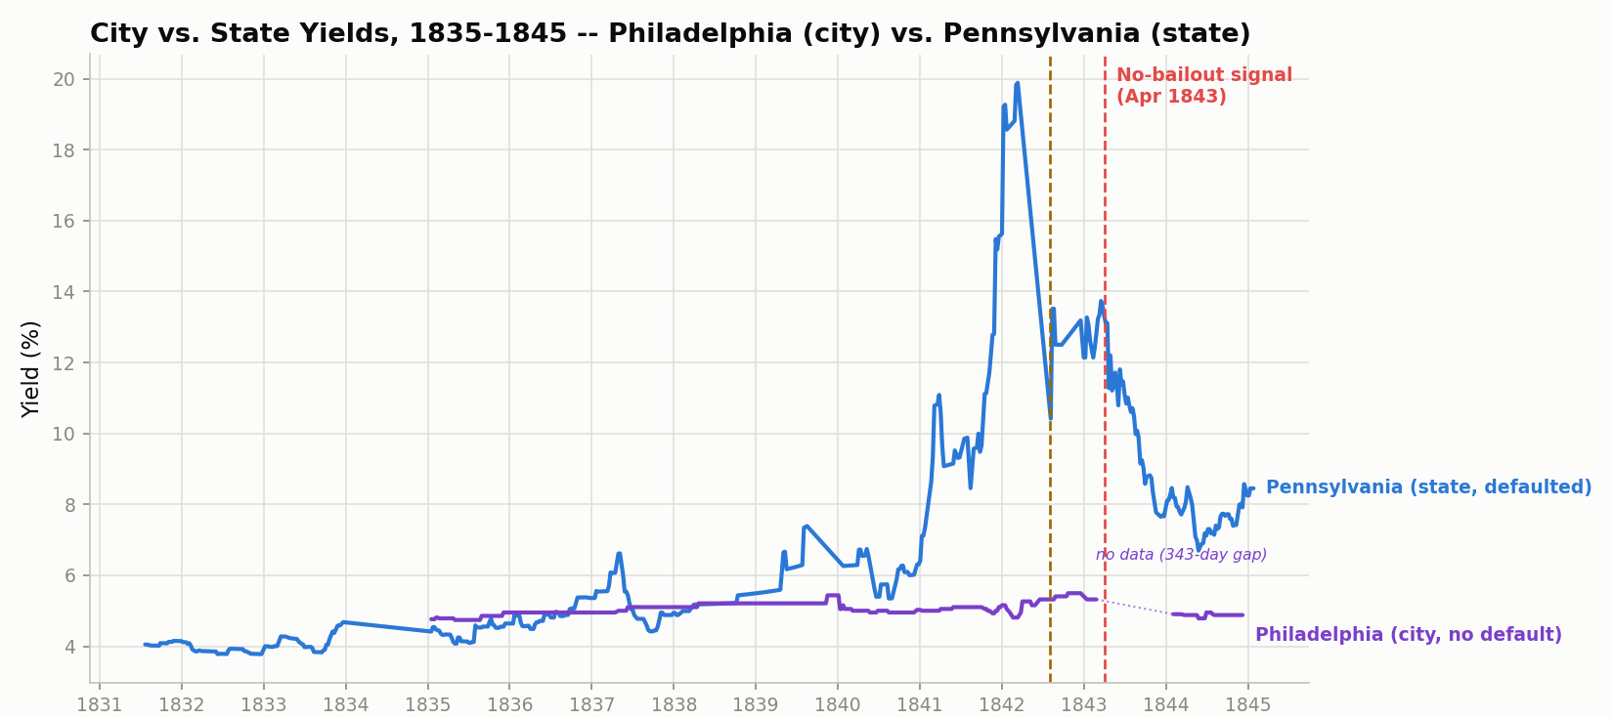
Philadelphia (city, purple) barely reacts to Pennsylvania's default while the state's own yield (blue) spikes toward 20%.
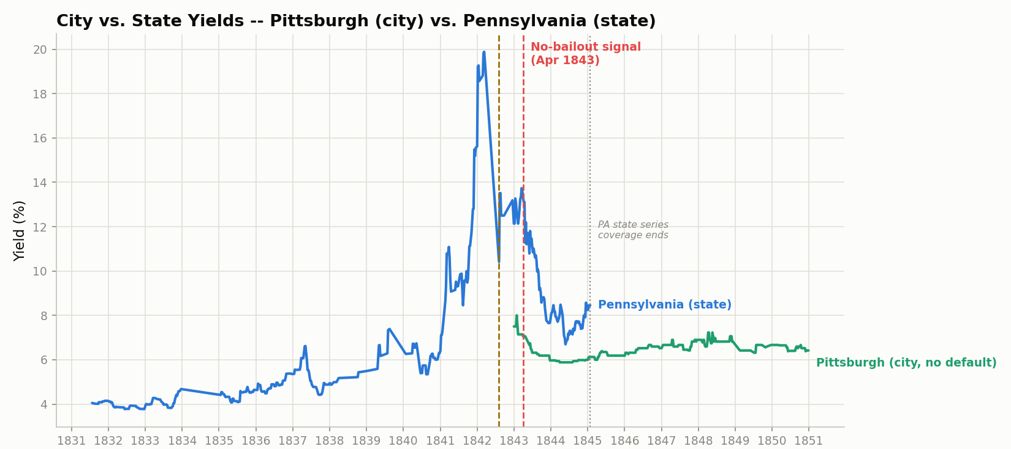
Pittsburgh (city, green) vs. Pennsylvania (state, blue) — the same ~2.65-point gap as Philadelphia, a second Pennsylvania city showing the same pattern.
SAY THIS
One more thing worth adding here — why didn't the city default, not just why didn't the market punish it. Philadelphia was legally its own thing, separate from the state, with its own taxing power and its own budget. The state's debt paid for state canals and railroads that Philadelphia had nothing to do with; the city's debt paid for city things, funded by the city's own taxes. Different entity, different money, so it never actually got pulled into the state's mess in the first place. I'll flag this is inference from how the finances were structured, not a single source that spells it out directly — but it's a solid, consistent picture.

3. What the Research Paper Will Cover — Section by Section
How the paper flows, part by part — a short description of each section and bullet points for what goes in it. Order is a proposal, not locked.

Introduction
Open on why this matters right now, then the historical parallel, then the question and a preview of the answer.
- The modern hook: the EU is currently debating "blue bonds" — joint EU borrowing — and the core dispute is whether a credible "no bailout" rule actually forces member states to keep their own finances in order (Hanno Lustig, March 2026).
- The historical parallel: the United States faced the same choice in the early 1840s, when nine states plus the Florida Territory defaulted and the federal government refused to assume their debts.
- The research question: did bond investors actually believe that refusal was permanent? If they did, the states that defaulted should have kept paying higher interest rates for years afterward.
- Preview of the answer: yes — and the market turned out to be a more careful judge than a simple panic story would predict.

The Problem — What Went Wrong in the 1840s
The setup the rest of the paper analyzes: how the states got into debt, how the crisis hit, and why the federal government's response is the interesting part.
- The 1830s borrowing boom: states borrowed heavily from British and Dutch investors to build canals, railroads, and banks.
- The Panic of 1837 crushed state tax revenue and trade.
- 1841–1843: nine states plus the Florida Territory defaulted or suspended interest payments.
- The federal government refused to take on the debts — a deliberate break from the 1790 precedent, when Hamilton had the federal government assume the states' Revolutionary War debt.
- Why this is the question worth studying: a "no bailout" rule only disciplines borrowers if lenders actually believe it will hold.

Data and Method
What the evidence is and how we turn it into a test.
- Source: transatlantic bond price records from the New York and Philadelphia exchanges, 1830s–1850s (EH.net Early U.S. Securities Prices).
- We compute interest rates (yields) ourselves, since the records give prices, not rates.
- Three groups of states: defaulted, risky-but-survived, and never-really-at-risk (the safe baseline).
- Two separate before/after moments, kept distinct so they don't get confused: the 1837 crash itself, and the 1843 federal no-bailout signal.

Main Result — Did the No-Bailout Signal Show Up in State Interest Rates?
The core finding: comparing the three groups of states after the federal refusal.
- After the signal, the states that defaulted (Pennsylvania, Indiana) kept paying a premium over the safe baseline (Ohio) — the market did not forgive and forget.
- The premium is real but modest for Pennsylvania (~2 percentage points) once a yield-calculation artifact is corrected; it is larger and more persistent for Indiana.
- The "risky but survived" states land in between — with honest caveats (New York's usable data starts late; Alabama's classification is still being confirmed).
- Read: the market treated the federal refusal as credible.

City Result — Does a State's Default Spill Onto Its Own City?
A distinct question the same data can answer: whether the punishment spread from a state to the city inside it.
- Philadelphia's borrowing cost barely moved when Pennsylvania defaulted, while the state's own rate spiked — no spillover.
- Pittsburgh replicates it; Cincinnati and New York City (whose states were fine) show no gap either — the city/state gap only opens when the state itself is in trouble.
- The mechanical reason: the city was a legally separate entity with its own revenue, not on the hook for the state's debt.
- Read: the market told state credit and city credit apart, even for the same place.

Robustness — Canal Bonds and the Indiana Tranches
An independent check on the main result, using a different kind of state debt.
- Bonds backed specifically by canal toll revenue, analyzed separately from general state debt.
- Indiana's 1847 restructuring split its canal debt into "preferred" and "deferred" slices; the market priced the difference by about 40 percentage points — the largest gap anywhere in the project.
- Shows the market pricing fine seniority distinctions, not reacting bluntly.

Discussion
What the pattern across all the results means, tied back to the modern debate.
- The through-line: the market was a careful discriminator — it separated the panic from the policy, the state from its city, and senior debt from junior debt.
- Back to the EU: this is what a credible no-bailout commitment looks like when investors believe it — sustained higher costs for the specific borrowers who defaulted, not blind contagion to everyone nearby.

Conclusion and Limitations
Restate the finding and be upfront about what the data can't do.
- The 1840s bond market treated the federal no-bailout stance as credible, and priced credit distinctions finely.
- Limitations stated plainly: some bonds have coverage gaps in the key windows; the exact anchor date rests partly on secondary sources; the Alabama classification and the Indiana deferred-coupon question are still open.

4. How I'll Run the Meeting
Spoken-flow notes — how I'll actually open and steer the conversation. Not a formal outline; this is what I'll say.
- Opening: "It's been a while, so I kept this short on purpose — I'm not going to walk through everything. Really just two answers I owe you, plus how I'm thinking about the paper." Set the expectation that this is a focused check-in, not a status marathon.
- Into the Indiana finding: "Last time, Hall, you asked which Indiana bonds got paid first. I can map that out clearly now." Give the preferred/deferred split and the odd-one-out fifth bond, then hand it back: "Does that answer what you were getting at, or were you after something more specific?" Flag the one thing I still can't resolve — the exact shortfall-split rule — and note the price data leans toward both sides taking a hit.
- Into the city-default question: "The other thing is why Philadelphia itself never defaulted — not why the market didn't punish it, which we already showed, but why the city never actually got into trouble." Walk the separate-corporation point, the state-debt-vs-city-debt split, and be upfront that it's inference from structure, not a single quotable source. Show the two charts as the supporting picture.
- Pivot to the paper: "If you're good with where things are, here's roughly how I see it coming together" — then walk the section-by-section flow from Section 3 above. Keep it loose: "Nothing's locked; I mainly want your read on the order and the framing."
- Closing: "So the two things I actually need are the Alabama call and your read on the Indiana deferred-coupon question — everything else is ready to write." I'll send a short recap of whatever we decide and start drafting the introduction next.

