1840s State Debt Credibility Test — Advisor Meeting, July 20, 2026

Research Question
Did bond markets treat the federal government's refusal to bail out defaulting states in the early 1840s as a credible commitment? The test: whether states that actually defaulted show persistently higher bond yields after the federal no-bailout signal than states that never defaulted, with states that were at real risk but ultimately survived landing in between. This ties to Hanno Lustig's March 2026 "Blue Bonds for Europe" post, which argues the EU's current debate over joint "blue bonds" repeats this exact dilemma, and that a credible no-bailout commitment is what forces real fiscal discipline. The 1840s episode is a real historical test of that argument: does the market actually believe a no-bailout commitment once it's made, or does it keep pricing in the possibility of rescue?

What's Changed Since Last Meeting
- Resolved all three open items from last meeting: before/after framing (panic window vs. policy window are now both explicitly defined and kept separate, not conflated), the no-bailout anchor date (Feb 11 1843, the Gwin/McDuffie assumption debate, reinforced by U.S. consul Christopher Hughes's Apr-Jul 1843 statements denying federal responsibility to European bankers -- flag: this still rests on secondary sources, not a primary-document read), and bond seniority (New York's canal bonds carry a real revenue pledge that the other states' general-obligation bonds lack -- resolved by switching to a maturity-matched New York GO bond for the primary comparison instead).
- Found and corrected a significant yield-calculation issue: yield-to-maturity assumes the bond redeems at full par on schedule, an assumption that breaks down for an issuer already in active default. Discovered via Pennsylvania: one bond (S-2410) showed a spurious 30% average YTM against the same data that gives ~9.5% under current yield. Adopted a rule to use current yield instead of YTM for any observation falling inside a state's own active-default period, regardless of that bond's proximity to its own maturity.
- Discovered Alabama did not actually default in this episode -- it raised direct taxation in early 1842 and used state-bank liquidation proceeds to keep meeting its debt service, unlike Pennsylvania and Indiana. Moved Alabama from the "defaulted" bucket to "risky but survived," pending your confirmation.
- Found that Pennsylvania's original headline finding (price falling from ~90 to ~40 by Aug-Sept 1842) is panic-window evidence, not policy-window persistence evidence -- the bond behind that number (S-2240) has zero usable observations after the April 1843 no-bailout signal. Pennsylvania's actual persistence evidence comes from two previously-unused bonds (S-2330, S-2410) found via a fuller codebook re-scan that turned up 34 Pennsylvania bond codes instead of the original 3.

Empirical Results

a. Panic-Window Comparison (pre-1843)
All five states/buckets, 1835-1845. Pennsylvania's price collapse is the sharpest and most visible move in the window (yield spiking above 15% into its Aug 1842 default). New York's canal bonds show real stress and a full recovery by 1843-45. Ohio dips hard alongside everyone else during the panic but recovers cleanly. Alabama and Indiana both show a sustained, not-fully-recovered elevation that persists through the end of this window.
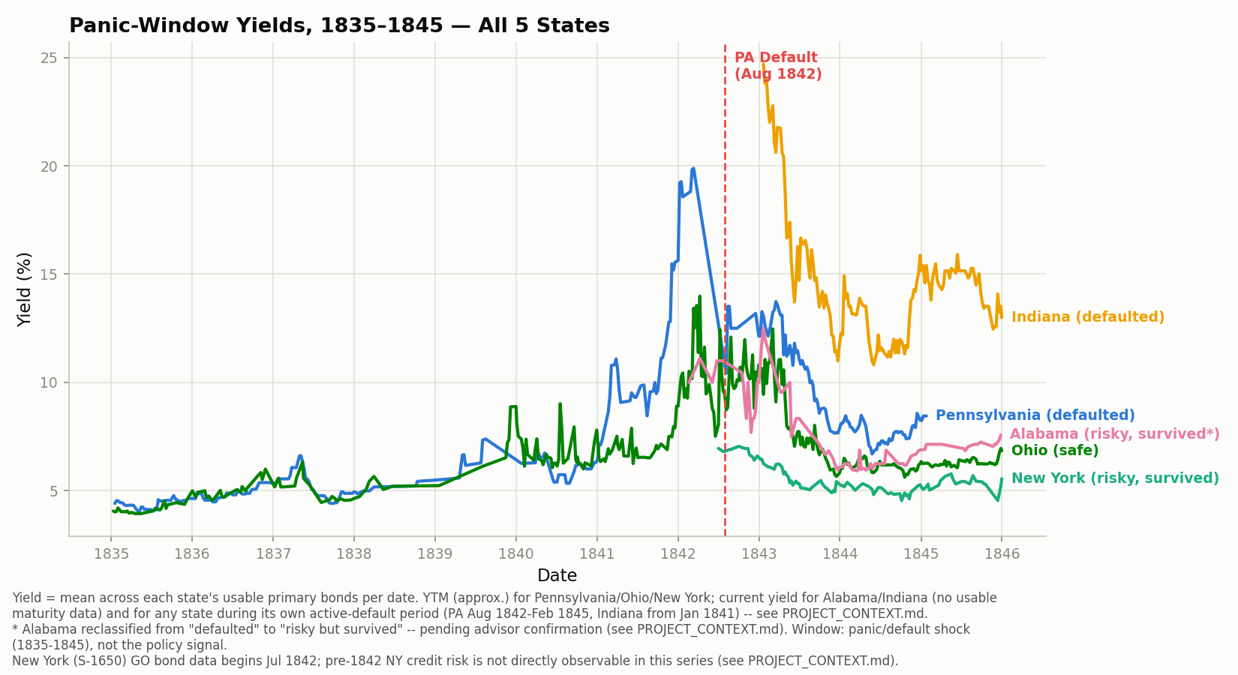
Yield = mean across each state's usable primary bonds per date. YTM (approx.) for Pennsylvania/Ohio/New York; current yield for Alabama/Indiana (no usable maturity data) and for any state during its own active-default period (PA Aug 1842-Feb 1845, Indiana from Jan 1841). Alabama reclassified from "defaulted" to "risky but survived" -- pending advisor confirmation. New York (S-1650) GO bond data begins Jul 1842; pre-1842 NY credit risk is not directly observable in this series.

b. Policy-Window Persistence, Short/Medium-Term (Apr 1843 onward)
Pennsylvania shows roughly a 2 percentage-point yield premium over Ohio in the ~20 months of post-signal data it can support (S-2270/S-2330/S-2410 combined). Alabama shows a premium of similar magnitude, also around 2pp, despite not technically defaulting. New York shows no measurable premium over Ohio in the window its GO bond is actually observable. Two caveats on the New York result, stated plainly: (1) New York's GO bond has zero price data before July 1842, so we cannot observe whether it was under stress during the actual 1839-42 trough -- this is a data-coverage gap, not a finding of safety. (2) Even within the window we can observe, New York's GO bond price never drops below par while its canal bonds do -- but the canal bonds carry toll-revenue risk that is distinct from general state creditworthiness, so this residual gap may not speak cleanly to New York's overall credit risk.
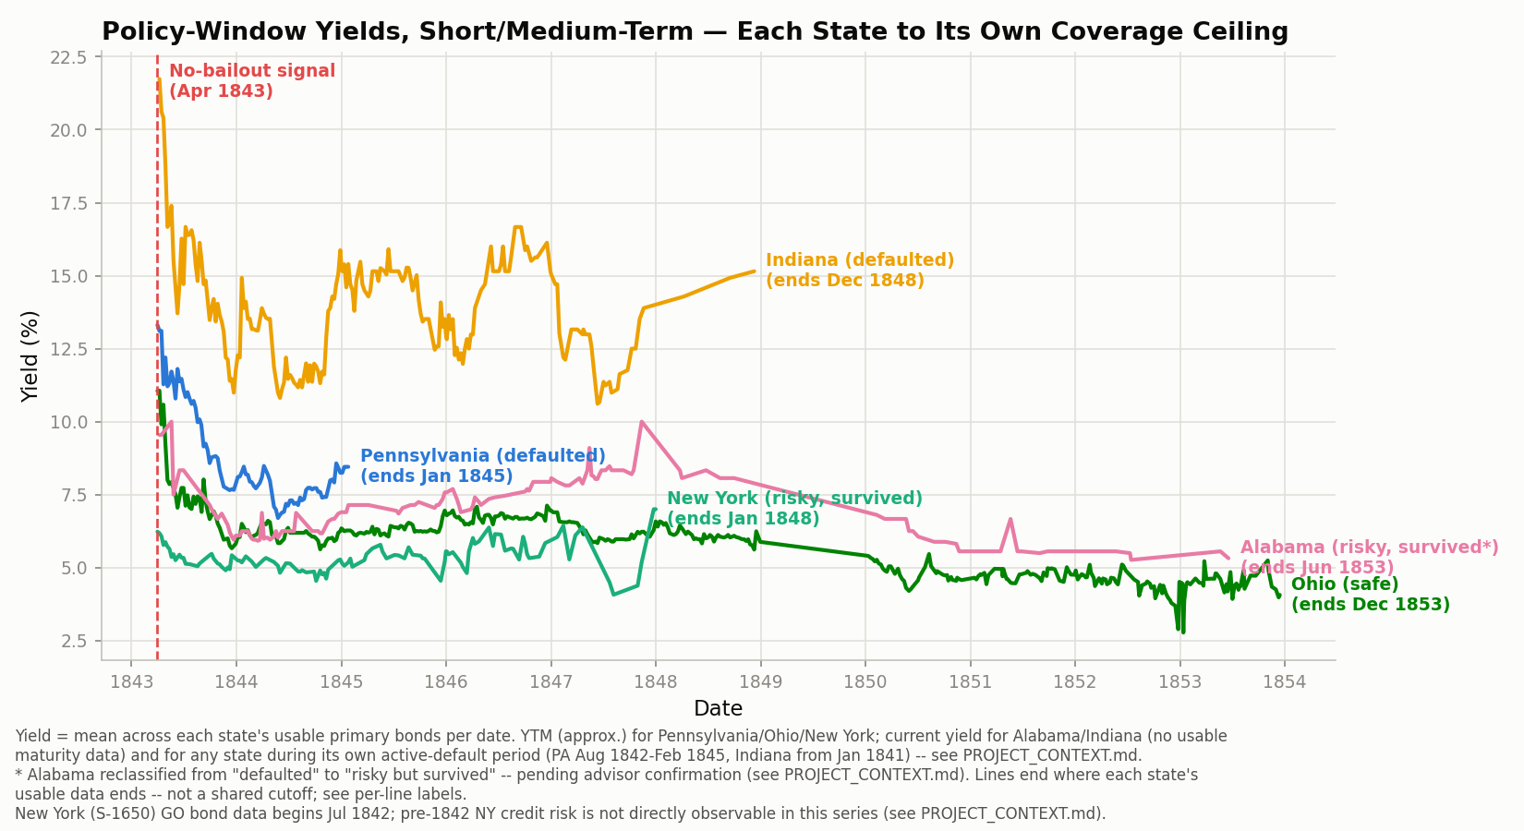
Yield = mean across each state's usable primary bonds per date. YTM (approx.) for Pennsylvania/Ohio/New York; current yield for Alabama/Indiana (no usable maturity data) and for any state during its own active-default period (PA Aug 1842-Feb 1845, Indiana from Jan 1841). Lines end where each state's usable data ends -- not a shared cutoff; see per-line labels. Alabama reclassified from "defaulted" to "risky but survived" -- pending advisor confirmation. New York (S-1650) GO bond data begins Jul 1842; pre-1842 NY credit risk is not directly observable in this series.

c. Policy-Window Persistence, Long-Term (through the 1850s)
Ohio vs. Alabama only -- the two states with genuine decade-spanning, dense coverage. Pennsylvania, Indiana, and New York do not have comparable long-run data and are excluded from this comparison rather than artificially extended. With Alabama reclassified, this chart no longer tests defaulted vs. safe -- it tests whether a risky-but-survived state's yield converges toward the safe state's over time. Alabama opens near-identical to Ohio right after the signal, widens to a ~2pp premium by 1847-48, then narrows but never fully closes through 1853.
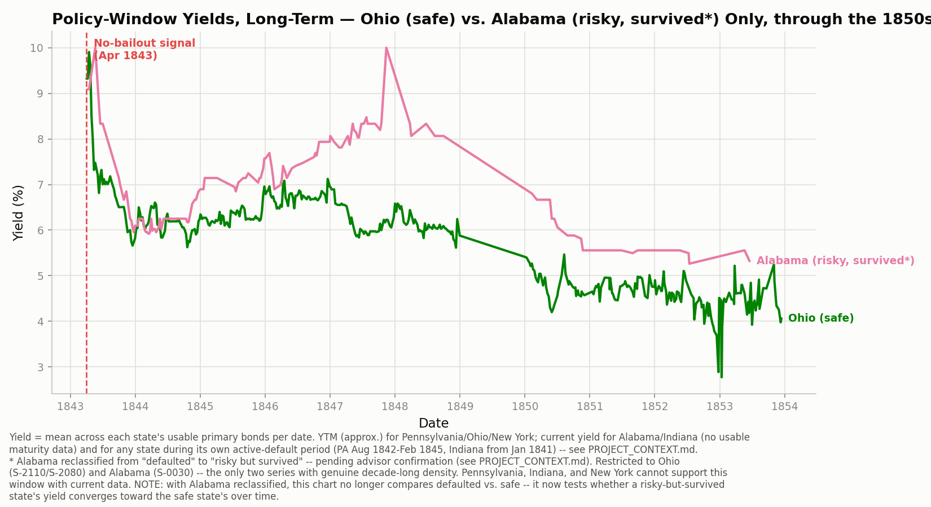
Restricted to Ohio (S-2110/S-2080) and Alabama (S-0030) -- the only two series with genuine decade-long density. Pennsylvania, Indiana, and New York cannot support this window with current data. Alabama reclassified from "defaulted" to "risky but survived" -- pending advisor confirmation.

Headline Takeaway
The market appears to price a consistent, modest (~2 percentage point) yield penalty for states that actually defaulted -- and Alabama's near-miss shows a premium of similar size despite never technically defaulting, suggesting the market was pricing real distress rather than the formal default event itself. But we don't see a comparable premium for a state whose distress didn't culminate in default (Ohio, which is the safe baseline throughout) or for New York, where the only usable instrument doesn't cover the period that would show it. This is a more precise, if more modest, claim than the original three-tier "graduated risk ladder" framing -- the persistence effect is real but smaller than first thought, and the middle bucket is better evidenced by Alabama than by New York right now.

Talking-Points Script
The following is written to be read aloud directly while screen-sharing this document, walking through the "what's changed," "results," and "takeaway" sections above.
Since we last talked, I closed out all three open items you flagged, and along the way I found a couple of things that actually change the shape of the results -- so let me walk through those first, then show you where the analysis stands now.
On the three open items: the before/after framing is now cleanly split into two separate windows -- a panic window around the 1837 shock, and a policy window around the actual no-bailout signal -- and I don't conflate them anywhere anymore. For the no-bailout date itself, I've settled on February 11, 1843, the Gwin/McDuffie assumption debate in Congress, which I'm treating as reinforced by consul Christopher Hughes's statements to European bankers that April through July. I want to flag that both of those rest on secondary sources -- I couldn't get into the Congressional Globe transcript or McGrane's book directly, so if the exact date matters for the writeup we should treat that as still needing a primary-source check.
[Pause here if Hall wants to push on the date -- he may know a way to access McGrane directly.]
On seniority: it turned out the New York bonds I'd originally picked were canal bonds, which carry a real revenue pledge on canal tolls -- that's a different security structure than the general-obligation bonds I was using for the other four states. I found a genuine New York GO bond, maturity-matched to the canal picks, and swapped it in for the primary comparison. I kept the canal bonds as a secondary reference, but they're not doing any work in the main results anymore.
Now, the more consequential finding: I caught a real problem in how I was computing yield. I'd been using yield-to-maturity everywhere I had a maturity date, but YTM assumes the bond pays back full face value on schedule -- and that assumption just doesn't hold for a state that's actively in default. I found this because one of Pennsylvania's bonds was showing a 30 percent average yield, which is a huge outlier -- and when I checked, the same price data gives about 9.5 percent under current yield instead. So I built a rule: for any state, during its own active-default period, use current yield instead of YTM, no matter how far that bond is from its own maturity. That fix alone brought Pennsylvania's post-signal premium over Ohio down from about 13 percentage points to about 2 -- which is a much more believable number, but it's also a much smaller effect than the original chart implied.
The other big finding: Alabama, which I'd had bucketed as "defaulted" since the very first pass through the codebook, actually didn't default in this episode at all. It raised taxes and liquidated its state bank to keep servicing its debt. So I've moved it into the "risky but survived" bucket alongside New York -- I want your sign-off on that before it's final, since it's been baked into every table and chart up to this point.
One more thing worth flagging: Pennsylvania's headline number from our very first pass -- the price falling from about 90 to about 40 by August-September 1842 -- turns out to be panic-window evidence only. The bond behind that number stops having usable data right around the signal date, so it can't actually speak to persistence. I found two other Pennsylvania bonds that do have real post-signal coverage, and those are what's driving the Pennsylvania numbers now.
So, walking through the three charts. First, the panic window -- this is the full five-state picture through 1845, and it looks close to what we expected: Pennsylvania's collapse is sharpest, New York's canal bonds dip and recover, Ohio dips with everyone else but comes back, and Alabama and Indiana both stay elevated without a clean recovery.
Second, the policy window, short and medium term. This is the one that actually tests the hypothesis. Pennsylvania and Alabama both show about a 2 percentage-point premium over Ohio, similar in size to each other even though only one of them technically defaulted. New York shows essentially no premium in this window -- but I want to be upfront that this comes with two caveats, not one clean finding. New York's GO bond simply has no price data before July 1842, so we can't see whether it was stressed during the actual worst of the crisis -- that's a coverage gap, not evidence of safety. And even in the window we can see, while the GO bond never drops below par, its canal bonds do -- but that could be a toll-revenue-specific risk rather than a statement about New York's general credit.
Third, the long-term window through the 1850s -- this only works for Ohio and Alabama, since they're the only two with real decade-spanning data. And here Alabama's premium over Ohio actually widens for a few years after the signal, peaking around 1847-48, then narrows but never fully closes through 1853.
So where that leaves us: the market does seem to price a consistent, modest penalty -- somewhere around 2 percentage points -- for states that actually got into real distress, whether or not they technically defaulted. What we don't have yet is a clean middle-bucket story from New York, because the instrument we have for it just doesn't cover the period that would show it. That's a more precise but more modest claim than the three-tier "graduated ladder" framing we started with, and I think that's an honest place to be right now rather than something to paper over.
That's where I'd like your input most: on the Alabama reclassification, and on whether it's worth chasing down a different New York instrument or additional data source to actually test the middle bucket properly.

Open Items for Next Phase
- The 1850s extension is only supportable for Ohio and Alabama with current data; Pennsylvania, Indiana, and New York all hit real data ceilings well before 1850 and cannot be extended into a full-decade comparison without a new data source.
- The canal/robustness comparison (New York S-1750/S-1820/S-1950, plus Ohio's and Indiana's canal bonds) has not yet been built as a standalone script -- it exists conceptually but isn't a reproducible output yet.
- The Indiana preferred/deferred tranche test (splitting the 1846-47 Butler Bill restructuring into its preferred vs. deferred canal debt) has not yet been run.
- The February 1843 no-bailout anchor date still rests on two secondary sources (a summary of the Congressional Globe debate and Hughes's statements as reported elsewhere) -- the original Congressional Globe transcript and McGrane's book were paywalled/inaccessible and this is not yet primary-source confirmed.

