KEV: Constant Evaluator

<https://k-ev.org>

***Online optimizer of the equilibrium constants***

***of the chemical reactions***

Web Application User Guide

by Drs. G. Gamov and A. Meshkov

TABLE OF CONTENTS

I. ABOUT KEV 6

II. GETTING STARTED 7

2.1 Log in or Sign up 7

2.2 Select a Problem 7

2.3 Input Data 8

2.4 Check the Data and Evaluate 9

2.5 Download Data 9

III. EQUILIBRIUM COMPOSITION 10

3.1 Select the Problem 10

3.2 Data Description and Manual Input 10

3.2.1 Stoichiometric matrix (Stoichiometric coefficients) 12

3.2.2 Decimal logarithms of equilibrium constants 13

3.2.3 Total (or equilibrium) concentrations of reagents 13

3.2.4 Component names 14

3.2.5 The component in relation to the yields of products are calculated 14

3.3 Evaluate 15

3.4 Output (Calculated) Data 15

3.5 Option: Equilibrium Concentrations as Input 16

3.6 Option: Upload Data from CSV or Tab Delimited File(s) 17

3.6.1 Stoichiometric matrix 18

3.6.2 Total (or equilibrium) concentrations of reagents 18

3.6.3 Decimal logarithms of equilibrium constants 18

Bulk upload (all files at once) 18

3.7 Option: Upload Data from XLSX Single File 22

3.7.1 Stoichiometric matrix 23

3.7.2 Total (or equilibrium) concentrations of reagents 23

3.7.3 Decimal logarithms of equilibrium constants 24

3.7.4 Component to get fractions of 24

3.8 Download Results of Calculations 25

3.8.1 Single xlsx file 25

3.8.2 Zip archive 26

IV. EQUILIBRIUM CONSTANTS EVALUATION FROM UV-Vis DATA 29

4.1 Select the Problem 29

4.2 Data Description and Manual Input 29

4.2.1 Stoichiometric matrix (Stoichiometric coefficients) 30

4.2.2 Decimal logarithms of equilibrium constants 31

4.2.3 Total (or equilibrium) concentrations of reagents 31

4.2.4 Component names 32

4.2.5 Absorbance and deviations 32

4.2.6 Molar extinction coefficients 33

4.2.7 Constants to evaluate and wavelengths to use 34

4.2.8 Threshold 34

4.2.8 Search density 35

4.3 Evaluate 35

4.4 Output (Calculated) Data 35

4.5 Option: Upload Data from CSV or Tab Delimited File(s) 38

4.5.1 Stoichiometric matrix 39

4.5.2 Total (or equilibrium) concentrations of reagents 39

4.5.3 Decimal logarithms of equilibrium constants 40

4.5.4 Absorbance 40

4.5.5 Molar extinction coefficients 40

4.5.6 Target 40

4.6 Option: Upload Data from CSV or Tab Delimited File(s) 41

4.7 Option: Upload Data from XLSX Single File 41

4.7.1. absorbance 41

4.7.2. mol_ext_coefficients 42

4.7.3. target 44

4.8 Option: Molar Extinction Coefficients Calculation 45

4.8.1 Select the Problem 45

4.8.2 Data Description 46

4.8.3 Upload Data from CSV or Tab Delimited File(s) 46

4.8.4 Option: Upload Data from XLSX Single File 48

4.9. More playground 50

V. EQUILIBRIUM CONSTANTS EVALUATION FROM POTENTIOMETRIC DATA 52

5.1 Select the Problem 52

5.2 Data Description and Manual Input 53

5.2.1 Stoichiometric matrix (Stoichiometric coefficients) 54

5.2.2 Decimal logarithms of equilibrium constants 55

5.2.3 Total (or equilibrium) concentrations of reagents 55

5.2.4 Component names 56

5.2.5 EMF and deviations 56

5.2.6 E0 and Slope 57

5.2.7 Constants to evaluate 57

5.3 Evaluate 57

5.4 Output (Calculated) Data 58

5.5 Option: Upload Data from CSV or Tab Delimited File(s) 60

5.5.1 Stoichiometric matrix 61

5.5.2 Total (or equilibrium) concentrations of reagents 61

5.5.3 Decimal logarithms of equilibrium constants 61

5.5.4 EMF 61

5.5.5 Target 62

5.6 Option: Upload Data from CSV or Tab Delimited File(s) 62

5.7 Option: Upload Data from XLSX Single File 62

5.7.1 emf 63

5.7.2 target 63

5.8. More playground 63

VI. EQUILIBRIUM CONSTANTS EVALUATION FROM NMR DATA (FAST EXCHANGE) 65

6.1 Select the Problem 65

6.2 Data Description and Manual Input 65

6.2.1 Stoichiometric matrix (Stoichiometric coefficients) 66

6.2.2 Decimal logarithms of equilibrium constants 67

6.2.3 Total (or equilibrium) concentrations of reagents 67

6.2.4 Component names 68

6.2.5 Chemical shifts and deviations 68

6.2.6 Chemical shifts of individual species 69

6.2.7 Constants to evaluate 69

6.3 Evaluate 69

6.4 Output (Calculated) Data 69

6.5 Option: Upload Data from CSV or Tab Delimited File(s) 72

6.5.1 Stoichiometric matrix 73

6.5.2 Total (or equilibrium) concentrations of reagents 73

6.5.3 Decimal logarithms of equilibrium constants 73

6.5.4 Chemical shifts 73

6.5.5 Target 74

6.5.6 Chemical shifts of individual species 74

6.6 Option: Upload Data from CSV or Tab Delimited File(s) 74

6.7 Option: Upload Data from XLSX Single File 74

6.7.1 chemical_shifts 75

6.7.2 target 76

6.7.2 individual_shifts 76

6.8. More playground 76

# I. ABOUT KEV

KEV is a chemical software developed for solving two classes of problems of the chemical equilibria theory. It is free, open source and available both as an online service and scripts bundle.

1. Equilibrium concentrations. Calculation of the equilibrium composition of the compounds mixture using stoichiometric scheme of reactions, total or equilibrium concentrations of reagents and known equilibrium constants.
2. Equilibrium constants. Estimation of the equilibrium constants from the experimental data (UV-Vis spectroscopy or potentiometric measurements).

KEV implements the statistical approach in solving equilibrium problems thus being broadly applicable across different systems (any system could be processed; theoretically, the number of chemical reactions occurring in the calculated mixture is unlimited), more accurate and reliable comparing with more traditional graphical methods.

What is described in this guide is **KEV web application (**<https://k-ev.org/kev>). If you are familiar with R Programming Language you could use **R scripts directly**:

* Download KEV repository from <https://gitlab.com/a.meshkov/KEV/> You could do it with Git or (if you have no idea what Git is and how to deal with it) directly from the web page using *Download* button (cloud and arrow image).
* Open *kev.Rproj* in RStudio. If you do not use RStudio be sure to set the working directory to the root of project with *setwd()* function.
* Play with *run.r* file (do not source the whole file, try different datasets and options)

# II. GETTING STARTED

## 2.1 Log in or Sign up

KEV web application requires the very simple authentication. Log in to <https://k-ev.org/kev> if you have already gained the login and password or register if you have not.

Please consider signing up is free and requires only sending a letter towards Dr. Aleksandr Meshkov or Dr. Georgiy Gamov via e-mails [ameshkoff@protonmail.com](mailto:ameshkoff@protonmail.com) or [ggamov@isuct.ru](mailto:ggamov@isuct.ru). In reply, you will be provided with the login and the password.

## 2.2 Select a Problem

After logging in you should choose which type of problem should be solved. KEV interface is divided in tabs corresponding specific calculation problems (Fig. 1):

* **Equilibrium concentrations.** Calculate the equilibrium composition of the mixture
* **Spectrophotometry.** Evaluate unknown equilibrium constants from the experimental spectral data (UV-Vis spectroscopy)
* **Extinction Coefficients.** Calculate molar extinction coefficients from a series of the experimental spectra data
* **EMF.** Evaluate unknown equilibrium constants from the potentiometric experimental data

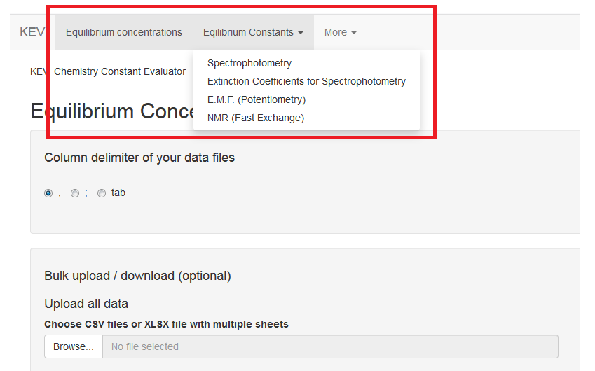

***Figure 1.*** *KEV interface. Different functionality tabs are marked with red*

## 2.3 Input Data

KEV is very flexible in the ways you can provide the data to. Use one of the options described below or mix them together.

* Manual input  
  + Type all the data in the tables provided
    - Add or remove rows and columns using context menu
    - Both “.” or “,” as decimal separator are avaiable
    - Do not use “,” or “ ” as a mark between big interval decimals
  + Copy + paste from Excel spreadsheets or a similar app
    - Copy from the source app, select cells in the KEV table and paste using hotkeys (Ctrl+V in Windows)
* Upload file(s)  
  + Upload all prepared data at once (*Bulk input*). Click *Upload all data* and upload one of the following options:
    - CSV or tab delimited files, one file for one table. Files should be properly named and properly formatted. Supported file formats:
      * CSV, both comma and semicolon separated
      * Tab separated file
    - Excel file with a few sheets (xlsx only). Every sheet should be properly named and properly formatted
  + Upload prepared data one table after another using *Choose CSV* under each table. So if you have 3 tables to fill prepare 3 files and then upload them using 3 different *Browse* buttons. Use this option if you want to change only part of the large dataset already uploaded. Supported file formats:
    - CSV, both comma and semicolon separated
    - Tab separated file

We recommend starting with *Copy + paste* option or *Upload all prepared data* at once.

Example input datasets could be obtained here: <https://gitlab.com/a.meshkov/KEV/tree/master/input>

* *concentrations*: Equilibrium composition
* *spectrophotometry*: Unknown Equilibrium constants via UV-Vis spectroscopy
* *emf*: Unknown Equilibrium constants via EMF
* *molar.extinction.coefficients*: Molar extinction coefficients from a series of the experimental spectra data

IMPORTANT: It is not possible to add or remove rows if the data is uploaded from the disc and not typed manually or pasted from another application.

TIP: To switch between column separators (“,”, “;” or *tab*) use *Column delimiter* in the left top of the window.

## 2.4 Check the Data and Evaluate

After the input data is provided check if all is OK. If not you will get a bunch of red and grey error messages. Most frequent error causes and fixes are:

* Check *Column delimiter* control. If you use csv file with semicolon ";" delimiter should be also ";"
* Check if component (molecule) names are consistent between different tables i.e. coefficient, concentrations and molar extinction matrices
* Check the same for wavelenghts
* If you are uploading data table by table just try to load remaining data, the “error” could be a temporary thing disappering after all the data is provided

Now when all is OK click *Evaluate* and wait till the unknown constants, concentrations and other stuff are calucalted.

## 2.5 Download Data

Both the input and calculated data could be downloaded to your local computer.

* Download one table. Click *csv* or *xlsx* button under the table you prefer to download. If you choose the CSV option the downloaded CSV file use the column separator defined by *Column delimiter* control.
* Download all the data, input and calculated (if available) as well. Choose *zip* or *xlsx* option of the *Download all data* in the *Bulk upload / download* section.
  + *zip*. Zip archive containing CSV files. The downloaded CSV file use the column separator defined by *Column delimiter* control.
  + *xlsx*. Excel file (xlsx) with multiple sheets

# III. EQUILIBRIUM COMPOSITION

## 3.1 Select the Problem

Select *Equilibrium concentrations* in the top menu to open the tab.

Let us consider the equilibria in the system containing phosphoric acid and Cu2+ ions at T 298.15 K. The example data could be obtained:

* Input Data
  + CSV comma separated files <https://gitlab.com/a.meshkov/KEV/tree/master/input/concentrations/ds.3p.long/csv.comma>
  + CSV semicolon separated files <https://gitlab.com/a.meshkov/KEV/tree/master/input/concentrations/ds.3p.long/csv.semicolon>
  + Tab separated files <https://gitlab.com/a.meshkov/KEV/tree/master/input/concentrations/ds.3p.long/txt.tab>
  + Excel (xlsx) file <https://gitlab.com/a.meshkov/KEV/tree/master/input/concentrations/ds.3p.long/example_eq_conc_calc.xlsx>
* Output (calculated) data
  + Zip archive with CSV files <https://gitlab.com/a.meshkov/KEV/tree/master/output/concentrations/ds.3p.long/gui/eq_conc_calc_res.zip>
  + Excel (xlsx) file <https://gitlab.com/a.meshkov/KEV/tree/master/output/concentrations/ds.3p.long/gui/eq_conc_calc_res.xlsx>

## 3.2 Data Description and Manual Input

In order to calculate the equilibrium concentrations of reagents and reactions’ product KEV requires the following data:

* Tables (matrices and vectors)
  + Stoichiometric matrix of reactions (a.k.a. Stioichiometric coefficients)
  + Decimal logarithms of equilibrium constants
  + Total (or equilibrium) concentrations of reagents
* Text input
  + The component in relation to the yields of products are calculated

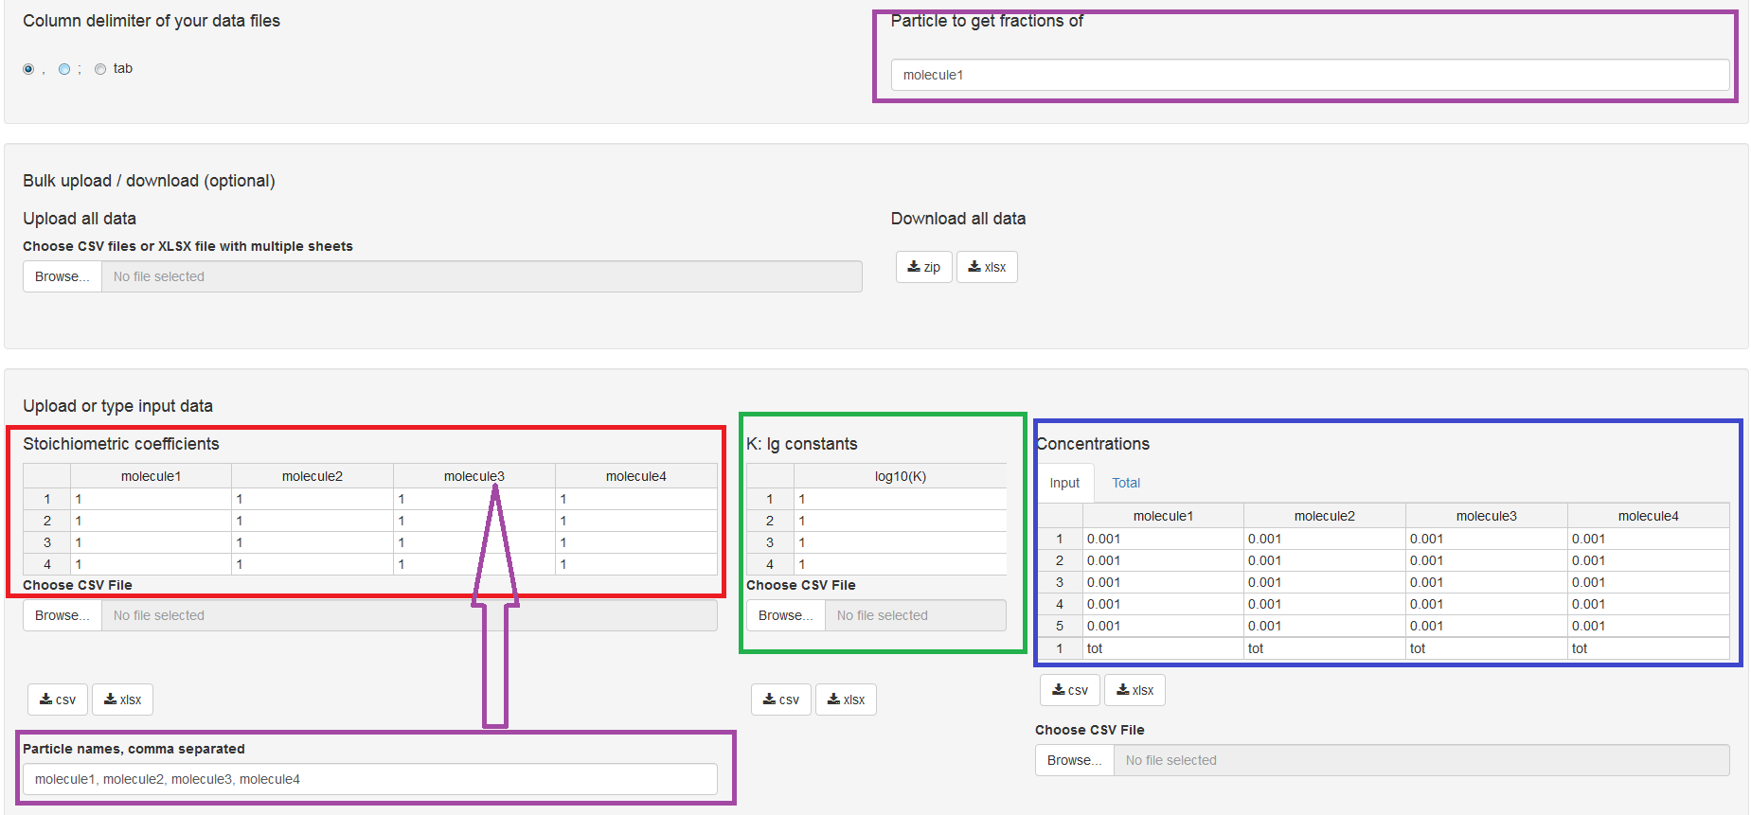

***Figure 2.*** *KEV interface. Table of stoichiometric coefficients is marked with red, table of decimal logarithms of equilibrium concentrations is marked with green, table of total (or equilibrium) concentrations of reagents is marked with blue, reagents names are marked with purple*

KEV is based on Brinkley’s method for describing the processes occurring in the solutions. This method requires all the reactions to be expressed as , *i* = 1, 2, 3, …, *N*. *Bj* is a symbol of *jth* component, the combination of which is called the *basis set*; *Ai* is a symbol of *ith* reaction product; *νij*is a stoichiometric coefficient before *jth* basis component in the *ith* product obtaining reaction. In this description, it does not matter what are the stoichiometric coefficients before products.



For the example data it is:

H+ + PO43- ↔ HPO42-; lg K = 11.68 (I = 0.101) [1] (1)

H+ + HPO43- ↔ H2PO4-; lg K = 6.75 (I = 0.101) [1] (2)

H+ + H2PO43- ↔ H3PO4; lg K = 1.80 (I = 0.101) [1] (3)

H2O + Cu2+↔ CuOH+ + H+; lg K = -8.12 (I = 0.05) [2] (4)

HPO42- + Cu2+ ↔ CuHPO4; lg K = 3.3 (I = 0.101) [2] (5)

H2PO4- + Cu2+ ↔ CuH2PO4+; lg K = 1.6 (I = 0) [2] (6)

2HPO42- + Cu2+ ↔ Cu(HPO4)22-; lg K = 4.7 (I = 0.5) [2] (7)

2H2PO4- + Cu2+ ↔ Cu(H2PO4)2; lg K = 1.0 (I = 3.0) [2] (8)

It could be seen easily that all products could be obtained by combination of three reagents only. Namely those are H+; PO43- and Cu2+. To make this more evident let us re-write the system of chemical reactions as follows:

H+ + PO43- ↔ HPO42-; lg K = 11.68 (I = 0.101) (9)

2H+ + PO43- ↔ H2PO4-; lg K = 18.43 (I = 0.101) (10)

3H+ + PO43- ↔ H3PO4; lg K = 20.23 (I = 0.101) (11)

-H+ + Cu2+ + H2O ↔ CuOH+ ; lg K = -8.12 (I = 0.05) (12)

H+ + PO43- + Cu2+ ↔ CuHPO4; lg K = 14.98 (I = 0.101) (13)

2H+ + PO43- + Cu2+ ↔ CuH2PO4+; lg K = 20.03 (I = 0) (14)

2H+ + 2PO43- + Cu2+ ↔ Cu(HPO4)22-; lg K = 28.06 (I = 0.5) (15)

4H+ + 2PO43- + Cu2+ ↔ Cu(H2PO4)2; lg K = 37.86 (I = 3.0) (16)

H+, PO43- and Cu2+ are so-called *basis components* or *basis set* or just *basis*. The choice of basis should be justified by the following assumptions: a) all the products should be obtained by combining the basis components; b) the number of basis components should be minimal (but the first condition must be met). Now provide this data to KEV.

### 3.2.1 Stoichiometric matrix (Stoichiometric coefficients)

Stoichiometric coefficients before H+, PO43- and Cu2+ form the following matrix:

1 1 0

2 1 0

3 1 0

-1 0 1

1 1 1

2 1 1

2 2 1

4 2 1

Type them into KEV table *Stoichiometric coefficients*. Adding or removing columns/rows could be made with the context menu (mouse right click).

TIP: If you do not want to type numbers cell by cell (we don’t), copy numbers into a blank Excel file, split data into columns and copy + paste it from the Excel file to the KEV table *Stoichiometric coefficients*

### 3.2.2 Decimal logarithms of equilibrium constants

Values of lg Ktotal (9-16) include stepwise protonation and metal complexation constants.

Total lg K values form lg K vector:

11.68

18.43

20.23

-8.12

14.98

20.03

28.06

37.86

Type it into KEV table *K: lg constants* preserving the order or copy + paste as for the stoichiometric matrix data.

IMPORTANT: Please note the decimal logarithms of equilibrium constants (lg K) should be input and not the K values

### 3.2.3 Total (or equilibrium) concentrations of reagents

Let us also give the total concentrations for three mixtures. For example, 1) C(H+) = 0.01; C(PO43-) = 0.01; C(Cu2+) = 0.01; 2) C(H+) = 0.02; C(PO43-) = 0.01; C(Cu2+) = 0.01; 3) C(H+) = 0.03; C(PO43-) = 0.01; C(Cu2+) = 0.01.

It forms another matrix (components as columns and mixtures as rows):

0.01 0.01 0.01

0.02 0.01 0.01

0.03 0.01 0.01

Type or copy + paste it to KEV table *Concentrations* >> *Input*

The footnote of the Table “Concentrations” contains a row of variables capable of taking two values: *tot* for total concentrations, and *eq* for equilibrium concentrations (if some input concentrations are equilibrium ones).

IMPORTANT: Check if the column number in *Stoichiometric coefficients* and *Concentrations* tables is equal. If one table has empty or excess columns remove them with the context menu (mouse right click)

### 3.2.4 Component names

Columns in both *Stoichiometric coefficients* and *Concentrations* tables have the same names which are the names of the base components. By default KEV uses component names *molecule1, molecule2, molecule3* etc. If you want to change them (and you’d better do) type new base component names into the *Component names, comma separated* field.

H, PO4, Cu

IMPORTANT: Make sure the quantity of reagents in the string *Component names, comma separated* corresponds to the quantity of columns of Table *Stoichiometric coefficients*. Delete or add columns if required

### 3.2.5 The component in relation to the yields of products are calculated

Type one of the component names into *Component to get fractions of* field. Make sure it corresponds to one of the component names in the *Component names, comma separated* field.

Taking all required values into KEV looks as follows (Fig. 3).

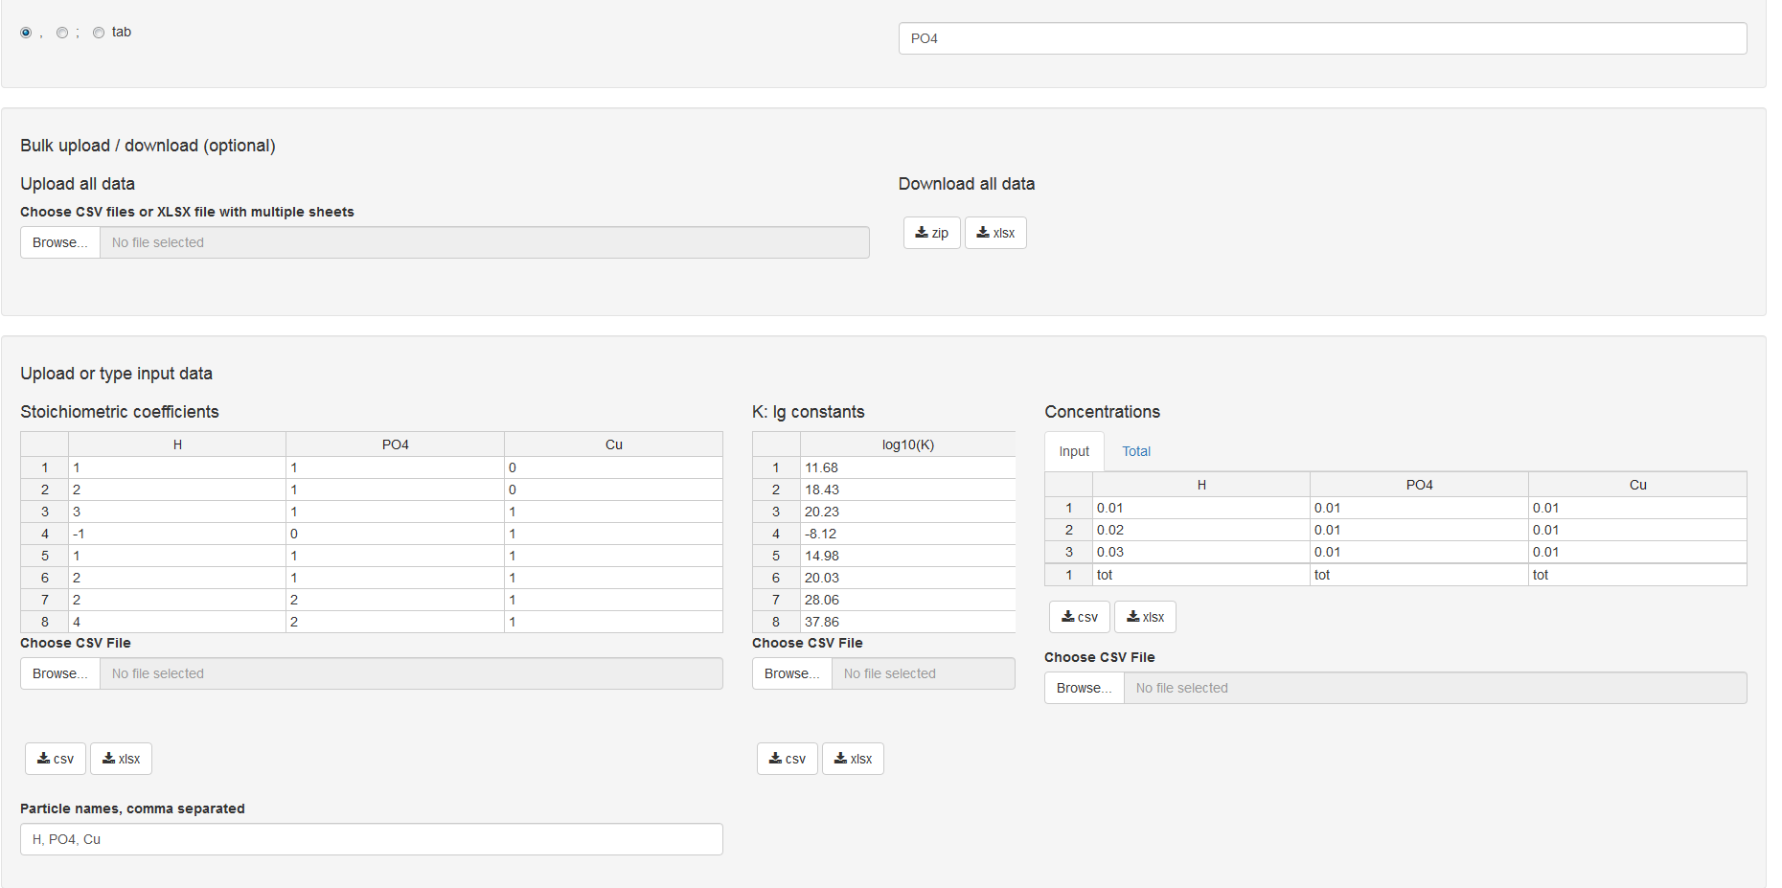

***Figure 3.*** *Data on equilibria in the system containing H+, PO43-, Cu2+ input into KEV*

## 3.3 Evaluate

After the input data is provided check if all is OK. If it is not you will get a bunch of red and grey error messages. Most frequent error causes and fixes are:

* Check *Column delimiter* control. If you use csv file with semicolon ";" delimiter should be also ";"
* Check if component (molecule) names are consistent between different tables i.e. coefficient, concentrations and molar extinction matrices
* Check the same for wavelenghts
* If you are uploading data table by table just try to load remaining data, the “error” could be a temporary thing disappering after all the data is provided

In order to calculate the equilibrium concentrations of the reagents and products click *Evaluate* button right under the input data tables.

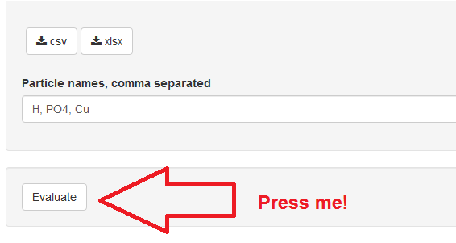

***Figure 4.*** *“Evaluate” button*

## 3.4 Output (Calculated) Data

The results will appear below a few moments later (Fig. 5):

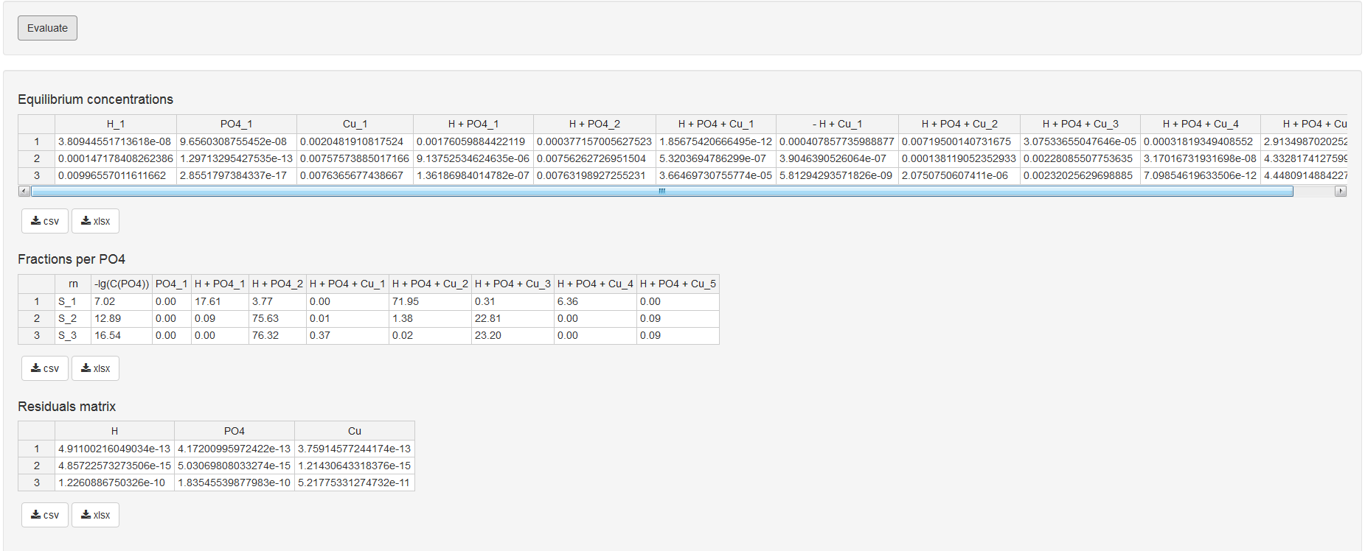

***Figure 5.*** *The results of equilibrium constants calculations for the system containing H+, PO43-, Cu2+*

* *Equilibrium concentrations*: all the equilibrium concentrations for basis components and products
* *Fractions per PO4*: yields of products in relation towards preliminarily chosen basis component (namely, PO43-)
* *Residual matrix*: relative errors of the calculated total concentrations (differencies between the calculated and observed concentrations divided by observed calculations)
* *Correlations >> Total* (in the upper part of the window, tab near the observed concentrations): calculated total concentrations

## 3.5 Option: Equilibrium Concentrations as Input

Let us consider now the hydrogen ions concentration is equilibrium but not the total one. To make a correspondent change one needs to replace the *tot* variable by *eq* variable in the footnote of the Table “Concentrations” (Fig. 6).

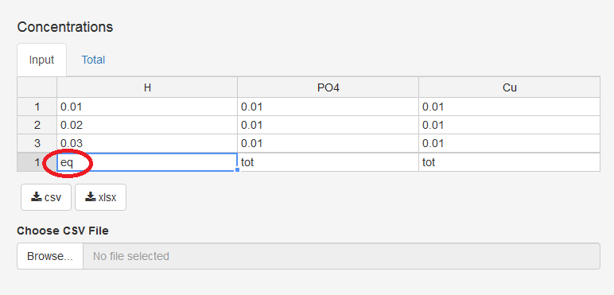

***Figure 6.*** *How to introduce the equilibrium concentration of basis component instead of total one*

Then again press the button *Evaluate* and the equilibrium concentrations of basis components and products will be calculated.

## 3.6 Option: Upload Data from CSV or Tab Delimited File(s)

All the data could be entered manually, however we recommend preparing the specific file (or files) containing all the required data.

TIP: Even if you input data manually you could save both input and output data in the file(s) so you could reproduce the research later or do minor modifications without retyping all the data from scratch.

CSV or tab delimited files are plain files with data delimited into columns with a specific delimiter (a.k.a. separator), mostly comma (,), semicolon (;) or tab (press *Tab* key in your preferred text editor to get the value).

These formats are very stable, platform independent and are used by a great range of applicatons and packages. There are at least four ways to format KEV input data as plain text files:

* Basic way: Type data using your preferred plain text editor such as Notepad on Windows
* Simplest way: Type or copy data to KEV, then download as CSV
* Dangerous way: Save from Excel using *Save as* option (could be some undesirable tricks)
* Advanced way: Use input from another app or package if format is the same as KEV requires

Please follow the recommendations below to format files in the right way.

TIP 1: Consider file names if you upload all data at once. If you upload file by file using *Choose CSV File* buttons there are no restrictions for file names

TIP 2: If you do not understand a word below use the Simplest way and consider only file names for the bulk input

### 3.6.1 Stoichiometric matrix

* File names allowed: *stoich_coefficients.csv, stoichiometric_coefficients.csv, stoich_coefficients, stoichiometric_coefficients, stoich_coefficients.txt, stoichiometric_coefficients.txt*. Prefix *input_* is also allowed. Remember: those names must be used if you upload all the files at once! If you upload them one by one, you are free to name the files whatever you want.
* First row: component names
* Following rows: stoichiometric coefficients, one row for one reaction

### 3.6.2 Total (or equilibrium) concentrations of reagents

* File names allowed: *concentrations.csv, concentrations, concentrations.txt*. Prefix *input_* is also allowed
* First row: total (*tot*) or equal (*eq*) concentrations
* Second row: component names
* Following rows: input concentrations, one row for one mixture

### 3.6.3 Decimal logarithms of equilibrium constants

* File names allowed: *k_constants_log10.csv, k_constants_log10, k_constants_log10.txt*. Prefix *input_* is also allowed
* First row: “k_constants_log10”
* Following rows: Decimal logarithms of equilibrium constants, one row for one reaction

Now when all files are prepared upload them to KEV.

### Bulk upload (all files at once)

Select *Upload all data* in the section *Bulk upload / download (optional)* clicking on the *Browse…* data. Select all input data files for this project at once and click *Open*.

TIP: You can also load only some of the input data files e.g. *concentrations* and *k_constants_log10* and *not stoich_coefficients*. The missing data could be uploaded later (e.g. from another directory) or typed manually.

IMPORTANT: If input data requires some consistency between input files there could be some temporary errors if some data is already uploaded and some not. Don’t panic! The errors to be gone when the full data is uploaded.

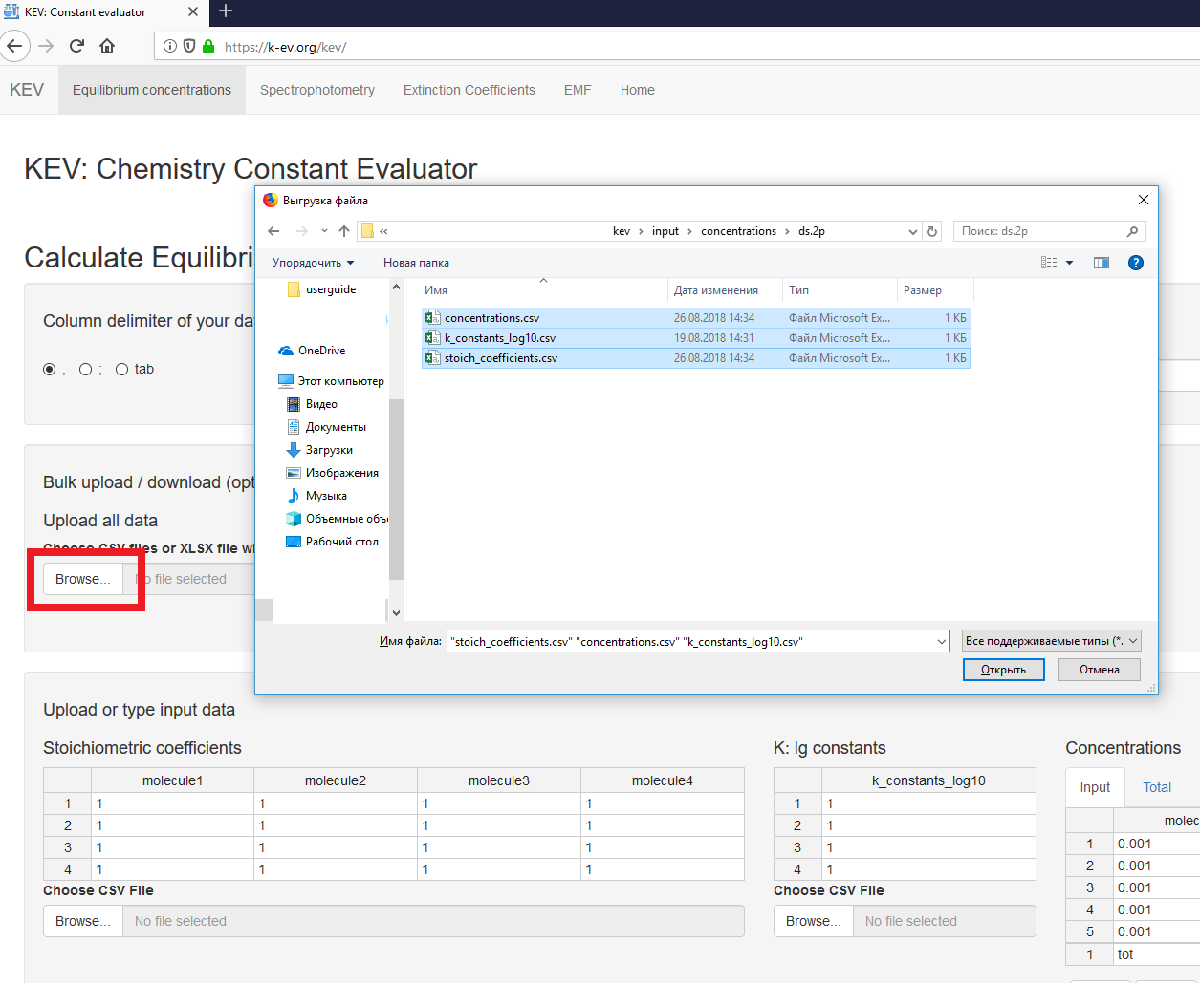

*Upload one file by another*

Upload one file by another could be of interest if you need to correct only a part of the previously uploaded data or a small part of data is not yet uploaded at all.

Select *Choose CSV File* clicking on the *Browse…* button under the table you are going to fill. Let’s begin e.g. from stoichiometric matrix. Remember, if you have chosen uploading one file by another there are no restrictions in file names – just pick the properly formatted one. The strict names must be given to files if you upload them all simultaneously using *Bulk upload* option. See sections 3.6.1-3.6.3 for details.

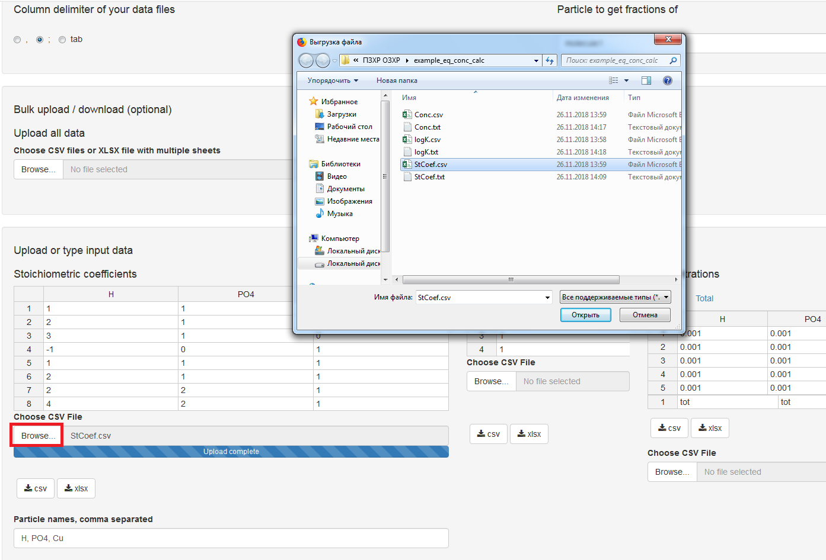

Then, let us upload the stoichiometric coefficients

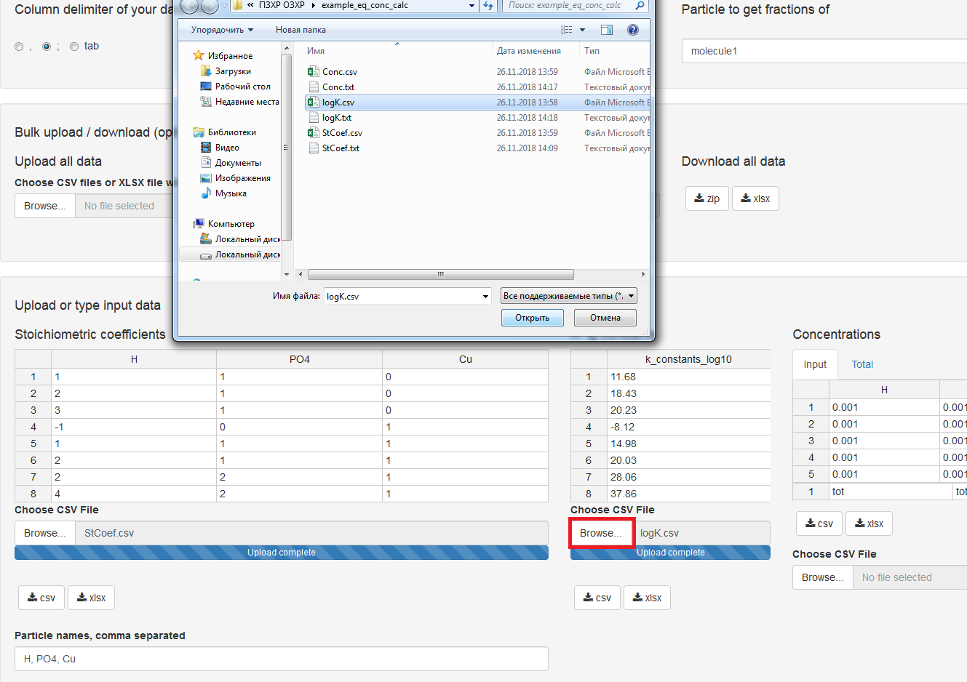

Finally, here the concentrations go!

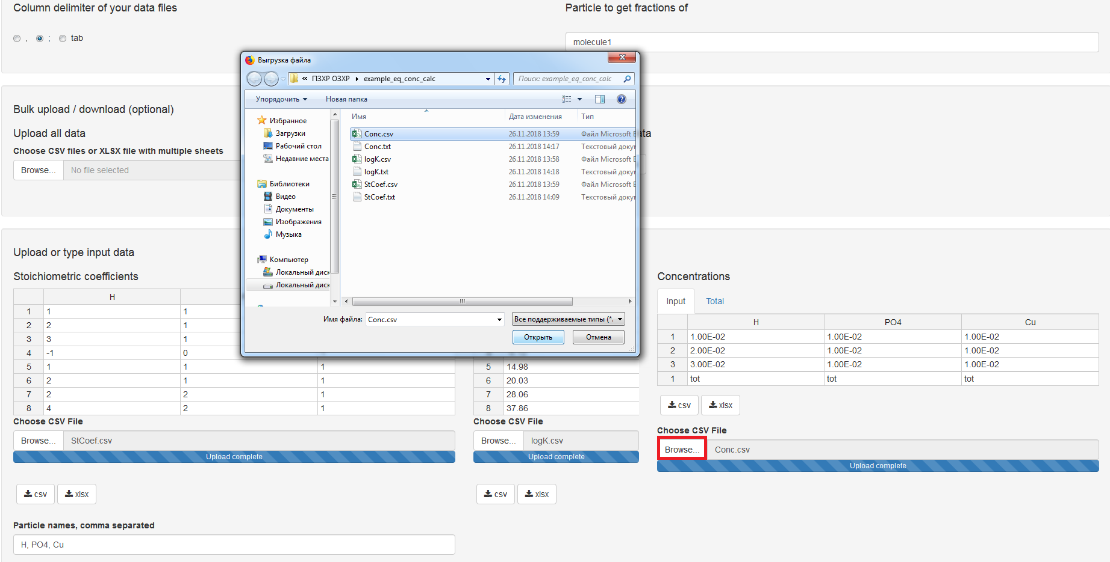

*Create CSV files with KEV*

* **Fill data in KEV and download.** If you are experiencing some problems with creating the input data files fill the data in KEV interface and download as a zip archive containing CSV files. Unzip archive and you can use them with the *Bulk upload* option next time.

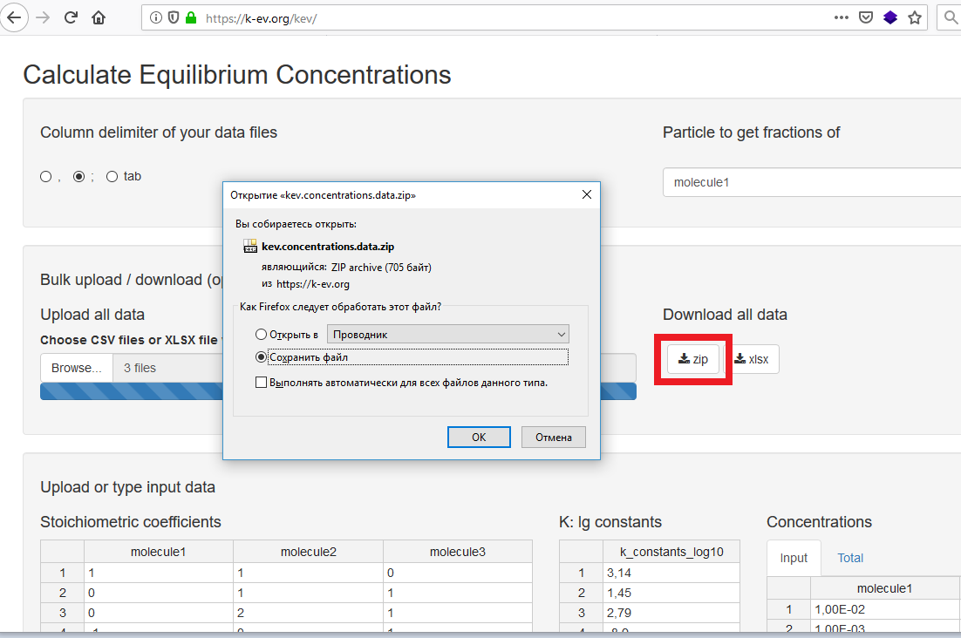

* **Download, fill on your desktop and upload.** Or you can download example files (i.e. do not fill anything before downloading) and fill them with data on your desktop.

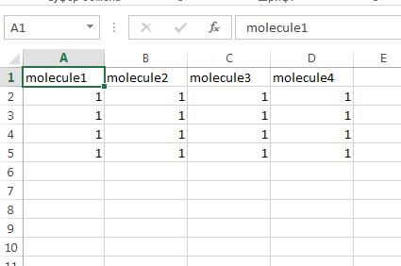

* **Download files one by one.** Or you can download, fille and upload files one by one if you prefer. Modify this blank file for stoichiometric coefficients; than save it in your preferable format, and all is done! We believe there is no need to repeat the same for other tables. The procedure is very similar: download, modify, save, upload.

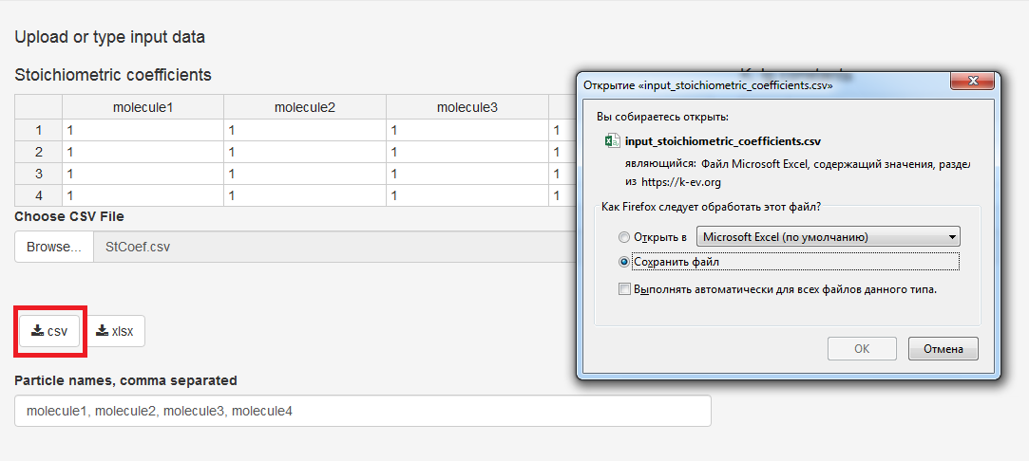

## 3.7 Option: Upload Data from XLSX Single File

KEV supports uploading and downloading Excel files in *xlsx* format.

IMPORTANT: *xls, xlsm* and *xlsb* are not supported yet. Convert them to *xlsx*, it is easy with Excel 2007 or newer.

The properly formatted file of the example system considered above could be downloaded via <https://gitlab.com/a.meshkov/KEV/tree/double/input/concentrations/ds.3p.long/example_eq_conc_calc.xlsx>

The file consists of four sheets

* the sheets *stoich_coefficients, concentrations* and  *k_constants_log10* cover KEV Tables
* the sheet *component_names* contains the name of *component to get fractions of* (Fig. 7).

IMPORTANT: Do not rename the sheets.

The input data should be written into file as it is shown for stoichiometric matrix (Fig. 7), concentrations, equilibrium constants logarithms and component name (Fig. 8).

### 3.7.1 Stoichiometric matrix

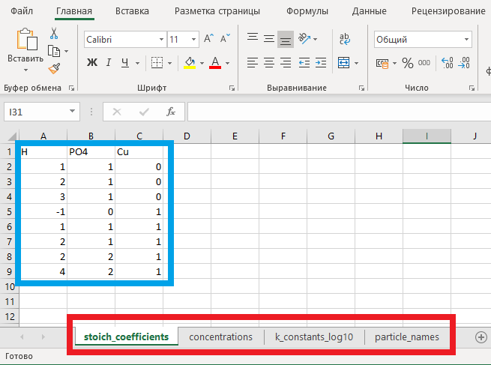

**Figure 7.** *Input data file tabs (marked with red), and stoichiometric matrix (marked with blue)*

### 3.7.2 Total (or equilibrium) concentrations of reagents

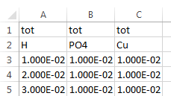

**Figure 8.** *Input data file – concentrations*

### 3.7.3 Decimal logarithms of equilibrium constants

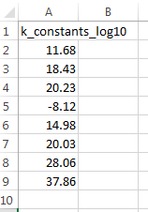

**Figure 9.** *Input data file – equilibrium constants logarithms*

### 3.7.4 Component to get fractions of

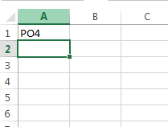

**Figure 10.** *Input data file – component name*

When the xlsx data file is done upload it into KEV the same way as the bulk upload with CSV files i.e. select *Upload all data*  in the *Bulk upload / download (optional)* section (Fig. 11).

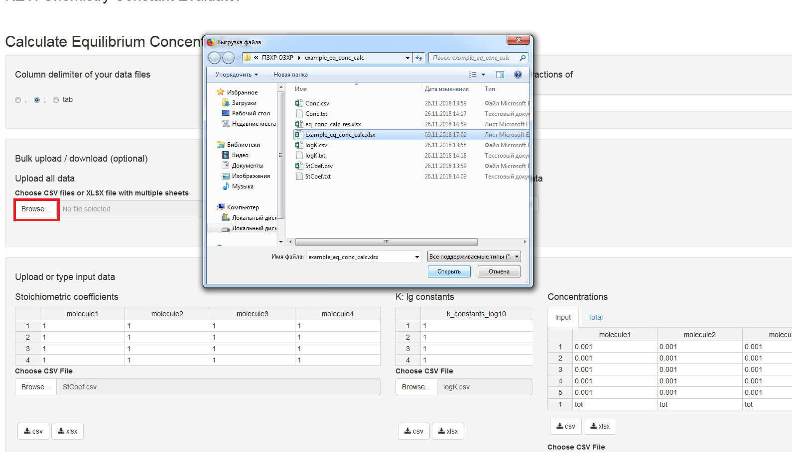

**Figure 11.** *How to upload the single .xlsx file containing all the data*

## 3.8 Download Results of Calculations

Just click *Download all data* in the *Bulk upload / download (optional)* section and choose your preferred forma (Fig. 12)t:

* zip: zip archive containing CSV files
* xlsx: single Excel file with multiple sheets

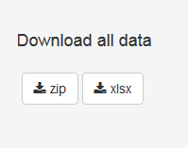

**Figure 12.** *Download the results together with input data*

### 3.8.1 Single xlsx file

The resulting .xlsx file contains all the input data and results in separate sheets (Fig. 13).

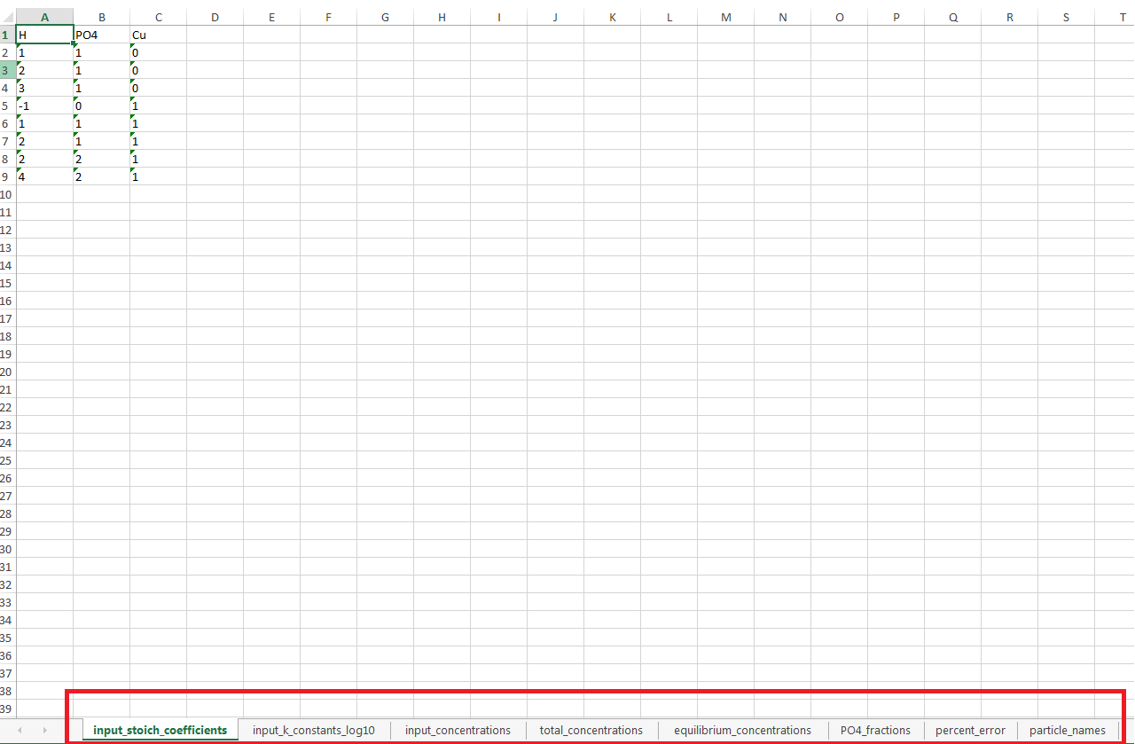

**Figure 13.** *Resulting .xlsx file*

### 3.8.2 Zip archive

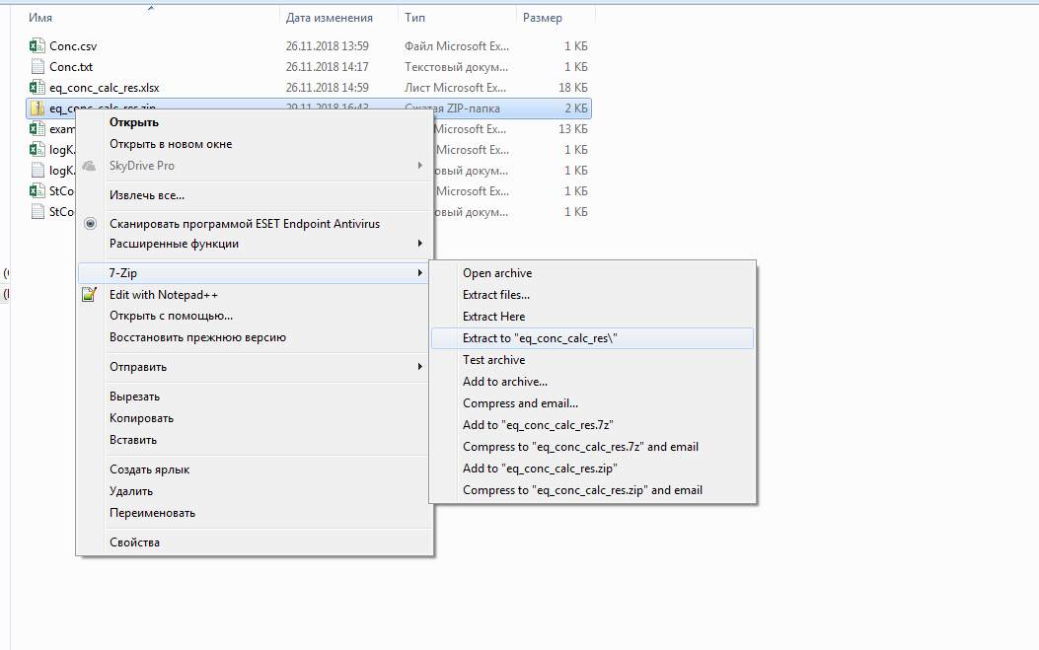

Archive unpacked contains following files:

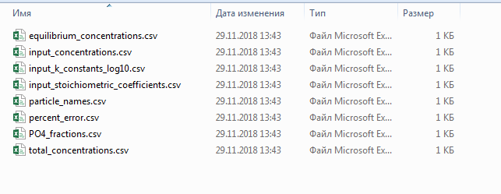

3.9 Speciation Diagrams

Speciation diagrams are the dependencies of chosen products/basic components yields on pC of other basic component. pH-dependent plots are widely distributed in literature describing protolytic properties of acids, bases and metal complexes.

To produce this type of plot the user should modify the input data via *pC range (optional)* tab in *Concentrations* tabset in the input section of the interface.

* Load input data for the system one prefers to calculate
* Switch to *pC range (optional)* tab
* Type the component name one wants to see at the *X* axis. Be sure it not to coincide with *Component to get fractions of*
* Define pC range for the component typed in the previous step using the slider
* Type total concentrations of the other components in the table *Total concentrations of other components*. Columns (i.e. components) could be added and removed via the context menu (mouse right click)
* Click *Update Input Concentrations* button
* Click *Evaluate* as usual

If the user doesn’t modify the input data, the plot would be produced anyway. However, it would illustrate calculations of the input mixture in this case.

The example of speciation diagram for the solution, containing PO43- (0.01 M) and Cu2+ (0.005 M) ions (pH is taken as X-axis) is given below:

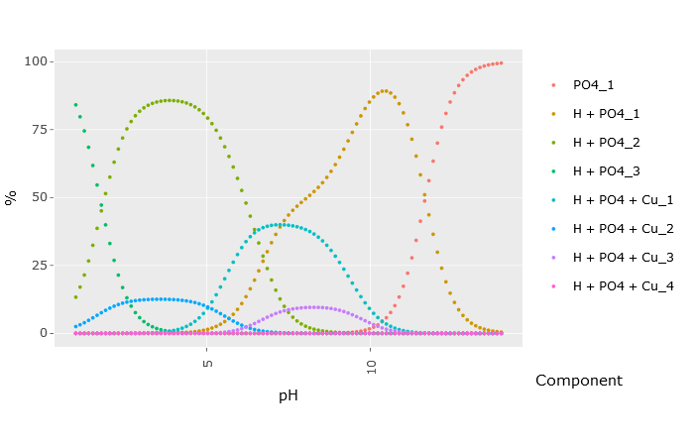

While in KEV, plots have some neat options such as zooming, panning, switching variables on and off *etc*. Plots could be downloaded from KEV as PNG images for further using.

**References to Section III**

1. K. J. Powell et. al. *Pure&Applied Chemistry* **2005**, *77(4)*, 739-800, doi: 10.1351/pac200577040739
2. K. J. Powell et. al. *Pure&Applied Chemistry* **2007**, *79(5)*, 895-950, doi: 10.1351/pac200779050895

# IV. EQUILIBRIUM CONSTANTS EVALUATION FROM UV-Vis DATA

## 4.1 Select the Problem

Click *Equilibrium constants* in the top menu and select *Spectrophotometry* from the expanding menu to open the tab.

Let us consider the reaction of hydrazone formation between pyridoxal 5’-phosphate (PLP) and 2-methyl-3-furoylcarbohydrazide (2MF3H) at pH 7.0 [1]:

PLP + 2MF3H ↔ Hydrazone (17).

The example data could be obtained:

* Input Data
  + CSV comma separated files <https://gitlab.com/a.meshkov/KEV/tree/master/input/spectrophotometry/dsl.9/csv.comma>
  + CSV semicolon separated files <https://gitlab.com/a.meshkov/KEV/tree/master/input/spectrophotometry/dsl.9/csv.semicolon>
  + Tab separated files <https://gitlab.com/a.meshkov/KEV/tree/master/input/spectrophotometry/dsl.9/txt.tab>
  + Excel (xlsx) file <https://gitlab.com/a.meshkov/KEV/tree/double/input/spectrophotometry/dsl.9/UV-Vis_input_example.xlsx>
* Output (calculated) data
  + Zip archive with CSV files <https://gitlab.com/a.meshkov/KEV/tree/double/output/spectrophotometry/dsl.9/gui/UV_Vis_results.zip>
  + Excel (xlsx) file <https://gitlab.com/a.meshkov/KEV/tree/double/output/spectrophotometry/dsl.9/gui/UV_Vis_results.xlsx>

## 4.2 Data Description and Manual Input

In order to evaluate the equilibrium constant(s) from UV-Vis experimental results KEV requires the following data:

* Tables (matrices and vectors)
  + Stoichiometric matrix of reactions (a.k.a. Stioichiometric coefficients)
  + Decimal logarithms of equilibrium constants
  + Total (or equilibrium) concentrations of reagents
  + Absorbance values at certain wavelengths with their experimental deviations
  + Molar extinction coefficients at the *very same* wavelengths as absorbance (optional)
* Text input (Fig. 16)
  + The name of constant(s) to be evaluated
  + Threshold (search algorithm precision)
  + Search density (default to 1)

The initial three tables are the same as in the case of calculation of the equilibrium composition. See Sections 3.2.1-3.2.3; 3.6-3.7 for details.

However, the additional information input is also in order. It includes absorbance values with the errors of their measuring and molar extinction coefficients (Fig. 15).

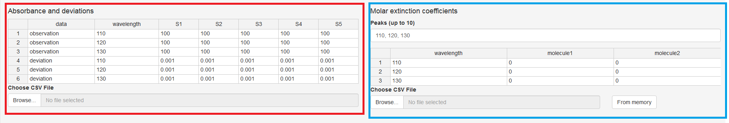

***Figure 15.*** *Screenshot of KEV interface. Experimental absorbances table is marked with red, molar extinction coefficients table is marked with blue*

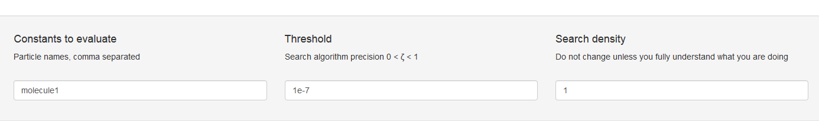

***Figure 16.*** *Additional information required for the calculations*

### 4.2.1 Stoichiometric matrix (Stoichiometric coefficients)

For the example given in Section 4.1 (reaction of hydrazone formation between pyridoxal 5’-phosphate (PLP) and 2-methyl-3-furoylcarbohydrazide (2MF3H) at pH 7.0) there are two basis component, 2MF3H and PLP, and the only reaction. Therefore, the stoichiometric matrix is following:

1 1

Is that all? Not yet: there is also an additional column *name*. It serves for naming the products of reactions. Let us name the product SB (Schiff Base). Then, the matrix looks like that:

1 1 SB

Type them into KEV table *Stoichiometric coefficients*. Adding or removing columns/rows could be made with the context menu (mouse right click).

TIP: If you do not want to type numbers cell by cell (we don’t), copy numbers into a blank Excel file, split data into columns and copy + paste it from the Excel file to the KEV table *Stoichiometric coefficients*

### 4.2.2 Decimal logarithms of equilibrium constants

There is the only reaction, so, the vector of lg Ktotal contains the only number:

5

Type it into KEV table *K: lg constants* preserving the order or copy + paste as for the stoichiometric matrix data.

IMPORTANT: Please note the decimal logarithms of equilibrium constants (lg K) should be input and not the K values

### 4.2.3 Total (or equilibrium) concentrations of reagents

Let us also give the total concentrations for three mixtures.

They form another matrix (components as columns, the first one is 2MF3H, the second one is PLP, and mixtures as rows):

0.0000144 0.0001486

0.0000288 0.0001486

0.0000432 0.0001486

0.0000576 0.0001486

0.0000720 0.0001486

0.0000864 0.0001486

0.0001008 0.0001486

0.0001152 0.0001486

0.0001296 0.0001486

0.0001440 0.0001486

Type or copy + paste it to KEV table *Concentrations* >> *Input*

The footnote of the Table “Concentrations” contains a row of variables capable of taking two values: *tot* for total concentrations, and *eq* for equilibrium concentrations (if some input concentrations are equilibrium ones). However, in the case of constants calculations *eq* value would hardly appear anywhere.

IMPORTANT: Check if the column number in *Stoichiometric coefficients* and *Concentrations* tables is equal. If one table has empty or excess columns remove them with the context menu (mouse right click)

After input of these data, it should look like that (Fig. 17):

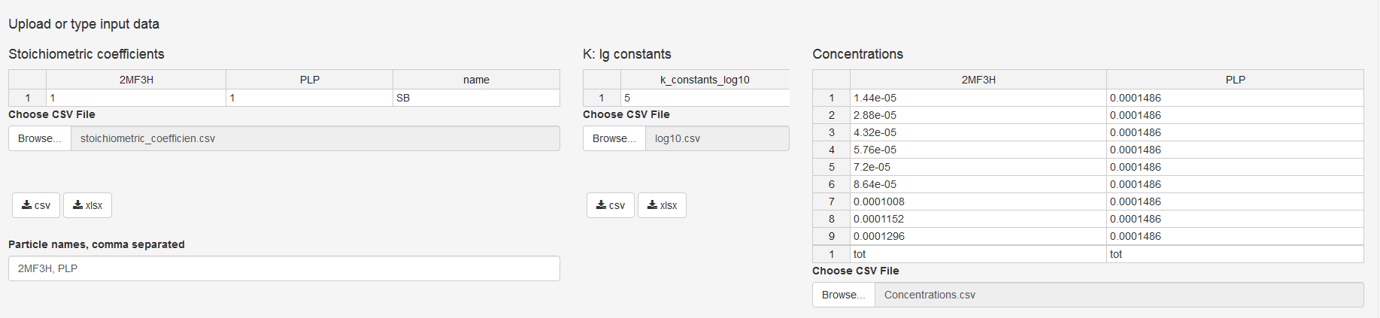

***Figure 17.*** *Stoichiometric coefficients, log K and concentrations input data for example (17)*

### 4.2.4 Component names

Columns in both *Stoichiometric coefficients* and *Concentrations* tables have the same names which are the names of the base components. By default KEV uses component names *molecule1, molecule2, molecule3* etc. If you want to change them (and you’d better do) type new base component names into the *Component names, comma separated* field.

2MF3H, PLP

IMPORTANT: Make sure the quantity of reagents in the string *Component names, comma separated* corresponds to the quantity of columns of Table *Stoichiometric coefficients*. Delete or add columns if required

### 4.2.5 Absorbance and deviations

The *Absorbance and deviations* table consists of following columns:

* *data.* The values in column *data* can take *observation* or *deviation* value. *observation* is your experimental value; the *deviation* is its experimental error of determination.
* *wavelength*. We recommend typing there the real wavelengths, for example, 297, 337, and 388 nm. However, you can mark them by some symbols you desire – just not get entangled later!
* Columns with experimental values and experimental deviations for every mixture (solution). They could be named *S1, S2, S3… SK* where *K* is the number of solutions used in calculations. In case of our example there are 9 solutions.

IMPORTANT: The *wavelength* cells for *deviations* must contain the same designations of wavelengths you have given to experimental values. If you marked the latter as 297, 337, 388, the deviations should be given also for 297, 337, 388 wavelengths.

The following table should be applied for the example (17):

observation 297 0.383 0.664 0.948 1.240 1.500 1.729 1.989 2.213 2.361

observation 337 0.432 0.54 0.64 0.744 0.831 0.913 1.009 1.089 1.145

observation 388 0.714 0.679 0.624 0.574 0.514 0.48 0.439 0.403 0.374

deviation 297 0.003 0.003 0.003 0.003 0.003 0.003 0.003 0.003 0.003

deviation 337 0.003 0.003 0.003 0.003 0.003 0.003 0.003 0.003 0.003

deviation 388 0.003 0.003 0.003 0.003 0.003 0.003 0.003 0.003 0.003

The upper three rows are experimental values of absorbance at 297, 337, 388 wavelengths. The lower three rows are the deviations at the same 297, 337, 388 wavelengths.

### 4.2.6 Molar extinction coefficients

It is strongly recommended to determine molar extinction coefficients for, at least, some of the reagents or products prior to the main experiment. Those pre-determined values help greatly in making the constant calculation results more reliable and valid.

The *Molar Extinction coefficients* table contains following columns:

* *wavelength.* We recommend typing there the real wavelengths, for example, 297, 337, and 388 nm. The values should correspond to *Absorbance and deviations* wavelengthes.
* Columns with molar extinctions coefficients for components with known molar extinction coefficients (both reagents and products). Name them with component names, e.g. *2MF3H*, *PLP*. There is no need in specifying somewhere, which components are with unknown molar extinction coefficients – just do not add/remove the corresponding column from this table, and KEV does the rest.

IMPORTANT: *wavelength* and component names should correspond to *Absorbance and deviations* wavelengthes and *Stoichiometric coefficients* reagent and product names respectively. I.e. if you have 297, 337 and 388 nm wavelengths in Absorbance and deviations table do not include 403 nm wavelength in Mollar Extinction coefficients table.

IMPORTANT: All the known molar extinction coefficients values should be specified in this table (even if all of them are zeros). KEV treats the reagents or products unspecified in this table as ones with unknown molar extinction coefficients, which should be determined.

Making preliminary calibration plots experiments, we determined the molar extinction coefficients for 2MF3H and PLP at 297, 337, 388 nm:

0 888

0 2252

0 5078

Type or copy + paste it to KEV table

The absorbance and molar extinction coefficients tables look now as follows (Fig. 18).

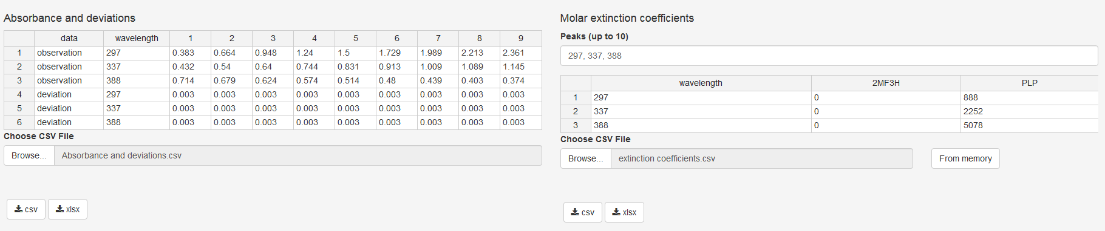

***Figure 18.*** *The data on absorbance and molar extinction coefficients for the reaction (17) at wavelengths values of 297, 337, 388 nm*

### 4.2.7 Constants to evaluate and wavelengths to use

Type one or more product names into*Constants to evaluate* field (Fig. 16). Make sure they correspond to the ones specified in the *Stoichiometric coefficients* table.

The wavelengths KEV uses for calculations should be specified in the *Molar extinction coefficients* field right above molar extinction coefficients table in the *Peaks (up to 10)* field. (Fig. 18). If dozens of molar extinction coefficients are known it is a good idea to restrict number of wavelengths used in the evluation process to peaks only. If none of peaks are specified the first 10 wavelengths to be used.

### 4.2.8 Threshold

The threshold parameter (a.k.a. ζ, spells *zeta* or *dzeta*) defines the search algorithm precision, default to 1e-7. The threshold should be 1 > ζ > 0.

* Increase it to speed up the algorithm (e.g. to 1e-4)
* Decrease it to increase accuracy (e.g. to 1e-8)
* However, in most cases the default value is the best choice

### 4.2.8 Search density

The search density parameter defines how many steps the algorithm performs in every direction on each step. The default value is 1 as in the classic direct search algorithm.

Increasing the search density could help in complex systems with many local minimums. E.g. try increase it to 2. Now on every step the algorithm checks not 1 possible value in each direction but 2: one equal to *learning rate * initial step* and the second one equal to *learning rate * initial step * 2*. I.e. it performs as you have started with two different learning rates simultaneounesly (or from different initial values).

The search density should be integer > 0. Do not use values > 3 for it slows down the algorithm too much and increases the risk of the computation error.

## 4.3 Evaluate

After the input data is provided check if all is OK. If it is not you will get a bunch of red and grey error messages. Most frequent error causes and fixes are:

* Check *Column delimiter* control. If you use csv file with semicolon ";" delimiter should be also ";"
* Check if component (molecule) names are consistent between different tables i.e. coefficient, concentrations and molar extinction matrices
* Check the same for wavelenghts
* If you are uploading data table by table just try to load remaining data, the “error” could be a temporary thing disappering after all the data is provided

In order to calculate the equilibrium concentrations of the reagents and products click *Evaluate* button right under the input data tables.

## 4.4 Output (Calculated) Data

The results will appear below a few moments later (Fig. 19):

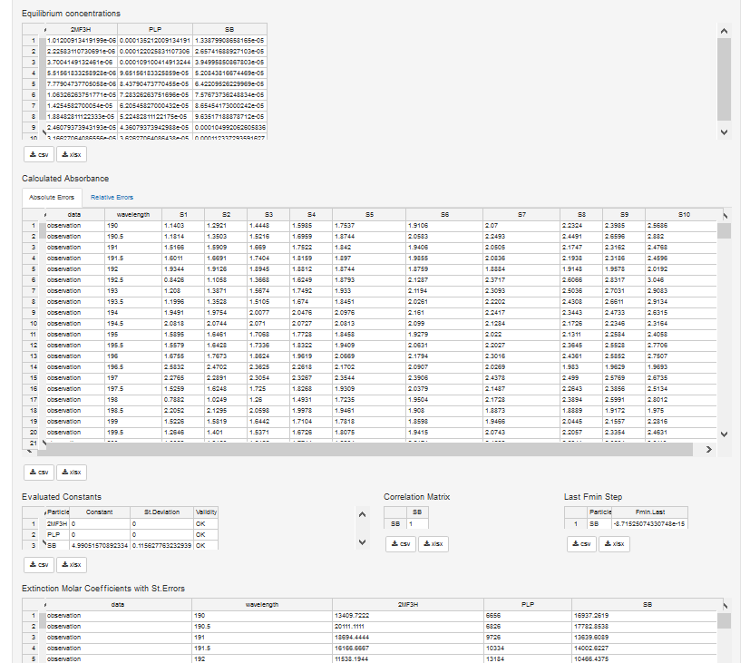

***Figure 19.*** *Results of constant evaluation for example (17)*

* *Equilibrium concentrations*: all the equilibrium concentrations for basis components and products
* *Calculated Absorbance*: the sum of superposition of input (calculated) molar extinction coefficients on the equilibrium concentrations of light-absorbing compounds.
* *Evaluated Constants*: the input and evaluated equilibrium constants. The standard deviations of evaluated constants are also specified there. *Validity* column takes one of the following values
  + *OK*: everything seems right
  + *Non-Sensitive*: varying the evaluated log K value does not alter the minimizing function
  + *-Inf* or *Inf*: no global minima of minimizing functions were found
  + *Insignificant*: the evaluated value of log K has a standard deviation exceeding 10% of log K value
* *Correlation matrix*: the matrix, which diagonal elements are equal to 1 while non-diagonal ones are the Pearson correlation coefficients between each pair of optimized parameters. Since the only constant was evaluated in this example, the correlation matrix consists of the only element equal to 1.
* *Adjusted R2*: the adjusted determination coefficient indicating the correlation between experimental and calculated data.
* *Extinction Molar Coefficients with St*. *Errors*: the input or calculated molar extinction coefficients. For the latter, the deviation of their determination by the least squares method is specified.

TIP: Pay attention to the *Validity* comments. In case of any not-OK signal appearance, try doing the following:

1. Check typos and errors in the input data. the table *Calculated Absorbance* with errors could give a clue, where the blunder had been made
2. Change the initial approximated value(s) of log K.
3. Increase the value of threshold (Fig. 16)
4. Increase the search density. The value should be a positive integer
5. Remember, that Insignificant comment is rather subjective. For example, the constant value of 0.8±0.1 might be accurate enough
6. If none of these helped, the experimental data might be insufficient or experimental design is unsuccessful

For example, let us imagine that the error has been made in the 7th solution at wavelength of 337, and 0.109 was input instead of correct 1.009. The high standard deviation indicates something went wrong, and in the appropriate cell of table of calculated absorbance we can see high absolute/relative error (Figure 20).

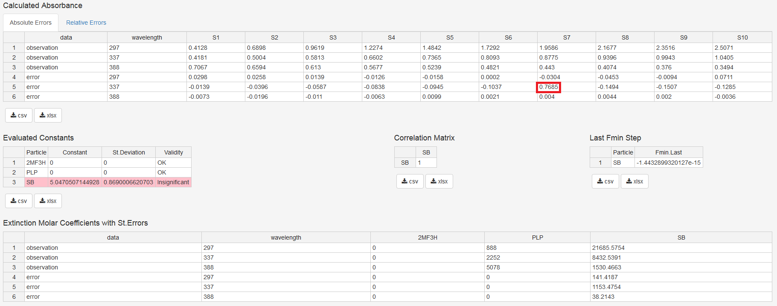

***Figure 20.*** *If something goes wrong, look for input errors and typos*

In order to simplify the analysis of errors, the possibility of plotting the experimental vs. calculated results (peaks only) or whole spectra is implemented. These tabs are located in the table *Calculated Absorbance*:

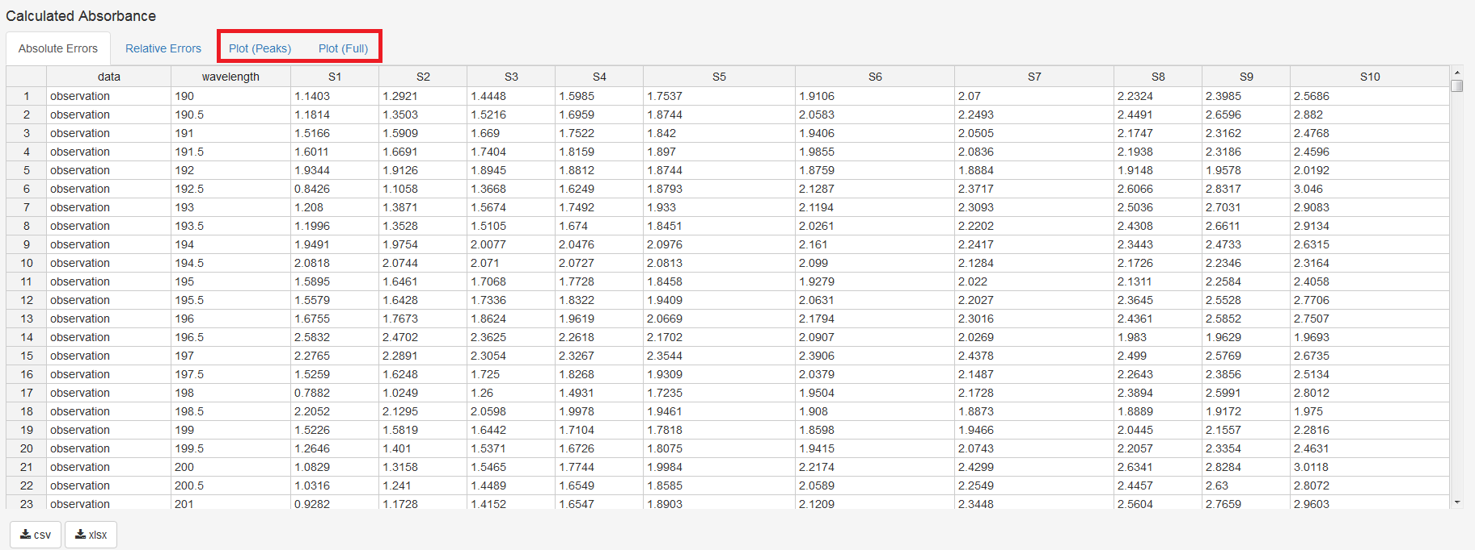

The plots are following:

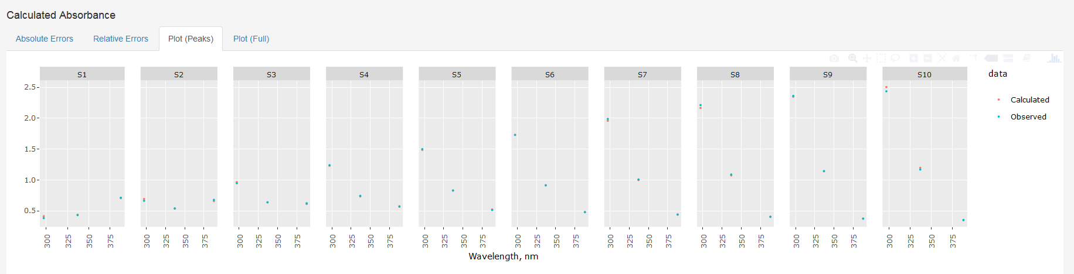

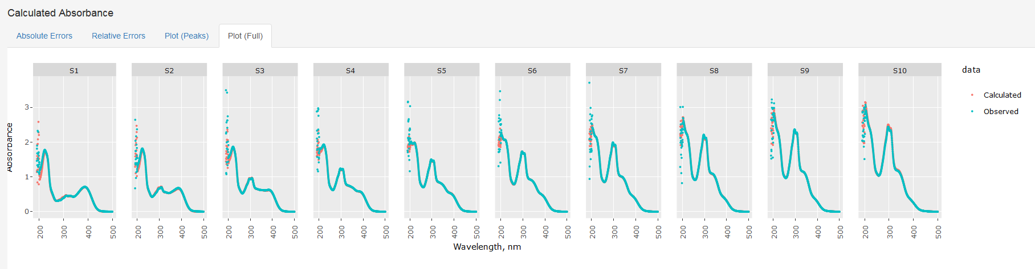

While in KEV, plots have some neat options such as zooming, panning, switching variables on and off *etc*. Plots could be downloaded from KEV as PNG images for further using.

## 4.5 Option: Upload Data from CSV or Tab Delimited File(s)

All the data could be entered manually, however we recommend preparing the specific file (or files) containing all the required data.

TIP: Even if you input data manually you could save both input and output data in the file(s) so you could reproduce the research later or do minor modifications without retyping all the data from scratch.

CSV or tab delimited files are plain files with data delimited into columns with a specific delimiter (a.k.a. separator), mostly comma (,), semicolon (;) or tab (press *Tab* key in your preferred text editor to get the value).

These formats are very stable, platform independent and are used by a great range of applicatons and packages. There are at least four ways to format KEV input data as plain text files:

* Basic way: Type data using your preferred plain text editor such as Notepad on Windows
* Simplest way: Type or copy data to KEV, then download as CSV
* Dangerous way: Save from Excel using *Save as* option (could be some undesirable tricks)
* Advanced way: Use input from another app or package if format is the same as KEV requires

Please follow the recommendations below to format files in the right way.

TIP 1: Consider file names if you upload all data at once. If you upload file by file using *Choose CSV File* buttons there are no restrictions for file names

TIP 2: If you do not understand a word below use the Simplest way and consider only file names for the bulk input

### 4.5.1 Stoichiometric matrix

* File names allowed: *stoich_coefficients.csv, stoichiometric_coefficients.csv, stoich_coefficients, stoichiometric_coefficients, stoich_coefficients.txt, stoichiometric_coefficients.txt*. Prefix *input_* is also allowed. Remember: those names must be used if you upload all the files at once! If you upload them one by one, you are free to name the files whatever you want.
* First row: component names, “name”
* Following rows: stoichiometric coefficients, one row for one reaction, and the name of reaction product.

### 4.5.2 Total (or equilibrium) concentrations of reagents

* File names allowed: *concentrations.csv, concentrations, concentrations.txt*. Prefix *input_* is also allowed
* First row: total (*tot*) or equal (*eq*) concentrations
* Second row: component names
* Following rows: input concentrations, one row for one mixture

### 4.5.3 Decimal logarithms of equilibrium constants

* File names allowed: *k_constants_log10.csv, k_constants_log10, k_constants_log10.txt*. Prefix *input_* is also allowed
* First row: “k_constants_log10”
* Following rows: Decimal logarithms of equilibrium constants, one row for one reaction

### 4.5.4 Absorbance

* File names allowed: *absorbance.csv, absorbance, absorbance.txt*. Prefix *input_* is also allowed. Remember: those names must be used if you upload all the files at once! If you upload them one by one, you are free to name the files whatever you want.
* First row: “data”, “wavelength”, solution numbers, e.g. “1”, “2”, “3”, etc.
* Following rows
  + Column *data:* either “observation” or “deviation”
  + Column *wavelength*: the wavelength identifier (e.g., “322”)
  + Following columns: experimental absorbance values or their deviations depending on what was specified in the first cell. The table must contain as many “observation” lines as “deviation” rows so every “observation” line corresponds to a “deviation” line with the same wavelength.

### 4.5.5 Molar extinction coefficients

* File names allowed: *molar_extinction_coefficients.csv, mol_ext_coefficients.csv, molar_extinction_coefficients, mol_ext_coefficients, molar_extinction_coefficients.txt, mol_ext_coefficients.txt*. Prefix *input_* is also allowed. Remember: those names must be used if you upload all the files at once! If you upload them one by one, you are free to name the files whatever you want.
* First row: “wavelength”, component names
* Following rows
  + Column *wavelength*: the wavelength identifier (e.g. “322”)
  + Following columns: molar extinction coefficients

### 4.5.6 Target

* File names allowed: *constants_names.csv, target.csv, constants_names, target, constants_names.txt, target.txt*. Remember: those names must be used if you upload all the files at once! If you upload them one by one, you are free to name the files whatever you want.
* First row: “constant”, product name (it must correspond to one of the names given in stoichiometric matrix)
* Second row: “wavelength”, wavelength name(s) (e.g. “322”). Optional. If *wavelength* row is missing the first 10 provided wavelengths to be used in calcualtion.

## 4.6 Option: Upload Data from CSV or Tab Delimited File(s)

Now when all files are prepared upload them to KEV.

See Section 3.6 for details. The uploading (all files at one time, one file by another) is pretty the same as in the case of equilibrium concentrations calculations.

## 4.7 Option: Upload Data from XLSX Single File

The first three sheets of this single .xlsx file are the same as for equilibrium composition problem (Section 3.7):

* *stoich_coefficients*
* *concentrations*
* *k_constants_log10*

New sheets are:

* *absorbance*
* *mol_ext_coefficients*
* *target*

IMPORTANT: Do not rename the sheets

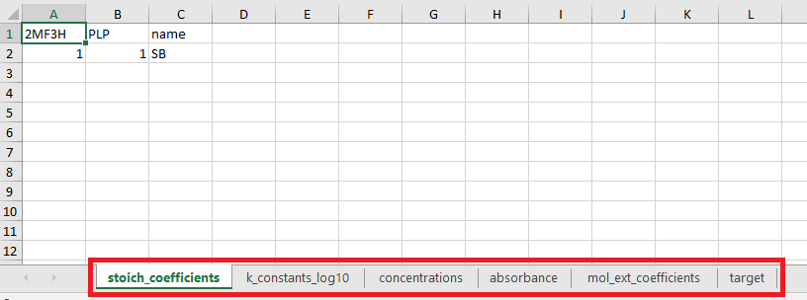 ***Figure 21****. Sheets in the input .xlsx file*

### 4.7.1. absorbance

*absorbance* sheet contains absorbance data. Type peaks data only or paste the whole spectra. Have a look how should they be formatted (Fig. 22). Do not forget the table of deviations should follow the observation (Fig. 23)

IMPORTANT: Do not forget specifying the deviations after experimental values in the same tab

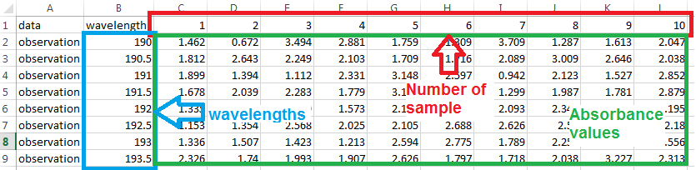

***Figure 22****. Formatting the absorbance tab with full spectra of mixtures 2MF3H + PLP*

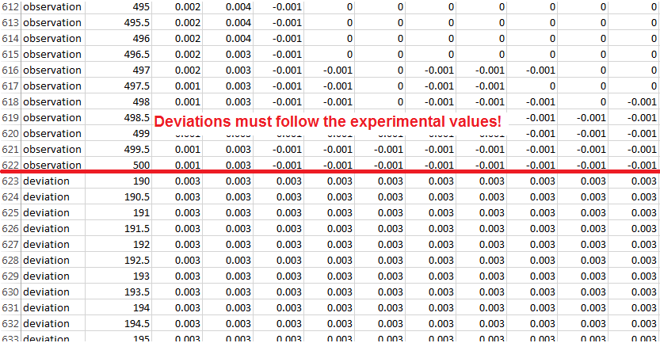

***Figure 23.*** *Yep, those are important too*

### 4.7.2. mol_ext_coefficients

Type known molar extinction coefficients for components and wavelengths or calculate them using KEV’s *Extinction Coefficient* tab (see the next Section 4.8).

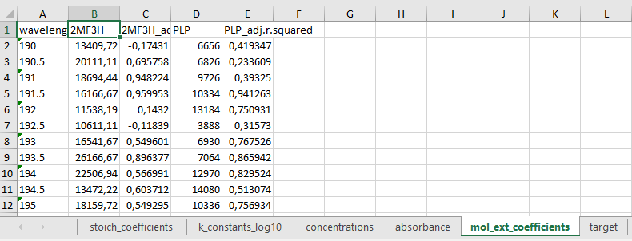

***Figure 24.*** *Molar extinction coefficients tab*

TIP: If you calculated the molar extinction coefficients with *Extinction Coefficients* tba just before evaluating the constant(s), you may upload them into the appropriate KEV table on the tab *Spectrophotometry* simply pressing the button *From memory* (Fig. 25).

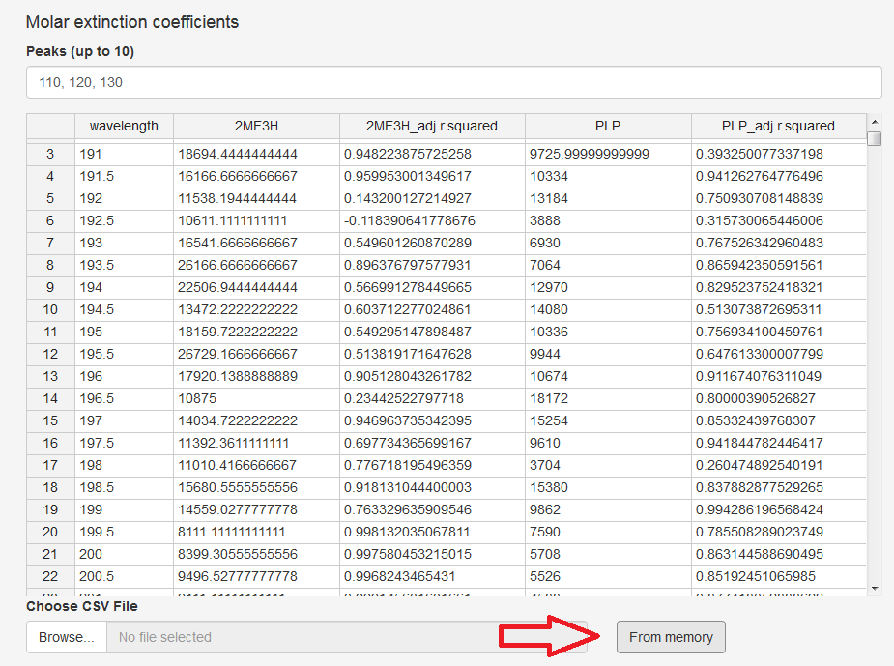

***Figure 25.*** *If there are some preliminary calculations on the tab “Extinction coefficients”, this button makes them into the table*

### 4.7.3. target

Finally, the sheet *target* defines constant(s) should be evaluated and wavelengths KEV should use for that aim (Fig. 26).

IMPORTANT: The name of constant(s) to be determined should correspond to those listed in the tab *stoich_coefficients*. Choose one or more from the reactions you have written.

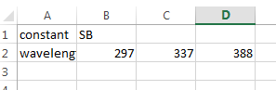

***Figure 26.*** *Target tab*

You might add some wavelengths either in KEV window on the appropriate field (Figure 27) or in the *target* tab of the .xlsx file you have uploaded. Remember that maximal number of wavelengths involved into calculations is limited to 10. The most characteristics values should be chosen (as a rule, they correspond to the absorbance maxima of reagents or products).

TIP: Do not use the values from non-informative ranges with strong solvent interference

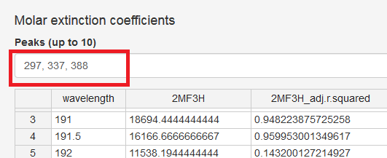

***Figure 27.*** *Wavelengths could be added if required, but their total number should not exceed 10*

When the xlsx data file is done upload it into KEV the same way as the bulk upload with CSV files i.e. select *Upload all data*  in the *Bulk upload / download (optional)* section (Fig. 11).

TIP: Since the whole spectra were taken for calculations, the molar extinction coefficients values at all wavelengths are calculated for the unknown components. It allows plotting their spectrum in any software with this functional (MS Excel, Origin etc.). Wonderful, isn’t it? It also provides an additional possibility to check the validity of constant calculation – if the calculated spectrum differs drastically from the experimental one or contains non-sense values (negative or too high ones), the results are incorrect.

The results could be downloaded by hitting the appropriate button (Fig. 28) as single .xlsx file whose tabs contain all the input and calculated tables or as an archived bunch of .csv files.

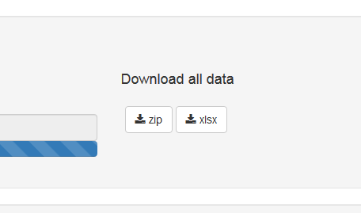

***Figure 28.*** *The results might be downloaded*

See Section 3.8 if you need details of results downloading.

## 4.8 Option: Molar Extinction Coefficients Calculation

A quick, convenient and reliable way to calculate the molar extinction coefficients is the calibration plot method. Finding them for some reagents, at least, makes the constant evaluation more reliable. KEV allows calculating molar extinction coefficients for every wavelength, for entire spectra of compounds. They could be easily taken for the constant evaluations and unknown components spectra calculations.

### 4.8.1 Select the Problem

Click *Equilibrium constants* in the top menu and select *Extinction Coefficients* in the expanding menu to open the tab (Fig. 29).

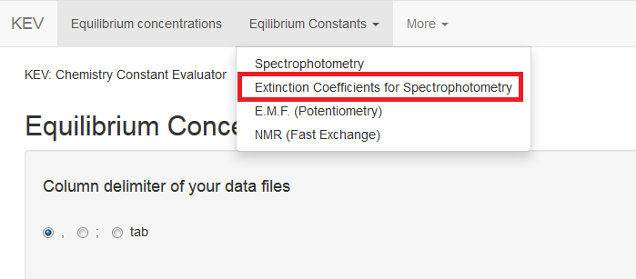

***Figure 29.*** *Extinction Coefficients tab*

### 4.8.2 Data Description

In order to calculate the extinction coefficients UV-Vis experimental results KEV requires the following data:

* Tables (matrices and vectors)
  + Absorbance values at certain wavelengths with component name and its total concentrations provided

There is no possibility to input data manually, because we assumed that the large amounts of values are to be processed here.

### 4.8.3 Upload Data from CSV or Tab Delimited File(s)

Please follow the recommendations below to format files in the right way.

* File names allowed: Any
* First row: component name
* Second row: “wavelength”, total concentrations
* Following rows
  + Column *wavelength*: wavelength identifier, e.g. 190, 190.5, 191, 191.5, 192 etc.
  + Following columns: experimental absorbance value for the solution with corresponding total concentration

IMPORTANT: All files should be formatted with the same delimiter (e.g. comma, semicolon or tab).

Now when all files are prepared upload them all at once selecting *Upload all data* clicking *Browse…* in the *Bulk upload section*.

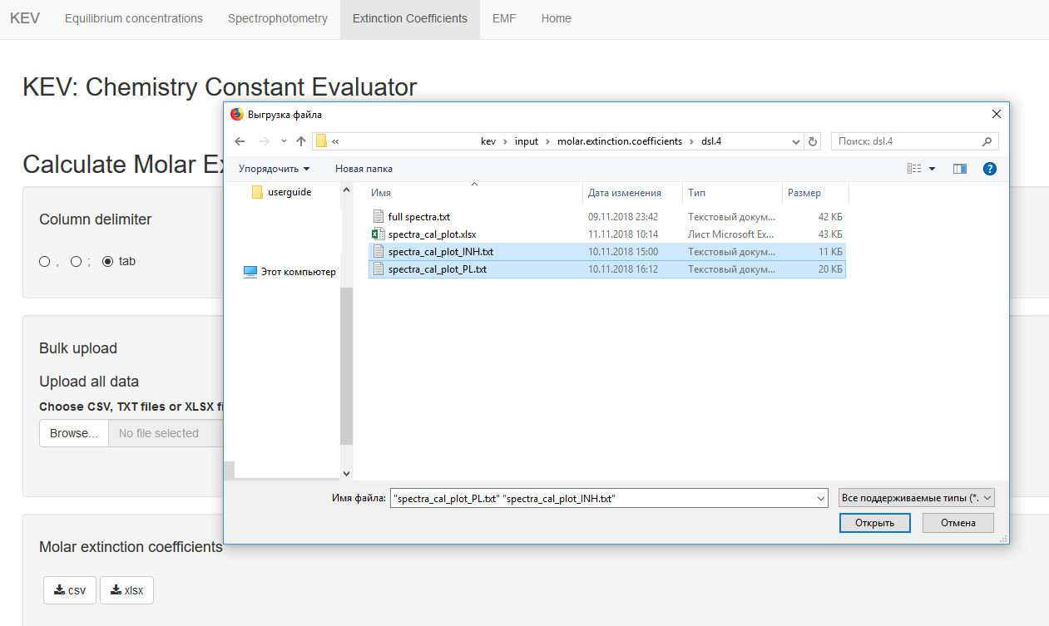

The calculations start immediately after uploading the file. The results should look as below:

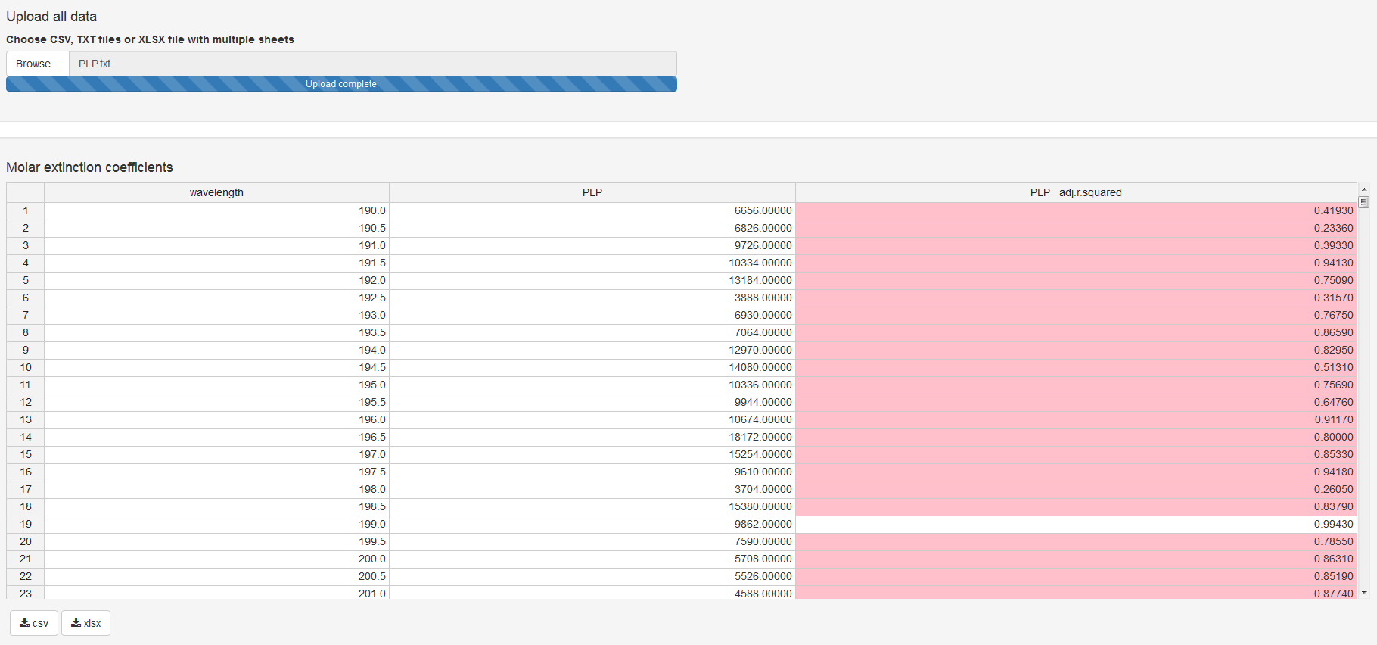

The calculated values of molar extinction coefficients are accompanied by adjusted R2 values. Some of them are marked with red (Fig. 23). It means, that the R2adj is too low (<0.95). Several reasons may lead to that result:

* Using the non-informative wavelengths range, and this is the case in the example. Make sure you are processing the data obtained in the spectral region, where the solvent makes no disturbance
* Another reason might be an error during the solution preparation, spectrophotometric measurements, or typo in the input file

TIP: Do not use the wavelengths from the troublesome wavelength range for constant evaluations later

The results could be downloaded from KEV in .xlsx or .csv format for further using in preparing the data for constant evaluation (see Fig. 26):

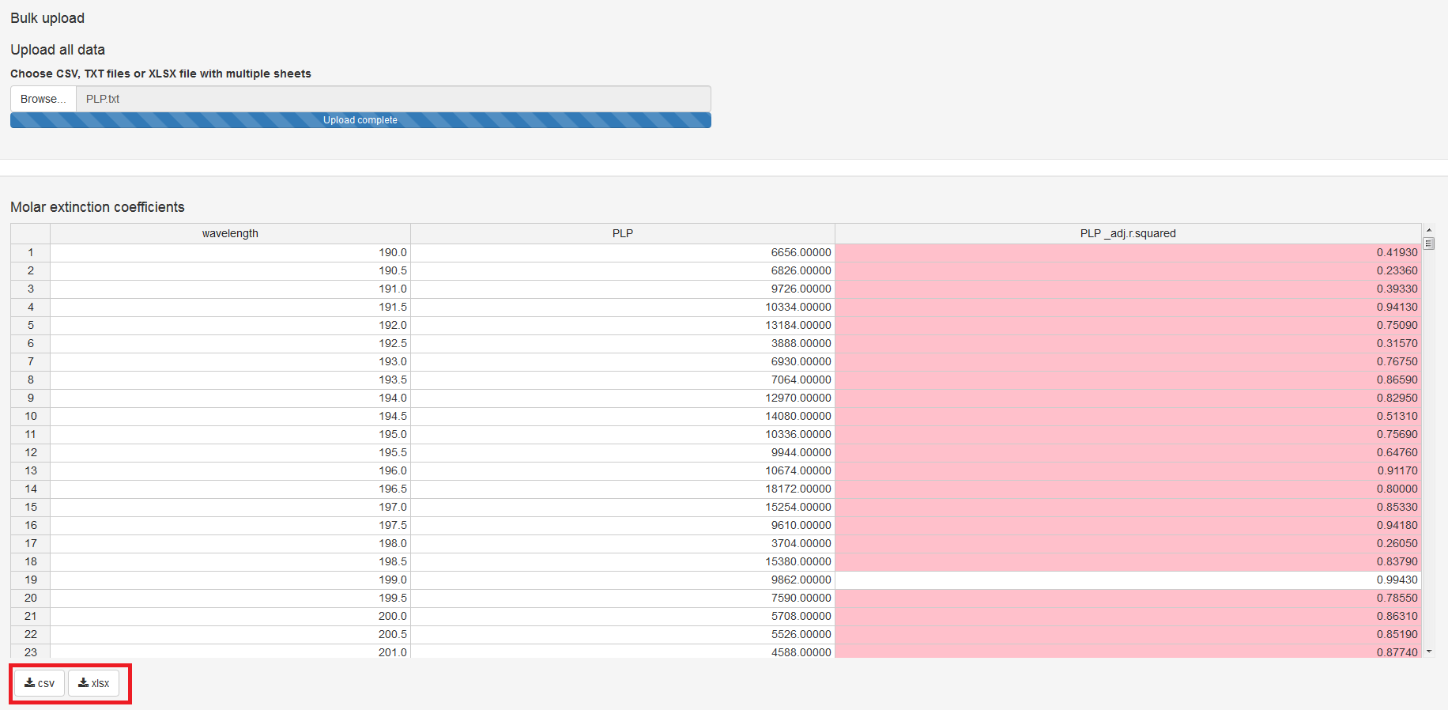

### 4.8.4 Option: Upload Data from XLSX Single File

The convenient way to calculate extinction coefficients is to prepare .xlsx file, containing the following information

* name of the compound
* wavelengths
* total concentrations of compound
* absorbance values at every wavelength

Several compounds could be input simultaneously on different sheets (See e.g. Fig. 30).

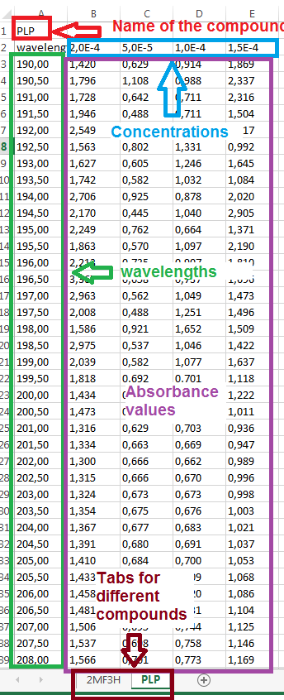

***Figure 30.*** *How to prepare .xlsx file for molar extinction coefficients calculation*

Upload the prepared xlsx file should be uploaded to KEV (Fig. 31) and the computation begins immediately.

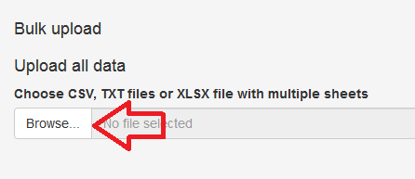

***Figure 31.*** *Uploading the data for molar extinction coefficients calculation*

After a short time, the results will appear (Fig. 32).

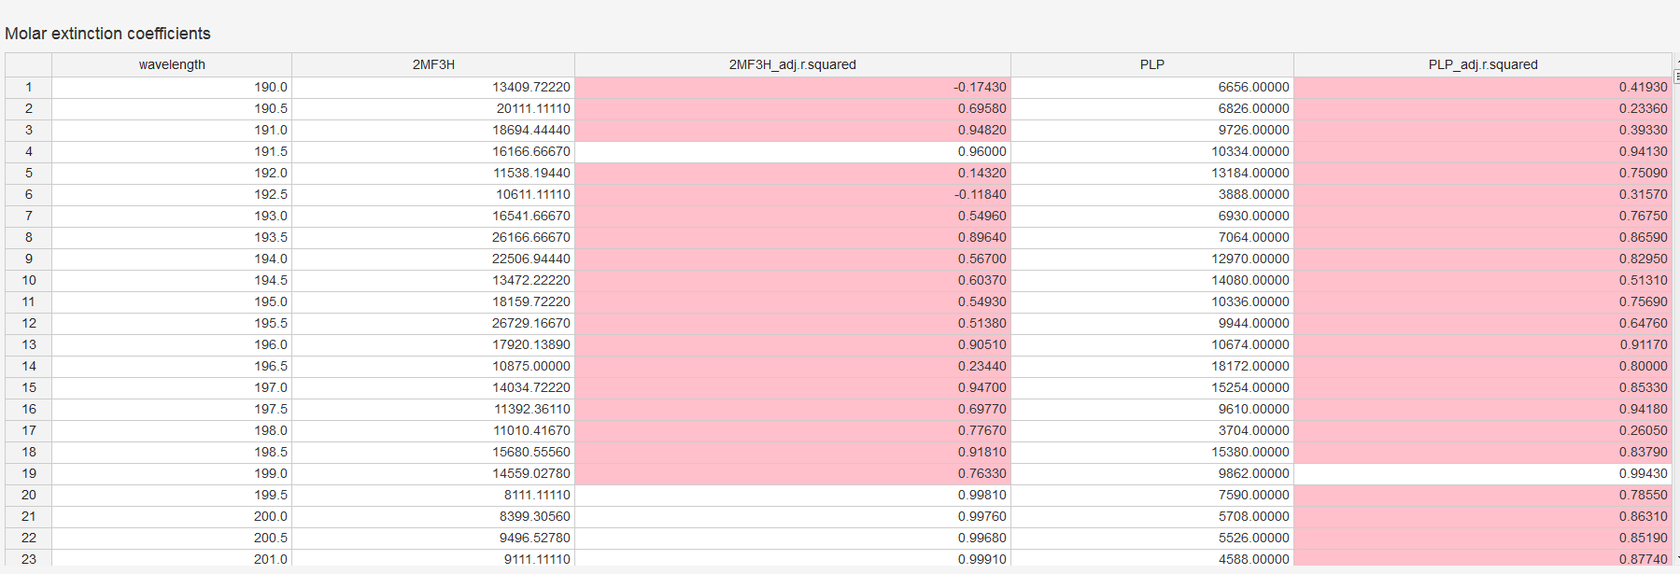

***Figure 32.*** *The results of calculation of molar extinction coefficients*

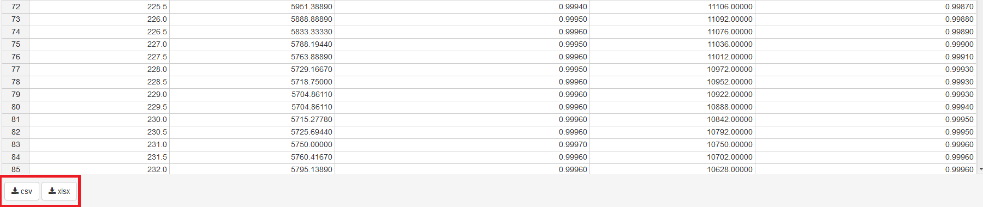

***Figure 33.*** *Downloading the results of calculation of molar extinction coefficients*

The results could be downloaded from KEV in .xlsx or .csv format (Fig. 33).

## 4.9. More playground

If you like to see the examples of constant evaluation for more complicated system including those with several parallel reactions or simultaneous determination of two constants, please, see [2] and [3], respectively.

**References to the Section IV**

1. G. A. Gamov et al. *Russ. J. Phys. Chem. A* **2019**, *93(2)*, 240-245, doi: 10.1134/S0036024419020110
2. <https://gitlab.com/a.meshkov/KEV/tree/master/input/spectrophotometry/dsl.5>
3. <https://gitlab.com/a.meshkov/KEV/tree/master/input/spectrophotometry/dsl.3>

# V. EQUILIBRIUM CONSTANTS EVALUATION FROM POTENTIOMETRIC DATA

## 5.1 Select the Problem

Click *Equilibrium constants* in the top menu and select *EMF* in the expanding menu to open the tab.

Let us consider the reaction of pyridoxine protonation in aqueous solution [1]. The experiment was designed as follows: pyridoxine hydrochloride (0.01017 M) was in the potentiometric cell (19.77 ml), and standardized NaOH (0.1347 M) served as a titrant. Therefore, there will be three basis components: H, L, and OH. The following reactions should be considered:

H + L ↔ HL; lg K = 4.5 (18),

-H + L ↔ L-; lg K = -8.35 (19),

H + OH ↔ HOH; lg K = 13.88 (20).

The example data could be obtained:

* Input Data
  + CSV comma separated files <https://gitlab.com/a.meshkov/KEV/tree/master/input/emf/dsp.1/csv.comma>
  + CSV semicolon separated files <https://gitlab.com/a.meshkov/KEV/tree/master/input/emf/dsp.1/csv.semicolon>
  + Tab separated files <https://gitlab.com/a.meshkov/KEV/tree/master/input/emf/dsp.1/txt.tab>
  + Excel (xlsx) file <https://gitlab.com/a.meshkov/KEV/tree/double/input/emf/dsp.1/data.input.xlsx>
* Output (calculated) data
  + Zip archive with CSV files https://gitlab.com/a.meshkov/KEV/tree/double/output/emf/dsp.1/gui/ kev.emf.constants.data.zip
  + Excel (xlsx) file https://gitlab.com/a.meshkov/KEV/tree/double/output/emf/dsp.1/gui/ kev.emf.constants.data.xlsx

## 5.2 Data Description and Manual Input

In order to evaluate the equilibrium constant(s) from potentiometric experimental results KEV requires the following data:

* Tables (matrices and vectors)
  + Stoichiometric matrix of reactions (a.k.a. Stioichiometric coefficients)
  + Decimal logarithms of equilibrium constants
  + Total (or equilibrium) concentrations of reagents
  + EMF values for certain indicator component with their experimental deviations
  + Standard potential and Nernst slope for the *very same* indicator component as EMF
* Text input
  + The name of constant(s), which should be evaluated
  + Threshold (search algorithm precision)
  + Search density (default to 1)

The initial three tables are the same as in the case of calculation of the equilibrium composition. See Sections 3.2.1-3.2.3; 3.6-3.7 for details.

However, the additional information input is also in order. It includes the values of potential difference between indicator and reference electrodes (or EMF) with the errors of their measuring as well as Nernst equation constants, namely, standard potential and slope (Fig. 33).

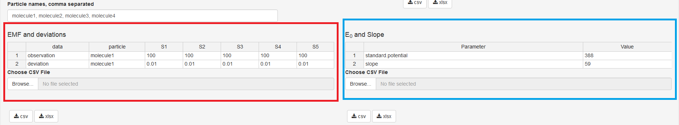

***Figure 34.*** *Screenshot of KEV interface. Experimental EMF table is marked with red, standard potential and Nernst slope are marked with blue.*

The name of indicator component should be specified in the “particle” column of the “EMD and deviations” table!

Potentiometric titration is a standard and often-used method of the constant determination. Therefore, you can be puzzled right now failing to find the fields where the volumes of titrant and titrand should be input. Let’s make it clear: there are none. The table of total concentrations serves instead of them. Every line of this table is a single point of titration.

How to convert the titration data into total concentrations? Let us consider the following values to be known: initial volume of titrand V0, volumes of titrant added Vt at every ith point (up to VT, the total volume of titrant added), total concentration of titrand Ccell and titrant Ctitr. In this case, the total concentration of compounds at every ith titration point could be calculated using following equations:

(21),



(22).



If titrand presents initially in the titrant solution with concentration Ctitr(titrand) and titrant presents initially in the cell with concentration Ccell(titrant) (but what do they do there?) the Eqs. (18), (19) should be replaced by more general expressions:

(23),



(24).



The calculations of concentration, thus, could be made easily using, e.g., MS Excel (more reliable) or couple of PhD students with calculators (more fun to the professor). Then just paste calculated concentrations into KEV table.

As an example of processing the results of potentiomentric titration using KEV, let us consider the determination of pyridoxine protonation constant in aqueous solution [1]. The experiment was designed as follows: pyridoxine hydrochloride (0.01017 M) was in the potentiometric cell (19.77 ml), and standardized NaOH (0.1347 M) served as a titrant. Therefore, there will be three basis components: H, L, and OH. The following reactions (18-20) should be considered. The process (18) constant is to be evaluated.

### 5.2.1 Stoichiometric matrix (Stoichiometric coefficients)

The following stoichiometric matrix corresponds to the processes (22)-(24):

1 1 0

-1 1 0

1 0 1

Is that all? Not yet: there is also an additional column, “name”. It serves for naming the products of reactions. Let us name the products “HL” (protonated ligand), “L-“ (dissociated ligand), “HOH” (water). Then, the table looks like that:

1 1 0 HL

-1 1 0 L-

1 0 1 HOH

Type it into KEV table *Stoichiometric coefficients*. Adding or removing columns/rows could be made with the context menu (mouse right click).

TIP: If you do not want to type numbers cell by cell (we don’t), copy numbers into a blank Excel file, split data into columns and copy + paste it from the Excel file to the KEV table *Stoichiometric coefficients*

### 5.2.2 Decimal logarithms of equilibrium constants

The vector of lg Ktotal contains the following values:

4.5

-8.35

13.88

Type it into KEV table *K: lg constants* preserving the order or copy + paste as for the stoichiometric matrix data.

IMPORTANT: Please note the decimal logarithms of equilibrium constants (lg K) should be input and not the K values

### 5.2.3 Total (or equilibrium) concentrations of reagents

So, the pyridoxine hydrochloride (0.01017 M) was in the potentiometric cell (19.77 ml), and standardized NaOH (0.1347 M) served as a titrant.

The following results of potentiometric titration were obtained:

Vtitr, ml EMF, mV δEMF, mV

0.001 163.700 0.010

0.081 142.000 0.010

0.175 123.300 0.010

0.281 110.700 0.010

0.360 102.400 0.010

0.444 94.200 0.010

0.684 72.200 0.010

0.781 63.500 0.010

0.857 56.000 0.010

0.942 44.200 0.010

We are free to calculate the total concentrations of the reagents using Eqs. (21), (22). Here are the results!

0.010169486 0.010169486 6.81301E-06

0.010128502 0.010128502 0.00054963

0.010080767 0.010080767 0.001181875

0.010027475 0.010027475 0.001887721

0.009988122 0.009988122 0.002408942

0.009946616 0.009946616 0.002958682

0.009829906 0.009829906 0.004504488

0.009783509 0.009783509 0.005119006

0.009747462 0.009747462 0.005596446

0.009707459 0.009707459 0.006126275

Remember the columns correspond to the component names, so name the first column *H*, the second one *L*, and the last one *OH*.

### 5.2.4 Component names

Columns in both *Stoichiometric coefficients* and *Concentrations* tables have the same names which are the names of the base components. By default KEV uses component names *molecule1, molecule2, molecule3* etc. If you want to change them (and you’d better do) type new base component names into the *Component names, comma separated* field.

H, L, OH

IMPORTANT: Make sure the quantity of reagents in the string *Component names, comma separated* corresponds to the quantity of columns of Table *Stoichiometric coefficients*. Delete or add columns if required

### 5.2.5 EMF and deviations

The *EMF and deviations* table consists of following columns:

* *data.* The values in column *data* can take *observation* or *deviation* value. *observation* is your experimental value; the *deviation* is its experimental error of determination.
* *component*. The name of indicated component. It is *H* in our example system.
* Columns with experimental values and experimental deviations for every mixture (solution). They could be named *S1, S2, S3… SK* where *K* is the number of solutions used in calculations. In case of our example there are 10 solutions.

IMPORTANT: The *component* cells for *deviations* must contain the same designation of indicator component as you have given to experimental values

The following matrix should be applied for the example (18-20):

observation H 163.7 142.0 123.3 110.7 102.4 94.2 72.2 63.5 56.0 44.2

deviation H 0.01 0.01 0.01 0.01 0.01 0.01 0.01 0.01 0.01

The upper row contains the experimental values of EMF. The lower one is for the deviations.

### 5.2.6 E0 and Slope

Standard potential and Nernst slope must be determined prior the calculations using, e.g., calibrating plot graph, i.e. the dependence of EMF on the logarithm of indicator component concentration.

IMPORTANT: Pay attention that during the calibration plot determination of E0 and slope, the logarithms of indicator component value should be used, but not the pH (pC) values

### 5.2.7 Constants to evaluate

Type one or more product names into*Constants to evaluate* field (Fig. 16). Make sure they correspond to the ones specified in the *Stoichiometric coefficients* table.

## 5.3 Evaluate

After the input data is provided check if all is OK. If it is not not you will get a bunch of red and grey error messages. Most frequent error causes and fixes are:

* Check *Column delimiter* control. If you use csv file with semicolon ";" delimiter should be also ";"
* Check if component (molecule) names are consistent between different tables i.e. coefficient, concentrations and molar extinction matrices
* If you are uploading data table by table just try to load remaining data, the “error” could be a temporary thing disappering after all the data is provided

In order to calculate the equilibrium concentrations of the reagents and products click *Evaluate* button right under the input data tables.

## 5.4 Output (Calculated) Data

The input data are ready for calculations (Fig. 35). Do not forget to specify the constant name to be evaluated, the standard potential and the slope determined from independent calibration plot experiment, where the EMF values were measured as function of known pH.

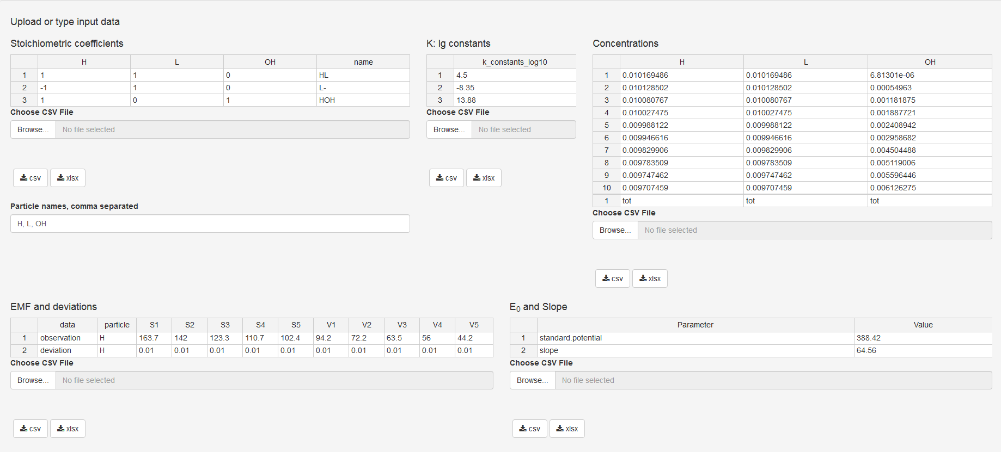

***Figure 35.*** *Input data of potentiometric titration for pyridoxine protonation constant determination in aqueous solution*

Press “Evaluate”. The results will appear below a few moments later (Fig. 36):

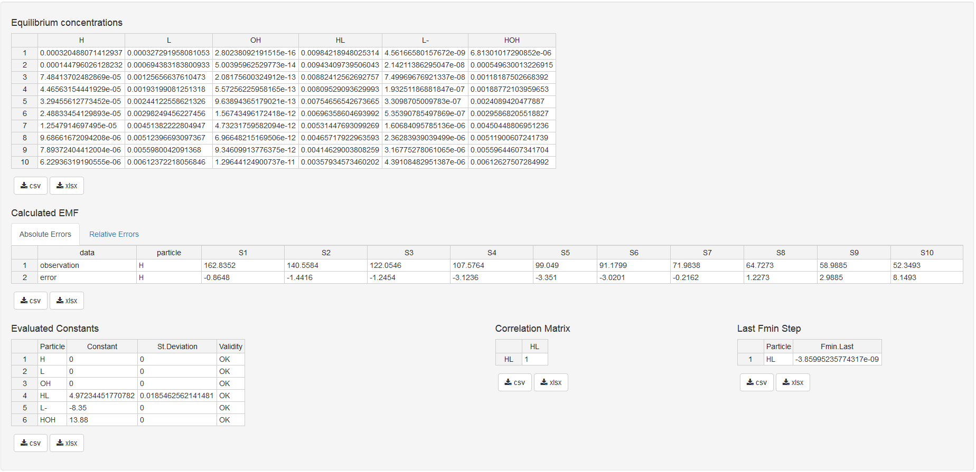

***Figure 35.*** *Results of calculations for potentiometric experiment*

* *Equilibrium concentrations*: all the equilibrium concentrations for basis components and products
* *Calculated EMF*: the EMF values calculated using calculated equilibrium concentrations of the indicator component and input standard potential and Nernst slope.
* *Evaluated Constants*: the input and evaluated equilibrium constants. The standard deviations of evaluated constants are also specified there. *Validity* column takes one of the following values
  + *OK*: everything seems right
  + *Non-Sensitive*: varying the evaluated log K value does not alter the minimizing function
  + *-Inf* or *Inf*: no global minima of minimizing functions were found
  + *Insignificant*: the evaluated value of log K has a standard deviation exceeding 10% of log K value
* *Correlation matrix*: the matrix, which diagonal elements are equal to 1 while non-diagonal ones are the Pearson correlation coefficients between each pair of optimized parameters. Since the only constant was evaluated in this example, the correlation matrix consists of the only element.
* *Adjusted R2*: the adjusted determination coefficient indicating the correlation between experimental and calculated data.

TIP: Pay attention to the *Validity* comments. In case of any not-OK signal appearance, try doing the following:

1. Check typos and errors in the input data. the table *Calculated Absorbance* with errors could give a clue, where the blunder had been made
2. Change the initial approximated value(s) of log K.
3. Increase the value of threshold (Fig. 16)
4. Increase the search density. The value should be a positive integer
5. Remember, that Insignificant comment is rather subjective. For example, the constant value of 0.8±0.1 might be accurate enough
6. If none of these helped, the experimental data might be insufficient or experimental design is unsuccessful

Since we have evaluated the only value of equilibrium constant, the table of correlation matrix consists of the only cell. Note that the *Evaluated constants* table contains the column *St. Deviation* reflecting the quality of model describing the experimental spectral data.

In order to avoid the errors caused by the incorrect manual input, we strongly recommend preparing the files (xlsx, CSV or TXT) containing all the data required.

In order to simplify the analysis of errors, the possibility of plotting the experimental vs. calculated results depending on the titration point number/solution number is implemented. This tab is located in the table *Calculated EMF*:

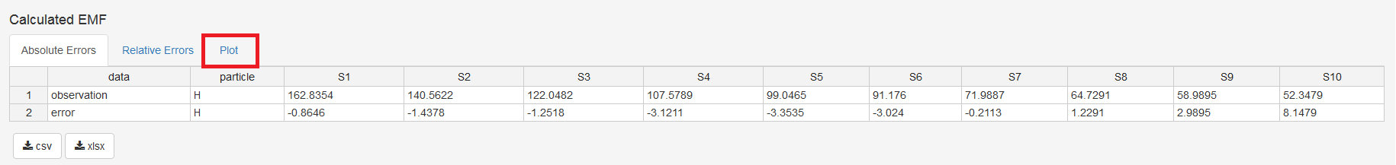

The plot is following:

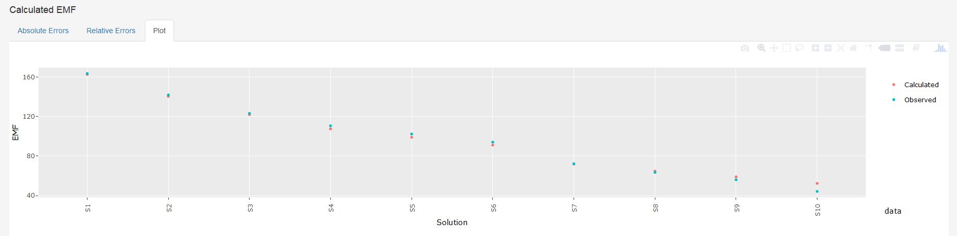

While in KEV, plots have some neat options such as zooming, panning, switching variables on and off *etc*. Plots could be downloaded from KEV as PNG images for further using.

## 5.5 Option: Upload Data from CSV or Tab Delimited File(s)

All the data could be entered manually however we recommend preparing the specific file (or files) containing all the required data.

TIP: Even if you input data manually you could save both input and output data in the file(s) so you could reproduce the research later or do minor modifications without retyping all the data from scratch.

CSV or tab delimited files are plain files with data delimited into columns with a specific delimiter (a.k.a. separator), mostly comma (,), semicolon (;) or tab (press *Tab* key in your preferred text editor to get the value).

These formats are very stable, platform independent and are used by a great range of applicatons and packages. There are at least four ways to format KEV input data as plain text files:

* Basic way: Type data using your preferred plain text editor such as Notepad on Windows
* Simplest way: Type or copy data to KEV, then download as CSV
* Dangerous way: Save from Excel using *Save as* option (could be some undesirable tricks)
* Advanced way: Use input from another app or package if format is the same as KEV requires

Please follow the recommendations below to format files in the right way.

TIP 1: Consider file names if you upload all data at once. If you upload file by file using *Choose CSV File* buttons there are no restrictions for file names

TIP 2: If you do not understand a word below use the Simplest way and consider only file names for the bulk input

### 5.5.1 Stoichiometric matrix

* File names allowed: *stoich_coefficients.csv, stoichiometric_coefficients.csv, stoich_coefficients, stoichiometric_coefficients, stoich_coefficients.txt, stoichiometric_coefficients.txt*. Prefix *input_* is also allowed. Remember: those names must be used if you upload all the files at once! If you upload them one by one, you are free to name the files whatever you want.
* First row: component names, “name”
* Following rows: stoichiometric coefficients, one row for one reaction, and the name of reaction product.

### 5.5.2 Total (or equilibrium) concentrations of reagents

* File names allowed: *concentrations.csv, concentrations, concentrations.txt*. Prefix *input_* is also allowed
* First row: total (*tot*) or equal (*eq*) concentrations
* Second row: component names
* Following rows: input concentrations, one row for one mixture

### 5.5.3 Decimal logarithms of equilibrium constants

* File names allowed: *k_constants_log10.csv, k_constants_log10, k_constants_log10.txt*. Prefix *input_* is also allowed
* First row: “k_constants_log10”
* Following rows: Decimal logarithms of equilibrium constants, one row for one reaction

### 5.5.4 EMF

* File names allowed: *emf.csv, emf, emf.txt*. Prefix *input_* is also allowed. Remember: those names must be used if you upload all the files at once! If you upload them one by one, you are free to name the files whatever you want.
* First row: “data”, “particle”, the different solutions names, e.g. “1”, “2”, “3”, etc.
* Following rows
  + Column *data*: either “observation” or “deviation”
  + Column component: indicator component symbol (e.g., “H”)
  + Following columns: experimental EMF values or their inaccuracies depending on what was specified in the first cell.

This table must contain one “observation” row and one “deviation” row.

### 5.5.5 Target

* File names allowed: *constants_names.csv, target.csv, constants_names, target, constants_names.txt, target.txt*. Remember: those names must be used if you upload all the files at once! If you upload them one by one, you are free to name the files whatever you want.
* First row: “standard.potential”, E0 value
* Second row: “slope”, Nernst slope value

## 5.6 Option: Upload Data from CSV or Tab Delimited File(s)

Now when all files are prepared upload them to KEV.

See Section 3.6 for details. The uploading (all files at one time, one file by another) is pretty the same as in the case of equilibrium concentrations calculations.

## 5.7 Option: Upload Data from XLSX Single File

The first three sheets of this single .xlsx file are the same as for equilibrium composition problem (Section 3.7):

* *stoich_coefficients*
* *concentrations*
* *k_constants_log10*

New sheets are:

* *emf*
* *target*

IMPORTANT: Do not rename the sheets

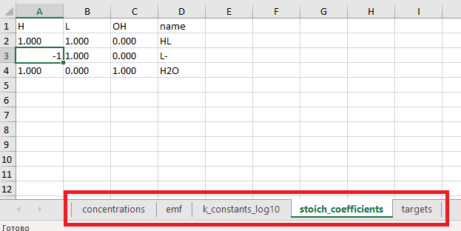

***Figure 36****. Sheets in the input .xlsx file*

### 5.7.1 emf

The formatted tab containing experimental EMF values looks as Fig. 37. Specify also the experimental inaccuracies.

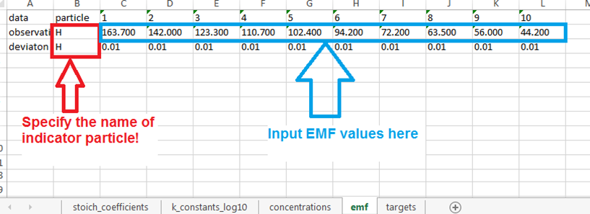

***Figure 37****. Tab containing experimental values of EMF*

### 5.7.2 target

Finally, the sheet *target* defines constant(s) should be evaluated, E0 and Nernst slope (Fig. 26).

IMPORTANT: The name of constant(s) to be determined should correspond to those listed in the tab *stoich_coefficients*. Choose one or more from the reactions you have written.

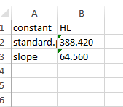

***Figure 38.*** *“targets” sheet*

Upload the .xlsx file and press “Evaluate”.

The results could be downloaded by hitting the appropriate button (Fig. 31) as single xlsx file whose tabs contain all the input and calculated tables or as an archived bunch of CSV files.

## 5.8. More playground

If you like to see the examples of constant evaluation for more complicated system including those with determination of two constants, please, visit [2].

**References to the Section V**

1. G. A. Gamov et al. *J. Chem. Thermodyn.* **2016**, *97*, 322-330, doi: 10.1016/j.jct.2016.02.011
2. <https://gitlab.com/a.meshkov/KEV/tree/master/input/emf/dsp.2>

# VI. EQUILIBRIUM CONSTANTS EVALUATION FROM NMR DATA (FAST EXCHANGE)

## 6.1 Select the Problem

Click *Equilibrium constants* in the top menu and select *NMR (Fast exchange)* in the expanding menu to open the tab.

Let us consider the reaction of the pyridoxal 5’-phosphate 2-furoyl hydrazone protonation in aqueous solution [1]. The experiment was designed as follows: hydrazone (0.08843 M) and standardized NaOH (0.3625 M) were in the NMR ampule (0.600 ml), and HCl (1.1885 M) served as a titrant. Therefore, there will be three basis components: H, L, and OH. The following reactions should be considered:

H + L ↔ HL; lg K = 11.5 (25),

H + OH ↔ HOH; lg K = 14 (26).

-H – OH ↔ HOHD; lg K = -14 (27)

The example data could be obtained:

* Input Data
  + CSV comma separated files <https://gitlab.com/a.meshkov/KEV/tree/master/input/nmr/dsn.4/comma>
  + CSV semicolon separated files https://gitlab.com/a.meshkov/KEV/tree/master/input/nmr/dsn.4/semicolon
  + Tab separated files

<https://gitlab.com/a.meshkov/KEV/tree/master/input/nmr/dsn.4/tab>

* + Excel (xlsx) file

<https://gitlab.com/a.meshkov/KEV/blob/master/input/nmr/dsn.4/carbon_3.xlsx>

* Output (calculated) data
  + Folders with CSV files with different delimiters <https://gitlab.com/a.meshkov/KEV/tree/master/output/nmr/dsn.4>

## 6.2 Data Description and Manual Input

In order to evaluate the equilibrium constant(s) from UV-Vis experimental results KEV requires the following data:

* Tables (matrices and vectors)
  + Stoichiometric matrix of reactions (a.k.a. Stioichiometric coefficients)
  + Decimal logarithms of equilibrium constants
  + Total (or equilibrium) concentrations of reagents
  + Chemical shifts values for certain indicator component with their experimental deviations
  + (Recommended) Chemical shifts of some individual species, e.g., for the same indicator component
* Text input
  + The name of constant(s), which should be evaluated
  + Threshold (search algorithm precision)
  + Search density (default to 1)

The initial three tables are the same as in the case of calculation of the equilibrium composition. See Sections 3.2.1-3.2.3; 3.6-3.7 for details.

However, the additional information input is also in order. It includes the values of chemical shifts with the errors of their measuring. The chemical shifts of individual species might be of use also (Fig. 39)

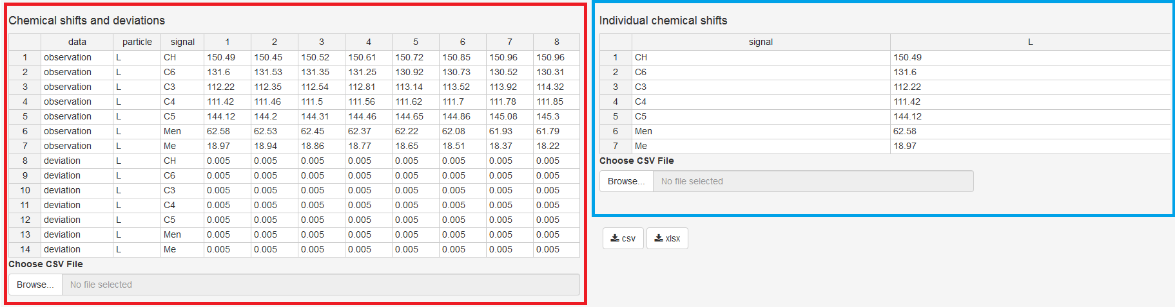

***Figure 39.*** *Screenshot of KEV interface. Experimental chemical shifts table is marked with red, the chemical shifts of the reagent are marked with blue.*

The name of indicator component should be specified in the “particle” column of the “Chemical shifts and deviations” table!

### 6.2.1 Stoichiometric matrix (Stoichiometric coefficients)

The following stoichiometric matrix corresponds to the processes (25)-(27):

1 1 0

1 0 1

-1 0 -1

Is that all? Not yet: there is also an additional column, “name”. It serves for naming the products of reactions. Let us name the products “HL” (protonated ligand), “HOH“ (water), “HOHD” (dissociated water). Then, the table looks like that:

1 1 0 HL

1 0 1 HOH

-1 0 -1 HOHD

Type it into KEV table *Stoichiometric coefficients*. Adding or removing columns/rows could be made with the context menu (mouse right click).

TIP: If you do not want to type numbers cell by cell (we don’t), copy numbers into a blank Excel file, split data into columns and copy + paste it from the Excel file to the KEV table *Stoichiometric coefficients*

### 6.2.2 Decimal logarithms of equilibrium constants

The vector of lg Ktotal contains the following values:

11.5

14

-14

Type it into KEV table *K: lg constants* preserving the order or copy + paste as for the stoichiometric matrix data.

IMPORTANT: Please note the decimal logarithms of equilibrium constants (lg K) should be input and not the K values

### 6.2.3 Total (or equilibrium) concentrations of reagents

The following total concentrations of reagents were used in the experiment:

0.265295431 0.08843181 0.33965375

0.277442859 0.08726823 0.335184622

0.28927477 0.08613488 0.330831575

0.300803299 0.08503059 0.326590144

0.312039966 0.08395425 0.322456092

0.322995716 0.08290482 0.318425391

0.333680954 0.08188131 0.314494213

0.344105577 0.08088275 0.310658918

Remember the columns correspond to the component names, so name the first column *H*, the second one *L*, and the last one *OH*.

### 6.2.4 Component names

Columns in both *Stoichiometric coefficients* and *Concentrations* tables have the same names which are the names of the base components. By default KEV uses component names *molecule1, molecule2, molecule3* etc. If you want to change them (and you’d better do) type new base component names into the *Component names, comma separated* field.

H, L, OH

IMPORTANT: Make sure the quantity of reagents in the string *Component names, comma separated* corresponds to the quantity of columns of Table *Stoichiometric coefficients*. Delete or add columns if required

### 6.2.5 Chemical shifts and deviations

The *Chemical shifts and deviations* table consists of following columns:

* *data.* The values in column *data* can take *observation* or *deviation* value. *observation* is your experimental value; the *deviation* is its experimental error of determination.
* *component*. The name of indicated component. It is *L* in our example system.
* *Signal.* The name of the observed nucleus (one might find it necessary, if there are more than one). You might use any naming of the nuclei observed in the experiment.
* Columns with experimental values and experimental deviations for every mixture (solution). They could be named *S1, S2, S3… SK* where *K* is the number of solutions used in calculations. In case of our example there are 8 solutions.

IMPORTANT: The *component* cells for *deviations* must contain the same designation of indicator component as you have given to experimental values

The following matrix should be applied for the example (18-20):

data particle signal 1 2 3 4 5 6 7 8

observation L CH 150.49 150.45 150.52 150.61 150.72 150.85 150.96 150.96

observation L C6 131.6 131.53 131.35 131.25 130.92 130.73 130.52 130.31

observation L C3 112.22 112.35 112.54 112.81 113.14 113.52 113.92 114.32

observation L C4 111.42 111.46 111.5 111.56 111.62 111.7 111.78 111.85

observation L C5 144.12 144.2 144.31 144.46 144.65 144.86 145.08 145.3

observation L Men 62.58 62.53 62.45 62.37 62.22 62.08 61.93 61.79

observation L Me 18.97 18.94 18.86 18.77 18.65 18.51 18.37 18.22

deviation L CH 0.005 0.005 0.005 0.005 0.005 0.005 0.005 0.005

deviation L C6 0.005 0.005 0.005 0.005 0.005 0.005 0.005 0.005

deviation L C3 0.005 0.005 0.005 0.005 0.005 0.005 0.005 0.005

deviation L C4 0.005 0.005 0.005 0.005 0.005 0.005 0.005 0.005

deviation L C5 0.005 0.005 0.005 0.005 0.005 0.005 0.005 0.005

deviation L Men 0.005 0.005 0.005 0.005 0.005 0.005 0.005 0.005

deviation L Me 0.005 0.005 0.005 0.005 0.005 0.005 0.005 0.005

The upper rows contain the experimental values of chemical shifts. The lower ones are for the deviations.

### 6.2.6 Chemical shifts of individual species

It is recommended to determine the chemical shifts for some components studied prior to main experiment. It helps a lot in obtaining results that are more reliable. In the example analyzed all the chemical shifts of *L* were measured.

### 6.2.7 Constants to evaluate

Type one or more product names into*Constants to evaluate* field (Fig. 16). Make sure they correspond to the ones specified in the *Stoichiometric coefficients* table.

## 6.3 Evaluate

After the input data is provided check if all is OK. If it is not not you will get a bunch of red and grey error messages. Most frequent error causes and fixes are:

* Check *Column delimiter* control. If you use csv file with semicolon ";" delimiter should be also ";"
* Check if component (molecule) names are consistent between different tables i.e. coefficient, concentrations and molar extinction matrices
* Check the same for names of signals
* If you are uploading data table by table just try to load remaining data, the “error” could be a temporary thing disappering after all the data is provided

In order to calculate the equilibrium concentrations of the reagents and products click *Evaluate* button right under the input data tables.

## 6.4 Output (Calculated) Data

The input data are ready for calculations (Fig. 40). Do not forget to specify the constant name to be evaluated.

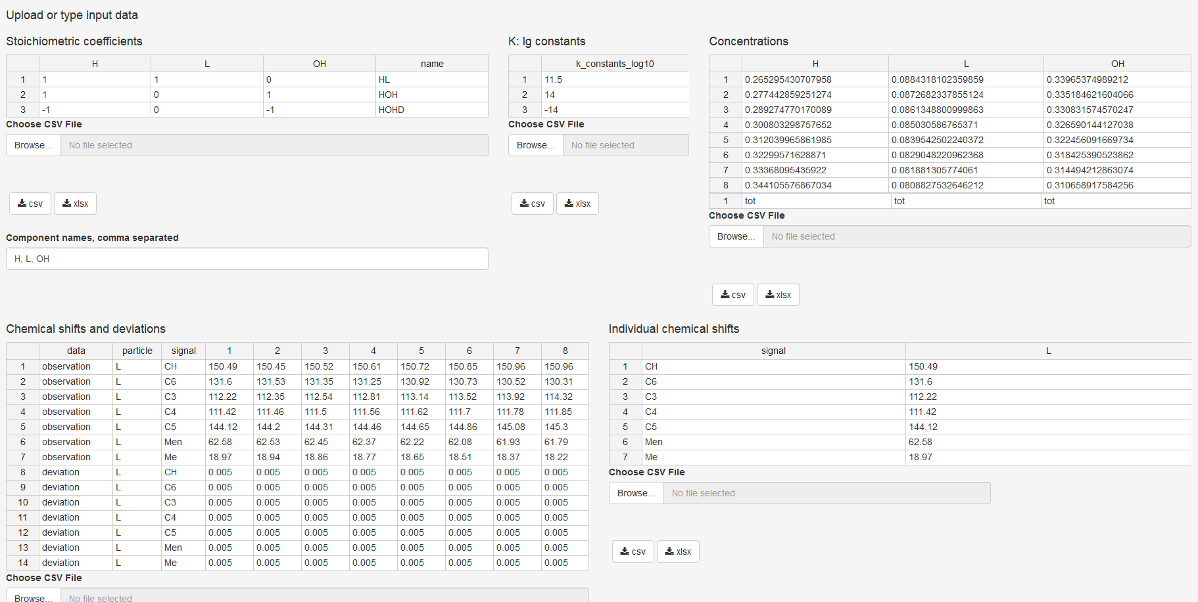

***Figure 40.*** *Input data of NMR titration for pyridoxal 5’-phosphate 2-furoyl hydrazone protonation constant determination in aqueous solution*

Press “Evaluate”. The results will appear below a few moments later (Fig. 41):

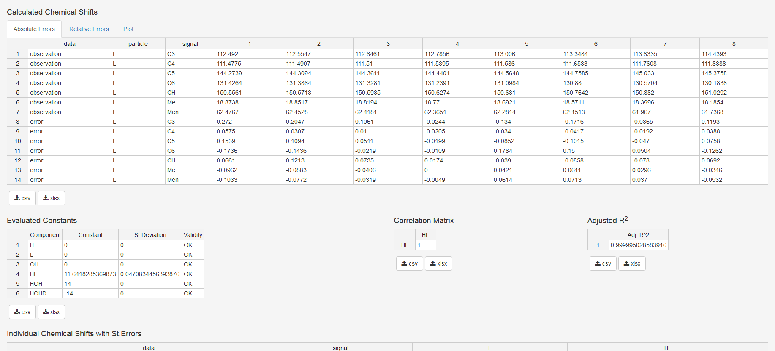

***Figure 41.*** *Results of calculations for NMR experiment*

* *Equilibrium concentrations*: all the equilibrium concentrations for basis components and products
* *Calculated Chemical Shifts*: the chemical shifts values calculated using calculated equilibrium concentrations of the indicator component and its derivatives.
* *Evaluated Constants*: the input and evaluated equilibrium constants. The standard deviations of evaluated constants are also specified there. *Validity* column takes one of the following values
  + *OK*: everything seems right
  + *Non-Sensitive*: varying the evaluated log K value does not alter the minimizing function
  + *-Inf* or *Inf*: no global minima of minimizing functions were found
  + *Insignificant*: the evaluated value of log K has a standard deviation exceeding 10% of log K value
* *Correlation matrix*: the matrix, which diagonal elements are equal to 1 while non-diagonal ones are the Pearson correlation coefficients between each pair of optimized parameters. Since the only constant was evaluated in this example, the correlation matrix consists of the only element.
* *Adjusted R2*: the adjusted determination coefficient indicating the correlation between experimental and calculated data.
* *Individual Chemical Shifts with St.Errors*. The calculated values of unknown chemical shifts of components derived from indicator component.

TIP: Pay attention to the *Validity* comments. In case of any not-OK signal appearance, try doing the following:

1. Check typos and errors in the input data. the table *Calculated Absorbance* with errors could give a clue, where the blunder had been made
2. Change the initial approximated value(s) of log K.
3. Increase the value of threshold (Fig. 16)
4. Increase the search density. The value should be a positive integer
5. Remember, that Insignificant comment is rather subjective. For example, the constant value of 0.8±0.1 might be accurate enough
6. If none of these helped, the experimental data might be insufficient or experimental design is unsuccessful

Since we have evaluated the only value of equilibrium constant, the table of correlation matrix consists of the only cell. Note that the *Evaluated constants* table contains the column *St. Deviation* reflecting the quality of model describing the experimental spectral data.

In order to avoid the errors caused by the incorrect manual input, we strongly recommend preparing the files (xlsx, CSV or TXT) containing all the data required.

In order to simplify the analysis of errors, the possibility of plotting the experimental vs. calculated results depending on the titration point number/solution number is implemented. This tab is located in the table *Calculated Chemical Shifts*:

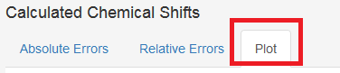

The plot is following:

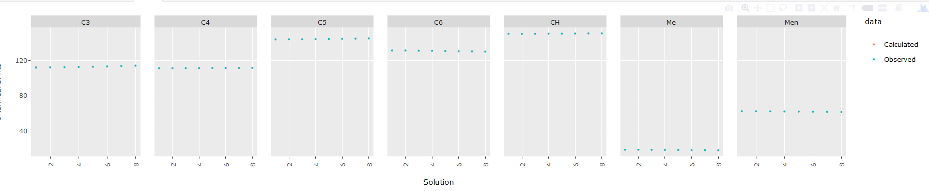

While in KEV, plots have some neat options such as zooming, panning, switching variables on and off *etc*. Plots could be downloaded from KEV as PNG images for further using.

## 6.5 Option: Upload Data from CSV or Tab Delimited File(s)

All the data could be entered manually however we recommend preparing the specific file (or files) containing all the required data.

TIP: Even if you input data manually you could save both input and output data in the file(s) so you could reproduce the research later or do minor modifications without retyping all the data from scratch.

CSV or tab delimited files are plain files with data delimited into columns with a specific delimiter (a.k.a. separator), mostly comma (,), semicolon (;) or tab (press *Tab* key in your preferred text editor to get the value).

These formats are very stable, platform independent and are used by a great range of applicatons and packages. There are at least four ways to format KEV input data as plain text files:

* Basic way: Type data using your preferred plain text editor such as Notepad on Windows
* Simplest way: Type or copy data to KEV, then download as CSV
* Dangerous way: Save from Excel using *Save as* option (could be some undesirable tricks)
* Advanced way: Use input from another app or package if format is the same as KEV requires

Please follow the recommendations below to format files in the right way.

TIP 1: Consider file names if you upload all data at once. If you upload file by file using *Choose CSV File* buttons there are no restrictions for file names

TIP 2: If you do not understand a word below use the Simplest way and consider only file names for the bulk input

### 6.5.1 Stoichiometric matrix

* File names allowed: *stoich_coefficients.csv, stoichiometric_coefficients.csv, stoich_coefficients, stoichiometric_coefficients, stoich_coefficients.txt, stoichiometric_coefficients.txt*. Prefix *input_* is also allowed. Remember: those names must be used if you upload all the files at once! If you upload them one by one, you are free to name the files whatever you want.
* First row: component names, “name”
* Following rows: stoichiometric coefficients, one row for one reaction, and the name of reaction product.

### 6.5.2 Total (or equilibrium) concentrations of reagents

* File names allowed: *concentrations.csv, concentrations, concentrations.txt*. Prefix *input_* is also allowed
* First row: total (*tot*) or equal (*eq*) concentrations
* Second row: component names
* Following rows: input concentrations, one row for one mixture

### 6.5.3 Decimal logarithms of equilibrium constants

* File names allowed: *k_constants_log10.csv, k_constants_log10, k_constants_log10.txt*. Prefix *input_* is also allowed
* First row: “k_constants_log10”
* Following rows: Decimal logarithms of equilibrium constants, one row for one reaction

### 6.5.4 Chemical shifts

* File names allowed: *chemical_shifts.csv, chemical_shifts, chemical_shifts.txt*. Prefix *input_* is also allowed. Remember: those names must be used if you upload all the files at once! If you upload them one by one, you are free to name the files whatever you want.
* First row: “data”, “particle”, “signal”, solution numbers, e.g. “1”, “2”, “3”, etc.
* Following rows
  + Column *data*: either “observation” or “deviation”
  + Column *particle*: indicator component symbol (e.g., “H”)
  + Column *signal*: signal names
  + Following columns: experimental chemical shift values or their inaccuracies depending on what was specified in the first cell.

This table must contain one “observation” row and one “deviation” row per signal.

### 6.5.5 Target

* File names allowed: *constants_names.csv, target.csv, targets.csv, constants_names, target, targets, constants_names.txt, target.txt, targets.txt*. Remember: those names must be used if you upload all the files at once! If you upload them one by one, you are free to name the files whatever you want.
* First row: “constant”, product names to tune constants of

### 6.5.6 Chemical shifts of individual species

* File names allowed: *individual_shifts.csv, individual_shifts, individual_shifts.txt*. Prefix *input_* is also allowed. Remember: those names must be used if you upload all the files at once! If you upload them one by one, you are free to name the files whatever you want.
* First row: “signal”, component names
* First column: signal names
* Following columns: individual chemical shift values

## 6.6 Option: Upload Data from CSV or Tab Delimited File(s)

Now when all files are prepared upload them to KEV.

See Section 3.6 for details. The uploading (all files at one time, one file by another) is pretty the same as in the case of equilibrium concentrations calculations.

## 6.7 Option: Upload Data from XLSX Single File

The first three sheets of this single .xlsx file are the same as for equilibrium composition problem (Section 3.7):

* *stoich_coefficients*
* *concentrations*
* *k_constants_log10*

New sheets are:

* *chemical_shifts*
* *target*
* *individual_shifts*

IMPORTANT: Do not rename the sheets

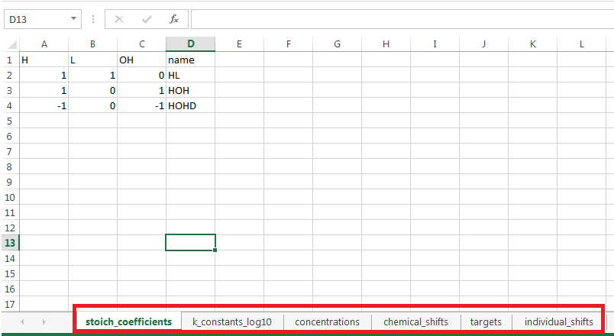

***Figure 42****. Sheets in the input .xlsx file*

### 6.7.1 chemical_shifts

The formatted tab containing experimental chemical shifts values looks as Fig. 37. Specify also the experimental inaccuracies.

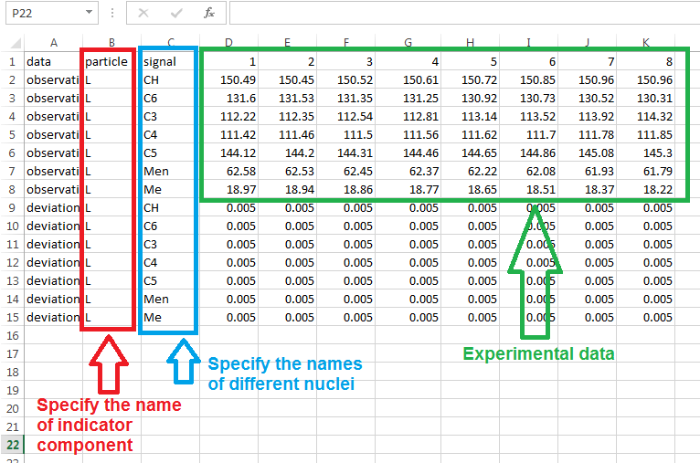

***Figure 43****. Tab containing experimental values of chemical shifts*

### 6.7.2 target

The sheet *target* defines constant(s) should be evaluated.

IMPORTANT: The name of constant(s) to be determined should correspond to those listed in the tab *stoich_coefficients*. Choose one or more from the reactions you have written.

### 6.7.2 individual_shifts

It is recommended to determine the chemical shifts for the indicator component or derived products prior to the calculations. Specify these values in this tab (Fig. 44).

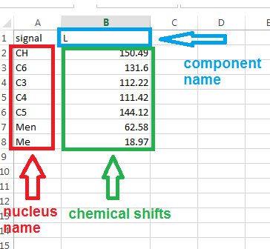

***Figure 43****. Tab containing chemical shifts of some compounds*

Upload the .xlsx file and press “Evaluate”.

The results could be downloaded by hitting the appropriate button (Fig. 31) as single xlsx file whose tabs contain all the input and calculated tables or as an archived bunch of CSV files.

## 6.8. More playground

If you like to see more examples of constant evaluation from NMR data, please, visit [1].

**References to the Section VI**

1. <https://gitlab.com/a.meshkov/KEV/tree/master/input/nmr>