-:- Society Management System -:-

* Society Management System v8 By Pankaj Goyani, here contributed for the management details relevant to society.

* This module helps to manage your Residential and Commercial & Housing Societies. Say goodbye to procedures of maintain your society files and documents in paper.

* We are Provide Management:

* Home Details
* Divisions

* General Accounting:
* Expenses
* Invoices
* Funds Management

* Events

* Society Complaints
* Society Funds

* Meter Details

* Creates a dashboard for accountants that includes:
* List of Homes to Remain Amounts
* Analysis of Water Meters

* Module Details :

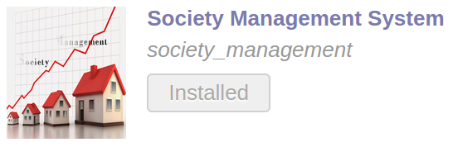

* Society Division Details:
(1)
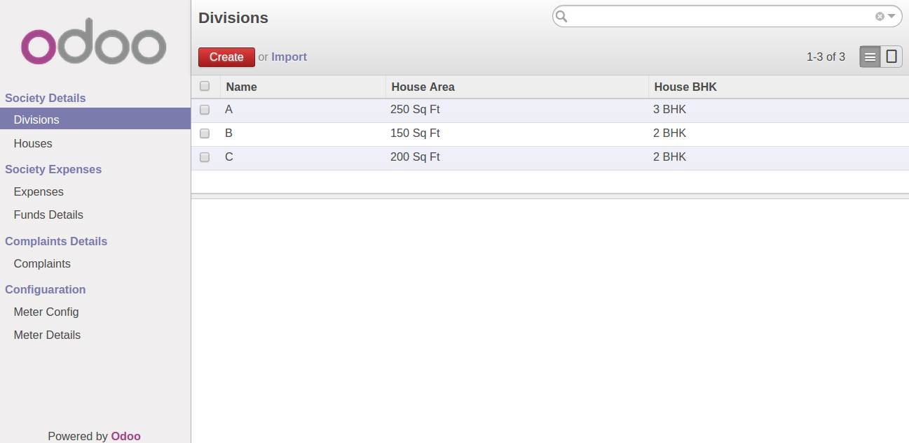

* Society Division Details:
(2)
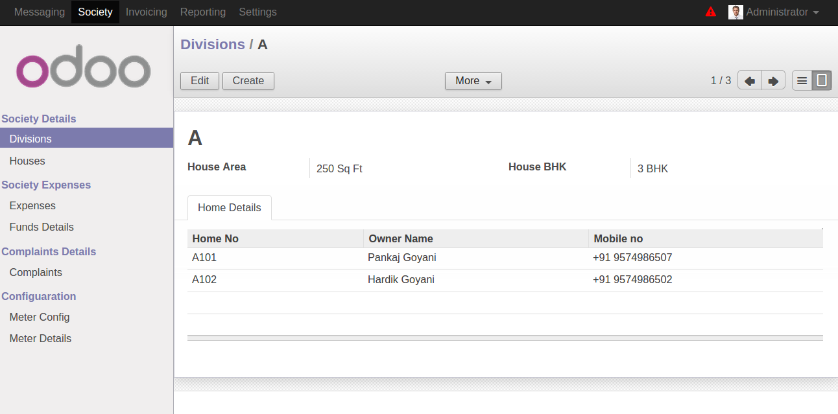

* Home Details:
(1)
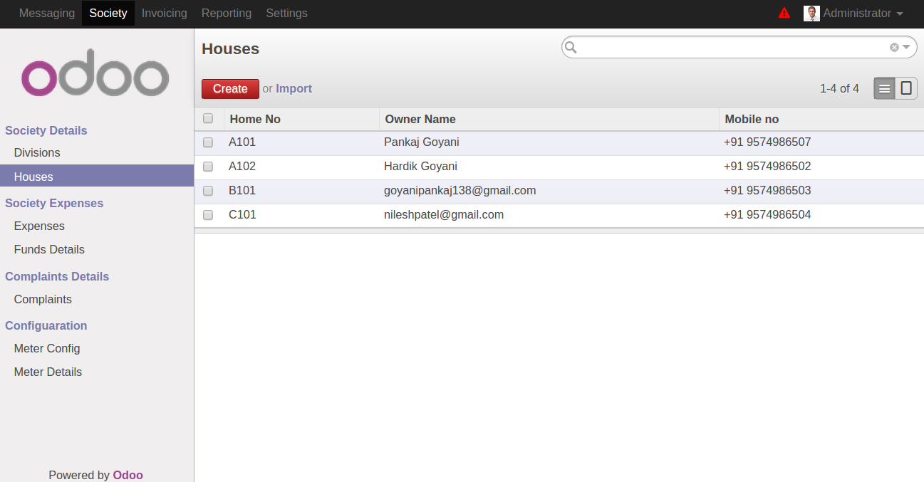

(2)
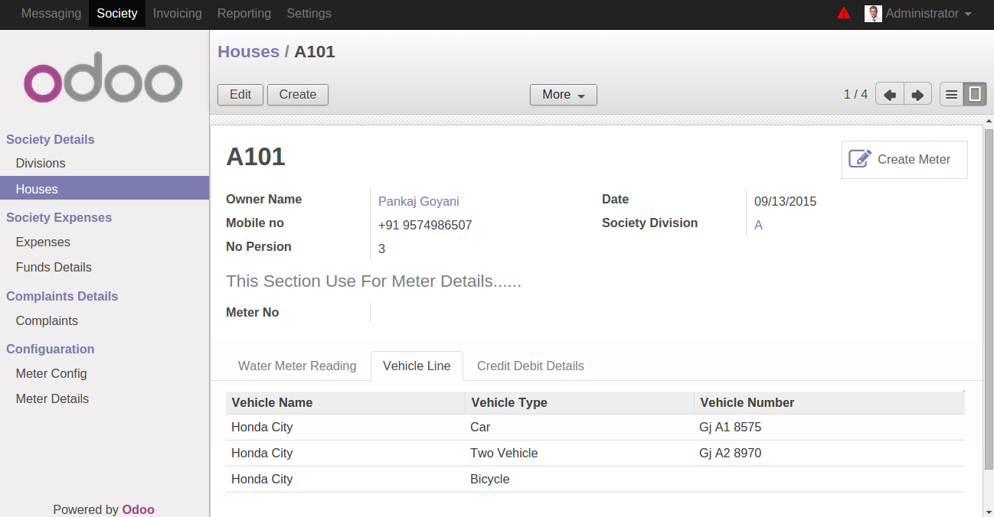

* Expense Details:
(1)
(2)

* Invoice Details:
(1)
(2)

* Funds Details:
(1)
(2)

* Complaints Details:
(1)
(2)

* Events Details:

* Assets Management:

* Meter Configuration (Per Unit Charge):

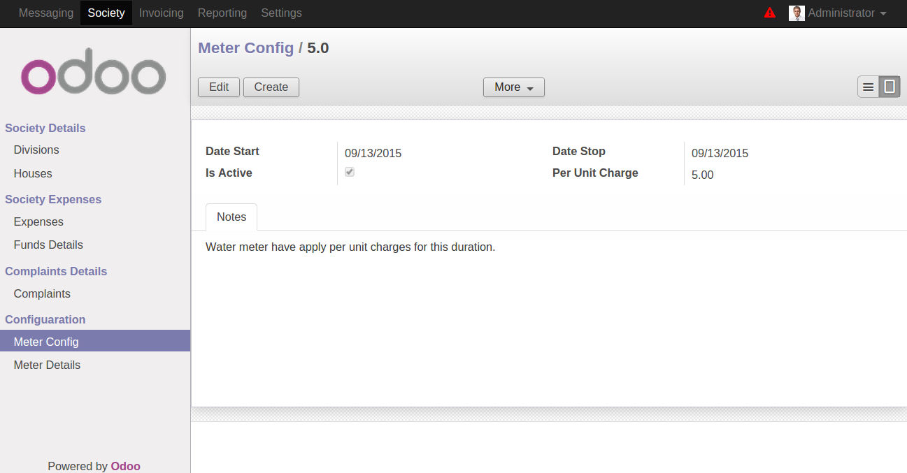

* Active Meter Details(Running Meter):

