
B Y A M E T E C S

DOC BF-01
SmartEPT — Complete Business Flow
From first visit to running installation: Marketing → Trial → Purchase → Provisioning → Operations → Lifetime lifecycle
━━━━━━━━
Version 1.0
12 August 2026
Prepared for: Ejaz Hussain, MD

AMETECS INDIA PRIVATE LIMITED · HYDERABAD

Contents
01 The Journey at a Glance
02 Stage 0 — Promotion & the First Visit
03 Stage 1 — Road A: the Free Trial (Cloud)
04 Stage 2 — Road B: the Direct /buy Pay-First Cart
05 Stage 3 — Road C: Quotations
06 Stage 4 — Road D: Sales-Assisted Orders & Credit
07 Stage 5A — Cloud Onboarding (deployment = cloud)
08 Stage 5B — On-Premises Onboarding (Perpetual)
09 Stage 6 — Life as a Customer
10 Touchpoint Matrix (who gets what, when)
11 Flow Guarantees (the rules that never bend)

1. The Journey at a Glance
SmartEPT sells one all-features product two ways. Every customer walks one of two roads after deciding to pay, and both start at the same front door:
PROMOTE → VISIT smartept.com → EXPLORE (pricing slider, FAQs) → one of:
- (A) Free Trial road — trial sign-up (email OTP) → 7-day SmartEPT Cloud trial → convert to paid from the portal.
- (B) Direct Buy road — /buy pay-first cart → pay → instant activation.
- (C) Quotation road — quote raised (self-serve, from the portal, or by sales for a prospect) → management pays the quote's pay link → same activation.
- (D) Sales-assisted / Credit road — admin creates the order; provisioning happens on the first rupee received (Paid / Partial / even ₹0-due credit by commercial judgement); balance is followed up manually.
Then, by deployment:
- CLOUD → tenant console auto-provisioned at admin.smartept.com/(slug) → one-click SSO from the client portal → agents installed on employee PCs → live monitoring.
- ON-PREMISES (Perpetual) → installer + licence downloads from the portal → installed on the client's own server → 7-day evaluation auto-starts → machine fingerprint sent to Ametecs → node-locked .lic issued from Central → imported → ACTIVE forever, fully offline.
And for life: renewals (cloud) / AMC (on-prem) → automated dunning → upgrades → storage top-ups → support → and, at the very end of a lapsed relationship, grace → suspension → purge.
The single non-negotiable money rule underneath everything: all payment state is computed from the payments ledger (order_payments) through one door — BillingService::recordPayment() — and provisioning fires on the first verified money, never on a promise.
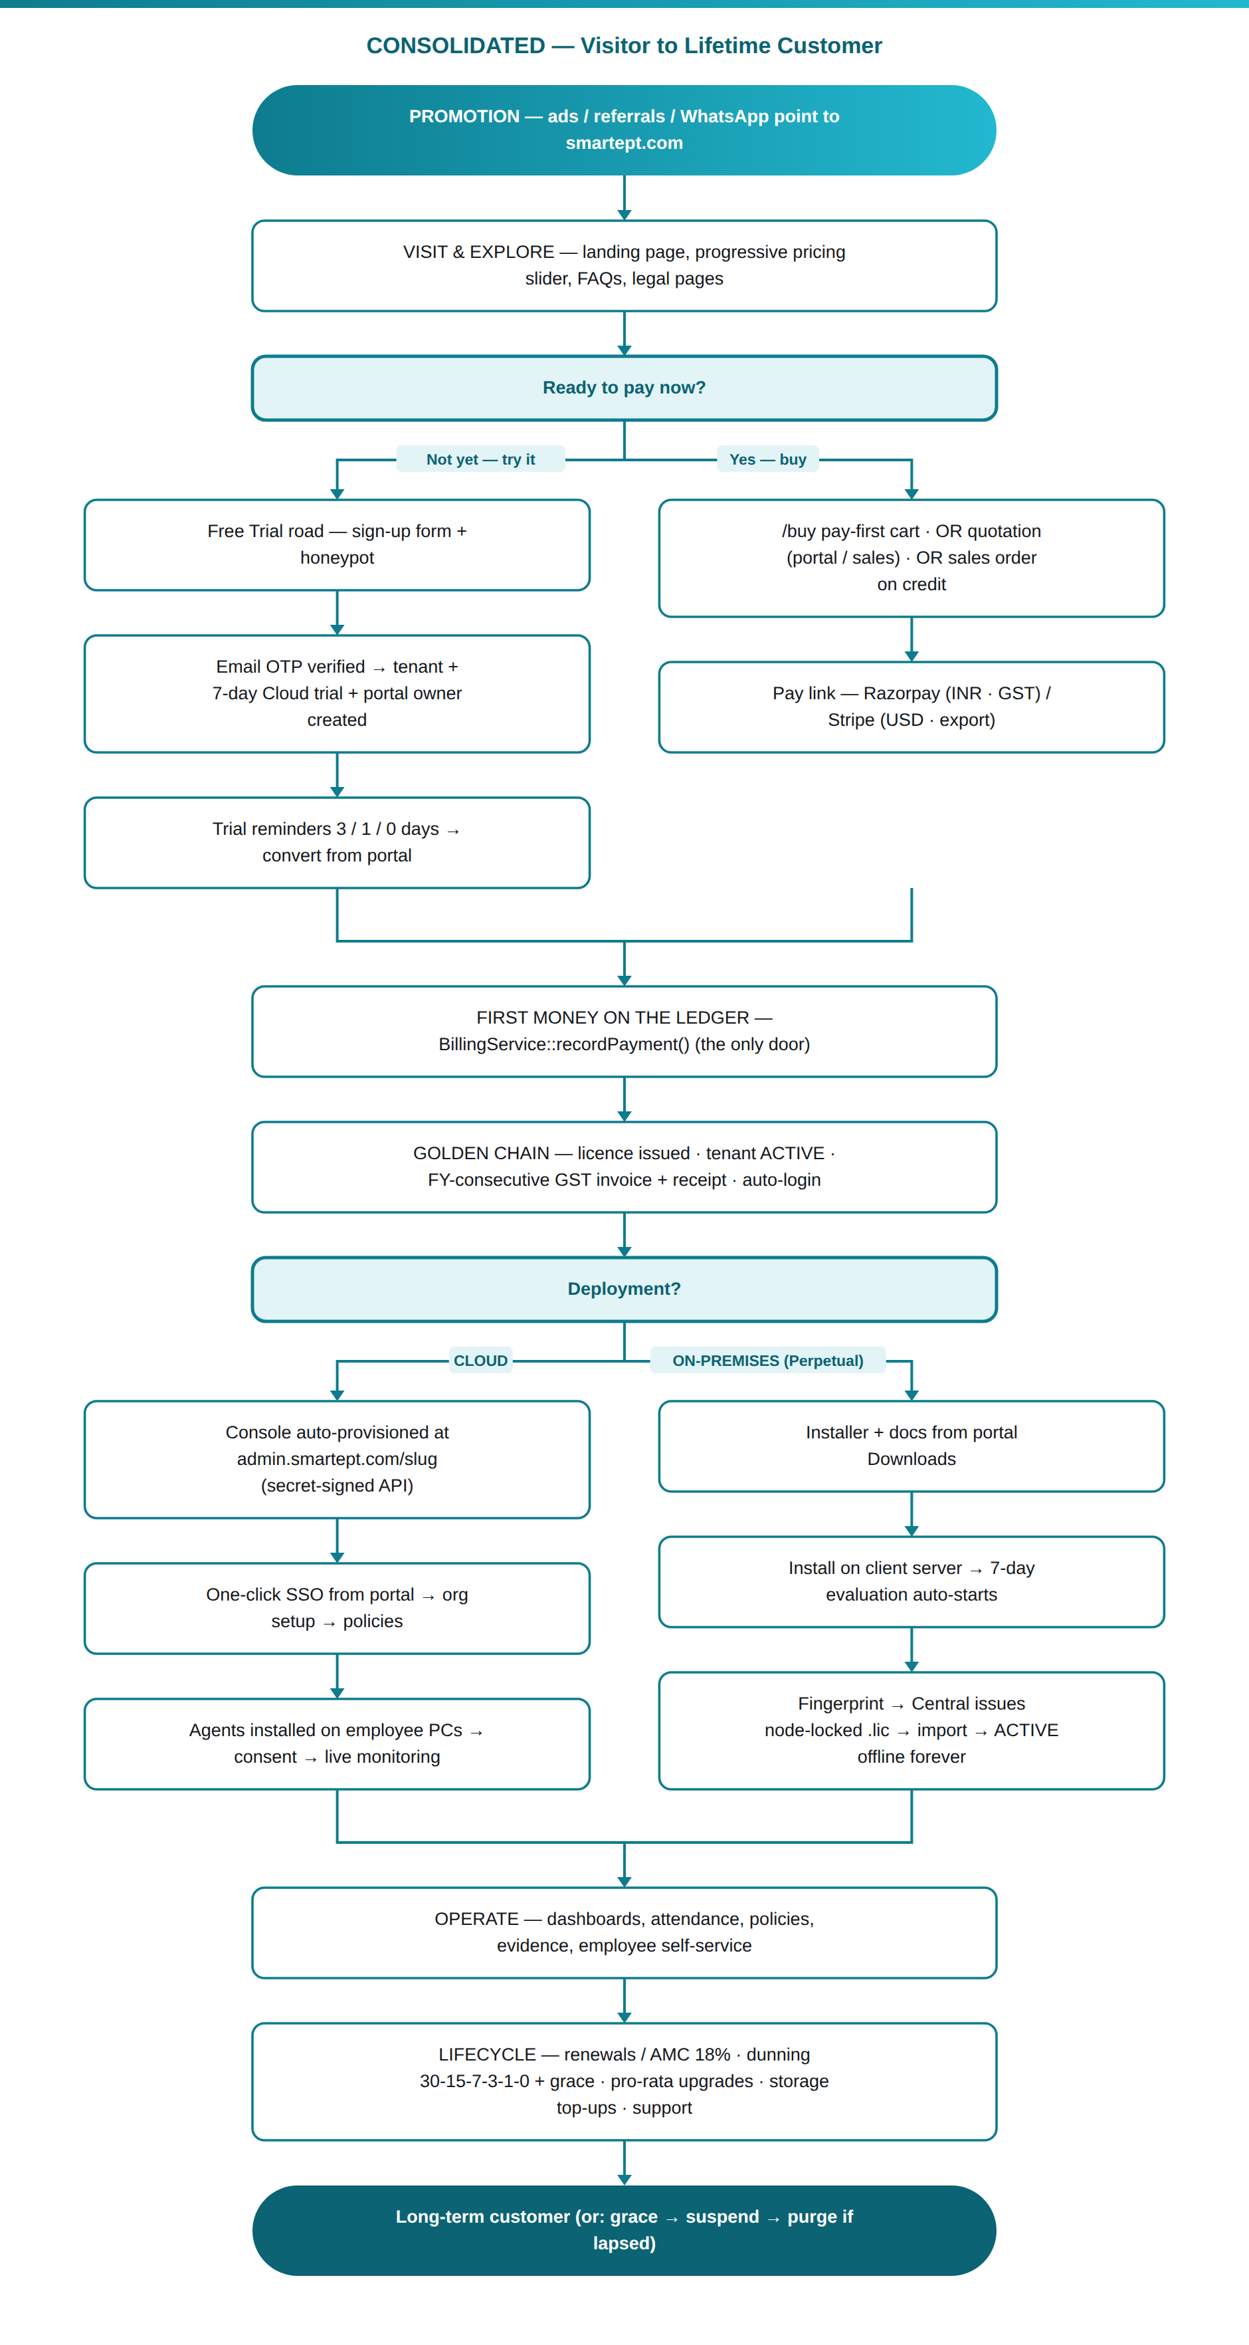

2. Stage 0 — Promotion & the First Visit
Actors: prospect, marketing, sales.
- Promotion (ads, LinkedIn, referrals, WhatsApp) points to smartept.com — the branded landing page (Landing CMS-managed; hero price is single-sourced from the entry pricing band, so marketing price and checkout price can never disagree).
- The visitor explores: feature sections, the interactive pricing slider (On-premises tab: one-time perpetual price, progressive milestone interpolation — 61 users shows ₹44,400, not a band jump; Cloud Hosting tab: per-user/month by volume band with Quarterly 0% / Half-Yearly −10% / Annual −25% advance pricing), FAQs, and legal pages (Terms, Privacy, Refunds — Razorpay-compliant).
- Exit ramps from the landing page:
  - Buy a licence → /buy with the slider's user count carried across (/buy?kind=perpetual&users=61).
  - Start a 7-day free trial → the client sign-up page.
  - WhatsApp lead form → opens WhatsApp chat AND silently records the lead in Central → Leads with an instant email to sales (fire-and-forget; never blocks the visitor).
  - Custom quote (above the last priced milestone, e.g. 200+ users) → WhatsApp contact; sales takes the Quotation road.
- Sales follows up leads from Central → Leads (status pipeline, notes).
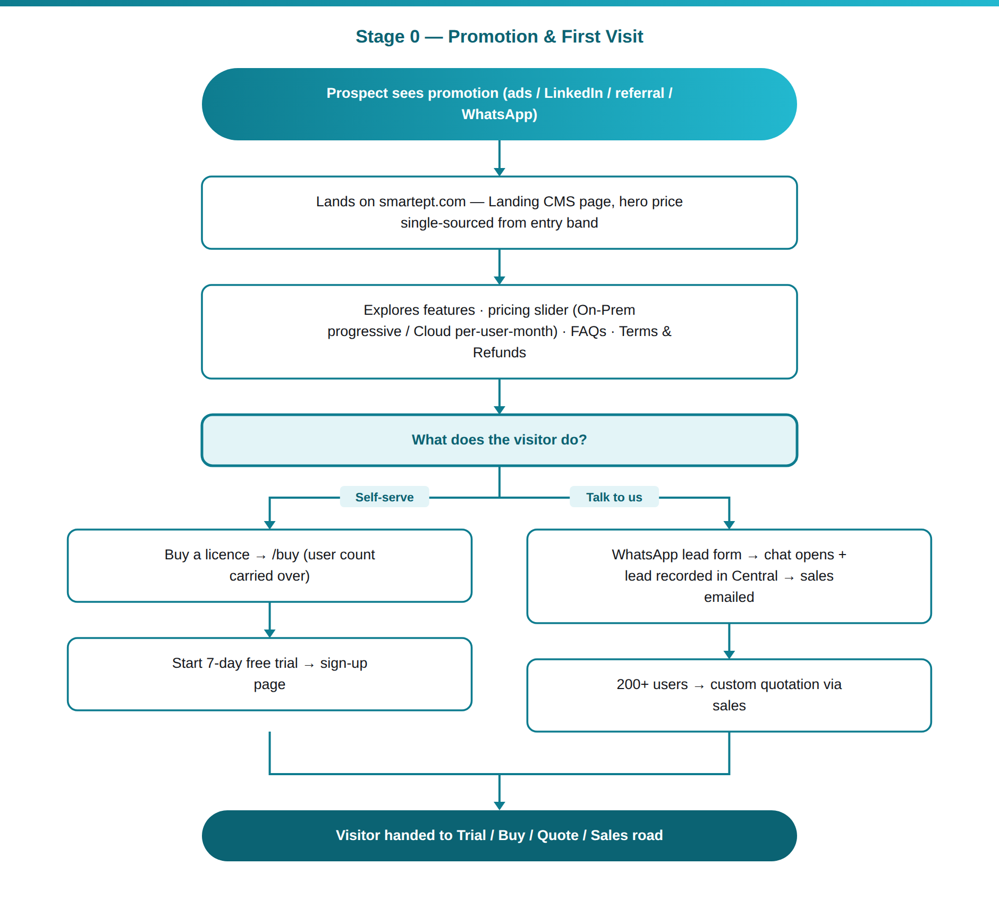

3. Stage 1 — Road A: the Free Trial (Cloud)
Actors: prospect ("owner" user), system.
- Sign-up form: company name, contact name, work email, phone, chosen password. An invisible honeypot field silently swallows bots (fake success, no OTP, no email).
- Email OTP gate: a 6-digit code is emailed (10-minute validity). Nothing is created before the code verifies. Wrong/expired code → clear error, no account.
- On verify (single DB transaction): Tenant (status trial, deployment cloud), 7-day trial provision, and the portal owner login — email pre-verified, GST state captured (decides CGST+SGST vs IGST later), terms acceptance timestamped. The user lands signed-in in the client portal.
- Trial experience: portal shows licences, downloads, storage, invoices, tickets, buy/upgrade. The trial is a lead in the sales pipeline from day one.
- Automated trial dunning: reminder emails at 3 / 1 / 0 days before expiry. Expired trials are eventually purged by the lifecycle ladder. Conversion is one click: Buy from the portal (Road B mechanics, same pricing engine).
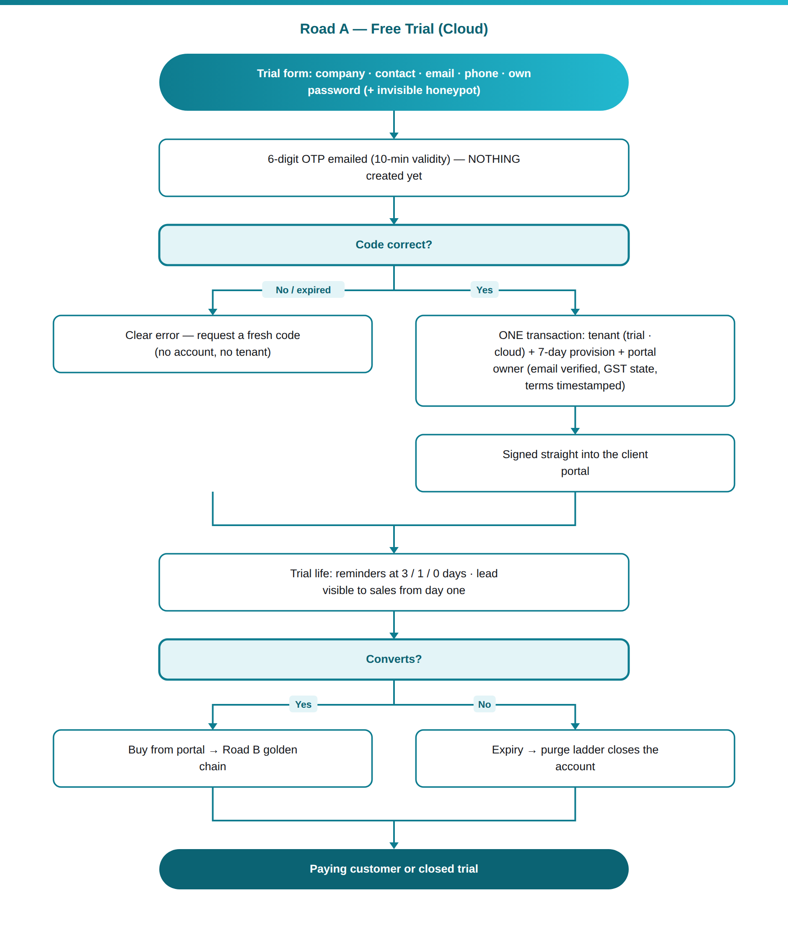

4. Stage 2 — Road B: the Direct /buy Pay-First Cart
Actors: buyer, system, payment gateway.
- /buy — one screen, everything live: How you buy (Rent·Cloud vs Own·Perpetual), Currency (₹ INR · GST invoice / $ USD · export invoice), Monitored users (price recalculates instantly — perpetual uses the same progressive interpolation as the backend; cloud shows per-user/month × cycle), Advance payment cycle (cloud only), optional Remote Assisted Setup (₹5,000 covers 30 devices, +₹100/extra device), Coupon (the box only appears when a live coupon exists; exclusive personal offers auto-apply on email entry), and the GST-correct total (CGST+SGST for Telangana, IGST for other states, 0% for USD export).
- Buyer fills company + contact + email + their own password + state (+ optional GSTIN, validated against the state code) and accepts Terms/Refunds.
- Submit → tenant is created in status pending with a portal login, and an order + pay link is generated. The browser goes straight to payment: Razorpay (INR — UPI/cards/netbanking; smartept.com is a Razorpay-verified website) or Stripe (USD international cards).
- Payment captured (gateway webhook payment.captured or return-flow verification) → recordPayment() → the golden chain fires automatically, same minute:
  - licence issued (SEPT-XXXX-… key; kind subscription or perpetual),
  - tenant flips active,
  - GST tax invoice cut with an FY-consecutive number + receipt, emailed,
  - coupon redemption counted,
  - cloud console provisioning kicked off (cloud) — and the buyer is auto-signed-in to their portal.
- Abandoned buys are rescued: an order left unpaid ~3 hours gets an automatic reminder email with the pay link; the buyer can also sign in any time and find the order waiting (their password already works — pay-later recovery for free).
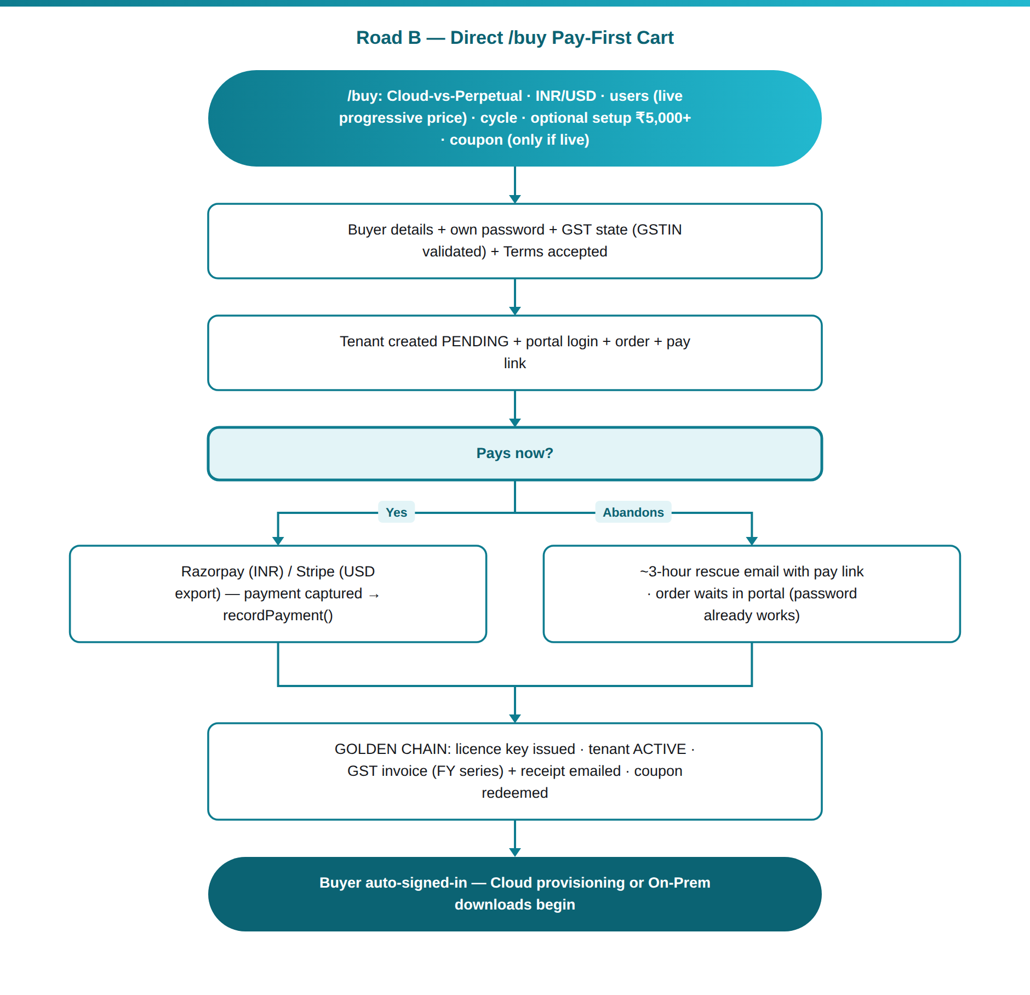

5. Stage 3 — Road C: Quotations
Three doors, one engine (identical pricing, quote numbers EPT-Q-FY-…):
- Portal self-quote — a manager configures users/kind in the portal and raises a quotation instead of paying (requested_by recorded). They get a printable branded quote + a pay link for management. The moment management pays it, the same golden chain activates everything. A locked-in coupon on a quote is honoured even if the code expires meanwhile.
- Admin prospect quote (one screen) — sales creates prospect tenant (status pending) + quote together for a brand-new company; email optional-send; the tenant self-activates when paid; portal owner auto-created on provisioning.
- Public/custom — above the last priced milestone the system refuses to price and routes to sales (WhatsApp) for a custom quotation.
- Unpaid quotes are chased automatically (quote-chaser dunning) and appear in the MD's daily money digest.
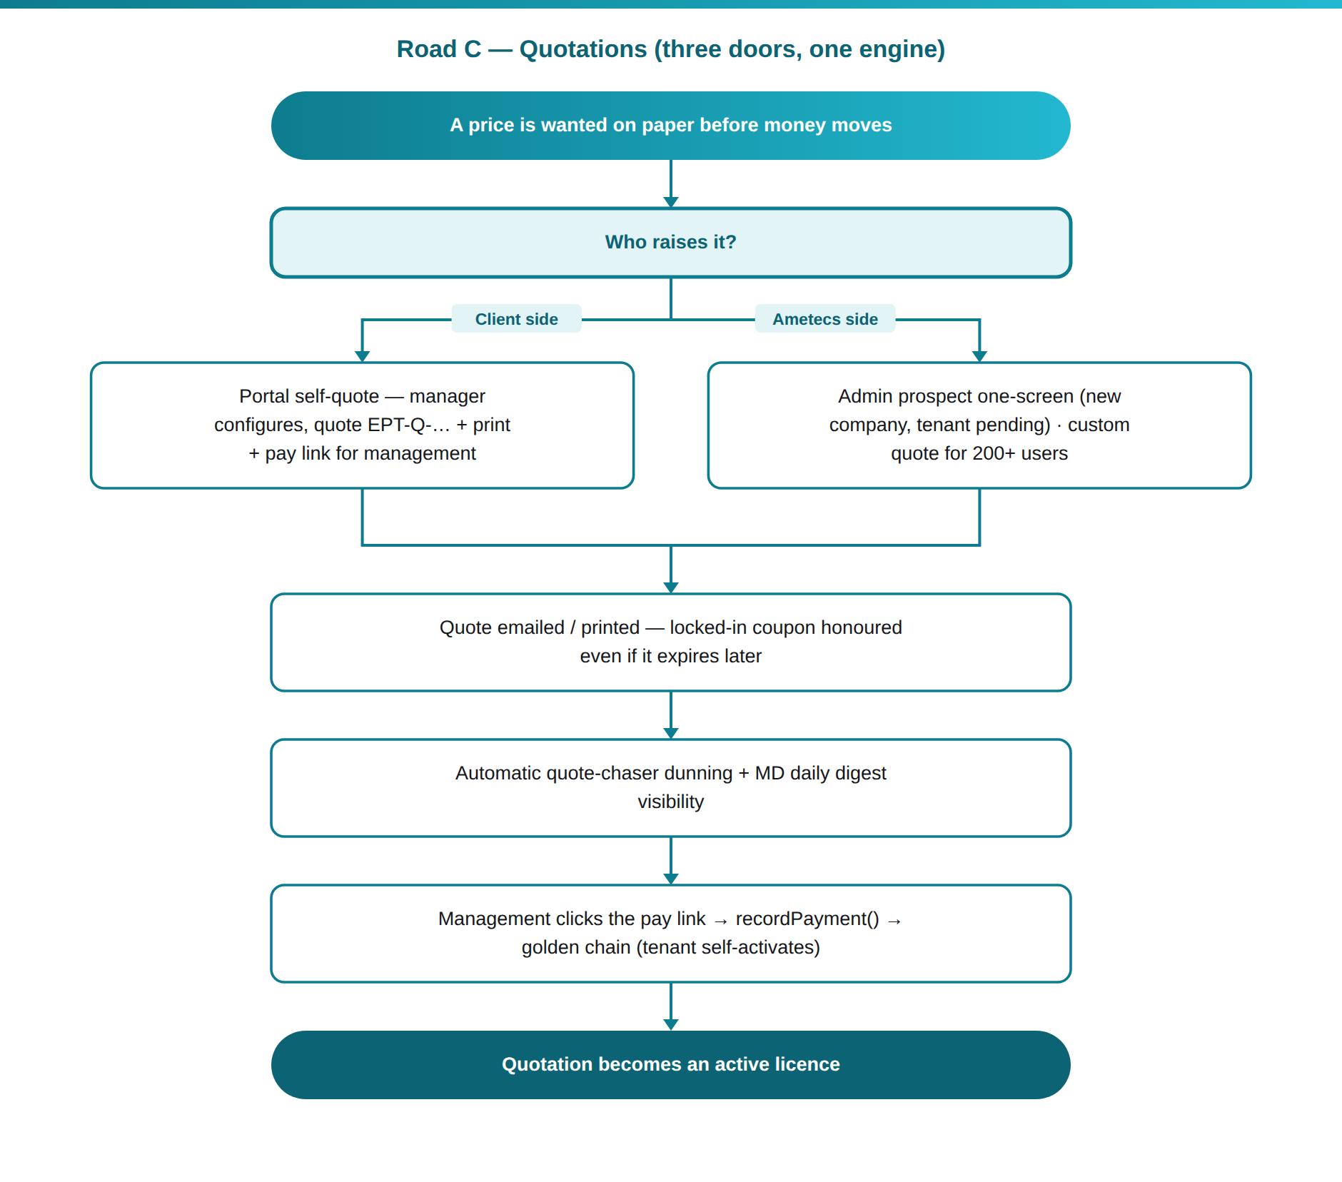

6. Stage 4 — Road D: Sales-Assisted Orders & Credit
- Admin (super/sales) raises an order for an existing client from Orders & Payments; records money via Mark Paid / Partial / Due (manual gateway with method noted).
- Credit is a commercial judgement: provisioning fires on the FIRST money recorded — even ₹0-due if management says so. The client goes live; the balance rides on the order.
- Credit Clients screen tracks every provisioned-on-credit balance with payable-by dates; overdue turns red as a manual follow-up reminder only — nothing auto-locks a credit client. The original pay link stays alive and collects exactly the balance; Record balance logs instalments (each on the ledger).
- Refunds/corrections go out as credit notes (printable), never by deleting money documents.
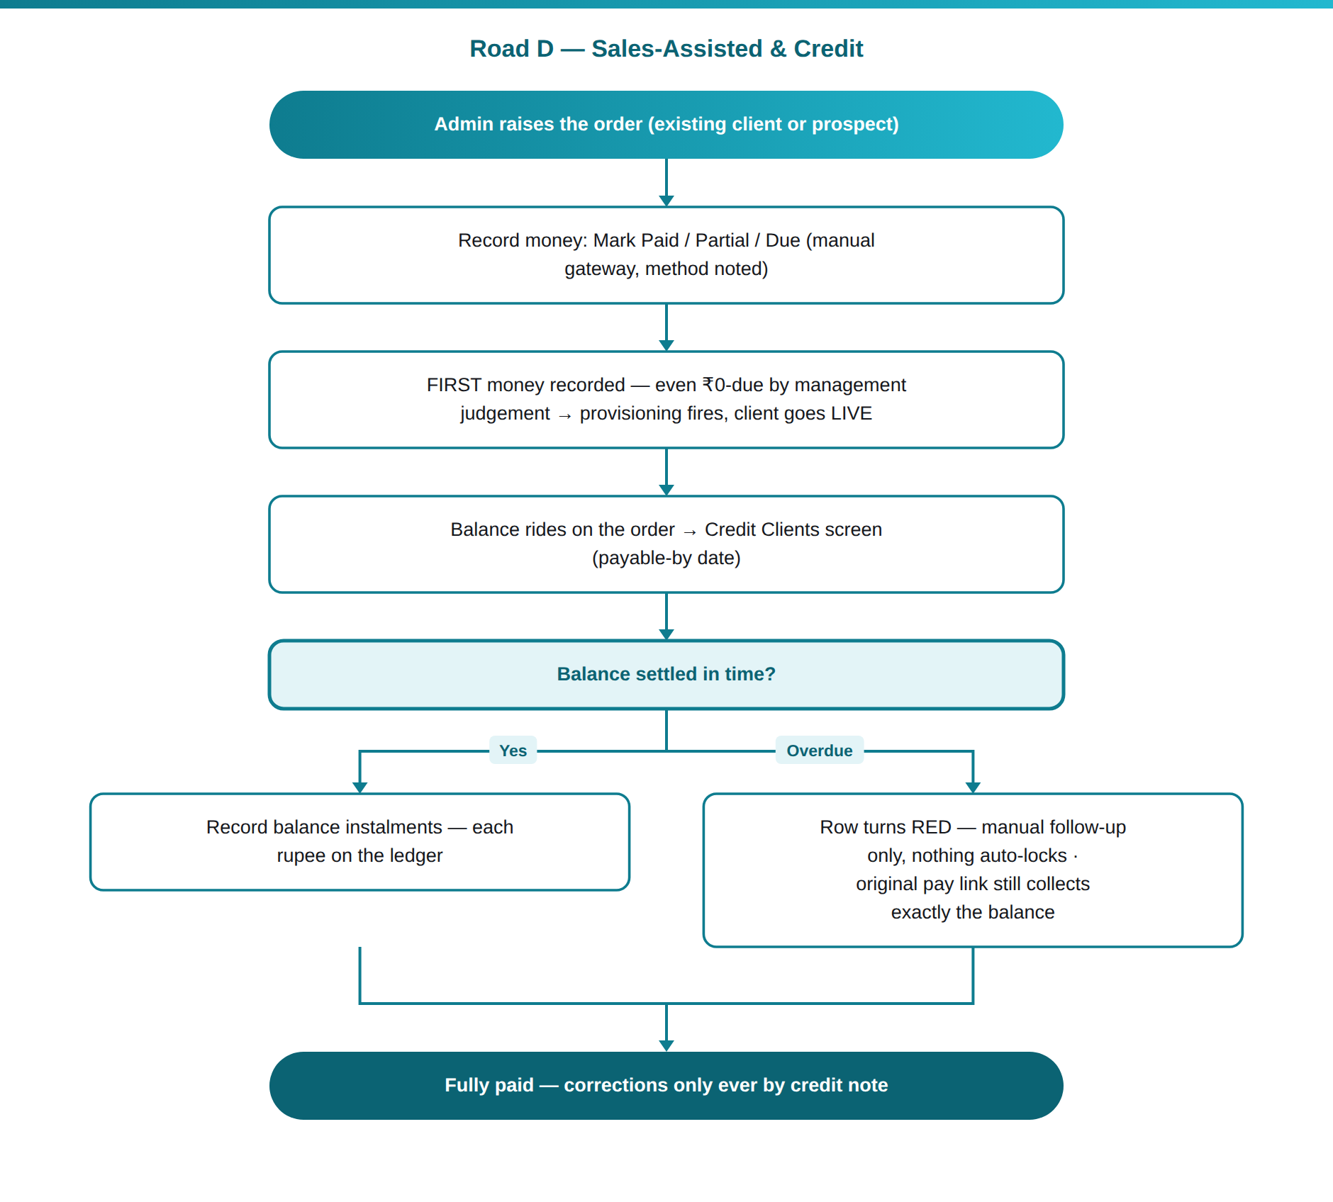

7. Stage 5A — Cloud Onboarding (deployment = cloud)
- On first money, Central calls the product server's provisioning API (secret-signed; Product URL + secrets configured in Central Settings) → a tenant workspace is created on admin.smartept.com with the client's slug (branded, tenant-locked login page at admin.smartept.com/slug).
- The portal shows the hosted console card; one-click SSO signs the owner into their console (HMAC-signed ticket — no password typed).
- Company setup in the console: organisation structure (branches/departments/teams/designations/shifts), users & roles (9 system roles + custom), policies (12 types with DEVICE>EMPLOYEE>TEAM>DEPARTMENT>BRANCH>COMPANY precedence), holidays, biometric devices if used.
- Agent rollout: download the Windows agent from the portal/console → install on employee PCs → each employee signs in → device registers (encrypted device token) → consent screen (hash-bound to the policy version) → tracking starts per policy. Optional Gate-to-PC: no work session until the biometric door IN punch.
- Seats are enforced server-side against the licence; storage = 500 MB pooled per user included, additional at the slab rates (₹3/2.5/2 per GB/month, 50 GB minimum) — usage visible in the portal, quota auto-trims oldest evidence at the cap.
- Suspension control stays with Central: suspend/enable pushes to the cloud console instantly (suspended tenant = login hard cut-off).
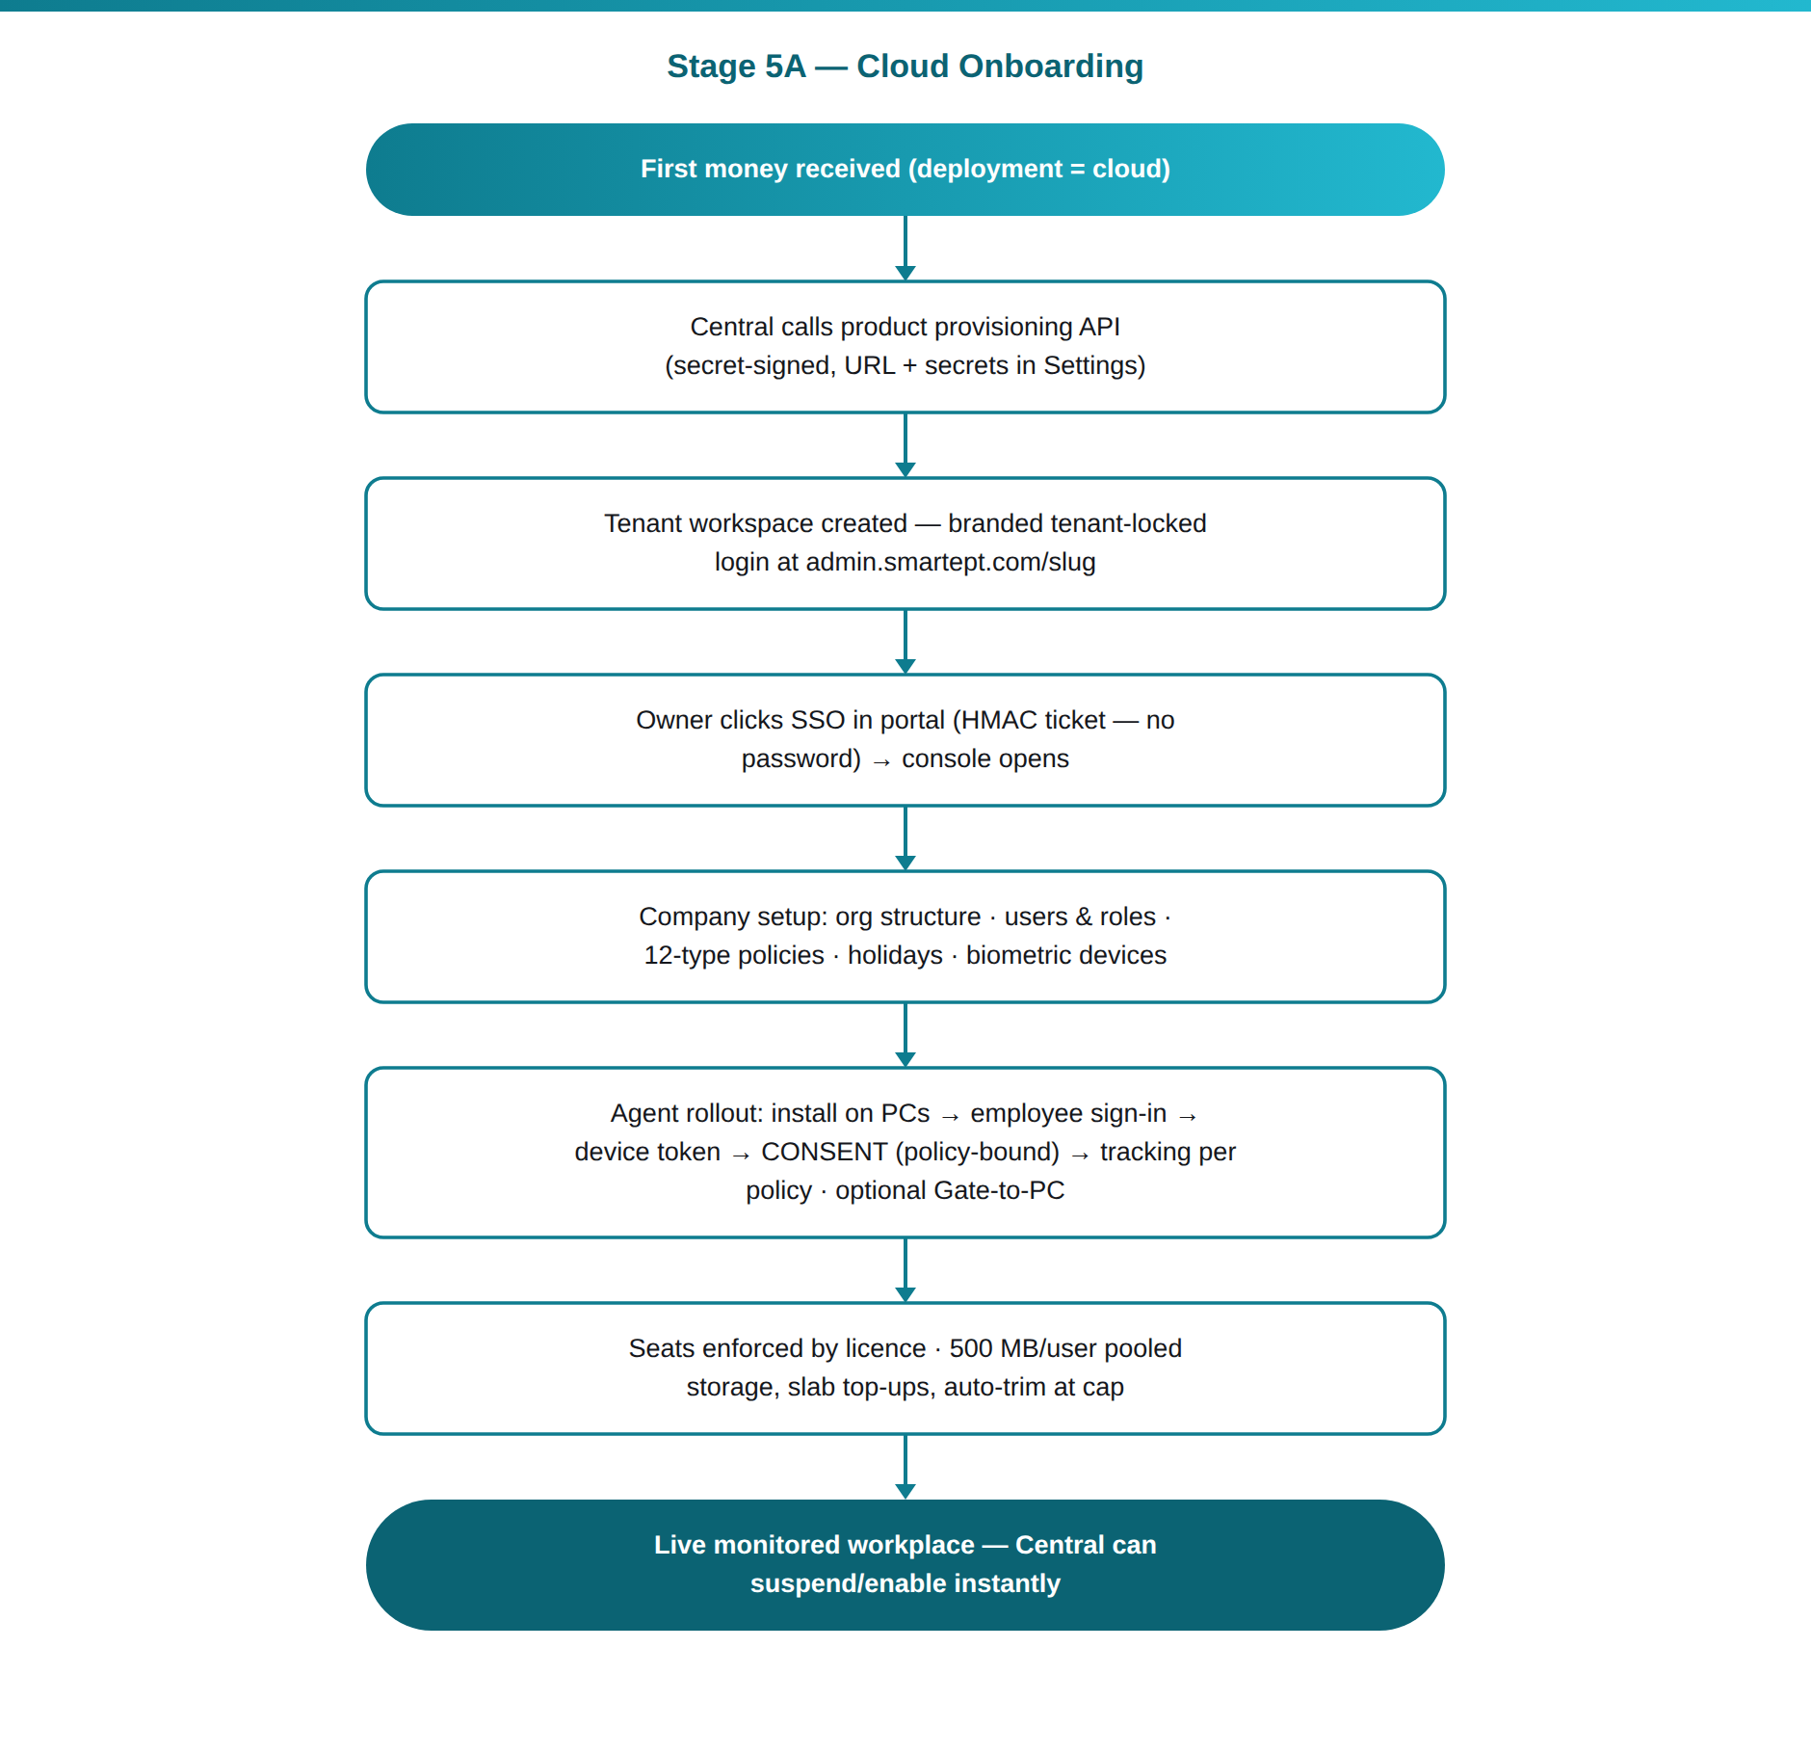

8. Stage 5B — On-Premises Onboarding (Perpetual)
- After payment the portal's Downloads area serves the product installer package (download-logged, quota-guarded) — the price already included the first 12 months of updates & support.
- Client (or Ametecs, if Remote Assisted Setup was bought) installs the console on the client's own server — Windows/Laragon/IIS or Linux/Nginx — and the 7-day evaluation starts automatically (full features, no licence file yet).
- Licensing (fully offline, node-locked): the console's Licence screen shows the server's machine fingerprint (one-click copy) → client sends it to Ametecs → Central issues the .lic file (RSA-2048-signed payload: key, company, device limit, kind perpetual, no expiry, fingerprint) → client imports it → status ACTIVE, forever, with no internet required. The product only carries the public key (SourceGuardian-protected) — it can verify but never forge.
- Wrong/replaced hardware later → Central's release-binding / shift-machine actions re-issue for the new fingerprint (history kept; server-mismatch attempts trip a fraud alert).
- Agent rollout and company setup proceed exactly as in Cloud (the console is the same product).
- AMC (optional, from Year 2): 18% per year of the prevailing progressive price for the client's user count — quoted and invoiced from Central; keeps updates & support flowing.
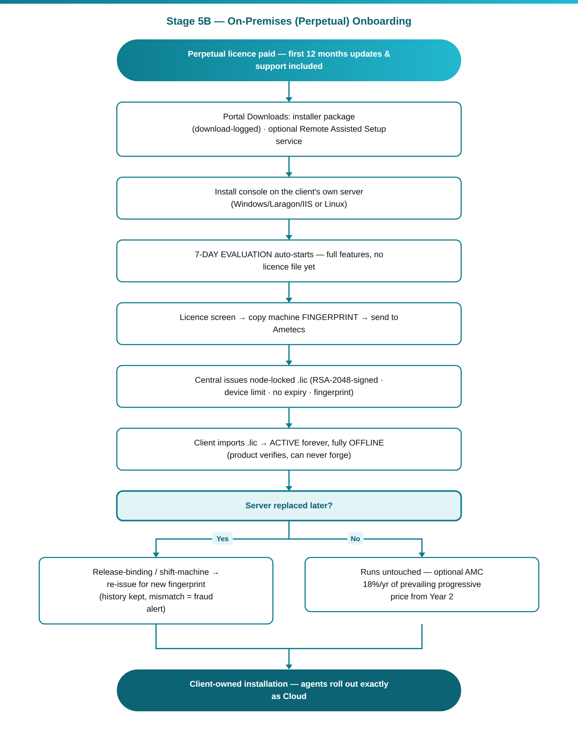

9. Stage 6 — Life as a Customer
Renewals (cloud): subscriptions run Quarterly / Half-Yearly / Annual in advance. Dunning emails at 30/15/7/3/1/0 days before expiry (all deduplicated), then a grace ladder after expiry; persistent non-payment → suspension → eventually the purge window closes the account (purged). One pay-link click at any point renews and re-activates.
Upgrades: cloud capacity rises mid-period pro-rata — the client pays only the remaining-days difference and the seat limit rises immediately. Perpetual capacity upgrades are priced from the same progressive engine at prevailing rates.
Money & compliance throughout: every rupee lands on the ledger; GST invoices FY-consecutive (reset 1 April, row-locked); amount-in-words; USD exports at 0% GST with the live twice-daily FX rate; accountant reports and the MD daily money digest summarise it all.
Self-service throughout (portal): buy/renew/upgrade/quote, invoices & receipts, downloads, storage meter, billing profile, support tickets, forgot-password by email OTP — with every email leaving via the client company's own SMTP when configured, else the Ametecs default relay.
Support & accountability: in-console Help & Troubleshooting (System Health), audit trail of every admin action, screenshot/evidence viewers access-logged, Danger-Zone data clearing OTP-protected with auto-backup.
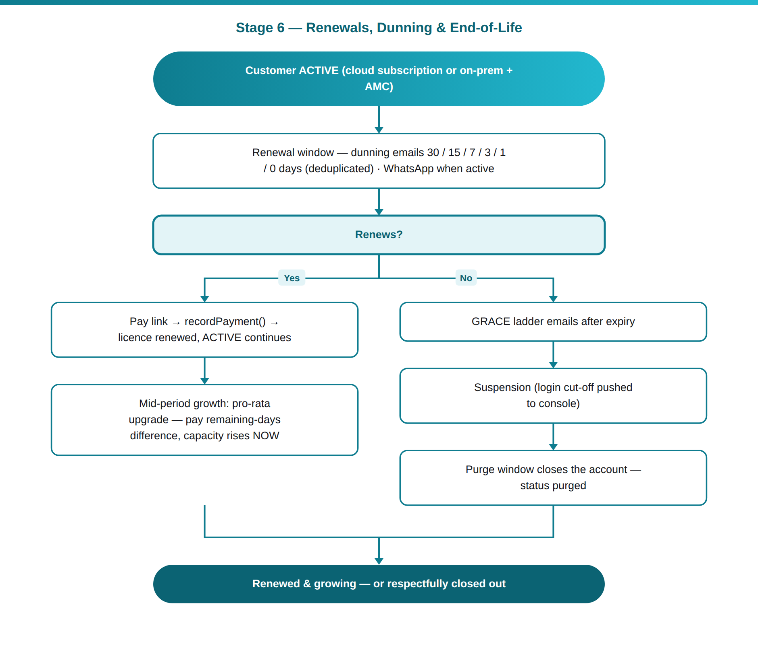

10. Touchpoint Matrix (who gets what, when)
Moment | Email | WhatsApp* | In-app
Lead form submitted | Sales alert | Chat opens | Central → Leads
Trial OTP / trial reminders 3-1-0 | ✓ | — | Sign-up page / portal
Order created / abandoned ~3h | Pay-link rescue | ✓ | Portal order card
Payment captured | Invoice + receipt + welcome | ✓ | Auto-login, licence live
Quote raised / chased | Quote PDF + pay link | ✓ | Portal quotes
Renewal dunning 30-15-7-3-1-0 + grace | ✓ | ✓ | Portal banner
Credit balance overdue | Manual follow-up | Manual | Credit Clients (red)
Password reset (portal & console) | OTP via company SMTP chain | — | Login cards
MD daily digest (after 07:00) | ✓ to MD | — | —

*WhatsApp touchpoints require the Interakt integration to be active in Settings.

11. Flow Guarantees (the rules that never bend)
- No money, no provisioning — activation only through recordPayment() on the ledger (credit's ₹0-first-money is an explicit management act, still through the same door).
- No verified email, no trial — OTP before any trial account exists.
- No ₹0 lifetime licence — Custom-Quote counts cannot price, cannot order, cannot activate.
- Backend prices, browser displays — every displayed price is recomputed server-side on submit.
- Money documents are never deleted once money exists — corrections by credit note; only ₹0-ledger test garbage is deletable (super admin, audited).
- Only licence metadata crosses Central↔Product — client monitoring data never leaves the client's deployment.
- Consent before tracking — the agent tracks only after the employee accepts the policy-bound consent, and transparency screens stay available to the employee.

