
B Y A M E T E C S

DOC BF-02
SmartEPT — Business Flow Testing Guide
End-to-end journey testing: 14 scenarios from first visit to lifetime lifecycle, step-by-step with expected results
━━━━━━━━
Version 1.0
12 August 2026
Prepared for: Ejaz Hussain, MD

AMETECS INDIA PRIVATE LIMITED · HYDERABAD

Contents
01 Purpose, Scope & Ground Rules
02 BF-01 — Visitor → Lead (marketing funnel)
03 BF-02 — Visitor → Free Trial (OTP-gated)
04 BF-03 — Trial → Paid Cloud (conversion + provisioning + agent)
05 BF-04 — Visitor → Direct Perpetual Buy → On-Prem Install → .lic ACTIVE
06 BF-05 — International USD Buy (export invoice)
07 BF-06 — Quotation Road (portal quote → management pays)
08 BF-07 — Sales-Assisted Credit Client
09 BF-08 — Coupons & Discounts on the Money Path
10 BF-09 — Renewal, Dunning & Suspension Ladder
11 BF-10 — Growth: Upgrades
12 BF-11 — AMC Year-2 (On-Prem)
13 BF-12 — Hardware Change (release / shift machine)
14 BF-13 — Corrections: Refund & Credit Note
15 BF-14 — Identity & Communications Backbone
16 Execution & Sign-off

1. Purpose, Scope & Ground Rules
This guide tests the business, not individual screens: each scenario walks one complete customer journey from the Business Flow document (DOC BF-01) and checks every hand-off — page → email → payment → ledger → licence → console → agent. Execute it after the unit-level Session Test Suite (DOC SR-02) is green.
Environment prerequisites (set up once):
- Test on the local Laragon stack first (smartept.com hosts-mapped, smartept.test product), then repeat the money-critical scenarios on live with ₹1-class real payments or gateway test mode.
- Central Settings filled: Razorpay keys, product URL + provisioning/SSO secrets, SMTP (email must actually deliver), USD rate; Interakt active if WhatsApp is to be tested.
- Pricing bands configured (use the standard set: 5–15 ₹15,000 … 151–200 ₹90,000, 201+ Custom) and one live coupon (e.g. WINTER26, 15%, ≥10 devices).
- Product console reachable; global SMTP set in product Ops → Email/SMTP; one test client company with its own SMTP for the client-relay scenario.
- Fresh test email inboxes (use plus-addressing: name+bf01@yourdomain) — every scenario uses a NEW email.
- Record every run in the companion Excel tracker (SmartEPT-Business-Flow-Testing-2026-08-12.xlsx): Status per step, evidence (screenshot/email) links in Remarks. Any failed step in BF-01…BF-07 is a release blocker — report to Ejaz sir immediately.
The consolidated journey under test:
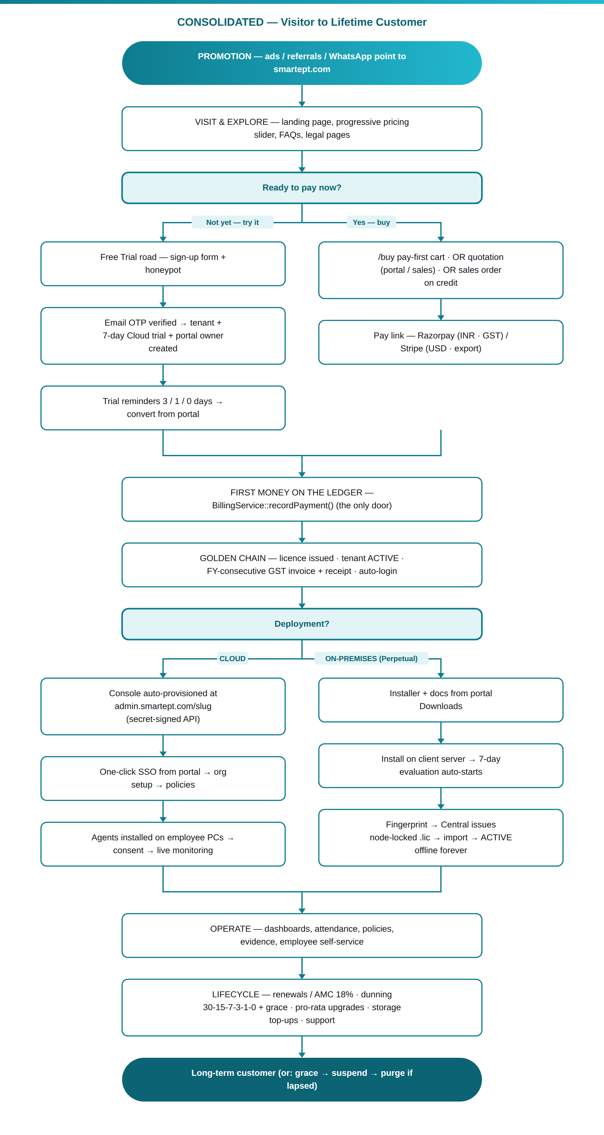

2. BF-01 — Visitor → Lead (marketing funnel)
Step | Actor | Action | Expected
1 | Visitor | Open smartept.com fresh (incognito) | Landing loads; hero price = first-band price; no ™/® anywhere
2 | Visitor | Play with pricing slider, On-premises tab: 41 / 61 / 201 users | ₹33,250 / ₹44,400 / "Custom quotation" — matches /buy exactly
3 | Visitor | Fill the WhatsApp lead form (name, company, phone, devices, plan) and send | WhatsApp chat opens pre-filled
4 | Sales | Check Central → Leads and the sales inbox | Lead recorded with devices + message; instant email to sales received
5 | Sales | Update lead status/notes | Pipeline reflects the change

Pass: visitor never blocked, lead captured twice (chat + CRM), prices consistent everywhere.

3. BF-02 — Visitor → Free Trial (OTP-gated)
Step | Actor | Action | Expected
1 | Prospect | Landing → Start free trial; fill form with NEW email, own password | Step 2 appears: "We emailed a 6-digit code…"
2 | Tester | Check Central admin BEFORE verifying | NO tenant / portal user exists yet
3 | Prospect | Enter a WRONG code | Clear error; still nothing created
4 | Prospect | Enter the emailed code | Trial activates; auto-login to client portal
5 | Tester | Verify in Central | Tenant status trial, deployment cloud, terms timestamped; owner user email-verified
6 | Tester | Check the lead/trial views | Trial visible to sales from day one
7 | Tester | (Time-shift or wait) trial reminders | Emails at 3 / 1 / 0 days before expiry, deduplicated

Pass: OTP is a hard gate; the trial exists only after verification; reminders fire.

4. BF-03 — Trial → Paid Cloud (conversion + provisioning + agent)
Step | Actor | Action | Expected
1 | Owner | From the BF-02 portal: Buy — Cloud, 25 users, Annual | Server quote: 25 × band rate × 12; GST per state
2 | Owner | Pay via Razorpay (test/₹1-class) | Payment captured; portal shows licence ACTIVE
3 | Tester | Verify the golden chain in Central | Ledger row; licence key SEPT-…; tenant active; FY-consecutive GST invoice + receipt emailed
4 | System | Cloud provisioning | Console created at admin.smartept.com/(slug); portal shows hosted-console card
5 | Owner | Click SSO | Signed into the console with NO password typed
6 | Admin | Set up org structure + a policy; install agent on one PC | Employee signs in → device registers → consent screen → tracking starts per policy
7 | Tester | Check seats + storage | Seat cap = licence limit enforced; storage meter shows pooled 500 MB/user

Pass: one unbroken chain from portal click to a monitored PC.

5. BF-04 — Visitor → Direct Perpetual Buy → On-Prem Install → .lic ACTIVE
Step | Actor | Action | Expected
1 | Buyer | /buy → Own·Perpetual, 61 users, INR, Telangana + GSTIN | Price ₹44,400 (progressive); GST = CGST+SGST split
2 | Buyer | Add Remote Assisted Setup; submit + pay | Setup ₹8,100 on its own line; payment captured
3 | Tester | Verify | Perpetual licence (no expiry) issued; invoice FY series; tenant active; buyer auto-signed-in
4 | Client | Portal → Downloads → installer | Download works and is logged
5 | Client | Install console on a test server | 7-day evaluation auto-starts, full features
6 | Client | Licence screen → copy machine fingerprint → send to Ametecs | Fingerprint copies in one click
7 | Ametecs | Central licence card → issue licence file for that fingerprint | .lic generated (needs signing key present)
8 | Client | Import .lic | Status ACTIVE — perpetual, offline; unplug internet and verify it stays active
9 | Tester | Try the same .lic on a DIFFERENT machine | Rejected: server mismatch (and Central alert on phone-home installs)

Pass: money → licence → sovereign offline installation, node-locked.

6. BF-05 — International USD Buy (export invoice)
Step | Actor | Action | Expected
1 | Buyer | /buy → USD currency, Cloud 30 users annual | $ prices at the admin FX rate; "GST — export (0%)"
2 | Buyer | Pay by card (Stripe path / export-invoice flow) | Payment recorded on the ledger
3 | Tester | Check invoice | 0% GST export invoice, FY-consecutive number, USD amounts

7. BF-06 — Quotation Road (portal quote → management pays)
Step | Actor | Action | Expected
1 | Manager | Portal → configure Perpetual 100 users → "Prefer a formal quotation" | Quote EPT-Q-… created; requested_by = manager; printable branded quote
2 | Manager | Copy the pay link; apply the live coupon on the quote | Coupon locked into the quote lines
3 | Tester | Disable the coupon in admin, then open the pay link | Quote still honours the locked-in discount
4 | Management | Pay the link | Golden chain: licence + invoice + activation
5 | Tester | (Separate run) leave a quote unpaid | Quote-chaser email goes out; quote appears in MD digest

8. BF-07 — Sales-Assisted Credit Client
Step | Actor | Action | Expected
1 | Sales | Admin → Quote for NEW client (prospect one-screen), Cloud 25 annual | Prospect tenant (pending) + quote created together
2 | Sales | Approve → Record Payment Partial (e.g. ₹5,000) with payable-by date | Provisioning fires on first money: tenant ACTIVE, licence issued, invoice cut
3 | Tester | Credit Clients screen | Row with total/received/balance/payable-by
4 | Tester | Let the date pass | Row turns RED — but the client is NOT locked out
5 | Sales | Record balance in two instalments | Each instalment on the ledger; balance reaches 0; row clears

9. BF-08 — Coupons & Discounts on the Money Path
Step | Actor | Action | Expected
1 | Buyer | /buy with the live coupon (≥10 devices) | Box visible; discount line BEFORE GST; totals correct
2 | Buyer | Same code below its min devices | "not valid" with reason
3 | Tester | Disable all coupons → reload /buy | Coupon box GONE entirely
4 | Tester | Exclusive coupon for a specific email | Auto-applies silently when that email is typed
5 | Tester | Ecosystem client (SmartDCM/PRS flag) | Flat 10% off every cycle/plan

10. BF-09 — Renewal, Dunning & Suspension Ladder
Step | Actor | Action | Expected
1 | Tester | Set a test cloud licence to expire in 30 days; run smartept:dunning | 30-day reminder email (deduplicated on re-run)
2 | Tester | Step expiry through 15/7/3/1/0 | Each reminder fires exactly once
3 | Client | Pay the renewal link at any point | Licence extends; ladder resets; ACTIVE
4 | Tester | (Separate tenant) let it expire | Grace ladder mails; then suspension — console login hard-blocked with clear message
5 | Ametecs | Resume from Central | Access restored instantly
6 | Tester | Let purge window pass; run dunning | Tenant status = purged (no SQL 1265 error), licences revoked

11. BF-10 — Growth: Upgrades
Step | Actor | Action | Expected
1 | Owner | Cloud client mid-period: upgrade 25 → 40 users | Pro-rata quote for remaining days ONLY; on payment the seat cap rises immediately, expiry unchanged
2 | Owner | Perpetual client: capacity upgrade request | Priced from the progressive engine at prevailing rates; new .lic re-issued after payment

12. BF-11 — AMC Year-2 (On-Prem)
Step | Actor | Action | Expected
1 | Ametecs | Raise AMC for the BF-04 client (61 users) | AMC = 18% of the PREVAILING progressive price for 61 users (18% × ₹44,400 = ₹7,992 at current bands)
2 | Client | Pay | AMC expiry advances one year; invoice cut

13. BF-12 — Hardware Change (release / shift machine)
Step | Actor | Action | Expected
1 | Client | Server dies; installs console on a new machine | New fingerprint shown; old .lic rejected on the new box
2 | Ametecs | Central → licence → shift-machine with the new fingerprint | New .lic issued; history keeps both bindings
3 | Client | Import on the new server | ACTIVE again; old machine can no longer validate

14. BF-13 — Corrections: Refund & Credit Note
Step | Actor | Action | Expected
1 | Ametecs | Refund part of a paid order | Credit note generated (printable), ledger shows the negative movement; invoice untouched
2 | Tester | Try to delete that paid order | Impossible — server refuses (money on ledger)
3 | Tester | Delete a ₹0 test quote instead | Allowed (super only), audit-logged

15. BF-14 — Identity & Communications Backbone
Step | Actor | Action | Expected
1 | Portal user | Forgot password on client portal | Email OTP → reset → sign-in (Central SMTP)
2 | Console user | Forgot password on product console | OTP arrives via the company's own SMTP when configured (check From/headers), else the global relay
3 | Company admin | Break the company SMTP password → Send test | Real relay error surfaced; fix → test passes
4 | Company admin | Clear company SMTP host | Next reset email goes via the global relay (fallback proven)
5 | Employee | EMPLOYEE-role forgot password | Works identically; employee portal opens
6 | Tester | Every mail sent above | Corresponding mail_logs row (sent/failed) exists

16. Execution & Sign-off
Run order: BF-01 → BF-14 (BF-09/10/11 can time-shift with test data). Track in the Excel: one row per step, Status PASS/FAIL/BLOCKED, evidence link. Sign-off rule: all BF-01…BF-07 fully PASS + no open P1 = business flow approved for launch. Findings go to Ejaz sir with scenario + step number + evidence.

