Operating Systems - Lab 1 18 Jan 2024

Animesh Mishra

2210110161

Q1

#include <stdio.h>  
  
int main() {  
 FILE *fp;  
 char path[1035];  
  
 // Open the command for reading.  
 fp = popen("ps -eo pid,user,args", "r");  
 if (fp == NULL) {  
 printf("Failed to run command\n");  
 return 1;  
 }  
  
 // Print the header  
 printf("%-8s%-20s%s\n", "PID", "USER", "COMMAND");  
  
 // Read the output a line at a time - output it.  
 while (fgets(path, sizeof(path) - 1, fp) != NULL) {  
 printf("%s", path);  
 }  
  
 // Close the file pointer.  
 pclose(fp);  
  
 return 0;  
}



**Similarities:**

Both display the PID (Process ID) of each running process.

They both show the associated user of each process.

The displayed commands give an idea of what each process is doing.

**Differences:**

The output format varies. Your process_list.c program seems to present a cleaner and more organized tabular format making it easier to read and understand.

The ps -A command may provide a more detailed and comprehensive set of information including additional columns.

Q2

(a)

animesh@Animesh-ROG:~$ more /proc/cpuinfo  
processor : 0  
vendor_id : AuthenticAMD  
cpu family : 25  
model : 68  
model name : AMD Ryzen 7 6800H with Radeon Graphics  
stepping : 1  
microcode : 0xffffffff  
cpu MHz : 3194.003  
cache size : 512 KB  
physical id : 0  
siblings : 16  
core id : 0  
cpu cores : 8  
apicid : 0  
initial apicid : 0  
fpu : yes  
fpu_exception : yes  
cpuid level : 13  
wp : yes  
flags : fpu vme de pse tsc msr pae mce cx8 apic sep mtrr pge mca cmov pat pse36 clflush mmx fxsr sse sse2 ht syscall nx mmxext fxsr_opt pdpe1gb rd  
tscp lm constant_tsc rep_good nopl tsc_reliable nonstop_tsc cpuid extd_apicid pni pclmulqdq ssse3 fma cx16 sse4_1 sse4_2 movbe popcnt aes xsave avx f16c rdr  
and hypervisor lahf_lm cmp_legacy svm cr8_legacy abm sse4a misalignsse 3dnowprefetch osvw topoext perfctr_core ssbd ibrs ibpb stibp vmmcall fsgsbase bmi1 av  
x2 smep bmi2 erms invpcid rdseed adx smap clflushopt clwb sha_ni xsaveopt xsavec xgetbv1 xsaves clzero xsaveerptr arat npt nrip_save tsc_scale vmcb_clean fl  
ushbyasid decodeassists pausefilter pfthreshold v_vmsave_vmload umip vaes vpclmulqdq rdpid fsrm  
bugs : sysret_ss_attrs null_seg spectre_v1 spectre_v2 spec_store_bypass srso  
bogomips : 6388.00  
TLB size : 2560 4K pages  
clflush size : 64  
cache_alignment : 64  
address sizes : 48 bits physical, 48 bits virtual

(b) CPU cores: 8

(c) processor: 15

(d) cpu MHz: 3194.003

(e) model name: AMD Ryzen 7 6800H with Radeon Graphics. The specific microarchitecture for the AMD Ryzen 7 6800H is based on the "Zen" architecture, which is developed by AMD.

(f) 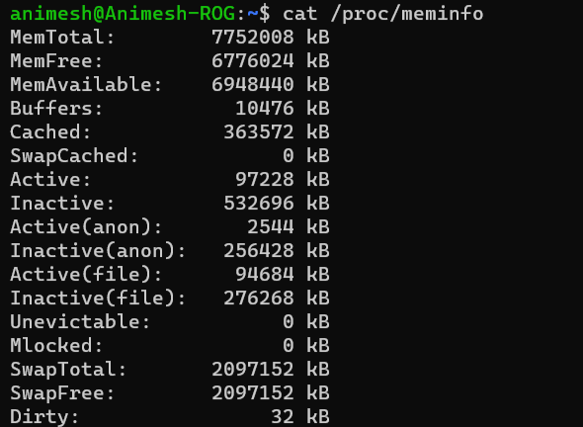

Total memory: 7752008 kB

(g) Free memory: 6776024 kB

Total number of forks: 848

Total number of context switches: 237961

Q3

1. The process with the command name cpu in the list. The first column represents the PID (Process ID) which is **1570.**
2. Percent of CPU consumed (%cpu) =100.0

Percent of memory consumed (%mem) =0.0

1. From the STAT column: R - This indicates that the process is running. So, the process with PID 1570 is currently running and actively consuming CPU resources.

Q4)

(a)

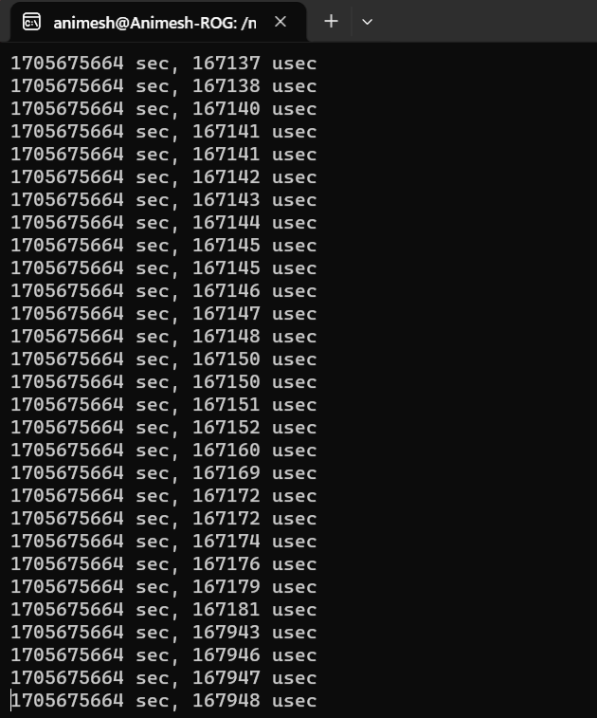

This program runs in an infinite loop printing output to the screen.

The PID of the process is **1689.**



(b) PIDs of all the ancestors

(c)

The file descriptors 0, 1, and 2 for the process with PID 1689 are pointing to the terminal device /dev/pts/2. This indicates that the process is directly interacting with the terminal.

(d)

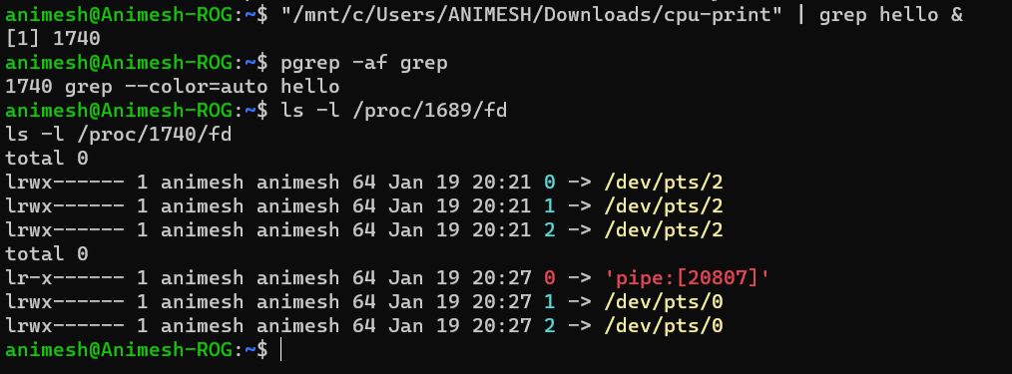

ls -l /proc/1689/fd command indicates the file descriptors for the cpu-print process (PID 1689), and it has its standard output and standard error redirected to a pipe ('pipe: [20807]'). Additionally, the output of ls -l /proc/1740/fd shows that the grep process (PID 1740) is reading from the same pipe.

Pipes in the shell are implemented by redirecting the standard output of one process to the standard input of another process, allowing the output of one command to serve as the input for another.

(e)

We can use which command to check if these commands have corresponding executables.

Hence,

Bash implements **cd** and **history** as built-in commands.

External executables (**ls** and **ps**) are in the Linux kernel directory tree.

Q5) **memory1.c**

* Allocates an array of integers with ARRAY_SIZE elements but does not access or modify any element.
* Prints process information and wait for user input before exiting.

**memory2.c**

* Allocates an array of integers with ARRAY_SIZE elements and initializes/modifies the first half of the array.
* Prints process information and wait for user input before exiting.

Expected Memory Behavior:

**memory1.c** is expected to have **relatively low memory usage** since it only allocates an array but doesn't perform any substantial operations on it.

**memory2.c** is expected to have **higher memory usage** due to the array operations, as it initializes and performs arithmetic on a significant portion of the array.

Q6) The script **make-copies.sh** is used to create 5000 copies of the **foo.pdf** file with different filenames in the **disk-files** folder.

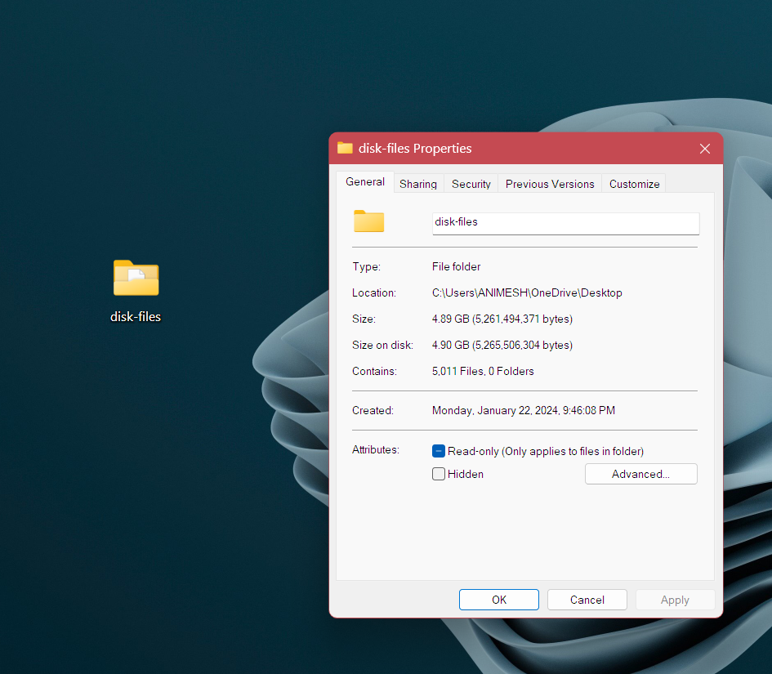

We use a tool like **iostat** to measure disk utilization while running each program.

Compiling programs disk.c and disk1.c and measuring the disk usage while the programs are running.

**%util** column, which indicates the percentage of time the disk is busy.