AMET BUSINESS SCHOOL
Guest Lecture Organised by the Department
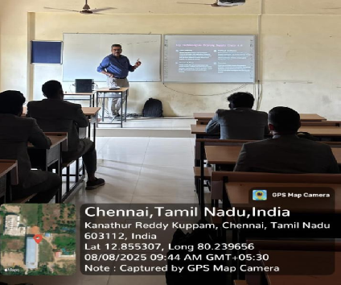 | 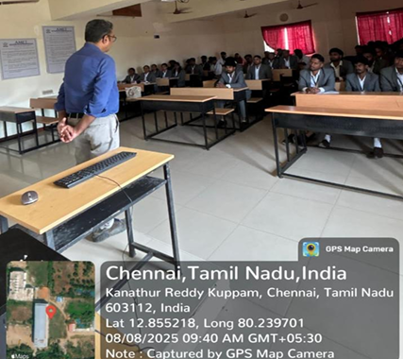
Guest Lecture on Role of Information Technology in Supply Chain delivered by
Mr. L. Balaji, Director – Production and Materials Control, Pegatron Technology on 8th August 2025

The Guest Lecture began with a comprehensive overview of the evolving landscape of supply chain management, emphasizing the transformative role of emerging technologies. The session explored how digital innovations are reshaping traditional practices and driving industry-wide evolution. Key technologies such as Internet of Things (IoT), Artificial Intelligence (AI), and Block Chain were spotlighted across the supply chain ecosystem. A particularly valuable segment of the lecture was the detailed roadmap for implementing IoT in supply chain operations. This included practical steps, strategic considerations, and real-world examples that illustrated how IoT can be leveraged to optimize logistics, monitor assets, and enable predictive maintenance.

Guest Lecture Organised by the Department
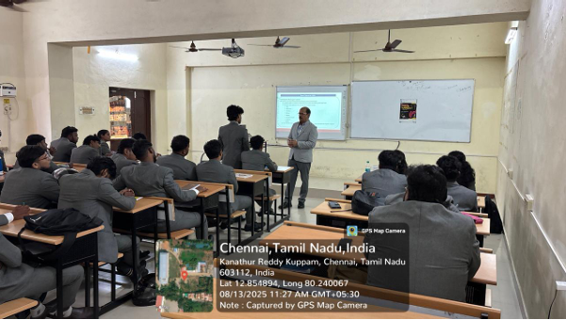 | 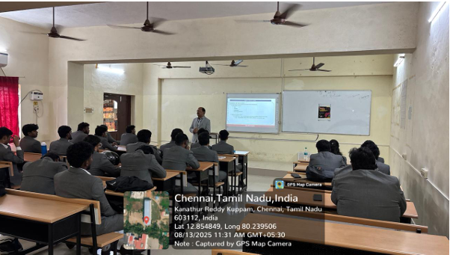
Guest Lecture Export and Import management delivered by Mr. Sudhanshu Kumar,
Academic Mentor and Area Chair –In various Management Schools, Greater Noida on
August 13, 2025

The session began with an introduction to Export–Import (EXIM) fundamentals. Emphasis was placed on the role of EXIM in global trade. Detailed discussion on the constituents of a export contract. Key elements covered includes Product specifications, Payment terms, Delivery schedules, Complaints and Return. The session demystified Incoterms (International Commercial Terms) used in global trade. Focus was on various used terms like CIF (Cost, Insurance, and Freight), DAP (Delivered at Place) etc.

Guest Lecture Organised by the Department
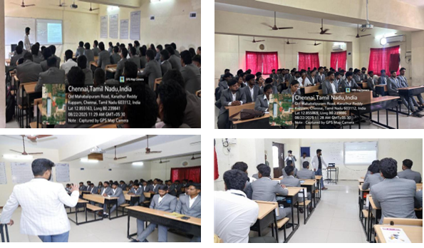
Gust Lecture on Air Freight Business Operations delivered by Mr. Gautham Raju, Senior Manager - Global Air Product & Head, Airfreight, India. Wiz Freight Tech and R&D Enter, Chennai on 22nd August 2025

The session opened with a comprehensive overview of Air Cargo. Air cargo is a $50 billion industry, transporting 35% of high-value goods globally. Government initiatives like Krishi Udaan 2.0 and major infrastructure projects are driving its growth. Key stakeholders such as ICAO, IATA, and FIATA ensure global standards and smooth operations. The core processes involve shippers, agents, customs, carriers, and consignees, supported by essential documents like MAWB, HAWB, manifests, and declarations. Safe handling and efficient movement are further ensured through proper marking and labeling (Fragile, Keep Dry, Temperature Limits), along with the use of ULDs and advanced airport facilities.

Guest Lecture Organised by the Department
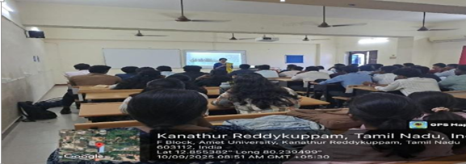 | 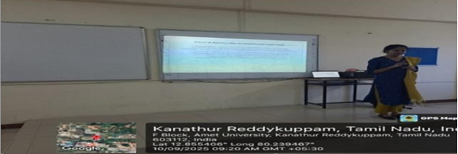
Guest Lecture on Your First step into Logistics (Insights from Expeditors) delivered by Mrs. Vallimuthu Asihwarya C., Senior Executive (Customs & Compliance), Expeditors on
10th September, 2025

Ms. Aishwarya delivered an insightful lecture on the logistics and supply chain industry. She explained core functions such as procurement, warehousing, transportation, customs clearance, and distribution. Key challenges discussed included high costs, regulatory hurdles, manpower shortages, sustainability, and cybersecurity. She emphasized the importance of compliance and documentation in global trade. Drawing from her experience at Expeditions, she highlighted accuracy, agility, and adaptability in operations. The session bridged theoretical knowledge with practical applications. She also guided students on developing skills in data analysis, Excel, and teamwork. Awareness of WMS, TMS, and ERP was encouraged to build strong career readiness.

Guest Lecture Organised by the Department
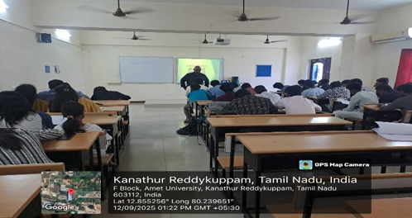 | 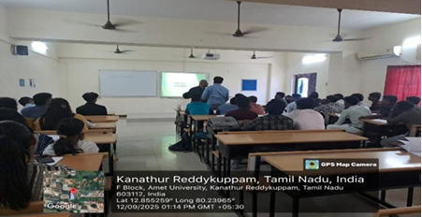
Guest Lecture on Cognitive Approaches to Effective Management in Logistics delivered by
Dr. M. Solomon, Consultant – Business Process Improvement, HR and Psychologists on
12th September, 2025

The session on goal setting highlighted goals as clear targets that provide direction, motivation, and purpose in life. A 24-hour time management wheel was introduced to help balance academics, personal care, rest, and family time effectively. Key skills for success such as stress tolerance, emotional stability, decision-making, problem-solving, communication, leadership, and resilience were emphasized. Students were guided to use the urgent–important matrix to focus on meaningful tasks while avoiding distractions. The SMART framework (Specific, Measurable, Attainable, Realistic, and Time-bound) was explained with practical examples like gaining knowledge and setting salary goals. The session concluded by stressing the need for balance across career, health, finance, relationships, and spirituality, providing a holistic roadmap to success.

Guest Lecture Organised by the Department
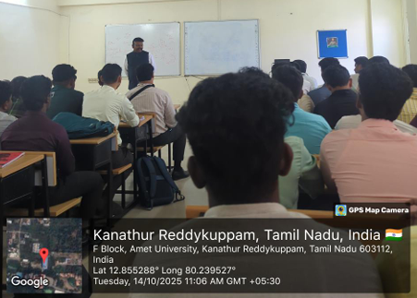 | 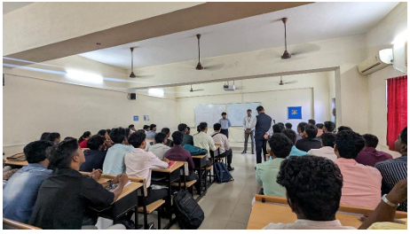
Guest Lecture on Key Pillars of Global Trade delivered by
Dr. Joshua Ebenezer,Expert - International Customs and Trade Laws, NuCov Facili-Trade, Mumbai on 14 Oct, 2025

A guest lecture on the topic “The Key Pillars of Global Trade” was organized to provide students with a comprehensive understanding of the fundamental aspects that drive international trade. The session was conducted by an eminent expert in the field of global business, who shared valuable insights on the principles, practices, and challenges involved in international trade operations. The lecture began with an overview of global trade and its importance in fostering economic growth, cultural exchange, and technological advancement. The speaker elaborated on the key pillars of global trade, namely market access, trade finance, logistics and supply chain management, regulatory compliance, and digital transformation.
Each pillar was explained with practical examples, highlighting how they contribute to the seamless movement of goods and services across borders. The session also addressed critical global trade issues such as tariff and non-tariff barriers, the impact of globalization, international trade agreements, and the role of institutions like the WTO in promoting fair trade practices. The guest emphasized the importance of innovation and sustainability in shaping future trade policies and encouraged students to develop analytical and strategic skills for careers in international business and trade management.
An interactive Q&A session followed, where students actively participated and gained clarity on various trade-related concepts. The lecture concluded with a vote of thanks, appreciating the guest’s efforts in sharing real-world knowledge and motivating students toward global trade opportunities.

WORKSHOP ORGANISED BY THE DEPARTMENT
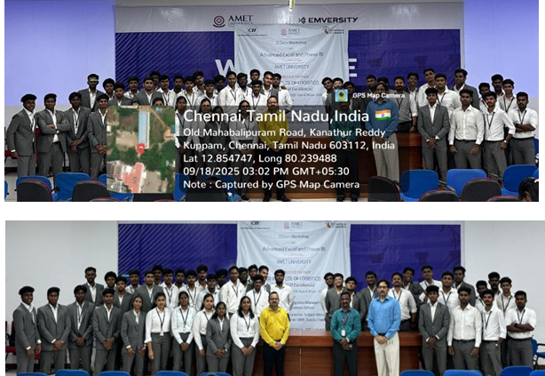
Three Days Workshop on Advanced Excel and Power BI from 16 to 18 September 2025
Mr. Anuj Kummar, Consultant and Corporate Trainer (AIML Supply Chain) CII – IL was the
Resource Person for the Workshop

A three-day workshop on Advanced Excel and Power BI was held on 16th–18th September at the Auditorium, led by Mr. Anuj Kumar. The first day focused on Advanced Excel, where participants learned advanced features such as text solver, location identification methods, and techniques for calculating arrows, gaining deeper insights into Excel’s analytical potential. The second and third days were dedicated to Power BI, covering its tools and options in detail. Participants practiced data cleaning, merging datasets, handling missing values, and creating impactful visualizations. The hands-on sessions provided clarity on converting raw data into meaningful dashboards. The workshop was conducted from 8:30 AM to 3:00 PM daily, ensuring an intensive learning experience. Interactive teaching methods kept the participants engaged throughout. The sessions enhanced technical skills in both Excel and Power BI. Participants gained practical exposure to industry-relevant tools. Overall, the workshop achieved its objective of strengthening data management and visualization proficiency.

