STUDENT’S ACHIEVEMENT OF SPORTS
State level Open Junior Kabaddi
The students of the Department of Commerce, AMET University, actively participated in the State Level Open Kabaddi Tournament organized by the Chengalpattu District Kabaddi Association on 15th and 16th January 2024.
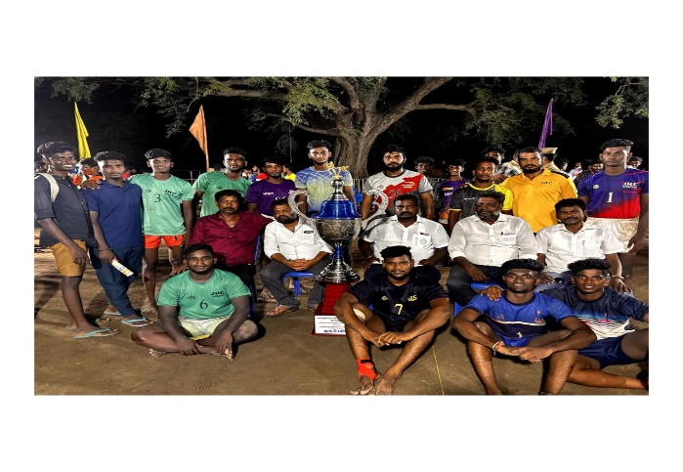 The tournament witnessed enthusiastic participation from various teams across the state, showcasing talent, sportsmanship, and competitive spirit. Representing AMET University, the Commerce Department team performed exceptionally well throughout the tournament and secured Second Place in this prestigious event. This achievement reflects the dedication, discipline, and team spirit of our students. The Department takes great pride in congratulating the entire Kabaddi team for their outstanding performance and contribution in bringing laurels to the institution. Such participation and recognition further strengthen the department’s commitment to holistic development, encouraging students to excel not only in academics but also in extracurricular activities.

State Level Open Kabaddi Tournament
The Department of Commerce, AMET University, proudly celebrates the outstanding achievements of its Kabaddi team in two prestigious tournaments held in March 2024.
On 2nd and 3rd March 2024, the team participated in the State Level Open Kabaddi Tournament organized by the Salem Kabaddi Association, where they showcased exceptional talent and teamwork, securing the First Place among several top teams from across Tamil Nadu.
 Following this remarkable success, the team also took part in the South India Level Open Kabaddi Tournament, competing against elite teams from multiple states across the southern region of the country. Their participation in this high-level tournament marks a significant milestone and reflects the growing excellence and competitive edge of the Commerce Department’s sports initiatives. These accomplishments are a testament to the dedication, discipline, and sporting spirit of our students. The Department extends its heartfelt congratulations to the entire team for their consistent efforts in bringing glory to AMET University.
Open State Level Public Kabaddi Tournament (Men)
2024 -25

The Department of Commerce, AMET University, proudly announces the participation of its students in the Open State Level Public Kabaddi Tournament (Men) 2023–24 organized by the Mayiladuthurai District Kabaddi Association.
- Name of the Tournament: Open State Level Public Kabaddi Tournament (Men) 2023–24
- Game: Kabaddi (Men)
- Organized by: Mayiladuthurai District Kabaddi Association
- Venue & Date: Mayiladuthurai, from 18.07.2024 to 20.07.2024
- YouTube link match Video https://www.youtube.com/live/bHj1QuHHN3M?si=QOm4YADSxXmTx3Lh

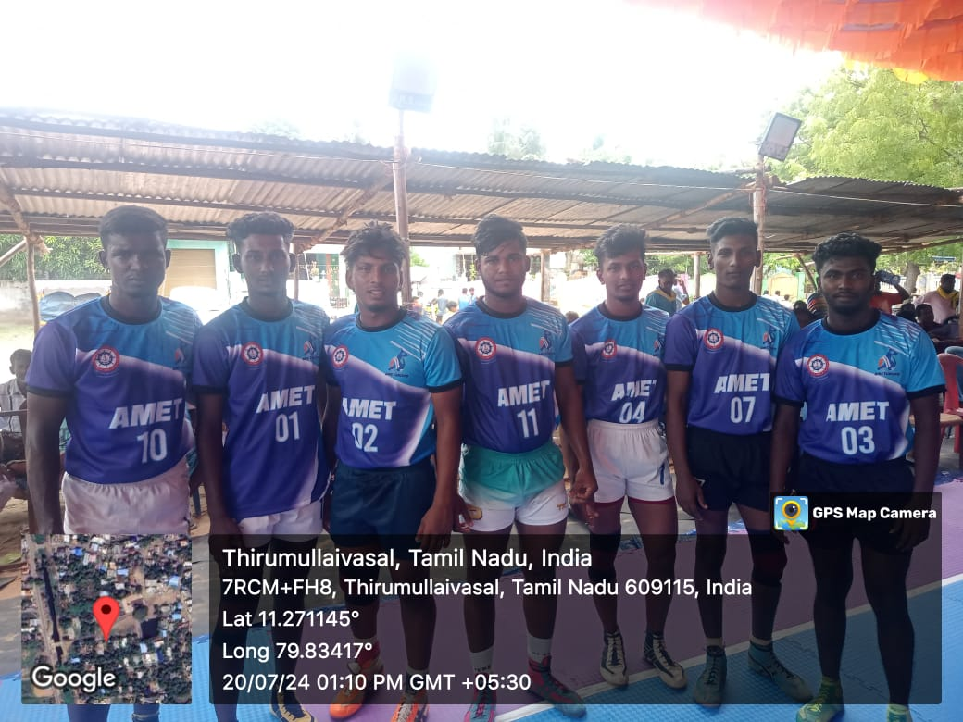
THENI DISTRICT. STATE LEVEL TOURNAMENT MATCH WINNER KABADDI (MEN) 2024 -25

The Department of Commerce, AMET University, is proud to announce the remarkable achievement of its students in the State Level Kabaddi Tournament (Men) held in Theni District on 11th June 2024. The event witnessed participation from numerous reputed teams across Tamil Nadu, showcasing high levels of skill, sportsmanship, and competitive spirit. Our students participated with exceptional energy, teamwork, and discipline, ultimately emerging as the Winners of the Tournament. Their victory is a testament to their dedication, rigorous practice, and the strong support provided by the university's sports department and faculty members.

Event Details
- Tournament Name: Theni District State Level Kabaddi Tournament (Men) 2024–25
- Organized by: Theni District Kabaddi Association
- Date: 11th June 2024
- Venue: Theni, Tamil Nadu
- Result: Winners – AMET University (Men)
