Evergreen voyager – Marine Department Magazine
Academic Year 2021-22 Even Semester Event Photos
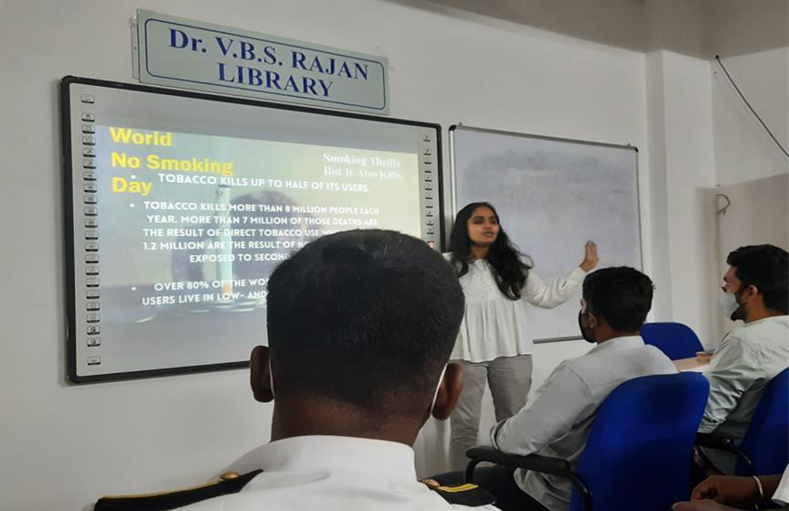

Observing with an awareness Programme on Ill effects of tobacco abuses and its consequences on 16.03.2022.

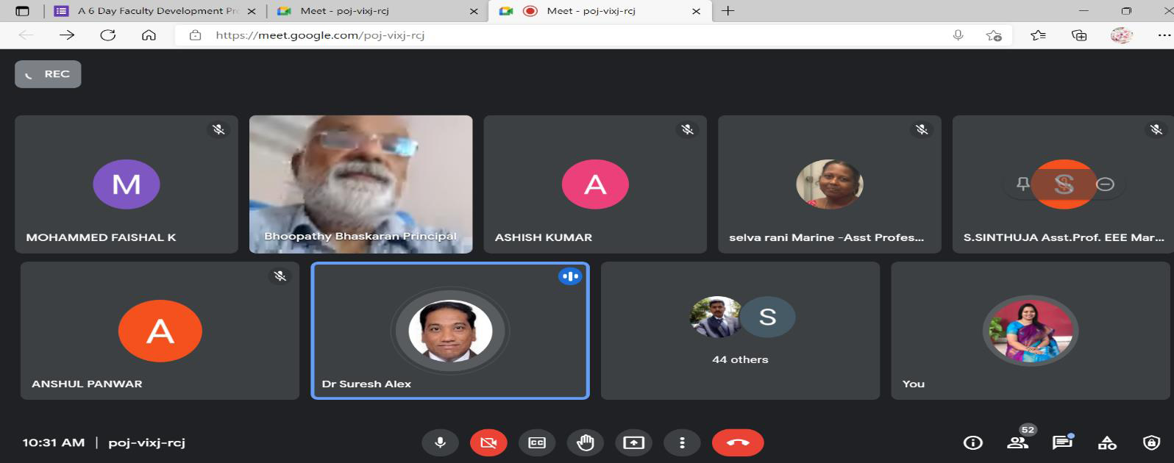

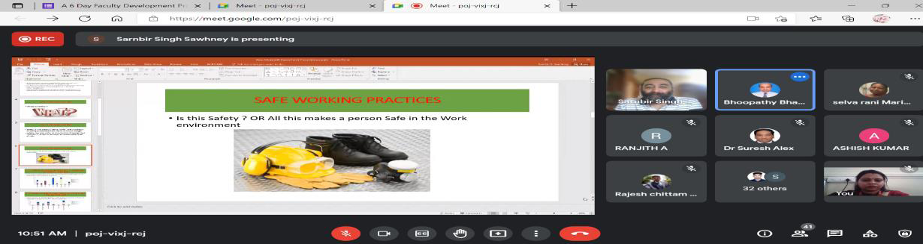

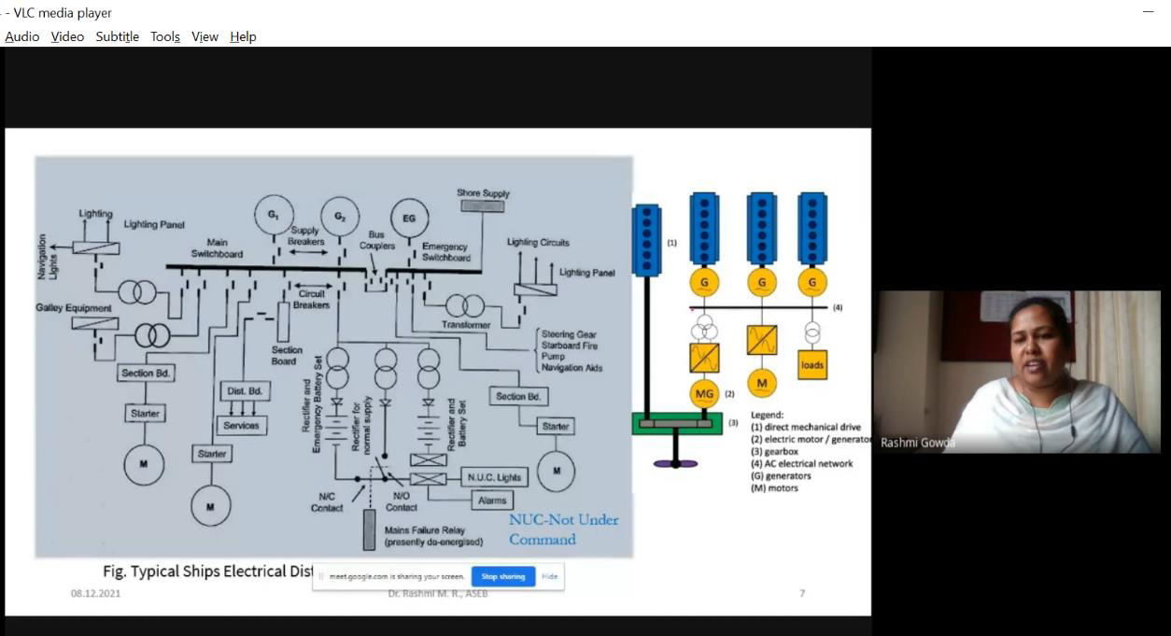

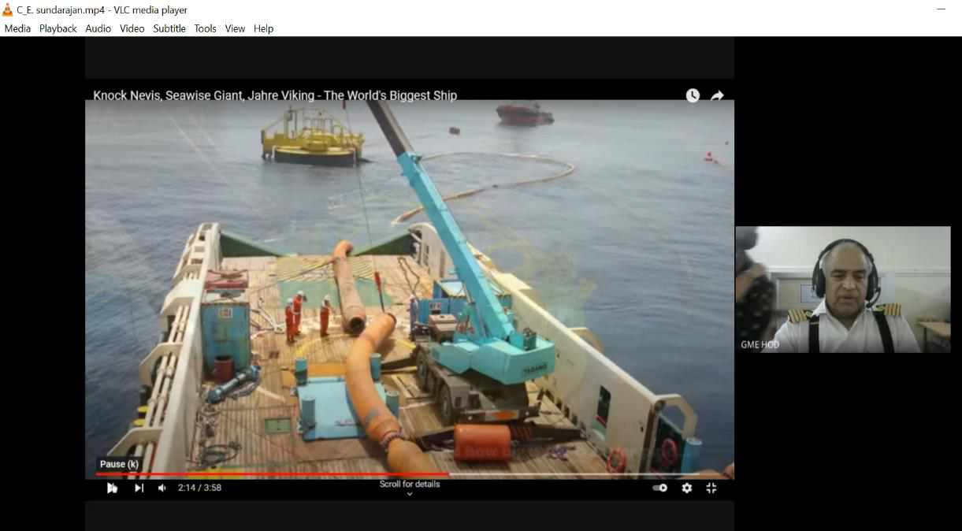
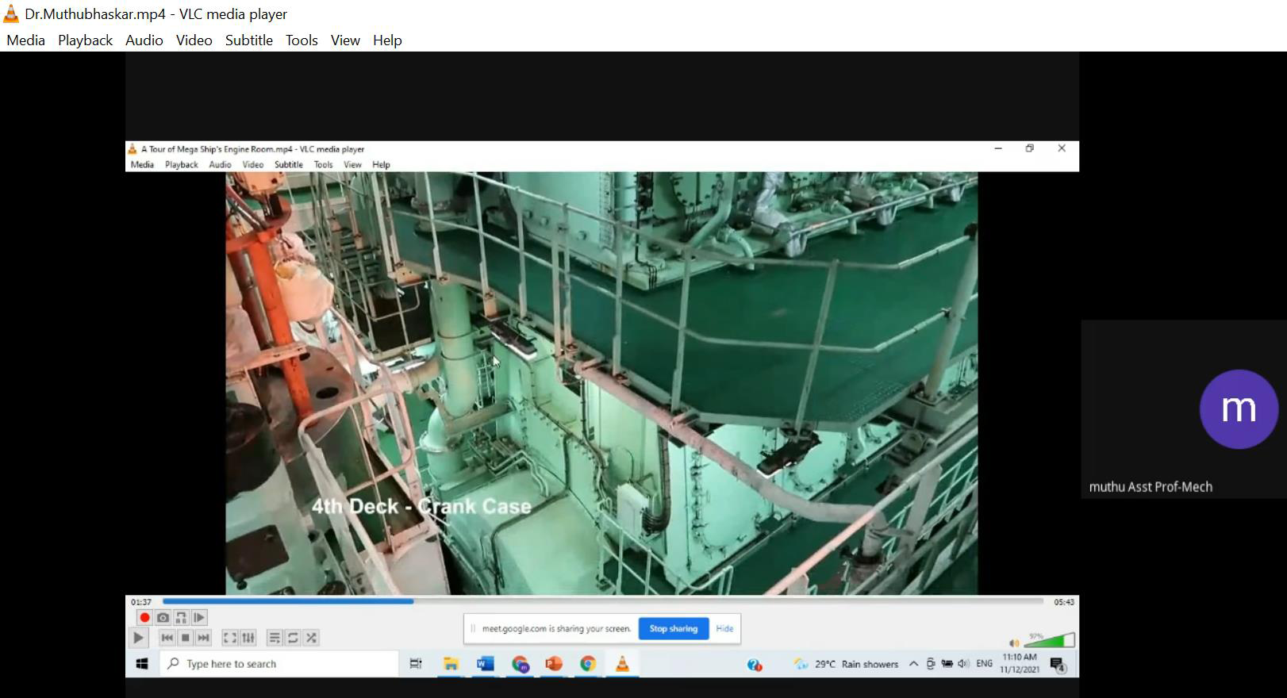
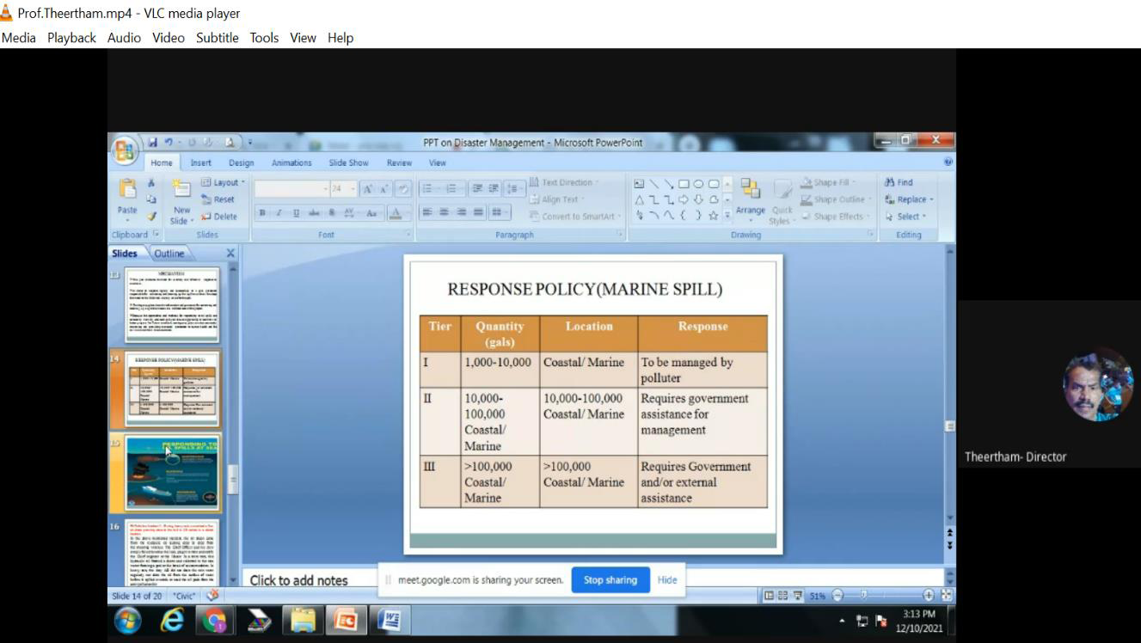
Faculty Development Programme on Safety Emergency Practices and Measures from 06.12.2021-11.12.2021 using google meet.

INTERNSHIP-HINDUSTAN SHIPYARD ON 16.05.2022 - 31.05.2022

Our Marine Cadets participated Holi Celebration

