Evergreen voyager – Marine Department Magazine
Academic Year 2021-22 Odd Semester Event Photos
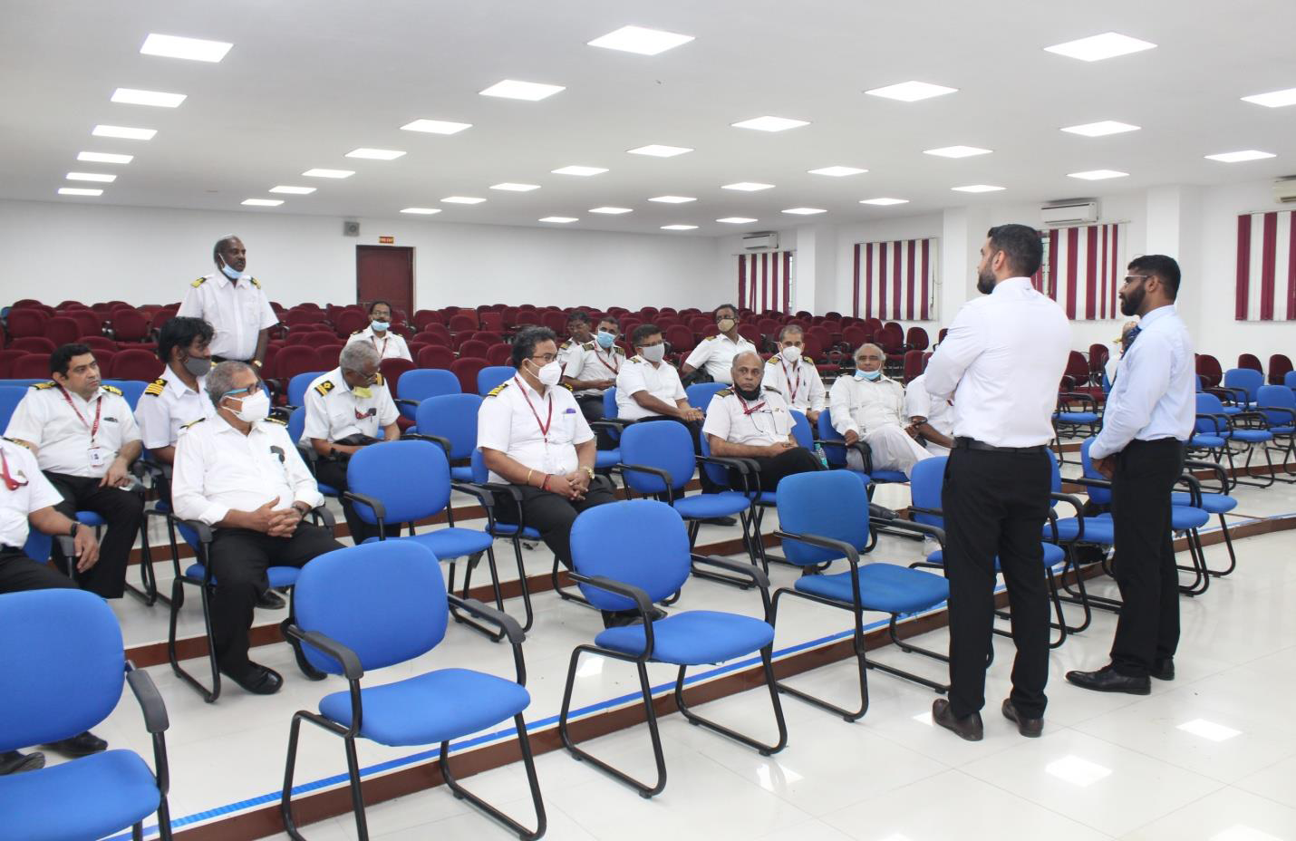
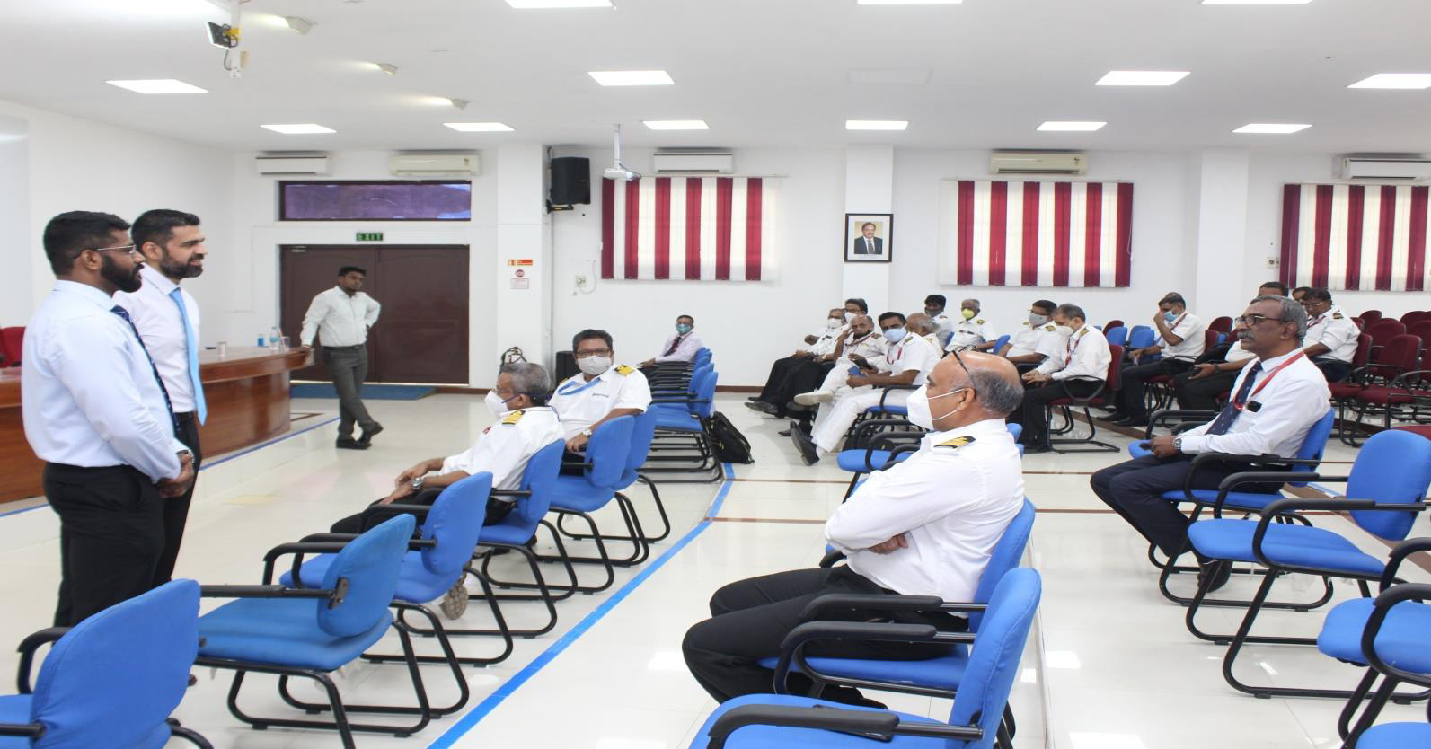
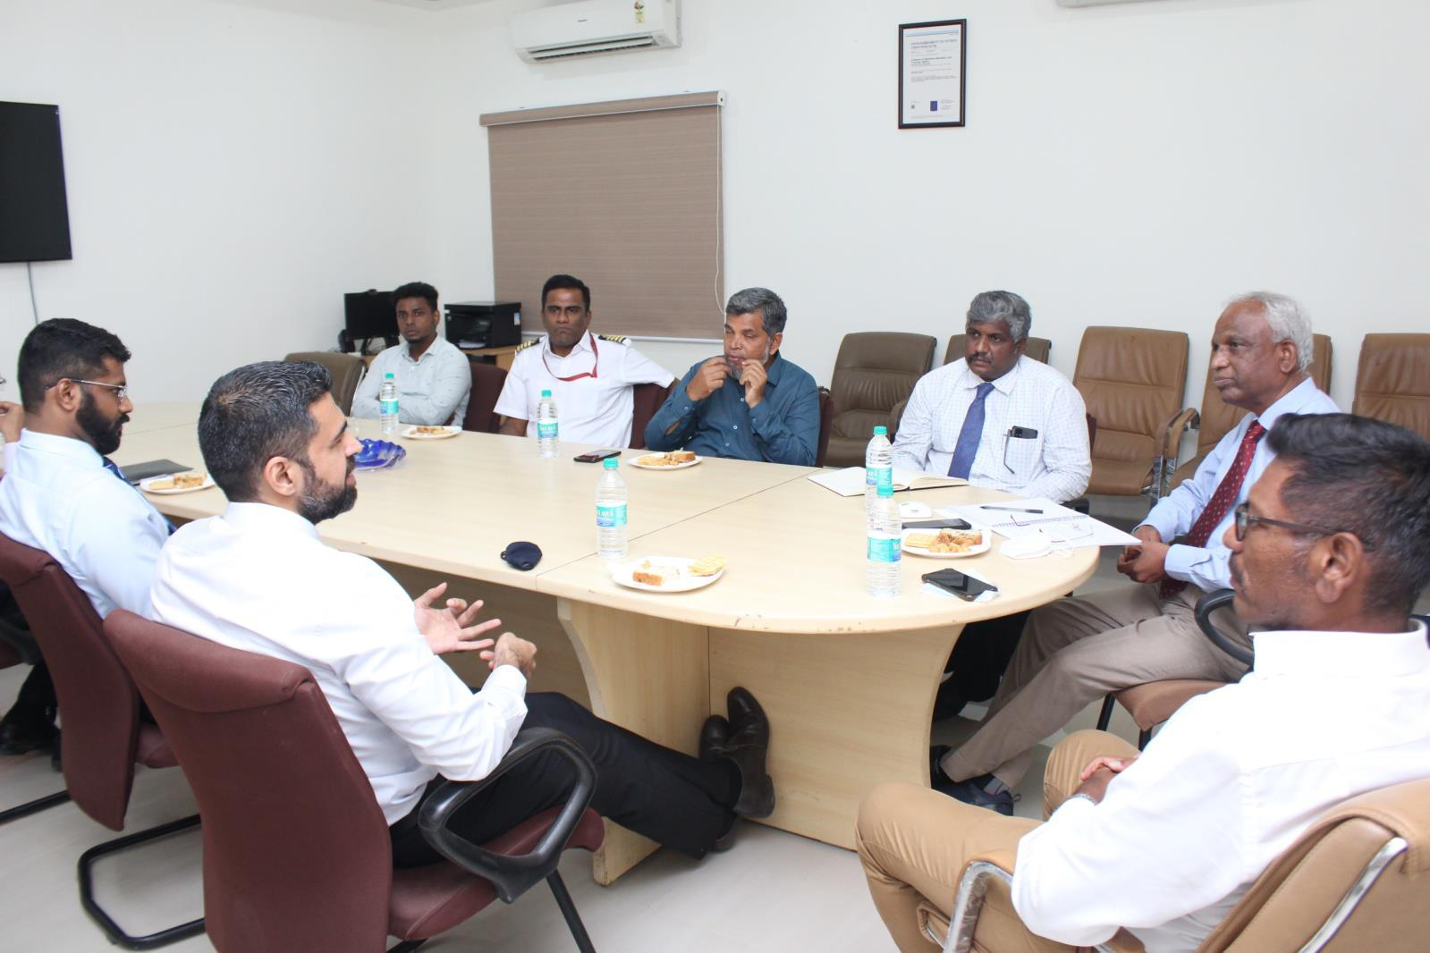
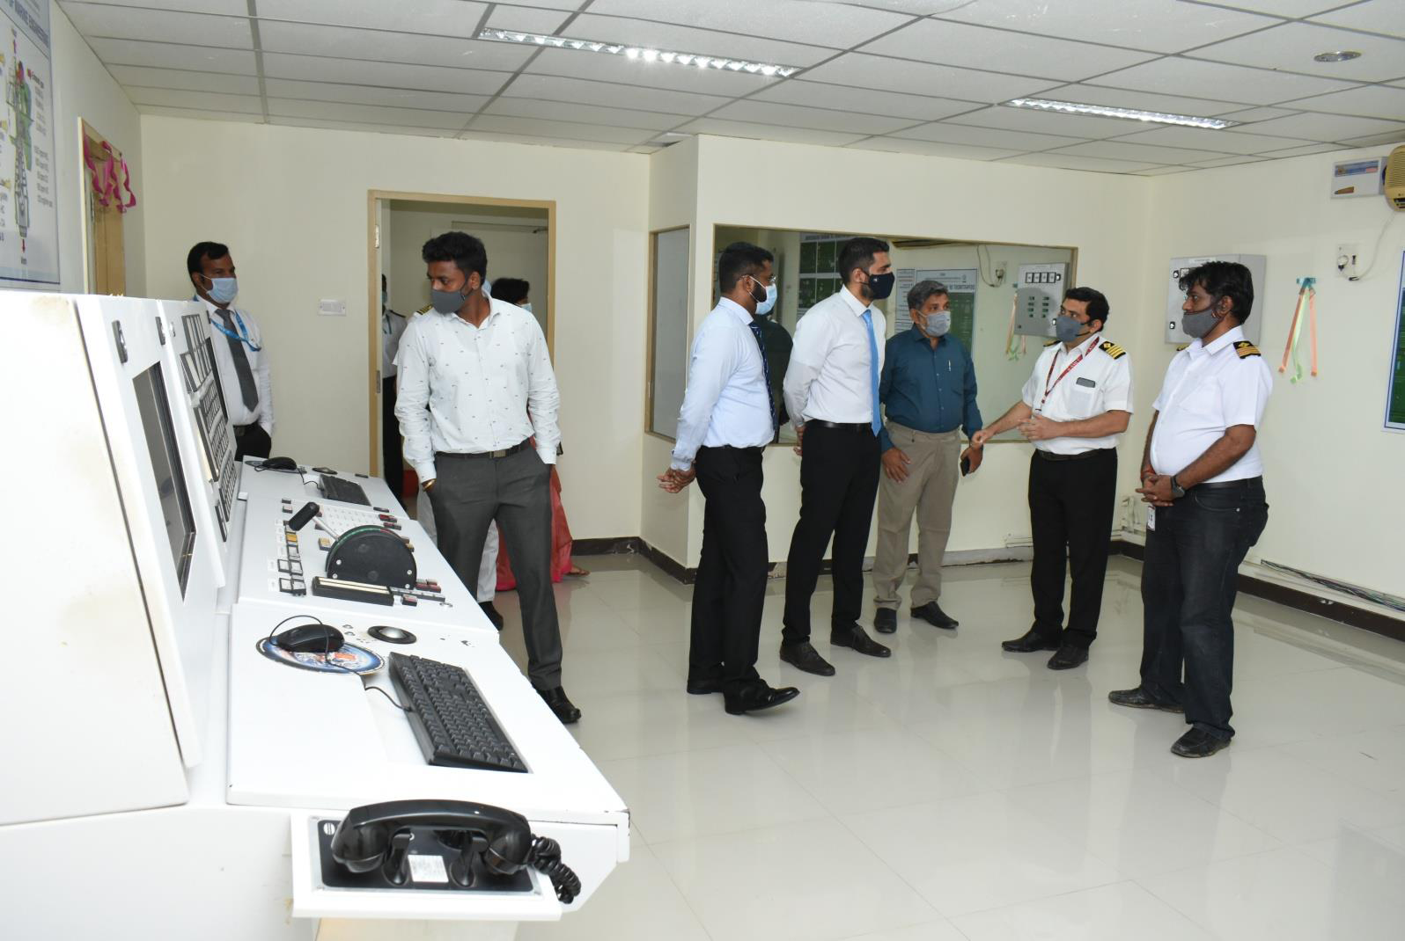
MARESK MEETING WITH CHIEF ENGINEERS 10.10.2021

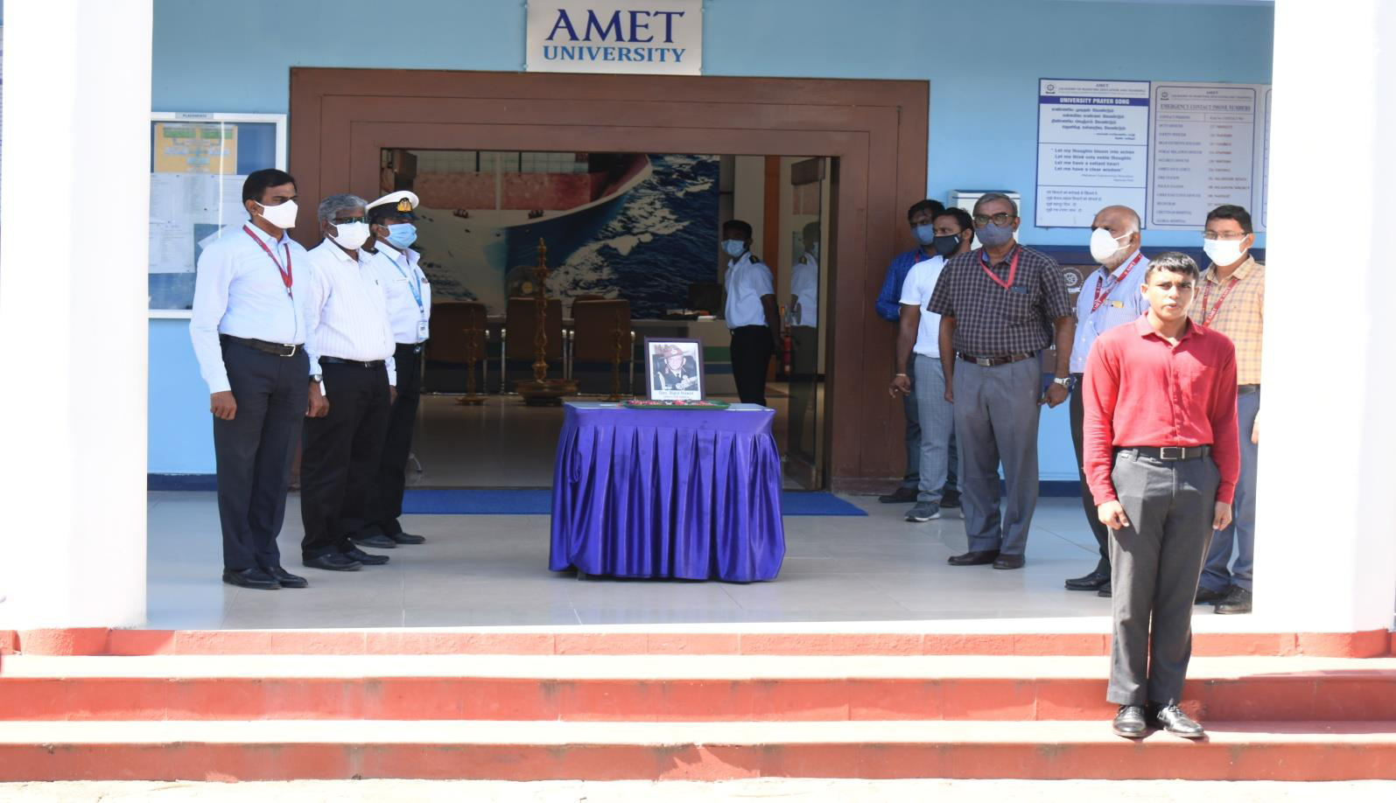
The Department of Marine Engineering, Academy of Maritime Education and Training, deemed to be University has organized GENERAL Bipin Laxman Singh Rawat condolence meeting at AMET Parade ground on 08.12.2021

The Department of Marine Engineering, Academy of Maritime Education and Training, deemed to be University has organized Beach cleaning at Kovalam beach on 16.12.2021.

