DEPARTMENT OF MARINE ENGINEERING
Establishment of “The Institution of Engineers (India)-AMET STUDENT CHAPTER”
12th April 2023
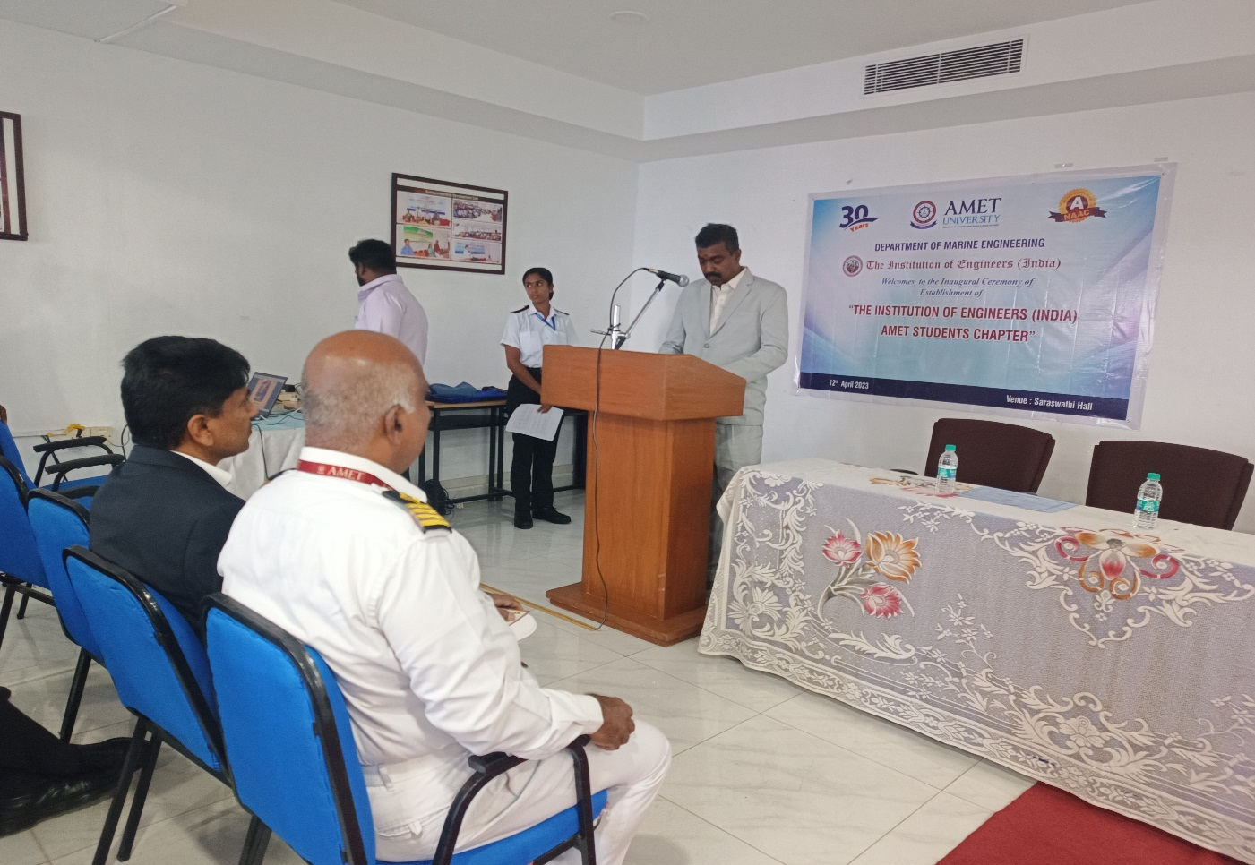
Chief Guest Mr. M.Shanmugasundaram (Chairman, IE(I), Kalpakkam Local Chapter) started his speech with the introduction of IE(I)

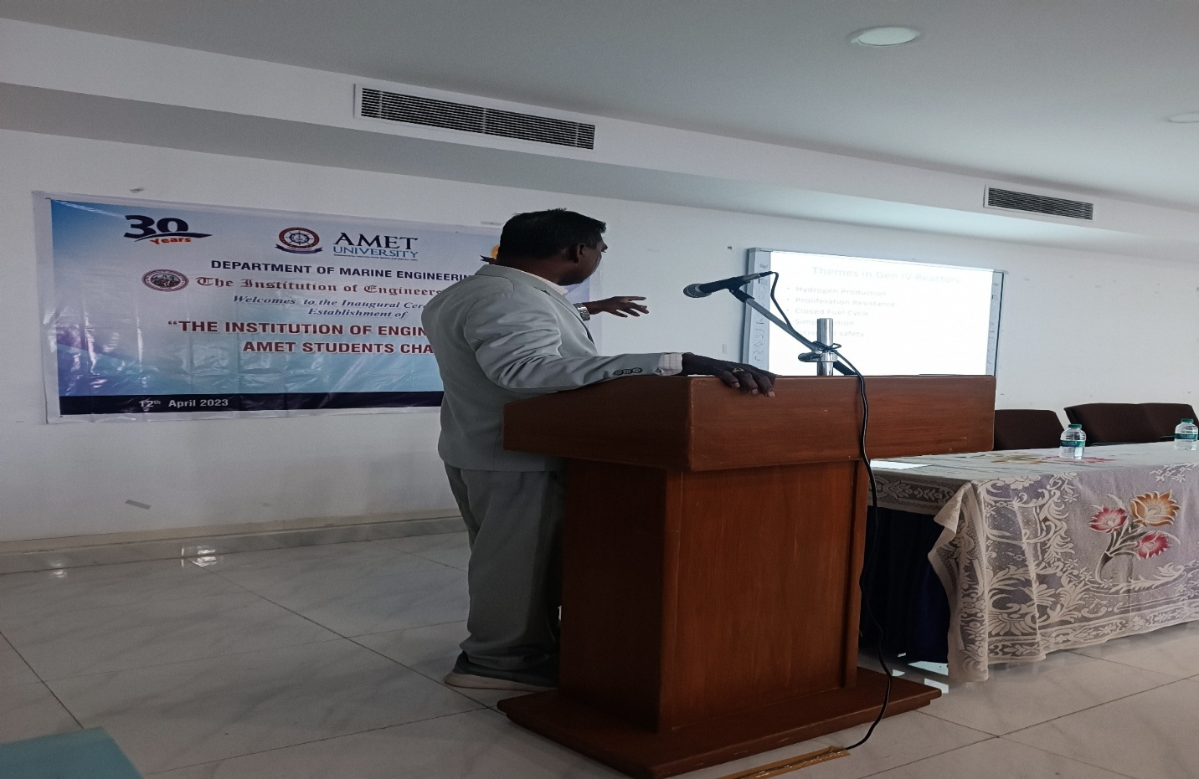
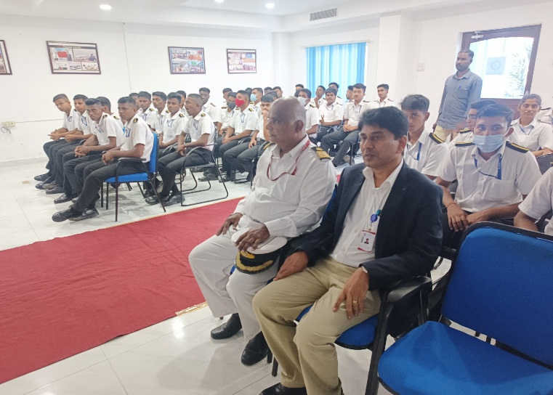 | 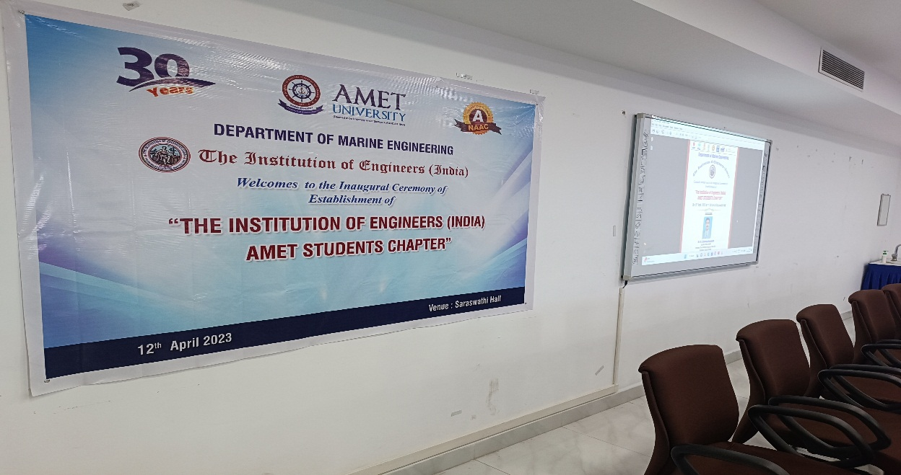
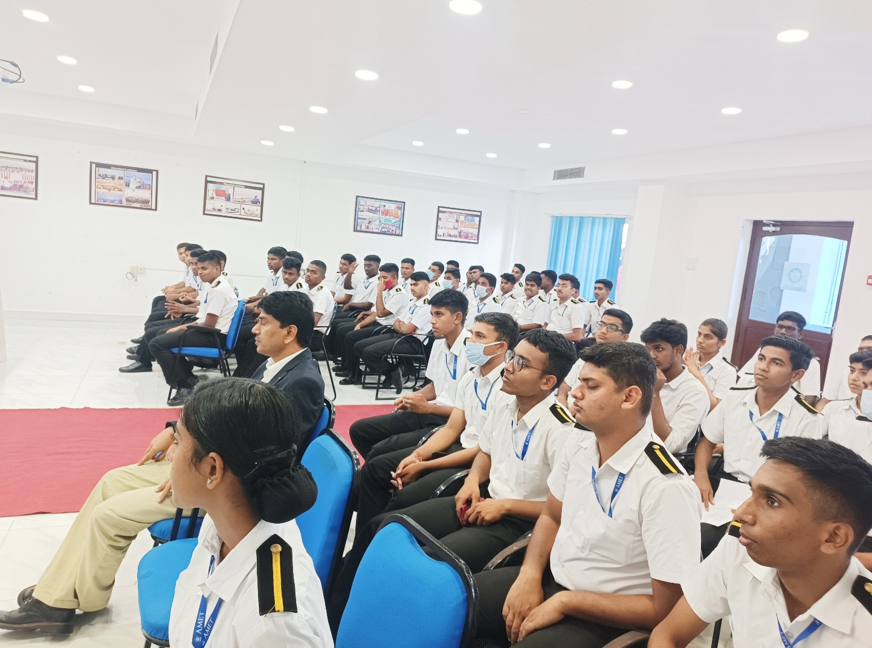
IEI Students Member

