MANDATORY INFORMATION ABOUT THE UNIVERSITY AND DEPARTMENTS-2025-26 ACADEMY OF MARITIME EDUCATION AND TRAINING (AMET)
(Declared as deemed to be University u/s 3 of UGC Act 1956)

Mandatory Disclosure | 2025-2026
AICTE File No | 1-44642541072
Last Approval Date | 25-04-2025
Name of the Institute | ACADEMY OF MARITIME EDUCATION AND TRAINING  (AMET) Deemed to be University
Address | #135, East Coast Road Kanathur, Chennai, Tamil Nadu
Pin Code | 603112
Longitude and Latitude | 12.5942° N; 80.2354° E
Longitude and Latitude | 12.5942° N; 80.2354° E
Institution e-mail address | office@ametuniv.ac.in
Contact Nos. | 044- 2744 4625/ 627/628
Latest UGC Approval | F.No.6-28/2005 (CPP-I/DU) : Dated 02nd April 2018
AICTE Approval Reference | Southern/1-36211439928/2023/EOA, Dated: 10-06-2023
DGS Approval Reference No: | 288426-2019-AQ-IND-UKAS dated 29th May 2022
Name of the Head of the Institution: | Prof.Dr.V.Rajendran Vice Chancellor
Tel. No. with STD Code: | 044-27444629 ; Extn 501
Mobile: | 9994137373
E Mail | vc@ametuniv.ac.in
Registrar | Dr. Sangeetha Albin
Tel.No. with STD code | 044-2744 4625 Extn. No. 107
E Mail ID | registrar@ametuniv.ac.in
Mobile No | 9962603081
Principal | Dr.T.Sasilatha, B.E., M.E., Ph.D.,
Tel No. with STD
E Mail | principalgp@ametuniv.ac.in
Mobile | +91 94447 52994
AISHE Code | U-0434
NIRF Code | Engineering: Institute ID: IR-E-U-0434  Management: Institute ID: IR-M-U-0434  General: Institute ID: IR-O-U-0434
NAAC Track ID (For ex. MHCOGN 18879) | TNUNGN11431
NAAC Executive Committee No. & Date: | EC/82/A&A- DATED SEPTEMBER 13, 2021
Website address: | https://www.ametuniv.ac.in
NAAC Accreditation Details | Cycle Grade CGPA Year of Accreditation Validity Period  2nd Cycle A 3.13 2021 September 12, 2026
Other credentials | - First Deemed to be University in India in Maritime Education  - Grade A1 Outstanding, the highest grade in Comprehensive Inspection Programme of the Directorate General of Shipping (DGS) continuously for the past FIVE years. Certified by DNV-GL [(Det Norske Veritas (Norway) – Germanischer International acclaimed Accreditation and Certification body.  - Secured FIFTH rank in overall (TOP SEVEN among Maritime Universities in the World) and SECOND rank in Research in the PIMET Ranking (Performance Indicators in Maritime Education and Training) by International Association of Maritime Universities (IAMU), Japan.  - Secured NIRF Ranking in the band of 250- 300 in the year 2021.  - B.E Mechanical Engineering, B.E Electrical and Electronics Engineering (Marine) and M.B.A Shipping and Logistics Management has been accredited by National Board of Accreditation (NBA) in the year 2021 for 3 years.  - ATAL Ranking of Institutions on Innovation Achievement (ARIIA): AMET is categorized as 'Band B' institution (rank between 26-50) in category of 'University & Deemed to be University (Private-Self- Financed)' in Atal Ranking of Institutions on Innovation Achievement (ARIIA) 2020 announced on 18th August 2020.  - AMET adopted International Standards in Curriculum as directed by the International Maritime Organization (IMO), United Kingdom, a United Nation’s Agency to govern Maritime Education in Maritime Universities in the World.  - Contributing Human Resource Development both Nationally and Internationally and for the development of National and International Economy by producing more than 15000 graduates of whom 90% are working as Captains, Chief Engineers in Ships and executives in Shipping and Allied Industries all over the World certification Body.

VISION
- To sustain identity as a World Class Leader in Maritime Education and empower learners with wholesome knowledge through progressive innovation in training, research and development which will render students a unique learning experience and a transformation impact on the Global Society.
MISSION
AMET will strive continuously to
- Impart value-based higher education and technical knowledge with uncompromising strides of an outstanding quality.
- Emerge as a Centre of Excellence inculcating skill development in recent technologies in accordance with industrial trends.
- Create World class research capabilities on par with the finest in the world and broaden student's horizons beyond classroom education.
- Nurture talent and entrepreneurship to enable all round personality development among students.
- Empower students across socio economic strata.
- Make a positive difference to society through technical education.
QUALITY POLICY
AMET is committed to provide the highest quality in education and be the most preferred institution for pursuing marine and marine related courses.
This will be achieved by consistent focus on:
- Providing a conducive, vibrant, progressive and enriching learning atmosphere.
- Teaching Excellence and Research Output.
- Global outlook and engaging with the world through learning, teaching and research.
- Providing competitive advantage in gaining employment for further academic opportunities.
- Maintaining excellent links with commerce and industry both national and international.
- Complying with all applicable requirements and continually improving the effectiveness of Quality Management System.
EXECUTIVE SUMMARY
The Academy of Maritime Education and Training (AMET) was established as a maritime academy with an enrolment of 14 cadets on 15th February 1993. Indeed, AMET was established by Dr J Ramachandran, a distinguished philanthropist, pioneering marine entrepreneur and founder of NAESEY (New Era Association of Educated Self Employed Youth). On 21stAugust 2007, the Ministry of Human Resources and Development, Government of India notified through Gazette of India, the Deemed to be University status to AMET under section 3 of UGC Act 1956 in de novo category. AMET has emerged as India’s first Deemed to be University in maritime education and continue as the only private maritime University recognized by University Grants Commission and the only member of International Association of Maritime Universities, in India. University firmly follows the norms and guidelines of the regulatory bodies concerned, University Grants Commission (UGC), All India Council for Technical Education (ACITE) and Directorate General of Shipping (DGS), Government of India. The University has been accredited by National Assessment and Accreditation Council with A Grade during 2021 which is valid upto 2026. AMET has been inspected by the Directorate General of Shipping through its Comprehensive Inspection Programme and was awarded with Grade A1 Outstanding for the past FIVE years continuously. All the technical programmes offered by the University are approved by the AICTE.
AMET started imparting training to candidates interested in becoming qualified maritime professionals. AMET has transformed the maritime education by augmenting the skill based domain into knowledge based domain by offering structured and innovative degree programmes. It has established and ultimately won a very high reputation in the International Maritime sector with a natural progression of becoming a Maritime University, the first of its kind to build up the indigenous knowledge base in maritime sector. As maritime education sector is vibrant there was a huge demand for admission to the various programs. The University is ever willing to accommodate the global changes required in the curriculum to provide experiential education to enable the students to be readily employable. The University has created exclusive infrastructure facilities such as Ship in Campus, Full Mission Ship Simulator, Unique laboratories like ‘Seamanship Lab’, ‘Navigational Lab’, ‘Fire Prevention & Control Lab’, ‘High Voltage lab’, expensive design software like ‘TRIBON, MIKE21’. In the long journey of over 30 years in Maritime Education, AMET University has always responded to all its stakeholders with respect and responsibility.
AMET works closely and cohesively with the global shipping industry and aligns its objectives regularly to suit the demands of the evolution in technology. With a consistent placement record AMET has been recognized as a premier institution for marine and marine related jobs and has earned a position as a trustworthy consultant for research and development projects wherein the investment is worth to the tune of several crores of rupees. Adducing to these achievements are the awards and accolades garnered by AMET for a range of activities in pursuit of excellence over the last two decades in maritime education, training, research and development. AMET has a very ambitious vision 2025 plan wherein it aims to be a KNOWLEDGE HUB for maritime studies and activities happening around the world. With a synergistic attitude prevailing among management, staff and student, AMET is all set to achieve and sustain a status par excellence.

EXECUTIVE COUNCIL

Sl. No | Members of the Executive Council | Designation
1 | Prof. Dr. V. Rajendran | Chairperson
2 | Dr. S. Ramachandra Setty, Department of Pharmacology, Government College of Pharmacy  Bangalore | UGC Nominee member
3 | Col.Dr. G. Thiruvasagam Former Vice Chancellor  AMET University, University of Madras, Bharathiar University | Eminent Academician  Member
4 | Capt. G. Ramaswamy, Founder and Head, Njorships Management Indian Pvt., Ltd, Chennai | Nominee of the Trust  Member
5 | Dr. T. Balasubramanian, Former Vice Chancellor  Chettinad Academy of Research and Education | Eminent Academician  Member
6 | Dr. R. Venkatesan, Scientist G and Progarmme Director, National Institute of Ocean Technology  Chennai | Eminent Academician  Member
7 | Capt. Gopal Srinivas, Principal DGS Courses | Member
8 | Dr. N.R. Ramkumar Director Physical Education | Member
9 | Dr. J. Rengamani, Professor and Director CDOE | Member
10 | Dr. K. Gayathri, Associate Professor, Dept. of Physics | Member
11 | Sub. Lt. A. Prem Anand, Assistant Professor, Dept. of NA & OE | Member
12 | Dr. V. Sangeetha Albin Registrar i/c | Ex. Officio Secretary

ANTI-RAGGING COMMITTEE
APPOINTMENT OF ANTI RAGGING COMMITTEE

The following faculty members, students and other persons from outside the University are appointed as members of the reconstitute and Anti-Ragging Committee for the Academic year 2025-26. They will carry out duties like solving Ragging Complaints expressed by the student and faculties on the campus in person, in writing or online.

Sl no | Name | Designation and Department | Phone | Role of committee
1 | Prof. Dr. V. Rajendran | Vice- Chancellor | 9994137373 | Chairperson
2 | Dr. Sangeetha Albin | Registrar i/c | 9962603081 | Member
3 | Capt. Gopal Srinivas | Principal DGS Courses | 9003071866 | Member
4 | Dr. S. Ramalingam | Professor & Head  Dept. of Mechanical Engineering  Dean- Students Welfare | 9444660285 | Member
5 | Mr. Mahesh Henry | Advocate | 9444319991 | Member
6 | Mr. Murugan | Inspector of Police  Kanathur Police Station | 9443265168 | Member
7 | Ms. Sandhya Rani Ramdass | Lady Member of NGO and Physcologist | 9840982160 | Member
8 | Mr. Dilli Ganesh | Media Person | 9003135791 | Member
9 | Mr. Varghese Mathew | Proctor | 9072469094 | Member
10 | Dr. K. Gayathri | Associate Professor  Dept. of Physics | 9789933245 | Member
11 | Mr. Prem Anandh | Asst. NCC Officer & Faculty Warden | 9003360606 | Member
12 | Mr. Asokan | Security Advisor | 7092222220 | Member
13 | Cdr. Mirdu Prayah | BE Marine Engg 4th Year | 6003140296 | Member
14 | M. Maria Roshan | BE EEE 4th year | 6381276082 | Member
15 | Cdt. Jeffrin Johnson | BSc Nautical Science 1st year | 9074569982 | Member
Roles and Responsibilities:

- Prevention of Ragging:
- Ensure that ragging in any form (physical, verbal, psychological or online) does not occur on campus.
- Promote a safe, respectful and inclusive environment for all students, especially new comers.

- Awareness and Sensitization
Conduct orientation programs, workshops, and seminars to educate students about:
- What constitutes ragging
- Legal consequences of ragging
- Students rights and responsibilities

- Monitoring and Vigilance
- Keep strict watch in hostels, classrooms, corridors, playgrounds, and common areas
- Coordinate with wardens, teachers, and security staff to identify risk areas and times.

- Receiving complaints
- Provide accessible and confidential channels for students to report ragging incidents.
- Encourage victims and witness to report without fear of retaliation

- Inquiry and Investigation:
- Promptly investigate reported cases of ragging in a fair an unbiased manner.
- Record statements from victims, witnesses and accused students.

- Taking Disciplinary action
- Recommended to enforce appropriate disciplinary measures against those found guilty, as per institutional rules and UGC/education board guidelines.
- Actions may include warnings, suspension, expulsion or reporting to legal authorities if required.

- Support to Victims
- Provide Emotional support and counselling to affected students.
- Ensure the safety and well-being of victims during and after the inquiry process.

- Coordination with Authorities
- Liaise with parents, local police, and higher education authorities when necessary.
- Ensure compliance with national anti-ragging laws and regulations.
- Regular review and reporting
- Periodic review the effectiveness of anti-ragging measures.
- Maintain records of compliance actions taken and preventive initiatives.

ANTI-RAGGING SQUAD
APPOINTMENT OF ANTI-DRUGS COMMITTEE
The following faculty members and outside member, are reconstitute and appointed as members of the Anti-Drugs Committee for the Academic year 2025-26. The committee remains essential in promoting student well-being, preventing drug misuse, and ensuring a secure and drug-free learning environment.
Sl.No | Name | Designation and Department | Portfolio | Mobile No
 | Dr.S.Ramalingam, | Professor & Head  Dept. of Mechanical Engineering  Dean- Students Welfare | Nodal Officer | 9444660285
 | Capt. Gopal Srinivas | Principal - DGS Programs | Member | 9003071866
 | Dr.T.Sasilatha | Principal General Programmes | Member | 9444752994
 | Sub. Lt. A. Prem Anandh | Associate (Dean – Administration) & NCC Officer | Member | 9003360606
 | Dr.G.Jenitha | Associate Professor Department of Mathematics  Associate (Dean - Student Welfare) | Member | 9842307816
 | Dr.V.T.Vimalananth | Associate (Dean - Student Welfare) | Member | 8148388360
 | Dr. Anita Rexalin Devaraj | Associate Professor Department of Physics | Member | 9025958564
 | Dr.C.Amirthakumar | Asst. Professor, Department of Physics | Committee Faculty Coordinator | 8678925122
 | Mrs.T.Magudeeswari | Inspector of Police, J12 Kanathur Police Station, Greater Chennai Police - South Zone - Adyar Police District - Neelangarai Range | Member | 9840499569
 | Mr. Rajasekar.G | ASO | Member | 9344003953
 | Mr. Mathew Varghese | Proctor | Member | 9072469094
AMET ANTI –DRUG COMMITTEE
Sl. No | Name | Department | POST | PHONE NUMBER
1 | Karuppannaswam Y | BSC NS-3rd Year | President | +91 88071 95685
2 | Kathir V | BE Naval Architecture-3rd Year | Vice President | +91 89254 87835
3 | Deekshai | BE Naval Architecture-3rd Year | Secretary | +91 81226 06938
4 | Sandra Saji | BSC NS-3rd Year | Joint Secretary | +91 88914 31231
5 | Mohandass | BSC NS-3rd Year | Anti-Drugs-Squad | +91 72996 86572
6 | Mishael Daniel | BSC N-3rd Year | Anti-Drugs-Squad | +91 63800 55714
7 | Atheedh A | BSC NS-3rd Year | Executive Member | +91 81290 61251
8 | Abdulla Adinan S | BE Marine Engineering -4th Year | Executive Member | +91 80989 50160
9 | Prathamesh Dadsaheb Bhandari | BE Marine Engineering -4th Year | Executive Member | +91 96298 36490
10 | Kassim Arshath Hussain A | BE Marine Engineering -4th Year | Executive Member | +91 82708 39048
11 | Lakshiythen P S | BSC NS-3rd Year | Executive Member | +91 93440 77647
12 | Kirubakaran B | EEE-4th Year | Executive Member | +91 88380 25224

Key Responsibilities of the Anti-Drugs Committee
- Promote Awareness: Conduct awareness programs on the dangers of drug abuse through seminars, posters, and campaigns.
- Monitor Campus Environment: Keep continuous vigilance to detect and prevent any drug-related activities within the campus.
- Provide Support & Counselling: Offer guidance, counselling, and referral services to students’ affected by or vulnerable to substance abuse.
- Coordinate with External Agencies: Work closely with local authorities, healthcare professionals, and NGOs to reinforce anti-drug initiatives.
- Enforce Institutional Policies: Implement and ensure strict adherence to the institution's anti-drug rules and recommend disciplinary actions when necessary.
- With the collective efforts of the committee members, we are confident that we can promote a campus environment free from drug abuse and substance-related issues. In this regard, I respectfully seek your kind approval for the reconstitution of the Anti-Drugs Committee for the academic year 2025–2026.
With the collective efforts of the committee members, we are confident that we can promote a campus environment free from drug abuse and substance-related issues. In this regard, I respectfully seek your kind approval for the reconstitution of the Anti-Drugs Committee for the academic year 2025–2026.

ACADEMIC COUNCIL

List of Members of the Academic Council 2025-26
S.No. | Name of the Member | Designation | Email Id
The Vice Chancellor as Chairperson
I | Prof.Dr.V.Rajendran  (Chairman) | Vice-Chancellor | vc@ametuniv.ac.in
The Registrar, as the Secretary of the Academic Council
II | Dr. V. Sangeetha Albin  (Secretary) | Registrar | registrar@ametuniv.ac.in
III. Principal/ Dean(S) / Director of Faculty
 | Capt.Gopal Srinivas | Principal, DGS Courses | principal@ametuniv.ac.in
 | Capt.K.Karthik | Principal, AMET Institute of Science and Technology | karthik.k@ametuniv.ac.in
 | Dr.T.Sasilatha | Principal – General Programmes | principalgp@ametuniv.ac.in
 | Dr.M.Jayaprakashvel | Special Officer & IQAC Coordinator | iqac@ametuniv.ac.in
 | Dr.A.Rajesh Kanna | Controller of Examinations | coe@ametuniv.ac.in
 | Dr.S.Priya | Dean - Academics | deanacd@ametuniv.ac.in
 | Dr.R.Muthezhilan | Dean - Research and Development | deanrnd@ametuniv.ac.in
 | Dr. A.Thanikasalam | Dean - Administration | deanadm@ametuniv.ac.in
 | Dr.S.Ramalingam | Dean - Students Welfare | deanstw@ametuniv.ac.in
 | Dr.D.Madhesh | Dean - Staff Welfare | deanstfw@ametuniv.ac.in
 | Dr.S.Bharathi Raja | Dean, Faculty of Engineering and Technology | deanet@ametuniv.ac.in
 | Dr.Anita R Warrier | Dean (i/c), Faculty of Science and Humanities | deansh@ametuniv.ac.in
 | Dr.J.Rengamani | Director - AMET Centre for Distance and Online Education | rengamani.j@ametuniv.ac.in
 | Dr. R.Karthikeyan | Director, AMET Institute of Science and Technology | r.karthi1968@ametuniv.ac.in
 | Dr.K.Gayathri | Director – Research Publications Incentives | gayathri.k@ametuniv.ac.in
IV. Heads of the Departments
 | Capt.P.Rajendran | Nautical Science | rajendran.p@ametuniv.ac.in
 | C/E. M.Muthu Kumar | Marine Engineering | muthuganga@ametuniv.ac.in
 | Dr.P.Sivabalan | Naval Architecture and Offshore Engineering | hodna@ametuniv.ac.in
 | Dr.R.Srinivasan | AMET Business School | hodabs@ametuniv.ac.in
 | Dr. C.M.Ramakritinan | Marine Biotechnology | hodmbt@ametuniv.ac.in
 | Dr.V.Sridevi | Electrical and Electronics Engineering | hodeee@ametuniv.ac.in
 | Dr. S.Ponmani, (i/c) | Mining Engineering | hodmin@ametuniv.ac.in
 | Dr. V.Amirthavalli | Petroleum Engineering | amirthavalli.v@ametuniv.ac.in
 | Dr.John Wyson | Food Processing Technology | hodfpt@ametuniv.ac.in
 | Dr.S.Subramaniyan | Maritime Commerce | hodcommerce@ametuniv.ac.in
 | Dr.D.Sivakumar | Computer Science and Engineering | hodcse@ametuniv.ac.in
 | Mr.P.Karthik | Advanced Computer Science | hodacs@ametuniv.ac.in
 | Dr. I. Paul raj | Aviation | hodavi@ametuniv.ac.in
 | Mr.Antony Gomez | Pre-Sea Modular Courses | stcw12course@gmail.com
 | Dr.P.Balaganesan | Mathematics | hodmaths@ametuniv.ac.in
 | Dr.C.Vairavan | English | hodenglish@ametuniv.ac.in
 | Dr.D.Arivazhagan | Director, E-Governance | prof.arivazhagan@ametuniv.ac.in
 | Dr.K.Sekar | Librarian | sekar@ametuniv.ac.in
 | Mr.P.Ramanathan | Additional Controller of Examinations | addl.coe@ametuniv.ac.in
V. Professors other than the Heads of the Departments (By Rotation of Seniority)
 | Dr.A.Shameem | AMET Business School | drshameem@ametuniv.ac.in
 | Dr.D.Lakshmi | EEE | lakshmi.d@ametuniv.ac.in
 | Dr.J.Ananth | Marine Engineering | jambuananth@ametuniv.ac.in
 | Dr.C.N.Ravi | Computer Science and Engineering | sivakumar.d@ametuniv.ac.in
VI. Two Associate Professors from the Departments other than the Heads of the Departments by Rotation of Seniority
1 | Capt.R.K.Kumar | Nautical Science | captrkkumar@ametuniv.ac.in
2 | Dr.R.Elavarasi | Electrical and Electronics Engineering | elavarasi.r@ametuniv.ac.in
VII. Two Assistant Professors from the Departments by Rotation of Seniority
1 | Dr.K.Manikandan | Electrical and Electronics Engineering | manikandaneee@ametuniv.ac.in
2 | Mr.A.R.Sivaram | Naval Architecture and Offshore Engineering | sivaramar@ametuniv.ac.in
VIII. Eminent educationist from other field related to the activities of the Institution / Deemed to be University who are not in the service of the Institution / Deemed to be University, nominated by the Vice-Chancellor
1 | Dr.K.Sivasami | Associate Professor & Head - SMET, Indian Maritime University, Chennai | ksivasami@imu.ac.in
2 | Dr.S.Swamynathan | Professor of Information Technology, Anna University | swamyns@annauniv.edu
3 | Dr.S.Rajadurai | President, CEO and Head of R&D, Sharda Motor Industries Ltd. | srajadurai@hotmail.com
4 | Dr.Chitra Krishnan | Former Professor and Head, Department of French, University of Madras | krishchi@gmail.com
5 | B.Thangapandian | CEO-CertifyTN  Head-Microsoft Training Division  Certiport US / South Asia | thangapandian@certifytn.com
IX. Eminent persons who are not members of the Teaching staff, co-opted by the Academic Council for their specialised knowledge
1 | C/E. Mr Suresh Shenoi | Project Manager, V Ships and IMEI Chairman | suresh.shenoi@vships.com
2 | Capt. Danny Jowher | Culture & Capability Manager, AP Moller Maersk | capt.danny@ametuniv.ac.in
3 | C/E. P.K.Mishra | Joint Managing Director of IRS Indian Register of Shipping | PK.Mishra@irclass.org
4 | Capt. Sartaj Gill | Chief Strategic Advisor V.Ships | sartajgill76@gmail.com
5 | Mr.J.Shyam Sundar | Director & Chief Operating Officer Flyjac Logistics Pvt. Ltd. | shyamsundar@flyjac.com
Student Representatives
1 | Mr.R.Nalliesvar | B.Sc Nautical Science III year | 9092345456  Nalliesvar24@gmail.com
2. | Mr.R.Deepan | BE Marine Engineering IV year | 9578959823 deep_ame22171@ametuniv.ac.in
3. | Ms.Dharshini.P | MBA II year ASL24014 | 8122872242  asl24014@ametuniv.ac.in
4. | Mr.Akthar Khan.R. | ANA22002 NAOE IV year | ana22002@ametuniv.ac.in 6383843352

MEMBERS OF THE RESEARCH ADVISORY COUNCIL (RAC)
The Research Advisory Council (RAC) of AMET University provides strategic guidance for promoting quality research, innovation, and academic excellence. Comprising eminent academicians, scientists, and senior faculty, the Council supports policy formulation, research monitoring, and interdisciplinary collaboration. The following members constitute the Research Advisory Council (RAC):
S.No. | Member of the Research Advisory Council | Designation
 | Prof. Dr.V.Rajendran  Vice-Chancellor, AMET University | Chairperson
 | Dr. Deepa Rajesh  Vice President (Academics), AMET | Special Invitee
 | Dr. William Selvamurthy  President, AMITY University,  Former Chief Controller – R&D, DRDO | Member  (Online)
 | Dr. T. Balasubramanian  Former Vice Chancellor,  CARE Deemed to be University (Chettinad) Chennai | Member  (Online)
 | Dr. R. Venkatesan  Scientist G National Institute of Ocean Technology (Rtd), Chennai | Member  (Online)
 | Shri. S. Vasudevan  Scientist G, Naval Physical Oceanographic Laboratory (DRDO), Kochi | Member  (Online)
 | Dr. K. Kadirvelu  Scientist F, DRDO-BU Centre for Life Sciences Coimbatore | Member  (Online)
 | Capt. Gopal Srinivas  Principal DGS Courses and Dean Nautical Science, AMET | Faculty Representative
 | Dr. T.Sasilatha  Principal – General Program, AMET | Faculty Representative
 | C/E. Muthuvel Muthukumar  Dean - Marine Engineering, AMET | Faculty Representative
 | Dr.Anita R Warrier  Den – Faculty of Science and Humanities, AMET | Faculty Representative
 | Dr. C. M. Ramakritinan  Professor and Head,  Department of Marine Biotechnology, AMET | Faculty Representative
 | Dr. R. Muthezhilan  Dean - Research and Development, AMET | Convener
 | Dr. S. Priya, Dean-Academics, AMET | Special Invitee
 | Dr. M. Jayaprakashvel, Special Officer - AMET | Special Invitee
 | Dr. V Sangeetha Albin  Registrar (i/c), AMET | (Ex-Officio Member)
NATIONAL ACADEMIC DEPOSITORY (NAD)

S.N  o. | Contact Person | Designation | E-Mail ID | Contact No
1 | Dr.V.Sangeetha Albin | Registrar i/c | registrar@ametuniv.ac.in | 044-2744 4625  Extn. No. 107
2 | Dr. A. Rajesh Kanna | Controller of Examinations i/c | coe@ametuniv.ac.in | 044-2744 4625  Extn. No. 132
3 | Dr.M.Jayaprakashvel | Coordinator, IQAC | iqac@ametuniv.ac.in | 044-2744 4625  Extn. No. 159
4 | Dr.D.Arivazhagan | Director-Centre for E-Governance | diregov@ametuniv.ac.in | 044-2744 4625  Extn. No. 408
5 | Mr.P.Ramanathan | Additional Controller of Examinations | addl.coe@ametuniv.ac.in | 044-2744 4625  Extn. No. 132
6 | Dr.R.Srinivasan | AMET Business School | srinivasan.r@ametuniv.ac.in | 044-2744 4625  Extn. No. 180

PATTERN OF PROGRAMMES

Pattern | Number of programmes | Remarks
Semester | 23 | CBCS System; OBE Pattern
Trimester | 0 | --
Annual | 0 | --

FACULTY INFORMATION
Total Number of Faculty (2025-2026)

Total | Asst. Professors | Associate Professors | Professors | Others(Visiting Faculty)
275 | 152 | 79 | 44 | -

No. of Permanent Faculty with Ph.D.,

DETAILS OF ADMINISTRATIVE AND TECHNICAL STAFF

Category | Number of Permanent  Employees | Number of Vacant  Positions | Number of permanent positions filled during the Year | Number of positions filled temporarily
Administrative Staff | 167 | 0 | 52 | -
Technical Staff | 122 | 0 | - | -

RESEARCH ACCOMPLISHMENTS
RESEARCH PUBLICATIONS

Sl. No | Details of Publication | No’s.
1 | Total no. of Publications | 198
2 | h-index of the University | 49
3 | No. of Books | 211
4 | No. of Patents filed and published

DETAILS OF SPONSORED PROJECT

S. No. | Title of the Projects | Funding agency | Status/ Year of Project Duration | Principal Investigator and Co-Principal Investigator | Sanctioned Amount
 | Exploring Marine Bioresources as Potential Natural Antifoulants: An In-Depth Study on Secondary Metabolites of Marine Actinomycetes | Ministry of Earth Sciences | 1st Year instalment released  2025-2027  (Rs. 14,65,411) | Dr. M. Jayaprakashvel (PI)  Dr. R. Vijayaraj (Co-PI) | Rs. 47,73 Lakhs
 | Sub-Sea Bioinvasion and its Ecological Impacts | Ministry of Earth Sciences | 1st Year instalment released  2025-2027  (Rs. 19,81,619) | Dr. C. M. Ramakritinan (PI),  Dr. M. Jayaprakashvel (Co-PI)  Captain K. Karthik (Co-PI) | Rs. 59.84 lakhs
 | Exploration by Integrating Artificial Intelligence and Machine Learning Towards a Sustainable Ecosystem: A Case Study on Automated Species Identification and Characterization | Ministry of Earth Sciences | 1st Year instalment released  2025-2027  (Rs. 5,19,320) | Dr. T. Sasilatha (PI)  Dr. R.Karthick Manoj (Co-PI) | Rs. 87.96 Lakhs
 | High-Density Copepod Live Feed Culture Technology for Augmenting Marine Finfish Seed Production | Science and Engineering Research Board | 1st Year instalment released  2024-2027  (Rs. 7,75,000) | Dr. R. Vijayaraj | Rs. 22,56 Lakhs
 | UGC-DAE Consortium for Scientific Research | UGC & DAE | For Utilize the Research facilities under the DAE laboratories | Dr. C. Amitha Kumar | -

INFRASTRUCTURE AND LEARNING RESOURCES TEACHING AND LEARNING

INFRASTRUCTURE

Sl.No | Details of Classrooms | No. of Halls
 | Total No. of Class rooms | 110
 | No. of Seminar Halls | 11
 | Total Built-in Area | 65510 sq.m
 | Total No. of Laboratories  (Department Laboratories-78, Research Laboratories-4) | 82
 | No of Conference Hall | 03
 | Total number of major Equipment | 124

Following Facilities are available as teaching learning aids
Wi-Fi
LCD Projectors
Computers / Laptops
Smart boards
Audio-Video equipments
Virtual Classrooms
Video lectures
Flipped classrooms
Tutorial classrooms

PHYSICAL FACILITIES
S.NO | NAME OF THE BLOCK | TOTAL NO.OF FLOORS
1 | Mahatma Gandhi Block | G+3
2 | Rabindranath Tagore Block | G+4
3 | Jawaharlal Nehru Block | G+4
4 | Bharathiyar Block | G+4
5 | Vivekanandar Block | G+2
6 | V.O Chidambaram Block | G+4
7 | Prof.VBS Rajan Block | G+3
8 | Ship-In-Campus | G+2
9 | Ganga Hostel-I | G+7
10 | Yamuna Hostel-II | G+6
11 | Kauvery –International Hostel | G+2
12 | Anapoorana Canteen -I | G+2
13 | Canteen -II | G+1
14 | Cafeteria | Ground floor
15 | Workshop-Extn.-III | Ground floor
16 | Mechanical Department Labs | Ground floor
17 | Swimming Pool with Gallery | Basement
18 | E.B. Power Room | Ground floor
19 | Reverse Osmosis (R.O) Plant | Ground floor
20 | Automated Teller Machine (ATM) | Ground floor
21 | Cylinder Storage Room | Ground floor
22 | Sewage Treatment Plant (STP) Plant | Ground floor
23 | E.B. Panel & Staff Room | G+1
24 | Container & Firefighting Lab | Ground floor
25 | Marine Auxiliary Workshop | Ground floor
26 | Washing Unit Room | Ground floor

LIST OF LABORATORIES

S.No | Name of the Course | Name of the Lab
 | B.E-Mechanical Engineering | Fluid Mechanics Lab
 |  | Thermal Engineering Lab-I
 |  | Thermal Engineering Lab-II
 |  | Refrigeration and Air Conditioning
 |  | Strength of Material Lab
 |  | Hydraulics and Pneumatics Lab
 |  | Modelling and Simulation(CAD/ CAM) lab
 | BE –Naval Architecture & Offshore Engineering | Ship Design Laboratory
 |  | Ship Drawing Laboratory
 |  | Marine Simulation laboratory
 |  | Marine Hydrodynamics Laboratory
 |  | Ship system Design
 |  | Numerical Marine Hydrodynamics Laboratory
 | ME –Naval Architecture & Offshore Engineering | Wave Simulation Laboratory
 | B.E-Marine Engineering | Diesel Engine Lab-I
 |  | Diesel Engine Lab-II
 |  | Diesel Engine Lab-III
 |  | Pump & Pumping System Lab-I
 |  | Pump & Pumping System Lab-II
 |  | Pump and Pumping System Lab-III
 |  | Engine Simulator Lab-I
 |  | Engine Simulator Lab-II
 |  | Fire Fighting Lab-I
 |  | Fire Fighting Lab-II
 |  | Fire Fighting Lab-III
 |  | Static Model Demonstration Lab-I
 |  | Static Model Demonstration Lab-II
 |  | Static Model Demonstration Lab-III
 |  | Welding Technology Lab-I
 |  | Welding Technology Lab-II
 |  | Welding Technology Lab-III
 | B.E- Electrical and Electronics Engineering | Electrical Machines Lab-I
 |  | Electrical Machines Lab-II
 |  | Electronics Lab
 |  | Marine Electrical Workshop-I
 |  | Marine Electrical Workshop-II
 |  | Marine Automation Lab-I
 |  | Marine Automation Lab-II
 |  | DSP and Embedded System Lab
 |  | High Voltage Switchgear Lab
 | M.E- Power Systems | Simulation Lab
 | B.E- Computer Science, AIDS, AIML (Charles Babbage lab 3 + New lab7) | Web Programming lab
 |  | Object Oriented Analysis and Design Lab
 |  | Operating System Lab
 |  | Security Governance law lab
 |  | Artificial Intelligence lab
 |  | Data Structure an algorithm lab
 |  | Computer Graphics lab
 |  | Data Mining lab
 |  | Python Programming lab
 | MBA-Logistics and Supply Chain Management | Business Lab
 | Research Laboratory | Nano photonics Research Laboratory
 |  | Optics and Photonics Laboratory
 |  | Opto-Electronics Laboratory
 |  | Energy and Biophotonics Lab
 |  | Marine Bioprospecting Lab
 |  | Marine Microbiology laboratory
 |  | Aquaculture Research Laboratory
 | General Engineering  (First Year) | Computer Lab – I
 |  | Computer Lab – II
 |  | Computer Lab - III
 |  | Chemistry Lab-I
 |  | Chemistry Lab-II
 |  | Physics Lab-1
 |  | Physics Lab-2
 | Computer Computing Centre | Computing Center -I
 |  | Computing Center - II
 | Language Lab | Language Lab – I
 |  | Language Lab – I
 | Workshop | Additional Workshop
 |  | Basic Workshop – 1
 |  | Basic Workshop – 2
 | Nautical Science | Seaman Ship Lab
 |  | 360° Full emission Bridge Simulator lab
 |  | O.O.W. Simulator lab
 |  | ECIDS Simulator lab
 | GMDSS | GMDSS Log Keeping
 | Specialized Research Centre | Industry Integrated Laboratory by L & T Edutech
 | Mech | Renewable Energy Lab

TEACHING AND LEARNING FACILITIES

S.No | Teaching and Learning Facilities | Quantity
1. | Total no of ICT Enabled Smart Classrooms | 110
2. | Seminar Halls | 11
3. | No. of Projectors | 98
4. | No. of Laptop/ system for Classrooms | 98
5. | Total no. of Laboratories | 82
6. | Ship in Campus | 01
7. | Engine room simulator | 01
8. | Full Mission Ship Simulator | 01
9. | Shri Janakiraman Auditorium | 450 Seating Capacity
10. | Library | First Floor-1
11. | Common Computer Centre | 03
12. | Media Centre-Educational Material Resource Development Centre(EMRDC) | 01
13. | Human Resource Development Centre | 01
14. | Centre for Skill and Career Development Centre | 01
15. | Swimming Pool | 01
16. | Audio Visual Room | 01

SPORTS, GAMES (INDOOR AND OUTDOOR), YOGA AND CULTURAL FACILITIES

S.No | Details | Particulars | Quantity
OUTDOOR GAMES
1. | Multi-Purpose 200 Mtrs Mud Track / Cricket Field / Football Field | Multipurpose facilities | 1
2. | Hand Ball Court | 1 Standard Court with Fencing | 1
3. | Kabaddi Court | 2 Standard Kabaddi Courts | 2
4. | Volley Ball Court | 2 Volleyball courts protected with fencing. | 3
5. | Basket Ball Court | 1 Basketball court with standard marking | 1
6. | Beach Volleyball | 1 Standard Court | 1
7. | Futsal Court | 2 Standard Courts | 1
8. | Cricket Nets | 2 Cricket Nets with cement concrete | 2
9. | Swimming Pool with Gallery | Swimming Pool with Proper Safety Measures (25 x 15 mtrs) | 1

INDOOR GAMES
S.No | Details | Particulars | Quantity
1 | Table Tennis | 6 Table Tennis boards | 6
2 | Badminton Court | 3 Courts with cement floors | 1
3 | Chess | 15 Chess Boards | 10
4 | Carrom | 18 Carrom Boards | 10
5 | Snooker | 1 Snooker Board | 1

GYMNASIUM

S.No | Details | Particulars | Quantity
1 | Boys Gym I | Gym 1 – 1st Year DG & All Non DG Cadets | 1
2 | Boys Gym II | Gym – II – DG Cadets (Ganga Hostel) | 1
3 | Girls Gym III | Girls Gym | 1
4 | Center for Yoga and Human Excellence | Centre has 1001.04 Sq.ft practice area with Certified Yoga Trainer | 1
5 | AMET Cultural Club  (Former name AMET Fine arts club) | Musical instruments like Drums Keyboards, Violin, Guitar and equipment such as Speakers, Amplifiers and Microphones available | 1
6 | Auditorium | Shri Janakiraman Auditorium (fully air conditioned with advanced audio-video equipment | 1
7 | Parade Ground | Multipurpose parade ground of area 26855.96 Sq.ft | 1

Dr.V. B. S. RAJAN LIBRARY
COLLECTION STATISTICS OF PRINT AND NON-PRINT RESOURCES
PRINT COLLECTIONS
Sr. No. | Collection Type | Number of Items
1 | Total No of Books | 104099
2 | Total No. of Titles | 19556
3 | Book Bank | 1224
4 | Theses /Project/dissertations | 2657
5 | Proceeding and standard | 26
6 | Patents | 50
7 | Reports | 23
8 | Bound (back) Volumes of Journals | 2461
9 | Print Journals | 126
10 | Rare Books Collections | 102
11 | News Papers | 14
NON-PRINT COLLECTIONS
Sr. No. | Collection Type | Number of Items
1 | CD/ DVD | 2793
2 | Subscribed E-Books | 220000
3 | Subscribed E-journals | 40954
4 | NPTEL videos | 36802

Sl.No | Logo | Accessibility in AMET Campus through AMET IP & links | Accessibility at home through remote access UR link
 |  EBSCO  (E- Journals) | https://www.ametuniv.ac.in/library-resources.html | https://idp.ametuniv.ac.in/  (individual login & password is given to all AMET users for example UN: sekar@ametuniv.ac.in PW: sekar@123)
 |  | https://www.ametuniv.ac.in/library-resources.html | https://idp.ametuniv.ac.in/
 |  | https://www.ametuniv.ac.in/library-resources.html | https://idp.ametuniv.ac.in/
 |  | http://www.delnet.in/ | http://delnet.in/ or http://164.100.247.26/  User name : tnamet Password : amet28  (common for all AMET users)
 |  | https://jgatenext.com/  User name: ametuniversityuser  Password: Jgate3@2024 | -
 |  | http://ugceresources.in/  (common for all AMET users) | http://ugceresources.in/  (common for all AMET users)
 | 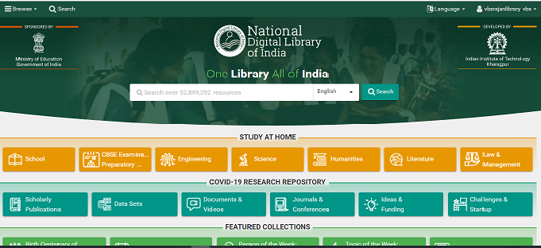 | https://ndl.iitkgp.ac.in/  User Login : vbsrajanlibrary@ametuniv.ac.in  Password : ametlibrary | https://ndl.iitkgp.ac.in/  User Login : vbsrajanlibrary@ametuniv.ac.in  Password : ametlibrary
 |  | https://shodhganga.inflibnet.ac.in/  Shodhganga are available in full-text in open access to the academic community world-wide. | https://shodhganga.inflibnet.ac.in/  Open Access for all user
 |  | https://ndltd.org/  Open Access for all user | https://ndltd.org/  Open Access for all user
 |  | http://ess.inflibnet.ac.in/ | http://ess.inflibnet.ac.in/
 |  | https://vidwan.inflibnet.ac.in/ | https://vidwan.inflibnet.ac.in/
 |  | https://shodhshuddhi.inflibnet.ac.in/  (common for all AMET users) | https://shodhshuddhi.inflibnet.ac.in/  (common for all AMET users)
 |  | https://idp.ametuniv.ac.in/  (individual login & password is given to all AMET users for example  UN: sekar@ametuniv.ac.in  PW: sekar@123) | https://idp.ametuniv.ac.in/  (individual login & password is given to all AMET users for example UN: sekar@ametuniv.ac.in PW: sekar@123)
 |  | 1 NPTEL – National Programme on Technology Enhanced Learning  2 NPTEL – National Programme on Technology Enhanced Learning | https://nptel.ac.in/  Open Access for all user
 |  | https://www.swayamprabha.gov.in/index.php/about  Open Access for all user | https://www.swayamprabha.gov.in/index.php/about  Open Access for all user
 |  | http://172.20.1.126:8080/jspui/ | Click: Digital Resources
 |  | https://www.vlab.co.in/about-us | https://www.vlab.co.in/about-us
 |  | https://spoken-tutorial.org/ | https://spoken-tutorial.org/
 |  | http://172.20.1.37:8080/AutoLib/  Type user name and Password as your library bar code ID for example: User Name : AU1616 Password: AU1616 | http://14.139.187.186:8080/AutoLib/index.jsp  Type user name and Password as your library bar code ID for example: User Name : AU1616 Password: AU1616
 |  | https://www.ametuniv.ac.in/library.html  Open Access for all user | https://www.ametuniv.ac.in/library.html  Open Access for all user
 | 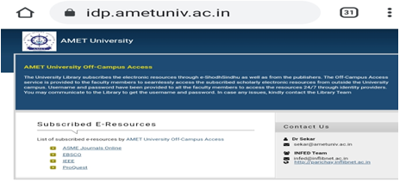 | Service provide By UGC-INFLIBNET through INFED | https://idp.ametuniv.ac.in/  (individual login & password is given all AMET users)
 | 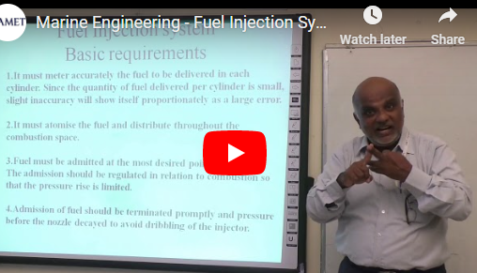 | https://www.ametuniv.ac.in/media-centre.html  Open Access for all user | https://www.ametuniv.ac.in/media-centre.html  Open Access for all user
 |  | http://epgp.inflibnet.ac.in/  Open Access for all user | http://epgp.inflibnet.ac.in/  Open Access for all user
 |  | http://content.inflibnet.ac.in/index.php/uploaded_content  Open Access for all user | http://content.inflibnet.ac.in/index.php/uploaded_content  Open Access for all user
 | 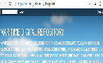 | https://maritimedigitalrepository.blogspot.com/  Open Access for all user | https://maritimedigitalrepository.blogspot.com/  Open Access for all user
 |  | www.egyankosh.ac.in | www.egyankosh.ac.in  Open Access for all user
 |  | www.cec-lor.edu.in | www.cec-lor.edu.in  Open Access for all user
 |    | https://ekumbh.aicte-india.org/#  Open Access for all user | https://ekumbh.aicte-india.org/#  Open Access for all user
 |   WITHERBYCONNECT | Please logon to www.imobookshelf.org, it will direct to www.witherbyconnect.com/imo  IMO Bookshelf Login: IMOCC86701  IMO Bookshelf Password: READ-NWDR-JRYA-3VKN-7GZR | Please logon to www.imobookshelf.org, it will direct to www.witherbyconnect.com/imo  IMO Bookshelf Login: IMOCC86701  IMO Bookshelf Password: READ-NWDR-JRYA-3VKN-7GZR
 |  | Abhilekh Patal is a digital repository thoughtfully curated by the National Archives of India (NAI).  https://www.abhilekh-patal.in/jspui/ | https://www.abhilekh-patal.in/jspui/
 |  | https://oercommons.org/hubs/NSDL | https://oercommons.org/hubs/NSDL
 |  | parliament Digital Library https://eparlib.nic.in/ | https://eparlib.nic.in/
 | UNESCO Digital Library | https://unesdoc.unesco.org/ | https://unesdoc.unesco.org/
 |   Directorate of Technical Education, Tamilnadu | http://www.tndte.gov.in/site/e-text-book/ | http://www.tndte.gov.in/site/e-text-book/
 |   IMO-EPUBLICATIONS | ttps://imo-epublications.org/  through IMO  User Name :vbsrajanlibrary@ametuniv.ac.in  Password: Library@12 | User Name :vbsrajanlibrary@ametuniv.ac.in  Password: Library@12
 | 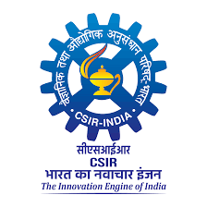  CSIR-NIScPR | https://or.niscpr.res.in/  Open Access for all user | https://or.niscpr.res.in/  Open Access for all user

LIBRARY FACILITIES
Shodhganga
Shodhganga : a reservoir of Indian theses is a digital repository of theses and dissertations submitted to Indian universities. AMET University is a member of INFLIBNET-Shodhganga with MoU.
DELNET E-Journals
Developing Library Network (DELNET) collects information, stores and disseminates among the member libraries through the development of a network of libraries. The Central Library of AMET has renewed the annual institutional membership subscription with the DELNET, so as to enable the user community to access more than 41000 e-journals and enormous e-books and Theses/Dissertations. Apart from electronic database, the Central Library of AMET is privileged to access the Union Catalogue of Books to explore Inter-Library Loan facility. DELNET E-resources can be accessed from on and off the campus.
EBSCO Business Source Elite
EBSCO Business Source Elite is a database, which consists of 1079 full text electronic journals related to all the branches of Management studies. The database consists of the contributions from world renowned publishers in the form of peer reviewed academic journal articles, magazines, abstracts and trade publications.
TALKING BOOK LIBRARY
Library has exclusively established Talking Library for Differently Abled Persons was in for the welfare of Differently Abled Persons in the academic year 2020-21. Talking Library Audio books CDs and online site providing access to a variety of web-based resources available on internet and intranet. It provides a way of organizing information from a variety of sources.
AMET LIBRARY WEB PORTAL
Library Portal is an interface to the Library resources and services to access e-question bank. The previous year question papers were scanned and uploaded. Open source e- journals and magazines, open source e-books, e-newspapers etc., are also made available.
PROQUEST E-JOURNALS AND E- BOOKS
PROQUEST is a firm and modern platform, which preserves rich, vast and varied collection of e-journals and e-books and renders services that enable strategic acquisition, management and passive dissemination. The subscription package consists of 220000 e-books of various disciplines. It is possible to access the database from on and off the campus.
J-GATE E-JOURNALS
J-Gate is an electronic gateway to global e-journal literature. Launched in 2001 by Informatics India Limited. J-Gate provides seamless access to millions of online journal articles offered by a variety of Publishers. 35550 e-journals related to Engineering & Technology are available.
IEEE E- JOURNALS
IEEE is the world’s largest technical professional organization dedicated to advancing technology for the benefit of humanity. It has highly cited publications of journals to support Engineering professionals. The subscribed IEEE All Society Periodical Package which consists of 183 e-Journals related to all the Engineering disciplines with a Back file to 1998.
ACCESS BARCODE CARDS
AMET provides Identity card with Barcode Technology, for all students and staff members, which can be utilized for registering GATE Entry as well as for borrowing the library resources.
RFID
RFID technology has been implemented successfully in library items identification. RFID technology which is helpful to prevent the book. Features of RFID technologies are as follows:
1. RFID tags replace both the EM security strips and barcode.
2. Simplify patron self-check-out/ check-in.
3. Radio frequency anti-theft detection is innovative and safe.
4. High-speed inventory and identify items which are out of proper order. RFID technology which is helpful to prevent the book.
DIGITAL LIBRARY
Library has a separate section for digital library, which consists of 50 computer systems with an internet speed of 1 GBPS of National Knowledge Network and 100 Mbps Tata Communications. Access of Internet in Digital Knowledge Centre enhances the facility to explore the electronic databases such as IEEE, ASME, J-Gate, DELNET E-Journals and PROQUEST E-books and E-journals subscribed by the Central Library.
Audio-Visual Section
Audio Visual section of the University Library equipped with Multimedia facilities to listen to the Video lectures delivered by AMET faculties and to listen to NPTEL(National Programme on Technology Enhanced Learning) courses and CD RoM’s with Overhead LCD Projector with Home theatre facility for better sound effects.
SWAYAM Prabha
It is facilitated to access high quality educational programmes of 32DTH Channels on 24x7 basis through “SWAYAM PRABHA”. The INFLIBNET Centre maintains the web portal “SWAYAM PRABHA”. Every, day, there will be new content for at least four hours which would be repeated 5 times a day, allowing the students to choose the time of their convenience. The contents are provided by NPTEL, IITs, UGC, CEC, IGNOU, NCERT and NIOS.
NATIONAL DIGITAL LIBRARY OF INDIA
The Central Library is a member of National Digital Library of India and also extended the service to support the students to become a member of the National Digital Library. Each and every student can access with their own user name and password to explore the resources of the Digital Library. The National Digital Library of India consists of more than 18,000 video lectures, 7 lakhs of e-books in 70 languages, 3 lakhs of research articles and more than 95000 theses, etc.,
NATIONAL PROGRAMME ON TECHNOLOGY ENHANCED LEARNING (NPTEL)
National Programme on Technology Enhanced Learning (NPTEL), funded by Ministry of Human Resource Development (MHRD), Government of India provides E-learning through online video courses in Engineering, Science and Humanities and Management streams. The mission of NPTEL is to enhance the quality of engineering education in the country by providing free online courseware. The collection consists of 31780 video courses.
INSTITUTIONAL MEMBERSHIP
The Central Library collaborates with other libraries to explore Inter-library Loan (ILL) to provide articles, books, and other materials to faculty members, researchers, students, through Institutional Membership with the following institutions:
➢ MALIBNET
➢ American Consulate Library
➢ British Council Library
➢ Anna University Library
➢ Anna Centenary Library
➢ DELNET
➢ National Digital Library of India (NDLI) & NDLI Club
➢ UGC-INFLIBNET-Shodhganga
➢ UGC-INFLIBNET E-ShodhSindhu Consortium for Higher Education
➢ INFLIBNET-INFED Remote access facilities

Our AMET University library has implemented the following platforms and services provided by higher education authorities like UGC,AICTE,NAAC,NBA, are as follows.

S.No | Higher Education Authority | Name of Product/Service | Link
1 | University Grants Commission (UGC) | E-Resources | http://ugceresources.in/
2 | Ministry of Education (MoE) | National Digital Library of India (NDLI) | https://ndl.iitkgp.ac.in/
3 | UGC-INFLIBNET | Shodhganga (Theses Repository) | https://shodhganga.inflibnet.ac.in/
4 | UGC-INFLIBNET | e-ShodhSindhu (Price Negotiation & E-Resources Access) | http://ess.inflibnet.ac.in/
5 | UGC-INFLIBNET | VIDWAN (Expert Database & National Researcher Network) | https://vidwan.inflibnet.ac.in/
6 | UGC-INFLIBNET | ShodhShuddhi (Plagiarism Detection Software) | https://shodhshuddhi.inflibnet.ac.in/
7 | UGC-INFLIBNET | INFED (Remote Access to E-Resources) | https://www.inflibnet.ac.in/infed/
8 | IITs (Funded by MoE) | NPTEL (Video & Web Courses) | https://nptel.ac.in/
9 | MoE | SWAYAM Prabha (Educational TV Channels) | https://www.swayamprabha.gov.in/
10 | MHRD / UGC-INFLIBNET | e-PG Pathshala (Postgraduate e-Content) | http://epgp.inflibnet.ac.in/
11 | UGC-INFLIBNET | Vidyamitra (Digital Repository of Learning Resources) | http://content.inflibnet.ac.in/
12 | AICTE | Ekumbh (Digital Platform for Teachers & Learners) | https://ekumbh.aicte-india.org/

GENERAL CAMPUS FACILITIES
S.NO | AMENITIES FACILITIES
1 | Ganga Hostel
2 | Yamuna Hostel
3 | International Hostel-Kauvery
4 | Health Care Centre
5 | Ambulance Service 24 x 7
6 | Student Counseling Centre
7 | Swimming Pool
8 | Cafeteria Centre
9 | Barrier Free Campus
10 | Gymnasium
11 | Dining Hall
12 | Electricity Generator 24 x 7
13 | Wi-Fi Enables Campus and Hostel
14 | Automated Teller Machine (ATM)
15 | Solar Power Plant
16 | Sewage Treatment Plant (STP)
17 | Indoor and Outdoor games
18 | Cultural Club
19 | Centre for Yoga and Human Excellence
20 | Reverse Osmosis (RO)Plant
21 | Reprography Facilities
22 | Marine Museum
23 | Green House
24 | Biogas plant
25 | Liquid Waste Management System
26 | Waste recycling system
27 | Plastic Free Campus
28 | Saloon
29 | Lift
30 | Help Desk
31 | Day Care Centre
32 | Media Centre
33 | Auditorium
34 | Parade Ground
35 | Common Computer lab
36 | Innovation, Incubation and Entrepreneurship Centre
37 | Student Council
38 | National Cadet Corps(NCC)
39 | National Service Scheme(NSS)
40 | CCTV Surveillance and Security Services 24 X 7 Hours
41 | Laundry Services

SHIP-IN-CAMPUS

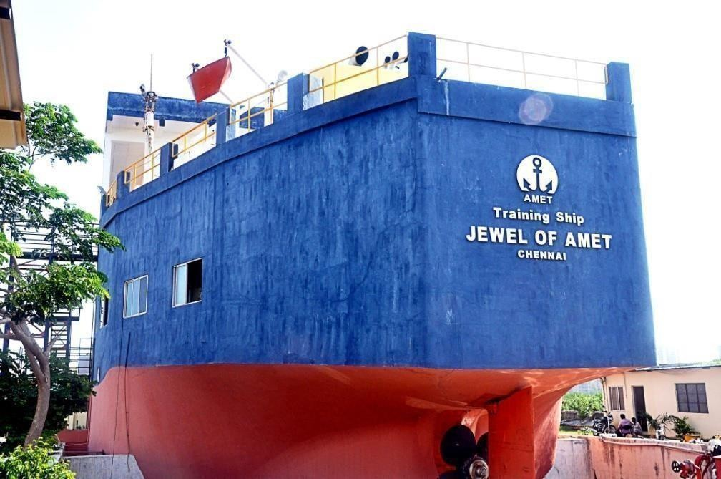

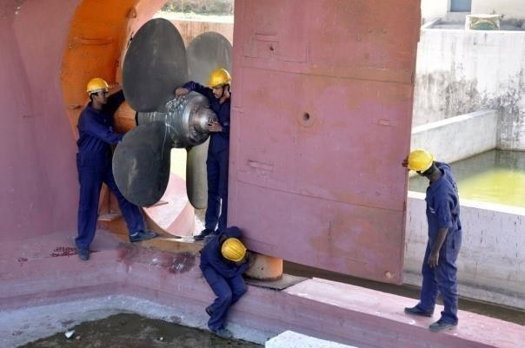
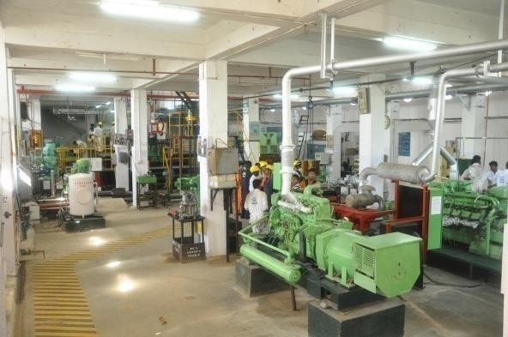

Working Main Engine (Deutz) 2200HP, Two working Auxiliary Engines (Deutz) 430HP each, Working Package Boiler - 1, Working Steering Gear - 1, One Working Overhead Gantry Crane and all other necessary working Auxiliary Machineries. Two Auxiliary Engines, Air Compressor, Various Pumps & Valves, Heat Exchanger, Steering Gear, Turbocharger.

FULL MISSION SHIP SIMULATOR

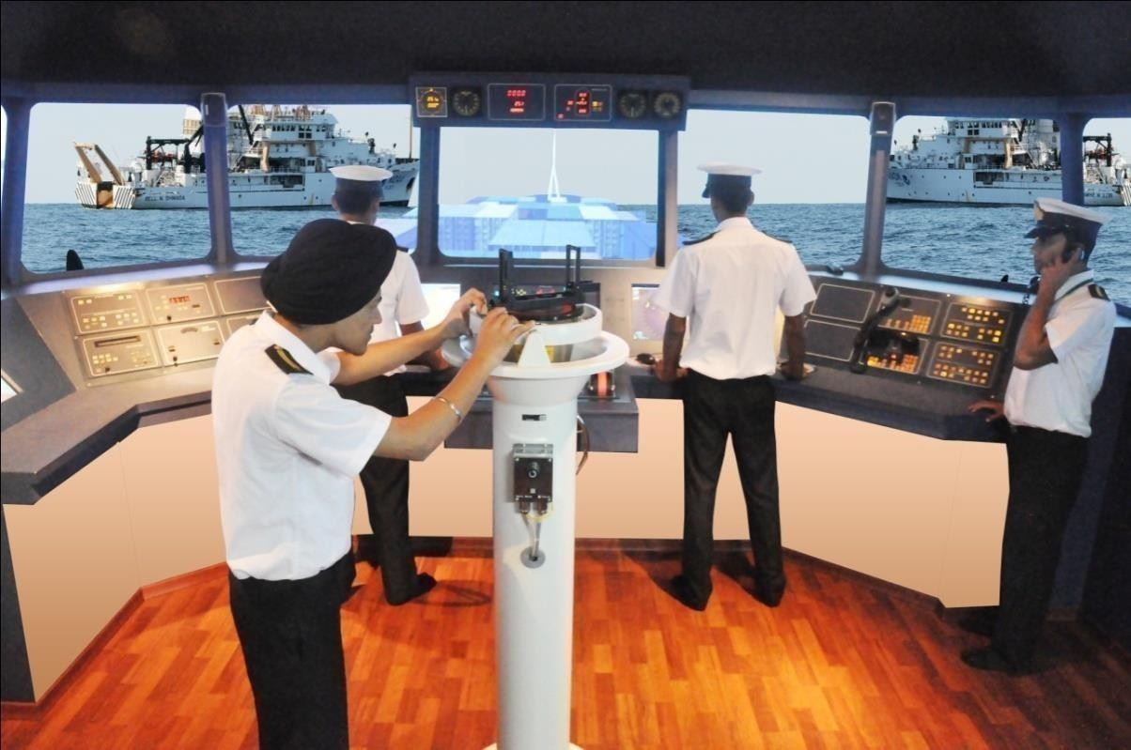
ENGINE ROOM SIMULATOR
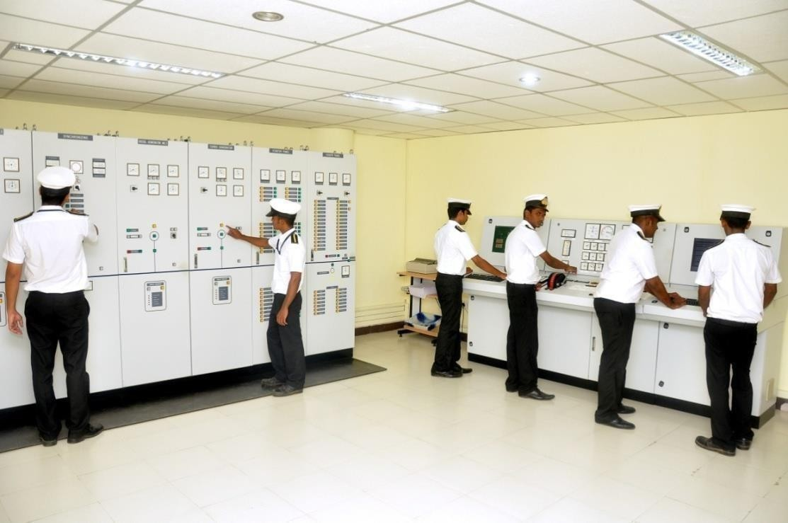

State of the art Ship Simulators “Polaris” for Bridge Navigation and “Neptune” for Engine room operations by KONGSBERG, NORWAY provide hands on training to students.

SOLAR POWER PLANT

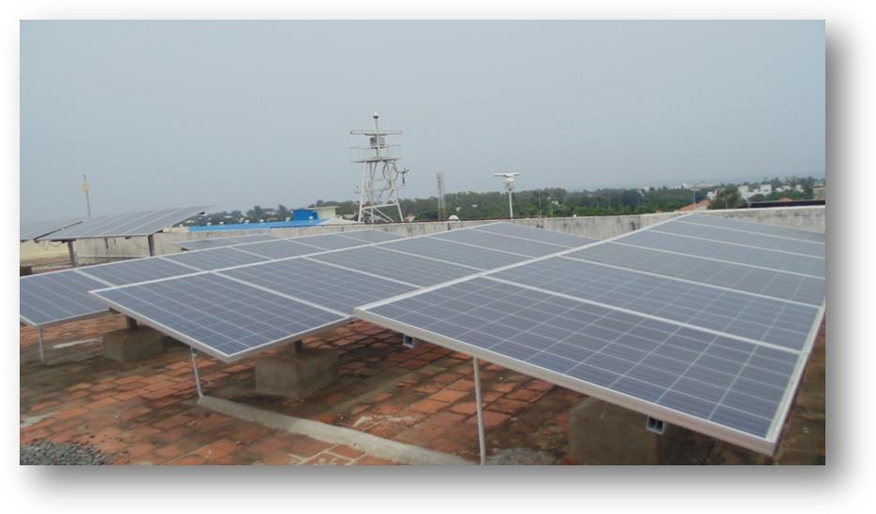

SOLAR POWER PLANT 30 KVA – RABINDRA NATH TAGORE BLOCK
SOLAR POWER PLANT 30KV – RABINDRANATH TAGORE BLOCK

SEWAGE TREATMENT PLANT
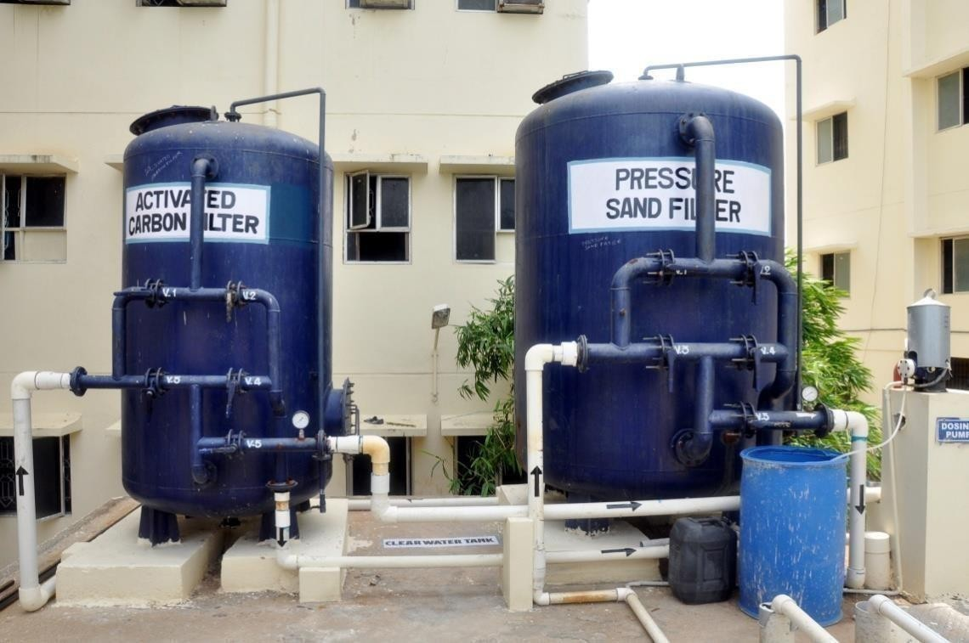

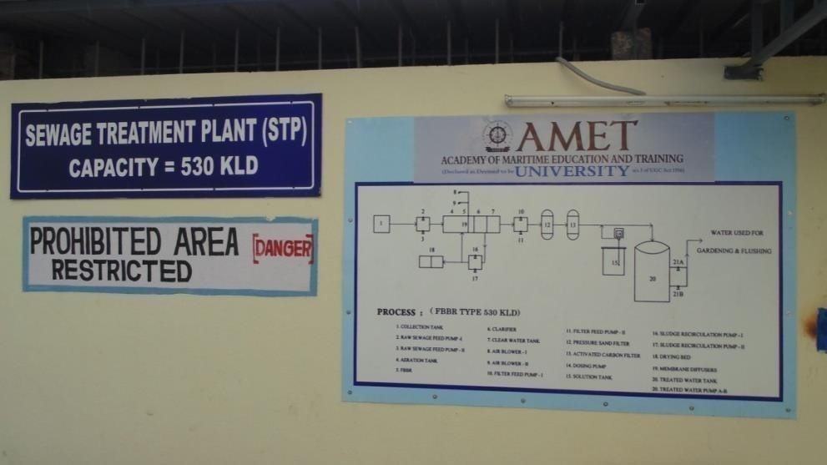
Sewage Treatment Plant of Capacity 530000 Liters per day is operational in the Campus to treat all the sewage outlets and the treated water is utilized in the campus garden.

REVERSE OSMOSIS PLANT

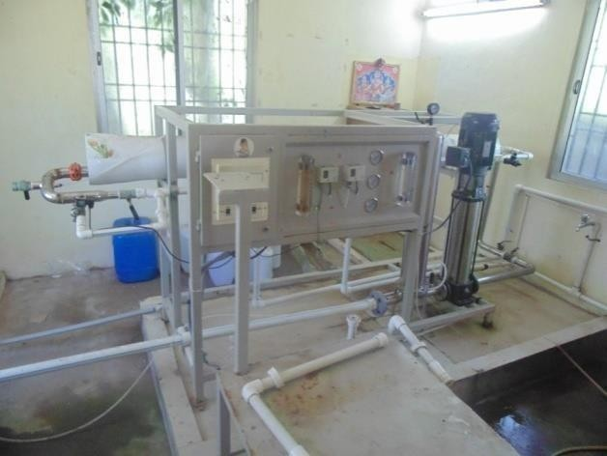
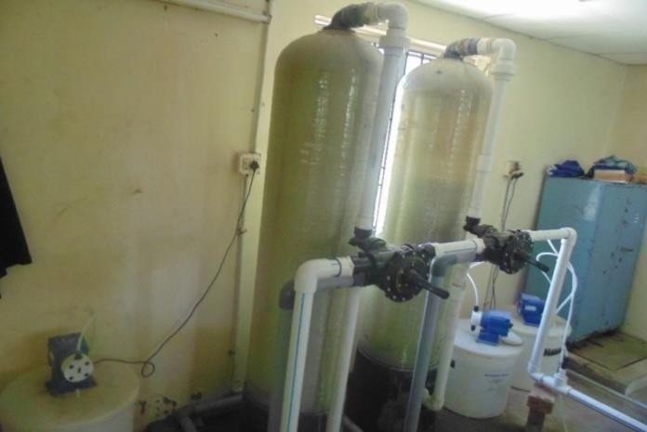
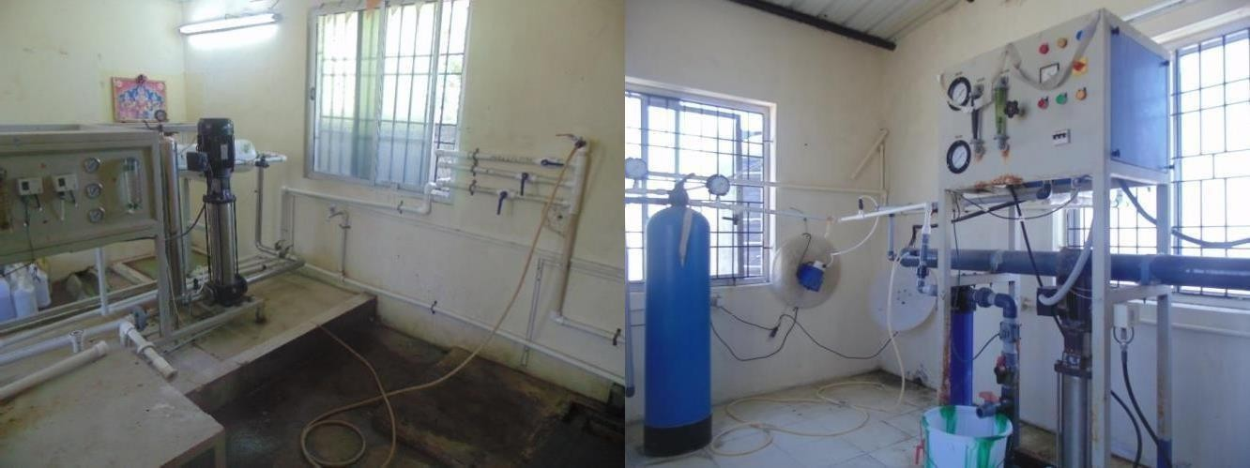

AMET University campus has two numbers of State of the art Reverse Osmosis Plants of capacity 2000 LPH & 500 LPH each. The water being tested for portability by certified agency. Campus has eight bore wells and two fresh water ponds.
FACILITIES FOR PHYSICALLY CHALLENGED
Special facilities are provided for differently-abled persons at Campus
• Wheelchair
• Lifts and Ramps
• Hand rails across corridors
• Seating arrangements in long corridors
• Separate Parking facility
• Reading space in the ground floor of main library.
• Toilets for differently-abled persons
• Necessary support for writing examinations
• Scholarships

STUDENT SUPPORT SERVICES
AMET is committed to providing a conducive learning environment to its students throughout the course of their study by attending to their needs and wellbeing through the following cells, centers and committees:
• AMET Alumni Association
• Anti-Ragging Committee
• Committee Against Sexual Harassment
• Student Council
• Career Development Centre
• Skill Development Centre
• Cultural Club
• Centre for Slow Learners/ Weaker Students
• Centre for Women Empowerment
• Earn while you Learn Scheme
• Equal Opportunity Cell
• Centre for Entrepreneurship, Innovation and Incubation (CEII)
• Educational Materials Resource Development Centre (EMRDC)
• Centre for ICT Enabled Education
• Green card System
• Green Box system
• Hostel Advisory Committee
• Placement Cell

• Seed money for student’s project.
• SC/ST student’s cell
• Sports Club
• 24x7 health center with ambulance facility
STUDENT PROGRESSION
The programmes offered at AMET are highly unique and exclusively job oriented. On an average 80% of the enrolled students are placed either through campus recruitments or through other modes. Remaining students either undertake higher studies both in India and abroad or pursue entrepreneurial opportunities.

SCHEME OF AMET SCHOLARSHIP
Name of Scheme:
- Shri Janakiraman Scholarship
- Single Girl Child Scholarship
- First Graduate Scholarship
- Single Parent Scholarship
- National/State Sports Scholarship
- Meritorious Scholarship
- Ex-Servicemen Scholarship
- Fishermen Scholarship
- Alumni Scholarship
- Scholarship for rank holders
- PG Scholarship
GOVERNMENT SCHOLARSHIP
Minority Scholarship
Fisheries Dept. Scholarship
Maritime Training Trust Scholarship
Ministry of Minority affairs
Department of empowerment of person with disabilities
Ministry of social justice and empowerment
Ministry of labour and employment
Ministry of tribal affairs
Department of social education and literacy
Department of higher education
Ministry of home affairs
Ministry of railway
University grants commission
National Scholarship Portal (NSP):
- Central Sector Schemes (Ministry of Education):
  - Central Sector Scheme of Scholarships for College and University Students.
  - National Means-cum-Merit Scholarship Scheme (NMMSS)
  - Special Scholarship Scheme for Jammu & Kashmir and Ladakh (PM-USP).
  - National Scholarship for Post-Graduate Studies.
- Ministry of Tribal Affairs & Social Justice:
  - National Fellowship and Scholarship for Higher Education of ST Students.
  - Top Class Education for SC Students.
  - Post-matric Scholarship for Students with Disabilities.
- Technical & Specialized Education (AICTE):
  - AICTE – Swanath Scholarship Scheme.
  - AICTE – Saksham Scholarship Scheme (for specially abled).
  - AICTE – Pragati Scholarship Scheme (for girl students).
- Other Prime Minister/Central Schemes:
  - Prime Minister's Scholarship Scheme for Central Armed Police Forces and Assam Rifles.
  - Prime Minister's Scholarship Scheme for Ministry of Railways.
  - Post-Matric Scholarship Scheme for Minority Communities.
NON-GOVERNMENT SCHOLARSHIP
Avul Pakir Jainulabdeen Abdul Kalam Fishermen Scholarship
Indira Gandhi Women Scholarship
Kalpana Chawla Advance Learner Scholarship
Kamarajar Scholarship for Economically Weaker Section
Mahatma Gandhi Rural Scholarship
P.T. Usha Sports Scholarship
H. Ramakrishnan Physically Challenged Scholarship
Saraswathi Scholarship for Employees Son/Daughter
Sundar Pichai Merit Incentive Scholarship / Best Performance Scholarship
Swami Vivekananda First Graduate Scholarship
Corporate Social Responsibility (CSR) Scholarship
- Buddy4Study Scholarship Support Programme 2025-26
- Kind Circle Scholarship for Meritorious Students 2025-26
- Bharti Airtel Scholarship Program 2025-26
- Mirae Asset Scholarship Program for Undergraduate Students
- HDFC Bank Parivartan's ECSS Programme for School Students (Merit-cum-Need Based) 2025-26
- HDFC Bank Parivartan's ECSS Programme for Undergraduate Students (Merit-cum-Need Based) 2025-26
- Panasonic Ratti Chhatr Scholarship 2025-26
- Rolls-Royce Wings4Her Scholarship for Women Engineering Students 2025-26
- Infosys Foundation STEM Stars Scholarship Program 2025-26
- Mohan T Advani Centennial Scholarship Programme for Engineering and Architecture Students 2025-26
- TVS Cheema Financial Assistance for Degree / Nursing Students 2025
- Legrand Empowering Scholarship Program 2025-26 (Special Category Application)
- Legrand Empowering Scholarship Program 2025-26 (General Category Application)
- Kotak Kanya Scholarship 2025-26
- U-Go Scholarship Program 2025-26
- Aspire Scholarship Program 2025-26
- DXC Progressing Minds Scholarship for Graduation Students in STEM 2025-26
- L'Oréal India For Young Women In Science Scholarships 2025-26 for UG Students
- JK Tyre Shiksha Sarthi Scholarship Program 2025-26
- SBIF Asha Scholarship for School Students 2025-26
- SBIF Asha Scholarship for Undergraduate Students 2025-26
- SBIF Asha Scholarship for Postgraduate Students 2025-26
- Mahindra Empower Her Scholarship Program 2025-26
- Aditya Birla Capital Scholarship for Professional Graduation 2025-26 (4 years)
- NASSCOM STEM Scholarship Program
- Nikon Scholarship Program 2025-26
- Foundation For Excellence Scholarship Program 2026
- Tata Capital Pankh Scholarship Program for Professional Courses (2025-26)

GOVERNANCE, LEADERSHIP AND MANAGEMENT
The following bodies and authorities responsible for the governance of AMET are in place and functioning as per the provisions contained in the UGC (Institutions Deemed to be Universities) Regulations, 2016 as amended from time to time
1. Board of Management
2. Academic Council
3. Planning and Monitoring Board
4. Finance Committee
5. Board of Studies
Regular meetings of the governing bodies as per the UGC Regulations are held.
1. Board of Management : 4 meetings in a year
2. Finance Committee – 2 meetings in a year
3. Planning and Monitoring Board – 2 meetings in a year
4. Academic Council – 4 meetings in a year
5. Board of Studies meeting of respective disciplines was held as and when required.
INSTITUTIONAL VALUES
The University, has emerged as a de novo category deemed to be University with the promise of excellence in marine and maritime education. The University has made the following accomplishments and continuing towards excellence in the same.
- Shaping the skill based marine and maritime training into knowledge based education and research.
- Undertaking research and development activities with specialized research centres and departments by involving experienced maritime experts
- Extension of research and social outreach activities for the sustained development of coastal community
The University aims to further enhance the maritime education and aspires to be a leading Maritime University with international standards. AMET envisages equipping itself to become the Global Knowledge Hub in Maritime Studies during 2025.

ADMISSION PROCEDURE
1. Admission Committee Meeting:
Admission Committee meeting is being conducted every year before the admission. The committee decides about the date of commencement of the admission and admission related implementation for the academic year.
2. Administrative Work:
The administrative work relating to Admissions is being done centrally by Admission Department of the University.
3. Eligibility Requirements for appearing in the Entrance Examination:
The eligibility requirements for all candidates for appearing in the Entrance Examination for admission to various programmes of study are given in the AMET University Prospectus and University Website as per DGS and UGC reservation norms.
4. Admission Process:
(i) Order of Approval from the Vice- Chancellor for the Admission Process: To initiate the admission process, an approval has to be obtained from the Vice Chancellor for any Academic year admissions.
(ii) Fees Structure Approval:
The Prescribed fee structure designed and approved by the fee fixation committee for various courses. Once it is approved it will be implemented for the relevant academic year.
(iii) Issuance of Application Forms and Prospects / Online Application:
The Application forms and Prospects for all courses prepared well in advance for issuing from December. Online Application forms will upload in the University website. Candidates can apply through online application from website.

Advertisement for Admission in leading National News Papers:
The detailed Admission Advertisement to various courses publish in the leading English and regional language newspapers across India and in University website. When admission process starts for the academic year. The e-Advertisement also publish across India Digital Marketing.
(iv) Participating in Educational Fair Stalls across India:
Every year Educational fairs are being conducted across India by the organizers. While participating in those fairs, awareness is created about various programs offered by the University among the candidates. This will promote the intake numbers of the admissions for various courses.
(v) Receiving Applications for various courses:
Candidates apply through Online towards the admission of various courses for the particular academic year. After receiving the filled application forms, the same will be scrutinized for the necessary admission process.
(vi) AMET University Online Entrance Exam for all courses:
AMET University Online Entrance Examination conducted through online mode across India in the month of May every year. Candidates will be informed about the examination date well in advance. Hall ticket for examination will be sent to the candidates. The pattern of the exam is objective type and no negative marks. The duration of the Examination is 90 minutes.
(vii) Medical Screening (For Selected Courses):
As a part of Admission process candidates those who have applied for DG Shipping approved courses, need to undergo medical screening which will be examined by the DG Shipping Approved Doctors. They need to ensure the fitness in the medical screening as per DG norms.
For other courses, there is no medical screening.
(viii) Interview Process
As a part of Admission process candidates have to attend Personal interview with concern department HOD’s.
(ix) Publishing the Rank List of Candidates for various courses:
The rank list for the various courses prepared based on their Academic Eligibility criteria (Marks of previous course), Entrance Exam Score, Interview score and Government reservation policy norms. The rank list published on the University notice boards and University website.
(x) Payment of fees and Issuing of Admission Letter:
The selected candidates can pay their course fee once the rank list published. The course fee can be paid in three terms per year. Payment of fee can be made through Cheque/ DD/ Online Transfer or swipe card. Once the first term fee paid the provisional admission letter, bonafide certificate and other related documents will be supplied to the candidates. Those who are admitted provisionally to the course will be cancelled if he/she has not submitted original certificates/not eligible as per the eligibility criteria. If any discrepancies found in admission, the management reserves all rights to cancel his/her admission.
5. No. of Seats:
The intake and offers for each programme of study are approved by the Board of Management (BOM) on the recommendations of the Centres/Schools concerned (Intake is the available seats and offer is the number to be offered to ensure filling up of the seats to the maximum extent close to intake before the last date).
Note:
i) The candidates who are due to appear in the respective qualifying examination prescribed of eligibility for admission to a particular programme of study are considered eligible to appear for the entrance examination. However, in the event of their selection they are granted admission subject to their securing the prescribed percentage of marks in the qualifying examination and submission of all documents including final mark sheet of the qualifying examination.
ii) Candidates selected for admission is made as per the Government reservation policy norms.
iii) The last date for seeking admission to any programme of study closes on the date decided by the admission committee and no admission is permitted thereafter.
However, those Foreign Nationals who have been selected for admission may be allowed to join with a marginal delay after considering as per Foreign Student’s Admission Policy.
Academic Curricula (Curricular Aspects)
https://www.ametuniv.ac.in/schools.html
ACTION PLAN FOR IMPROVEMENT OF RESEARCH AND INNOVATION
1. The Research Promotion Policy of the University will be implemented with more schemes. In addition to the existing two Research Centers and Seven Specialized Labs, AMET would establish three more research centers with Government and Industry sponsorship, to focus on the latest technological advancements such as Drugs from Sea (Marine Bioprospecting), Advanced Functional Materials, Autonomous Ships and Remotely Operated Vehicles etc.
2. Selected Five Departments of the University will be nurtured and oriented to get National Recognition for Research Infrastructure like DST-FIST
3. University will strengthen the Business Incubator by getting more external fund to promote the startups and innovation by the students.
4. With the growing strength in intellectual capital and state-of-the-art-infrastructure, the University envisages to equipping itself to become the Global Maritime Knowledge Hub during 2025.
5. To become full-fledged Deemed to be University by overcoming the limitations of being a de novo category University and enhancing the status in various National Ranking and Accreditations such as NIRF, NBA and NAAC.

 |  |  | 
FEE STRUCTURE OF MBA HOSPITALITY ADMINISTRATION
2025-2027 (2 YEARS)
FEE DETAILS | I Year |  |  | II Year *
 | I | II | III | I | II | III
 | Jul'2025 | Nov'2025 | Mar'2026 | July'2026 | Nov'2026 | Mar'2027
Admission & Registration Fee  (Non Refundable) | 25000
Tuition Fee | 30000 | 50000 | 55000 | 55000 | 50000 | 55000
Value added Fee |  | 5000 |  |  | 5000
Convocation Fee |  |  |  |  |  | 2000
Term Fee | 55000 | 55000 | 55000 | 55000 | 55000 | 57000
Annual Fee | 165000 |  |  | 167000
 |  | 165000 |  |  | 167000
OPTIONAL FEE DETAILS | I Year |  |  | II Year*
 | Jul'2025 | Nov'2025 | Mar'2026 | July'2026 | Nov'2026 | Mar'2027
Food & Accommodation Fee | 45000 | 40000 | 40000 | 45000 | 40000 | 40000
Bus Fee (including Complementary Breakfast)
15km and below | 25000 | 25000 | 0 | 25000 | 25000 | 0
16km to 30km | 30000 | 30000 | 0 | 30000 | 30000 | 0
31km to 50km | 35000 | 35000 | 0 | 35000 | 35000 | 0
Note:
• Refundable Caution deposit Rs 10000/- to be paid along with I year I term Fee
• Refundable Hostel Caution deposit Rs 10000/- to be paid along with I year I term Fee
• Examination Fee has to be paid every semester separately
• * Subject to Fee Revision
