**ASSIGNMENT 1**

**AMEY ASHOK SAWANT 700740611**

Github Link: <https://github.com/amey-13/CS_5170_Machine_Learning>

Video recording: <https://drive.google.com/drive/u/1/folders/1_coA-xY3dmOk_MEI4UFib6kKpcwRV-WL>

Using the sort() function to sort the list in ascending order of their values.

Using the min() and max() functions to get the minimum and maximum values in the list as per the requirement.

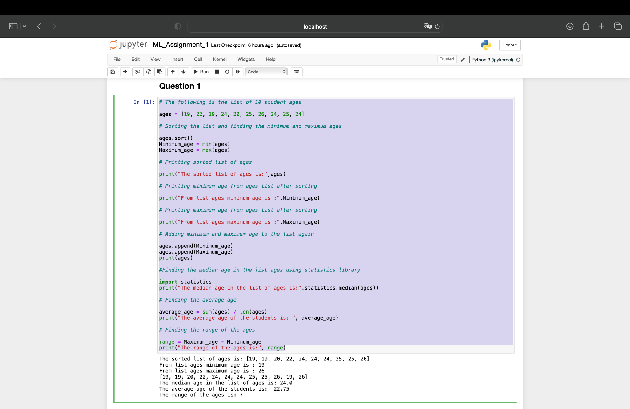

Creating an empty dictionary DOG and adding key and values in the dictionary.

Getting the number of items in the dictionary using the len() function. Getting the type of the values by using the type() function.

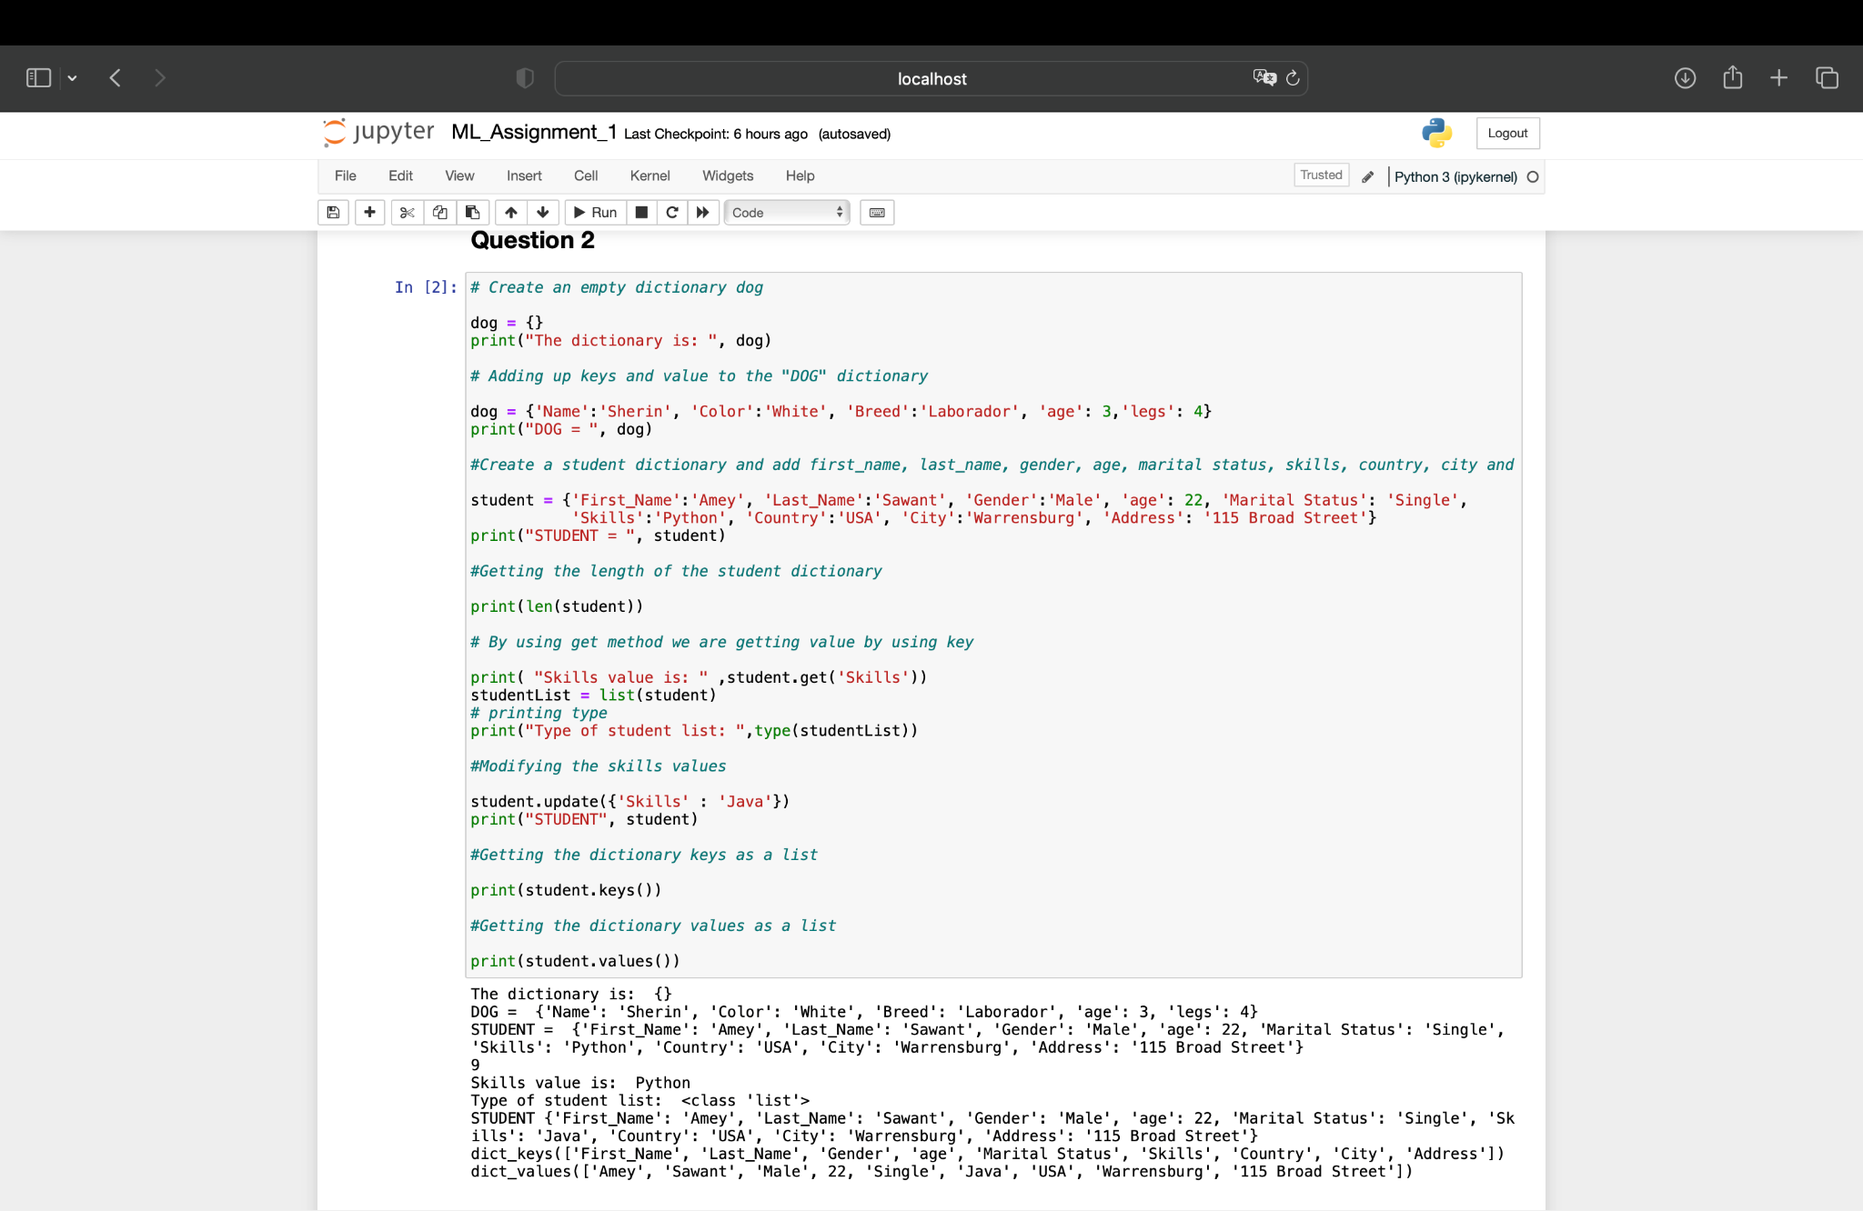

Creating two tuples containing sister and brother names and then making it one tuple as siblings by adding the brother and sister tuples. Then adding one more tuple to it containing the mom and dad names and renaming it to family.

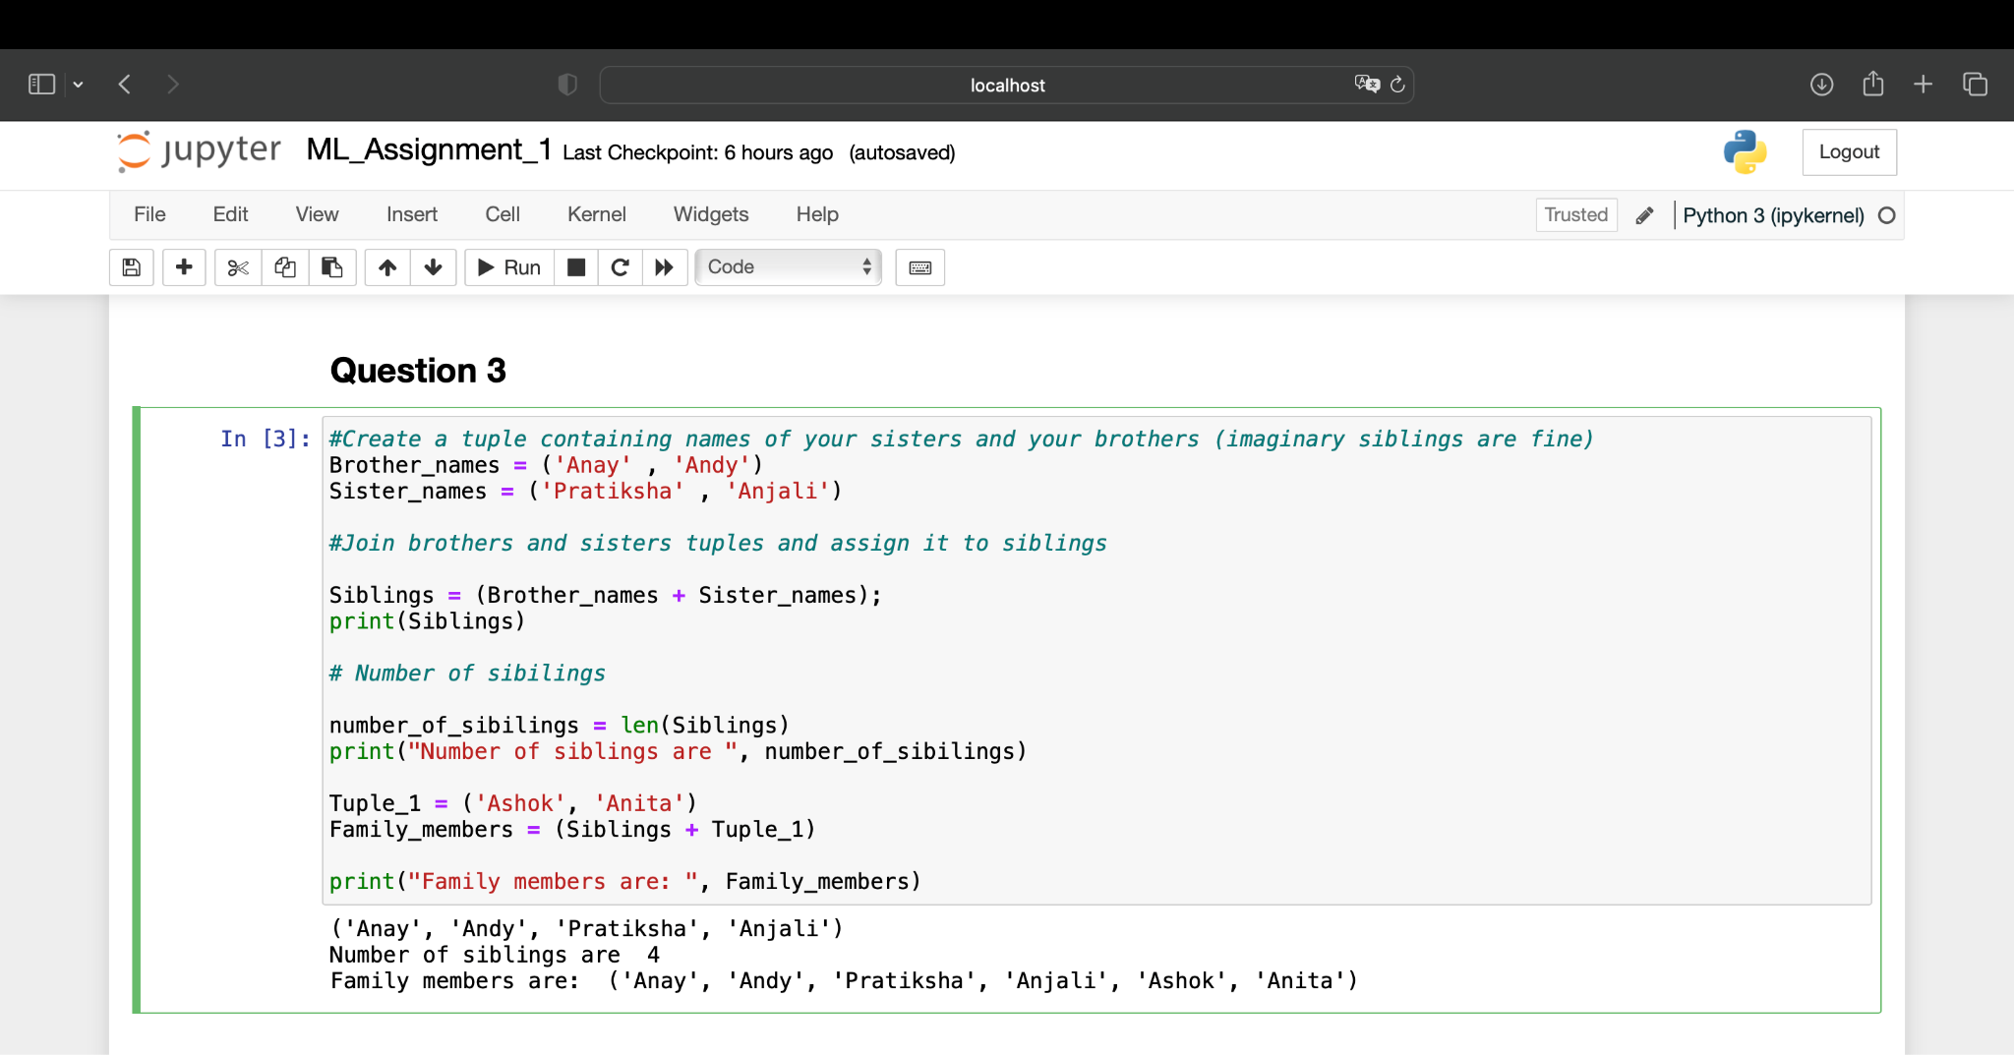

In this question we have performed operations on set like finding the length of the set and adding new items to the set and inserting and deleting items from the set.

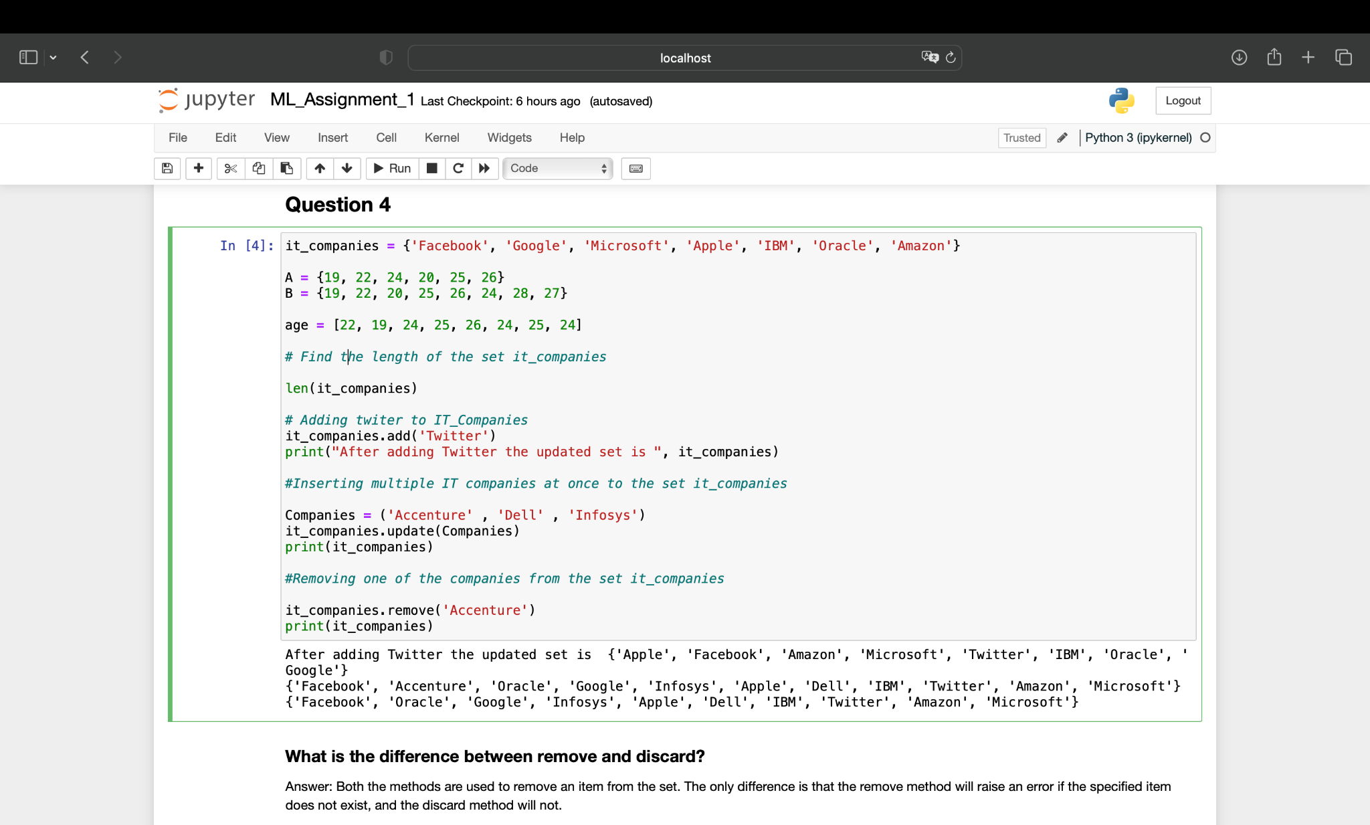

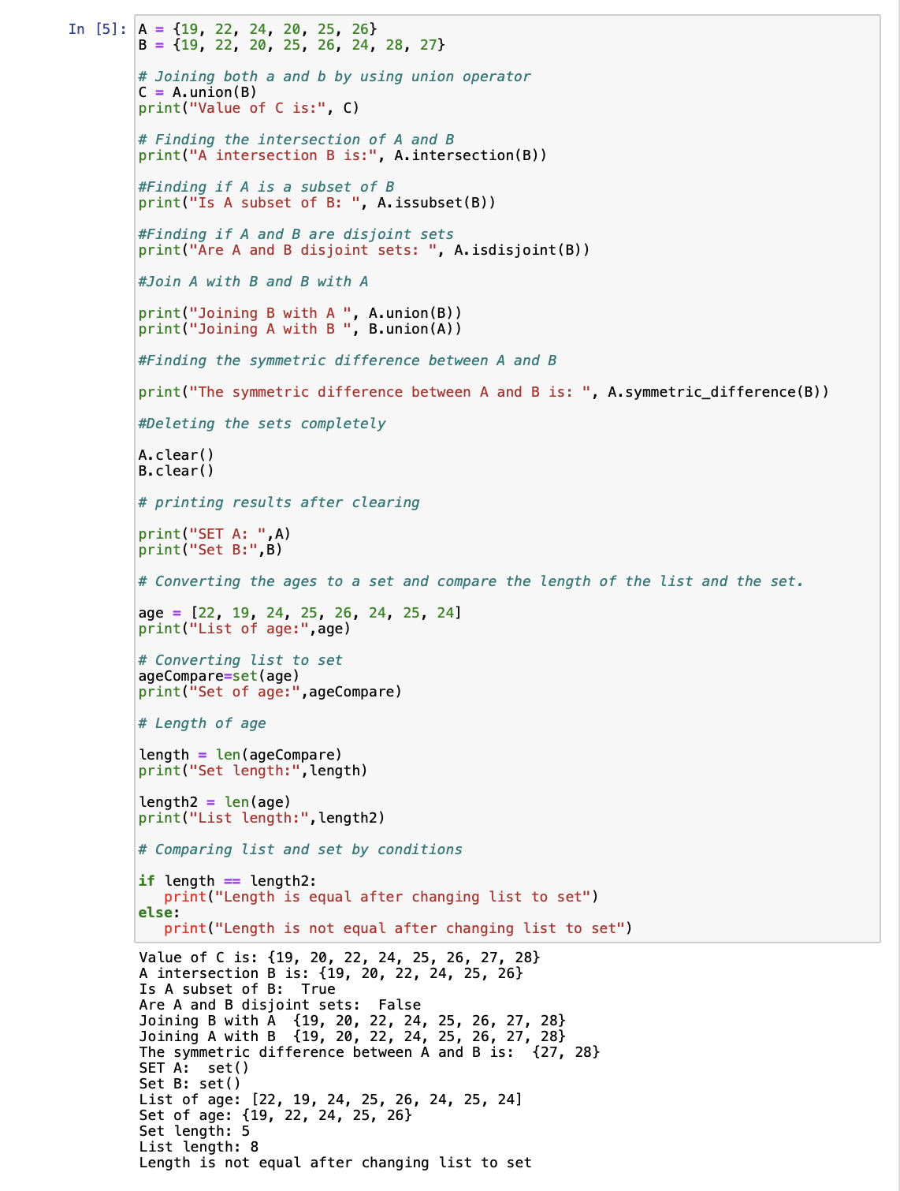

In this problem we have found the area and the circumference of the circle given the radius of the circle and storing them in the variables _area_of_circle_ and _circumference_of_circle_

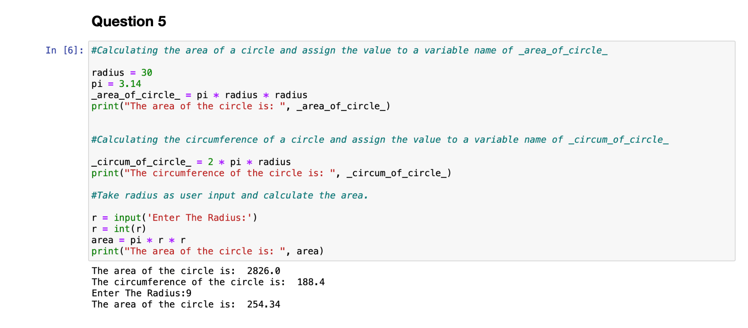

Finding the number of unique words in the sentence by splitting the sentence into set and then counting the number of items in the set.

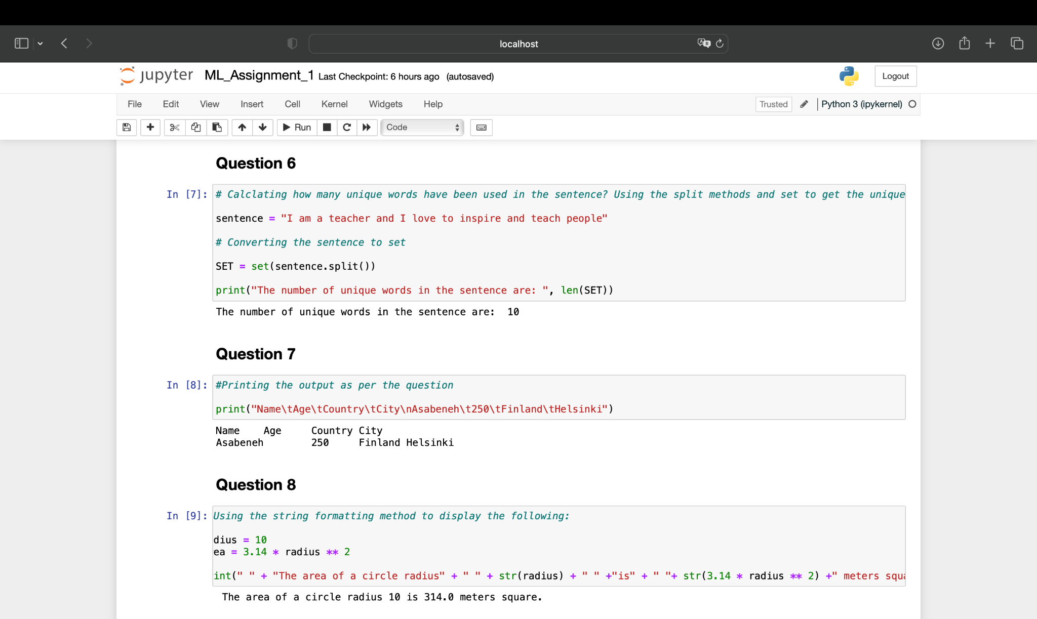

Here we have used string formatting to display the sentence in a particular pattern. In the next question, we have found the equivalent weight in kilograms of the entered weight in pounds using a loop.

