**Name:** Shivanshu Anant Suryakar

**PRN:** 1841048

**Class**: LY BTech Computer (L3)

**Subject:** Cloud Computing

**Aim:** To solve Google crossword puzzles to check the knowledge.

**Solution:-**

Puzzle was based on a google cloud serverless computing topic.

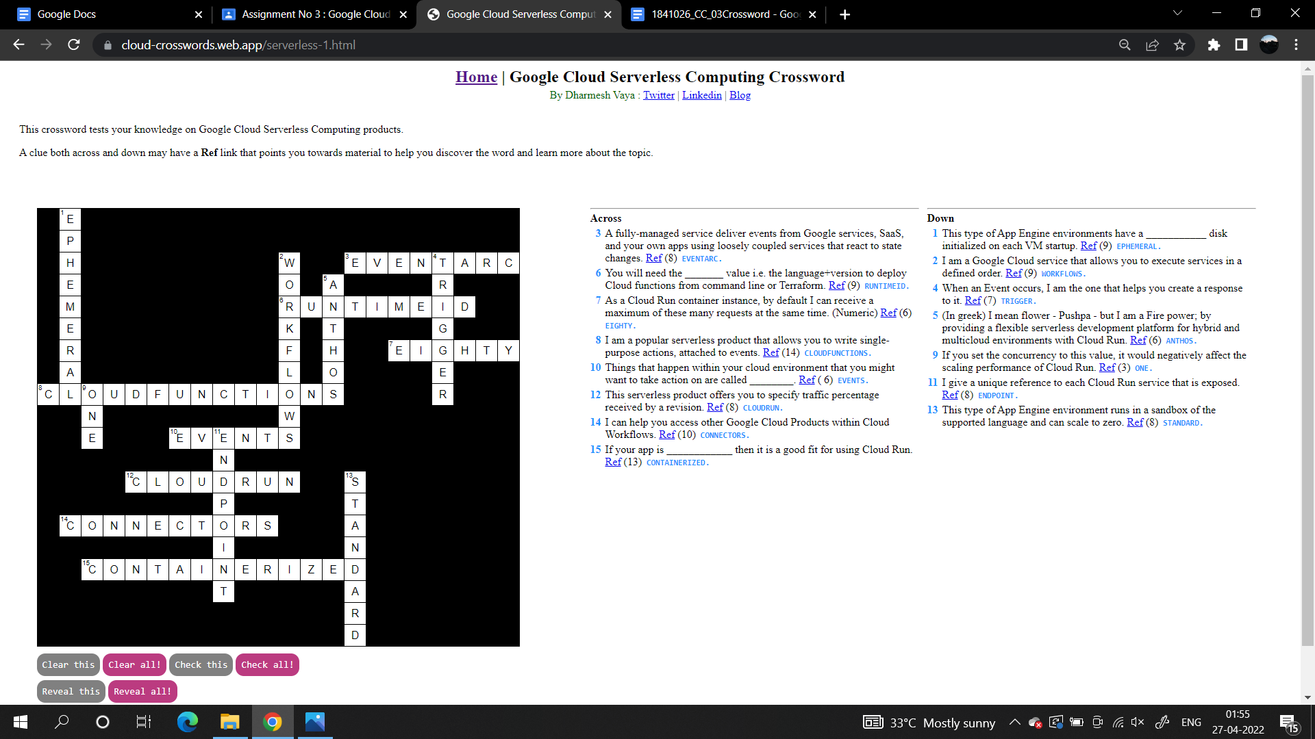

**Conclusion:**

Tested a fun puzzle with knowledge grading.