**Name:** Shivanshu Anant Suryakar

**PRN:** 1841048

**Class:** L.Y. BTech (Computer) (L3)

**Subject:** Cloud Computing.

**Aim:** To install and configure google cloud app engine.

**Theory:**

App Engine is a fully managed, serverless platform for developing and hosting web applications at scale. You can choose from several popular languages, libraries, and frameworks to develop your apps, and then let App Engine take care of provisioning servers and scaling your app instances based on demand.

**Steps:**

1. **Download the SDK google app engine and install it.**

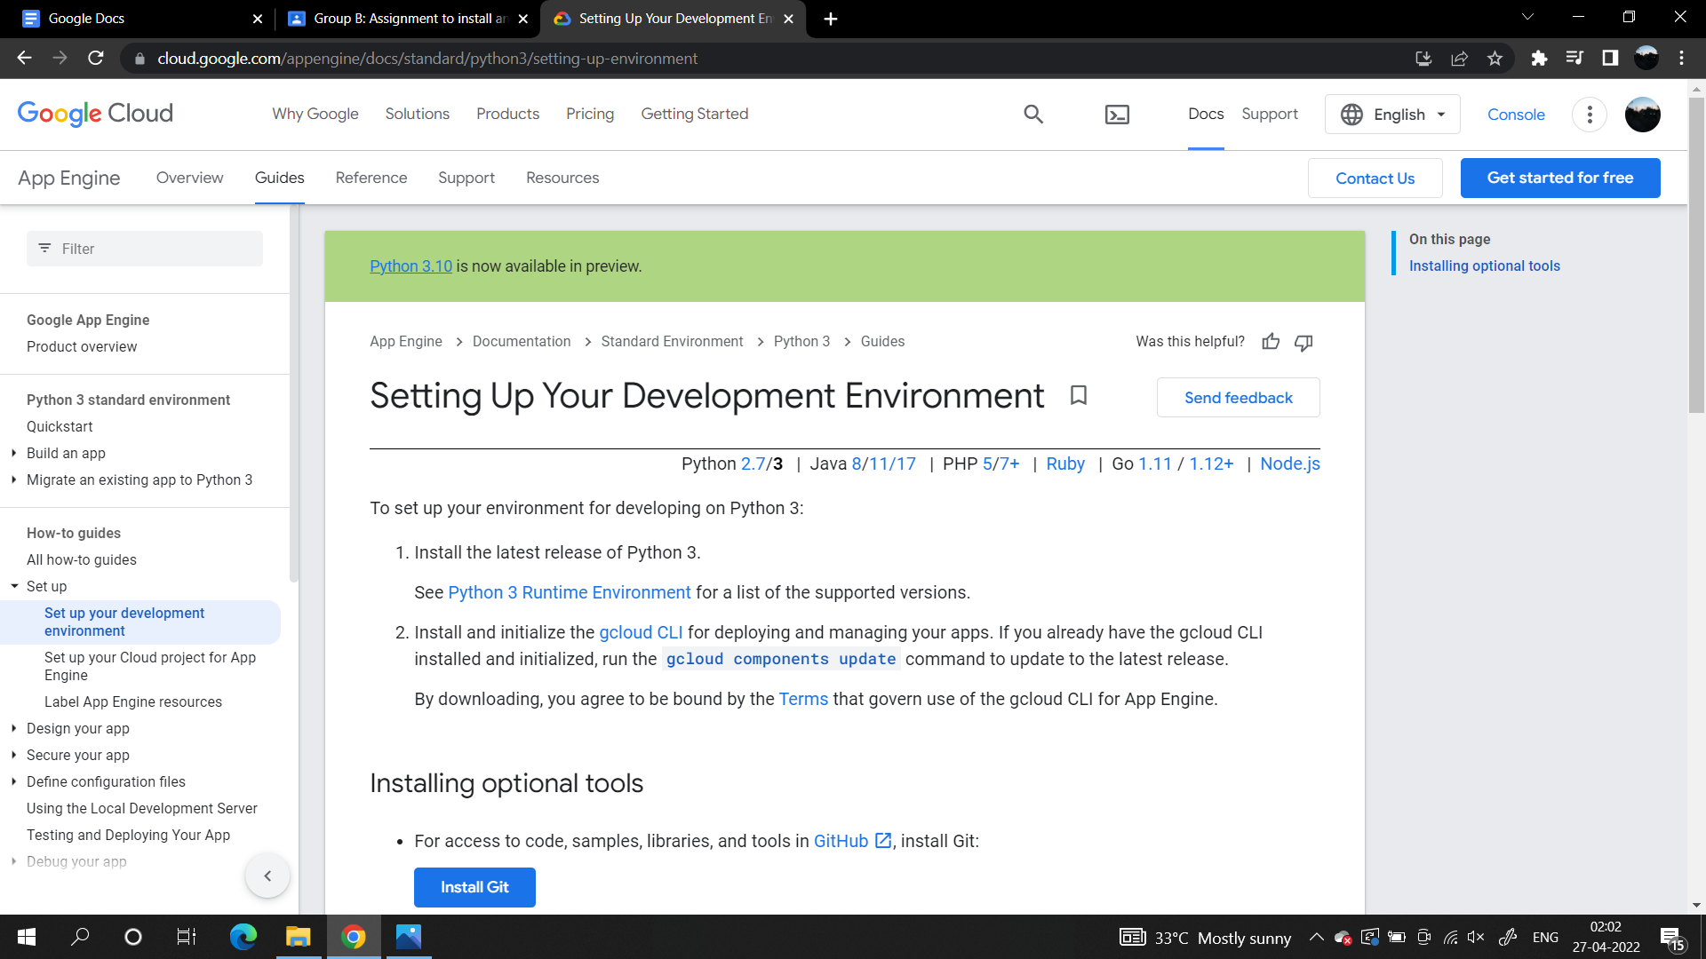

**2) Download and CLI for Google App Engine:**

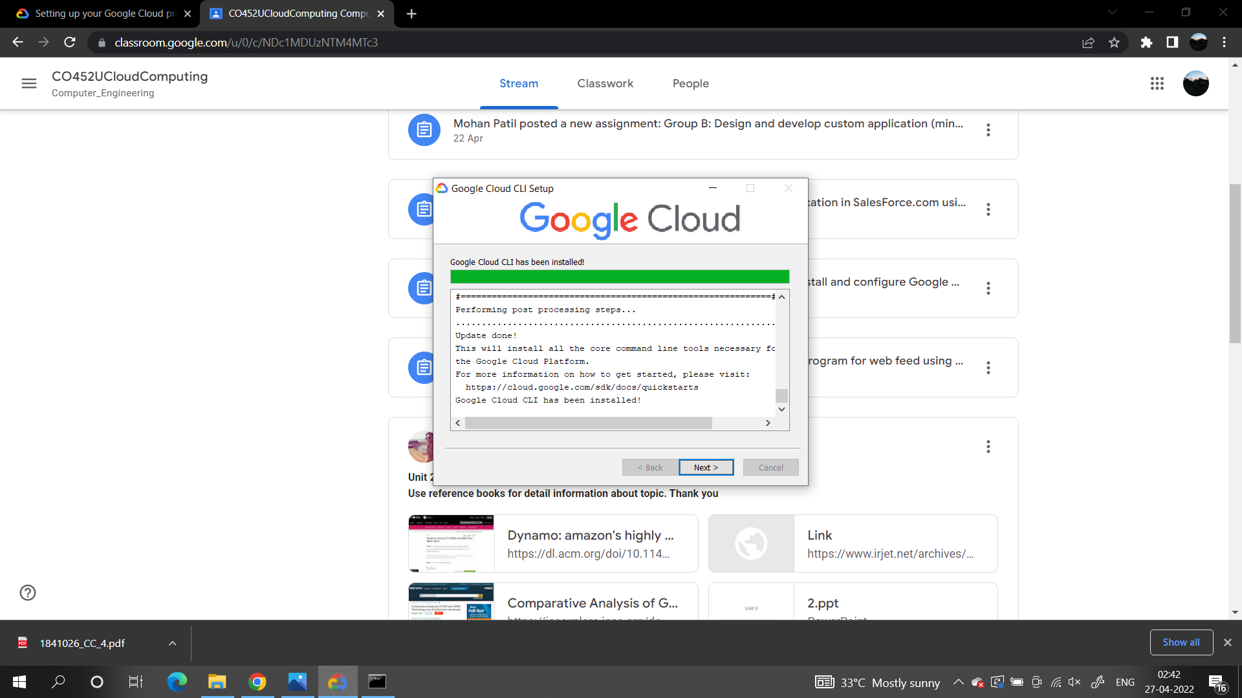

**4) Run the command to check if installed properly and authenticate the user:**

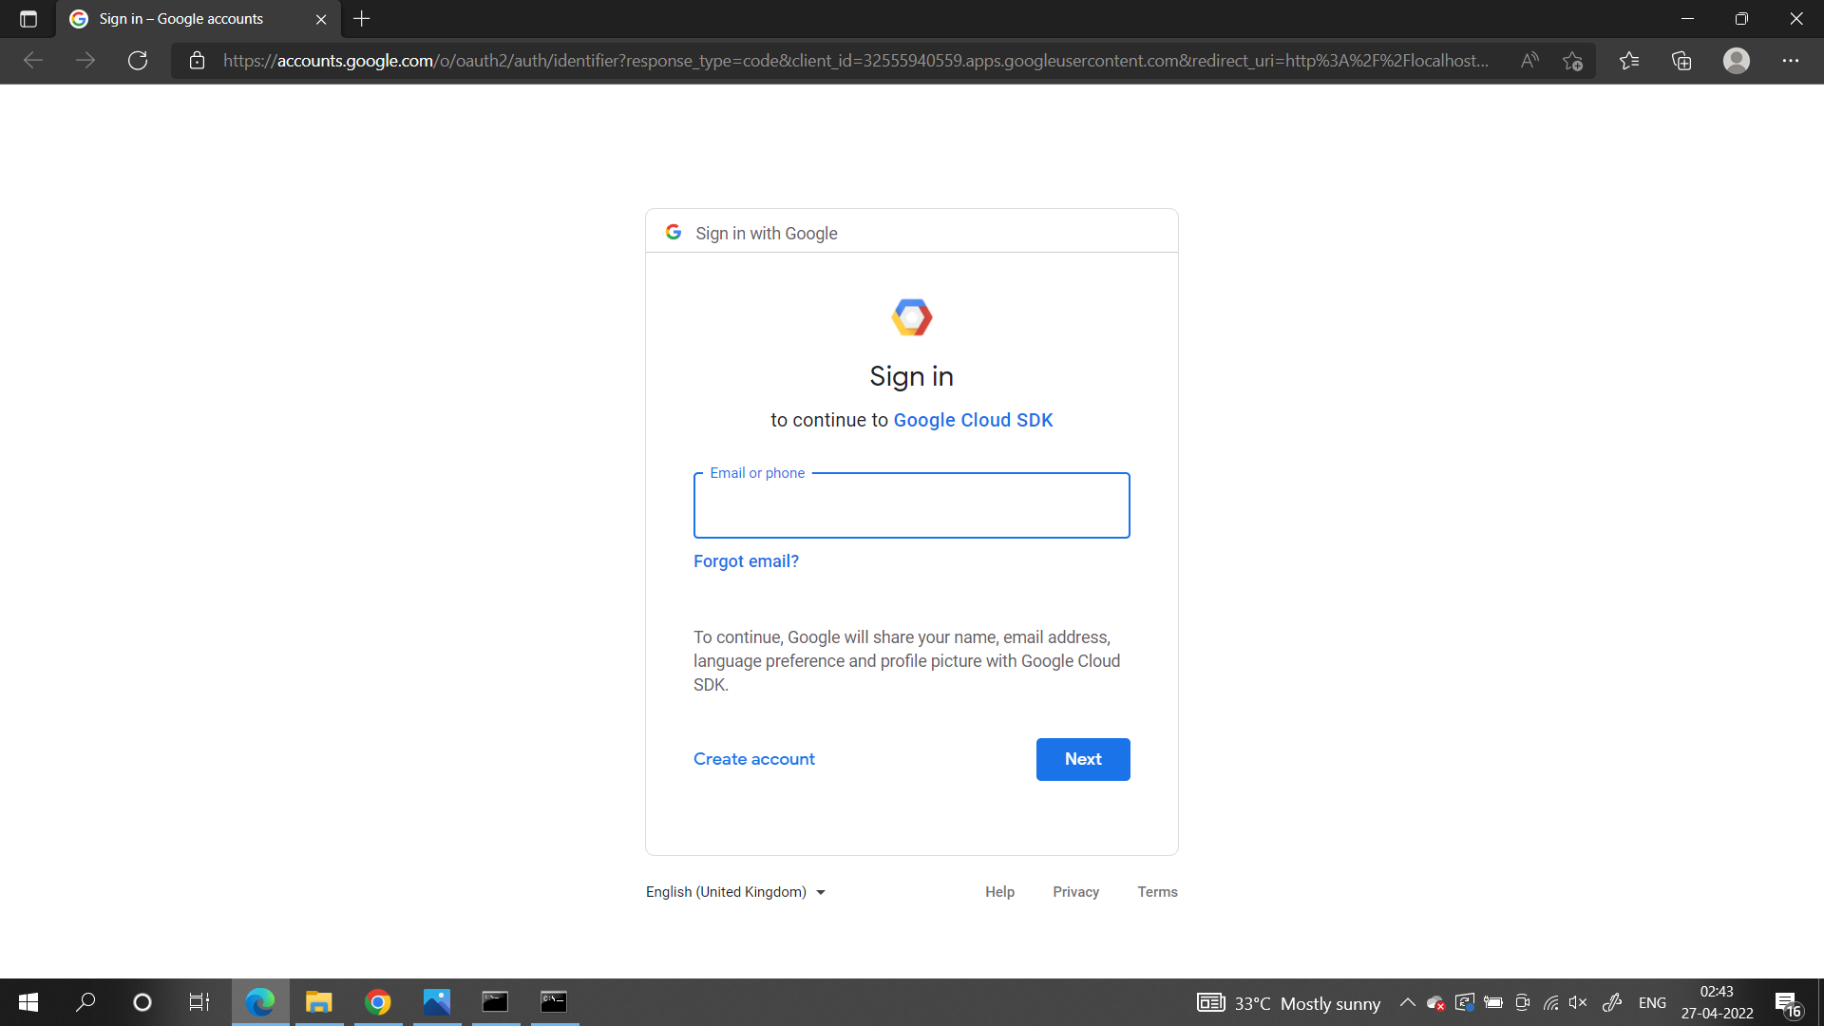

**5) Create and project and deploy:**

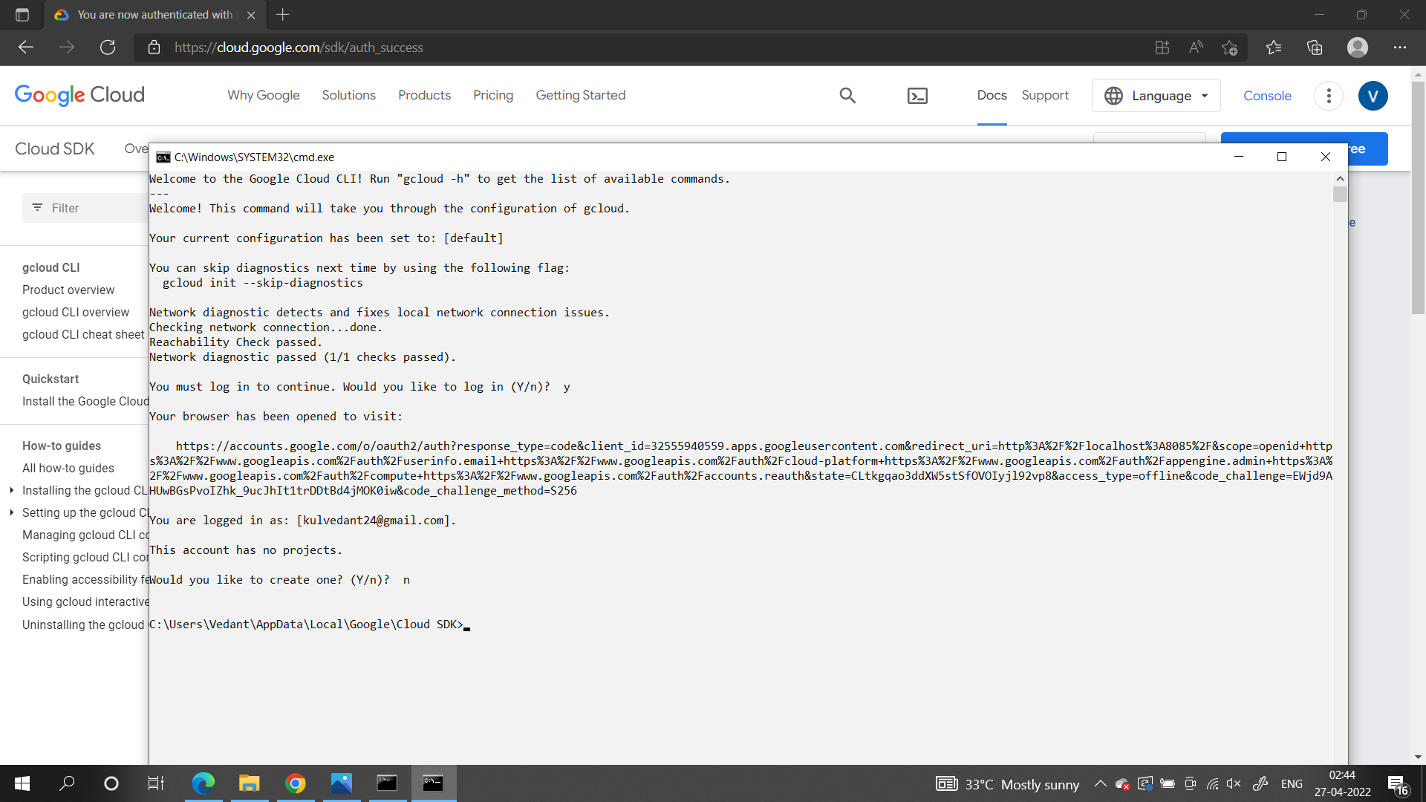

**Conclusion:**

As a result we have installed the Google APP engine CLI and now can create apps in Python/ Core java/ Go etc. and deploy it.