**Name: Shivanshu Anant Suryakar**

**PRN: 1841048**

**Class: LY BTech Computer (L3)**

**Subject: Cloud Computing**

**Aim: To set up owncloud on the ubuntu system.**

**THEORY:-**

OwnCloud is open-source software, first developed in 2010, that allows you to run a personal cloud file storage service. It has features that are comparable to other cloud storage services such as Dropbox. The OwnCloud server software can be installed free of charge on Linux, and the client software can be installed on computers running Windows, OS X, or Linux. Mobile apps are also available for Android and iOS.

OwnCloud is a file server that enables secure storage, collaboration and sharing. It is convenient to store files in the cloud, so they are available on any device and can be shared with a few clicks. There are a lot of popular providers like Google, Apple, Facebook, Twitter and Dropbox. With a lot of these vendors, files are stored and processed beyond users control. With U.S. firms, files are subject to the Cloud Act and thus to government snooping. ownCloud helps users regain their digital sovereignty. It provides lots of convenient features, too, but also stores files securely and efficiently. There are no backdoors, you can check, it’s open source. Users can install ownCloud themselves or rent a managed instance. You want to use ownCloud to benefit from the upsides of the public clouds while being in control of your data.

**The following steps are followed to create and install owncloud on an ubuntu machine:-**

**Step 1 – Update Ubuntu system packages:**

This is done to sync the OS with latest versions so to install a good version of a tool.

Command Used:- sudo apt update –y && sudo apt upgrade -y

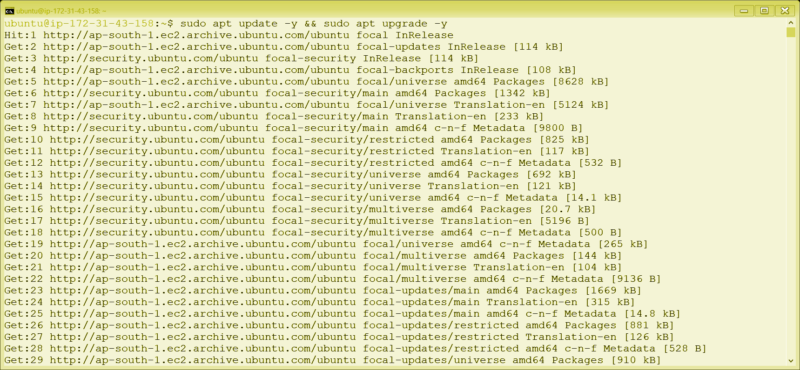

**Step 2 – Create OCC Helper Script:**

A file is created and made executable.

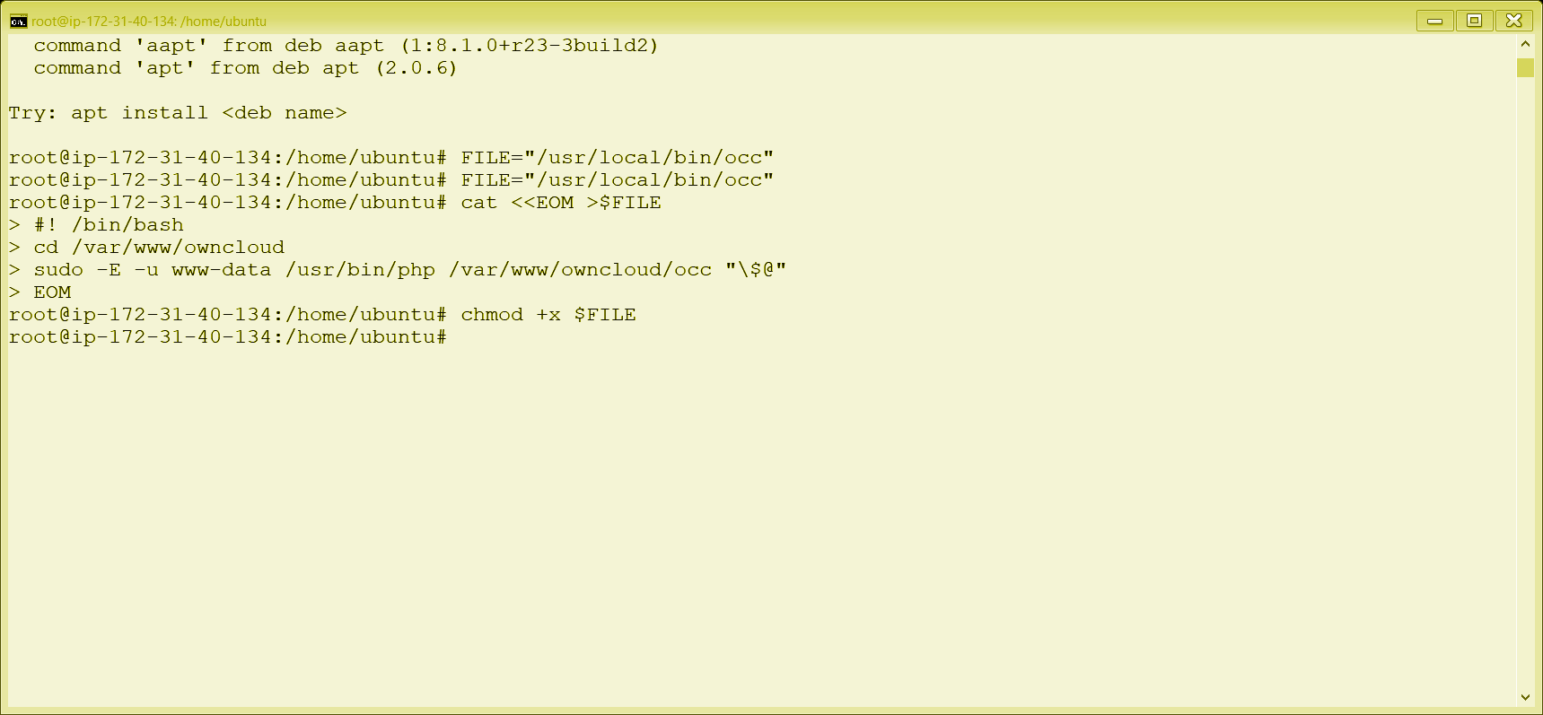

**Step 3 – Install required packages**

As we are a root user now we install some required packages like mariadb, apache2, openssl, php, etc.

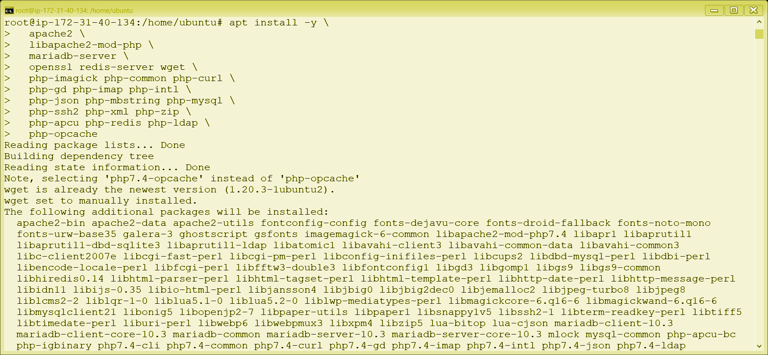

**Step 4- Install smbclient php module:-**

A php client is installed to talkback to the server.

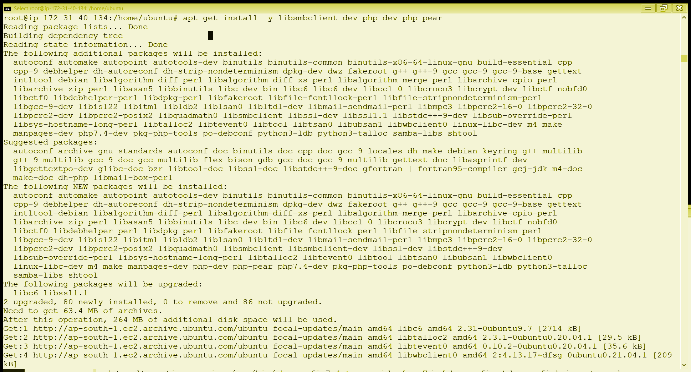

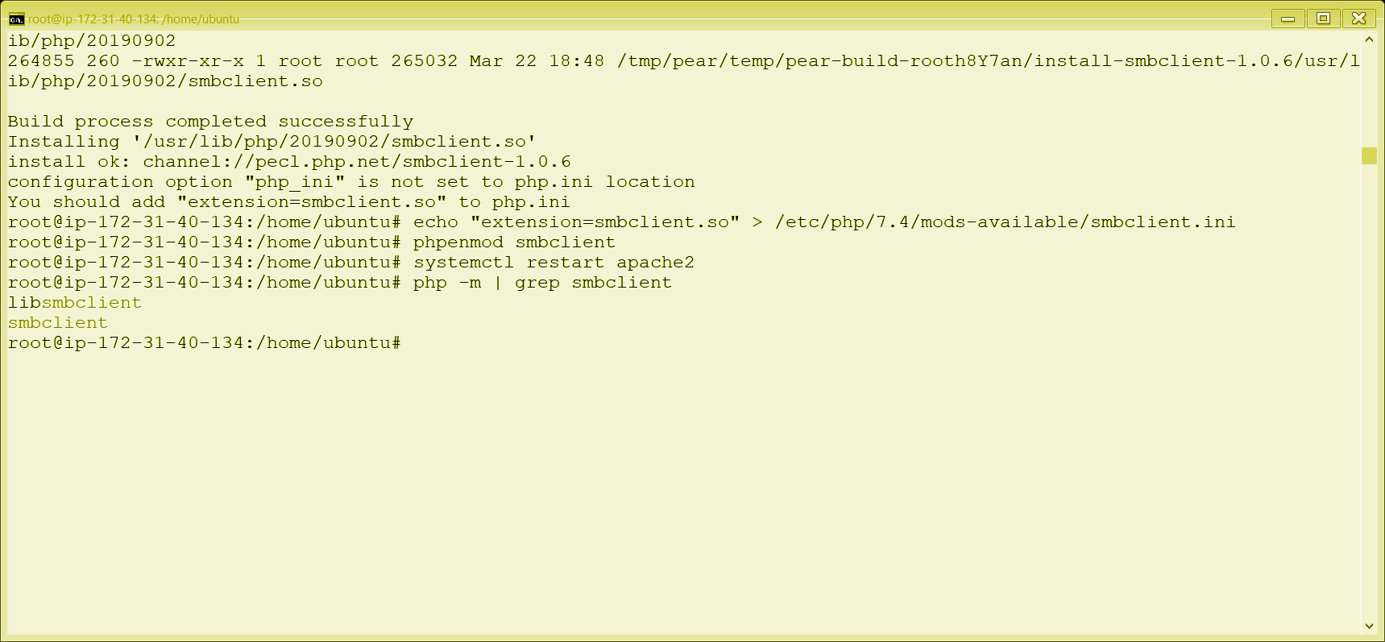

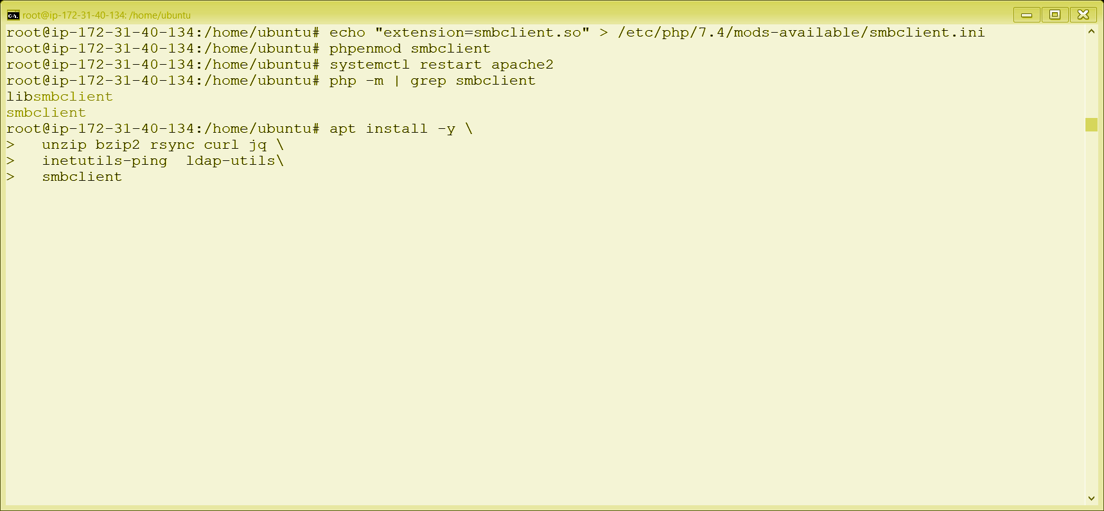

**Step 5- Configure Apache:-**

Here we configure the apache that is adding the name, adding root file etc.

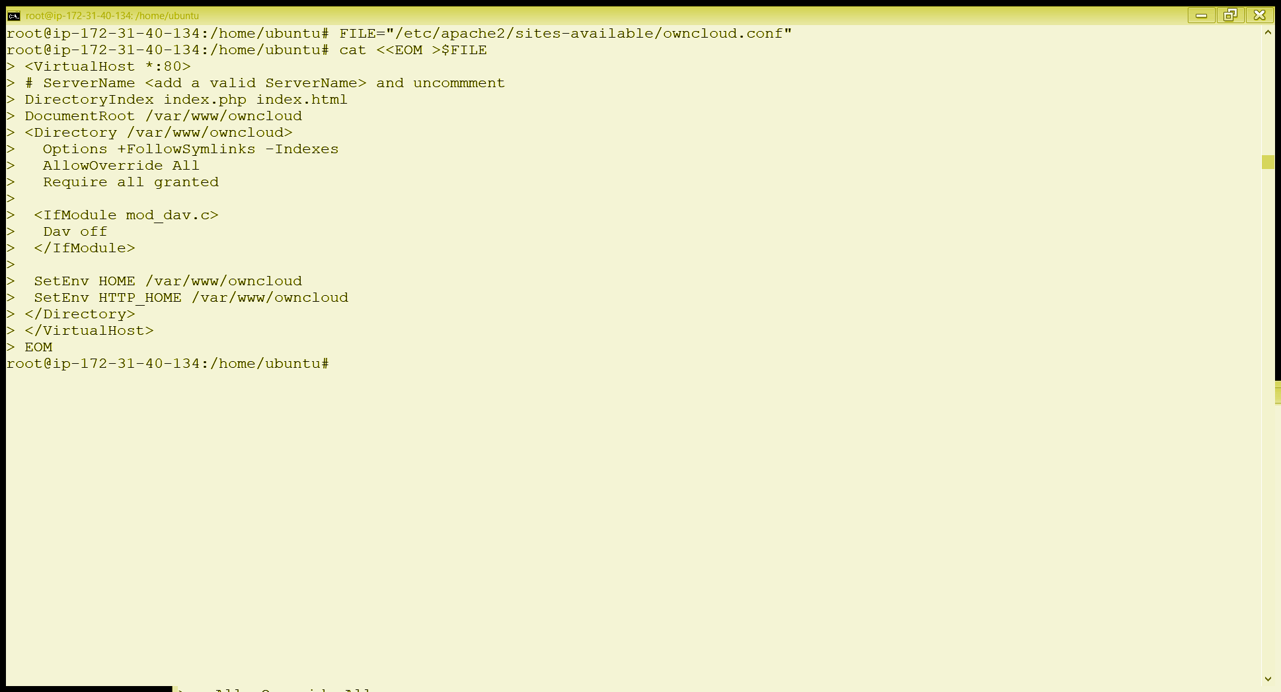

**Step 6 – Enable Virtual host configuration:-**

Apache requires enabling owncloud and all the services.

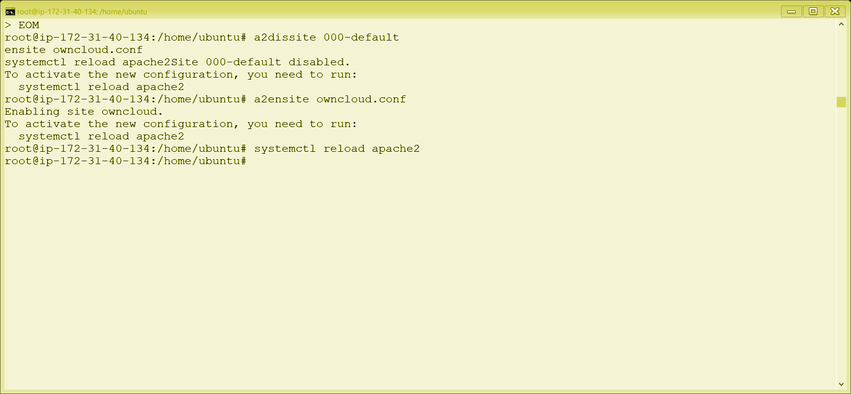

**Step 7 – Configure Database:-**

Database is required to be configured, that is the mysql database is used as base to the owncloud.

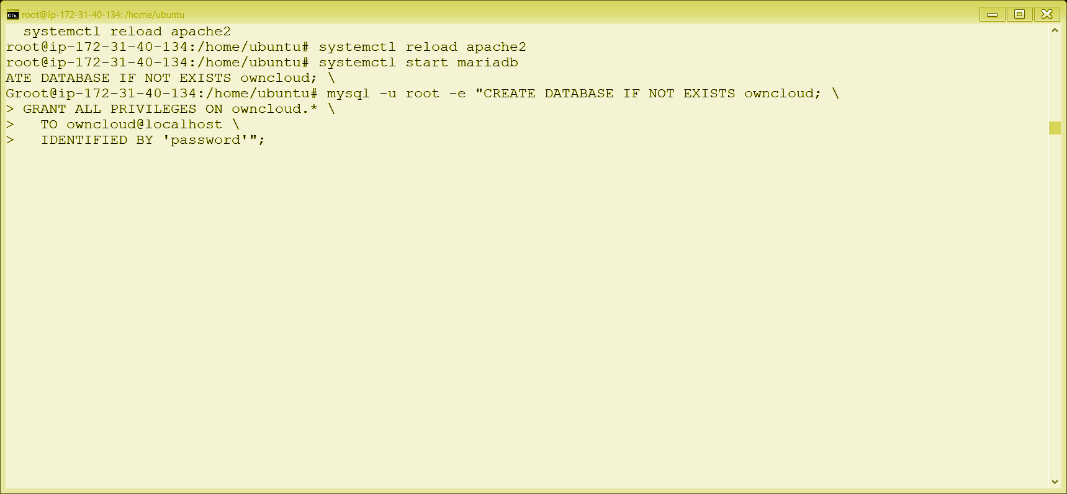

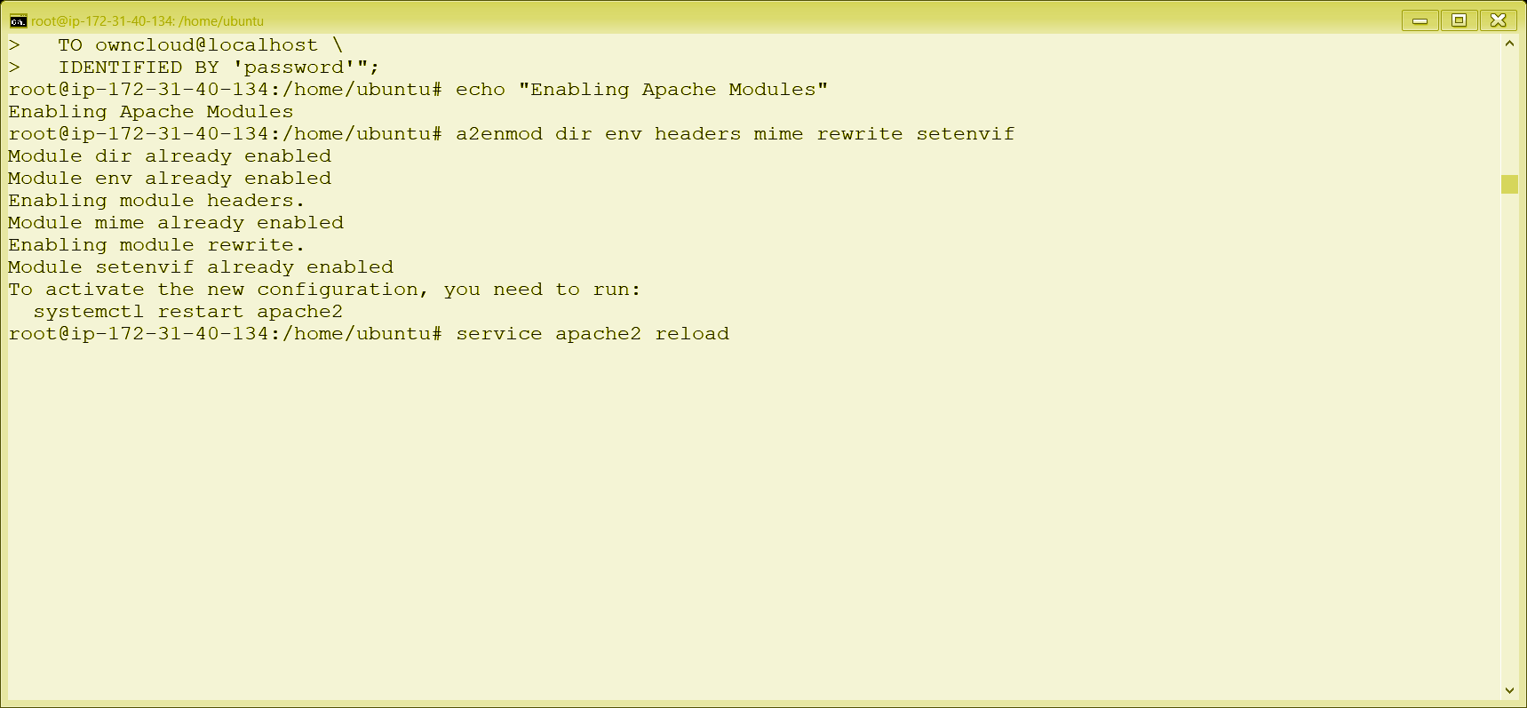

**Step 8 – Download ownCloud:-**

Now we download the owncloud cloud from the official website and extract the tar file.

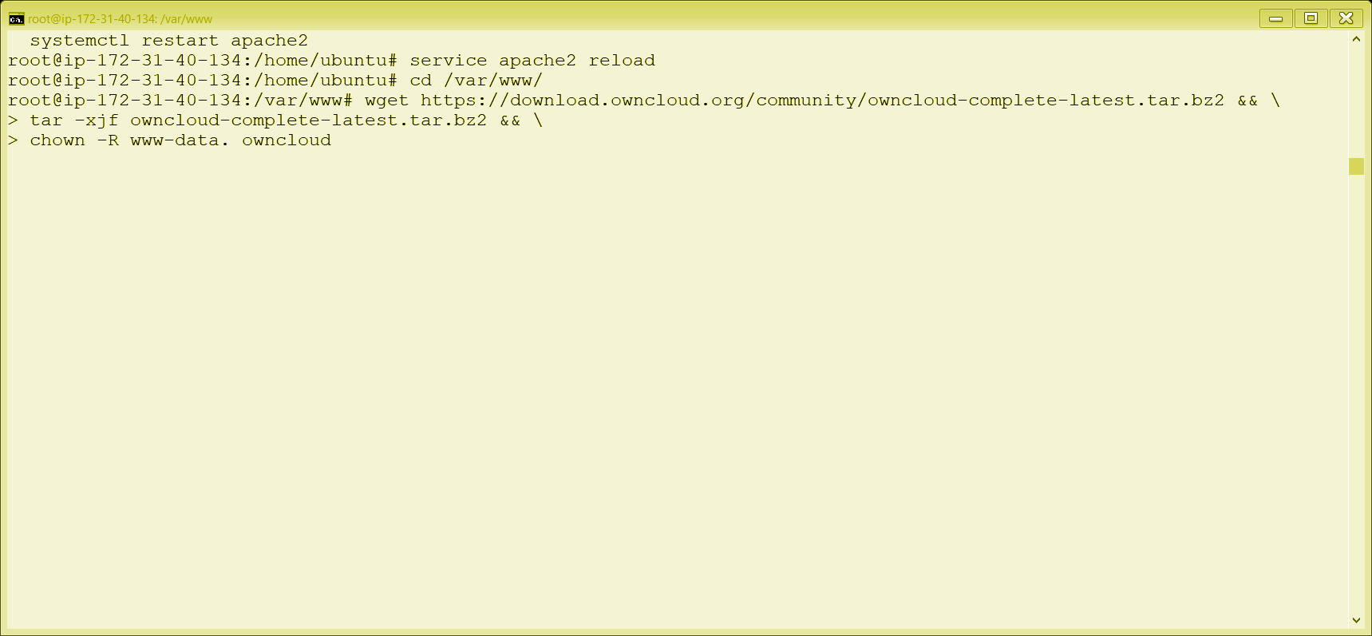

**Step 9 – Install ownCloud:-**

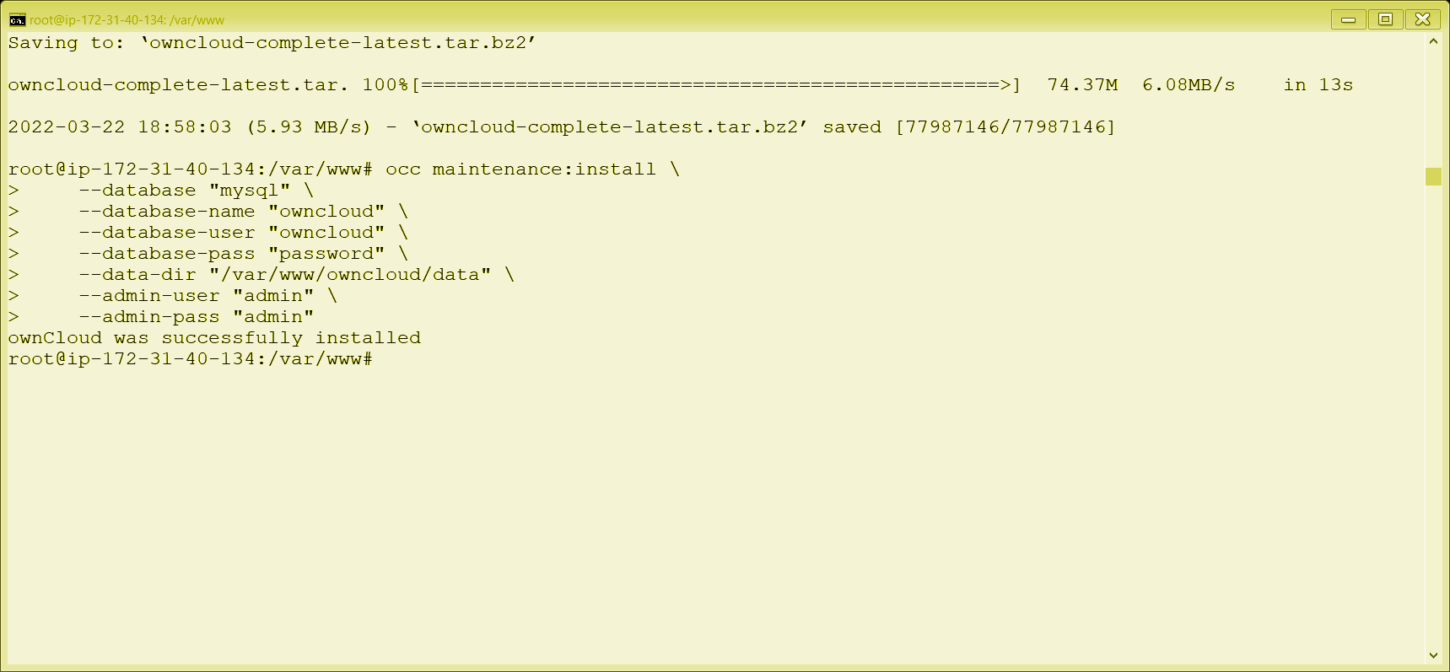

**Step 10 – Configure ownCloud’s Trusted Domains:-**

Now we configure owncloud to the database that is username password is provided so as to store local data.

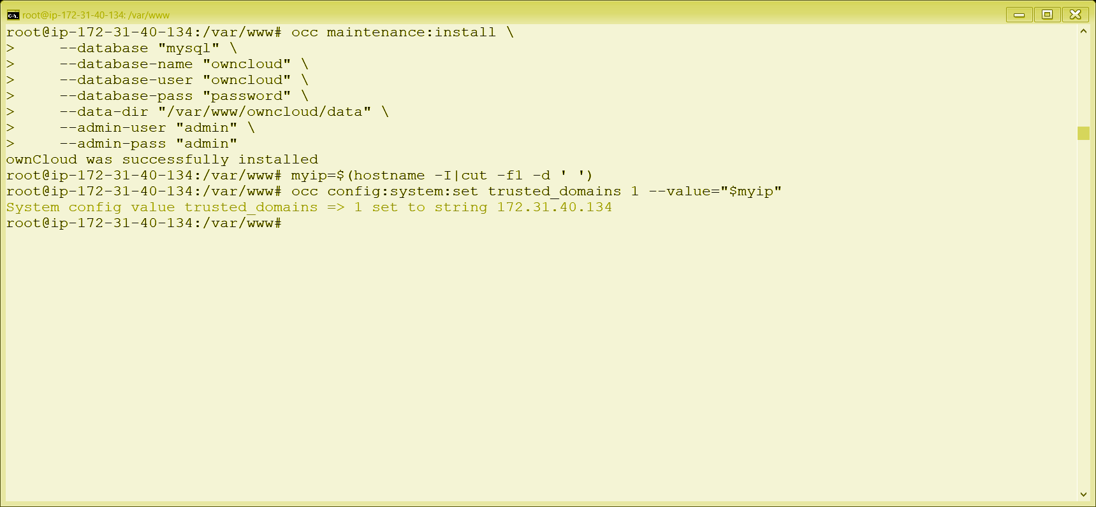

**Step 11 – Set up cron job:-**

Cron jobs are commands or shell-based scripts that are scheduled to periodically run at fixed times, dates, or intervals. To run Cron jobs with ownCloud, we recommend that you use the occ system:cron command.

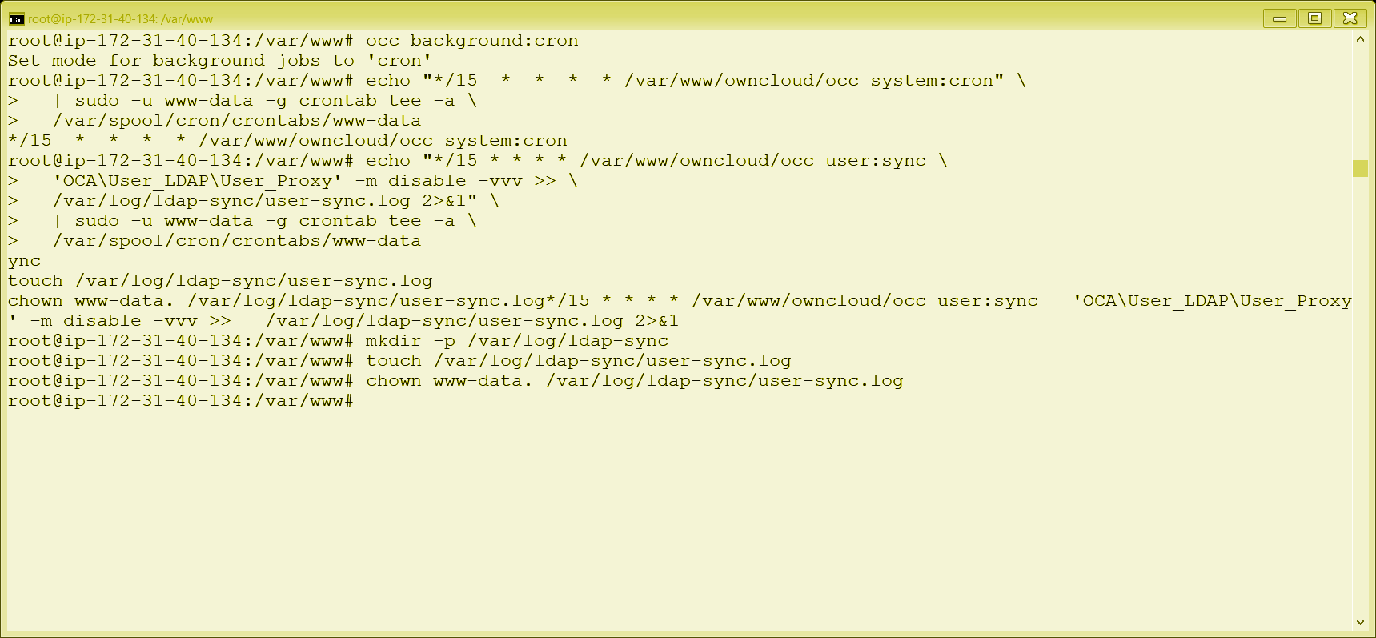

**Step 12 – Configure Caching and File Locking**

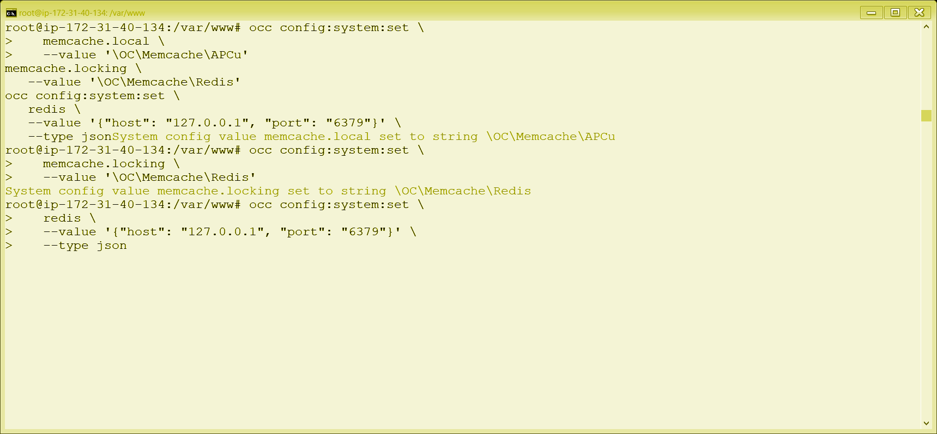

**Step 13 – Configure Log Rotation**

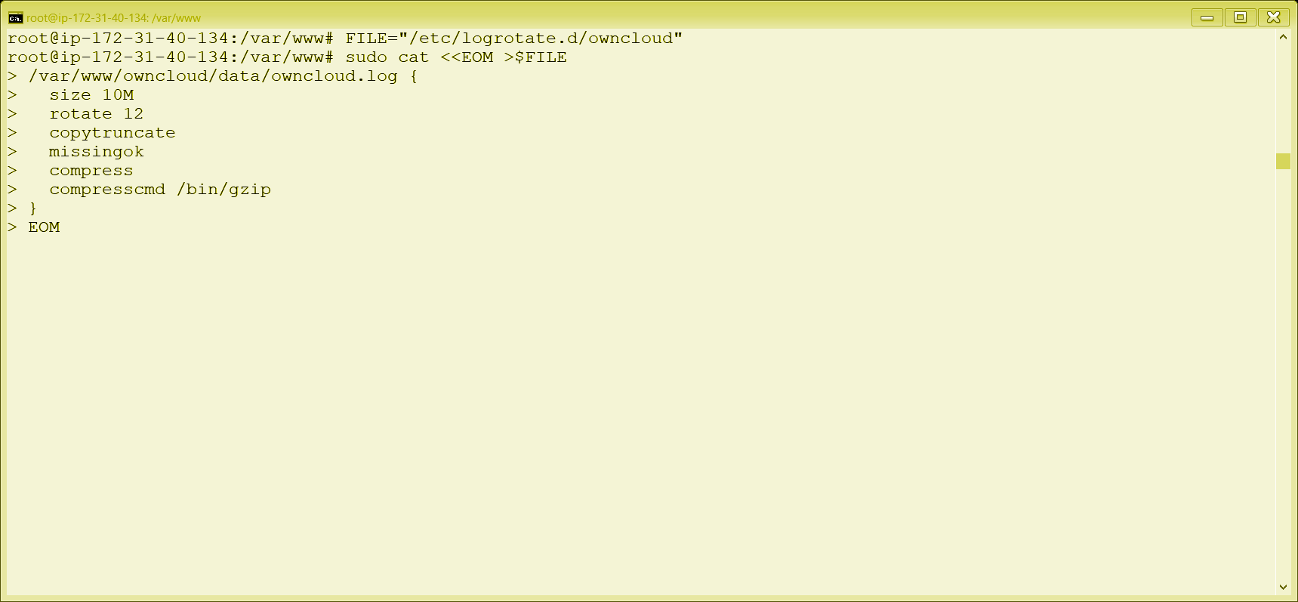

**Step 14 – Finalize installation**

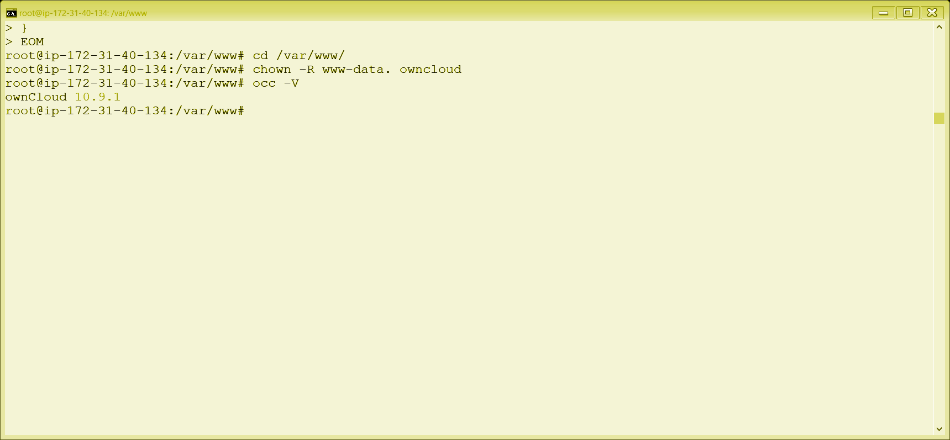

**Conclusion:-**

We have hence seen that owncloud is a considerable option for secure storage and sharing of data. There are many other uses of owncloud including versionisation, drag and drop upload etc.

We have now installed and configured owncloud and are able to use it as remote secure storage and share the files over a cloud.