**Name:** Shivanshu Anant Suryakar

**PRN:** 1841048

**Class**: LY BTech Computer (L3)

**Subject:** Cloud Computing

**Aim:** To install Ubuntu System of windows using Virtual Box (Virtualization).

**Theory:-**

Virtualization is a concept basically divided in two parts:

1. **Local Virtualization:**

Here the host is the local system for example Windows or MAC and the required system is installed on a virtual memory which is part of actual memory.

1. **Cloud Virtualization:**

Here host is the remote system of the service provider and the user uses the virtual machine via the internet.

Except for the storage being remote or local there are very small differences in the installation and hosting process of the both.

For local virtualization we use **VMware** which is an oracle based virtualization tool and for cloud virtual systems we can create an **EC2 instance of AWS** and follow a similar procedure.

**Steps to achieve a virtual machine:-**

1. **Download and install VMware:-**

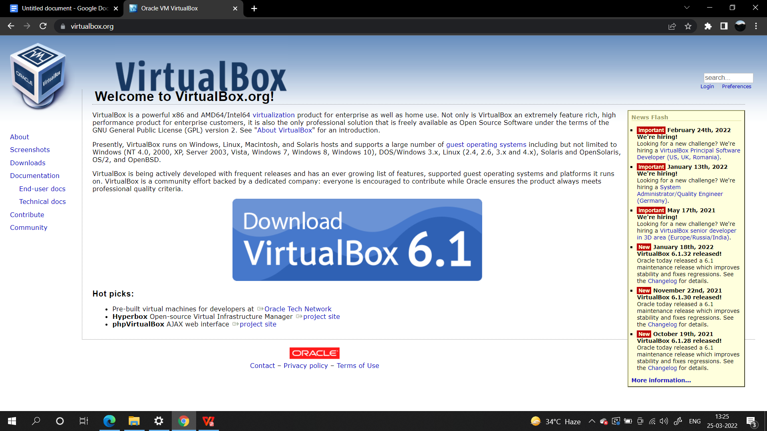

1. **After installing we need to download the ISO image file of the system we want to install. These are present on official websites and are open source for linux.**

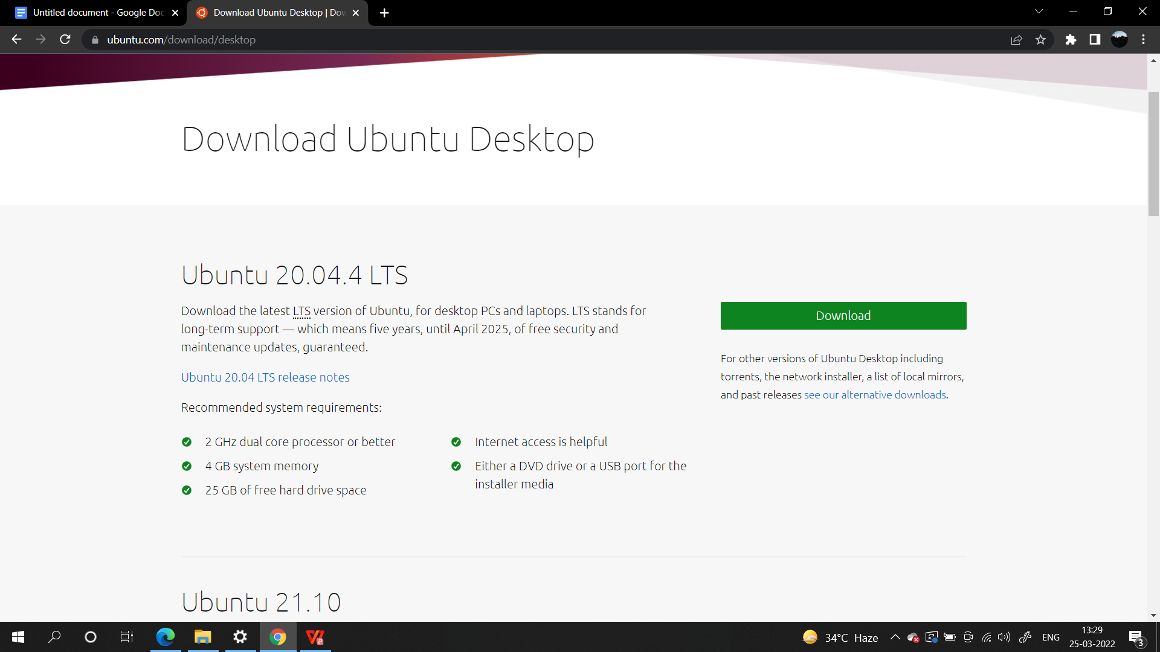

1. **We add a new machine using the new key on the console:-**

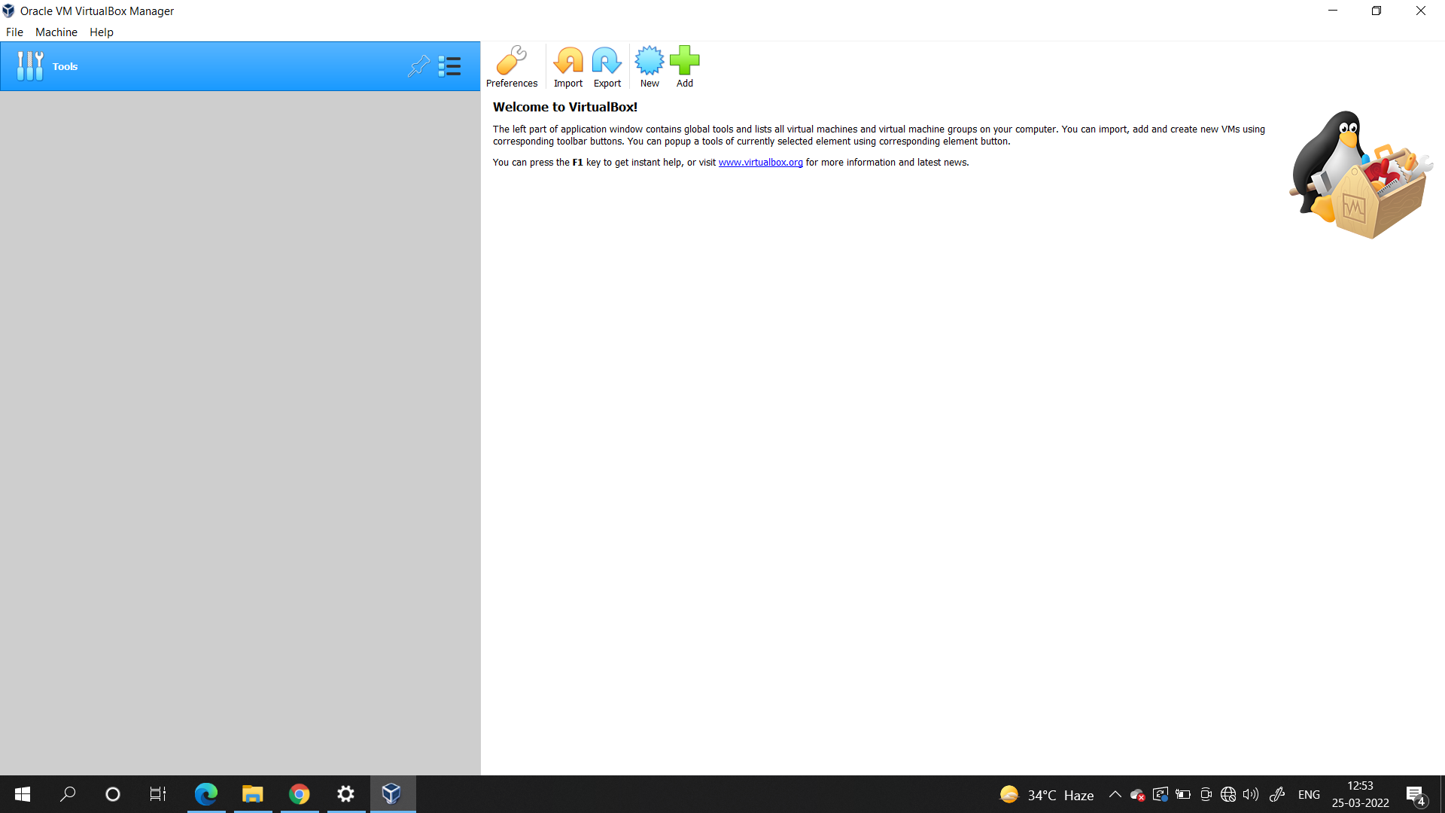

1. **Now we create an instance of ubuntu, and allot a folder to reside:**

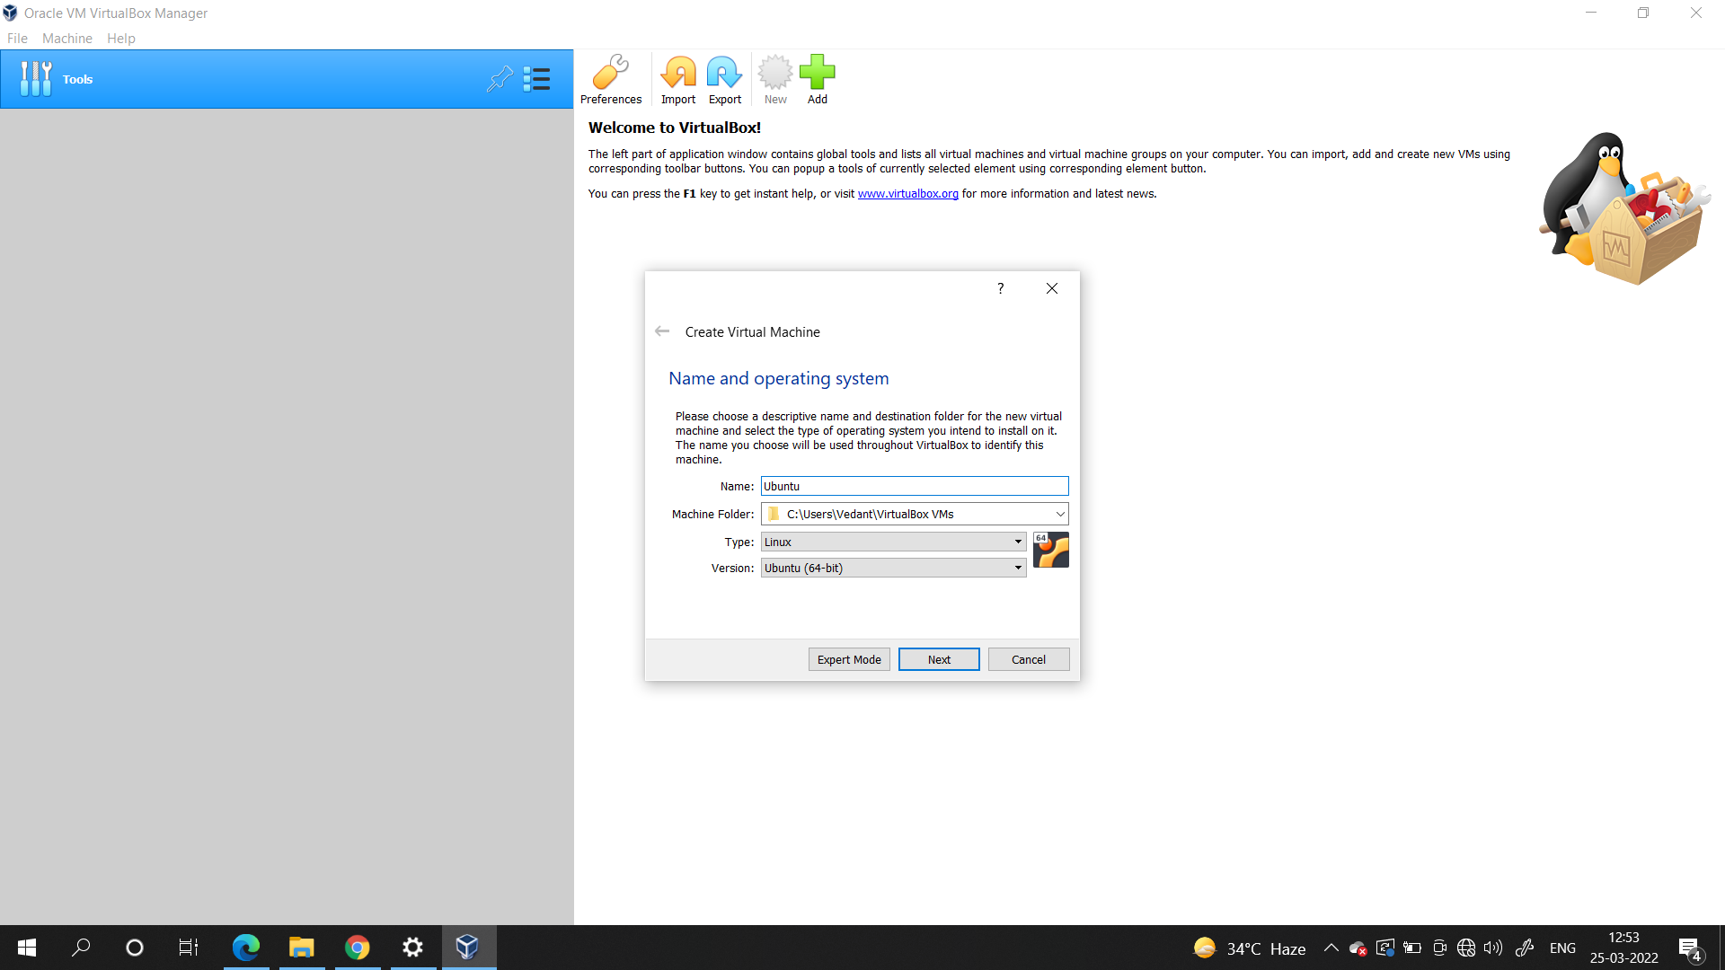

1. **We now select the RAM required which is used when we run the machine from our local machine:-**

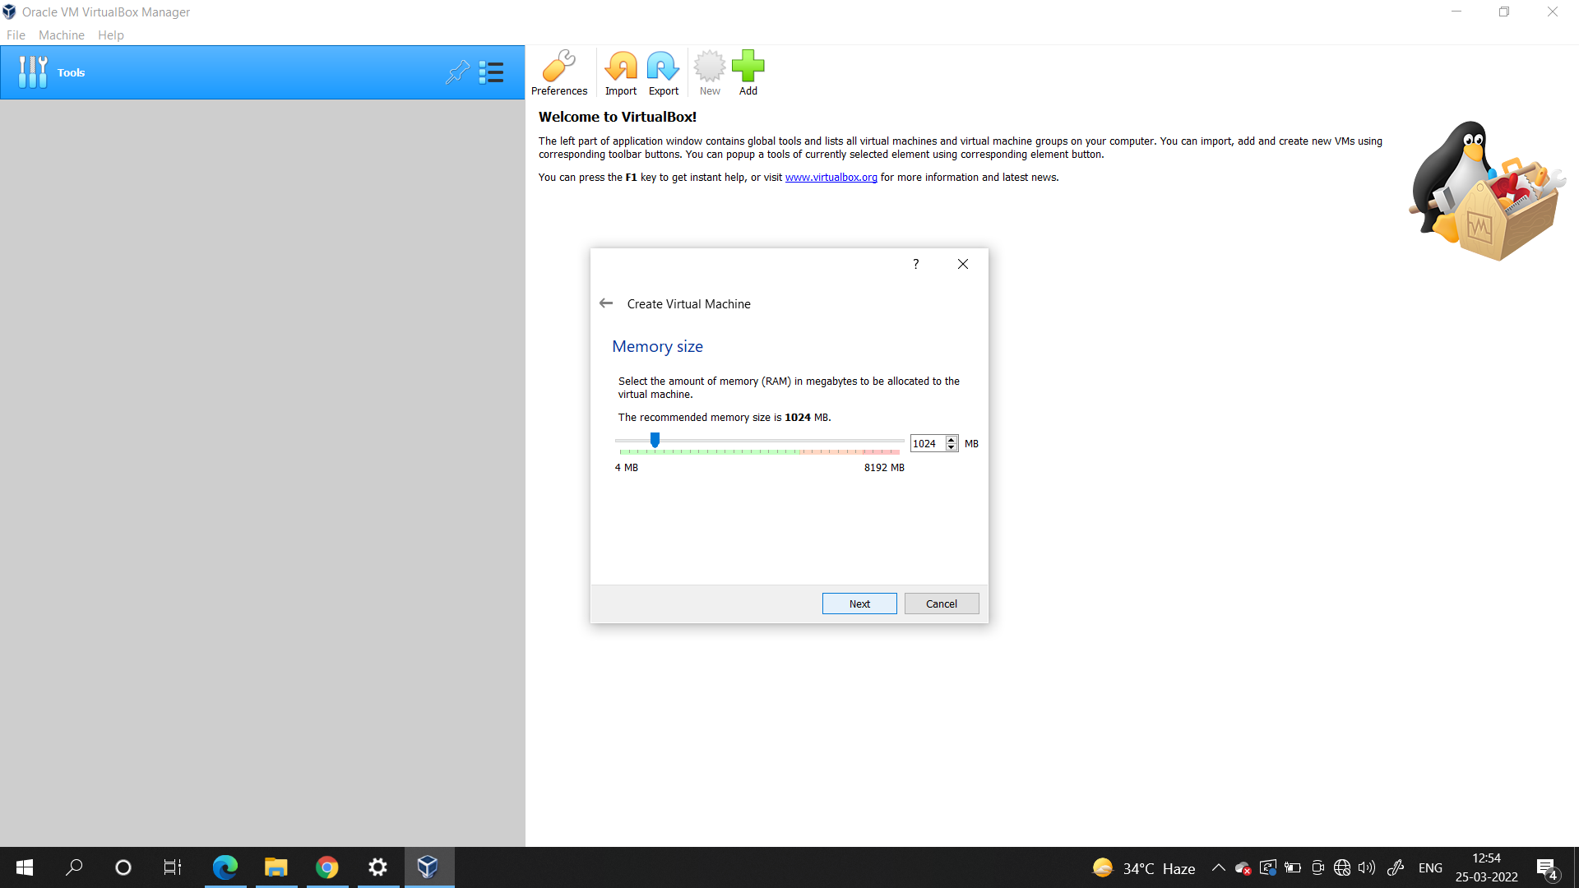

1. **Now add the actual volatile memory usually 10-15 Gb of memory is enough for regular use :-**

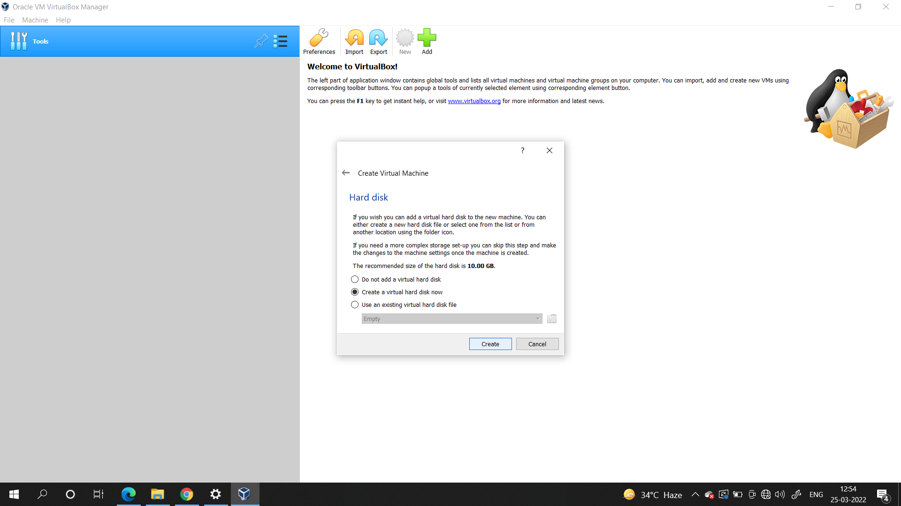

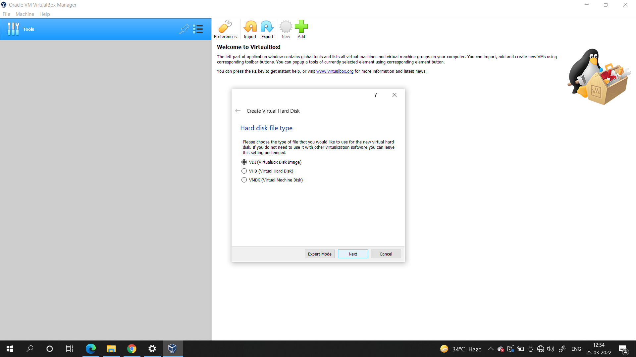

1. **A dynamic HDD is created from memory borrowed from main machine, also there is an option to get a fixed size reserved space.**

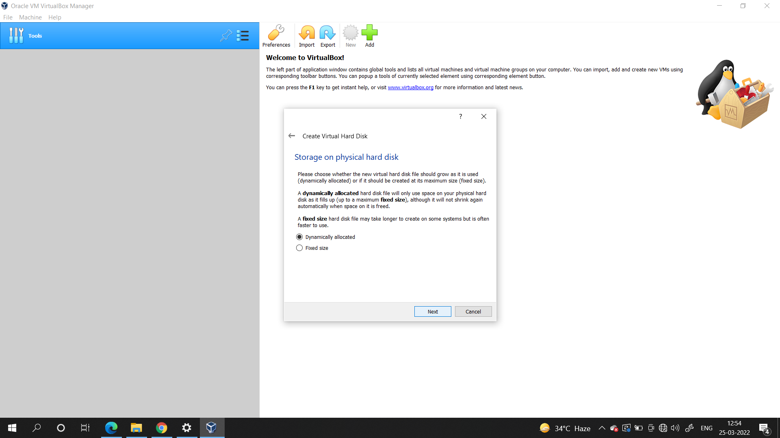

1. **Now we select the Virtual HDD size and the system is ready to run:-**

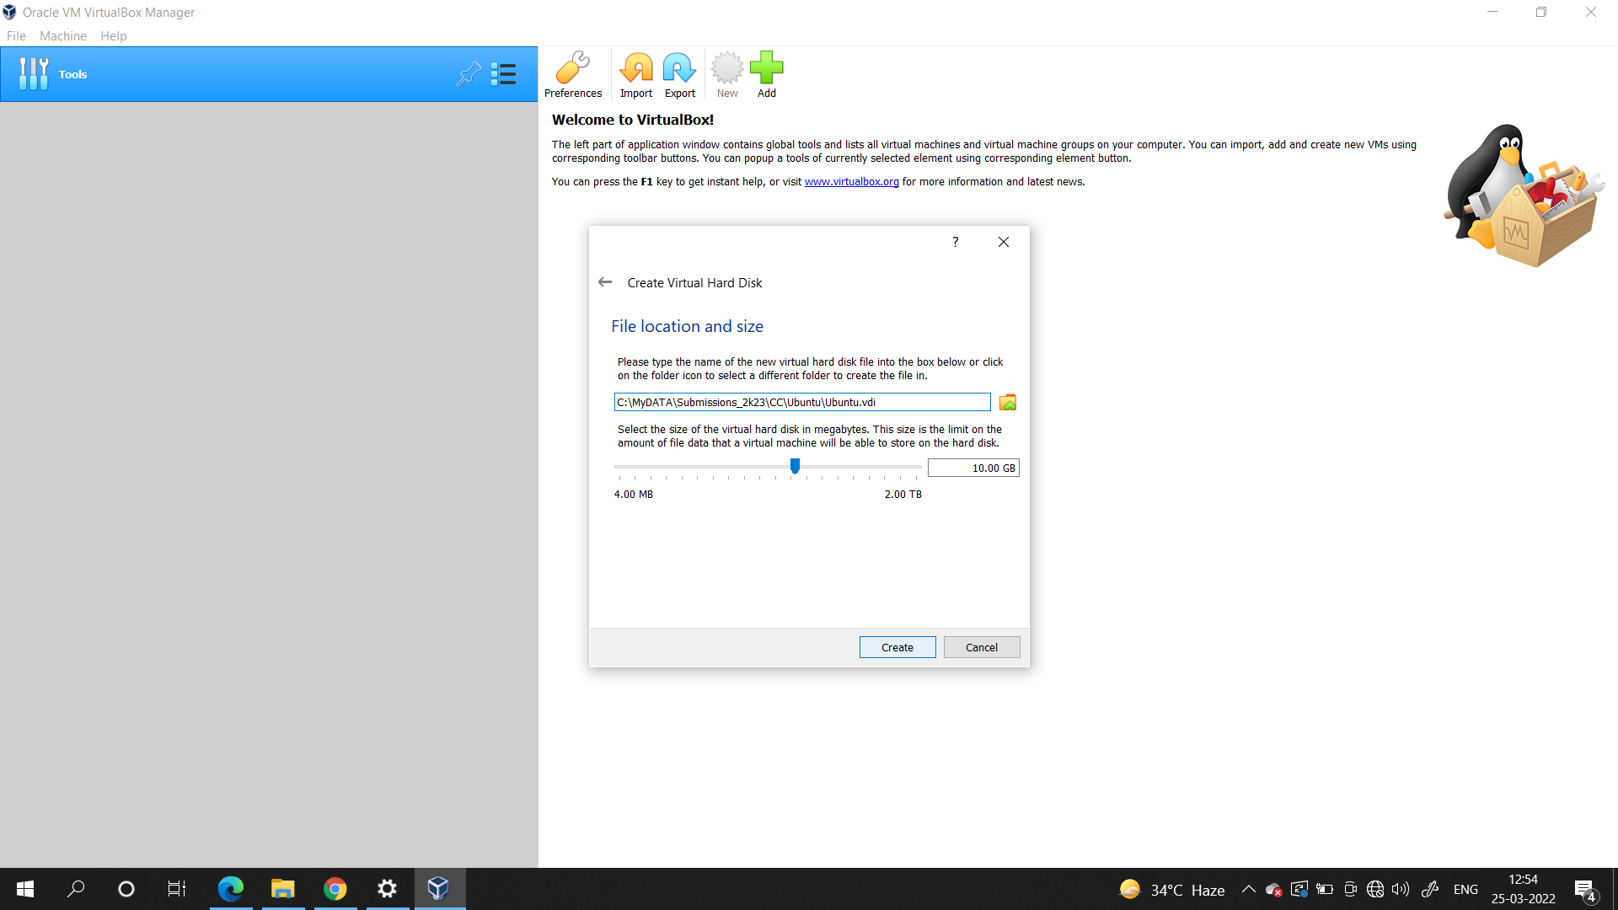

1. **And we are ready with all the hardware for the OS and can simply turn it on add the ISO image and the system gets installed :-**

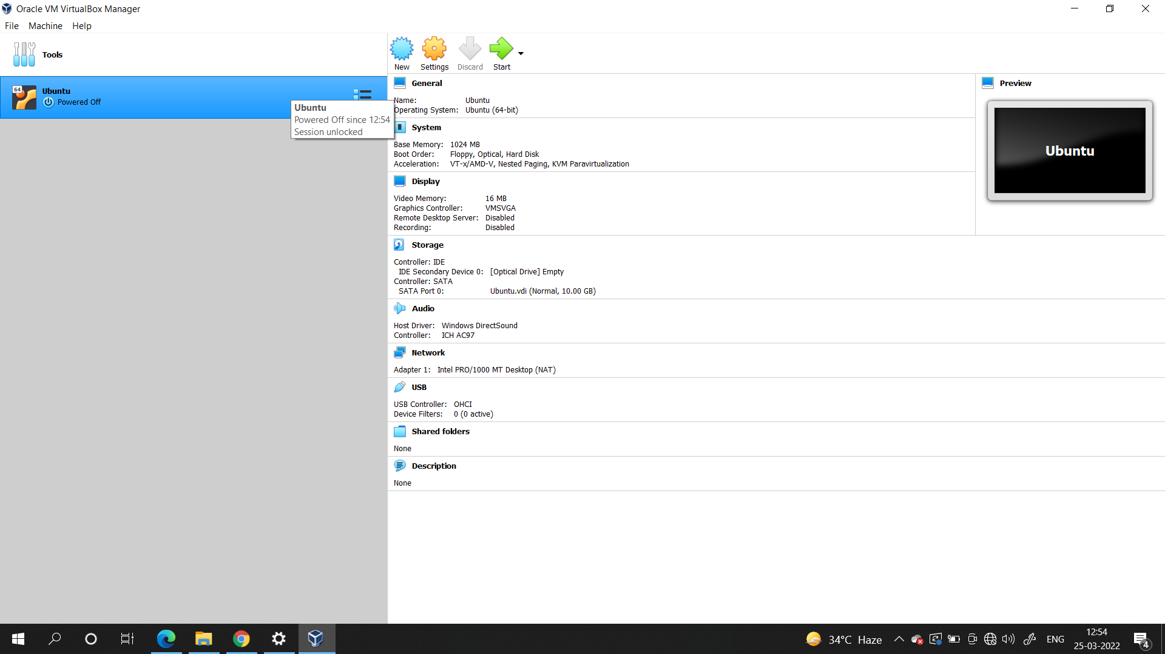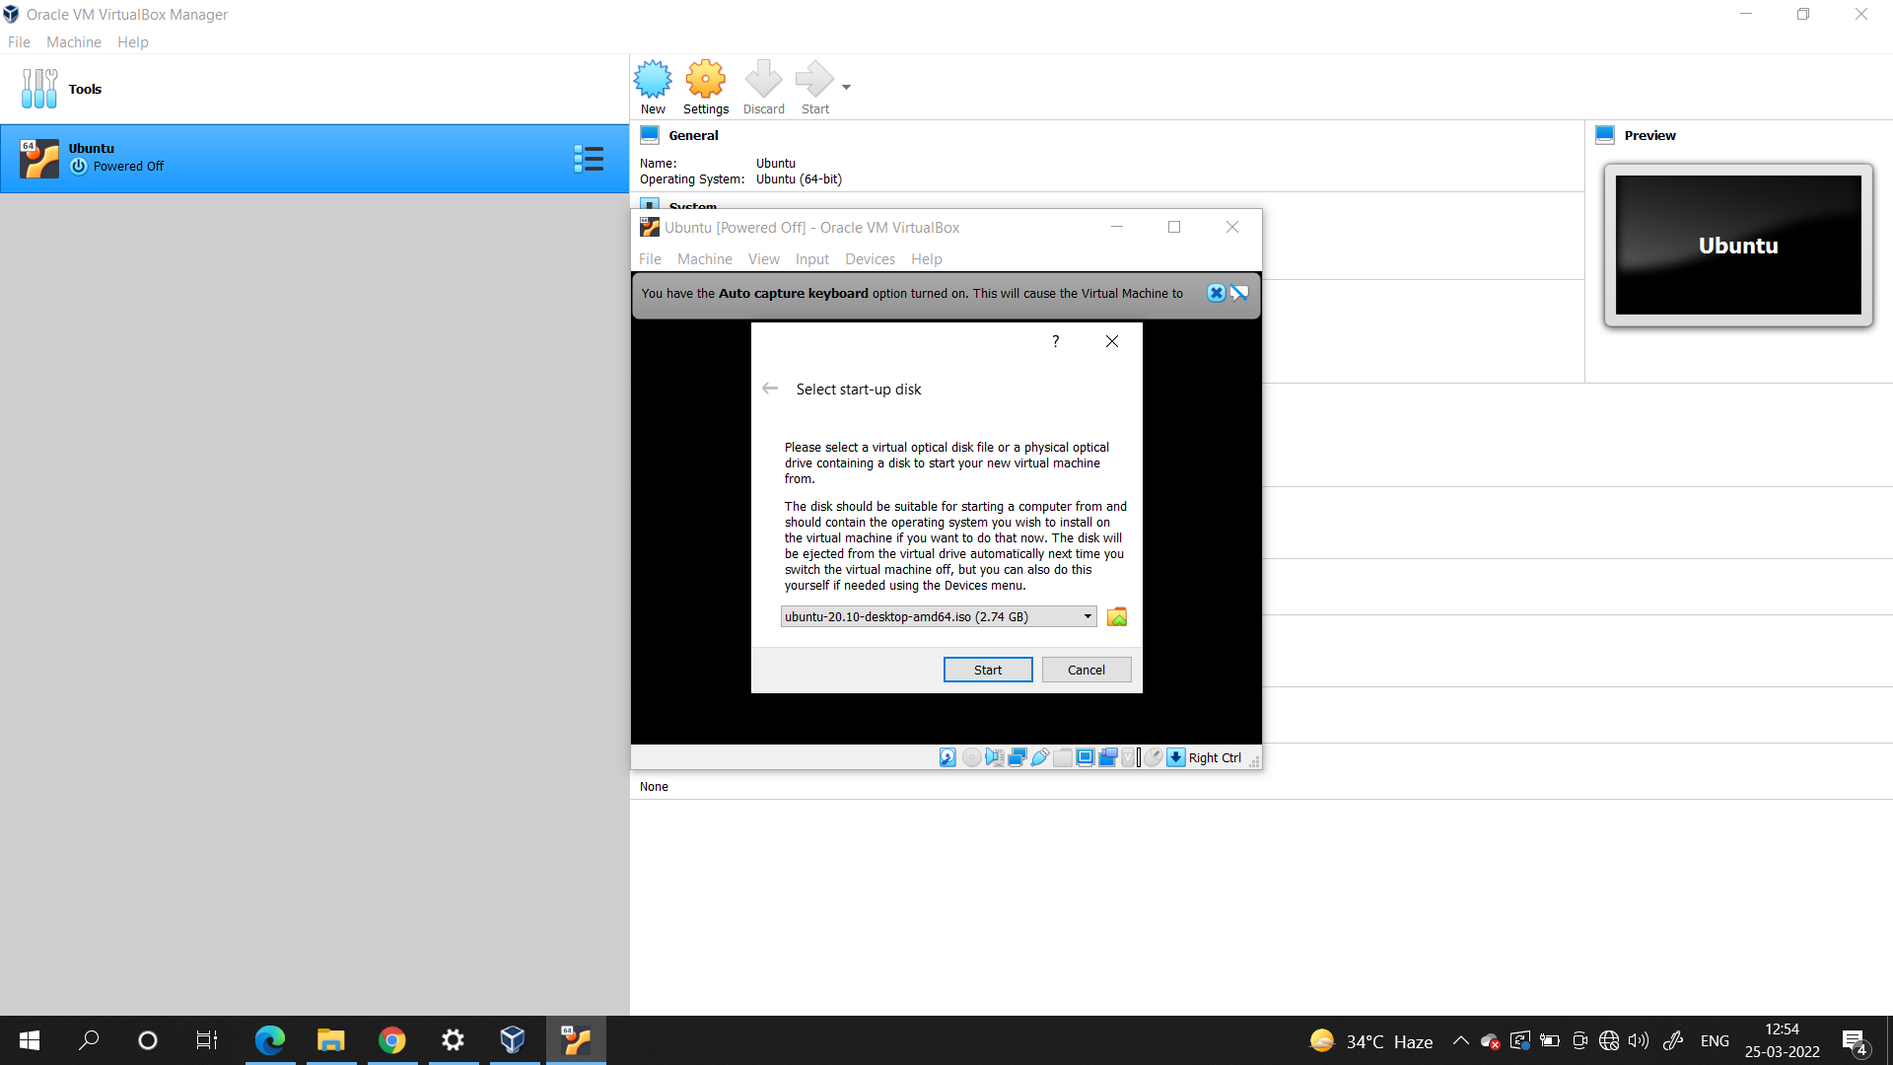

**Conclusion:**

We have hence learned the basic process to install a virtual system on windows, similar procedure with minor changes can be done to launch remote instances on cloud.