**Practical No :**

**Name:** Amey Shamrao Nagmode **PRN:** 1841032

**Class:** L.Y. BTech (Computer) **Batch** : LY2

**Subject:** Cloud Computing Lab

**Aim:** Create a simple application in Apex Programming language.

**Theory:**

Created a simple apex calculator that runs on an online salesforce apex deployer.

**Code:**

**<apex:page controller="Sample">**

**<apex:form >**

**<apex:pageBlock >**

**<apex:pageBlockSection >**

**<apex:pageBlockSectionItem >**

**<apex:outputLabel value="Value 1"/>**

**</apex:pageBlockSectionItem>**

**<apex:pageBlockSectionItem >**

**<apex:inputText value="{!val1}"/>**

**</apex:pageBlockSectionItem>**

**<apex:pageBlockSectionItem >**

**<apex:outputLabel value="Value 2"/>**

**</apex:pageBlockSectionItem>**

**<apex:pageBlockSectionItem >**

**<apex:inputText value="{!val2}"/>**

**</apex:pageBlockSectionItem>**

**<apex:pageBlockSectionItem >**

**<apex:selectRadio value="{!func}" layout="pageDirection">**

**<apex:selectOption itemValue="add" itemLabel="Add"/>**

**<apex:selectOption itemValue="sub" itemLabel="Subtract"/>**

**<apex:selectOption itemValue="div" itemLabel="Division"/>**

**<apex:selectOption itemValue="mod" itemLabel="Modulo Division"/>**

**</apex:selectRadio>**

**</apex:pageBlockSectionItem>**

**<apex:pageBlockSectionItem >**

**</apex:pageBlockSectionItem>**

**<apex:pageBlockSectionItem >**

**<apex:outputLabel value="Result"/>**

**</apex:pageBlockSectionItem>**

**<apex:pageBlockSectionItem >**

**<apex:inputText value="{!result}" id="res"/><apex:actionStatus id="sts" startText="Finding..."/>**

**</apex:pageBlockSectionItem>**

**</apex:pageBlockSection>**

**<apex:pageBlockButtons >**

**<apex:commandButton value="Find" action="{!find}" reRender="res" status="sts"/>**

**</apex:pageBlockButtons>**

**</apex:pageBlock>**

**</apex:form>**

**</apex:page>**

**Apex Code:**

**public class Sample**

**{**

**public Double val1 {get;set;}**

**public Double val2 {get;set;}**

**public Double result {get;set;}**

**public String func {get;set;}**

**public Sample()**

**{**

**}**

**public void find()**

**{**

**if(func == 'add')**

**{**

**result = val1 + val2;**

**}**

**else if(func == 'sub')**

**{**

**result = val1 - val2;**

**}**

**else if(func == 'div')**

**{**

**result = val1 / val2;**

**}**

**else**

**{**

**Integer temp = math.mod(Integer.valueOf(val1) , Integer.valueOf(val2));**

**result = Double.valueOf(temp);**

**}**

**}**

**}**

Output:

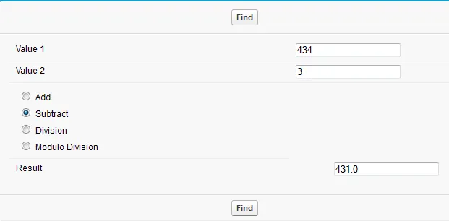

**Conclusion:**

Salesforce is a cloud platform allowing to create and deploy projects, created a simple calculator using apex a salesforce based language.