Article

Habitat-driven variation in sexual dimorphism of amphipods
Amey Danole1,2*, Fernando Tuya2, Francisco Otero-Ferrer2, Sonia Díaz-Vergara2 and Sandra Navarro-Mayoral2

1 University of Groningen, Groningen, The Netherlands; a.danole@student.rug.nl
2 Biodiversity and Conservation Research Group, IU-ECOAQUA, Scientific and Technological Marine Park of the Universidad de Las Palmas de Gran Canaria, Telde 35214, Spain
* Correspondence: a.danole@student.rug.nl
Abstract 1
Sexual dimorphism in morphological traits is widespread across animals and can result 2
from differing life-history strategies, sex-specific competition, and ecological interactions 3
influenced by habitat structure. For epifaunal organisms such as amphipods, habitat 4
complexity mediates access to food, mate encounters, and refuge. This study investigates 5
sex-related variation in body size and gnathopod 2 ratio (gnathopod 2 length/body length) 6
in two amphipod species, Ampithoe ramondi and Caprella acanthifera, across four benthic 7
habitats: rhodolith beds, macroalgae-dominated reefs, seagrass meadows, and black coral 8
forests. A. ramondi occurred in all habitats except black coral forests, with males larger 9
than females only in macroalgae-dominated reefs and exhibiting higher gnathopod ratios, 10
increasing across macroalgae-dominated reefs, seagrass meadows and rhodolith beds. C. 11
acanthifera was found in macroalgae-dominated reefs and black coral forests, with males 12
larger on average but no significant habitat-related variation in dimorphism. These results 13
indicate that sexual dimorphism patterns are species-specific, shaped by habitat-specific 14
ecological pressures and life-history strategies. Expanding such analyses to more taxa 15
and with balanced sampling across habitats and environmental gradients will offer deeper 16
insight into how natural and sexual selection interact and inform how these dynamics may 17
shift under changing climate regimes. 18
Keywords: Amphipoda, sexual dimorphism, sexual selection, marine ecology, Canary 19
Islands 20

Received:
Revised:
Accepted:
Published:
Copyright: © 2026 by the authors. Submitted to Journal Not Specified for possible open access publication under the terms and conditions of the Creative Commons Attribution
(CC BY) license.
- Introduction 21
Sexual dimorphism refers to differences between males and females of a species, 22
which can result from sexual or fecundity selection or from intersexual niche divergence 23
[1–3]. Sexual selection favours traits that increase mating success, whereas fecundity 24
selection acts primarily on traits enhancing reproductive output. In contrast, intersexual 25
niche divergence arises when males and females experience different ecological pressures 26
and consequently specialize on distinct resources or habitats. These differences may be 27
morphological, physiological, or behavioural, and their magnitude and direction are often 28
shaped by abiotic (e.g. temperature, nutrient availability or habitat structure) and biotic 29
factors (e.g. predation pressure or interactions with other organisms) [1,4]. For example, 30
shared parental care or limited mate availability can limit the development of certain traits, 31
reducing dimorphism and favouring more similar (monomorphic) characteristics [5]. By 32
contrast, when sexual selection strongly favours one sex, intense competition for mates can 33
drive the evolution of exaggerated traits and behaviours, resulting in pronounced sexual 34
dimorphism [2,6,7]. While sexual dimorphism across habitats has been widely studied 35

in terrestrial organisms [8,9], there are very few studies in marine systems examining 36 how sexual dimorphism varies within the same species across different habitats [10–12]. 37 Past studies in marine-associated species have shown that sexual dimorphism can be 38 associated with sex-specific habitat use [10] or with differences in selection pressures across 39 environments [12], yet comparative evidence of how dimorphic traits vary across marine 40 habitats within species is scarce, limiting our understanding of how environmental context 41 shapes the expression of dimorphic traits. 42
The Amphipoda is one of the most ecologically diverse crustacean orders, encom- 43
passing over 10,000 species [13,14] inhabiting all aquatic environments worldwide, from 44
hadal depths to alpine freshwater streams, from lightless groundwaters to tropical forests, 45
and from sea bottom sediments to the entrails of gelatinous plankton [15]. Amphipods 46
display diverse mating strategies and pronounced sexual dimorphism, particularly in the 47
enlarged male gnathopods in some families. This variation provides an opportunity to 48
examine how ecological context shapes trait expression [17]. For instance, in caprellid 49
amphipods (family Caprellidae) from the Pagasitikos Gulf, pronounced sexual dimorphism 50
in body size has been reported [18]. In some amphipod families, the first two pairs of 51
pereopods are modified into gnathopods, with the second pair typically enlarged in males 52
and used during copulation [19]. Such marked dimorphism in gnathopods suggests a role 53
as sexually selected traits as proposed or demonstrated in their use in intrasexual contests, 54
defence, nest-guarding, territorial interactions, courtship displays, and assessment of fe- 55
male quality or as weapons [20–24]. Although direct evidence for amphipod gnathopods as 56
weapons is limited, their morphology and associated behaviours suggest a role in mating 57
competition, likely shaped by selective pressures such as mate guarding or signalling in 58
complex habitats. Thus, understanding sexual dimorphism in amphipods requires con- 59
sidering ecological context, as habitat structure, host associations, and feeding ecology 60
influence the selective pressures acting on these traits [20,25,26]. Habitat complexity, in 61
particular, can modulate the intensity and expression of sexual dimorphism by altering 62
predation risk, resource availability, and mate encounter rates. In structurally complex 63
habitats, such as macroalgae-dominated reefs, increased shelter and niche availability may 64
reduce predation pressure and allow the persistence of a wider range of phenotypes [27,28]. 65
This can facilitate the expression of exaggerated traits associated with sexual selection. In 66
contrast, in less complex habitats with limited refuge and resources, such as black coral 67
forests lacking epiphytic layers, smaller body sizes and reduced trait exaggeration may 68
be favoured due to energetic constraints and higher exposure to predation [16]. More 69
broadly, habitat structure can influence mating systems by shaping mate encounter rates 70
and competitive interactions, thereby affecting the strength of sexual selection [1,4]. For 71
example, in amphipods, structurally complex environments may allow males with different 72
body sizes or gnathopod morphologies to succeed under different microhabitat conditions, 73
highlighting how habitat architecture can modulate patterns of sexual dimorphism [29]. 74
Although previous work has highlighted the role of habitat complexity in shaping sexual 75
dimorphism, the mechanisms linking ecological context to trait expression in amphipods 76
remain poorly understood. The present study aims to address this gap by examining how 77
habitat and ecological factors influence body size and gnathopod dimorphism. 78
The coastal habitats of the Canary Islands include black coral forests, rhodolith beds, 79
seagrass meadows and macroalgae-dominated beds on reefs [30–33]. These complex 80
habitats can affect survival, predation risk, mate encounters, and the expression of mor- 81
phological and behavioural traits. Although all four habitats share three-dimensional 82
architecture, they differ in structural arrangement, a factor that may shape the selective 83
pressures acting on amphipods and the development of sexually dimorphic traits [29]. 84
Amphipods, in particular, maintain a close relationship with their habitats due to their 85

direct development, limited mobility and, in some cases, specialised feeding strategies, 86 which constrain their dispersal [16,34]. Recent studies on amphipods show that sexual 87 dimorphism can be lineage-specific and context-dependent, with certain traits diverging 88 adaptively among cryptic freshwater lineages [35] or differing in specific morphological 89 traits consistent with sexual dimorphism in marine populations [36]. Few studies have com- 90 pared sexual dimorphism across habitats within marine amphipod species. Thus, taking 91 advantage of their strong habitat association, we studied amphipods across habitats with 92 varying structural complexity to assess how these differences influence trait expression and 93 sexual dimorphism. We sampled amphipod species across the four aforementioned benthic 94 habitats in Gran Canaria. Morphological traits (i.e. body length and gnathopod 2 size) 95 were measured as functional traits to assess how habitat influences sexual dimorphism. 96 We focused on two amphipod species, A. ramondi and C. acanthifera, exhibiting contrasting 97 morphologies and mating strategies, allowing us to explore how sexual dimorphism varies 98 across habitats. We hypothesise that sexual dimorphism is more pronounced in structurally 99 intricate habitats, where fine-scale habitat complexity creates microhabitats that intensify 100 selective pressures such as mate competition, differential resource access, and predation 101 risk. 102

- Materials and Methods 103
  - Study region 104
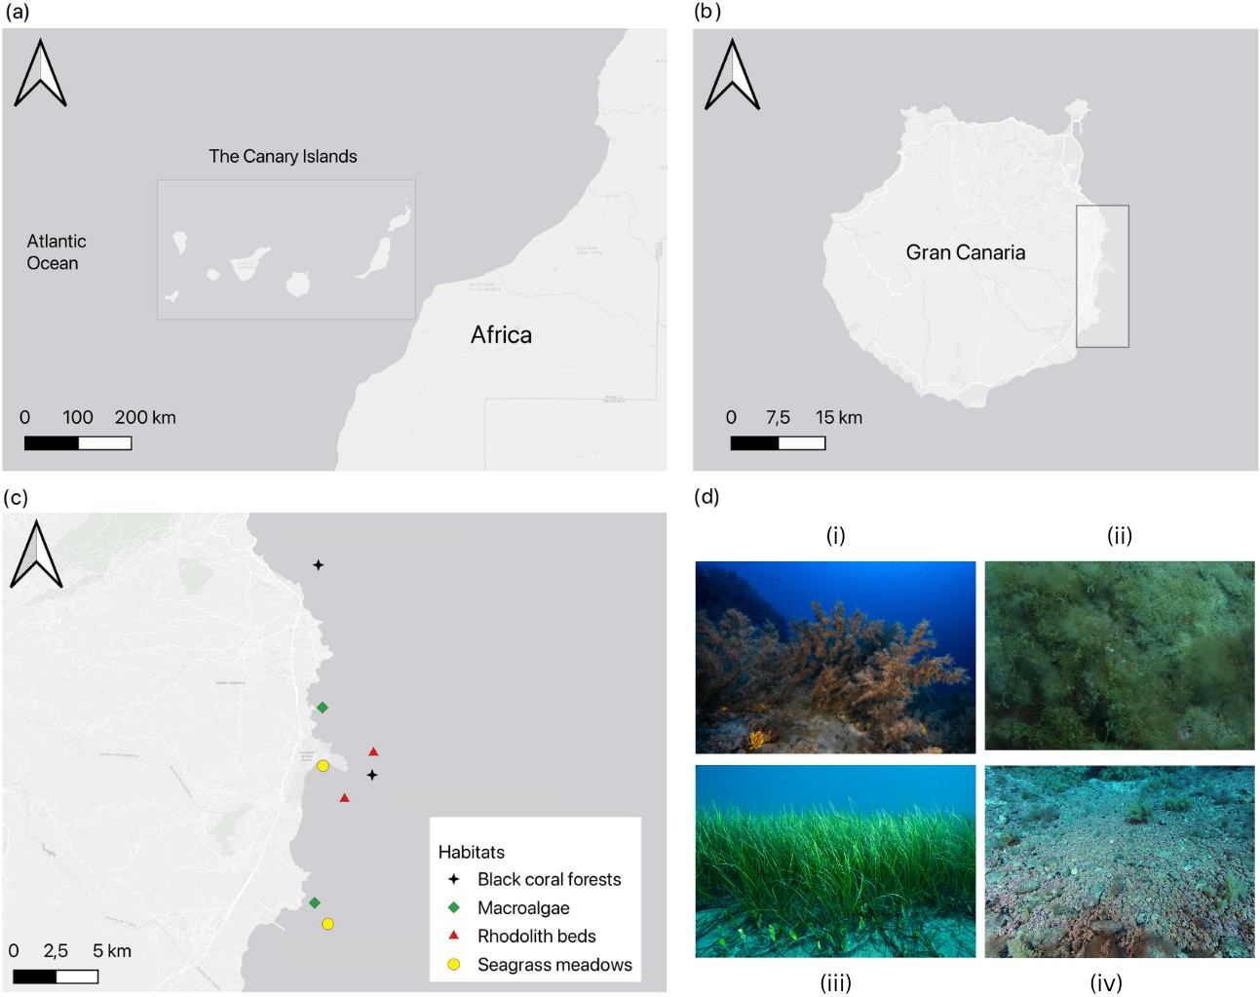
Figure 1. (A) The Canary Islands Archipelago (28.292° N, 16.629° W) lies in the Atlantic Ocean off northwestern Africa. (B) Gran Canaria (27.9202° N, 15.5474° W) is located approximately 150 km from the Moroccan coast; sampling was focused on the eastern shore (grey inset). (C) Map of sampling sites across four benthic habitats - black coral, macroalgae-dominated reefs, rhodolith beds, and seagrass meadows, surveyed at five distinct locations along the eastern coast of Gran Canaria, viz. Jinámar, Tufia, Gando, Risco Verde, and Arinaga (from north to south), with a maximum distance of around 21 km between Jinámar in the north and Arinaga in the southeast. (D) Representative habitat images: (i) black coral forests, (ii) macroalgae-dominated reefs, (iii) seagrass meadows, and
(iv) rhodolith beds, photographed at study sites around Gran Canaria. (photo credit: Franck Gazzola and Fernando Espino)
  - Study Sites and Habitats 105
Specimens were collected from two locations at each of four marine habitats around 106
the eastern coastal areas of Gran Canaria (Fig. 1), including seagrass meadows, rhodolith 107
beds, macroalgae-dominated reefs, and black corals. Sampling was conducted from 2018 to 108
2022. Rhodolith beds were sampled in 2015 and 2016 [27], seagrass meadows between 2016 109
and 2018 [37], and black coral forests in November–December 2022 [16]. Amphipods from 110
macroalgae-dominated reefs were collected in the summer of 2024. Detailed information 111
on sample sizes, including the number of individuals per habitat, year, and species, as well 112
as the specific sampling methodologies, is provided in the referenced studies. 113
Because the sites are geographically close and experience similar broad-scale envi- 114
ronmental conditions (see Supplementary Fig. A4), any differences observed in sexual 115
dimorphism among habitats are likely attributable to habitat-specific structural features 116
rather than overall environmental variation. The eastern coast of Gran Canaria is character- 117
ized by steep volcanic slopes and a mixture of hard and soft substrates that support diverse 118
benthic habitats. Local hydrography is influenced by persistent northeast trade winds, 119

which generate wind-driven waves and swells [38], while surrounding waters are largely 120 oligotrophic, with occasional inputs of cooler, nutrient-rich water from coastal upwelling 121 [39]. The eastern shoreline features a range of subtidal habitats including extensive rocky 122 platforms, sandy plains, and biogenic assemblages. Based on existing knowledge of habitat 123 distribution and ecological relevance to amphipod assemblages, representative sites were 124 selected within the four most abundant and structurally distinct habitats in the region. 125
  - Sampling Design and Specimen Collection 126
Sampling was conducted by SCUBA diving at depths of 18–50 m for rhodolith beds, 127
8–12 m for seagrass meadows, 3–8 m for macroalgae-dominated reefs, and 25–32 m for 128
black coral forests. Samples associated with each habitat were retrieved and processed in 129
the laboratory to extract epifaunal amphipods. For rhodolith beds, five random 25 × 25 cm 130
quadrats of rhodolith nodules were hand-collected by SCUBA divers, frozen at −20 ◦C, and 131
epifauna extracted and sorted. For seagrass meadows, five random 25 × 25 cm quadrats 132
containing seagrass canopy were bagged, cut at sediment, and sieved for epifauna. For 133
macroalgae-dominated reefs, holdfasts were cut within five random 25 × 25 cm quadrats, 134
bagged, frozen, washed, sieved, and mobile fauna identified. Following the method de- 135
scribed by [37], for black coral forests, epifauna was collected by briefly vacuuming the top 136
branches of Antipathella wollastoni underwater and preserved in ethanol. Vacuuming was 137
performed using an ad hoc vacuum cleaner for a standardized duration of 20 seconds per 138
colony. Collected samples were transported to the laboratory in seawater-filled containers. 139
Except for black coral samples, which were processed fresh to prevent epifaunal damage, 140
all other samples were stored at −20 ◦C until sorting. 141
  - Specimen Processing and Preservation 142
In the laboratory, each sample was inspected, and epifauna was separated from plant 143
and algal matter, sediment, and coral mucus using a 250 µm mesh. To avoid bias in size- 144
based comparisons, all habitats used the same mesh size. Organisms were preserved in 145
96% ethanol. No ethical approval was required for all but black corals [40], as none of the 146
other species are legally protected in Spain. 147
  - Identification and Species Determination 148
All individuals were identified to the lowest possible taxonomic level using a stere- 149
omicroscope (OPTIKA SZP-10, Ponteranica, Italy) and a compound microscope (Leica 150
DM1000 LED, Wetzlar, Germany) [41–43], and preserved in absolute ethanol. Taxonomic 151
keys employed included Bellan-Santini et al. [43], Ruffo [44,45], Bellan-Santini et al. [46], 152
with specific references for the genus Caprella [47]. Sex determination for all specimens was 153
carried out using the same taxonomic keys. 154
Ampithoe ramondi and Caprella acanthifera were the primary focus of this study, as 155
sufficient individuals of both sexes were collected across habitats to allow analysis of 156
sexual dimorphism. Ampithoe ramondi occurred in three habitats (rhodolith beds, seagrass 157
meadows, and macroalgae-dominated reefs), whereas Caprella acanthifera was restricted to 158
two habitats (macroalgae-dominated reefs and black coral forests). 159
  - Morphometric Measurements 160
In the laboratory, individuals were examined under a stereomicroscope (OPTIKA, SZP- 161
10, C-P8, Ponteranica, Italy) mounted with its associated camera. Images were analysed 162
using ImageJ [? ]. Morphometric traits measured included body length (determined by 163
measuring the distance from the dorsal margin at the base of the first antennae to the 164
posterior end of the telson following the methodology described by Wilhelm et al., 1998) 165
and Gnathopod 2 length, which was calculated by measuring along the circumference of 166

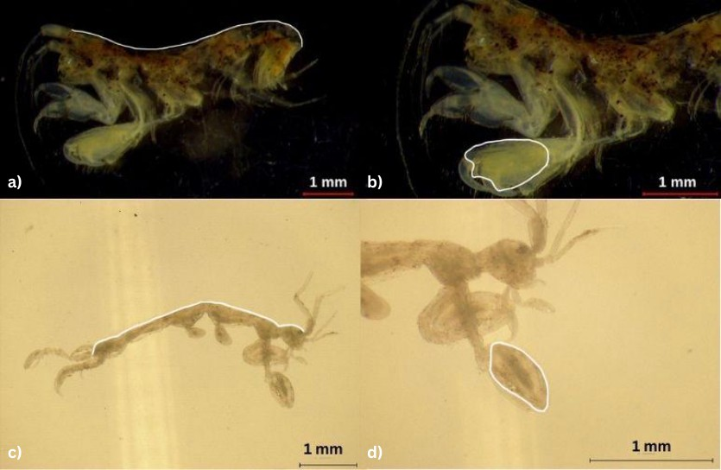
Figure 2. Images illustrating body length (panels a, c) and gnathopod 2 length (panels b, d) measure- ments for a male Ampithoe ramondi (a, b) and Caprella acanthifera (c, d) individual.
the gnathopod-2 oriented towards the observer under the microscope (refer Supplementary 167 Table A1 and Fig. 2). Measurement resolution was estimated at 0.01–0.05 mm, depending 168 on image scale calibration (either 0.5 mm or 1 mm per image). To ensure that only sexually 169 mature adults were included in the analyses, we selected the largest individuals from each 170 population for analysis. 171
  - Data Analysis 172
The Sexual Dimorphism Index (SDI) was calculated using the standard formula: 173
SDI = (mean male trait – mean female trait) / mean female trait, which was applied to each 174
of the traits analysed (refer Supplementary Figure A1). A positive SDI value indicates that 175
males have larger average trait values, which is often interpreted as male-biased sexual 176
selection, whereas a negative SDI indicates that females have larger average trait values, 177
which is typically associated with fecundity-based selection. We note that these associations 178
represent general expectations and have not been empirically demonstrated for the species 179
studied. This approach follows the widely used method proposed by [49] for quantifying 180
sexual dimorphism in morphological traits. 181
Data wrangling and statistical analysis were carried out in RStudio version 2024.09.1+394 182
“Cranberry Hibiscus” using R version 4.4.2 [50]. For interspecific comparisons, we included 183
a minimum of five individuals per sex of the two targeted species and fitted linear models 184
to test the effects of species, sex, and their interaction on body length and gnathopod ratio. 185
Gnathopod ratio was calculated by dividing the gnathopod length by the individual’s body 186
length to account for differences in body size. For species-specific analyses, univariate 187
linear models were applied separately to each species to test for the effects of sex and habitat 188
on each morphometric trait. For gnathopod ratio data, which are constrained between 0 189
and 1, beta regression models were implemented using the glmmTMB package [51]. with a 190
logit link. Model diagnostics, including residual distribution, heteroscedasticity, and nor- 191
mality, were assessed visually and using simulation-based methods via the DHARMa package 192
[52]. We computed estimated marginal means (EMMs) using the emmeans package [53] to 193

examine interaction effects (Sex × Habitat), followed by visualization of these contrasts. 194
Visualizations were generated using ggplot2 [54]. 195
- Results 196
  - Sex-specific allometry comparisons 197
In A. ramondi, gnathopod 2 length scaled positively with body size (β = 0.95, the slope 198
of the regression of gnathopod 2 length on body length; p < 0.001; Fig.??), with males 199
exhibiting a marginally steeper slope than females (β = 0.13, p = 0.32), although this 200
difference was not statistically significant. The sex effect alone was also non-significant 201
(β = 0.21, p = 0.36), indicating that while males tend to have longer gnathopods, the scaling 202
relationship between gnathopod length and body length is broadly similar across sexes. 203
Conversely, in C. acanthifera, neither body length (β = −0.03, p = 0.93), sex (β = −0.46, 204
p = 0.56), nor their interaction (β = 0.68, p = 0.21) significantly predicted gnathopod 205
2 length. These results suggest that sexual dimorphism in gnathopod 2 exaggeration is 206
less pronounced or absent in C. acanthifera, with both sexes exhibiting comparable scaling 207
patterns. 208


Figure 3. Relationship between log-transformed body length and log-transformed gnathopod 2 length for Ampithoe ramondi and Caprella acanthifera. Points represent individual measurements and shaded areas represent 95% confidence intervals. Regression statistics are as follows: A. ramondi females (intercept = -1.57, 95% CI [-1.71, -1.43]; slope = 0.95, 95% CI [0.86, 1.04]; r = 0.91, n = 84, p <
0.001); A. ramondi males (intercept = -1.37, 95% CI [-1.98, -0.76]; slope = 1.08, 95% CI [0.74, 1.42]; r =
0.76, n = 33, p < 0.001); C. acanthifera females (intercept = -0.20, 95% CI [-1.06, 0.67]; slope = -0.03, 95%
CI [-0.67, 0.61]; r = 0.01, n = 37, p = 0.931); C. acanthifera males (intercept = -0.65, 95% CI [-1.90, 0.60];
slope = 0.65, 95% CI [-0.20, 1.50]; r = 0.48, n = 12, p = 0.119). Data represent all individuals sampled across all habitats.
We also examined habitat-specific allometry of gnathopod ratios within each sex using 209
log-transformed body length. In A. ramondi, males exhibited positive scaling of gnathopod 210
ratio with body size in rhodolith beds (slope = 0.45, 95% CI [0.13, 0.77]), whereas females 211
showed no strong scaling (0.04, 95% CI [-0.15, 0.23]). In macroalgae-dominated reefs and 212
seagrass meadows, slopes were near zero for both sexes, indicating broadly consistent 213
gnathopod ratios across body sizes (refer Supplementary Fig. A2). For C. acanthifera, neither 214
sex showed strong allometric scaling of gnathopod ratio with body size across the sampled 215

habitats of black-coral forests and macroalgae-dominated reefs, with slopes ranging from 216
-0.01 to 0.19 and 95% confidence intervals overlapping zero (refer Supplementary Fig. A3). 217 These results suggest that sex-specific exaggeration of gnathopod ratio is most pronounced 218 in male A. ramondi in rhodolith beds, while habitat has little effect on allometry in other cases. 219 While gnathopod-to-body length ratios were used to compare traits, their interpretation 220 relies on the assumption of approximate isometric scaling. For A. ramondi, where scaling is 221 near isometric, ratios provide a meaningful comparison. For C. acanthifera, where scaling 222 deviates from isometry, ratios should be interpreted cautiously, and results are primarily 223 descriptive rather than indicative of strict allometric relationships. 224
  - Species-specific analyses 225
    - Ampithoe ramondi 226
Body length 227
Ampithoe ramondi occurred in rhodolith beds, macroalgae-dominated reefs, and sea- 228
grass meadows, but was not found in black coral forests during sampling. For A. ramondi, 229
SDI for body length was low across habitats (rhodolith beds: 0.059; macroalgae-dominated 230
reefs: 0.12; seagrass meadows: -0.017), whereas gnathopod ratios showed stronger dimor- 231
phism, particularly in rhodolith beds (0.7) and seagrass meadows (0.58; see Supplementary 232
Fig. A1). Body length in Ampithoe ramondi was significantly influenced by habitat, sex, 233
and their interaction (adjusted R2 = 0.27, p < 0.001; Fig. 4). Individuals from macroalgae- 234
dominated reefs were significantly smaller than those from rhodolith beds (β = −2.64, 235
p < 0.001), while body length in seagrass meadows did not differ significantly from 236
rhodolith beds (β = −0.56, p = 0.45). Although males were on average larger than females, 237
this difference was not statistically significant overall (β = 0.36, p = 0.68). A significant 238
Sex × Habitat interaction (p < 0.005) indicated that the effect of sex on body length varied 239
among habitats, with the greatest difference observed in macroalgae-dominated reefs, 240
where males were larger than females. In contrast, sex-related differences were negligible 241
in seagrass meadows and rhodolith beds. 242

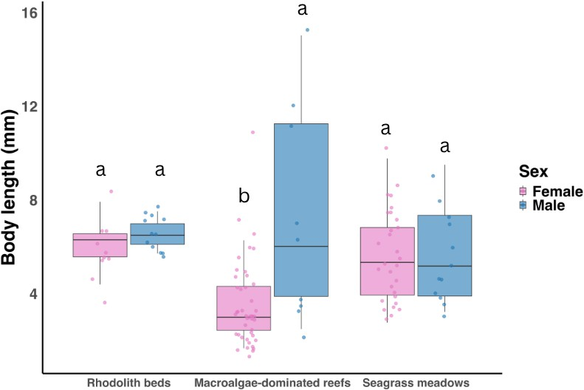
Figure 4. Box plot showing body length differences between females (pink) and males (blue) of Amp- ithoe ramondi across rhodolith beds, macroalgae-dominated reefs, and seagrass meadows. Different letters above boxes indicate significant differences (p < 0.05) based on Tukey’s HSD post-hoc tests; groups sharing a letter are not statistically different. Sample sizes (F = female, M = male) for each habitat are as follows: rhodolith beds — F = 10, M = 12; macroalgae-dominated reefs — F = 45, M = 9; seagrass meadows — F = 29, M = 12.
Gnathopod ratio 243
Beta regression analysis revealed significant effects of sex ( p < 0.001), habitat 244
(macroalgae-dominated reefs: p = 0.035; seagrass meadows: p = 0.016), and their in- 245
teraction (male × macroalgae-dominated reefs: p < 0.001 ) on gnathopod ratio (Fig. 5). The 246
difference between males and females was negligible in macroalgae-dominated reefs, but 247
males had higher gnathopod ratios than females in seagrass meadows and rhodolith beds. 248
Male gnathopod ratios were highest relative to females in rhodolith beds (female/male 249
odds ratio = 0.47, 95% CI [0.37, 0.59], p < 0.0001), intermediate in seagrass meadows (0.57, 250
95% CI [0.47, 0.69], p < 0.0001), and negligible in macroalgae-dominated reefs (0.87, 95% 251
CI[0.71, 1.07], p = 0.196). 252

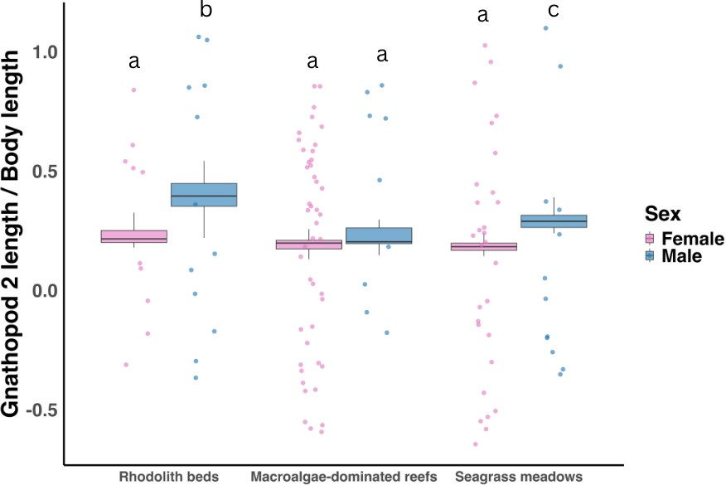
Figure 5. Box plot showing gnathopod ratio differences between females (pink) and males (blue) of Ampithoe ramondi in rhodolith beds, macroalgae-dominated reefs and seagrass meadows. Different letters above boxes indicate significant differences (p < 0.05) based on Tukey’s HSD post-hoc tests; groups sharing a letter are not statistically different. Sample sizes for each species and sex are provided in Fig. 4
    - Caprella acanthifera 253
Body length 254
Caprella acanthifera was recorded only in macroalgae-dominated reefs and black coral 255
forests and was not observed in the other sampled habitats. Caprella acanthifera exhibited 256
moderate SDI for both traits, with gnathopod ratio dimorphism highest in macroalgae- 257 dominated reefs (0.52) and minimal in black coral forests (0.026; see Supplementary Fig. A1). 258 The linear model indicated a significant effect of sex on body length (p = 0.01, Fig. 6), 259
with males larger than females (β = 1.54, p = 0.009). Habitat had a significant effect, with 260
individuals in black coral forests being smaller than those in macroalgae-dominated reefs 261
(β = −0.85, p = 0.0006), but the interaction between sex and habitat was not significant 262
(β = −0.38, p = 0.37), indicating that the male–female size difference was consistent across 263
habitats. 264

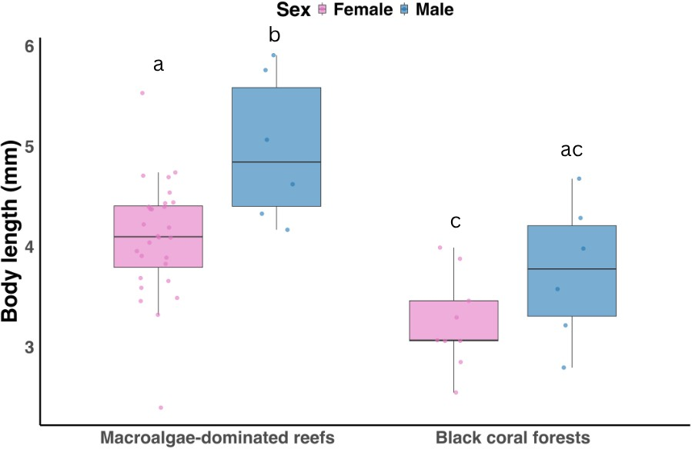
Figure 6. Box plot showing body length differences between females (pink) and males (blue) of Caprella acanthifera in macroalgae-dominated reefs and black coral forests. Different letters above boxes indicate significant differences (p < 0.05) based on Tukey’s HSD post-hoc tests; groups sharing a letter are not statistically different. Sample sizes for each habitat are as follows (F = female, M = male): Macroalgae-dominated reefs — F = 28, M = 6; Black coral forest — F = 9, M = 6.
Gnathopod ratio 265
Beta regression analysis revealed significant effects of sex (p < 0.001 ), habitat (p < 266
0.001 ), and their interaction (p < 0.001 ) on gnathopod ratio in C. acanthifera (Fig. 7). Males 267
had higher gnathopod ratios than females in macroalgae-dominated reefs, whereas the 268
male-female difference was reduced in black coral forests. 269

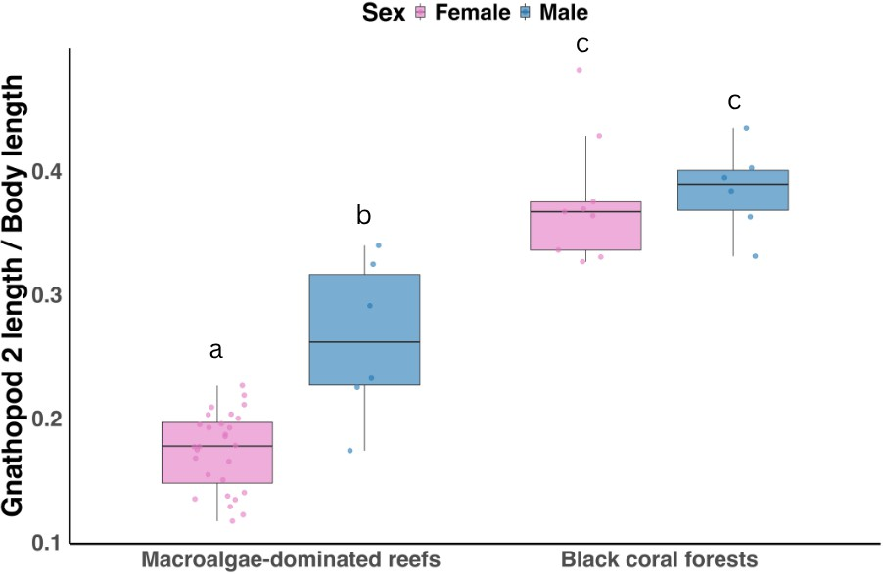
Figure 7. Box plot showing gnathopod ratio differences between females (pink) and males (blue) of Caprella acanthifera in macroalgae-dominated reefs and black coral forests. Different letters above boxes indicate significant differences (p < 0.05) based on Tukey’s HSD post-hoc tests; groups sharing a letter are not statistically different. Sample sizes for each species and sex are provided in Fig. 6.
- Discussion 270
Sexual dimorphism in amphipod morphology varied significantly by species and 271
habitat. Ampithoe ramondi exhibited pronounced male-biased dimorphism in body length 272
and gnathopod ratio, particularly in macroalgae-dominated reefs. Similarly, Caprella acan- 273
thifera showed male-biased dimorphism in body length in macroalgae-dominated reefs, 274
but gnathopod size was similar between sexes across habitats. Differences in reproductive 275
strategies, mating competition [55,56], and habitat-specific factors such as resource avail- 276
ability or predation [57] likely underlie the observed patterns. However, direct comparisons 277
between A. ramondi and C. acanthifera are constrained by the fact that macroalgae-dominated 278
reefs were the only habitat common to both species. 279
Habitat plays a central role in modulating trait expression. In A. ramondi, individuals 280
from rhodolith beds were consistently larger than those from macroalgae-dominated reefs 281
or seagrass meadows. This pattern may reflect differences in available colonisable space 282
and niche diversity among benthic habitats, where structurally complex environments can 283
reduce competition for space and resources and support larger body sizes [16]. Bathymetric 284
range may further mediate these patterns through differences in environmental stability 285
and resource availability, including light penetration and epiphytic development, which 286
increase habitat complexity and vary temporally. Shallow habitats are often subject to 287
strong intra-annual variability, such as winter storms and swell, favouring species adapted 288
to fluctuating habitat structure and resource inputs, whereas deeper habitats tend to 289
experience lower but more stable resource availability. Compared to the other habitats 290
considered in this study, rhodolith beds occur at greater depths and are characterised by 291
extensive interstitial spaces [58] that may buffer hydrodynamic stress and provide more 292
stable microhabitats, potentially allowing greater energetic investment in body growth. 293
The largest degree of sexual dimorphism in body size in A. ramondi occurred in 294
macroalgae-dominated reefs, where males were significantly larger than females. Macroal- 295
gae provide both shelter [59] and trophic resources supporting diverse and stable amphipod 296

communities [60]. They are well-established facilitators of amphipod assemblages, with 297 more diverse macroalgae-dominated reefs supporting higher biodiversity richness due 298 to enhanced niche partitioning and habitat complexity [61]. The three-dimensional struc- 299 ture of macroalgae-dominated reefs promotes sediment accumulation and increases prey 300 availability, benefiting both detritivorous and carnivorous species [62]. Amphipods often 301 function as mesoherbivores, consuming macroalgae directly [63], and forming close asso- 302 ciations with these habitats [64]. This pattern may reflect higher mating competition or 303 more favourable energetic and ecological conditions for trait exaggeration in macroalgae- 304 dominated reefs, which offer increased food resources, structural complexity, and refuge 305 [61,62]. 306
  - Sexual Selection, Trait Scaling, and Ecological Modulation 307
Allometric scaling of gnathopod 2 length in A. ramondi showed a consistent positive 308
relationship with body size, with males tending toward slightly steeper scaling than females, 309
although this difference was not statistically significant. This pattern suggests that males 310
may invest relatively more in gnathopod 2 as a sexually selected trait, consistent with 311
patterns reported in other amphipods and crustaceans [55]. Investment in gnathopod 312
length relative to body size may be lower in individuals that prioritise overall body size, 313
which can also influence reproductive success [20,65]. In contrast, C. acanthifera showed no 314
significant differences in scaling relationships between sexes, and gnathopod lengths were 315
more conserved across habitats. Limited sexual dimorphism in this species may reflect 316
its generalist diet, including macroalgae, detritus, and epiphytes, potentially reducing the 317
scope for resource monopolisation and male-specific trait exaggeration [66]. Unlike carrier 318
species that grasp females by hooking unenlarged gnathopods under the coxae or anterior 319
pereon segments, caprellid males typically guard mates by attending, i.e., maintaining 320
close proximity, often by positioning themselves over the female or sharing her tube [55]. 321
In these mate-guarding taxa, the enlarged gnathopods are held free and not used for 322
grasping; instead, they are employed in mate takeovers, agonistic interactions, defence, 323
and possibly to assess the female’s reproductive state through contact pheromones [55]. 324
Due to their sedentary and often gregarious habits, attending males are not energetically 325
burdened by physically carrying a mate, but since they remain close to the female and must 326
actively defend her, there is selective pressure for mechanisms that signal dominance or 327
reproductive quality [55]. As a result, some attending species exhibit strong sexual selection 328
on exaggerated traits wherein some males monopolise females [56], and others defend 329
mating clusters [67]. Several species evolve conspicuous weaponry on the gnathopods for 330
use in fights, such as poison spines in Caprella gorgonia [68] or thumb-like projections in 331
Dyopedos porrectus [69]. That both C. acanthifera and A. ramondi belong to mate-attending 332
superfamilies (Caprellidea and Corophioidea, respectively) yet show contrasting levels 333
of dimorphism suggests that even within a shared guarding strategy, habitat use, and 334
competitive context can shape the strength and nature of sexual selection. These findings 335
suggest that sexual dimorphism in Caprelloidea may be less labile or subject to different 336
selective pressures compared to Corophioidea. 337
  - Ecological Complexity and Habitat Structure 338
A. ramondi and C. acanthifera share broadly similar feeding habits: both species rely 339
heavily on detritus (over 65% of their diets), with A. ramondi supplementing its detritivorous 340
diet with herbivory [70,71], while C. acanthifera consumes algae and exhibits omnivory [72]. 341
Despite this dietary overlap, differences in mobility, microhabitat selection, male–male 342
competition, and mating behaviour can influence the expression of sexually dimorphic 343
traits. For instance, more mobile males may encounter mates more frequently and compete 344

more intensely, selecting for larger gnathopods, whereas species with lower mobility 345 or reduced mate competition may exhibit weaker sexual dimorphism. Thus, ecological 346 and behavioural factors beyond diet are likely to shape the observed patterns of sexual 347 dimorphism in these amphipods. 348
The four habitats studied—rhodolith beds, macroalgae-dominated reefs, seagrass 349
meadows, and black coral forests—differ markedly in structural complexity, resource 350
availability, and predator presence, all of which can influence amphipod behaviour and 351
the expression of morphological traits. Macroalgae-dominated reefs exhibit fine-scale 352
structural intricacy, providing abundant attachment sites and food resources [59]. This 353
complexity likely increases male–female encounter rates, intensifies male–male competition, 354
and favours the evolution of conspicuous or exaggerated male traits. Rhodolith beds, 355
formed by free-living coralline algae, create three-dimensional matrices whose complexity 356
varies with rhodolith size and aggregation [27]. These beds can support high amphipod 357
densities and moderate encounter rates; however, spatial constraints may limit movement 358
and reduce opportunities for males to monopolise mates. Seagrass meadows are highly 359
productive but generally more homogeneous [33], offering limited refuge from predators 360
and potentially reducing the intensity of sexual selection. Nevertheless, denser or more 361
structurally complex seagrass meadows can support higher amphipod densities and species 362
richness [28], indicating that structural complexity alone does not fully predict selective 363
pressures on trait exaggeration. 364
Black coral forests are vertically stratified and structurally complex, forming numerous 365
microhabitats atop rocky substrates [73]. Despite this complexity, high predator diversity 366
and reduced light in deeper regions can constrain mate searching, favour cryptic behaviours, 367
and moderate sexual selection intensity [37]. When sufficiently dense, these forests form 368
aggregations known as ‘coral forests’ [74], which provide protection against currents and 369
predation [75]. Overall, the influence of habitat on sexual dimorphism emerges from the 370
interaction between structural complexity, resource distribution, predator presence, and 371
species-specific behaviour. Consequently, habitat effects on trait exaggeration are likely 372
variable across amphipod taxa, with some species expressing strong dimorphism under 373
certain ecological contexts while others maintain more conserved trait patterns. 374
  - Future Directions 375
While this study demonstrates the influence of habitat and sex on amphipod morpho- 376
logical traits, incorporating adult sex ratio (ASR) would provide deeper insight into the 377
demographic mechanisms driving sexual dimorphism. ASR, defined as the ratio of adult 378
females to males in a population, is often used as a proxy for the strength and direction 379
of sexual selection [76], and its variation across habitats may correlate with shifts in di- 380
morphism intensity. For example, female-biased ASRs, potentially arising in energetically 381
constrained or high-predation habitats, could lead to reduced male-male competition and 382
diminished exaggeration of sexually selected traits [77]. Conversely, male-biased ASRs may 383
amplify selection for competitive traits and accentuate dimorphism [77]. ASR could not be 384
reliably calculated due to sampling limitations, including selective counts (e.g., stopping 385
after obtaining enough males in A. ramondi) and damaged specimens that prevented sex 386
identification and use in analysis. 387
As habitat structure shifts under ongoing environmental change, these alterations will 388
reshape the ecological context in which sexual traits evolve. Seagrass meadows support 389
diverse epifaunal communities as well as epiphytic macroalgae [78], are experiencing 390
widespread decline at local, regional, and global scales [79]. In this context, tracking future 391
trends in sexual dimorphism, and how such changes influence both population dynamics 392
and life-history traits like mating behaviour and reproductive strategies, will be crucial. 393

Temperature-dependent increases in amphipod metabolic rates can accelerate life-history 394 traits such as growth and reproduction, potentially leading to faster age at sexual maturity 395 and higher local population densities. These changes may influence the timing of male and 396 female maturation, encounter rates, and the intensity of male–male competition or female 397 mate choice, thereby modulating sexual selection and contributing to variation in sexual 398 dimorphism. Future studies should examine how such temperature-driven effects shape 399 sexual selection processes and dimorphism patterns across habitats. 400
A key limitation of this study is the absence of direct measurements of habitat complex- 401
ity, which constrains our ability to explicitly link morphological variation to environmental 402
structure. Future research should therefore include quantitative assessments of habitat 403
complexity to better connect habitat heterogeneity with sexually dimorphic trait divergence. 404
- Conclusions 405
Our findings show that sexual dimorphism in amphipod morphology varies between 406
habitats and may be influenced by ecological context and sex-specific selective pressures, 407
although these pressures were not directly measured. Ampithoe ramondi demonstrated 408
clear sexual dimorphism in body length and gnathopod 2 length, with expression varying 409
among habitats. In contrast, Caprella acanthifera showed weaker, more conserved patterns. 410
Due to limited within-species comparisons across all four habitats and mixed patterns 411
across traits, no uniform relationship could be established. The interaction between natural 412
and sexual selection, modulated by habitat structure and possibly adult sex ratios, governs 413
the expression of sexually dimorphic traits. 414
The inclusion of demographic, behavioural, and genetic variables in future studies 415
will be essential to disentangle the selective pressures driving sexual dimorphism, such as 416
mate competition, resource allocation, and predation risk. While sexual selection may not 417
strongly drive adaptation under changing environmental conditions, it remains relevant. 418
Environmental shifts can alter the costs of sexually selected traits, potentially leading 419
to evolutionary hedging of those traits. Habitats such as seagrass meadows are often 420
structurally simple, but can attain fine-scale complexity through epiphytic communities, 421
including macroalgae, which increase surface area, enhance nutrient-rich food availability, 422
provide habitat for epifauna, and modulate predation pressure [80,81]. Rhodolith beds 423
too gain a secondary structural layer from epiphytic algae, creating a cascade effect that 424
enhances habitat complexity. These epiphytes provide numerous microhabitats, refuge from 425
predators, and a wider range of body sizes, reducing intra- and interspecific competition. 426
Macroalgae-dominated reefs similarly form dense, structurally intricate habitats that trap 427
sediment and detritus, supplying both physical structure and trophic resources. In contrast, 428
black coral forests lack epiphytic layers, resulting in a more uniform and competitive 429
environment. Accounting for these layered habitat components in future studies will be 430
crucial for better understanding how habitat-specific factors influence the intensity and 431
expression of sexual dimorphism. 432
Author Contributions: Conceptualization, A.D., F.T. and S.N.-M.; Methodology, S.N.-M., F.O.-F., F.T. 433
and S.D.-V.; Validation, F.T. and S.N.-M.; Formal analysis, A.D.; Investigation, A.D.; Data curation, 434
A.D.; Writing—original draft preparation, A.D.; Writing—review and editing, A.D., F.T., S.N.-M. and 435
F.O.-F.; Visualization, A.D.; Supervision, F.T. and S.N.-M.; Project administration, F.T. and S.N.-M. All 436
authors have read and agreed to the published version of the manuscript. 437
Institutional Review Board Statement: All procedures involving animals in this study were con- 438
ducted in accordance with the ethical guidelines and regulations of Universidad de Las Palmas de 439
Gran Canaria. 440

Data Availability Statement: All data and analysis scripts used in this study, including the fi- 441 nal processed dataset and R scripts for analyses, are publicly available in the following GitHub 442 repository: https://github.com/amey-danole/Habitat-driven-variation-in-sexual-dimorphism-of- 443
amphipods. 444
Acknowledgments: 445
I would like to sincerely thank Lucia Castillo for her daily guidance, thoughtful insights, and 446
encouragement throughout the project, which were instrumental in shaping this study. I am also 447
grateful to Benjamin Heather-Clark for his moral support, which helped me remain focused and 448
committed, allowing me to persevere and complete this study, knowing I was never working alone. 449
Conflicts of Interest: The authors declare no conflicts of interest. The funders had no role in the design 450
of the study; in the collection, analyses, or interpretation of data; in the writing of the manuscript; or 451
in the decision to publish the results’. 452
Appendix A Supplementary Information 453
Table A1. Sample sizes and functional trait measurements for Ampithoe ramondi and Caprella acanthifera across four benthic habitats around Gran Canaria. M = males, F = females. BL = body length (mm), Gn2 = gnathopod 2 length (mm). Values shown are the median BL, median Gn2, and the geometric mean of Gn2/BL.

Habitat | Species | Total | M | F | BL | Gn2 | Gn2/BL
Rhodolith beds | Ampithoe ramondi | 22 | 12 | 10 | 6.367 | 2.040 | 0.305
Macroalgae-dominated reefs | Ampithoe ramondi | 54 | 9 | 45 | 3.258 | 0.630 | 0.196
Seagrass meadows | Ampithoe ramondi | 41 | 12 | 29 | 5.337 | 1.108 | 0.210
Black coral forests | Caprella acanthifera | 15 | 6 | 9 | 3.294 | 1.294 | 0.377
Macroalgae-dominated reefs | Caprella acanthifera | 34 | 6 | 28 | 4.205 | 0.776 | 0.184

Table A2. Linear model results for Ampithoe ramondi body length as a function of sex and habitat. Control = Rhodolith beds, M = Macroalgae-dominated reefs, S = Seagrass meadows. Significance codes: ∗ ∗ ∗ p < 0.001, ∗∗ p < 0.01, ∗ p < 0.05. Residual standard error = 2.027, Adjusted R2 = 0.267, F-statistic = 9.46 on 5 and 111 DF, p-value = 1.555e-07.

Term | Estimate | Std. Error | t value | p-value
(Intercept) | 6.185 | 0.641 | 9.650 | <0.001 ***
Sex_labelMale | 0.362 | 0.868 | 0.417 | 0.677
HabitatM | -2.636 | 0.709 | -3.720 | 0.0003 ***
HabitatS | -0.565 | 0.743 | -0.760 | 0.449
Sex_labelMale:HabitatM | 3.274 | 1.141 | 2.871 | 0.0049 **
Sex_labelMale:HabitatS | -0.455 | 1.112 | -0.409 | 0.683

Table A3. Beta regression results for Ampithoe ramondi gnathopod ratio as a function of sex and habitat (logit link). Control = Rhodolith beds, M = Macroalgae-dominated reefs, S = Seagrass meadows. Significance codes: ∗ ∗ ∗ p < 0.001, ∗∗ p < 0.01, ∗ p < 0.05. Model AIC = -356.5, BIC = -337.1, log-likelihood = 185.2, df.resid = 110.

Term | Estimate | Std. Error | z value | p-value
(Intercept) | -1.187 | 0.090 | -13.202 | <0.001 ***
Sex_labelMale | 0.760 | 0.115 | 6.619 | <0.001 ***
HabitatM | -0.212 | 0.100 | -2.105 | 0.035 *
HabitatS | -0.256 | 0.106 | -2.408 | 0.016 *
Sex_labelMale:HabitatM | -0.622 | 0.157 | -3.974 | <0.001 ***
Sex_labelMale:HabitatS | -0.201 | 0.149 | -1.349 | 0.177

Table A4. Linear model results for Caprella acanthifera body length as a function of sex and habitat. Control = Macroalgae-dominated reefs, B = Black-coral forests. Significance codes: ∗ ∗ ∗ p < 0.001,
∗∗ p < 0.01, ∗ p < 0.05. Residual standard error = 0.595 on 45 DF, R2 = 0.418, Adjusted R2 = 0.379,
F(3,45) = 10.76, p = 1.875e-05.

Term | Estimate | Std. Error | t value | p-value
(Intercept) | 4.090 | 0.112 | 36.389 | <0.001 ***
Sex_labelMale | 0.885 | 0.268 | 3.306 | 0.002 **
HabitatB | -0.845 | 0.228 | -3.709 | 0.001 ***
Sex_labelMale:HabitatB | -0.375 | 0.412 | -0.910 | 0.368

Table A5. Beta regression results for Caprella acanthifera gnathopod ratio as a function of sex and habitat. Control = Macroalgae-dominated reefs, B = Black-coral forests. Significance codes: ∗ ∗ ∗ p < 0.001, ∗∗ p < 0.01, ∗ p < 0.05. Family = beta, link = logit, dispersion parameter = 118, AIC = -171.6, BIC = -162.2, logLik = 90.8, df.resid = 44.

Term | Estimate | Std. Error | z value | p-value
(Intercept) | -1.553 | 0.045 | -34.19 | <0.001 ***
Sex_labelMale | 0.517 | 0.096 | 5.38 | <0.001 ***
HabitatB | 1.044 | 0.078 | 13.45 | <0.001 ***
Sex_labelMale:HabitatB | -0.475 | 0.138 | -3.44 | 0.001 ***


Figure A1. Sexual Dimorphism Index (SDI) for Ampithoe ramondi in Rhodolith beds (R), Macroalgae- dominated reefs (M), and Seagrass meadows (S), and for Caprella acanthifera in Macroalgae-dominated reefs (M) and Black coral forests (B).



Figure A2. Sex-specific allometry of gnathopod ratio versus body length across habitats for Ampithoe ramondi. Points represent individual measurements, with colors indicating sex (female: pink, male: blue). Linear-regression lines (±95% CI) are shown for each sex. Facets represent habitats (R: Rhodolith beds, M: Macroalgae-dominated reefs, S: Seagrass meadows).


Figure A3. Sex-specific allometry of gnathopod ratio versus body length across habitats for Caprella acanthifera. Points represent individual measurements, with colors indicating sex (female: pink, male: blue). Linear-regression lines (±95% CI) are shown for each sex. Facets represent habitats (M: Macroalgae-dominated reefs, B: Black-coral forests).

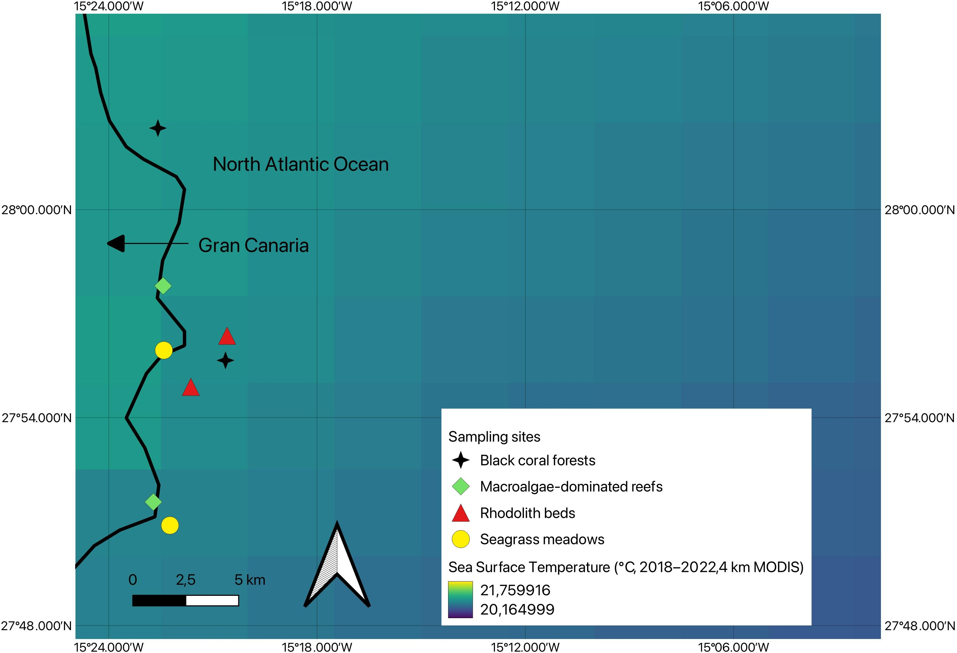

Figure A4. Spatial distribution of the sampling sites along the eastern coast of Gran Canaria overlaid on the average sea surface temperature (SST, ◦C) from 2018 to 2022, corresponding to the years of sampling. The SST values were derived from MODIS satellite observations at 4 km resolution. As shown, SST is relatively uniform across the study sites, indicating minimal variation in this key environmental variable.
References 454
- Shine, R. Ecological causes for the evolution of sexual dimorphism: A review of the evidence. The Quarterly Review of Biology 455
1989, 64, 419–461. 456
- Andersson, M. Sexual selection; Princeton University Press, 1994. 457
- Stillwell, R.C.; Blanckenhorn, W.U.; Teder, T.; Davidowitz, G.; Fox, C.W. Sex differences in phenotypic plasticity affect variation in 458
sexual size dimorphism in insects: From physiology to evolution. Annual Review of Entomology 2010, 55, 227–245. 459
- Endler, J.A. Signals, signal conditions, and the direction of evolution. American Naturalist 1992, 139, S125–S153. https: 460
//doi.org/10.1086/285308. 461
- Clutton-Brock, T. Sexual selection in males and females. Science 2007, 318, 1882–1885. 462
- Darwin, C. The descent of man, and selection in relation to sex; Vol. 1, John Murray, 1871. 463
- Lande, R. Sexual dimorphism, sexual selection, and adaptation in polygenic characters. Evolution 1980, 34, 292–305. https: 464
//doi.org/10.2307/2407393. 465
- Ford, S.M. Evolution of sexual dimorphism in body weight in platyrrhines. American Journal of Primatology 1994, 34, 221–244. 466
- Geist, V.; Bayer, M. Sexual dimorphism in the Cervidae and its relation to habitat. Journal of Zoology 1988, 214, 45–53. 467
- Cleasby, I.R.; Wakefield, E.D.; Bodey, T.W.; Davies, R.D.; Patrick, S.C.; Newton, J.; Votier, S.C.; Bearhop, S.; et al. Sexual segregation 468
in a wide-ranging marine predator is a consequence of habitat selection. Marine Ecology Progress Series 2015, 518, 1–12. 469
- Losos, J.B.; Butler, M. Sexual Dimorphism in Body Size and Shape in Relation to Habitat Use among. Lizard social behavior 2003, p. 470
356. 471
- Wikelski, M.; Trillmich, F. Body size and sexual size dimorphism in marine iguanas fluctuate as a result of opposing natural and 472
sexual selection: an island comparison. Evolution 1997, 51, 922–936. 473
- Arfianti, T.; Wilson, S.; Costello, M.J. Progress in the discovery of amphipod crustaceans. PeerJ 2018, 6, e5187. 474
- Horton, T.; De Broyer, C.; Bellan-Santini, D.; Coleman, C.O.; Copilas, -Ciocianu, D.; Corbari, L.; Daneliya, M.E.; Dauvin, J.C.; 475
Decock, W.; Fanini, L.; et al. The World Amphipoda Database: history and progress. Australian Museum 2023. 476
- Lowry, J.K.; Myers, A.A. A phylogeny and classification of the Amphipoda with the establishment of the new order Ingolfiellida 477
(Crustacea: Peracarida). Zootaxa 2017, 4265, 1–89. 478

- Navarro-Mayoral, S.; Díaz-Vergara, S.; Bosch, N.E.; Tuya, F.; Bramanti, L.; Fernandez-Gonzalez, V.; Terrana, L.; Espino, F.; Haroun, 479 R.; Otero-Ferrer, F. Inside the mesophotic zone: taxonomic and trait diversity of epifauna associated with black coral forests 480 across an oceanic archipelago. Coral Reefs 2025, pp. 1–19. 481
- Copilas, -Ciocianu, D.; Boros, B.V.; Šidagyte˙-Copilas, E. Morphology mirrors trophic niche in a freshwater amphipod community. 482
Freshwater Biology 2021, 66, 1968–1979. 483
- Lolas, A.; Vafidis, D. Population dynamics of two caprellid species (Crustaceae: Amphipoda: Caprellidae) from shallow hard 484
bottom assemblages. Marine Biodiversity 2013, 43, 227–236. 485
- Hume, K.D.; Elwood, R.W.; Dick, J.T.; Morrison, J. Sexual dimorphism in amphipods: the role of male posterior gnathopods 486
revealed in Gammarus pulex. Behavioral Ecology and Sociobiology 2005, 58, 264–269. 487
- Wellborn, G.A. Selection on a sexually dimorphic trait in ecotypes within the Hyalella azteca species complex (Amphipoda: 488
Hyalellidae). The American Midland Naturalist 2000, 143, 212–225. 489
- Takeshita, F.; Wada, S. Morphological comparison of the second gnathopod in males of four caprellid species (Amphipoda: 490
Caprellidae). Journal of Crustacean Biology 2012, 32, 673–676. 491
- Darwin, T.J.; Krapp-Schickel, T. A new species of leucothoid amphipod, Anamixis bananarama, sp. n., from shallow coral reefs in 492
French Polynesia (Crustacea, Amphipoda, Leucothoidae). ZooKeys 2011, p. 1. 493
- Thomas, J.D.; Klebba, K.N. New species and host associations of commensal leucothoid amphipods from coral reefs in Florida 494
and Belize (Crustacea: Amphipoda). Zootaxa 2007, 1494, 1. 495
- Longo, S.; Ray, W.; Farley, G.; Harrison, J.; Jorge, J.; Kaji, T.; Palmer, A.R.; Patek, S. Snaps of a tiny amphipod push the boundary 496
of ultrafast, repeatable movement. Current Biology 2021, 31, R116–R117. 497
- Wellborn, G.A. Trade-off between competitive ability and antipredator adaptation in a freshwater amphipod species complex. 498
Ecology 2002, 83, 129–136. 499
- Wellborn, G.A.; Bartholf, S.E. Ecological context and the importance of body and gnathopod size for pairing success in two 500
amphipod ecomorphs. Oecologia 2005, 143, 308–316. 501
- Navarro-Mayoral, S.; Fernandez-Gonzalez, V.; Otero-Ferrer, F.; Tuya, F. Spatio-temporal variability of amphipod assemblages 502
associated with rhodolith seabeds. Marine and Freshwater Research 2020, 72, 76–83. https://doi.org/10.1071/MF19177. 503
- Navarro-Mayoral, S.; Tuya, F.; Prado, P.; Marco-Méndez, C.; Fernandez-Gonzalez, V.; Fernández-Torquemada, Y.; Espino, F.; de la 504
Ossa, J.A.; Vilella, D.M.; Machado, M.; et al. Drivers of variation in seagrass-associated amphipods across biogeographical areas. 505
Marine Environmental Research 2023, 186, 105918. 506
- Premate, E.; Fišer, Ž.; Biró, A.; Copilas¸-Ciocianu, D.; Fromhage, L.; Jennions, M.; Borko, Š.; Herczeg, G.; Balázs, G.; Kralj-Fišer, S.; 507
et al. Sexual dimorphism in subterranean amphipod crustaceans covaries with subterranean habitat type. Journal of Evolutionary 508
Biology 2024, 37, 487–500. 509
- Bosch, N.E.; Espino, F.; Tuya, F.; Haroun, R.; Bramanti, L.; Otero-Ferrer, F. Black coral forests enhance taxonomic and functional 510
distinctiveness of mesophotic fishes in an oceanic island: implications for biodiversity conservation. Scientific Reports 2023, 511
13, 4963. 512
- Pérez-Peris, I.; Navarro-Mayoral, S.; de Esteban, M.C.; Tuya, F.; Peña, V.; Barbara, I.; Neves, P.; Ribeiro, C.; Abreu, A.; Grall, J.; 513
et al. Effect of depth across a latitudinal gradient in the structure of rhodolith seabeds and associated biota across the eastern 514
Atlantic Ocean. Diversity 2023, 15, 103. 515
- Alfonso, B.; Hernández, J.C.; Sangil, C.; Martín, L.; Expósito, F.J.; Díaz, J.P.; Sansón, M. Fast climatic changes place an endemic 516
Canary Island macroalga at extinction risk. Regional Environmental Change 2021, 21, 113. 517
- Barbera, C.; Tuya, F.; Boyra, A.; Sanchez-Jerez, P.; Blanch, I.; Haroun, R.J. Spatial variation in the structural parameters of 518
Cymodocea nodosa seagrass meadows in the Canary Islands: a multiscaled approach. Botanica marina (Print) 2005. 519
- Fernandez-Gonzalez, V.; Navarro-Mayoral, S.; Sanchez-Jerez, P. Connectivity patterns for direct developing invertebrates in frag- 520 mented marine habitats: fish farms fouling as source population in the establishment and maintenance of local metapopulations. 521 Frontiers in Marine Science 2021, 8, 785260. 522
- Kabus, J.; Schaub, C.; Fritsche, D.; Cocchiararo, B.; Fišer, C.; Grabowski, M.; Karaouzas, I.; Shumka, S.; Jourdan, J. Morphological 523
crypsis within a crustacean species complex is driven by within-species phenotypic diversification. Scientific Reports 2025. 524
- Song, C.; Wang, Y.; Sha, Z. Redescription of the species Caprella algaceus Vassilenko, 1967 (Amphipoda, Caprellidae) based on a 525
new record from the Yellow Sea, PR China, using an integrated approach. Crustaceana 2025, 98, 927–951. 526
- Navarro-Mayoral, S.; Gouillieux, B.; Fernandez-Gonzalez, V.; Tuya, F.; Lecoquierre, N.; Bramanti, L.; Terrana, L.; Espino, F.; Flot, 527
J.F.; Haroun, R.; et al. “Hidden” biodiversity: a new amphipod genus dominates epifauna in association with a mesophotic black 528
coral forest. Coral Reefs 2024, 43, 655–672. 529
- Smith, A.; Jackson, D.W.; Cooper, J.A.G.; Beyers, M.; Breen, C. Whole-island wind bifurcation and localized topographic steering: 530
Impacts on aeolian dune dynamics. Science of the Total Environment 2021, 763, 144444. 531

- Ortiz, J.; Arístegui, J.; Hernández-Hernández, N.; Fernández-Méndez, M.; Riebesell, U. Oligotrophic phytoplankton community 532 effectively adjusts to artificial upwelling regardless of intensity, but differently among upwelling modes. Frontiers in Marine 533 Science 2022, 9, 880550. 534
- Wagner, D.; Luck, D.G.; Toonen, R.J. The biology and ecology of black corals (Cnidaria: Anthozoa: Hexacorallia: Antipatharia). 535
Advances in Marine Biology 2012, 63, 67–132. 536
- Bellan-Santini, D.; Karaman, G.; Krapp-Schickel, G.; Ledoyer, M.; Myers, A.; Ruffo, S.; Schiecke, U. The Amphipoda of the 537
Mediterranean. Part 1: Gammaridae (Acanthonotozomatidae to Gammaridae); 1982. 538
- Bellan-Santini, D.; Diviacco, G.; Krapp-Schickel, G.; Ruffo, S. The Amphipoda of the Mediterranean. Part 2. Gammaridea (Haustoriidae 539
to Lysianassidae); 1989. 540
- Bellan-Santini, D.; Karaman, G.; Krapp-Schickel, G.; Ledoyer, M.; Ruffo, S. The amphipoda of the mediterranean. Part 3: Gammaridea 541
(melphidippidae to talitridae), ingolfiellidea, caprellidea; 1993. 542
- Ruffo, S. Family Argissidae. The Amphipoda of the Mediterranean, Part 1982, 1, 159–161. 543
- Ruffo, S. The Amphipoda of the Mediterranean. Part 2. Gammaridea (Haustoriidae to Lysianassidae). Mémoires de l’Institut 544
océanographique, Monaco 1989, 13, 365–576. 545
- Bellan-Santini, D.; Karaman, G.; Ledoyer, M.; Myers, A.; Ruffo, S.; Vader, W. The Amphipoda of the Mediterranean. Part 4: Localities 546
and Map, Addenda to Parts 1-3, Key to Families, Ecology, Faunistics and Zoogeography, Bibliography, Index; 1998. 547
- Guerra-García, J.; Takeuchi, I. The Caprellidea (Crustacea: Amphipoda) from Ceuta, North Africa, with the description of three 548
species of Caprella, a key to the species of Caprella, and biogeographical discussion. Journal of Natural History 2002, 36, 675–713. 549
- Wilhelm, F.M.; Lasenby, D.C. Seasonal trends in the head capsule length and body length/weight relationships of two amphipod 550
species. Crustaceana 1998, pp. 399–410. 551
- Lovich, J.E.; Gibbons, J.W. A review of techniques for quantifying sexual size dimorphism. Growth, Development, and Aging: GDA 552
1992, 56, 269–281. 553
- R Core Team. R: A language and environment for statistical computing. R Foundation for Statistical Computing, 2024. 554
- Brooks, M.E.; Kristensen, K.; van Benthem, K.J.; Magnusson, A.; Berg, C.W.; Nielsen, A.; Skaug, H.J.; Maechler, M.; Bolker, B.M. 555
glmmTMB balances speed and flexibility among packages for zero-inflated generalized linear mixed modeling. The R Journal 556
2017, 9, 378–400. 557
- Hartig, F. DHARMa: Residual diagnostics for hierarchical (multi-level / mixed) regression models, 2024. R package version 0.4.7. 558
- Lenth, R. emmeans: Estimated marginal means, aka least-squares means, 2025. R package version 1.11.1. 559
- Wickham, H. ggplot2: Elegant graphics for data analysis; Springer-Verlag, 2016. 560
- Conlan, K.E. Precopulatory mating behavior and sexual dimorphism in the amphipod Crustacea. Hydrobiologia 1991, 223, 255–282. 561
- Borowsky, B.; Borowsky, R. The reproductive behaviors of the amphipod crustacean Gammarus palustris (Bousfield) and 562
some insights into the nature of their stimuli. Journal of Experimental Marine Biology and Ecology 1987, 107, 131–144. https: 563
//doi.org/10.1016/0022-0981(87)90191-2. 564
- Bazikalova, A.Y. Taxonomy, ecology, and distribution of genera Micruropus Stebbing and Pseudomicruropus nov. 565
gen.(Amphipoda; Gammaridea). Tr. Limnol. Inst., Akad. Nauk SSSR, Sib. Otd 1962, 2, 3–140. 566
- Cabrito, A.; de Juan, S.; Hinz, H.; Maynou, F. Morphological insights into the three-dimensional complexity of rhodolith beds. 567
Marine Biology 2024, 171, 127. 568
- Lippert, H.; Iken, K.; Rachor, E.; Wiencke, C. Macrofauna associated with macroalgae in the Kongsfjord (Spitsbergen). Polar 569
Biology 2001, 24, 512–522. 570
- Hughes, A.R.; Stachowicz, J.J. Genetic diversity enhances the resistance of a seagrass ecosystem to disturbance. Proceedings of the 571
National Academy of Sciences 2004, 101, 8998–9002. https://doi.org/10.1073/pnas.0402642101. 572
- Ferreira, A.P.; Jacobucci, G.B.; Leite, F.P.P. Title TBD. In press 2025. 573
- Edgar, G.J.; Aoki, M. Resource limitation and fish predation: their importance to mobile epifauna associated with Japanese 574
Sargassum. Oecologia 1993, 95, 122–133. 575
- Poore, A.G.; Campbell, A.H.; Coleman, R.A.; Edgar, G.J.; Jormalainen, V.; Reynolds, P.L.; Sotka, E.E.; Stachowicz, J.J.; Taylor, R.B.; 576
Vanderklift, M.A.; et al. Global patterns in the impact of marine herbivores on benthic primary producers. Ecology letters 2012, 577
15, 912–922. 578
- Leite, F.P.P.; Tanaka, M.O.; Gebara, R.S. Structural variation in the brown alga Sargassum cymosum and its effects on associated 579
amphipod assemblages. Brazilian Journal of Biology 2007, 67, 215–221. 580
- Clutton-Brock, T. The functions of antlers. Behaviour 1982, 79, 108–124. 581
- Cruz-Rivera, E.; Hay, M.E. The effects of diet mixing on consumer fitness: macroalgae, epiphytes, and animal matter as food for 582
marine amphipods. Oecologia 2000, 123, 252–264. 583
- Emlen, S.T.; Oring, L.W. Ecology, sexual selection, and the evolution of mating systems. Science 1977, 197, 215–223. https: 584
//doi.org/10.1126/science.327542. 585

- Lewbel, G.S. Sexual dimorphism and intraspecific aggression, and their relationship to sex ratios in Caprella gorgonia Laubitz & 586
Lewbel (Crustacea: Amphipoda: Caprellidae). Journal of experimental marine Biology and Ecology 1978, 33, 133–151. 587
- Mattson, S.; Cedhagen, T. Aspects of the behaviour and ecology of Dyopedos monacanthus (Metzger) and D. porrectus Bate, 588
with comparative notes on Dulichia tuberculata Boeck (Crustacea: Amphipoda: Podoceridae). Journal of Experimental Marine 589
Biology and Ecology 1989, 127, 253–272. 590
- Castejón-Silvo, I.; Jaume, D.; Terrados, J. Feeding preferences of amphipod crustaceans Ampithoe ramondi and Gammarella 591
fucicola for Posidonia oceanica seeds and leaves. CSIC-Instituto de Ciencias del Mar (ICM) 2019. 592
- Guerra-García, J.M.; Martínez-Pita, I.; Pita, M.L. Fatty acid composition of the Caprellidea (Crustacea: Amphipoda) from the 593
Strait of Gibraltar. Scientia Marina 2004, 68, 501–510. 594
- Michel, L.N.; Dauby, P.; Gobert, S.; Graeve, M.; Nyssen, F.; Thelen, N.; Lepoint, G. Dominant amphipods of Posidonia oceanica 595
seagrass meadows display considerable trophic diversity. Marine Ecology 2015, 36, 969–981. 596
- Czechowska, K.; Feldens, P.; Tuya, F.; Cosme de Esteban, M.; Espino, F.; Haroun, R.; Otero-Ferrer, F. Testing side-scan sonar 597
and multibeam echosounder to study black coral gardens: A case study from Macaronesia. Remote Sensing 2020, 12, 3244. 598
https://doi.org/10.3390/rs12193244. 599
- Rossi, S.; Bramanti, L.; Gori, A.; Orejas, C. An overview of the animal forests of the world. In Marine animal forests: The ecology of 600
benthic biodiversity hotspots; Rossi, S.; Bramanti, L.; Gori, A.; Orejas, C., Eds.; Springer, 2017; pp. 1–28. 601
- Buhl-Mortensen, L.; Buhl-Mortensen, P.; Rungruangsak-Torrissen, K.; Schwach, V.; Hjort, J.; Jakobsen, T.; Toresen, R. Cold 602
temperate coral habitats. Corals in a changing world 2018, 9. 603
- Janicke, T.; Morrow, E.H. Operational sex ratio predicts the opportunity and direction of sexual selection across animals. Ecology 604
letters 2018, 21, 384–391. 605
- Kokko, H.; Jennions, M.D. Parental investment, sexual selection and sex ratios. Journal of Evolutionary Biology 2008, 21, 919–948. 606
https://doi.org/10.1111/j.1420-9101.2008.01540.x. 607
- Tuya, F.; Png Gonzalez, L.; Riera, R.; Haroun, R.; Espino, F. Ecological structure and function differs between habitats dominated 608
by seagrasses and green seaweeds. Marine Environmental Research 2014, 98, 1–13. 609
- Tuya, F.; Ribeiro-Leite, L.; Arto-Cuesta, N.; Coca, J.; Haroun, R.; Espino, F. Decadal changes in the structure of Cymodocea nodosa 610
seagrass meadows: Natural vs. human influences. Estuarine, Coastal and Shelf Science 2014, 137, 41–49. 611
- Leber, K.M. The influence of predatory decapods, refuge, and microhabitat selection on seagrass communities. Ecology 1985, 612
66, 1951–1964. 613
- Moksnes, P.O.; Gullström, M.; Tryman, K.; Baden, S. Trophic cascades in a temperate seagrass community. Oikos 2008, 614
117, 763–777. 615
Disclaimer/Publisher’s Note: The statements, opinions and data contained in all publications are solely those of the individual 616
author(s) and contributor(s) and not of MDPI and/or the editor(s). MDPI and/or the editor(s) disclaim responsibility for any injury to 617
people or property resulting from any ideas, methods, instructions or products referred to in the content. 618

