

Image Classification

Submitted by:

Amey Prabhune

**ACKNOWLEDGMENT**

I take this an opportunity to thank all those who have directly inspired and helped us towards successful completion of this project report. We express our sincere thanks to SME MR. Shubham Yadav for his guidance.

**INTRODUCTION**

* Business Problem Framing

To build a deep learning based Image Classification model on images that will be scraped from e-commerce portal.

* Conceptual Background of the Domain Problem

The idea behind this project is to build a deep learning-based Image Classification model on images that will be scraped from e-commerce portal. This is done to make the model more and more robust.

* Motivation for the Problem Undertaken

Images are one of the major sources of data in the field of data science and AI. This field is making appropriate use of information that can be gathered through images by examining its features and details. We are trying to give you an exposure of how an end to end project is developed in this field

**Analytical Problem Framing**

* Mathematical/ Analytical Modeling of the Problem
  + For the data collection I have used Selenium.
  + For model building I have used tensorflow, keras, and deep learning model.
* Data Sources and their formats

I scrape saree, Jeans, Trouser data images. I scrape 300 images. More the data better the model. In this section I Scrape the data from websites. I did web scraping for this.

* Data Pre-processing Done

In our dataset we did image processing on images like reshape.

* Data Inputs- Logic- Output Relationships

Our data set contains 3 types of images saree, jeans(men),trouser(men). We have more than 300 images. We have scrap all this images from Google and create our train and test dataset.

* Hardware and Software Requirements and Tools Used
  1. Software Requirement :
     1. Excel
     2. OS – windows , Linux
     3. Jupyter Notebook
     4. Internet browser
  2. Hardware Requirement:
     1. RAM: 4 GB or more than.
     2. ROM: 50 GM or more than.
     3. Internet connection.

**Model/s Development and Evaluation**

* Identification of possible problem-solving approaches (methods)

Our problem is of image recognition. We need to do classification between three different types. We need to create neural network for image recognition.

* Testing of Identified Approaches (Algorithms)
  1. Sequential model
  2. Image data generator for image rescale
  3. Opencv
  4. Keras
  5. Tensorflow.
* Run and Evaluate selected models

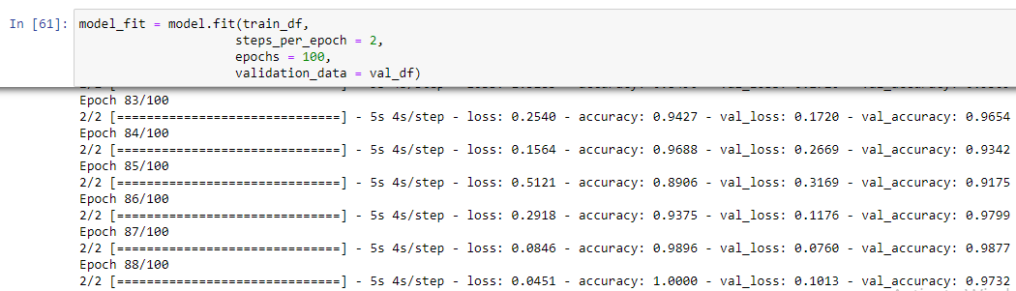

**CONCLUSION**

* Key Findings and Conclusions of the Study
  1. We have to scrap data from website for dataset.
  2. We need to create neural network.
  3. 3 types of images.
* Limitations of this work and Scope for Future Work
  1. Data: Lack of Good Data.
  2. Time: building a deep learning model is time consuming.
  3. Performance: Performance cannot guaranteed.