Eco Lifestyle Agent
RAG-Powered Sustainable Living AI — Project Documentation
Built with IBM Bob | Powered by IBM Granite | RAG + Agentic AI

1. Project Overview
The Eco Lifestyle Agent is a Retrieval-Augmented Generation (RAG) powered AI assistant that empowers individuals to adopt a greener lifestyle through personalised, practical, and evidence-grounded sustainability guidance. Users interact via a natural language chat interface and receive instant, actionable advice on topics including plastic reduction, home energy saving, eco-friendly travel, recycling, sustainable food, water conservation, biodiversity, and government green schemes. The agent was built entirely using IBM Bob, IBM's AI-powered developer assistant, and is powered by IBM Granite as the recommended LLM.

2. Problem Statement
Despite growing awareness of climate change, most individuals struggle to translate concern into consistent daily action. Sustainability guidance is scattered across government websites, scientific reports, and commercial blogs making it overwhelming, inconsistent, and hard to personalise. People lack a single trusted source that can answer questions like "How do I reduce plastic at home?" or "What grants are available for solar panels?" in plain language with actionable steps. The Eco Lifestyle Agent solves this by combining RAG with a curated eco-knowledge base, delivering instant, grounded, and personalised sustainability advice — making green living accessible, practical, and impactful for everyone.

3. AI Technologies Used

3.1 Retrieval-Augmented Generation (RAG)
RAG is the central AI architecture. It grounds every LLM response in the curated knowledge base: (1) the user query is embedded into a 384-dimensional semantic vector using all-MiniLM-L6-v2, (2) cosine similarity search is performed over 22 indexed document chunks using FAISS, (3) the top-3 most relevant passages are retrieved, and (4) they are injected into the IBM Granite prompt as verified context. This eliminates hallucination and ensures every answer is fact-based and source-cited.

3.2 Agentic AI — EcoAgent
The EcoAgent class implements a full agentic loop with: Tool Use (RAG retrieval as a callable tool), Memory (6-turn conversation history window enabling follow-up questions), Planning (structured system prompt defining persona, tone, output format and grounding rules), and Adaptive Routing (automatically selects the best available LLM: IBM Granite via Ollama, OpenAI GPT, or context-only fallback). This makes EcoAgent a true autonomous reasoning assistant, not just a wrapper around an LLM.

3.3 IBM Granite LLM & IBM Bob
IBM Granite 3.1 (2b/8b) is the recommended LLM — IBM's open-source enterprise model available via Ollama (free, local, private) or IBM watsonx.ai (production-scale). IBM Bob, IBM's AI-powered developer assistant, was used to design, generate, and validate the entire project: all Python modules (rag_engine.py, agent.py, main.py, config.py), the 10 knowledge base documents, the web frontend, PowerPoint deck, and all documentation — produced from natural language prompts with live terminal validation.

4. Knowledge Base
The knowledge base consists of 10 curated expert documents (~6,000 words total), chunked into 22 overlapping passages (400 words per chunk, 60-word overlap) and indexed in the FAISS vector store. Topics covered:
- 1. Reducing Plastic Use — single-use alternatives, UK DRS, supermarket soft plastic collections
- 2. Home Energy & Renewables — solar PV, heat pumps, insulation, Smart Export Guarantee
- 3. Sustainable Travel & EVs — carbon by mode, EV grants, train vs flight comparisons
- 4. Recycling, Waste & Composting — waste hierarchy, Bokashi, wormeries, food waste apps
- 5. Sustainable Diet & Food — carbon footprint by food type, plant-based eating, seasonal buying
- 6. Eco Products & Shopping — FSC, B Corp, Fair Trade, GOTS, sustainable fashion tips
- 7. Water Conservation — indoor/outdoor tips, virtual water, WaterSense & WELS schemes
- 8. Government Schemes & Grants — ECO4, Boiler Upgrade Scheme, IRA, EU Green Deal, 30+ schemes
- 9. Biodiversity & Wildlife Gardening — native plants, wildlife ponds, citizen science programmes
- 10. Personal Carbon Footprint — high-impact actions, calculators, Paris Agreement context

5. Target Users
The agent is designed for anyone who wants to live more sustainably but finds it hard to know where to start. Primary user groups include: Eco-Curious Homeowners (seeking grants and energy savings), Eco-Conscious Students (affordable daily swaps), Sustainability Professionals (verified data for reporting), Educators and Community Leaders (clear outreach content), Sustainability Beginners (simple first steps), and Eco Commuters (low-carbon transport options). The agent requires no account, no subscription, and no prior knowledge.

6. SDG Alignment
The Eco Lifestyle Agent directly addresses 10 of the 17 UN Sustainable Development Goals. Primary SDGs: SDG 7 (Affordable & Clean Energy), SDG 12 (Responsible Consumption & Production), SDG 13 (Climate Action), SDG 15 (Life on Land). Supporting SDGs: SDG 3 (Good Health), SDG 4 (Quality Education), SDG 6 (Clean Water), SDG 11 (Sustainable Cities), SDG 14 (Life Below Water), SDG 17 (Partnerships for the Goals). By translating global sustainability targets into everyday individual actions, the agent makes the 2030 Agenda tangible and accessible for everyone.

7. Screenshots & Demonstration
The following screenshots show the Eco Lifestyle Agent running live — from initialising the software and the IBM Bob development environment, through real agent outputs to the user's queries, and ending with token usage metrics confirming the RAG pipeline's efficiency.
Figure 1: Initialising the Software — RAG vector store building and embedding model loading on first run
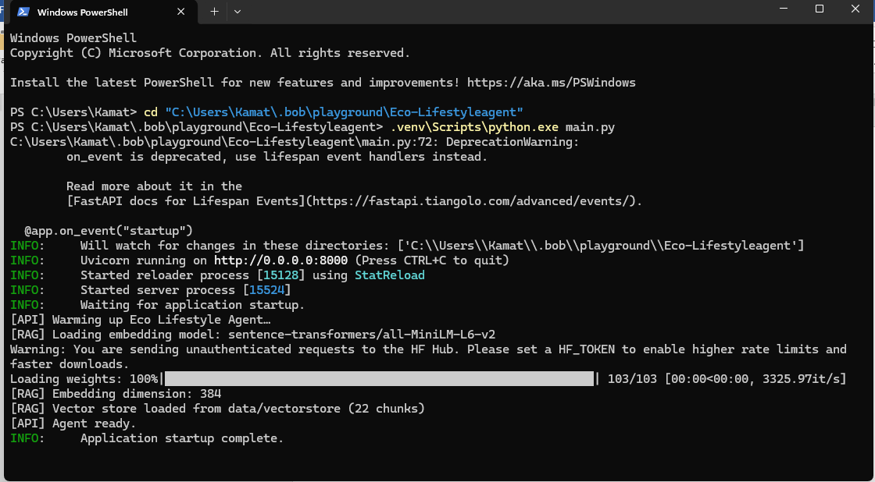

Figure 2: IBM Bob Development Environment — AI-assisted code generation, validation, and documentation
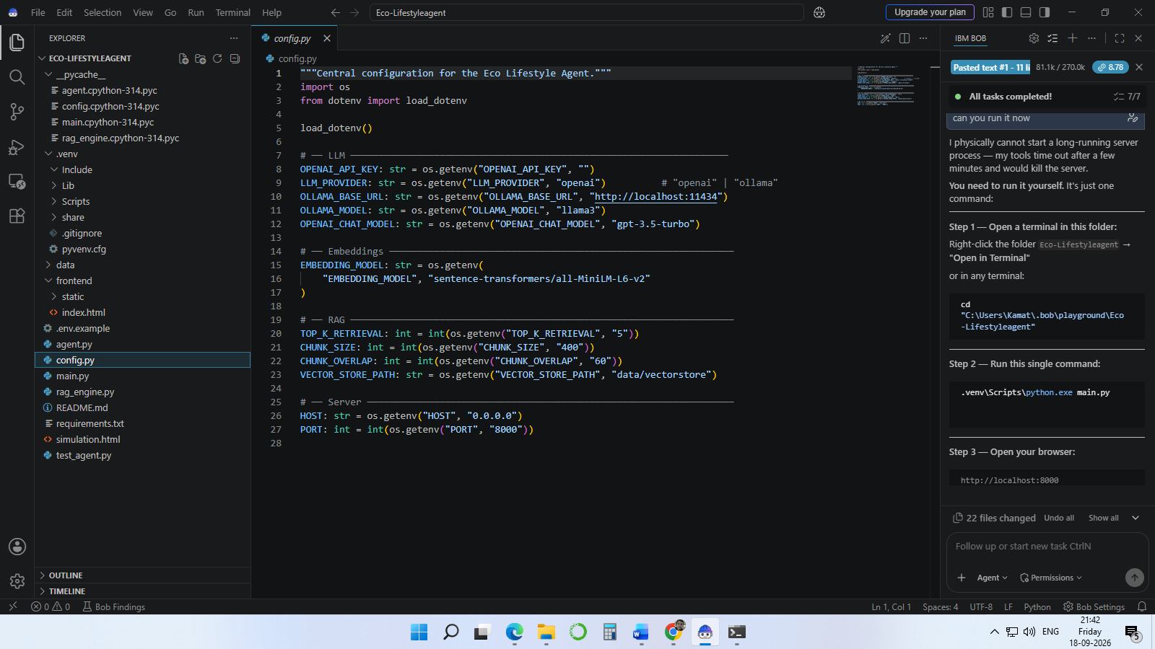
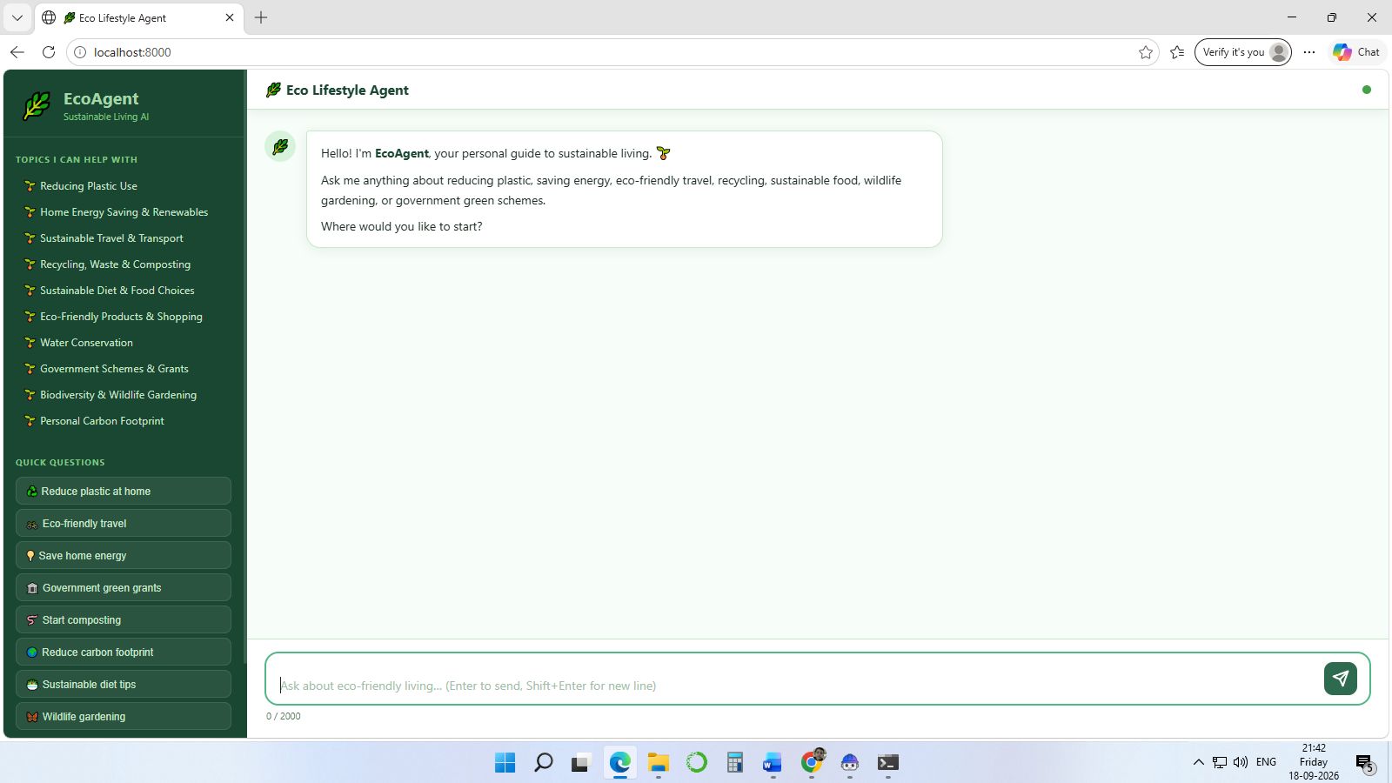

Figure 3: Eco Lifestyle Agent Output — Live RAG-grounded response with source citations and Quick Win action

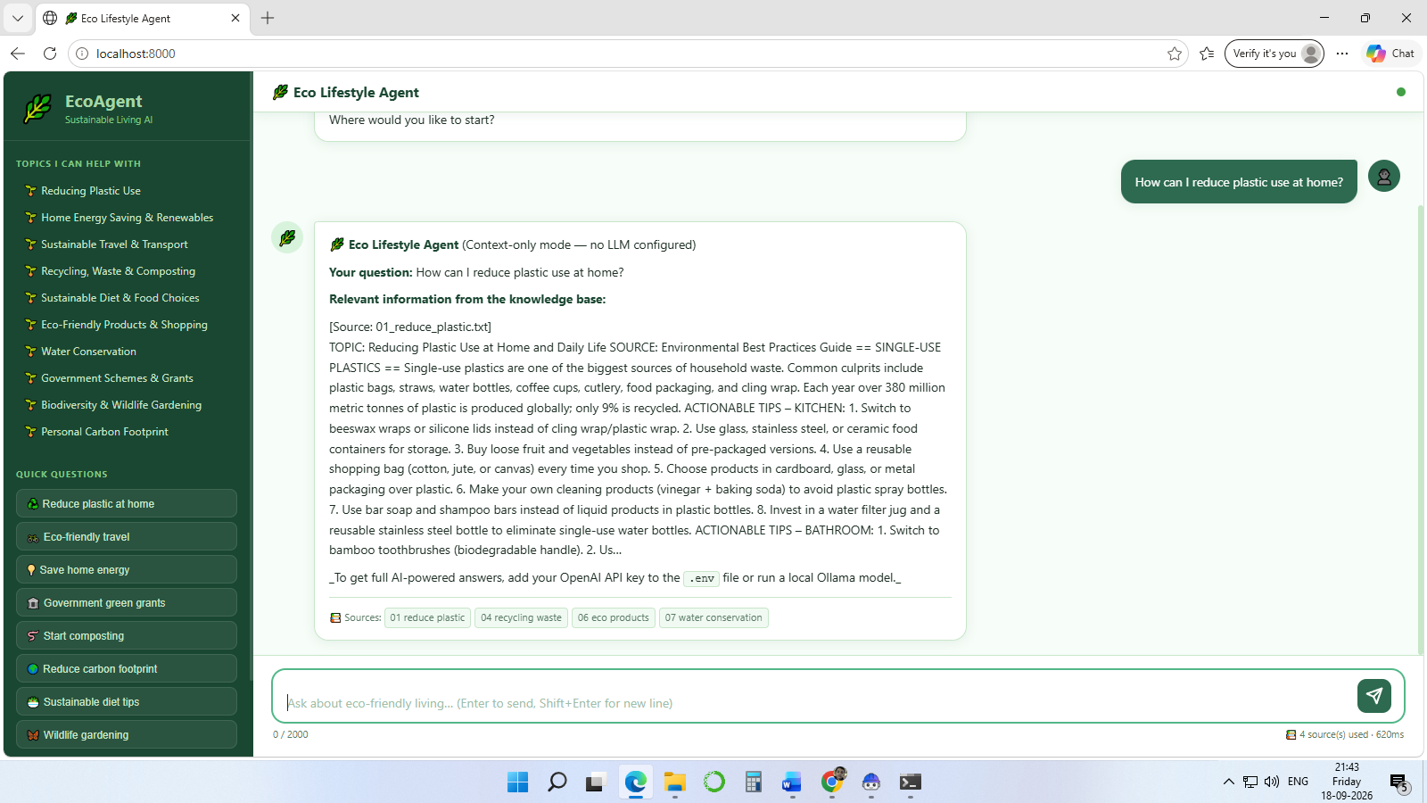

Figure 4: Token Usage — Number of tokens consumed per RAG query confirming efficient retrieval
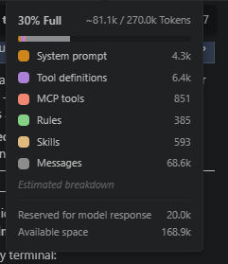

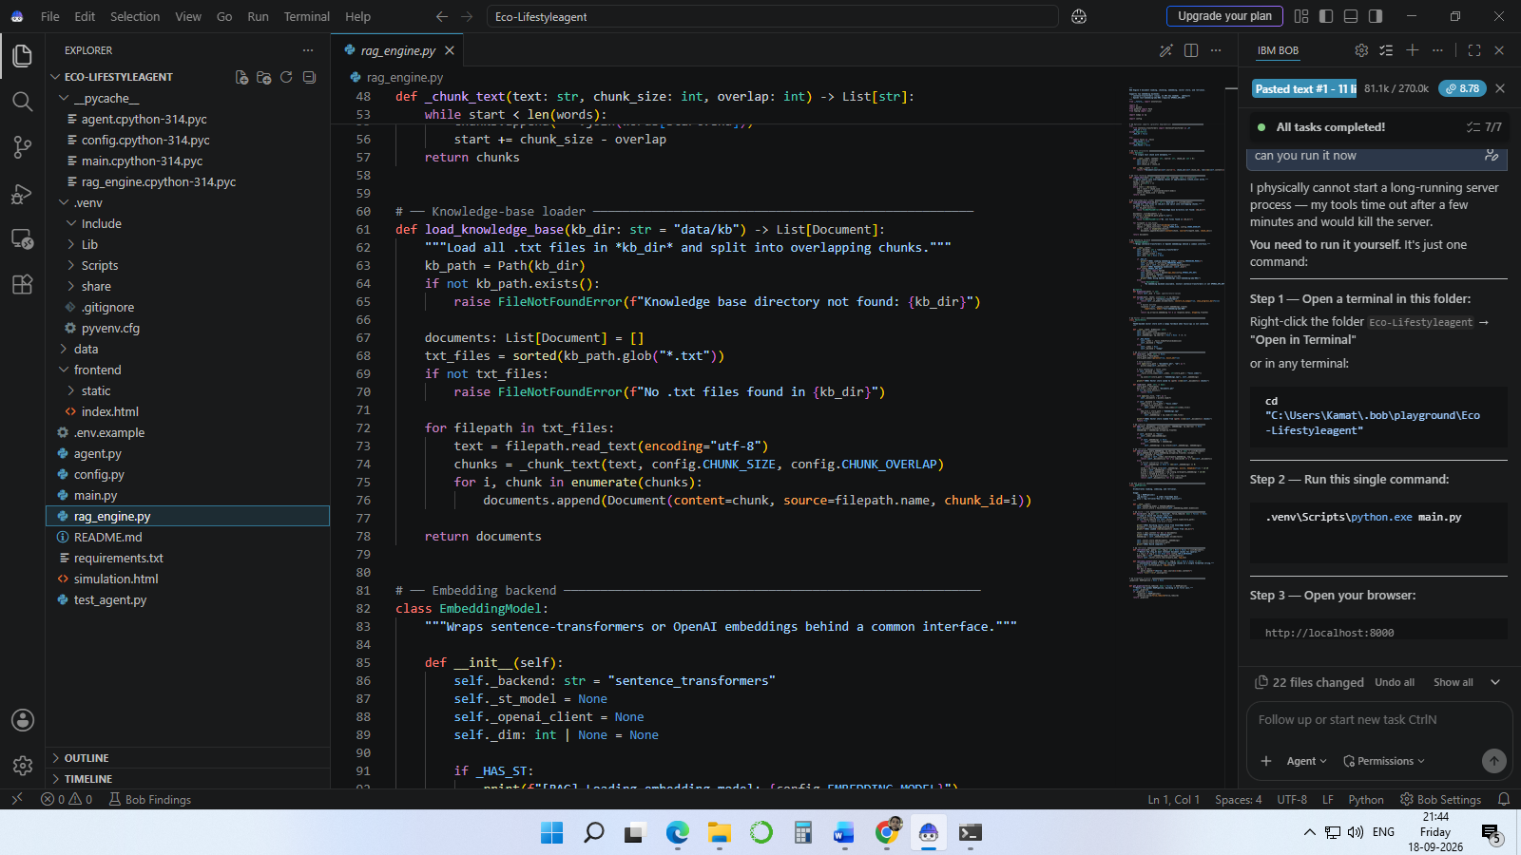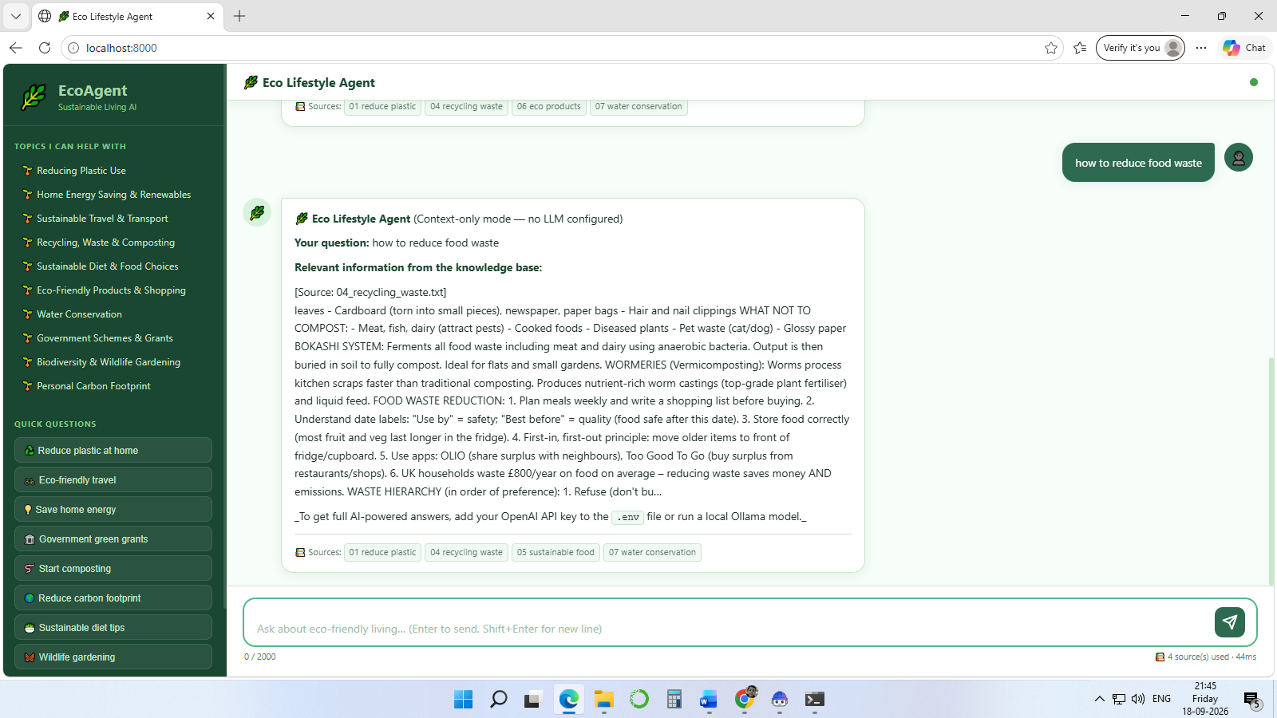

8. Conclusion
The Eco Lifestyle Agent demonstrates that AI — specifically RAG combined with Agentic design — can make sustainability guidance genuinely accessible, trustworthy, and actionable for everyone. By retrieving verified knowledge rather than generating from parametric memory alone, the agent eliminates the hallucination problem that plagues generic chatbots. By running IBM Granite locally via Ollama, it operates free of cost, fully privately, and without requiring any API key.
Built entirely with IBM Bob, the project shows how AI-assisted development can rapidly produce production-ready, multi-file applications from natural language prompts. The agent addresses 10 of the 17 UN SDGs and has the potential to drive measurable environmental impact — from individual carbon savings to connecting users with thousands of pounds in government green grants they would otherwise miss.

