Lab Report: K-Nearest Neighbours from Scratch
By Amey Parashar, 23/CS/047
Aim: To implement K-Nearest Neighbours algorithm from scratch using Numpy and Pandas
Theory:
- K-Nearest Neighbours (KNN) is a non-parametric, instance-based supervised machine learning algorithm employed for both classification and regression tasks.
- Its core mechanism operates on the principle of proximity, predicting the class or value of a new data point by examining its 'K' closest neighbours within the training dataset, as determined by a specified distance metric (e.g., Euclidean).
- For classification, the new point is assigned to the class most frequently occurring among its K neighbours (majority vote); for regression, its value is typically predicted as the average or median of the values of its K neighbours.
- As a "lazy learner," KNN defers computation until prediction time, storing the entire training dataset rather than constructing an explicit model during a distinct training phase.

Observations:
Datasets Used: Iris, Wine
EDA for Iris Dataset:
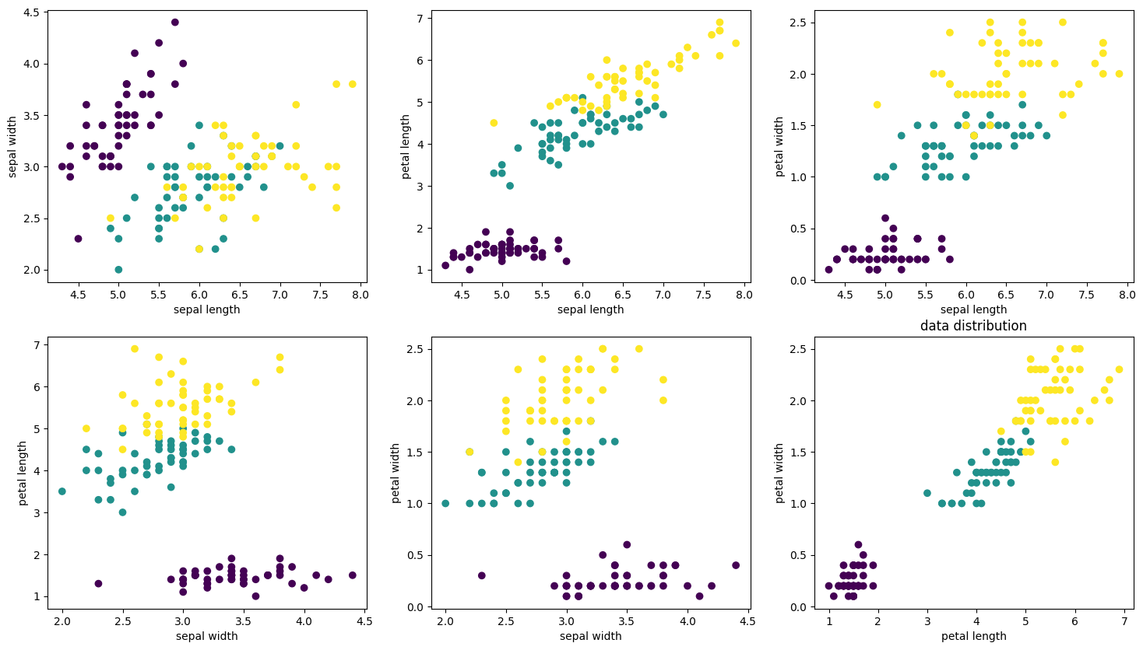

EDA for Wine Dataset:
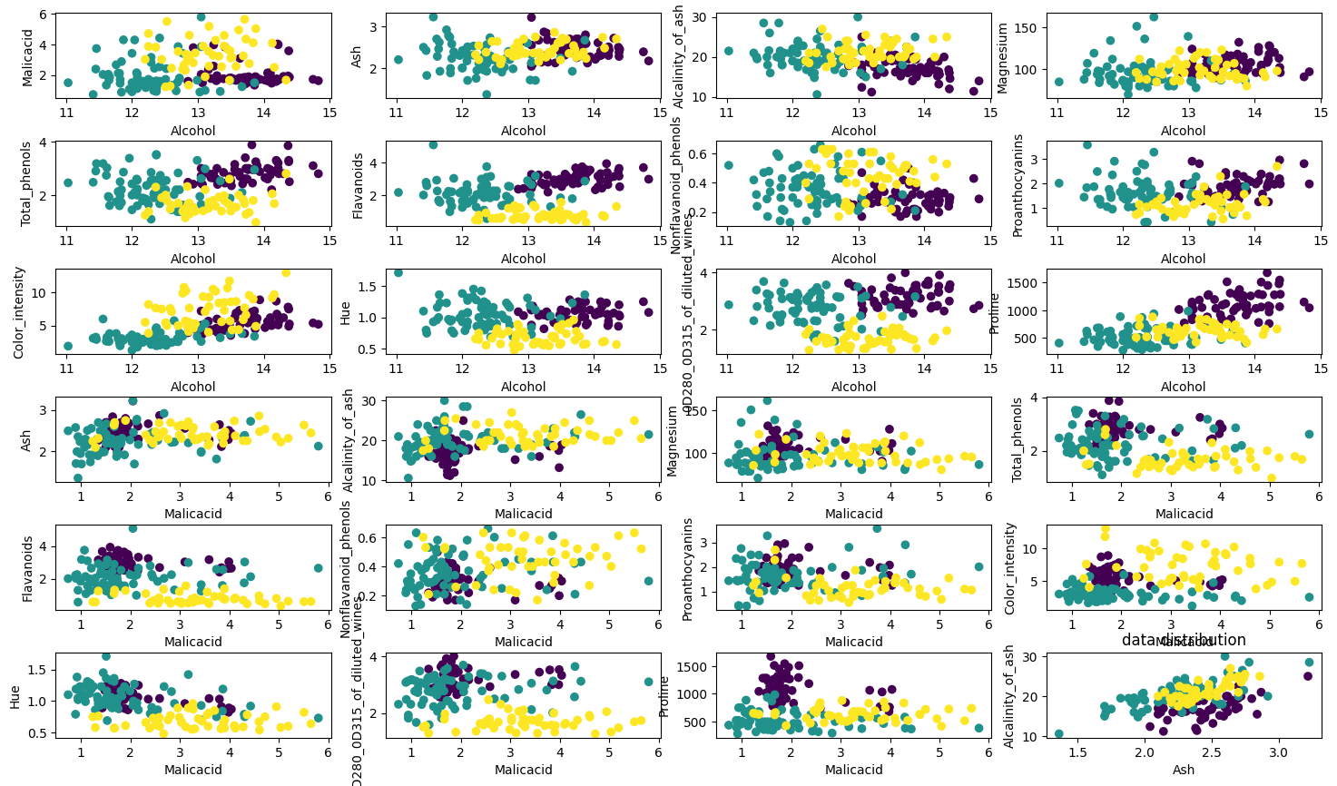

Analysis:
- Feature pair Petal length vs Petal Width provides the best and cleanest separation between the three classes.
- The setosa class is inherently easier to distinguish, as it forms a distinct, linearly separable cluster in most of the plots, especially those involving petal dimensions.
Performance on IRIS dataset
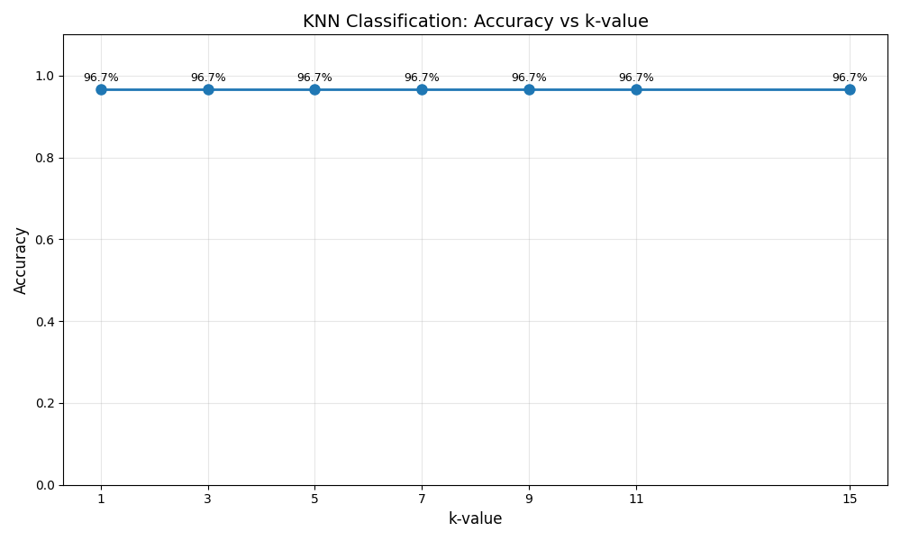
For all K values from 1-15 the model performs the same due to the inherent ease in the problem in the dataset

Performance on Wine dataset
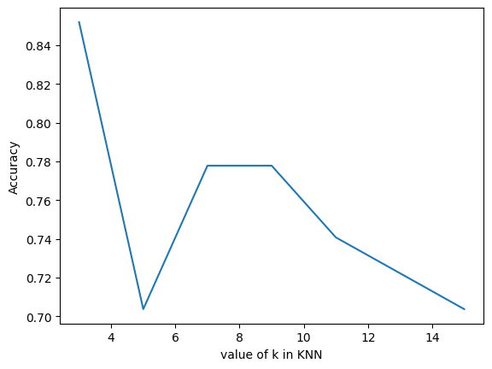
Best Performing K value: 3

Conclusion: Knn algorithm was successfully implemented using numpy and pandas, K values vs accuracy was plotted and best values were found for IRIS and Wine dataset

